Reproducible Physics-Constrained LLM-Assisted Symbolic Regression for Interpretable Band-Gap Modeling in Hybrid Perovskites
Research Article

Abstract
Compositionally tunable hybrid organic-inorganic perovskites require models that are accurate enough for screening yet simple enough to expose chemically interpretable design rules. Here we present a reproducible physics-constrained large-language-model-assisted symbolic regression (LLM-SR) workflow in which the LLM proposes candidate equation structures only, while all numerical coefficients are fitted by ordinary least squares. Candidate structures are screened by five-fold cross-validation on the training set and the final model is frozen using constrained parsimony, variance-inflation factors, coefficient confidence intervals, and bootstrap sign stability before the held-out test set is evaluated. The final frozen M4 model contains eight non-constant terms plus an intercept: Sn, Br, Cl, Cs, Sn², Br², Cs·Sn, and Cs·Cl. It achieves a fixed five-fold training-CV RMSE of 0.057532 eV and a same-source held-out test RMSE of 0.060613 eV with R² = 0.976545. All retained slopes have bootstrap sign stability of at least 0.999, whereas the discarded Cl² term has a confidence interval crossing zero and sign stability of 0.603 when added to M4. Exhaustive polynomial search, PySR, GPLearn, regularization controls, Gaussian-process regression, gradient boosting, random forests, XGBoost, repeated LLM runs, SHAP analyses, and group-aware splits were used to audit reproducibility, interpretability, and applicability. Black-box models can be more accurate, and SHAP corroborates the dominant Br/Sn/Cl hierarchy while revealing localized Br·Cl interactions compressed by the compact global formula. Group-aware tests show that M4 is most reliable for interpolation within the dominant I/Br-rich composition manifold, whereas Cl-containing and Cs-rich families define applicability boundaries. The contribution is therefore an auditable protocol for converting stochastic LLM proposals into a diagnostically frozen, domain-limited analytical surrogate, rather than a claim of universal LLM superiority or unrestricted ABX3 extrapolation.
Keywords: hybrid perovskites; band gap; symbolic regression; large language models; interpretable machine learning; SHAP; applicability domain

1. Introduction
Hybrid organic-inorganic perovskites (HOIPs) have become a central semiconductor platform for photovoltaics, light-emitting diodes, photodetectors, and tandem devices because their electronic structure can be tuned over a wide energy range by composition [1-4]. In three-dimensional ABX3 perovskites, replacement of Pb by Sn at the B site generally narrows the band gap, whereas substitution of I by Br or Cl at the X site produces a blue shift. Nonlinear bowing is common in mixed-metal and mixed-halide systems, and the A-site cation can indirectly affect the band gap through lattice dimensions, octahedral tilting, phase stability, and local structural disorder [5-8]. These coupled effects make the band gap an ideal test case for composition-property modeling: it is technologically important, experimentally abundant, and sufficiently nonlinear that a purely linear rule is inadequate.
Data-driven models can capture these trends, but the representation of knowledge matters. Ensemble trees and Gaussian processes often provide strong prediction accuracy, yet their design guidance is mediated through post hoc tools or numerical queries rather than a reusable closed-form rule [10]. Classical symbolic regression addresses this interpretability problem by searching directly over equations [11-13]. However, unconstrained searches can expand into large operator spaces, produce algebraically different expressions across random seeds, and exploit correlations created by compositional closure. These risks are amplified in materials datasets that are small, heterogeneous, and concentrated in a limited composition manifold. Recent work has explored large language models as scientific equation generators or program-guided hypothesis proposers [14], but a scientifically defensible workflow must separate stochastic structure generation from numerical fitting and model selection.
We therefore use the LLM only as a constrained symbolic-structure proposer. The prompt fixes the admissible variables, limits expressions to main effects, squared terms, and a small number of pairwise interactions, forbids coefficients and non-polynomial operators, and expands the search in stages from M0 to M4. Every coefficient is subsequently determined by ordinary least squares (OLS). Five-fold cross-validation (CV) on the training partition governs screening, and the held-out test set is unavailable during generation, fitting, pruning, and freezing. This separation is essential: the LLM supplies hypotheses, whereas deterministic statistical procedures decide whether those hypotheses survive.
The contribution is consequently not a claim that an LLM discovered the universally best band-gap equation. It is a constrained and auditable symbolic-modeling workflow that combines structure generation, CV-qualified parsimony, coefficient diagnostics, conventional symbolic and statistical baselines, repeated LLM runs, black-box prediction benchmarks, SHAP interpretation, and group-aware sensitivity analysis. These tests yield a diagnostically frozen Cs-Cl-containing M4 formula with eight non-constant terms plus an intercept. We evaluate LLM-SR not only by held-out accuracy, but also by structural reproducibility, comparison with conventional symbolic regression, coefficient behavior under compositional collinearity, agreement and tension with SHAP, and sensitivity to composition-family exclusion. The result is a domain-limited first-pass surrogate for interpolation and composition screening within the represented data manifold, with an explicitly defined applicability domain.
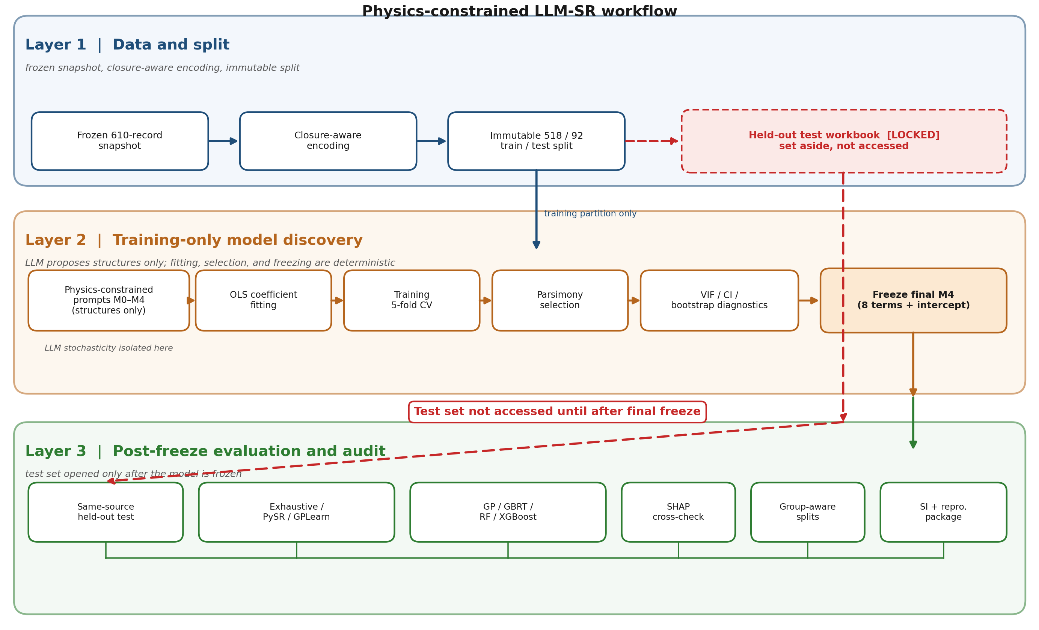
Figure 1. Physics-constrained LLM-SR workflow. The frozen dataset is closure-aware encoded and split into immutable training and held-out test workbooks. The LLM proposes symbolic structures only; OLS fitting, training-CV screening, parsimony selection, and VIF/confidence-interval/bootstrap diagnostics are performed using the training partition. The held-out test set and post-freeze audits are used only after model freezing.

2. Materials and Methods

2.1. Dataset source, curation scope, and evidence boundary
The source data were derived from the open Perovskite Database Project described by Jacobsson et al. [9]. The analysis used a frozen local workbook snapshot dated January 28, 2026. The retained scope was restricted to three-dimensional ABX3 HOIP compositions represented by A-site fractions FA, MA, and Cs; B-site fractions Pb and Sn; X-site fractions I, Br, and Cl; and a reported optical band gap. No journal impact factor, Journal Citation Reports category, or publication-prestige criterion was used, because such filters do not directly assess measurement quality and would introduce a bibliometric selection bias. The band-gap distribution was not artificially balanced, truncated, oversampled, or reshaped.
The archived evidence begins from the frozen 610-record local snapshot. The upstream database-export log and the row-by-row exclusion record that preceded this snapshot are not available; the reproducibility claims in this work therefore refer to the frozen 610-row snapshot and all downstream analyses, not to a fully reconstructable database-to-snapshot extraction pipeline. The directly auditable curation steps and this upstream evidence gap are itemized in Supplementary Note S1 and Figure S1.
Inclusion criteria. A record was retained when it described a 3D ABX3 hybrid organic-inorganic perovskite with the A site limited to FA, MA, and Cs, the B site limited to Pb and Sn, and the X site limited to I, Br, and Cl; when composition fractions and an optical band gap (E_{g}) were both available; and when it could be represented as a record-level observation.
Exclusion and non-use criteria. No impact-factor, Journal Citation Reports, or publication-prestige filter was applied; no large-perovskite-group filter was applied; the E_{g} distribution was not artificially balanced, truncated, oversampled, or reshaped; and duplicate measurements were not averaged in the primary analysis. These criteria document how the 610 records were obtained and confirm that neither journal reputation nor the band-gap distribution was used as a selection filter.

2.2. Composition encoding, closure constraints, and duplicate handling
Fractions are represented on a 0-1 scale. Because each crystallographic site is compositionally closed, FA + MA + Cs = 1, Pb + Sn = 1, and I + Br + Cl = 1 in an ideal record. Pb, I, and FA were therefore treated as implicit baselines, and the active raw variables of the final formula are Sn, Br, Cl, and Cs. This encoding avoids exact linear dependence within a site while keeping every retained variable an interpretable site fraction.
MA was not treated as chemically irrelevant. Because FA, MA, and Cs are compositionally closed, including all A-site fractions together with an intercept would create exact linear dependence; the final equation therefore uses Cs as a restricted A-site correction, with FA and MA absorbed into the implicit baseline. MA-containing encodings were evaluated as sensitivity controls and are reported in Supplementary Note S8. MA is retained as a meaningful, tolerance-factor-related variable in that sensitivity analysis; it is omitted from the final active set for closure and parsimony reasons, not because its physical effect is assumed to be negligible.
At the 610-record snapshot level, duplicate and repeated-composition records were audited rather than removed. The complete duplicate-composition table is provided in Supplementary Note S1. The primary model retained record-level observations because the compact composition-only representation does not encode processing, phase state, or measurement-condition metadata, and reported band gaps can differ across these conditions for the same nominal composition. Exact train/test row overlap, shared composition groups, and shared model-feature combinations were separately quantified and used to motivate the group-aware sensitivity analyses; the corresponding counts are tabulated in Supplementary Note S3.
A separate strict closure audit (tolerance 10^-6) was used only for the group-aware sensitivity analysis. Fractions were not silently renormalized: 11 training rows and two test rows exceeded the tolerance. The group-aware workflow excluded the 11 affected training rows and used 507 valid training records, whereas the two affected test rows were documented for reference because the test set was never used to select any model. The primary frozen model remains the structure fitted to the predeclared 518-row training file, preserving the original analysis path, while the strict-QC workflow tests whether the conclusions persist under a more conservative data policy.

2.3. Immutable train/test split and representativeness audit
The supplied split was fixed at 85/15, with 518 records assigned to training and 92 to test, and the split files were treated as immutable analysis inputs. The training partition alone was used for candidate screening, OLS coefficient estimation during cross-validation, pruning, repeated-CV comparison, bootstrap analysis, and final model freezing. The held-out test workbook was loaded only after the final structure had been frozen.
The target distribution is concentrated in the technologically common 1.5-1.7 eV interval, which contains 268 training records (51.7%) and 43 test records (46.7%). The training mean and standard deviation are 1.651 and 0.310 eV, compared with 1.695 and 0.398 eV for the test set, so the test set is somewhat broader and more enriched in high-gap observations: 10.9% of test records have E_{g} >= 2.2 eV, versus 6.9% of training records. Cl-containing compositions are sparse, with 27 training and eight test records having Cl > 0. At the four-variable model-feature level, 29 unique Sn-Br-Cl-Cs combinations (43 test rows) are shared with training, whereas 49 test rows have unseen four-variable combinations. Dataset representativeness and split overlap are summarized in Figure 2 and Supplementary Note S3; Figure 2 is a split-fairness audit rather than a performance result.
The 92-record test set is therefore a legitimate same-source held-out set for non-selection evaluation, but it is not an independent literature-validation panel. Because several test records share composition-level or model-feature neighborhoods with training records, the random-split test error is interpreted as interpolation performance within the represented data manifold. Transfer beyond this manifold was evaluated separately by the group-aware splitting described in Section 2.7.
Fixed model comparisons used five-fold KFold(n_splits=5, shuffle=True, random_state=42). A repeated-CV audit used 100 independently shuffled five-fold partitions with seeds 0-99, and the repeated LLM-workflow experiments used their separately archived CV seed 20260607. All metrics were computed in electronvolts, with RMSE as the primary predictive metric and MAE and R² as supporting metrics.

2.4. Physics-constrained LLM structure proposal
The LLM was used only as a constrained structure proposer. Physical knowledge was encoded through the admissible term space and the order in which that space was expanded, rather than by prescribing coefficient signs. At every stage the model output had to be a single symbolic structure without numerical coefficients or explanatory text, and the LLM could not access the test data or any test metric during generation, fitting, pruning, or freezing.
M0 allowed only a constant and the linear Sn, Br, and Cl terms. M1 added the univariate curvature terms Sn², Br², and Cl² but prohibited interactions. M2 allowed a small number of pairwise interactions among Sn, Br, and Cl to represent metal-halide and mixed-halide coupling. M3 introduced Cs and permitted selected Cs-Sn, Cs-Br, and Cs-Cl interactions, with Cs² optional. M4 requested simplification of a late-stage quadratic model to eight to eleven non-constant terms. Across all stages, logarithms, exponentials, ratios, cubic and higher powers, and newly invented variables were forbidden, and the LLM was not permitted to fit coefficients. No coefficient sign was forced at any stage.
These constraints serve two purposes. First, they enforce a dimensional and compositional interpretation, so that every term is a site fraction, a bowing-like quadratic correction, or a pairwise composition coupling. Second, they reduce the chance that the model exploits a numerically convenient but scientifically opaque operator.
The exact prompts, output-format checks, and stage-specific admissible term pools are provided in Supplementary Note S4, and the global generation and fitting settings are summarized there in Table S7. The primary LLM interface and its archived model string, the access date, the temperature and top-p settings where available, the maximum candidate count per stage, and all external-model sensitivity settings are recorded in Supplementary Note S10. A single archived model identifier is used consistently throughout the manuscript and Supporting Information.

2.5. OLS fitting, cross-validation, selection, and diagnostic freezing
For any candidate structure, a design matrix was constructed from the included terms and an intercept, and coefficients were fitted by ordinary least squares (OLS) on the current training data. During five-fold cross-validation (CV), coefficients were refitted within each training fold and evaluated on the corresponding validation fold. The held-out test set played no role in this process.
Candidates were evaluated and frozen by the following deterministic procedure:
- parse the LLM output into a permitted term set;
- reject any structure containing forbidden variables or operators;
- fit OLS on the training folds only;
- compute the five-fold training-CV RMSE;
- define stage-equivalent candidates as those within 5% of the best CV RMSE for that stage;
- select the fewest-term structure within this window, breaking ties by lower CV RMSE;
- refit the selected structures on the full training data;
- compute VIF, OLS 95% confidence intervals, bootstrap 95% confidence intervals, and bootstrap sign stability;
- remove terms with unstable intervals or signs, or with excessive collinearity;
- freeze the final structure;
- evaluate the held-out test set once.
Across stages, structures with CV RMSE below 0.06 eV entered the late-stage candidate pool. Bootstrap confidence intervals and sign stability used 1000 training-row resamples with seed 2026, where sign stability is the fraction of bootstrap fits in which a coefficient retained the sign of its full-training estimate. The final structure contains eight non-constant terms plus an intercept; it was selected from the late-stage M4-family candidate pool and was not obtained by deleting a single interaction from the historical 13-term model. Terms with weak confidence support, unstable bootstrap signs, or severe collinearity were removed even if they marginally improved training fit, and the final formula was frozen before any test evaluation.
The repeated-occurrence frequency of an LLM-proposed terminal interaction was recorded as a stochasticity diagnostic, but it was not used as the final selection criterion. When repeated generation favored an alternative terminal interaction (a Cs·Br-containing candidate), that competing candidate was compared head-to-head against the diagnostically frozen Cs·Cl-containing structure using fixed CV, repeated CV, VIF, confidence intervals, bootstrap sign stability, and subgroup errors. This comparison is reported in Supplementary Note S6.

2.6. Baseline, ablation, and interpretability controls
All baseline and ablation models used the same frozen training/test split, the same composition inputs, and the same training-only selection principle. Hyperparameter selection, parsimony tuning, and symbolic-expression selection were performed on the training split only, and the held-out test set was evaluated only after the corresponding baseline structure or trained predictor had been selected.
Conventional symbolic and polynomial search. An exhaustive OLS search evaluated all 511 non-empty subsets of the nine-term anion polynomial dictionary {Sn, Br, Cl, Sn², Br², Cl², Sn·Br, Sn·Cl, Br·Cl}. PySR was run with five random seeds under polynomial and richer operator settings. A compact GPLearn baseline used composition variables, the operators add/subtract/multiply, a parsimony grid selected by training five-fold CV, and five independent full-training refits. Because the operator set and computational budget of this GPLearn run were deliberately limited, its result is interpreted as a stability/control experiment rather than a definitive tuning study.
Classical statistical selection. LASSO, ridge, elastic net, and stepwise or exhaustive AIC/BIC analyses were applied to the anion polynomial dictionary [20-23]. These methods were used as pruning diagnostics, not as direct selectors of the final A-site-containing model.
Repeated LLM workflows. Thirty isolated M0-M4 runs were executed with identical prompts, data, candidate counts, and CV rules; coefficient fitting remained deterministic, and only structure generation was stochastic. Additional Qwen and DeepSeek runs at multiple temperature settings provided a cross-model sensitivity check. Exact regeneration was not required; the target question was whether compact M4-family backbones repeatedly reappeared.
Black-box benchmarks and SHAP. Gaussian-process regression (GP), gradient-boosted regression trees (GBRT), random forests (RF), and XGBoost were optimized on the training split [15-18]. SHAP values were calculated for the tree models to compare global feature importance and interaction patterns with the symbolic coefficients [19].

2.7. Group-aware sensitivity and external-validation boundary
Using the strict-QC 507-row training set, the entire candidate-screening and fitting procedure was rerun under 20 composition-family group-shuffle splits, halide leave-one-group-out (LOGO), and A-site LOGO. Screening occurred inside each outer training partition, and the held-out group was evaluated only after a structure had been selected and refitted. No test-set information entered group construction or model selection.
Composition-family groups were defined from coarse composition categories rather than from the held-out test set, and group labels were constructed before model selection inside each split. Halide groups separated I-rich, Br-rich, mixed-halide, and Cl-containing records, where a record was assigned to a halide category by its dominant X-site fraction and Cl-containing denotes Cl > 0. A-site groups separated FA-rich, MA-rich, Cs-rich, and mixed-A records by the dominant A-site fraction. The exact category rules and the per-record group assignments are listed in the group-aware manifest in Supplementary Note S12.
Independent external validation was not used for model selection and is not claimed. The held-out test set is drawn from the same frozen database snapshot as the training data, and the archive does not contain a verified independent literature-validation panel with harmonized measurement conditions. Broad transferability is therefore not asserted unless and until a verified external panel is assembled; the external-validation status and a completion protocol are documented in Supplementary Note S13.

3. Results and Discussion

3.1. Dataset structure, split fairness, and composition bias
Table 1 and Figure 2 summarize the modeling population. Training and test means are similar for Sn and Br, while the test set has slightly more Cl and MA and slightly less Cs. The principal difference is tail coverage: the test target distribution is broader and more enriched in high-gap records. This is useful for challenging the model, but the small number of Cl-containing records means that aggregate metrics are dominated by I/Br-rich compositions.
Table 1. Dataset and fixed-split summary.
Cohort | n | E_{g} mean ± SD (eV) | Median (eV) | 1.5-1.7 eV | E_{g} >= 2.2 eV | Cl > 0
Training | 518 | 1.651 ± 0.310 | 1.606 | 268 (51.7%) | 36 (6.9%) | 27
Held-out test | 92 | 1.695 ± 0.398 | 1.615 | 43 (46.7%) | 10 (10.9%) | 8

The marginal correlations support the staged physical design. In the training set, Br and Cl correlate positively with E_{g} (r = 0.630 and 0.687), Sn correlates negatively (r = -0.385), and the A-site fractions are substantially weaker (r = 0.159 for Cs and 0.078 for MA). These values should not be interpreted as causal coefficients because site closure and nonlinear response distort marginal relationships. They nevertheless explain why M0-M2 focused on Sn and the halides, while A-site terms were introduced only after the dominant B/X-site structure was established.
The train/test split resembles the overall target distribution in the central region, but it is not a strict composition holdout. Forty-three test rows share one of 29 Sn-Br-Cl-Cs combinations with training, while 49 rows are unseen in the four-variable M4 representation. Final M4 has RMSE 0.0528 eV on the shared-combination subset and 0.0667 eV on the unseen-combination subset. The latter is still useful performance, but the gap confirms that random-split accuracy partly reflects interpolation around previously observed composition coordinates. The group-aware section therefore carries more weight for claims about transfer to new composition families. In short, the split is suitable for same-source interpolation assessment but not for unrestricted composition extrapolation.
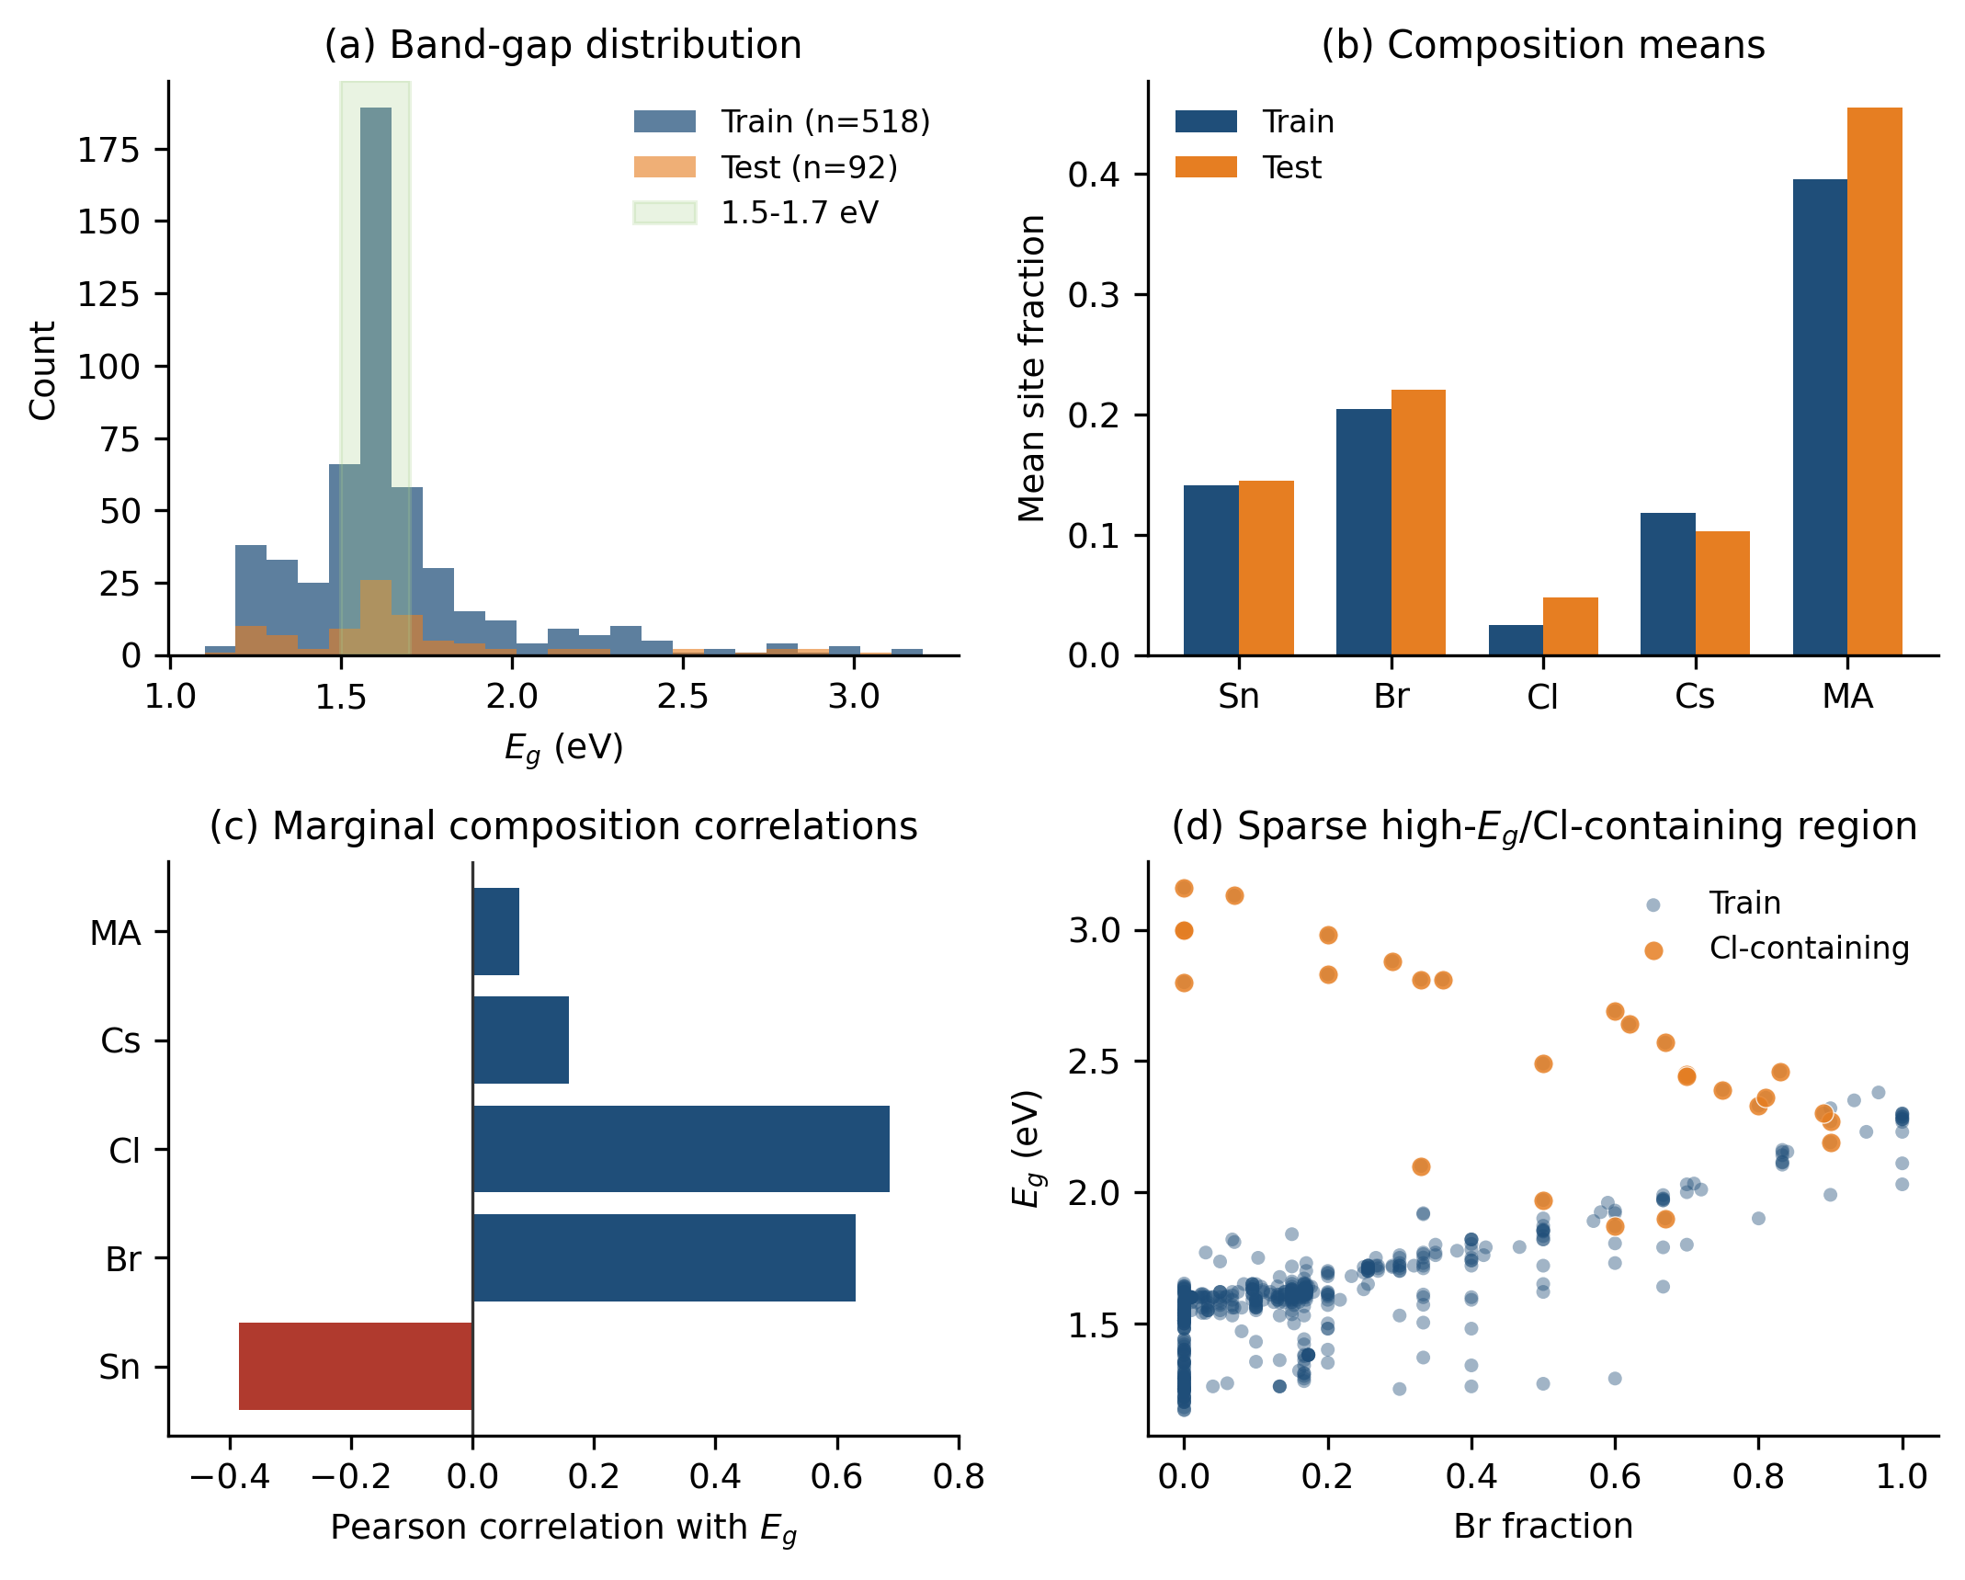
Figure 2. Dataset structure and representativeness. (a) Training and test band-gap distributions, with the dense 1.5-1.7 eV interval highlighted. (b) Mean fractions of the active composition variables. (c) Training-set marginal correlations with the band gap. (d) Sparse Cl-containing observations occupy much of the high-gap tail. The dense 1.5-1.7 eV region dominates model fitting, whereas high-gap Cl-containing compositions define a sparse boundary regime.

3.2. Stage-wise evolution from M0 to the final M4 family
The stage sequence demonstrates that increasing nominal expressiveness does not guarantee monotonic validation improvement. The M0 linear model, containing only Sn, Br, and Cl, has CV RMSE 0.08773 eV. Adding univariate curvature in M1 reduces the CV RMSE to 0.06394 eV, confirming the importance of bowing-like behavior, especially for Sn and Br. The full anion interaction model used as M2 has CV RMSE 0.06655 eV, worse than M1 despite having more terms. Its fitted Cl, Cl², and Br·Cl coefficients become large and mutually compensating, a symptom of sparse Cl coverage and collinearity rather than a robust physical correction.
Introducing constrained Cs interactions in M3-full lowers the CV RMSE to 0.05833 eV. This improvement is important because a nine-term anion-only core gives 0.06655 eV and the best six-term anion exhaustive subset gives 0.06285 eV. A-site information therefore contributes, but not as a large independent main effect. Its value appears mainly through interaction terms that condition the Sn and halide response.
The final M4 (eight non-constant terms plus an intercept) is a diagnostically pruned and frozen compact model selected from this late-stage family. Its fixed CV RMSE is 0.05753 eV, lower than the 14-term M3-full reference, while its term count is reduced from 14 to eight. Repeated five-fold CV gives 0.05806 eV for final M4 and 0.06006 eV for M3-full. The paired difference is -0.00200 eV, with a 95% interval from -0.00263 to -0.00147 eV. The result shows that the additional full-model terms were not merely unnecessary for interpretability; on repeated splits they were also detrimental to validation performance. Although M3-full and the historical 13-term M4 reach lower post hoc test RMSEs (0.054620 and 0.053835 eV) than the frozen 8-term model (0.060613 eV), they were not selected, because test error was not part of the freeze criterion and because their additional terms were diagnostically weaker; the stage-wise values are tabulated in Supplementary Table S9.

3.3. Final frozen M4: equation, coefficient diagnostics, and held-out test performance
The final formula is:
E_{g} = 1.55527 - 1.10253 Sn + 0.34320 Br + 1.61932 Cl + 0.12268 Cs + 0.91702 Sn² + 0.36607 Br² - 0.22716 Cs·Sn - 0.32528 Cs·Cl
The intercept corresponds to the implicit FA-Pb-I baseline of the chosen encoding, not a universal band gap for every pure material state. The model contains eight non-constant terms plus an intercept. The negative linear Sn coefficient is consistent with Pb-to-Sn gap narrowing. The positive Sn² term introduces curvature, allowing the magnitude of the Sn effect to vary across the substitution range. Br and Cl have positive main effects, consistent with I-to-Br-to-Cl blue shifting, while Br² captures nonlinear mixed-halide behavior. The small positive Cs main effect and negative Cs·Sn and Cs·Cl interactions represent a minimal A-site correction. They do not imply that A-site chemistry dominates the electronic structure.
After freezing, final M4 was fitted once to the full 518-row training set and evaluated on the 92-row held-out test set. Training RMSE, MAE, and R² are 0.05411 eV, 0.03926 eV, and 0.96938. On the held-out test set the RMSE, MAE, median absolute error, maximum absolute error, and R² are 0.06061 eV, 0.04676 eV, 0.03665 eV, 0.18355 eV, and 0.97655. The Cl-containing test RMSE is 0.11180 eV, nearly twice the aggregate value, locating the main error concentration in the sparse Cl regime. Because the freeze decision used only the training partition, this test set is reported as a same-source held-out evaluation rather than as a selection criterion; its independent-validation status is discussed in Section 3.9.
All eight slopes are statistically and numerically stable. No OLS or bootstrap confidence interval crosses zero. Bootstrap sign stability is 1.000 for seven slopes and 0.999 for Cs·Cl. The largest VIF is 15.79 for Sn², followed by 15.17 for Sn; Br and Br² have VIFs near nine. These values reflect the expected correlation between a raw fraction and its square. They are higher than conservative textbook thresholds, but remain far below the pathological values in the unpruned model, where the maximum VIF is 3250 because Cl, Cl², and Br·Cl are almost linearly dependent over the sparse Cl-containing subset [25]. The complete per-coefficient OLS statistics, bootstrap intervals, and VIF values are tabulated in Supplementary Tables S11A and S11B, and their key behavior is summarized in Figure 3.
The Cl² diagnostic is decisive. When Cl² is added to final M4, its OLS and bootstrap intervals cross zero, bootstrap sign stability is 0.603, and the nested F-test gives p = 0.2332. Adding it also worsens fixed CV RMSE from 0.05753 to 0.05826 eV and increases maximum VIF. Cl² was therefore not retained. Therefore, Cl² was not a borderline omission; it failed both predictive and inferential diagnostics. Similar logic removed Cs², Sn·Br, Sn·Cl, Br·Cl, and Cs·Br from the frozen model. Their exclusion does not mean that the underlying physical couplings never occur. It means that these terms could not be represented as stable independent coefficients in this dataset and encoding.
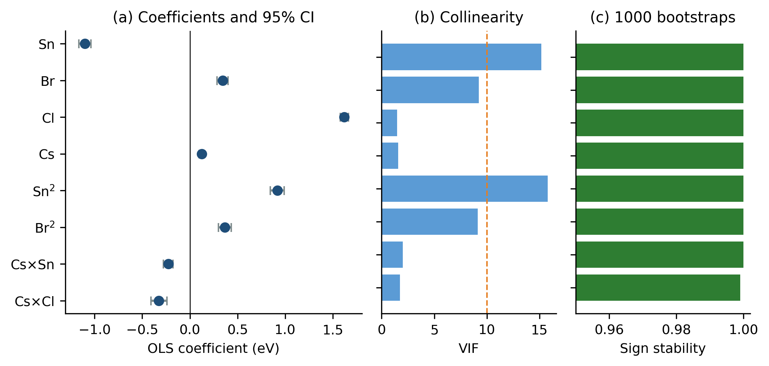
Figure 3. Diagnostics for the final frozen M4. (a) OLS coefficients and 95% confidence intervals. (b) Variance-inflation factors; the dashed line marks VIF = 10. (c) Bootstrap sign stability from 1000 training-row resamples; the sign-stability axis is truncated to 0.95-1.00 to resolve the small differences between near-unity values.

3.4. Comparison with conventional symbolic regression and polynomial search
The conventional baselines clarify what the LLM contributes and what it does not. Exhaustive search over all 511 anion-only polynomial subsets is deterministic and highly interpretable. Its best structure contains Sn, Br, Cl, Sn², Br², and Sn·Br, with CV RMSE 0.06285 eV and post hoc test RMSE 0.06671 eV. This is a strong compact baseline, but it lacks the A-site interactions needed to reach the final M4 validation level. The result also weakens the case for Cl²: the global optimum excludes it.
Sparse regularization provides similar diagnostic evidence. Minimum-CV LASSO and elastic net keep all nine anion terms, whereas the one-standard-error solutions set Cl² and Br·Cl to zero but retain Sn·Br and Sn·Cl. Stepwise AIC and BIC select seven terms: Sn, Br, Cl, Sn², Br², Sn·Br, and Sn·Cl. Exhaustive AIC/BIC prefer the full nine-term anion model because their likelihood penalties do not directly account for coefficient sign stability or the interpretability cost of collinearity. None of these methods exactly reproduces final M4, but together they show that prediction-optimal term retention and diagnostically stable term retention are different objectives.
PySR reaches test errors close to M4 in some runs but exhibits structural variability. Across five polynomial-operator seeds, the best-equation test RMSE has mean 0.0683 eV, standard deviation 0.0096 eV, and minimum 0.0610 eV; all five selected structures are different. The richer operator setting gives mean 0.0637 eV and minimum 0.0611 eV, again with five unique selected expressions. Complexity-matched PySR expressions can reach lower post hoc errors, but they are algebraically less transparent than the eight named polynomial terms.
The compact GPLearn experiment performs substantially worse, with CV RMSE 0.1453 eV and mean test RMSE 0.1773 ± 0.0228 eV across five independent refits. The evolved programs are also seed-dependent. This result should not be interpreted as a universal ranking of genetic programming: the run used a deliberately constrained operator set and limited computational budget. It demonstrates that merely enabling evolutionary symbolic search does not guarantee a stable, accurate, and compact equation under a practical search budget.
Table 2. Symbolic-regression and statistical control benchmarks. Black-box predictors are reported separately in Figure 4 and Supplementary Table S21.
Method | Model/search type | CV RMSE (eV) | Test RMSE (eV) | Interpretation
Final frozen M4 | eight non-constant terms plus intercept | 0.0575 | 0.0606 | Frozen; high coefficient stability
Exhaustive-6 | Anion polynomial subset | 0.0629 | 0.0667 | Deterministic; excludes A-site
PySR-P | Five symbolic runs | n/a | 0.0683 ± 0.0096 | Five unique selected structures
GPLearn | Compact genetic-programming baseline | 0.1453 | 0.1773 ± 0.0228 | Exploratory limited-budget run

Taken together, the baselines do not establish that LLM-SR is an unconstrained accuracy optimizer. Rather, the LLM is useful for proposing physically organized candidate families that include a small A-site correction without exhaustively enumerating every cross-site polynomial. Deterministic diagnostics still decide which proposal is acceptable.

3.5. LLM stochasticity and repeated-run stability
Structure generation is stochastic even though coefficient fitting is deterministic. In a direct set of 30 independent M4-only proposals, all outputs satisfied the 8-11-term constraint, but seven normalized structures appeared. Sn, Br, Cl, Cs, Sn², Sn·Br, and Sn·Cl were proposed in every run; Br² appeared in 93.3% and Cs·Br in 96.7%, while Cs·Cl appeared in 30.0% and Cs·Sn in 10.0%. These frequencies demonstrate that individual terminal interactions are not deterministic outputs of the language model. They also measure the prompt-level prior of the language model rather than the outcome of selection: the complete M0-M4 workflow measures the result after cross-validation filtering and diagnostic pruning, so a term that is frequent in direct prompting (for example Sn·Br and Sn·Cl, proposed in every direct run) need not survive to the selected model, and raw proposal frequency is therefore not expected to match final selected-term frequency. The direct and selected-term frequencies are tabulated side by side in Supplementary Table S19.
A second experiment repeated the complete M0-M4 workflow 30 times with 16 candidates at each stage and deterministic CV selection. M0 and M1 converged to the same stage structures in all runs, M2 retained the M1 structure in 29 of 30 runs, and M3 consistently added Cs and Cs·Sn. The selected M4 structure was identical across these workflow repetitions but ended with Cs·Br rather than the Cs·Cl term in the final frozen model. Its CV RMSE was 0.05813 eV and test RMSE 0.06176 eV.
This apparent difference is informative rather than contradictory. Repeated runs consistently recover a compact M4-family backbone containing Sn, Br, Cl, Cs, Sn², Br², and Cs·Sn, while the terminal A-site-halide interaction varies between Cs·Br and Cs·Cl depending on the proposal pool. The final Cs·Cl-containing formula was not chosen by majority vote. It was frozen after fixed and repeated CV, VIF, confidence-interval, bootstrap, and subgroup diagnostics favored it. External Qwen and DeepSeek runs likewise produced multiple structures but median test errors near 0.0618 eV for most temperature settings. Reproducibility therefore resides in the constrained workflow and the recurring model family, not in word-for-word regeneration of a single LLM response. The numerical difference between the two eight-term candidates is small (fixed five-fold CV RMSE 0.057532 eV for the Cs·Cl model versus 0.058127 eV for the Cs·Br candidate; test RMSE 0.060613 versus 0.061758 eV), so the conclusion is not that Cs·Cl is universally superior to Cs·Br, but that the frozen model was selected by the predeclared diagnostic rule rather than by LLM proposal frequency. The full head-to-head comparison is given in Supplementary Table S10A.

3.6. Black-box benchmark and SHAP interpretability cross-check
Black-box models were trained on the same frozen split using a compact site-fraction input set, and they establish the accuracy level achievable with that representation. Their input set included MA as an additional closure-aware A-site descriptor (Sn, Br, Cl, Cs, and MA), so these models should be interpreted as predictive ceilings rather than exact same-feature comparisons with the final four-variable M4 equation. The best GP model uses this input set with a Matérn-1.5 kernel. It achieves CV RMSE 0.05132 eV and test RMSE 0.04860 eV. GBRT gives CV/test RMSE of 0.05325/0.05202 eV, RF gives 0.05968/0.05586 eV, and XGBoost gives 0.05127/0.06056 eV. Final M4 is therefore competitive but not uniformly superior. Its test RMSE is close to XGBoost and about 0.012 eV higher than GP.
This accuracy difference is the cost of restricting the model to eight explicit terms. The symbolic model can be evaluated manually, differentiated analytically, converted directly into a composition map, and audited coefficient by coefficient. GP and tree ensembles are better choices when predictive refinement is the primary objective, particularly near nonlinear boundaries. M4 is intended as a first-pass design surrogate and explanatory model.
SHAP provides an independent cross-check. For GBRT, mean absolute SHAP importance is 0.1078 eV for Br, 0.0966 eV for Sn, 0.0813 eV for Cl, 0.0128 eV for Cs, and 0.0121 eV for MA. RF and XGBoost give the same qualitative ranking. This agrees with M4's dominant B/X-site structure and weak A-site correction. The direction of SHAP dependence is also consistent: increasing Sn generally lowers the prediction, while increasing Br and Cl raises it.
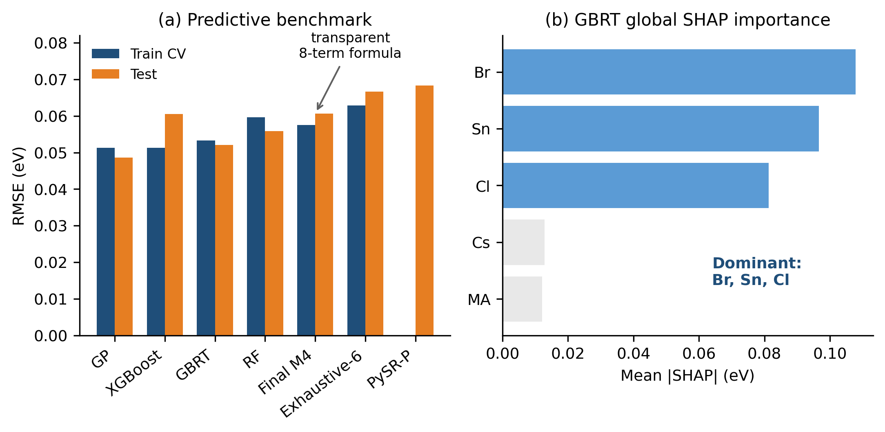
Figure 4. Predictive and interpretability benchmarks. (a) Training-CV and held-out test RMSE for black-box and compact analytical models. PySR-P is shown by its across-seed mean post hoc test RMSE; a directly comparable CV value was not available in the project output. (b) GBRT global SHAP importance. The black-box models (GP, GBRT, RF, XGBoost) use Sn, Br, Cl, Cs, and MA, whereas final M4 uses Sn, Br, Cl, Cs and their derived quadratic and interaction terms; the black-box results are therefore an MA-augmented predictive ceiling rather than a same-feature comparison.
SHAP also reveals a limitation of the compact formula. The largest interaction in GBRT, RF, and XGBoost is Br·Cl, with mean absolute interaction SHAP of 0.00725, 0.00841, and 0.01651 eV, respectively. Final M4 contains no explicit Br·Cl term because that term is unstable in OLS and strongly coupled to Cl and Cl² under sparse Cl sampling. These findings are not mutually exclusive. The black-box models can represent localized Br·Cl interaction regions without assigning one global coefficient, whereas the compact analytical model requires a single stable coefficient over the full training manifold. SHAP therefore supports the main composition hierarchy while identifying nonlinear regions that M4 compresses or omits. In particular, it supports the dominant B/X-site structure of M4 while showing that the omitted Br·Cl interaction is a localized nonlinear feature that black-box models capture more readily; the term-by-term comparison of symbolic and SHAP trends is given in Supplementary Table S22. The absence of an explicit Br·Cl term in M4 is thus a stability-parsimony decision, not a denial of the underlying physical coupling.

3.7. MA encoding sensitivity and A-site interpretation
MA was not excluded because it is physically irrelevant. Under the A-site closure FA + MA + Cs = 1, all three fractions cannot be included with an intercept without exact dependence. FA was used as the implicit baseline. The question was therefore whether MA or Cs provided the more useful minimal correction in the available data.
The nine-term Sn-Br-Cl core has CV RMSE 0.06655 eV. Adding only a Cs main effect leaves the error essentially unchanged at 0.06657 eV. Adding only MA improves it slightly to 0.06559 eV, and adding both Cs and MA main effects gives 0.06441 eV. In contrast, the Cs interaction model reaches 0.05833 eV. Thus the useful A-site signal is not a strong isolated linear effect; it is a composition-dependent correction associated with Cs interactions.
The frozen model retains Cs, Cs·Sn, and Cs·Cl as the minimum A-site encoding supported by CV and coefficient diagnostics. MA-rich post hoc RMSE is 0.06010 eV, compared with 0.05796 eV for the 14-term full model, a difference of 0.00214 eV. This small aggregate difference does not guarantee reliability for pure-MA or unusual MA-dominated systems. Those compositions should be checked against local training density and, when possible, evaluated with a nonlinear benchmark.

3.8. Group-aware splitting and applicability domain
Random splitting estimates interpolation within a data manifold that contains repeated and nearby compositions. Group-aware splitting asks a harder question: can the workflow select a useful model when entire composition families are absent from training? The 20 composition-family group-shuffle splits produce mean RMSE 0.08844 eV, median 0.07496 eV, and worst-case 0.16223 eV. Mean Jaccard similarity between selected terms and frozen M4 is 0.779. Sn, Br, Cl, and Sn² are selected in every split; Br² appears in 70%, Cs in 75%, Cs·Sn in 60%, and Cs·Cl in 55%. Cl² and Br·Cl are never selected. These frequencies reinforce the stable backbone and the weaker identifiability of specific A-site interactions.
Halide LOGO exposes the clearest boundary. Holding out mixed-halide, I-rich, or Br-rich groups gives RMSE of 0.05564, 0.06620, and 0.07259 eV, respectively. Holding out all Cl-containing compositions gives RMSE 0.88940 eV. This extreme result occurs because the model has almost no information from which to learn the steep Cl effect when the entire Cl region is removed. It is consistent with the sparse high-gap Cl distribution in Figure 2 and with the instability of global Cl-related interaction coefficients in larger polynomials.
A-site LOGO is less severe but still heterogeneous. Held-out mixed-A and FA-rich groups have RMSE 0.02612 and 0.05691 eV; MA-rich gives 0.08501 eV; Cs-rich gives 0.17382 eV. The Cs-rich error supports treating the Cs terms as local corrections rather than a guarantee of extrapolation to isolated Cs-rich families.
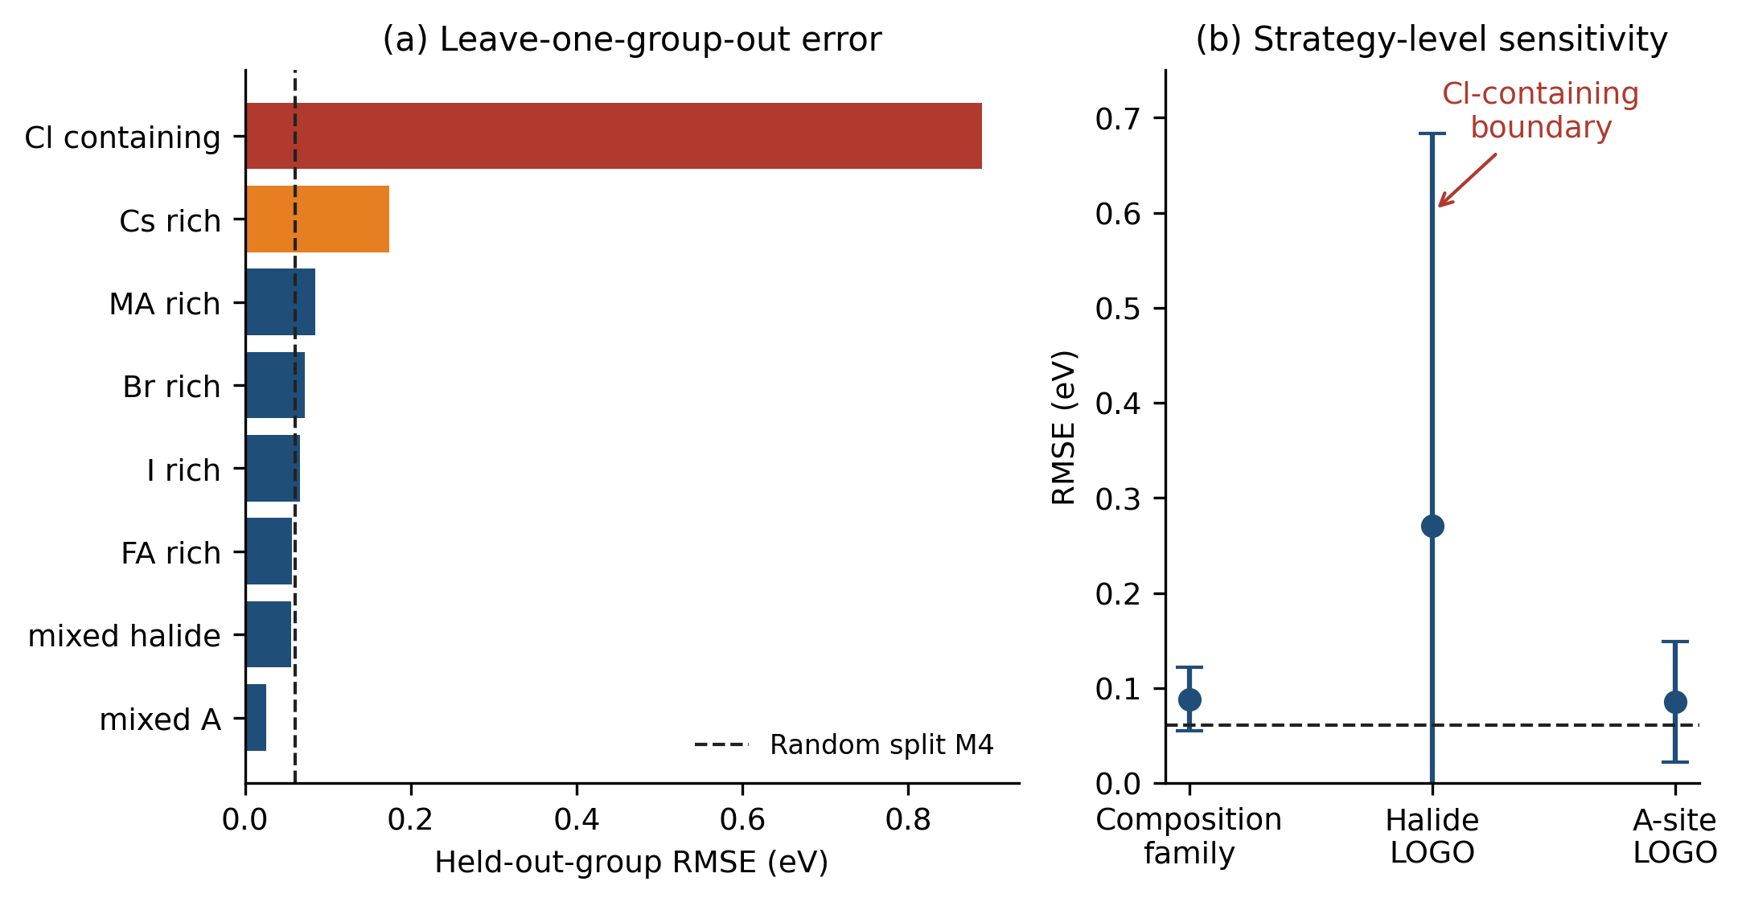
Figure 5. Group-aware sensitivity and applicability domain. (a) Errors for specific held-out halide and A-site groups. (b) Mean and standard deviation across composition-family, halide-LOGO, and A-site-LOGO strategies. The dashed line is the fixed random-split M4 test RMSE. The Cl-containing leave-one-group-out error (0.88940 eV) is an off-scale boundary-failure case from the sparsest halide regime; it is retained on the same axis as an explicit boundary-failure case, and the per-group held-out errors and sample counts are reported in Supplementary Table S24A.
The group-aware analysis does not invalidate M4; it defines where the formula should and should not be used. The Cl-LOGO result in particular should be interpreted as a boundary-failure diagnostic, obtained when essentially all Cl information is removed from a small Cl-containing subset, rather than as an ordinary expected prediction error. M4 is reliable mainly for interpolation in the dominant I/Br-rich composition manifold represented by the training data. Predictions for Cl-containing, strongly Cs-rich, or otherwise isolated families require a local-density check and should be confirmed with additional data or a nonlinear model. The random split and group-aware tests answer different questions, and both are required for an honest assessment.

3.9. External-validation status and limitation
The 92-row test set is a same-source held-out set rather than an independent literature-validation panel. Because the archive does not contain a harmonized external panel with documented temperature, phase state, measurement protocol, and uncertainty, we do not claim independent external validation. The strongest current evidence is therefore the combination of held-out interpolation performance (Section 3.3) and the group-aware applicability-domain tests (Section 3.8); a full external-validation completion protocol is provided in Supplementary Note S13.

3.10. Composition-guided design demonstration
The practical advantage of an analytical surrogate is that it can be evaluated over dense composition grids without retraining or repeated model calls. Figure 6 illustrates two slices of the final M4 response. The first varies Sn and Br at Cs = 0.10 and Cl = 0; the second varies Br and Cl at Cs = 0.10 and Sn = 0. In both cases the remaining site fractions are defined by closure.
To avoid presenting unconstrained extrapolation as design guidance, grid points are displayed only when their Euclidean distance in the Sn-Br-Cl-Cs feature space is no greater than 0.25 from at least one training composition. The hatched region marks an illustrative 1.60-1.80 eV window that flags candidate regions for follow-up screening rather than recommended compositions. In the Cl-free slice, increasing Sn lowers the gap while Br raises it, and the quadratic terms create curved iso-gap contours. In the halide slice, relatively small Cl additions produce a steep blue shift, but the admissible colored region narrows where the training data become sparse. A set of representative locally constrained grid points drawn from this window, with their predicted gaps and nearest training distances, is listed in Supplementary Table S26.
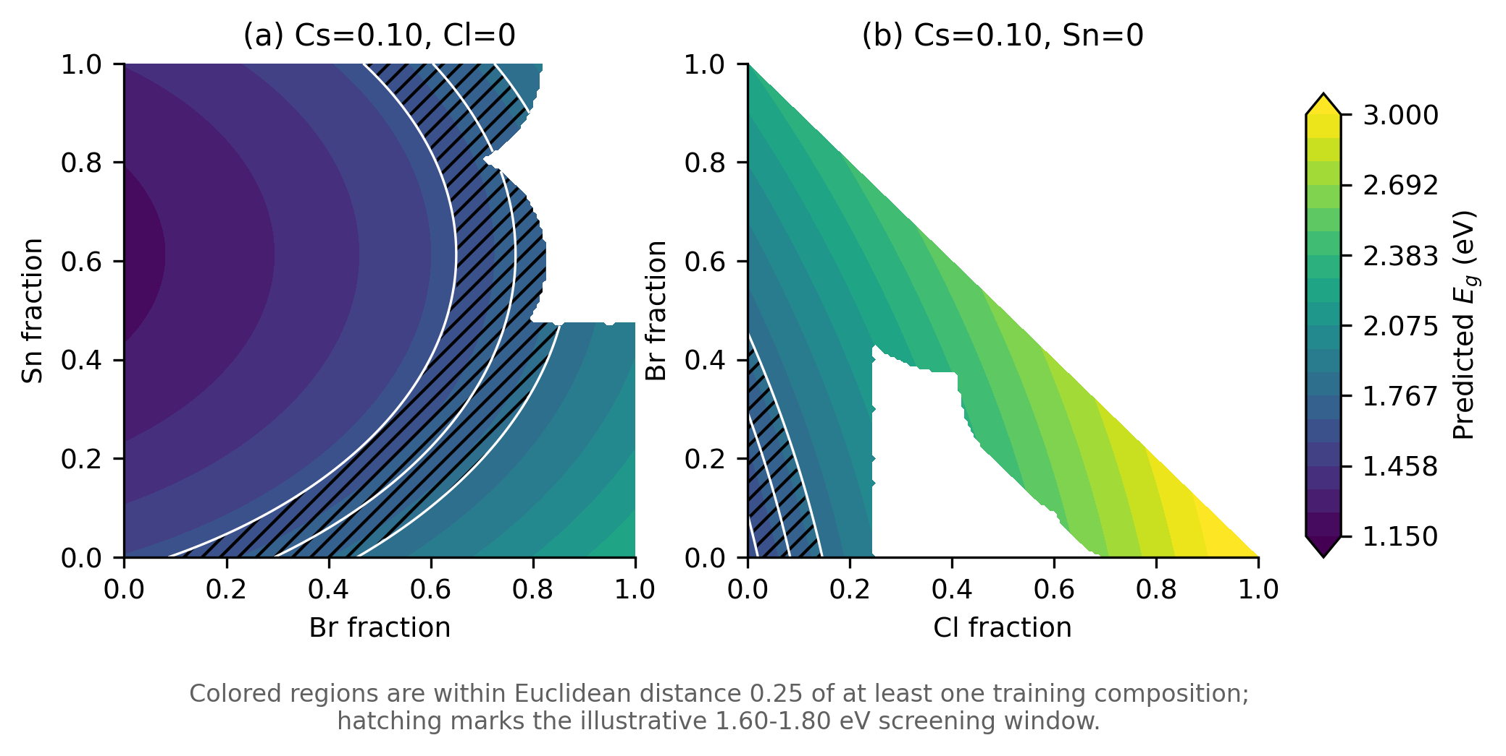
Figure 6. Composition-guided design maps generated directly from final M4. Colored regions satisfy a local training-density criterion; white areas are outside that illustrative applicability mask. Hatching marks predicted E_{g} between 1.60 and 1.80 eV. The distance mask is illustrative and should not be interpreted as a calibrated uncertainty estimate.
Such maps can support rapid screening for a target gap, lower-Sn candidates, or composition trajectories that preserve an optical objective. They cannot replace phase-stability calculations, defect analysis, synthesis feasibility, or experimental validation. The most appropriate workflow is sequential: use M4 to generate transparent first-pass candidates within the represented domain, use black-box or physics-based models for local refinement, and confirm final candidates experimentally.

4. Conclusions
This work presents a reproducible physics-constrained LLM-assisted symbolic regression workflow for HOIP band-gap modeling. The LLM proposes structures in a restricted polynomial term space; it does not fit coefficients or inspect test performance. OLS, training-set five-fold CV, constrained parsimony, VIF, confidence intervals, bootstrap sign stability, and subgroup diagnostics determine the final model.
The diagnostically frozen M4, with eight non-constant terms plus an intercept, achieves CV RMSE 0.057532 eV and a same-source held-out test RMSE of 0.060613 eV with R² = 0.976545. Its coefficient directions are physically readable and bootstrap-stable. Cl² and several interaction terms are excluded because they are unstable or collinearity-heavy, not because the associated physical phenomena are impossible. Conventional symbolic and statistical baselines support the need for curvature and selective interaction terms but do not reproduce the same parsimony-diagnostic balance. Black-box models, especially Gaussian-process regression and GBRT, reach lower errors and are preferable when maximum predictive accuracy is the objective; the value of M4 lies instead in its closed-form expression and coefficient-level interpretability rather than in maximal accuracy.
Repeated LLM experiments support recovery of a compact M4-family backbone, while the terminal A-site-halide interaction remains stochastic. SHAP corroborates the dominant roles of Br, Sn, and Cl and exposes localized Br·Cl interactions that the compact global formula omits. Group-aware splits establish the central limitation: M4 is a strong interpolative surrogate within the dominant I/Br-rich composition manifold, but Cl-containing and Cs-rich families define its applicability boundaries, and it is not suitable for unconditional extrapolation across the full ABX3 space. The scientific contribution is therefore an auditable workflow for converting stochastic LLM proposals into a diagnostically frozen, domain-limited analytical surrogate; it is not a claim that the LLM is universally superior to PySR, GPLearn, or black-box regressors, nor a claim of unrestricted ABX3 extrapolation.

Author contributions
Conceptualization: X.X.; methodology: X.X.; software: X.X.; validation: X.X.; formal analysis: X.X.; investigation: X.X.; data curation: X.X.; writing - original draft: X.X.; writing - review and editing: X.X.; visualization: X.X.; supervision: X.X.; project administration: X.X.; funding acquisition: X.X.

Conflicts of interest
There are no conflicts to declare.

Acknowledgements
This work was supported by the Academic Degree and Postgraduate Education Reform Project of Sichuan Province, China (YJGXM25-B066).

Data and Code Availability
The frozen local dataset snapshot, fixed train/test workbooks, model-comparison tables, prompts, repeated-run logs, benchmark outputs, SHAP summaries, group-aware split manifests, and analysis scripts are contained in the accompanying project archive. The SHA-256 checksums are: dataset.xlsx, 2F4A5A0CA845137EC39798F8E06FF4F110B93458FD12B91EFF1D52A16B2B037A; training workbook, A329CA43106A835BEBC16516731871C9681D5704DBAB7C539E8C8DF07E3FF873; test workbook, 00BECF24ED7FE8866F5D3C966F2B2C2F0397C973EE372885EB145F8B94FC5352. A public GitHub release and immutable Zenodo archive should be created before journal submission; no unverified public URL is asserted here.

Supporting Information
The Supporting Information contains the complete dataset audit, closure-aware encoding checks, immutable split summary, prompt templates, M0-M4 stage tables, final-model diagnostics, non-LLM symbolic-regression controls, repeated LLM runs, black-box and SHAP analyses, group-aware split manifests, external-validation status, composition-guided design examples, and the local reproducibility manifest.

References
- Kojima, A.; Teshima, K.; Shirai, Y.; Miyasaka, T. Organometal Halide Perovskites as Visible-Light Sensitizers for Photovoltaic Cells. J. Am. Chem. Soc. 2009, 131, 6050-6051. https://doi.org/10.1021/ja809598r.
- Lee, M. M.; Teuscher, J.; Miyasaka, T.; Murakami, T. N.; Snaith, H. J. Efficient Hybrid Solar Cells Based on Meso-Superstructured Organometal Halide Perovskites. Science 2012, 338, 643-647. https://doi.org/10.1126/science.1228604.
- Green, M. A.; Ho-Baillie, A.; Snaith, H. J. The Emergence of Perovskite Solar Cells. Nat. Photonics 2014, 8, 506-514. https://doi.org/10.1038/nphoton.2014.134.
- Stranks, S. D.; Eperon, G. E.; Grancini, G.; et al. Electron-Hole Diffusion Lengths Exceeding 1 Micrometer in an Organometal Trihalide Perovskite Absorber. Science 2013, 342, 341-344. https://doi.org/10.1126/science.1243982.
- Filip, M. R.; Eperon, G. E.; Snaith, H. J.; Giustino, F. Steric Engineering of Metal-Halide Perovskites with Tunable Optical Band Gaps. Nat. Commun. 2014, 5, 5757. https://doi.org/10.1038/ncomms6757.
- Jacobsson, T. J.; Pazoki, M.; Hagfeldt, A.; Edvinsson, T. Goldschmidt's Rules and Strontium Replacement in Lead Halogen Perovskite Solar Cells: Theory and Preliminary Experiments on CH3NH3SrI3. J. Phys. Chem. C 2015, 119, 25673-25683. https://doi.org/10.1021/acs.jpcc.5b06436.
- Ogomi, Y.; Morita, A.; Tsukamoto, S.; et al. CH3NH3SnxPb(1-x)I3 Perovskite Solar Cells Covering up to 1060 nm. J. Phys. Chem. Lett. 2014, 5, 1004-1011. https://doi.org/10.1021/jz5002117.
- Noh, J. H.; Im, S. H.; Heo, J. H.; Mandal, T. N.; Seok, S. I. Chemical Management for Colorful, Efficient, and Stable Inorganic-Organic Hybrid Nanostructured Solar Cells. Nano Lett. 2013, 13, 1764-1769. https://doi.org/10.1021/nl400349b.
- Jacobsson, T. J.; Hultqvist, A.; García-Fernández, A.; et al. An Open-Access Database and Analysis Tool for Perovskite Solar Cells Based on the FAIR Data Principles. Nat. Energy 2022, 7, 107-115. https://doi.org/10.1038/s41560-021-00941-3.
- Butler, K. T.; Davies, D. W.; Cartwright, H.; Isayev, O.; Walsh, A. Machine Learning for Molecular and Materials Science. Nature 2018, 559, 547-555. https://doi.org/10.1038/s41586-018-0337-2.
- Schmidt, M.; Lipson, H. Distilling Free-Form Natural Laws from Experimental Data. Science 2009, 324, 81-85. https://doi.org/10.1126/science.1165893.
- Udrescu, S.-M.; Tegmark, M. AI Feynman: A Physics-Inspired Method for Symbolic Regression. Sci. Adv. 2020, 6, eaay2631. https://doi.org/10.1126/sciadv.aay2631.
- Cranmer, M. Interpretable Machine Learning for Science with PySR and SymbolicRegression.jl. arXiv 2023, arXiv:2305.01582. https://doi.org/10.48550/arXiv.2305.01582.
- Shojaee, P.; Meidani, K.; Gupta, S.; Farimani, A. B.; Reddy, C. K. LLM-SR: Scientific Equation Discovery via Programming with Large Language Models. arXiv 2024, arXiv:2404.18400. https://doi.org/10.48550/arXiv.2404.18400.
- Breiman, L. Random Forests. Mach. Learn. 2001, 45, 5-32. https://doi.org/10.1023/A:1010933404324.
- Friedman, J. H. Greedy Function Approximation: A Gradient Boosting Machine. Ann. Stat. 2001, 29, 1189-1232. https://doi.org/10.1214/aos/1013203451.
- Chen, T.; Guestrin, C. XGBoost: A Scalable Tree Boosting System. In Proceedings of the 22nd ACM SIGKDD International Conference on Knowledge Discovery and Data Mining; ACM: New York, 2016; pp 785-794. https://doi.org/10.1145/2939672.2939785.
- Rasmussen, C. E.; Williams, C. K. I. Gaussian Processes for Machine Learning; MIT Press: Cambridge, MA, 2006.
- Lundberg, S. M.; Lee, S.-I. A Unified Approach to Interpreting Model Predictions. In Advances in Neural Information Processing Systems 30; 2017; pp 4765-4774.
- Tibshirani, R. Regression Shrinkage and Selection via the Lasso. J. R. Stat. Soc. B 1996, 58, 267-288. https://doi.org/10.1111/j.2517-6161.1996.tb02080.x.
- Zou, H.; Hastie, T. Regularization and Variable Selection via the Elastic Net. J. R. Stat. Soc. B 2005, 67, 301-320. https://doi.org/10.1111/j.1467-9868.2005.00503.x.
- Akaike, H. A New Look at the Statistical Model Identification. IEEE Trans. Autom. Control 1974, 19, 716-723. https://doi.org/10.1109/TAC.1974.1100705.
- Schwarz, G. Estimating the Dimension of a Model. Ann. Stat. 1978, 6, 461-464. https://doi.org/10.1214/aos/1176344136.
- Efron, B.; Tibshirani, R. J. An Introduction to the Bootstrap; Chapman & Hall/CRC: New York, 1993.
- Belsley, D. A.; Kuh, E.; Welsch, R. E. Regression Diagnostics: Identifying Influential Data and Sources of Collinearity; Wiley: New York, 1980.
- Pedregosa, F.; Varoquaux, G.; Gramfort, A.; et al. Scikit-learn: Machine Learning in Python. J. Mach. Learn. Res. 2011, 12, 2825-2830.
- Wilkinson, M. D.; Dumontier, M.; Aalbersberg, I. J.; et al. The FAIR Guiding Principles for Scientific Data Management and Stewardship. Sci. Data 2016, 3, 160018. https://doi.org/10.1038/sdata.2016.18.

