SUPPLEMENTARY INFORMATION
Reproducible Physics-Constrained LLM-Assisted Symbolic Regression for Interpretable Band-Gap Modeling in Hybrid Perovskites
Evidence package for the revised manuscript
Scope: This Supplementary Information documents dataset integrity, closure-aware encoding, immutable split files, exact M0-M4 prompts, stage-wise selection, final-model diagnostics, non-LLM controls, LLM stochasticity, SHAP cross-checks, group-aware sensitivity, design demonstrations, and the local reproducibility manifest.
Version lock: Throughout this document, Final frozen M4 with eight non-constant terms plus an intercept refers exclusively to the Cs·Cl-containing formula below. The historical 13-term M4, the repeated-run Cs·Br candidate, and anion-only polynomial models are not called the final model.
E_{g} = 1.55527 - 1.10253 Sn + 0.34320 Br + 1.61932 Cl + 0.12268 Cs + 0.91702 Sn² + 0.36607 Br² - 0.22716 Cs·Sn - 0.32528 Cs·Cl
CV RMSE = 0.057532 eV | Test RMSE = 0.060613 eV | Test R² = 0.976545
Evidence boundary: The archive contains a same-source held-out test set but no verified independent literature validation set. No external-validation table, parity plot, repository URL, or Zenodo DOI is fabricated in this document.

Contents
S1 Dataset curation and duplicate-record handling
S2 Composition encoding and closure constraints
S3 Train/test split reproducibility and fairness
S4 Exact prompt templates and physical constraints
S5 Stage-wise candidate generation and M0-M4 evolution
S6 Final M4 freezing rule and model nomenclature
S7 Coefficient diagnostics, VIF, confidence intervals, and bootstrap
S8 MA and A-site encoding sensitivity
S9 Non-LLM symbolic regression and statistical controls
S10 Repeated LLM runs and cross-model stochasticity
S11 Black-box baselines and SHAP cross-check
S12 Group-aware splitting and applicability domain
S13 Independent external-validation status
S14 Composition-guided design demonstration
S15 Reproducibility package and file manifest
Table S0. Where each Methods component is documented.
Main Methods component | SI location | Archive files
Dataset source, scope, and evidence boundary (2.1) | S1 | dataset.xlsx
Composition encoding and closure constraints (2.2) | S2 | closure-audit tables
Duplicate and repeated-record handling (2.2) | S1 | dataset.xlsx
Immutable train/test split and audit (2.3) | S3 | 训练集.xlsx (training_set.xlsx) / 测试集.xlsx (test_set.xlsx)
Physics-constrained prompts (2.4) | S4 | llmrepeated/prompts/
Stage-wise M0–M4 evolution (2.4–2.5) | S5 | M0-M4.xlsx
OLS fitting, selection, and diagnostic freezing (2.5) | S6, S7 | final_M4_coefficients_CI_bootstrap.csv
LLM-frequency vs. final selection (2.5) | S6, S10 | llmrepeated/repeated_runs_30/
MA and A-site encoding sensitivity (2.2, 2.6) | S8 | ma_asite_encoding_sensitivity.xlsx
Non-LLM symbolic and statistical controls (2.6) | S9 | exhaustive / LASSO / PySR / GPLearn
Repeated LLM and cross-model runs (2.6) | S10 | llmrepeated/external_api_runs/
Black-box baselines and SHAP (2.6) | S11 | GPlearning, GBRT+SHAP, RFXGBoost+SHAP
Group-aware sensitivity (2.7) | S12 | Group-aware split sensitivity/
External-validation boundary (2.7) | S13 | none verified
Composition-guided design demonstration | S14 | design-screen outputs
Reproducibility package and manifest | S15 | manifest / checksums

Supplementary Note S1. Dataset curation and duplicate-record handling
The source data were derived from the open Perovskite Database Project described by Jacobsson et al. The frozen local workbook snapshot is dated January 28, 2026. The retained scope is three-dimensional ABX3 hybrid perovskites represented by A-site fractions FA, MA, and Cs; B-site fractions Pb and Sn; X-site fractions I, Br, and Cl; and a reported optical band gap. Journal impact factor, Journal Citation Reports category, and publication-prestige filters were not used. The target distribution was not balanced, truncated, oversampled, or reshaped.
The archive begins at a 610-row record-level worksheet. The preceding database export and row-by-row exclusion log are not available, so counts before the 610-row snapshot cannot be reconstructed. Table S1 separates directly auditable steps from this upstream evidence gap.
Table S1. Dataset curation workflow and evidence status.
Step | Criterion or operation | Retained records | Evidence status
1 | Source database export | Not recoverable | Pre-610 export not archived
2 | Restrict to 3D ABX3; A={FA, MA, Cs}; B={Pb, Sn}; X={I, Br, Cl}; E_{g} present | 610 | Documented scope; upstream row log absent
3 | No IF/JCR or publication-prestige filter | 610 | Documented policy
4 | No artificial E_{g} balancing or truncation | 610 | Distribution retained
5 | Retain record-level duplicate measurements | 610 | Primary analysis policy
6 | Immutable 85/15 workbooks | 518 / 92 | Checksummed train/test inputs
7 | Strict closure sensitivity without renormalization | 507 training rows | Group-aware analysis only

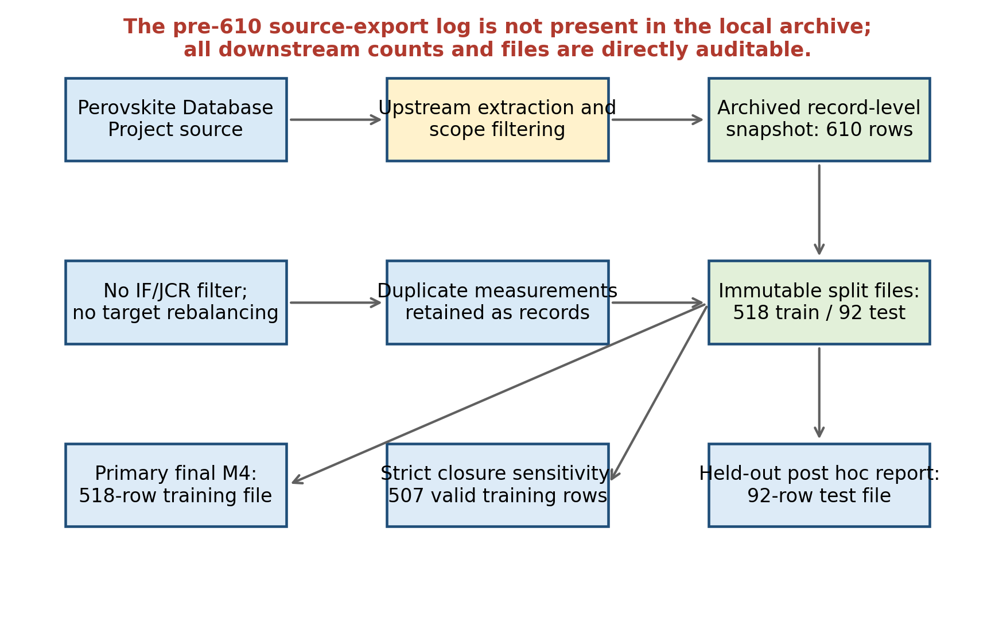
Figure S1. Evidence-aware data workflow. The archived record-level snapshot contains 610 rows and is exactly partitioned into the 518-row training and 92-row test workbooks. The upstream extraction log is not present. Strict closure filtering was used only for the group-aware sensitivity workflow.
The 610-row worksheet contains 599 unique complete rows and 552 unique compositions when E_{g} is excluded. There are 48 composition groups with more than one measurement, corresponding to 58 records beyond one record per composition. Eleven records are exact duplicates of an existing complete row, including E_{g}. The primary analysis retained these measurements as separate records because the archive does not contain measurement-condition metadata sufficient to justify averaging. The auxiliary processed worksheet contains 519 means derived from the 575-row Cl-free subset and was not used to construct Final M4.
Table S2. Complete duplicate-composition audit. All listed measurements were retained as separate records in the primary 610-row analysis.
Composition fractions | n | E_{g} min | E_{g} max | E_{g} mean | E_{g} SD
FA0 MA1 Cs0 | Pb1 Sn0 | I0.9 Br0.1 Cl0 | 4 | 1.562 | 1.650 | 1.595 | 0.038
FA0.6 MA0.4 Cs0 | Pb0.4 Sn0.6 | I1 Br0 Cl0 | 4 | 1.249 | 1.250 | 1.250 | 0.000
FA0.85 MA0.15 Cs0 | Pb1 Sn0 | I0.85 Br0.15 Cl0 | 4 | 1.580 | 1.625 | 1.597 | 0.021
FA0 MA0 Cs1 | Pb1 Sn0 | I0.667 Br0.333 Cl0 | 3 | 1.910 | 1.920 | 1.915 | 0.005
FA0.79 MA0.16 Cs0.05 | Pb1 Sn0 | I0.83 Br0.17 Cl0 | 3 | 1.590 | 1.630 | 1.612 | 0.020
FA0.79 MA0.16 Cs0.05 | Pb1 Sn0 | I0.9 Br0.1 Cl0 | 3 | 1.550 | 1.590 | 1.570 | 0.020
FA0.8 MA0.15 Cs0.05 | Pb1 Sn0 | I0.85 Br0.15 Cl0 | 3 | 1.590 | 1.610 | 1.602 | 0.011
FA0 MA0.8 Cs0.2 | Pb1 Sn0 | I1 Br0 Cl0 | 2 | 1.570 | 1.620 | 1.595 | 0.035
FA0 MA0.9 Cs0.1 | Pb1 Sn0 | I1 Br0 Cl0 | 2 | 1.540 | 1.606 | 1.573 | 0.047
FA0 MA0.95 Cs0.05 | Pb1 Sn0 | I1 Br0 Cl0 | 2 | 1.510 | 1.610 | 1.560 | 0.071
FA0 MA1 Cs0 | Pb0.7 Sn0.3 | I1 Br0 Cl0 | 2 | 1.278 | 1.285 | 1.282 | 0.005
FA0 MA1 Cs0 | Pb0.75 Sn0.25 | I1 Br0 Cl0 | 2 | 1.240 | 1.240 | 1.240 | 0.000
FA0 MA1 Cs0 | Pb1 Sn0 | I0 Br0 Cl1 | 2 | 3.040 | 3.160 | 3.100 | 0.085
FA0 MA1 Cs0 | Pb1 Sn0 | I0 Br0.2 Cl0.8 | 2 | 2.830 | 2.980 | 2.905 | 0.106
FA0 MA1 Cs0 | Pb1 Sn0 | I0 Br1 Cl0 | 2 | 2.110 | 2.300 | 2.205 | 0.134
FA0 MA1 Cs0 | Pb1 Sn0 | I0.5 Br0.5 Cl0 | 2 | 1.720 | 1.872 | 1.796 | 0.107
FA0 MA1 Cs0 | Pb1 Sn0 | I0.58 Br0.42 Cl0 | 2 | 1.790 | 1.900 | 1.845 | 0.078
FA0 MA1 Cs0 | Pb1 Sn0 | I0.667 Br0.333 Cl0 | 2 | 1.600 | 1.800 | 1.700 | 0.141
FA0 MA1 Cs0 | Pb1 Sn0 | I0.95 Br0.05 Cl0 | 2 | 1.570 | 1.577 | 1.573 | 0.005
FA0 MA1 Cs0 | Pb1 Sn0 | I0.973 Br0.027 Cl0 | 2 | 1.600 | 1.610 | 1.605 | 0.007
FA0 MA1 Cs0 | Pb1 Sn0 | I0.99 Br0.01 Cl0 | 2 | 1.600 | 1.600 | 1.600 | 0.000
FA0.3 MA0.7 Cs0 | Pb1 Sn0 | I0.9 Br0.1 Cl0 | 2 | 1.580 | 1.603 | 1.591 | 0.016
FA0.3 MA0.7 Cs0 | Pb1 Sn0 | I1 Br0 Cl0 | 2 | 1.550 | 1.583 | 1.567 | 0.023
FA0.4 MA0.6 Cs0 | Pb1 Sn0 | I1 Br0 Cl0 | 2 | 1.541 | 1.544 | 1.542 | 0.002
FA0.7 MA0 Cs0.3 | Pb1 Sn0 | I1 Br0 Cl0 | 2 | 1.512 | 1.580 | 1.546 | 0.048
FA0.7 MA0.25 Cs0.05 | Pb1 Sn0 | I1 Br0 Cl0 | 2 | 1.510 | 1.510 | 1.510 | 0.000
FA0.75 MA0 Cs0.25 | Pb1 Sn0 | I0.8 Br0.2 Cl0 | 2 | 1.694 | 1.700 | 1.697 | 0.004
FA0.75 MA0.15 Cs0.1 | Pb1 Sn0 | I0.83 Br0.17 Cl0 | 2 | 1.610 | 1.630 | 1.620 | 0.014
FA0.75 MA0.15 Cs0.1 | Pb1 Sn0 | I0.833 Br0.167 Cl0 | 2 | 1.610 | 1.630 | 1.620 | 0.014
FA0.75 MA0.15 Cs0.1 | Pb1 Sn0 | I0.85 Br0.15 Cl0 | 2 | 1.630 | 1.630 | 1.630 | 0.000
FA0.75 MA0.25 Cs0 | Pb0 Sn1 | I1 Br0 Cl0 | 2 | 1.354 | 1.400 | 1.377 | 0.033
FA0.765 MA0.135 Cs0.1 | Pb1 Sn0 | I0.85 Br0.15 Cl0 | 2 | 1.611 | 1.611 | 1.611 | 0.000
FA0.78 MA0.14 Cs0.08 | Pb1 Sn0 | I0.86 Br0.14 Cl0 | 2 | 1.610 | 1.610 | 1.610 | 0.000
FA0.7885 MA0.1615 Cs0.05 | Pb1 Sn0 | I0.9 Br0.1 Cl0 | 2 | 1.550 | 1.565 | 1.558 | 0.011
FA0.79 MA0.15 Cs0.06 | Pb1 Sn0 | I0.85 Br0.15 Cl0 | 2 | 1.593 | 1.640 | 1.616 | 0.033
FA0.79 MA0.16 Cs0.05 | Pb1 Sn0 | I0.833 Br0.167 Cl0 | 2 | 1.565 | 1.630 | 1.597 | 0.046
FA0.79 MA0.16 Cs0.05 | Pb1 Sn0 | I0.84 Br0.16 Cl0 | 2 | 1.582 | 1.600 | 1.591 | 0.013
FA0.8 MA0.16 Cs0.04 | Pb1 Sn0 | I0.833 Br0.167 Cl0 | 2 | 1.610 | 1.633 | 1.622 | 0.016
FA0.81 MA0.14 Cs0.05 | Pb1 Sn0 | I0.85 Br0.15 Cl0 | 2 | 1.597 | 1.630 | 1.613 | 0.023
FA0.83 MA0 Cs0.17 | Pb1 Sn0 | I0.6 Br0.4 Cl0 | 2 | 1.740 | 1.750 | 1.745 | 0.007
FA0.83 MA0.17 Cs0 | Pb1 Sn0 | I0.83 Br0.17 Cl0 | 2 | 1.600 | 1.620 | 1.610 | 0.014
FA0.83 MA0.17 Cs0 | Pb1 Sn0 | I0.833 Br0.167 Cl0 | 2 | 1.606 | 1.622 | 1.614 | 0.011
FA0.85 MA0 Cs0.15 | Pb1 Sn0 | I0.9 Br0.1 Cl0 | 2 | 1.560 | 1.560 | 1.560 | 0.000
FA0.85 MA0.15 Cs0 | Pb1 Sn0 | I0.833 Br0.167 Cl0 | 2 | 1.625 | 1.650 | 1.637 | 0.018
FA1 MA0 Cs0 | Pb0 Sn1 | I1 Br0 Cl0 | 2 | 1.400 | 1.400 | 1.400 | 0.000
FA1 MA0 Cs0 | Pb0.5 Sn0.5 | I1 Br0 Cl0 | 2 | 1.170 | 1.220 | 1.195 | 0.035
FA1 MA0 Cs0 | Pb1 Sn0 | I0 Br1 Cl0 | 2 | 2.230 | 2.268 | 2.249 | 0.027
FA1 MA0 Cs0 | Pb1 Sn0 | I1 Br0 Cl0 | 2 | 1.480 | 1.480 | 1.480 | 0.000

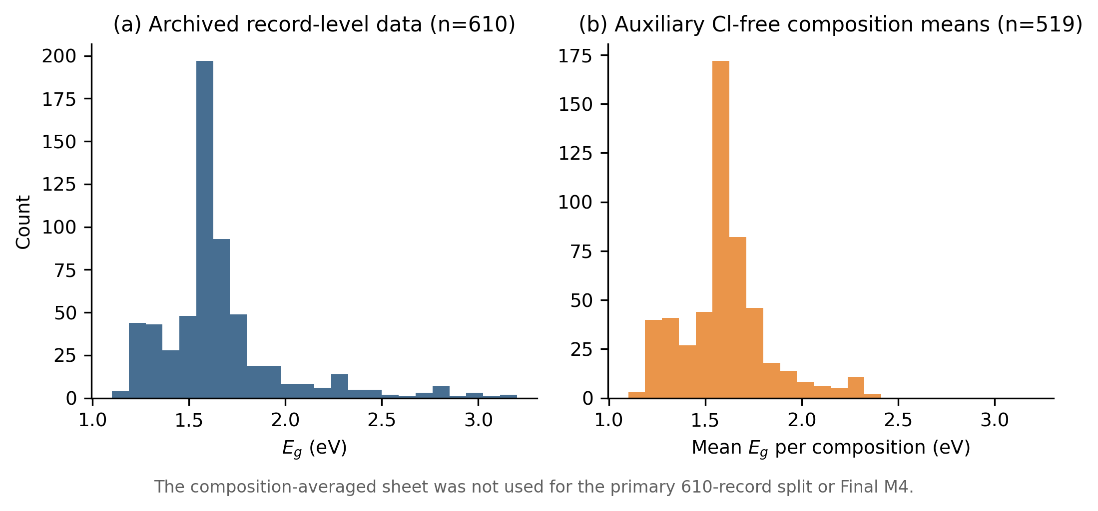
Figure S2. Archived record-level and auxiliary composition-averaged band-gap distributions. Panel (a) is the 610-record primary dataset. Panel (b) is the 519-row composition-mean sheet derived from the Cl-free subset and is shown only to document the workbook contents.
Interpretation: The difference between record-level and composition-mean distributions arises from duplicate handling and the Cl-free scope of the auxiliary sheet. It is not evidence of target balancing.

Supplementary Note S2. Composition encoding and closure constraints
The regression variables are site fractions rather than a larger physicochemical descriptor set. Closure makes several fractions algebraically dependent. With an intercept, including all fractions from a site would create exact linear dependence. The final representation therefore uses Sn for the B site, Br and Cl for the X site, and a restricted Cs correction for the A site.
Table S3. Independent and dependent composition variables.
Site | Fractions | Independent variables in Final M4 | Closure relation and omitted baseline
B | Pb, Sn | Sn | Pb = 1 - Sn
X | I, Br, Cl | Br, Cl | I = 1 - Br - Cl
A | FA, MA, Cs | Cs | FA + MA = 1 - Cs; MA sensitivity tested separately

Fractions were not renormalized. A strict tolerance of 10^-6 was applied in the group-aware sensitivity analysis. Eleven training rows failed at least one A-, B-, or X-site closure check and were excluded from that sensitivity workflow, leaving 507 rows. The primary final-model analysis retained the immutable 518-row training workbook so that model comparisons remained consistent with the frozen split. Two test rows had closure issues and were retained only as reference observations; the test set was never used for selection.
Table S4. Closure audit for immutable split workbooks.
Cohort | n | Pass | Issue | Max |A-1| | Max |B-1| | Max |X-1|
Training | 518 | 507 | 11 | 0.0400 | 0.0100 | 0.0170
Held-out test | 92 | 90 | 2 | 0.0008 | 0.0000 | 0.0000

No sign constraints: Coefficient signs were not imposed manually. Physical knowledge entered through closure-aware variables, the admissible quadratic term space, stage-wise expansion, and diagnostic filtering.

Supplementary Note S3. Train/test split reproducibility and fairness
The supplied split was fixed before the present analysis and was treated as immutable. The training workbook contains 518 rows and the test workbook 92 rows. Their combined complete-row multiset is exactly equal to the 610-row archived worksheet, so no record was added or lost during splitting. The original split-generation seed is not present in the archive and was not recovered by testing scikit-learn train_test_split(test_size=0.15) seeds 0-199999. Reproducibility is therefore based on the checksummed split files rather than a reconstructed seed.
All candidate generation, OLS fitting during cross-validation, pruning, bootstrap analysis, and final freezing used the training workbook only. The held-out workbook was evaluated after the Final M4 structure was locked. Fixed model comparisons used five-fold KFold(n_splits=5, shuffle=True, random_state=42); repeated workflow experiments used their separately archived CV seed 20260607.
Table S5. Summary statistics for immutable train and test splits.
Variable | Train mean ± SD | Train median | Train range | Test mean ± SD | Test median | Test range
E_{g} | 1.6512 ± 0.3095 | 1.6060 | 1.1700-3.1600 | 1.6946 ± 0.3979 | 1.6150 | 1.1800-3.0400
Sn | 0.1408 ± 0.2906 | 0.0000 | 0.0000-1.0000 | 0.1452 ± 0.2876 | 0.0000 | 0.0000-1.0000
Br | 0.2047 ± 0.2498 | 0.1500 | 0.0000-1.0000 | 0.2204 ± 0.2670 | 0.1365 | 0.0000-1.0000
Cl | 0.0253 ± 0.1305 | 0.0000 | 0.0000-1.0000 | 0.0477 ± 0.1685 | 0.0000 | 0.0000-1.0000
Cs | 0.1185 ± 0.2380 | 0.0200 | 0.0000-1.0000 | 0.1032 ± 0.2285 | 0.0000 | 0.0000-1.0000
MA | 0.3952 ± 0.4008 | 0.1700 | 0.0000-1.0000 | 0.4546 ± 0.4098 | 0.2834 | 0.0000-1.0000
FA | 0.4862 ± 0.3798 | 0.6600 | 0.0000-1.0000 | 0.4422 ± 0.3765 | 0.6000 | 0.0000-1.0000

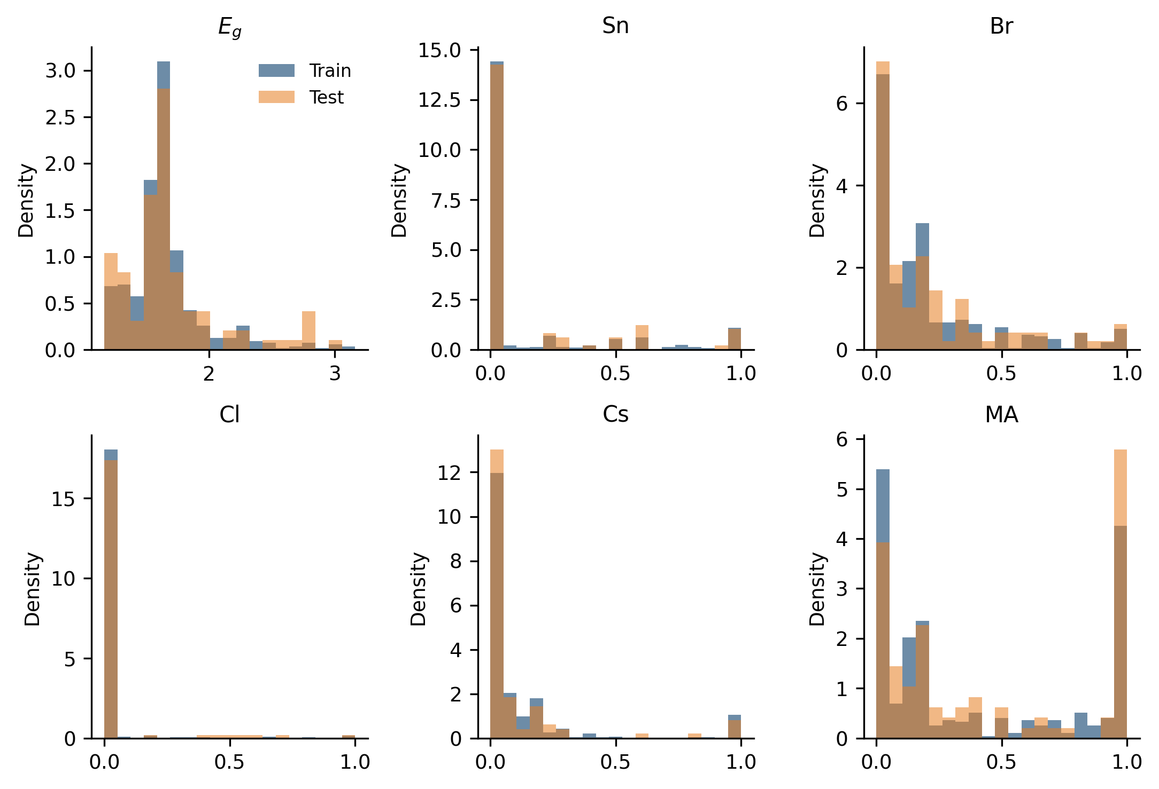
Figure S3. Train/test distribution comparison for E_{g} and composition fractions. The dominant density lies in the I/Br-rich composition manifold; Cl-containing observations remain sparse.
Table S6. Duplicate and overlap audit across the fixed split.
Audit item | Result | Interpretation
Exact complete rows shared across train/test | 2 unique; 2 test rows | Potential optimistic leakage for two records
Exact composition groups shared across train/test | 13 groups; 13 test rows | Same fractions, E_{g} may differ
Shared Final-M4 feature combinations | 29 combinations; 43 test rows | Interpolation at model-feature level
Unseen Final-M4 feature combinations | 49 test rows | Harder local generalization
M4 RMSE on shared feature combinations | 0.052815 eV | Lower-error interpolation subset
M4 RMSE on unseen feature combinations | 0.066710 eV | Higher-error subset

Fairness limitation: Random splitting does not eliminate composition-family overlap. This is why the group-aware analyses in Note S12 are required and why the random-split test error is interpreted as interpolation performance rather than unrestricted extrapolation.
Table S6A. Analysis design and leakage-control summary.
Component | Setting | Leakage-control role
Dataset snapshot | 610 record-level observations | Fixed downstream input
Training/test split | 518/92 immutable workbooks | Prevents resplitting optimization
Candidate generation | LLM structures only | No coefficients or test metrics
Coefficient fitting | OLS | Deterministic given the structure
Selection metric | Training five-fold CV RMSE | Test-independent screening
Final freeze | VIF, CI, bootstrap, subgroup diagnostics | Prevents test-set-driven pruning
Test evaluation | Once, after freeze | Post hoc only
External validation | Not currently verified | No overclaiming

Supplementary Note S4. Exact prompt templates and physical constraints
The LLM proposed symbolic structures only. It did not receive coefficient values, raw data rows, or held-out test metrics in the frozen direct templates. Numerical coefficients were estimated locally by OLS. Candidate selection was performed by local training-set cross-validation and deterministic diagnostics.
Table S7. Global prompt and fitting constraints.
Constraint | Setting
Variables | Composition fractions only
Operators | Addition, subtraction, multiplication, and square
Maximum order | Quadratic
Interactions | Pairwise only
Forbidden forms | Ratios except as explicitly disallowed, log, exp, trigonometric functions, cubic and higher powers
LLM output | One expression structure; no numerical coefficients; no explanation
Coefficient fitting | OLS on training data
Primary selection | Training five-fold CV plus parsimony and diagnostics
Test usage | Post hoc after the structure freeze
LLM role | Candidate structure proposal only
Sign constraints | None imposed

Box S1. Exact prompt template for M0.
You are a materials-physics and symbolic-regression expert. We aim to build an interpretable analytical model for the optical band gap E_{g} (eV) of 3D ABX3 hybrid perovskites.
Input features are composition fractions with clear physical meaning:
Sn (B-site Sn fraction), Br and Cl (X-site halide fractions). Each lies in [0,1].
Task: Propose a strictly linear analytical structure (constant + first-order terms only) to be later fitted on the training set.
Constraints:
1) Allowed terms: {constant, Sn, Br, Cl} only.
2) Do NOT use squared terms, interaction products, ratios, logs, exponentials, or any higher-order terms.
3) Keep the structure minimal and physically interpretable.
4) Do NOT provide any numerical coefficients and do NOT explain.
Output format: output exactly one line, e.g.
E_{g} = a0 + a1*Sn + a2*Br + a3*Cl
Box S2. Exact prompt template for M1.
You are a materials-physics and symbolic-regression expert. The linear baseline is insufficient; we want to capture single-variable nonlinearity (curvature) in the band-gap response.
Inputs: Sn, Br, Cl in [0,1].
Task: Propose an interpretable quadratic structure with main effects and squared terms, to be fitted later on the training set.
Constraints:
1) Allowed terms: {constant, Sn, Br, Cl, Sn^2, Br^2, Cl^2}.
2) Do NOT use any interaction/product terms (e.g., Sn*Br), and do NOT use higher powers.
3) Do NOT use ratios, logs, exponentials, or any non-polynomial terms.
4) Keep the structure compact; do not include unnecessary terms.
5) Do NOT provide numerical coefficients and do NOT explain.
Output format: exactly one line, e.g.
E_{g} = a0 + a1*Sn + a2*Br + a3*Cl + a4*Sn^2 + a5*Br^2 + a6*Cl^2
Box S3. Exact prompt template for M2.
You are a materials-physics and symbolic-regression expert. To capture metal-halide coupling and mixed-halide effects, we now allow second-order interaction terms.
Inputs: Sn, Br, Cl in [0,1].
Task: Propose a second-order (quadratic) analytical structure that may include main effects, squared terms, and a small number of physically motivated pairwise interactions, to be fitted later on the training set.
Allowed term pool:
- Main effects: Sn, Br, Cl
- Squares: Sn^2, Br^2, Cl^2
- Pairwise interactions (choose up to 2-3): Sn*Br, Sn*Cl, Br*Cl
- Constant term
Constraints:
1) Use only the term pool above. No higher-order terms, no ratios, no logs, no exponentials.
2) Use at most 2-3 interaction terms; prioritize physically meaningful couplings (metal-halide and mixed-halide).
3) Keep total non-constant terms <= 10.
4) Do NOT provide numerical coefficients and do NOT explain.
Output format: exactly one line, a single expression structure.
Box S4. Exact prompt template for M3.
You are a materials-physics and symbolic-regression expert. We now incorporate A-site effects by introducing Cs (A-site Cs fraction in [0,1]) in addition to Sn, Br, Cl.
Inputs: Sn, Br, Cl, Cs in [0,1].
Task: Propose an interpretable quadratic analytical structure that includes Cs main effects and (optionally) Cs-related coupling terms, to be fitted later on the training set.
Allowed terms:
- Main effects: Sn, Br, Cl, Cs
- Squares: Sn^2, Br^2, Cl^2, Cs^2 (optional)
- Interactions: prioritize Cs with B/X terms (Cs*Sn, Cs*Br, Cs*Cl)
- Optionally keep a small number of {Sn*Br, Sn*Cl, Br*Cl} if physically justified
- Constant term
Constraints:
1) Only quadratic terms (main, squares, pairwise products). No higher-order, ratios, logs, exponentials.
2) Total interaction terms <= 4; prioritize Cs-coupling terms first.
3) Keep the structure compact (target <= 12 non-constant terms).
4) Do NOT provide numerical coefficients and do NOT explain.
Output format: exactly one line, a single expression structure.
Box S5. Exact prompt template for M4.
You are a symbolic-regression and materials-physics expert. We already have a relatively expressive quadratic model using Sn/Br/Cl/Cs (main effects + squares + a few interactions). Now we want the final recommended formula: simplify the structure as much as possible while maintaining near-optimal predictive performance (to be verified on a held-out test set).
Inputs: Sn, Br, Cl, Cs in [0,1].
Task: Propose a final simplified quadratic structure:
- Allowed: constant + a subset of main effects + a small subset of squares + a small subset of key pairwise interactions
- Not allowed: any cubic+ terms, ratios, logs, exponentials
Hard constraints:
1) Minimize complexity: target 8-11 non-constant terms total.
2) Every retained term must have clear physical meaning (Sn doping, halide mixing, A-site stabilization/lattice effect, and key couplings).
3) Prefer terms likely to generalize: strong main effects + only a few essential couplings (e.g., Sn-halide, Cs-B/X).
4) Do NOT provide numerical coefficients and do NOT explain.
Output format: exactly one line, the final expression structure.
Physical-knowledge implementation: Knowledge was encoded through closure-aware variables, restricted operator sets, staged expansion from main effects to curvature and selected interactions, and post hoc coefficient diagnostics. No coefficient sign was forced.

Supplementary Note S5. Stage-wise candidate generation and M0-M4 evolution
The stage ladder was designed to separate increasingly complex physical hypotheses. M0 tests linear substitution effects. M1 adds single-variable curvature. M2 opens selected metal-halide and mixed-halide interactions. M3 introduces restricted A-site terms. Final M4 is a new diagnostic freeze obtained after removing unstable and collinearity-heavy terms from the larger late-stage candidates.
Table S8. Stage-wise admissible term space.
Stage | Admissible terms | Purpose
M0 | Sn, Br, Cl | Linear baseline
M1 | M0 + Sn², Br², Cl² | Single-variable curvature
M2 | M1 + Sn·Br, Sn·Cl, Br·Cl | B-X and mixed-halide coupling
M3 | M2 + Cs, Cs², Cs·Sn, Cs·Br, Cs·Cl | Restricted A-site testing
Final M4 | Sn, Br, Cl, Cs, Sn², Br², Cs·Sn, Cs·Cl | Frozen compact formula after diagnostics

Table S9. Stage-wise performance. Test values are post hoc and were not used to select the final structure.
Model | Terms | CV RMSE | Test RMSE | Role
M0 | 3 | 0.087733 | 0.085887 | Linear baseline
M1 | 6 | 0.063939 | 0.071660 | Main effects + squares
M2 | 9 | 0.066548 | 0.066416 | Full anion quadratic
M3-full | 14 | 0.058333 | 0.054620 | Expressive Cs interaction model
Historical 13-term M4 | 13 | 0.059460 | 0.053835 | Pre-final parsimony candidate
Final frozen M4 | 8 | 0.057532 | 0.060613 | Only final model in the revision

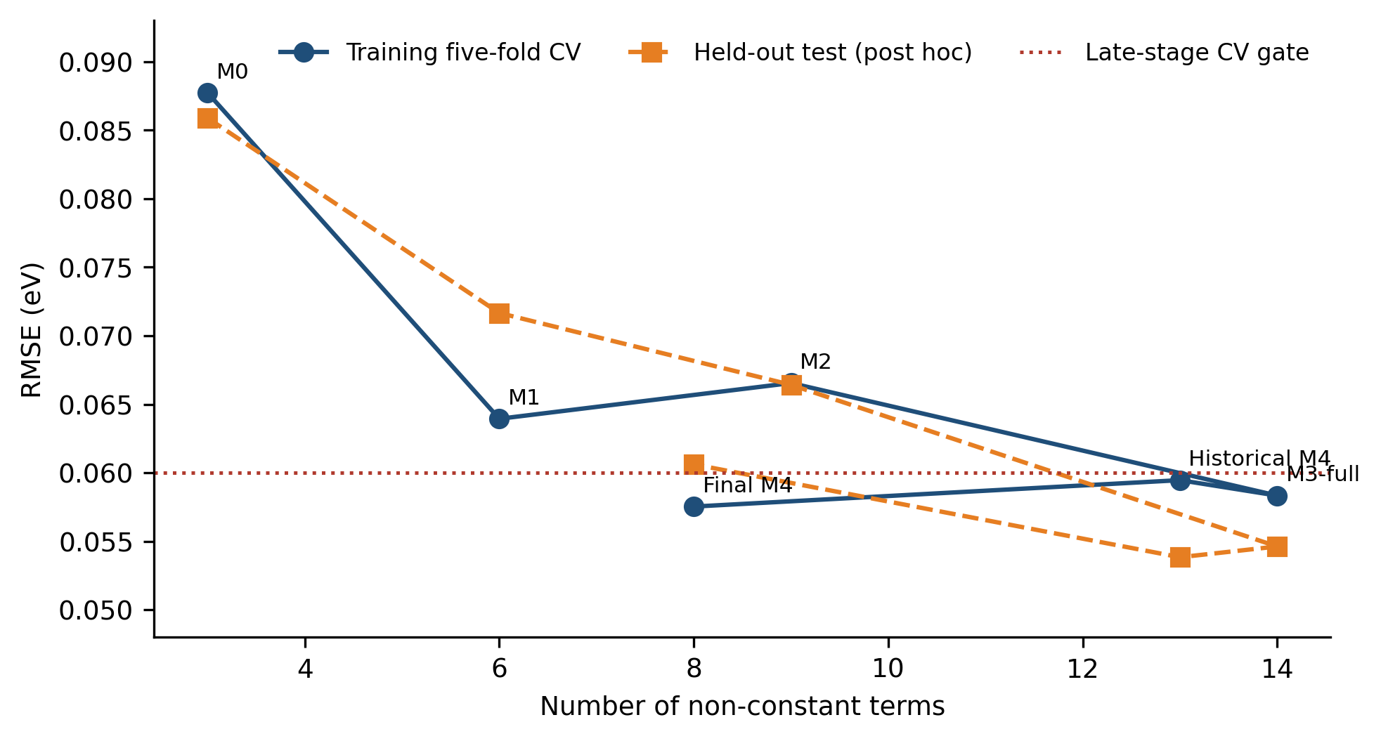
Figure S4. Cross-validation RMSE versus model complexity. The post hoc test curve is shown for transparency but was not used for the freeze decision. Final M4 attains the lowest reported fixed-CV error among the named stage models while using eight terms.
The historical M3 and 13-term M4 workbooks predate the diagnostic freeze and are retained as an audit trail. Their lower post hoc test errors do not override the training-CV and coefficient-stability rules. The final formula was refitted after the eight-term structure was locked.

Supplementary Note S6. Final M4 freezing rule and model nomenclature
The freeze rule combined: (i) training five-fold CV qualification; (ii) constrained parsimony; (iii) VIF and confidence-interval checks; (iv) 1000-resample bootstrap sign stability; (v) Cl² nested-model diagnostics; and (vi) subgroup and group-aware sensitivity. Test RMSE was not an optimization target.
Table S10. Model nomenclature and final-version locking.
Locked name | Term set | Role | Final?
Final frozen M4 | Sn, Br, Cl, Cs, Sn², Br², Cs·Sn, Cs·Cl | Revision endpoint | Yes
Historical 13-term M4 | Includes Cl², Cs², Sn·Br, Sn·Cl, Cs·Br, Cs·Cl | Pre-final candidate | No
M3-full | 14-term Cs interaction polynomial | Expressive late-stage reference | No
LLM-stable compact candidate | Sn, Br, Cl, Cs, Sn², Br², Cs·Sn, Cs·Br | 30-run stability reference | No
Anion-only exhaustive best | Sn, Br, Cl, Sn², Br², Sn·Br | Deterministic ablation | No
Anion-only main + quadratic | Sn, Br, Cl, Sn², Br², Cl² | Historical diagnostic candidate | No
LLM-frequency versus diagnostic selection. The most frequently generated terminal interaction in the repeated workflows is Cs·Br, whereas the final frozen model retains Cs·Cl. The two eight-term candidates are compared head-to-head below. The Cs·Cl model was selected on fixed cross-validation and full coefficient diagnostics, not by generation frequency.
Table S10A. Head-to-head comparison between the LLM-stable Cs·Br candidate and the final frozen Cs·Cl M4. Generation frequency is treated as a stochasticity diagnostic, whereas the final freeze is based on cross-validation and coefficient diagnostics.
Metric | LLM-stable Cs·Br candidate | Final frozen Cs·Cl M4
Non-constant terms | 8 (Sn, Br, Cl, Cs, Sn², Br², Cs·Sn, Cs·Br) | 8 (Sn, Br, Cl, Cs, Sn², Br², Cs·Sn, Cs·Cl)
Fixed five-fold CV RMSE (eV) | 0.058127 | 0.057532
Repeated five-fold CV RMSE (eV) | 0.058127 (repeated-workflow median) | 0.058056 (100-repeat mean)
Held-out test RMSE, post hoc (eV) | 0.061758 | 0.060613
Coefficient diagnostics | Per-coefficient values archived with repeated runs | Tables S11A–S11B; sign stability ≥ 0.999, max VIF 15.79
Selection basis | Most frequent in repeated generation | Lower fixed CV RMSE with full diagnostic support
Final decision | Stability reference only | Selected and frozen
Cl-containing subgroup test RMSE (eV) | Not separately archived for this candidate | 0.11180 (see Section 3.3)

Why the historical model is not final: The 13-term candidate has a lower test RMSE (0.053835 eV) than the frozen eight-term model, but it was not selected on the test set. It contains diagnostically weak and collinearity-heavy terms. Calling it final would contradict the declared training-only selection protocol.

Supplementary Note S7. Coefficient diagnostics, VIF, confidence intervals, and bootstrap
Final M4 was fitted by OLS on all 518 training rows after the structure freeze. OLS intervals use the standard linear-model covariance estimate. The bootstrap used 1000 row-resampling fits with seed 2026. Sign stability is the fraction of bootstrap coefficients with the same sign as the full-training estimate.
Table S11A. Final M4 OLS coefficient statistics and VIF.
Term | Coefficient | SE | p value | OLS 95% CI | VIF
Intercept | 1.555265 | 0.004406 | <1e-300 | [1.546609, 1.563922] | -
Sn | -1.102528 | 0.032179 | 2.83e-134 | [-1.165747, -1.039309] | 15.17
Br | 0.343195 | 0.029218 | 2.35e-28 | [0.285793, 0.400598] | 9.25
Cl | 1.619318 | 0.022434 | 1.55e-269 | [1.575242, 1.663393] | 1.49
Cs | 0.122679 | 0.012680 | 1.94e-20 | [0.097768, 0.147590] | 1.58
Sn² | 0.917022 | 0.036856 | 5.24e-90 | [0.844612, 0.989431] | 15.79
Br² | 0.366074 | 0.033377 | 2.85e-25 | [0.300501, 0.431647] | 9.12
Cs·Sn | -0.227156 | 0.025116 | 3.17e-18 | [-0.276501, -0.177812] | 2.01
Cs·Cl | -0.325275 | 0.042080 | 5.79e-14 | [-0.407948, -0.242602] | 1.73

Table S11B. Final M4 bootstrap coefficient statistics.
Term | Bootstrap mean | Bootstrap SD | Bootstrap 95% CI | Sign stability
Intercept | 1.554497 | 0.004851 | [1.544938, 1.564177] | 1.000
Sn | -1.100958 | 0.040947 | [-1.184979, -1.025275] | 1.000
Br | 0.347758 | 0.035870 | [0.275388, 0.416536] | 1.000
Cl | 1.623873 | 0.039354 | [1.548830, 1.703259] | 1.000
Cs | 0.124323 | 0.020683 | [0.082180, 0.163094] | 1.000
Sn² | 0.915352 | 0.045650 | [0.828282, 1.006160] | 1.000
Br² | 0.362629 | 0.037784 | [0.287875, 0.436703] | 1.000
Cs·Sn | -0.227421 | 0.041680 | [-0.308960, -0.142616] | 1.000
Cs·Cl | -0.367204 | 0.148857 | [-0.726226, -0.148771] | 0.999

All retained slope intervals exclude zero. Sign stability is 1.000 for seven slopes and 0.999 for Cs·Cl. Sn and Sn² have VIF values near 15, and Br and Br² near 9, reflecting expected dependence between raw polynomial terms. The interaction terms remain low-VIF. These values are materially lower than the maximum VIF above 3000 in the 14-term full polynomial.
Table S12. Removed-term diagnostic for adding Cl² to Final M4.
Diagnostic | Final M4 | Final M4 + Cl² | Interpretation
CV RMSE | 0.057532 | 0.058256 | Worse with Cl²
Test RMSE | 0.060613 | 0.062508 | Post hoc error also worse
AIC | -3003.783 | -3003.233 | No support for added term
BIC | -2965.533 | -2960.733 | Penalizes added term
Maximum VIF | 15.786 | 16.177 | Slightly higher
Cl² coefficient | - | 0.103629 | Small relative to uncertainty
Cl² OLS 95% CI | - | [-0.066945, 0.274202] | Crosses zero
Cl² bootstrap 95% CI | - | [-0.411010, 0.505612] | Crosses zero
Cl² sign stability | - | 0.6034 | Insufficient
Nested F-test p value | - | 0.2332 | Added term not supported

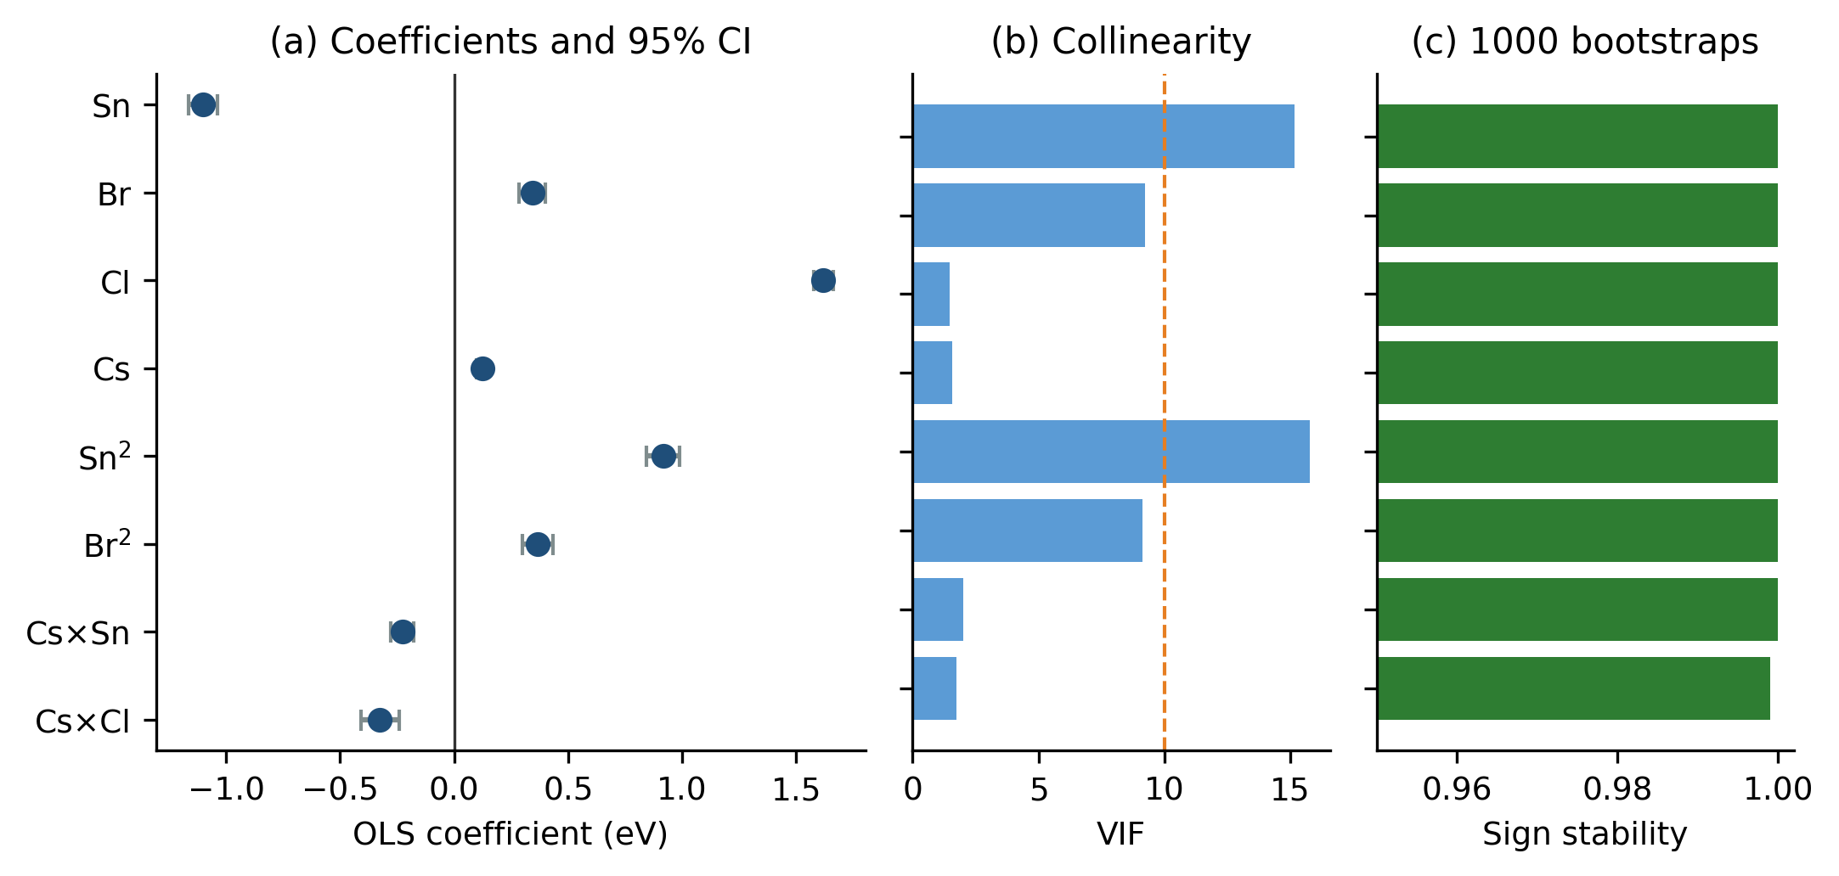
Figure S5. Final M4 coefficient diagnostics. (a) OLS coefficients and 95% confidence intervals. (b) VIF for raw polynomial terms. (c) Bootstrap sign stability across 1000 resamples.
A 100-repeat five-fold CV audit gave mean RMSE 0.058056 eV with between-partition SD 0.008714 eV, close to the fixed-fold value 0.057532 eV. Final training RMSE, MAE, and R² were 0.054108 eV, 0.039261 eV, and 0.969382. Held-out test RMSE, MAE, median absolute error, maximum absolute error, and R² were 0.060613 eV, 0.046760 eV, 0.036645 eV, 0.183551 eV, and 0.976545.

Supplementary Note S8. MA and A-site encoding sensitivity
MA was not removed because it is physically irrelevant. Under FA + MA + Cs = 1, all three A-site fractions cannot enter an intercept-containing linear model without exact dependence. FA was treated as the omitted baseline. The sensitivity analysis compared the nine-term Sn-Br-Cl core, isolated Cs or MA main effects, joint Cs and MA main effects, and the full Cs interaction structure.
Table S13. A-site encoding sensitivity.
Model | A-site encoding | k | CV RMSE | Test RMSE | Interpretation
Sn-Br-Cl + Cs interactions | Cs nonlinear/interactions | 14 | 0.058333 | 0.054620 | Training CV primary; test post hoc
Sn-Br-Cl + Cs + MA | Cs and MA main effects | 11 | 0.064405 | 0.063302 | Training CV primary; test post hoc
Sn-Br-Cl + MA | MA main effect | 10 | 0.065590 | 0.065933 | Training CV primary; test post hoc
Sn-Br-Cl core | No A-site term | 9 | 0.066548 | 0.066416 | Training CV primary; test post hoc
Sn-Br-Cl + Cs | Cs main effect | 10 | 0.066566 | 0.065252 | Training CV primary; test post hoc
Final frozen M4 | Cs main + Cs·Sn + Cs·Cl | 8 | 0.057532 | 0.060613 | Diagnostic freeze

The core CV RMSE is 0.066548 eV. Adding Cs alone leaves the error unchanged at 0.066566 eV. MA alone gives 0.065590 eV, and Cs + MA main effects give 0.064405 eV. The Cs interaction model reaches 0.058333 eV. Thus the available A-site signal is mainly conditional, not a large isolated linear MA or Cs effect. The final compact model retains Cs, Cs·Sn, and Cs·Cl. MA-rich systems remain part of the applicability-domain caution because explicit MA did not show a systematic compact-model advantage.

Supplementary Note S9. Non-LLM symbolic regression and statistical controls
Conventional controls were evaluated on the same immutable train/test files. Their purpose is not to prove universal superiority of one search algorithm. They test whether compact low-order structures are reachable without an LLM and whether the final freeze can be justified by deterministic or stochastic alternatives.
Table S14. Compact GPLearn baseline.
Setting or result | Archived value
Variables | Sn, Br, Cl, Cs, MA
Function set | add, subtract, multiply
Population / generations | 300 / 12
Tournament size | 20
Parsimony grid | 1e-6, 1e-5, 1e-4
Selection | Minimum mean five-fold training CV RMSE
CV RMSE ± SD | 0.145284 ± 0.032713 eV
Independent full-training refits | 5 (5 unique programs)
Test RMSE mean ± SD | 0.177322 ± 0.022785 eV
Test RMSE range | 0.141786-0.193834 eV
Best post hoc program | add(add(Cl, Br), sub(1.462, mul(0.344, Sn)))

GPLearn scope: The operator set and search budget were deliberately compact. This result is a limited-budget control, not a universal statement about genetic programming.
Table S15. PySR repeated-run results.
Search space | Seeds | Mean best test RMSE | Minimum | Unique best structures | Complexity range
Polynomial operators | 5 | 0.0683 ± 0.0096 | 0.0610 | 5 | 15-33
Richer operators | 5 | 0.0637 ± 0.0028 | 0.0611 | 5 | 20-31

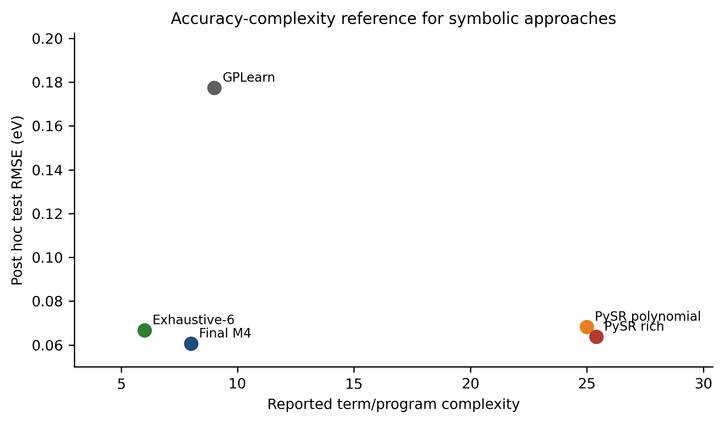
Figure S7. Accuracy-complexity reference for symbolic approaches. Complexity definitions are method-specific and are used only as an approximate visual reference.
Table S16. Exhaustive search over all 511 non-empty subsets of the nine-term anion polynomial dictionary.
Best k | Best terms | CV RMSE | Test RMSE | Pareto status
1 | Cl | 0.225271 | 0.241747 | Yes
2 | Br, Cl | 0.134708 | 0.144643 | Yes
3 | Sn, Br, Cl | 0.087733 | 0.085887 | Yes
4 | Sn, Br, Cl, Sn² | 0.068229 | 0.068946 | Yes
5 | Sn, Br, Cl, Sn², Br² | 0.063099 | 0.071471 | Yes
6 | Sn, Br, Cl, Sn², Br², Sn·Br | 0.062853 | 0.066711 | Global best
7 | Sn, Br, Cl, Sn², Br², Sn·Br, Br·Cl | 0.063671 | 0.067048 | No
8 | Sn, Br, Cl, Sn², Br², Cl², Sn·Br, Br·Cl | 0.063611 | 0.068587 | No
9 | All nine anion terms | 0.066548 | 0.066416 | No

The deterministic optimum is a six-term anion model and excludes Cl². It is a strong compact baseline but does not include the A-site interactions that lower the final M4 CV error. Exhaustive search therefore shows that low-order polynomial structure is not unique to the LLM workflow while also weakening the case for retaining Cl².
Table S17. Regularization and information-criterion controls.
Method | Rule | k | Selected terms | CV RMSE | Cl² removed?
LASSO | Minimum CV | 9 | Sn, Br, Cl, Sn², Br², Cl², Sn·Br, Sn·Cl, Br·Cl | 0.066319 | No
LASSO | 1-SE sparse | 7 | Sn, Br, Cl, Sn², Br², Sn·Br, Sn·Cl | 0.070303 | Yes
Ridge | Minimum CV | 9 | Sn, Br, Cl, Sn², Br², Cl², Sn·Br, Sn·Cl, Br·Cl | 0.066732 | No
Elastic Net | Minimum CV | 9 | Sn, Br, Cl, Sn², Br², Cl², Sn·Br, Sn·Cl, Br·Cl | 0.066320 | No
Elastic Net | 1-SE sparse | 7 | Sn, Br, Cl, Sn², Br², Sn·Br, Sn·Cl | 0.069714 | Yes
Stepwise | AIC | 7 | Cl, Br, Sn, Sn², Br², Sn·Cl, Sn·Br | n/a | Yes
Stepwise | BIC | 7 | Cl, Br, Sn, Sn², Br², Sn·Cl, Sn·Br | n/a | Yes
All subsets | AIC | 9 | All nine anion terms | n/a | No
All subsets | BIC | 9 | All nine anion terms | n/a | No

Minimum-CV LASSO and Elastic Net keep all nine terms because their selected penalties are effectively zero. Their 1-SE rules remove Cl² and Br·Cl but retain Sn·Br and Sn·Cl. Stepwise AIC and BIC select the same seven-term interaction model, whereas exhaustive AIC/BIC favor the full nine-term model. These controls support pruning as a reasonable objective but do not reproduce the exact final support.
Control conclusion: Conventional methods can reach low-order polynomial structures. The LLM-SR workflow is best interpreted as a controlled hypothesis-generation route that combines domain constraints, parsimony, and diagnostics, not as a universally superior optimizer.

Supplementary Note S10. Repeated LLM runs and cross-model stochasticity
Stochasticity was examined in three ways: 30 direct M4 prompt calls, 30 complete M0-M4 workflows, and repeated Qwen and DeepSeek workflows at three temperatures. Repeated runs were used to assess the stability of the M4-family backbone, not to choose the final formula by majority vote.
Table S18. Repeated LLM run settings.
Experiment | Model/provider identifier | Runs | Generation controls | Local evaluation
Direct M4 prompts | Archived Codex/gpt-5.5 identifier | 30 | Temperature and seed not exposed; isolated sessions | Term normalization only
Complete M0-M4 workflows | Archived Codex/gpt-5.5 identifier | 30 | 16 candidates per stage; reasoning effort low | CV seed 20260607; 2400 accepted candidates
Qwen workflows | qwen-plus | 10 per T | T = 0.2, 0.7, 1.0; top_p = 1; max_tokens = 3000 | CV seed 20260607
DeepSeek workflows | deepseek-v4-flash | 10 per T | T = 0.2, 0.7, 1.0; top_p = 1; max_tokens = 3000 | CV seed 20260607

Table S19. Term frequency in direct M4 outputs and selected models from 30 complete workflows.
Term | Direct count | Direct % | Full-workflow count | Full-workflow %
Sn | 30 | 100.0% | 30 | 100.0%
Br | 30 | 100.0% | 30 | 100.0%
Cl | 30 | 100.0% | 30 | 100.0%
Cs | 30 | 100.0% | 30 | 100.0%
Sn² | 30 | 100.0% | 30 | 100.0%
Br² | 28 | 93.3% | 30 | 100.0%
Cl² | 24 | 80.0% | 0 | 0.0%
Cs² | 12 | 40.0% | 0 | 0.0%
Sn·Br | 30 | 100.0% | 0 | 0.0%
Sn·Cl | 30 | 100.0% | 0 | 0.0%
Br·Cl | 2 | 6.7% | 0 | 0.0%
Cs·Sn | 3 | 10.0% | 30 | 100.0%
Cs·Br | 29 | 96.7% | 30 | 100.0%
Cs·Cl | 9 | 30.0% | 0 | 0.0%

The 30 direct M4 outputs contained 7 normalized structures. The complete workflows converged to one eight-term Cs·Br-containing candidate in 30/30 runs, with CV RMSE 0.058127 eV and test RMSE 0.061758 eV. This establishes empirical stability under the archived configuration, not deterministic seed-controlled reproducibility.
Table S20. Cross-provider repeated workflow summary.
Provider | T | n | Unique structures | Median CV | Median test | Test IQR | Test range
qwen | 0.2 | 10 | 7 | 0.058620 | 0.061848 | 0.002951 | 0.056340-0.277741
qwen | 0.7 | 10 | 2 | 0.058127 | 0.061758 | 0.000000 | 0.061758-0.065470
qwen | 1.0 | 10 | 3 | 0.058127 | 0.061758 | 0.000502 | 0.061758-0.065470
deepseek | 0.2 | 10 | 3 | 0.058127 | 0.061758 | 0.002941 | 0.061758-0.065944
deepseek | 0.7 | 10 | 3 | 0.058127 | 0.061758 | 0.000000 | 0.056509-0.065680
deepseek | 1.0 | 10 | 5 | 0.058296 | 0.061758 | 0.001145 | 0.056340-0.065680

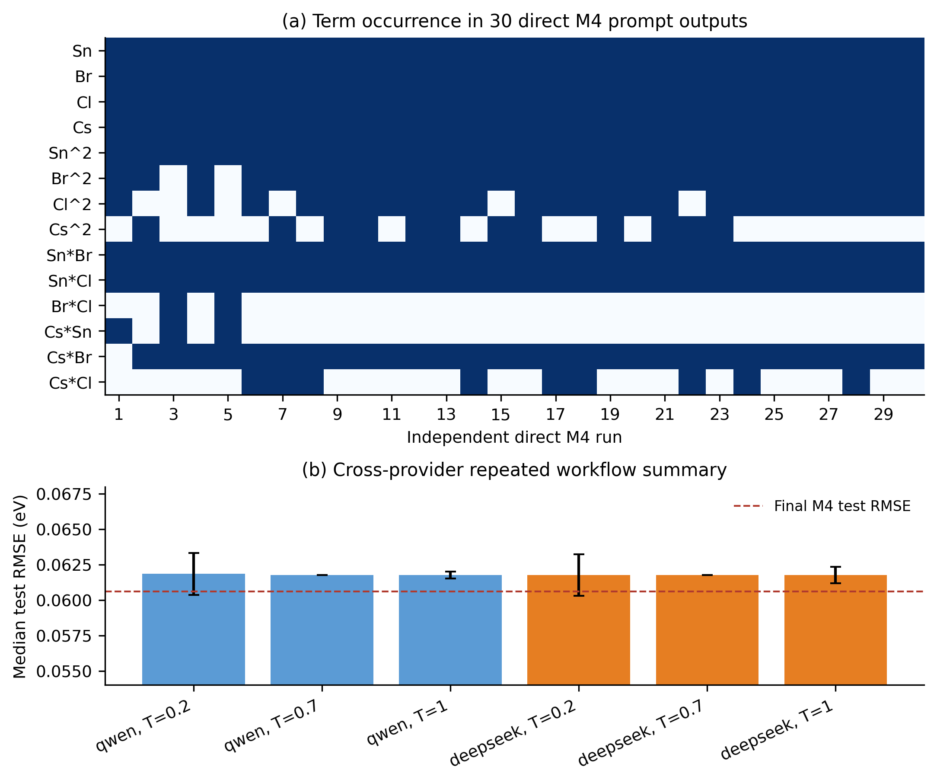
Figure S6. LLM stochasticity. (a) Term occurrence in 30 independent direct M4 prompt outputs. Dark cells indicate inclusion. (b) Median held-out error for repeated Qwen and DeepSeek workflows; error bars show half the interquartile range.
Cs·Br is frequent in repeated generation and is the terminal term in all 30 complete-workflow selected candidates. Cs·Cl is less frequent in direct generation. The final revision nevertheless retains Cs·Cl because the freeze decision was made after local OLS fitting, CV, confidence intervals, bootstrap sign stability, and interaction-specific diagnostics. Majority vote over generated structures was not the selection rule.

Supplementary Note S11. Black-box baselines and SHAP cross-check
Gaussian-process regression and tree ensembles provide predictive reference points using a compact site-fraction input set. Their input set additionally includes MA as a closure-aware A-site descriptor (Sn, Br, Cl, Cs, MA), so these models are reported as an MA-augmented predictive ceiling rather than an exact same-feature comparison with the final four-variable M4 equation. They are not equation-discovery methods, but they test the accuracy cost of restricting the response to eight explicit global terms.
Table S21. Black-box and final analytical model performance.
Method | Inputs/model | CV RMSE | Test RMSE | Test MAE | Test R²
Gaussian process | Sn, Br, Cl, Cs, MA; Matérn-1.5 | 0.051320 | 0.048604 | 0.037050 | 0.984919
GBRT | Sn, Br, Cl, Cs, MA | 0.053247 | 0.052021 | 0.040229 | 0.982724
Random forest | Sn, Br, Cl, Cs, MA | 0.059683 | 0.055863 | n/a | 0.980078
XGBoost | Sn, Br, Cl, Cs, MA | 0.051267 | 0.060565 | n/a | 0.976583
Final M4 | Eight-term OLS equation | 0.057532 | 0.060613 | 0.046760 | 0.976545

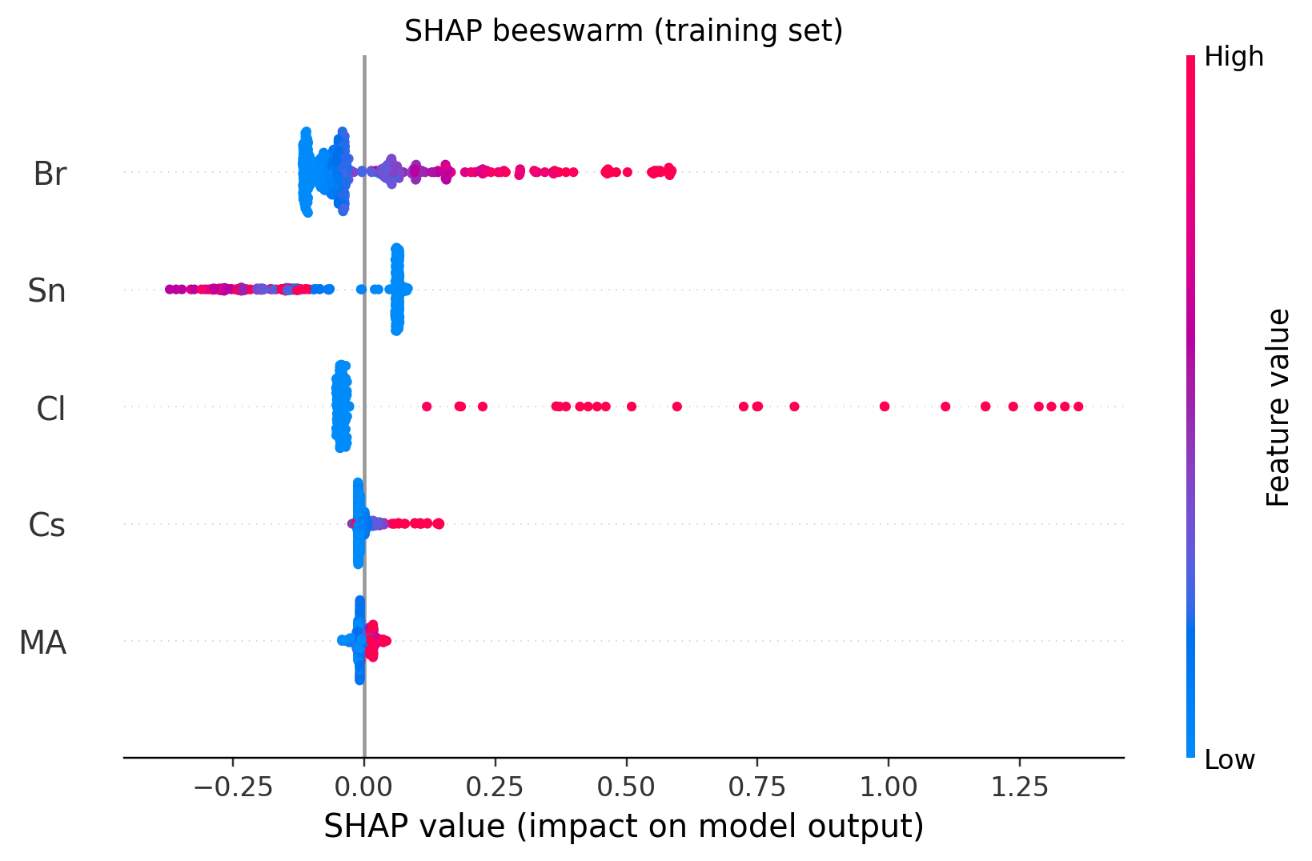
Figure S8. GBRT SHAP beeswarm. Br, Sn, and Cl dominate the response; Cs and MA are smaller corrections.
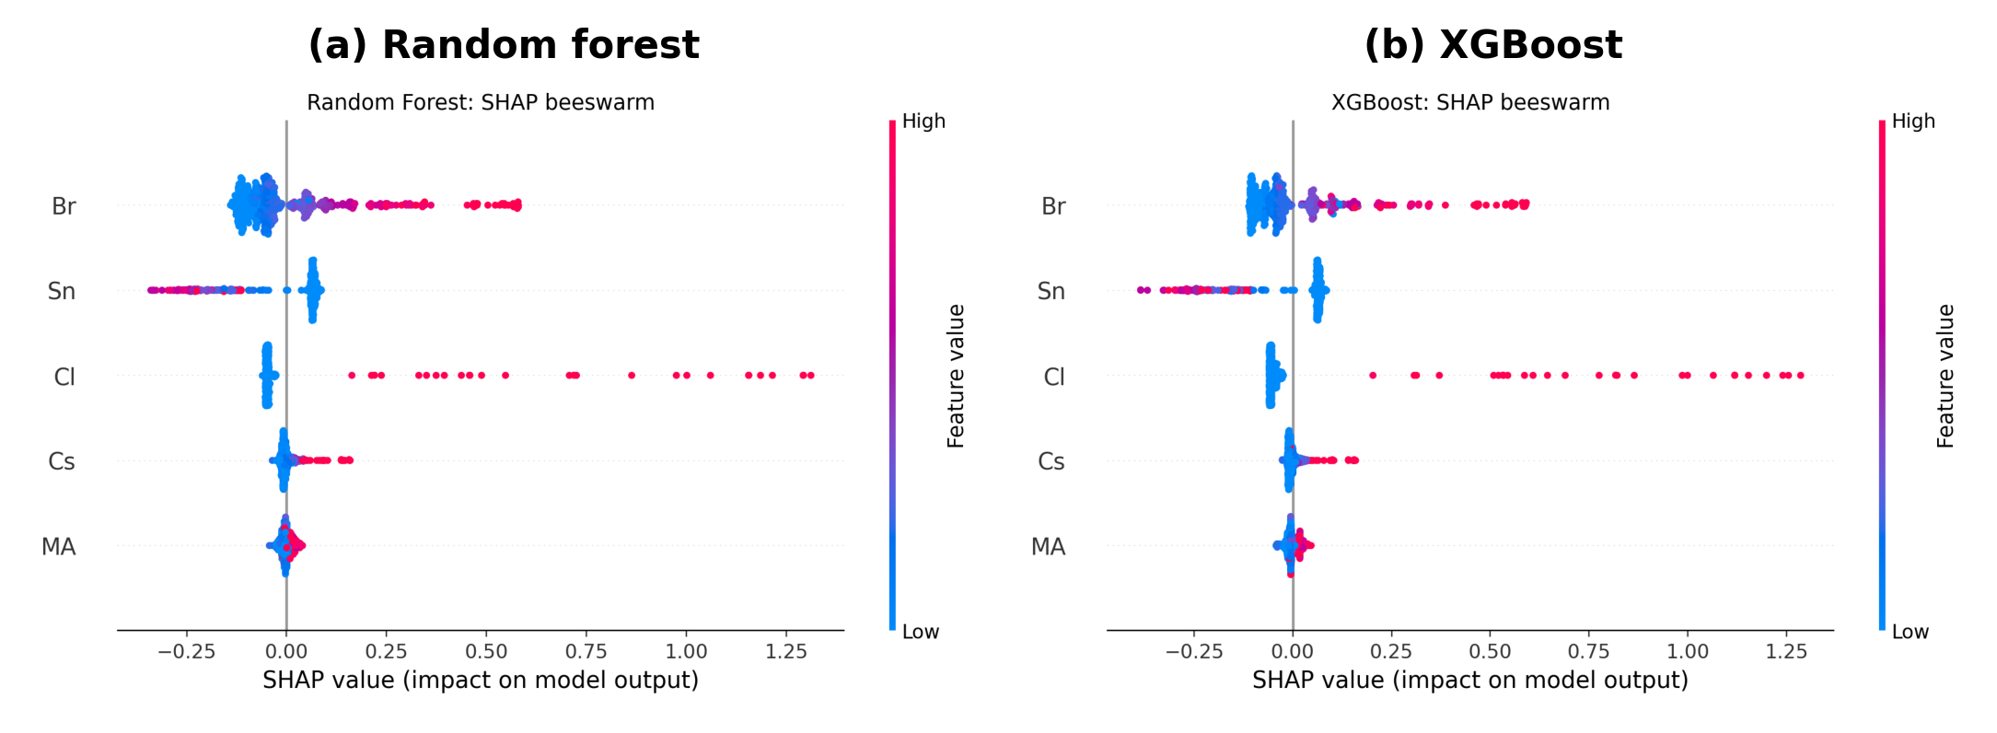
Figure S9. SHAP beeswarm plots for random forest and XGBoost. Both reproduce the same dominant feature hierarchy and response directions as GBRT.
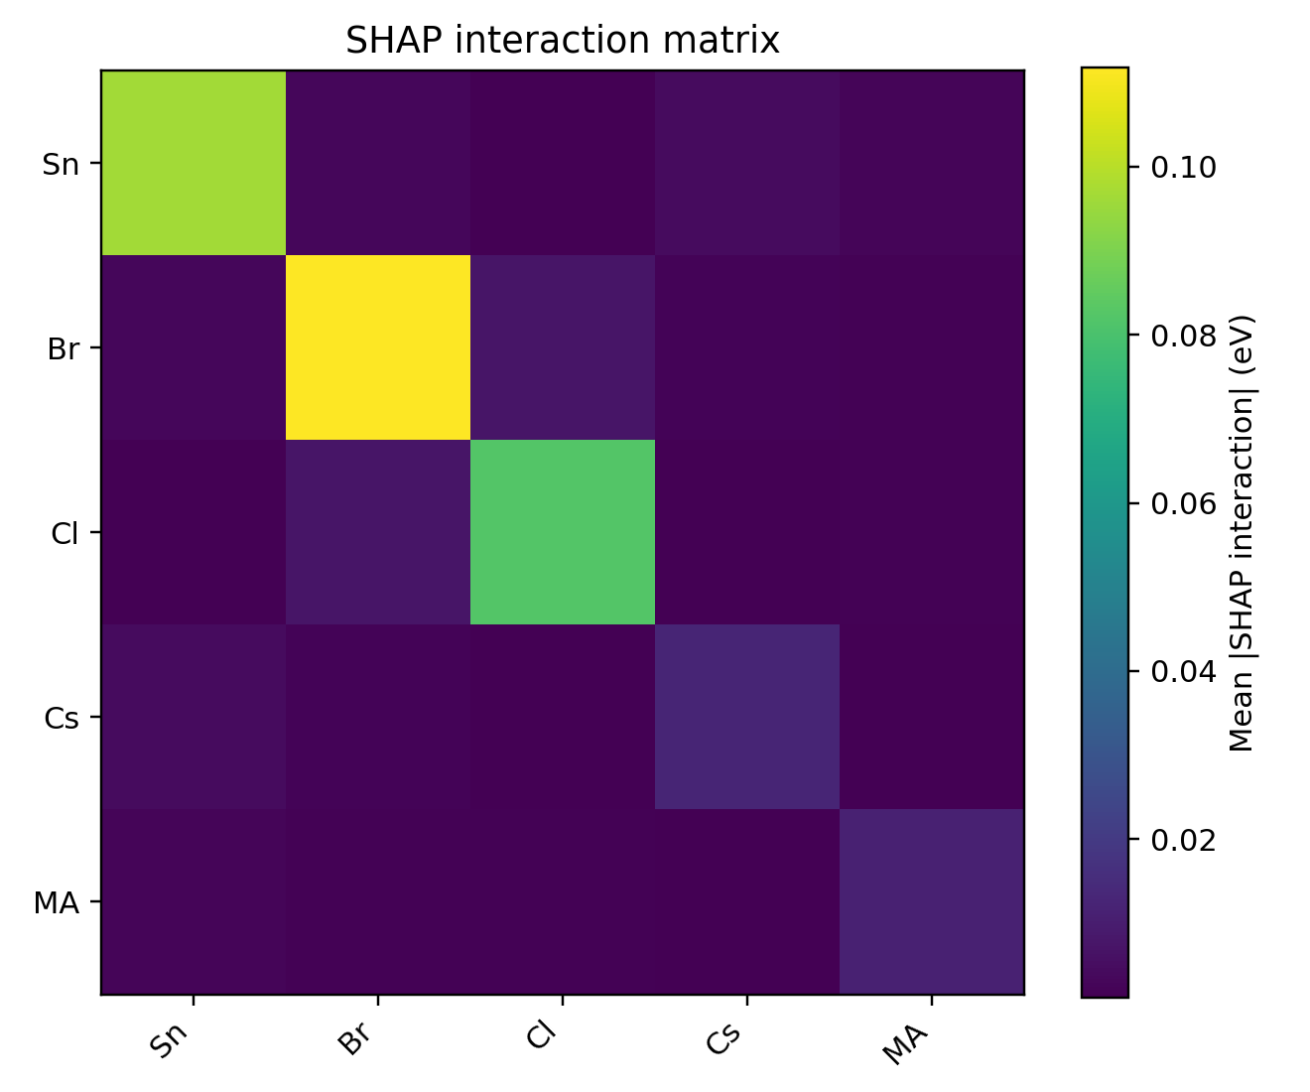
Figure S10. GBRT SHAP interaction matrix. The diagonal represents main effects; the largest off-diagonal interaction is Br·Cl.
Table S22. Symbolic coefficient trends versus SHAP trends.
Feature or pair | Final M4 representation | SHAP evidence | Cross-check
Sn | Negative main; positive Sn² curvature | GBRT mean |SHAP| 0.0966; dependence decreases with Sn | Consistent
Br | Positive main and Br² curvature | GBRT 0.1078; RF 0.1087; XGB 0.0984 | Consistent dominant effect
Cl | Strong positive main | GBRT 0.0813; sparse high positive responses | Consistent but data-sparse
Cs | Small positive main; negative Cs·Sn and Cs·Cl | GBRT 0.0128; RF 0.0126; XGB 0.0127 | Small conditional effect
MA | Not explicit in final formula | GBRT 0.0121; RF 0.0099; XGB 0.0120 | Small omitted-baseline correction
Br-Cl | No global term retained | Top interaction: 0.00725 GBRT; 0.00841 RF; 0.01651 XGB | Localized nonlinearity omitted by compact formula
Sn-Cs | Cs·Sn retained | GBRT interaction 0.00436 | Consistent coupling

SHAP supports the dominant roles of halide and Sn substitution while identifying Br·Cl as a localized nonlinear region better captured by black-box models. The absence of Br·Cl from Final M4 is therefore a stability-parsimony decision, not a claim that Br·Cl coupling is physically absent.

Supplementary Note S12. Group-aware splitting and applicability domain
Group-aware analysis used the 507-row strict-closure subset and repeated the full candidate-selection workflow. Composition-family group shuffle tests generalization across combined A/B/X families. Halide and A-site leave-one-group-out tests deliberately remove entire chemistry regimes from training. These are sensitivity analyses and did not alter the frozen random-split model.
Table S23. Group-aware split performance summary.
Strategy | Splits | Mean RMSE | SD | Median | Worst | Mean Jaccard
composition_family_group_shuffle | 20 | 0.088443 | 0.033548 | 0.074959 | 0.162225 | 0.779
halide_logo | 4 | 0.270957 | 0.412355 | 0.069395 | 0.889401 | 0.875
a_site_logo | 4 | 0.085468 | 0.063624 | 0.070964 | 0.173822 | 0.851

Table S24A. Leave-one-group-out results, with held-out group, held-out sample count, error metrics, and interpretation. Held-out sample counts are reported directly in the table to clarify the sparsity of each excluded chemistry regime.
Split strategy | Held-out group | n held out | RMSE / eV | MAE / eV | Interpretation
Halide LOGO | Br-rich | 58 | 0.072594 | 0.056629 | represented Br-rich regime
Halide LOGO | Cl-containing | 27 | 0.889401 | 0.727853 | boundary-failure diagnostic
Halide LOGO | I-rich | 354 | 0.066196 | 0.050570 | dominant represented regime
Halide LOGO | mixed-halide | 68 | 0.055639 | 0.045029 | interpolation-like mixed regime
A-site LOGO | Cs-rich | 32 | 0.173822 | 0.141544 | A-site boundary
A-site LOGO | FA-rich | 284 | 0.056914 | 0.043838 | well-represented regime
A-site LOGO | MA-rich | 189 | 0.085013 | 0.061022 | moderate transfer
A-site LOGO | mixed-A | 2 | 0.026123 | 0.020098 | very small mixed-A holdout; descriptive only

Table S24B. Selected-term frequencies under group-aware workflows.
Strategy | Term | Selected count | Frequency
composition_family_group_shuffle | Sn | 20 | 100.0%
composition_family_group_shuffle | Br | 20 | 100.0%
composition_family_group_shuffle | Cl | 20 | 100.0%
composition_family_group_shuffle | Sn² | 20 | 100.0%
composition_family_group_shuffle | Br² | 14 | 70.0%
composition_family_group_shuffle | Cl² | 0 | 0.0%
composition_family_group_shuffle | Cs | 15 | 75.0%
composition_family_group_shuffle | Cs·Sn | 12 | 60.0%
composition_family_group_shuffle | Cs·Br | 3 | 15.0%
composition_family_group_shuffle | Cs·Cl | 11 | 55.0%
composition_family_group_shuffle | Br·Cl | 0 | 0.0%
halide_logo | Sn | 4 | 100.0%
halide_logo | Br | 4 | 100.0%
halide_logo | Cl | 3 | 75.0%
halide_logo | Sn² | 4 | 100.0%
halide_logo | Br² | 4 | 100.0%
halide_logo | Cl² | 0 | 0.0%
halide_logo | Cs | 4 | 100.0%
halide_logo | Cs·Sn | 4 | 100.0%
halide_logo | Cs·Br | 0 | 0.0%
halide_logo | Cs·Cl | 1 | 25.0%
halide_logo | Br·Cl | 0 | 0.0%
a_site_logo | Sn | 4 | 100.0%
a_site_logo | Br | 4 | 100.0%
a_site_logo | Cl | 4 | 100.0%
a_site_logo | Sn² | 4 | 100.0%
a_site_logo | Br² | 4 | 100.0%
a_site_logo | Cl² | 0 | 0.0%
a_site_logo | Cs | 3 | 75.0%
a_site_logo | Cs·Sn | 3 | 75.0%
a_site_logo | Cs·Br | 1 | 25.0%
a_site_logo | Cs·Cl | 2 | 50.0%
a_site_logo | Br·Cl | 0 | 0.0%

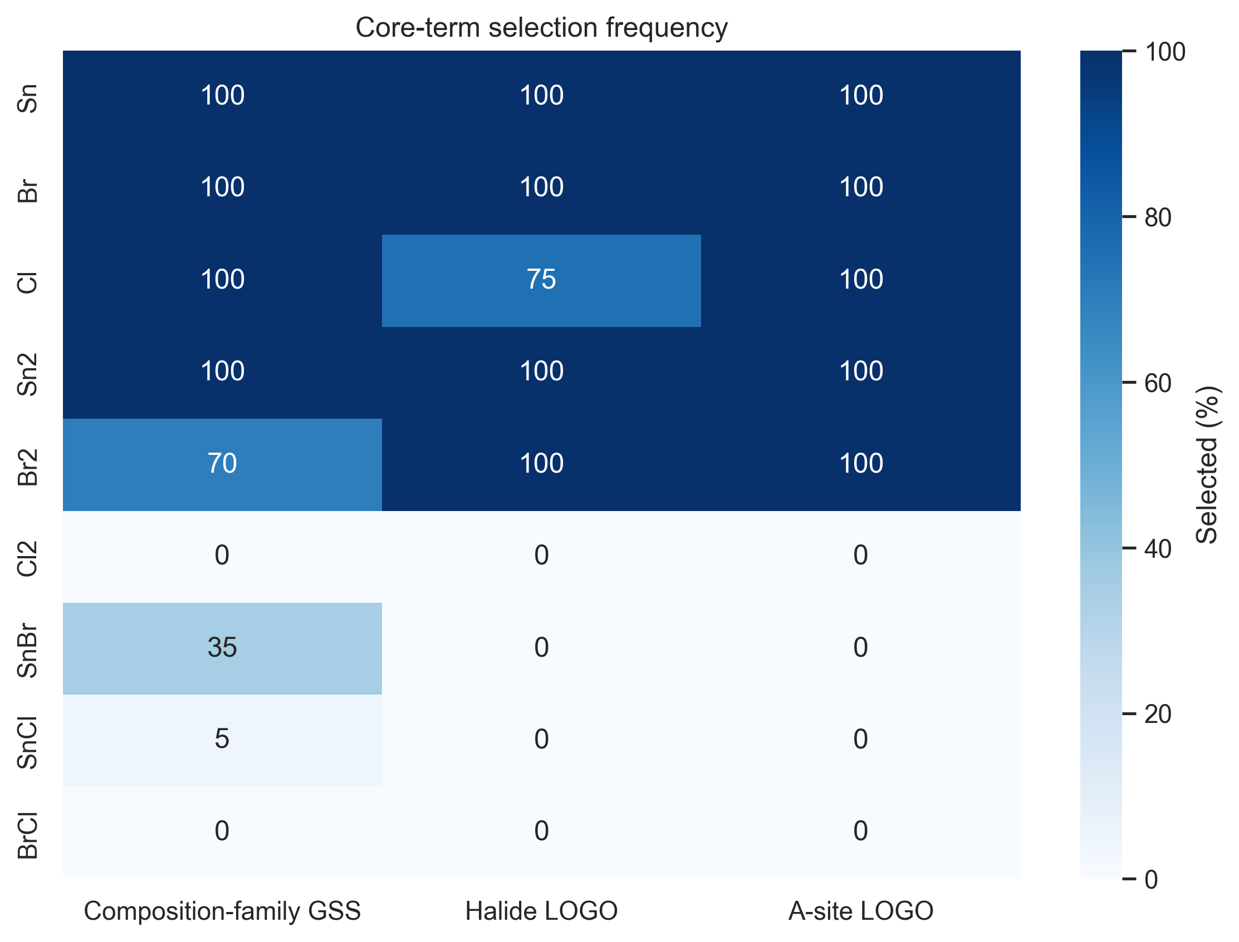
Figure S11. Term-selection frequency under composition-family, halide-LOGO, and A-site-LOGO workflows. Core terms Sn, Br, Cl, Sn², and Br² are repeatedly selected, whereas sparse-regime interaction terms are less stable.
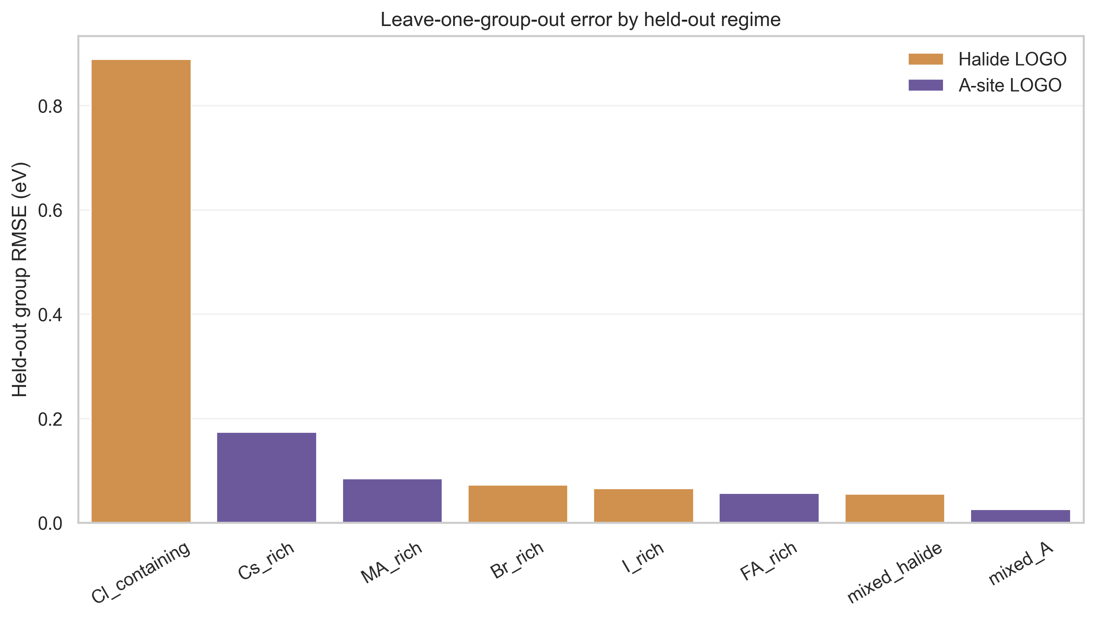
Figure S12. Held-out-group errors. Removing the full Cl-containing regime produces the dominant failure case; Cs-rich holdout is the strongest A-site boundary. The mixed-A group is shown for completeness but has only two held-out records.
Composition-family splits give mean RMSE 0.08844 eV and median 0.07496 eV. Holding out mixed-halide, I-rich, or Br-rich groups gives 0.05564, 0.06620, and 0.07259 eV, whereas holding out all Cl-containing compositions gives 0.88940 eV. A-site LOGO gives 0.02612 eV for mixed-A, 0.05691 eV for FA-rich, 0.08501 eV for MA-rich, and 0.17382 eV for Cs-rich.
Applicability-domain conclusion: Final M4 is an interpolation surrogate for the dominant represented manifold. Strict halide extrapolation, especially into Cl-containing families without Cl examples in training, and isolated Cs-rich families require additional data or a nonlinear model. The Cl-containing leave-one-group-out partition is the sparsest halide boundary regime; its 0.88940 eV error reflects near-total removal of Cl information and should be read as a boundary-failure diagnostic rather than as an ordinary expected prediction error. Per-group held-out errors and sample counts are reported in Table S24A; the Cl-containing group comprises only 27 of the 507 strict-QC training records, so leaving it out removes essentially all Cl information from training. The sample counts are reported to clarify the sparsity of the held-out regimes, not to discount the boundary failure.

Supplementary Note S13. Independent external-validation status
The 92-row held-out workbook is drawn from the same frozen database snapshot as the training data. It is a legitimate non-selection test set but not an independent literature validation set. The project archive does not contain a verified external panel with composition provenance, measurement conditions, deduplication against the source database, and harmonized optical-gap definitions.
Table S25. External-validation evidence status and required completion protocol.
Evidence item | Current archive status | Submission-ready requirement
Independent literature compositions | Not included in the current archive | Assemble a composition-resolved external set
Proof of non-overlap with source database | Not included in the current archive | Deduplicate by composition, citation, and measurement record
Temperature, phase, and measurement method | Not harmonized | Archive metadata and uncertainty
Final M4 predictions | Not generated for an independent set | Apply frozen formula without refitting
External RMSE, MAE, median AE, max AE | Not reported | Report overall and subgroup metrics
Parity and absolute-error figures | Not produced | Generate only after the dataset is verified
Model-selection role | Must remain none | Use external data for transferability reporting only

No fabricated validation: This SI intentionally omits an external parity plot and sample list because the required source-grounded dataset is absent. The strongest current evidence is the immutable held-out split plus the group-aware sensitivity analysis.

Supplementary Note S14. Composition-guided design demonstration
The closed-form model can be evaluated over dense composition grids without retraining. Figure S13 shows two response slices. Colored regions are restricted by distance to the training manifold; white regions are withheld rather than presented as valid predictions.
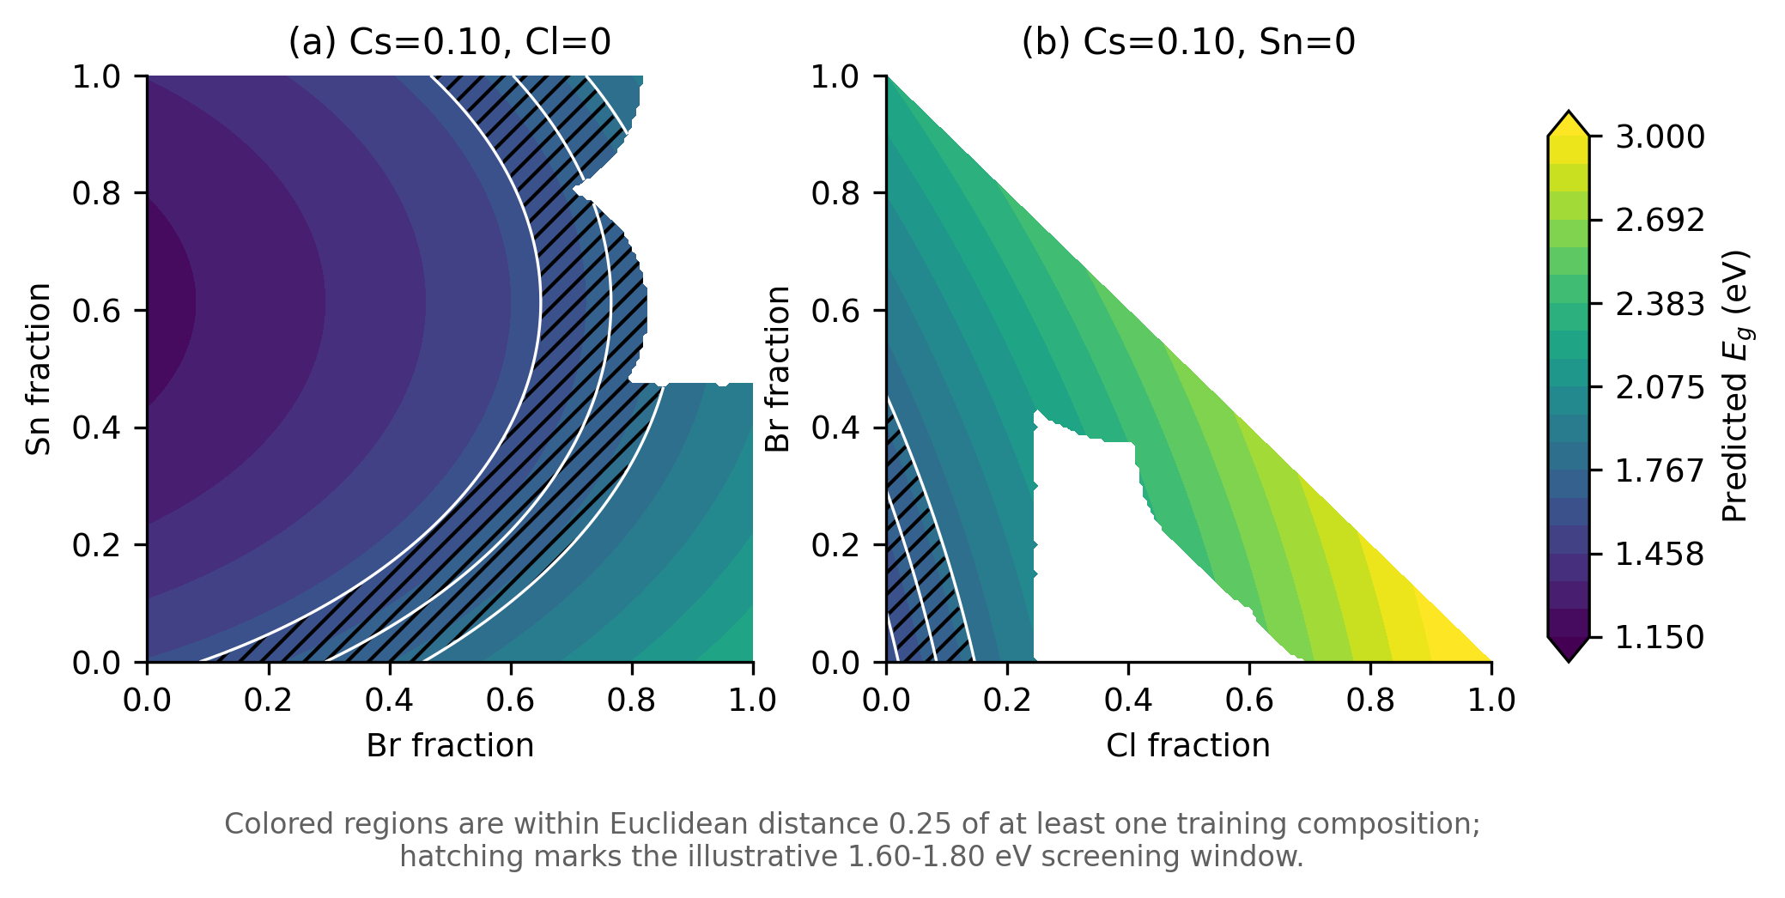
Figure S13. Band-gap landscapes generated by Final M4. Colored points are within Euclidean distance 0.25 of a training composition in the Sn-Br-Cl-Cs space. Hatching marks the illustrative 1.60-1.80 eV target window.
An additional screen generated 100,000 local perturbations around archived training compositions with seed 20260609. A-site and X-site fractions were perturbed on their simplices, Sn was locally perturbed, and Pb was set by closure. Candidates were required to have predicted E_{g} between 1.60 and 1.80 eV, nearest-training distance no greater than 0.15 in Sn-Br-Cl-Cs-MA space, Cs no greater than 0.50, and Cl no greater than 0.15. This left 30,119 illustrative points. Twelve compositionally separated examples are reported below.
Table S26. Illustrative locally constrained candidates in the 1.60-1.80 eV window. Fraction strings are FA/MA/Cs, Pb/Sn, and I/Br/Cl.
Candidate | A site | B site | X site | Pred. E_{g} | Nearest d
C01 | 0.785/0.153/0.062 | 1.000/0.000 | 0.857/0.142/0.001 | 1.620 | 0.009
C02 | 0.849/0.151/0.000 | 0.968/0.032 | 0.769/0.231/0.000 | 1.620 | 0.044
C03 | 0.907/0.000/0.093 | 0.965/0.035 | 0.714/0.282/0.004 | 1.660 | 0.040
C04 | 0.311/0.682/0.007 | 1.000/0.000 | 0.762/0.237/0.001 | 1.660 | 0.042
C05 | 0.591/0.185/0.224 | 1.000/0.000 | 0.739/0.258/0.003 | 1.700 | 0.028
C06 | 0.000/0.992/0.008 | 0.992/0.008 | 0.674/0.324/0.002 | 1.700 | 0.017
C07 | 0.578/0.097/0.325 | 0.989/0.011 | 0.734/0.266/0.001 | 1.700 | 0.029
C08 | 0.000/1.000/0.000 | 0.780/0.220 | 0.345/0.654/0.001 | 1.740 | 0.055
C09 | 0.001/0.999/0.000 | 0.951/0.049 | 0.539/0.460/0.001 | 1.740 | 0.050
C10 | 0.763/0.001/0.236 | 1.000/0.000 | 0.600/0.400/0.000 | 1.780 | 0.036
C11 | 0.826/0.073/0.101 | 0.993/0.007 | 0.564/0.435/0.001 | 1.780 | 0.046
C12 | 0.548/0.322/0.129 | 1.000/0.000 | 0.580/0.420/0.000 | 1.780 | 0.116

These rows are model-guided examples, not discovered materials. They do not include phase stability, defect tolerance, synthesis feasibility, processing conditions, or uncertainty in the experimental target. Candidate ranking should therefore be followed by nonlinear local refinement and experimental or physics-based validation.

Supplementary Note S15. Reproducibility package and file manifest
The local project archive contains the fixed data files, prompts, repeated-run records, statistical diagnostics, black-box outputs, group-aware manifests, and scripts listed below. Public repository and archival identifiers are not present. Before journal submission, the archive should be reorganized into a clean release, an environment lock should be added, and immutable GitHub/Zenodo identifiers should be created.
Table S27. Reproducibility package manifest.
File or folder | Description | Used for | Status
dataset.xlsx | 610-row record-level snapshot plus auxiliary sheets | Dataset audit | Present
训练集.xlsx (training_set.xlsx) | Immutable 518-row training workbook | All model fitting and selection | Present
测试集.xlsx (test_set.xlsx) | Immutable 92-row held-out workbook | Post hoc evaluation | Present
M0-M4.xlsx | Historical stage formulas | Stage audit | Present
llmrepeated/prompts/M0.txt ... M4.txt | Exact direct prompt templates | Prompt reproducibility | Present
VIF CI bootstrap/final_M4_coefficients_CI_bootstrap.csv | OLS, CI, bootstrap, and VIF statistics | Final diagnostics | Present
VIF CI bootstrap/Cl2_retention_diagnostic.csv | Nested Cl² comparison | Removed-term evidence | Present
MA A-site 编码敏感性/ma_asite_encoding_sensitivity.xlsx (encoding_sensitivity/ma_asite_encoding_sensitivity.xlsx) | A-site encoding comparison | MA sensitivity | Present
Exhaustive polynomial search/exhaustive_polynomial_search.xlsx | All 511 anion models and Pareto tables | Deterministic control | Present
LASSO Ridge Elastic Net + Stepwise AICBIC/*.xlsx,csv | Regularization and information criteria | Selection controls | Present
results_pysr/ | Five-seed PySR outputs and Pareto files | Symbolic baseline | Present
_paper_build/run_gplearn_baseline.py | Compact GPLearn experiment | Symbolic baseline | Present
_paper_build/gplearn/ | GPLearn CV and seed outputs | Symbolic baseline | Present
llmrepeated/raw_outputs/ | Thirty direct M4 raw/normalized outputs | Stochasticity | Present
llmrepeated/repeated_runs_30/ | Thirty complete M0-M4 workflows | Stochasticity and audit | Present
llmrepeated/external_api_runs/ | Qwen/DeepSeek runs, manifests, and summaries | Cross-model stability | Present
GPlearning/ | Gaussian-process selection and predictions | Predictive benchmark | Present
GBRT + SHAP/ | GBRT model selection, SHAP arrays, and figures | Interpretability | Present
RFXGBoost + SHAP/ | RF/XGBoost metrics and SHAP outputs | Interpretability | Present
Group-aware split sensitivity/scripts,src,outputs | Validated group splits, workflows, tests, and figures | Applicability domain | Present
最后的M4/ (final_M4/) | Final freeze summary and formula records | Version lock | Present
_si_build/prepare_si_assets.py | SI audit tables, design screen, and figures | This SI | Present
_si_build/build_si_docx.py | Deterministic DOCX builder | This SI | Present
environment.yml / requirements lock | Complete software environment | Portable rerun | Not present
Public GitHub URL | Versioned public repository | Access | Not present
Zenodo DOI | Immutable archival release | Citation | Not present

The three principal SHA-256 checksums are: dataset.xlsx, 2F4A5A0CA845137EC39798F8E06FF4F110B93458FD12B91EFF1D52A16B2B037A; training workbook, A329CA43106A835BEBC16516731871C9681D5704DBAB7C539E8C8DF07E3FF873; test workbook, 00BECF24ED7FE8866F5D3C966F2B2C2F0397C973EE372885EB145F8B94FC5352. The repeated-workflow manifests also record prompt hashes, model identifiers, CV seeds, candidate counts, Python, NumPy, and pandas versions.

Reproduction sequence
Step 1: Verify the three data-file checksums and use the immutable training/test workbooks.
Step 2: Read the exact M0-M4 templates and candidate schemas in `llmrepeated`.
Step 3: Run local OLS and five-fold CV; do not use the held-out workbook for candidate selection.
Step 4: Regenerate final coefficient diagnostics from the VIF/CI/bootstrap workflow.
Step 5: Regenerate non-LLM, black-box, SHAP, and group-aware controls from their archived scripts and manifests.
Step 6: Use `_si_build/prepare_si_assets.py` and `_si_build/build_si_docx.py` to reproduce this document.

Data Availability Statement
The frozen local dataset snapshot, immutable train/test workbooks, exact prompts, repeated-run logs, benchmark outputs, SHAP summaries, group-aware split manifests, and analysis scripts are contained in the accompanying project archive. A public GitHub release and immutable Zenodo archive should be created before submission. No unverified public URL or DOI is asserted here.

Supplementary References
1. Jacobsson, T. J.; Hultqvist, A.; García-Fernández, A.; et al. An Open-Access Database and Analysis Tool for Perovskite Solar Cells Based on the FAIR Data Principles. Nat. Energy 2022, 7, 107-115. https://doi.org/10.1038/s41560-021-00941-3.
2. Schmidt, M.; Lipson, H. Distilling Free-Form Natural Laws from Experimental Data. Science 2009, 324, 81-85. https://doi.org/10.1126/science.1165893.
3. Cranmer, M. Interpretable Machine Learning for Science with PySR and SymbolicRegression.jl. arXiv 2023, arXiv:2305.01582. https://doi.org/10.48550/arXiv.2305.01582.
4. Shojaee, P.; Meidani, K.; Gupta, S.; Farimani, A. B.; Reddy, C. K. LLM-SR: Scientific Equation Discovery via Programming with Large Language Models. arXiv 2024, arXiv:2404.18400. https://doi.org/10.48550/arXiv.2404.18400.
5. Breiman, L. Random Forests. Mach. Learn. 2001, 45, 5-32. https://doi.org/10.1023/A:1010933404324.
6. Friedman, J. H. Greedy Function Approximation: A Gradient Boosting Machine. Ann. Stat. 2001, 29, 1189-1232. https://doi.org/10.1214/aos/1013203451.
7. Chen, T.; Guestrin, C. XGBoost: A Scalable Tree Boosting System. Proc. KDD 2016, 785-794. https://doi.org/10.1145/2939672.2939785.
8. Rasmussen, C. E.; Williams, C. K. I. Gaussian Processes for Machine Learning; MIT Press: Cambridge, MA, 2006.
9. Lundberg, S. M.; Lee, S.-I. A Unified Approach to Interpreting Model Predictions. Adv. Neural Inf. Process. Syst. 2017, 30, 4765-4774.
10. Efron, B.; Tibshirani, R. J. An Introduction to the Bootstrap; Chapman & Hall/CRC: New York, 1993.

