Development proposal for   
ISO 19115 Metadata Community Adaptor

Qiping Yan

Email: [qiping@aol.com](mailto:qiping@aol.com)

Web: http://cse.unr.edu/~yanq

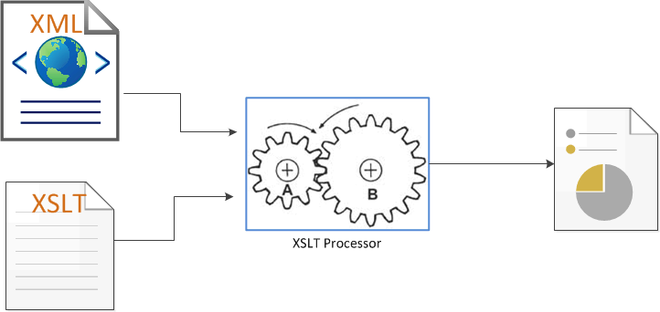

2012.12

date

December 14, 2012

# Project Title

ISO 19115 Metadata Community Adaptor

# Project Description

This project will involve designing and implementing a web service system to transform between different geography metadata standards to the ISO 19115 metadata standard format and vice versa.

The system will be integrated into the NCCP portal as a service wrapper or layer to provide ISO 19115 standard metadata to researchers and involving partners to enhance NCCP’s functionalities on data discovering, exploring, sharing, and cataloguing.

It can be further modified for a geography clearinghouse to provide its users with a broad format support for metadata submission and metadata format transformation.

The project will be implemented in a Microsoft IIS web server using standard SOAP web service technology, XML, XALT, and C#. The database support will be based on a Microsoft SQL Server.

# Scope

We will do the following:

MS Visio ERD design of the database and web service functionalities.

MS Visual Studio design of the web user interface.

C# programming for the web service, user interface and SQL server support.

Cross-browser testing for web service and user interface.

Documentation and user’s guide in PDF format.

# Budget

We will need 2 to 3 people to work on this project and the budget is (2-3 person) * 4 month * monthly wages/stipend.

# Timescale

We would anticipate the project taking 12-15 weeks to finish. The actual time will depend on the higher ranking management turnaround time like responding to designs and modification suggestions etc.

# About our team

Teamwork makes dream work. Our team will include Qiping Yan and 1-2 people (to be hired later) plus consulting support from NCCP (Mike and Eric) and advisement from Dr. Dascalu and Dr. Harris.

Qiping Yan, a CSE PhD student, has extensive experience in web application development. He is specialized on database design and implementation, web application architecture, user interface design, membership/content management server side programming. Past works include: USDiners.com ([www.USDiners.com](http://www.USDiners.com)), AllDiners.com ([www.AllDiners.com](http://www.AllDiners.com)), iDiners.com ([www.iDiners.com](http://www.iDiners.com)), RenoDiners.com ([www.RenoDiners.com](http://www.RenoDiners.com)).

More information is available on his personal website [www.cse.unr.edu/~yanq](http://www.cse.unr.edu/~yanq)

More resumes will be added here as more team members join.

# Timeline

|  |  |
| --- | --- |
| Planning | 2 weeks |
| Database design and implementation | 2 weeks |
| Web user interface design | 1 week |
| Web service design and implementation | 3-4 weeks |
| Putting everything together | 1-2 weeks |
| Testing and debugging | 1 week |
| Migrate into NCCP | 1-2 weeks |
| Manpower requirement | 2-3 full timers with helps from NCCP (Mike and Eric) |

# Hardware and software requirements

The following list is the minimum requirement for the project development.

Hardware:

1 dedicated workstation with 2 monitors (the lab pc will suffice)

1 printer

Software:

|  |  |  |  |
| --- | --- | --- | --- |
| **Software** | **Already have** | **Free Download** | **Free from DreamSpark** |
| Windows 7 Pro | ✓ |  |  |
| Windows Server 2008 with IIS |  |  | ✓ |
| MS SQL Server 2008 |  |  | ✓ |
| Visual Studio 2010 |  |  | ✓ |
| MS Visio |  |  | ✓ |
| MS Office | ✓ |  |  |
| oXygen | ✓ |  |  |
| Latex for professional Technical documentation and user’s guide |  | ✓ |  |

Some reference books will improve efficiency: Visual studio reference book and SQL server handbook is preferred.