Pde：

 in 

 on 

Finite element formulation:









FEM:

Find 





Mesh-dependent peclet number and mesh-dependent Damkohler number:





Example2:

Boundary:

U=0

U=1

Domain:(0,1)*(0,1)

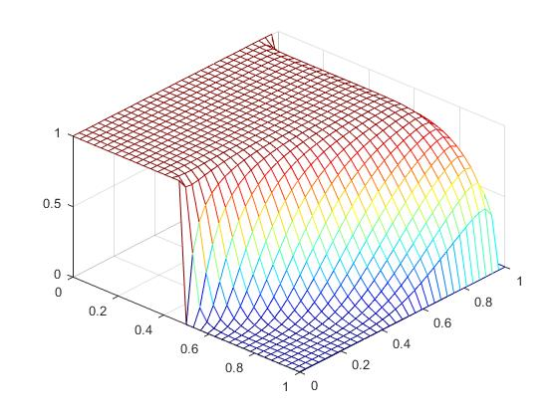a=(1/2,) 

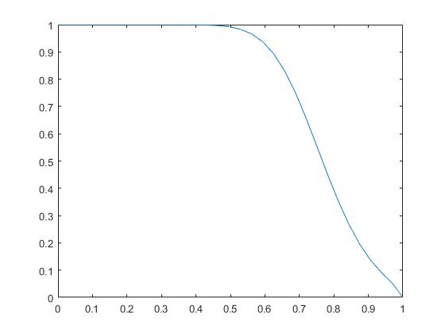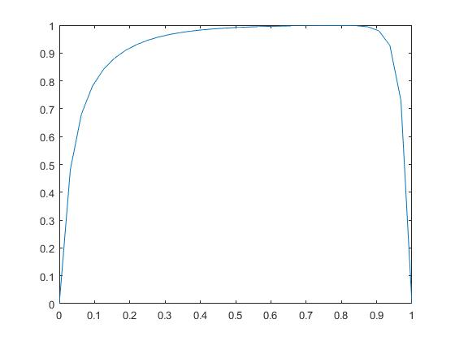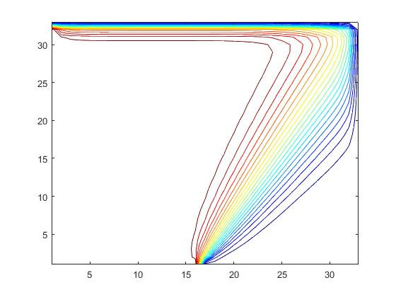

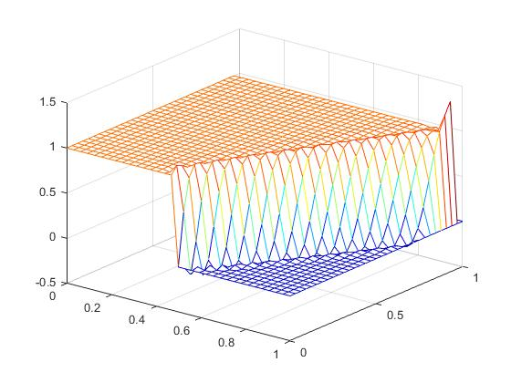

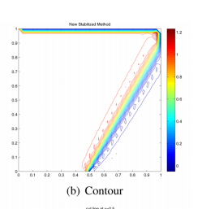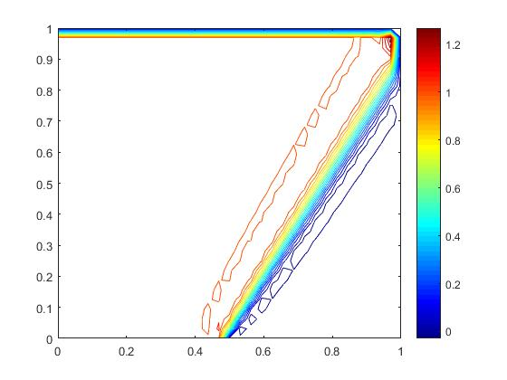

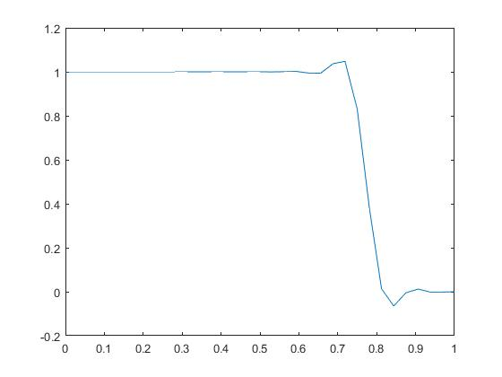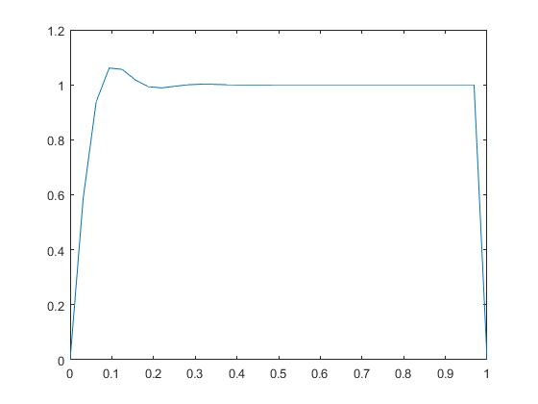

Example3:

依赖时间的对流扩散问题

在单位区域  上，考虑如下问题：

 在，

边界条件和t=0时u的图像如下：

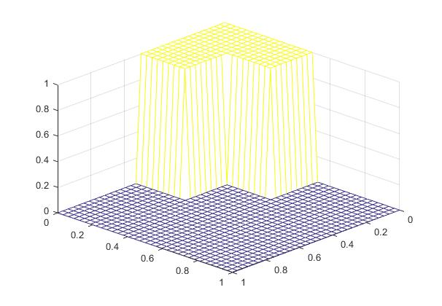

U=0

U=1

U=1

a



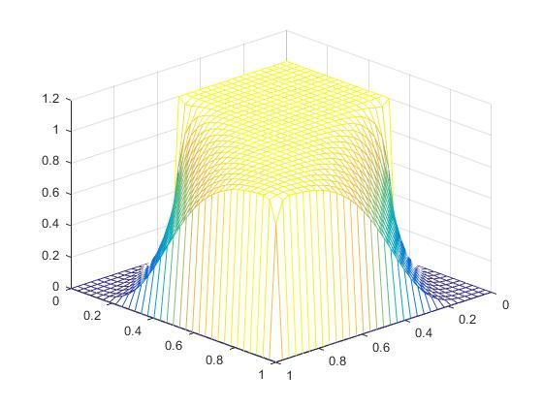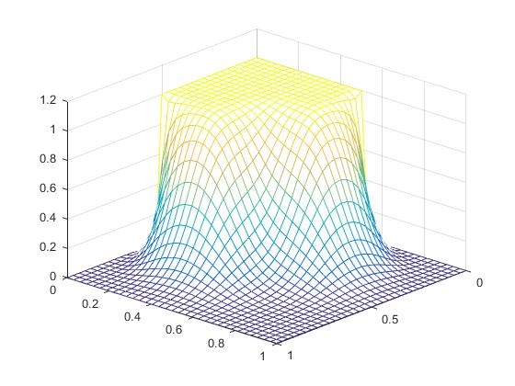 

 

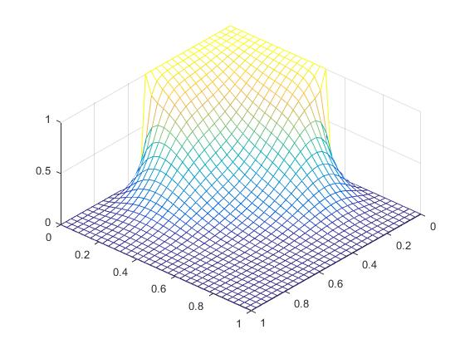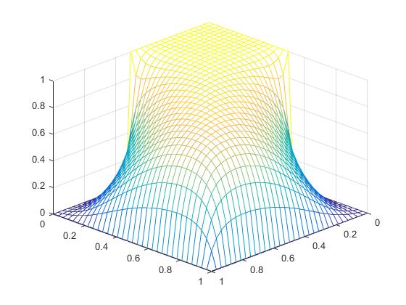

 

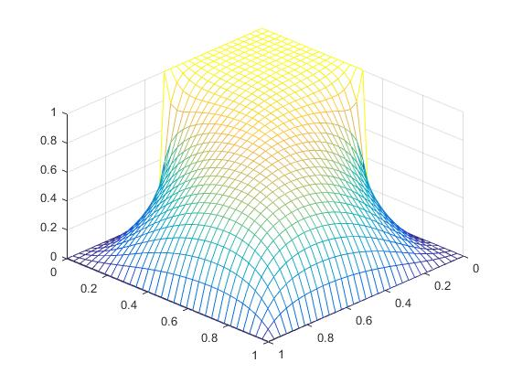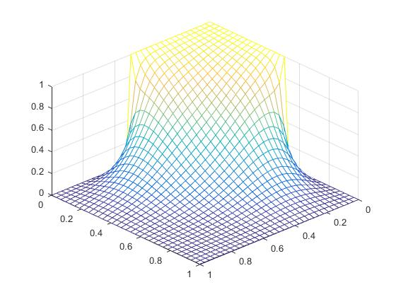

Example4

NEW Stabilized FEM：

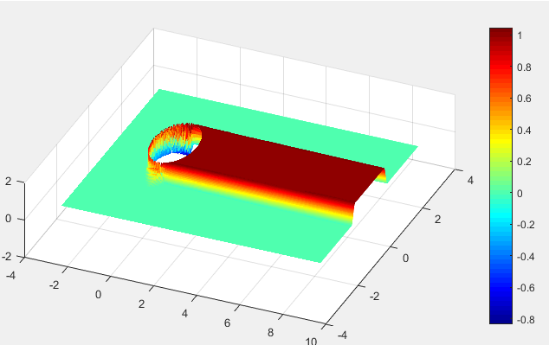

SUPG:

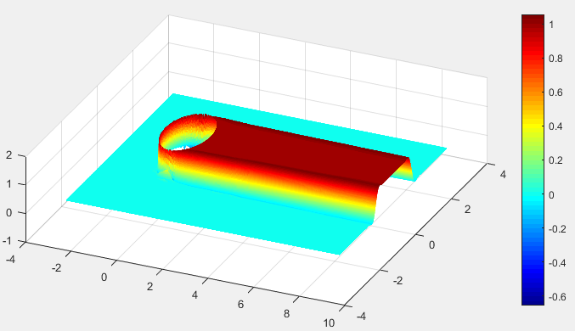

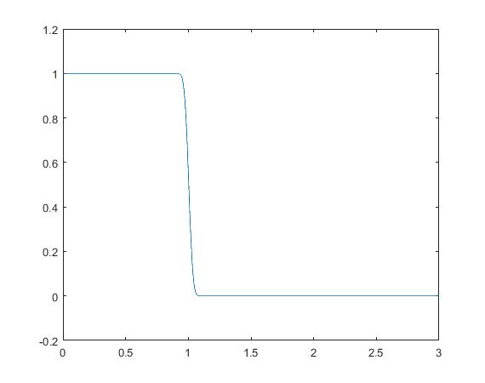Y=1 X=4

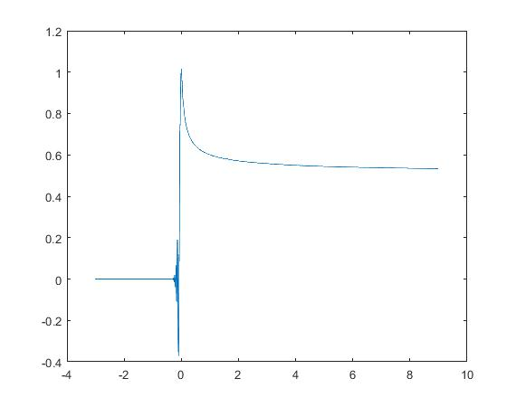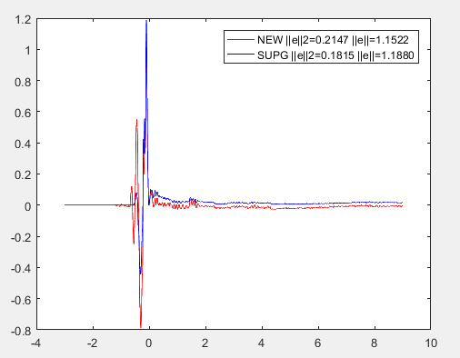

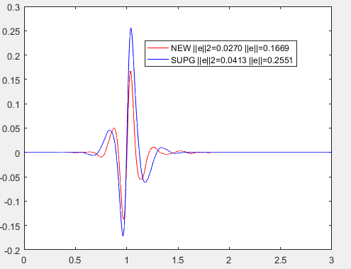

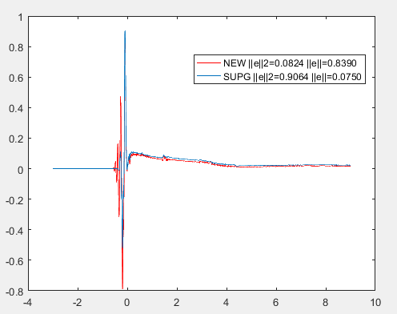

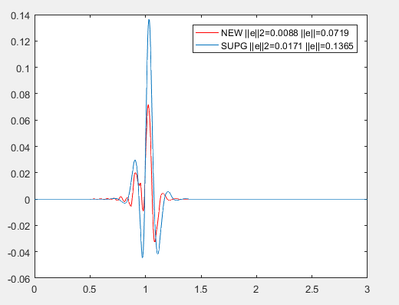

Pde:



 

U=1



b

U=0



Formulation I:



+

=

 , 

EXAMPLE 1:



U=sin(pi*x)*sin(pi*y),

domain：[0,1]×[0,1]

boundary：g=0

**b=**(-cos(55/150*pi) , -sin(55/180*pi)) =0;

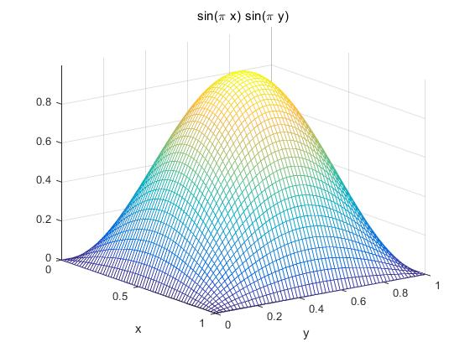

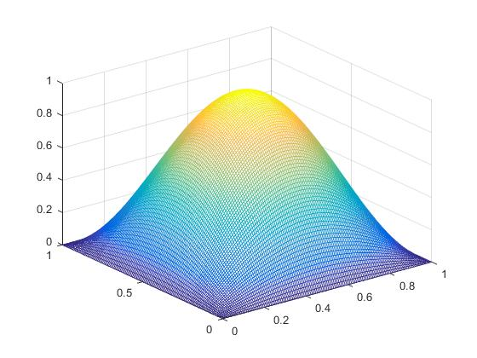

EPSILON =1

|  |  |  |  |  |  |
| --- | --- | --- | --- | --- | --- |
| L2 | 1/32 | 1/64 | 1/128 | 1/256 | order |
| b=0.1 | 2.7204e-03 | 6.7201e-04 | 1.6745e-04 | 4.1825e-05 | 2.0013 |
| b=1 | 2.6257e-03 | 6.4867e-04 | 1.6164e-04 | 4.0374e-05 | 2.0013 |
| b=10 | 2.0091e-03 | 4.9671e-04 | 1.2380e-04 | 3.0925e-05 | 2.0012 |
| b=100 | 1.0748e-03 | 2.6697e-04 | 6.6619e-05 | 1.6647e-05 | 2.0007 |

|  |  |  |  |  |  |
| --- | --- | --- | --- | --- | --- |
| H1 | 1/32 | 1/64 | 1/128 | 1/256 | order |
| b=0.1 | 4.7863e-02 | 2.3941e-02 | 1.1972e-02 | 5.9861e-03 | 0.99996 |
| b=1 | 4.7863e-02 | 2.3941e-02 | 1.1972e-02 | 5.9861e-03 | 0.99996 |
| b=10 | 4.7867e-02 | 2.3942e-02 | 1.1972e-02 | 5.9861e-03 | 0.99997 |
| b=100 | 4.7908e-02 | 2.3947e-02 | 1.1973e-02 | 5.9862e-03 | 1 |

EPSILON=10e-6

|  |  |  |  |  |  |
| --- | --- | --- | --- | --- | --- |
| L2 | 1/32 | 1/64 | 1/128 | 1/256 | order |
| b=0.1 | 2.3260e-02 | 5.1712e-03 | 1.2332e-03 | 3.0240e-04 | 2.0279 |
| b=1 | 1.8504e-02 | 4.2931e-03 | 1.0436e-03 | 2.5814e-04 | 2.0154 |
| b=10 | 5.8040e-03 | 1.5357e-03 | 3.9930e-04 | 1.0209e-04 | 1.9677 |
| b=100 | 9.7334e-04 | 2.6832e-04 | 7.4978e-05 | 2.0581e-05 | 1.8652 |

|  |  |  |  |  |  |
| --- | --- | --- | --- | --- | --- |
| H1 | 1/32 | 1/64 | 1/128 | 1/256 | order |
| b=0.1 | 6.2527e-02 | 2.7630e-02 | 1.2946e-02 | 6.2393e-03 | 1.053 |
| b=1 | 5.8539e-02 | 2.6869e-02 | 1.2764e-02 | 6.1933e-03 | 1.0433 |
| b=10 | 5.0249e-02 | 2.4744e-02 | 1.2220e-02 | 6.0568e-03 | 1.0126 |
| b=100 | 4.7990e-02 | 2.4010e-02 | 1.2012e-02 | 6.0051e-03 | 1.0002 |

Example

U=1



b

U=0

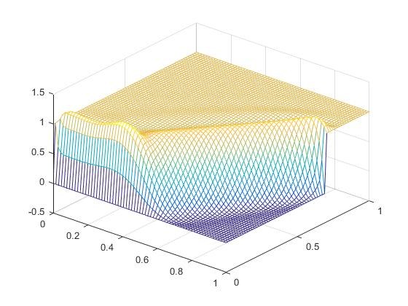

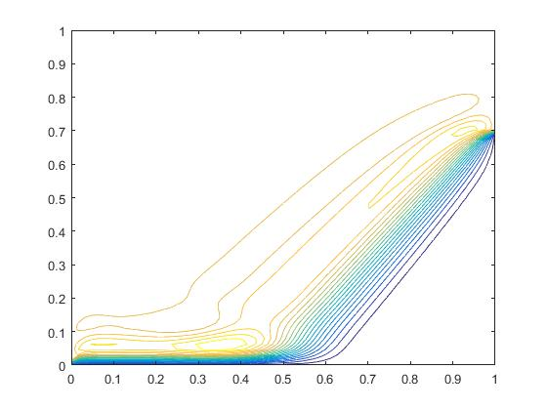

Formulation II:



+=

EXAMPLE 1:



U=sin(pi*x)*sin(pi*y),

domain：[0,1]×[0,1]

boundary：g=0

**b=**(-cos(55/150*pi) , -sin(55/180*pi)) =0;

Epsilon =1

|  |  |  |  |  |  |
| --- | --- | --- | --- | --- | --- |
| L2 | 1/16 | 1/32 | 1/64 | 1/128 | order |
| b=0.1 | 3.3912e-01 | 1.7435e-01 | 8.8661e-02 | 4.4754e-02 | 0.98628 |
| b=1 | 3.2293e-01 | 1.6738e-01 | 8.5478e-02 | 4.3241e-02 | 0.98314 |
| b=10 | 2.2640e-01 | 1.2389e-01 | 6.5204e-02 | 3.3515e-02 | 0.96015 |
| b=100 | 8.8665e-02 | 5.5494e-02 | 3.2017e-02 | 1.7382e-02 | 0.88119 |

|  |  |  |  |  |  |
| --- | --- | --- | --- | --- | --- |
| H1 | 1/16 | 1/32 | 1/64 | 1/128 | order |
| b=0.1 | 1.5298e-01 | 8.3419e-02 | 4.3991e-02 | 2.2661e-02 | 0.95701 |
| b=1 | 1.5088e-01 | 8.2687e-02 | 4.3733e-02 | 2.2564e-02 | 0.95471 |
| b=10 | 1.5858e-01 | 8.9167e-02 | 4.7877e-02 | 2.4909e-02 | 0.94269 |
| b=100 | 2.0156e-01 | 1.2744e-01 | 7.3714e-02 | 4.0055e-02 | 0.87998 |

Epsilon = 10e-6

|  |  |  |  |  |  |
| --- | --- | --- | --- | --- | --- |
| L2 | 1/32 | 1/64 | 1/128 | 1/256 | order |
| b=0.1 | 2.2895e-02 | 5.2295e-03 | 1.2529e-03 | 3.0686e-04 | 2.0296 |
| b=1 | 1.9424e-02 | 4.5767e-03 | 1.1080e-03 | 2.7239e-04 | 2.0242 |
| b=10 | 6.9261e-03 | 1.8469e-03 | 4.8065e-04 | 1.2276e-04 | 1.9691 |
| b=100 | 1.0199e-03 | 3.0048e-04 | 8.9670e-05 | 2.6062e-05 | 1.7827 |

|  |  |  |  |  |  |
| --- | --- | --- | --- | --- | --- |
| H1 | 1/32 | 1/64 | 1/128 | 1/256 | order |
| b=0.1 | 7.6771e-02 | 3.2542e-02 | 1.4403e-02 | 6.6410e-03 | 1.1169 |
| b=1 | 7.0583e-02 | 3.0906e-02 | 1.3954e-02 | 6.5203e-03 | 1.0977 |
| b=10 | 5.3608e-02 | 2.6049e-02 | 1.2668e-02 | 6.1936e-03 | 1.0323 |
| b=100 | 4.8034e-02 | 2.4085e-02 | 1.2066e-02 | 6.0349e-03 | 0.99953 |

Example2:

