**Supplementary table 1. Coefficients of Lasso**

(Intercept) 1015264.95

bedrooms -31596.15

bathrooms 62561.15

floors -68670.04

waterfront 167961.32

condition 55350.53

grade 222897.84

sqft_above 349054.86

yr_built -112568.96

sqft_living15 78826.18

sqft_lot15 -61824.62

renovated 37425.87

**Supplementary table 2. Coefficients of Ridge**

(Intercept) 1015264.95

bedrooms -24139.67

bathrooms 78684.68

floors -45611.98

waterfront 160474.33

condition 53721.59

grade 210169.10

sqft_above 294945.08

yr_built -100348.62

sqft_living15 95028.49

sqft_lot15 -55235.53

renovated 40909.55

**Supplementary table 3. Linear regression**

(Intercept) 1015264.95

bedrooms -34437.47

bathrooms 65257.28

floors -71640.76

waterfront 168577.38

condition 56133.67

grade 223264.37

sqft_above 351195.02

yr_built -113860.87

sqft_living15 79102.44

sqft_lot15 -63380.83

renovated 38112.10

**Supplementary table 4. GAM**

Parametric coefficients:

Estimate Std. Error t value Pr(>|t|)

(Intercept) 1017962 10423 97.666 < 2e-16 ***

waterfront 183376 11185 16.395 < 2e-16 ***

renovated 32026 11990 2.671 0.00767 **

condition 75758 11737 6.455 1.61e-10 ***

floors -49683 16422 -3.025 0.00254 **

bedrooms 2675 13095 0.204 0.83818

grade 284825 19946 14.280 < 2e-16 ***

Approximate significance of smooth terms:

edf Ref.df F p-value

s(bathrooms) 4.156 9 1.502 0.00559 **

s(yr_built) 2.719 9 4.650 1.23e-10 ***

s(sqft_living15) 3.171 9 7.816 < 2e-16 ***

s(sqft_above) 8.991 9 33.244 < 2e-16 ***

s(sqft_lot15) 8.438 9 6.139 3.83e-09 ***

**Supplementary table 5. MARS**

coefficients

(Intercept) 1424255.95

waterfront 104211.58

h(0.991457-grade) -253916.38

h(grade-0.991457) 619678.81

h(2.21789-sqft_above) -172941.69

h(1.2179-yr_built) 94426.53

h(bathrooms-0.0901828) * waterfront 115500.40

h(sqft_above-2.21789) * sqft_lot15 -192553.81

h(bedrooms-0.234135) * h(sqft_above-2.21789) 460633.22

h(1.2179-yr_built) * h(sqft_living15- -0.131201) 139969.87

**Supplementary table 5.**

**Variable importance of MARS based on generalized cross-validation statistics**

grade 100.00

yr_built 53.92

sqft_living15 53.92

bathrooms 44.89

waterfront 44.89

bedrooms 34.85

sqft_above 34.85

sqft_lot15 30.18

condition 0.00

renovated 0.00

floors 0.00

**Supplementary figure 1. Variable importance of random forests (classification tree)**

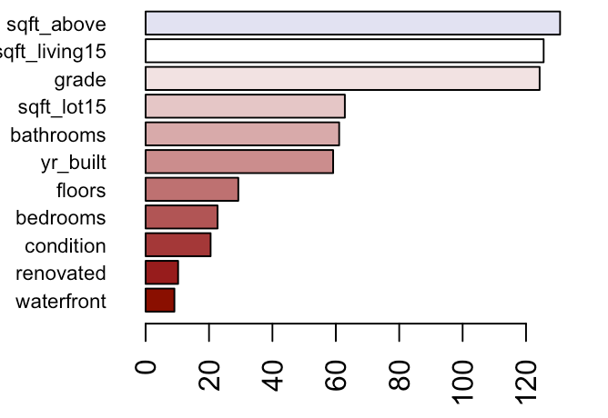

**Supplementary figure 2. Variable importance of boosting (classification tree)**



**Supplementary figure 3. Variable importance of adaptive boosting (classification tree)**

