Fundemntals of databases project report

A Local Email System

ICS 324

Lab 52

Prepared for:

Mr. Yahya Garout

By:

Saleh Alghusson

Sultan Alsehibani

Hassan Shaaban

Contents

1. Introduction 3

2. The Problem Statement 3

3. Conceptual Design (EER diagram) 4

4. Logical Design (The Relational Schema) 5

5. Tools 5

6. The User Manual 5

7. Conclusion 10

8. Distribution of Project Tasks 10

# Introduction

Emails have become one of the most important communication methods in these days. However, many email systems don’t store the emails and their attachments permanently. Moreover, many email system programs don’t allow storing attachments to the local machine automatically. We believe that there is a need for an email system which stores the emails in database along with their attachments.

# The Problem Statement

Consider an email system which offers the client to send and retrieve emails from an existing email account to the local machine along with their attachments. The data requirements for this system are summarized as follows:

1. The Email system has users who are identified by a unique id number and are described by their username and their password.
2. Each user may have one or more email accounts which are identified by a unique email account id number and they are described by and Email address, email password, email preferences and a (pop3 or imap4 flag)
3. Managers have additional information which is their area of responsibility in the organization.
4. Email messages belong to an email account and they are identified by an email message id number and described by recipients, subject, body and a time stamp.
5. An email message may be a sent email message or a received email message.
6. Sent email message has two additional information. One is an importance flag and the other is a successful sent flag.
7. One or more attachments might be contained in one email message. Attachments are identified by a unique id number and they are described by a name, an extension and a file path.
8. Received email messages has three additional information. The first is the priority flag, the second is a spam flag and finally a read flag.
9. A service provider provides email accounts and they are identified by a unique service provider number and it is described by a name.
10. Each service provider may have one or more servers to send or receive and send emails.

# Conceptual Design (EER diagram)

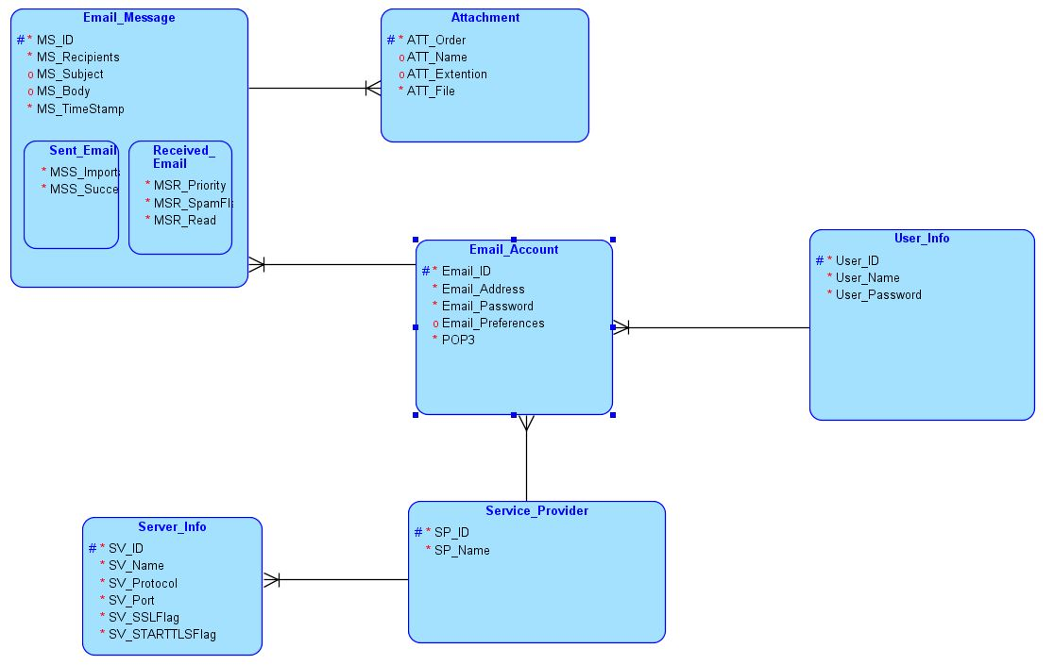

# 

# Logical Design (The Relational Schema)

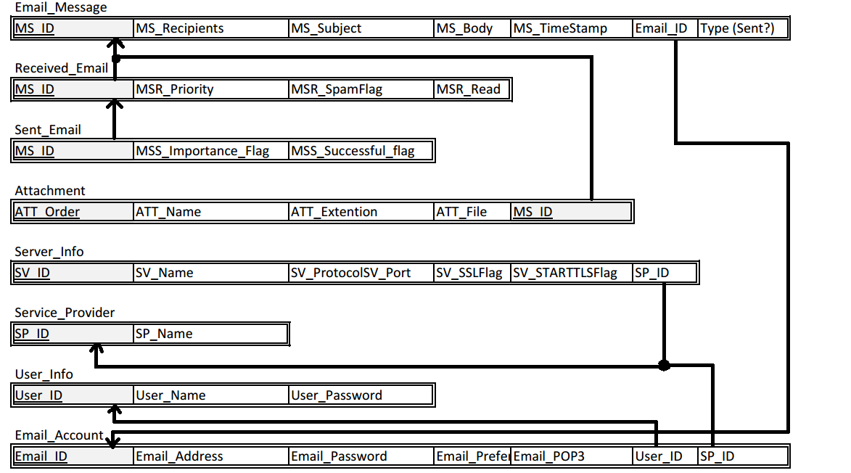

# Tools

* The user interfaces were implemented using C#.
* The database is created by SQL server 2012.
* The EER model were designed using Data modeler from Oracle.

# The User Manual

In the user program there are five windows (forms) explained as follows:

First, the login screen where the user needs to provide his username and password to login to the system.

If the user doesn’t have a username he can press on the “new user” button which will take him to a new window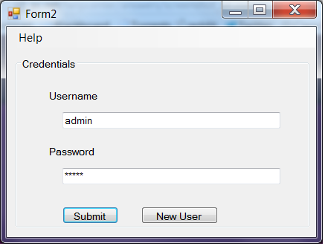

After that, there is the new user window where the user provides a username and a password. When the user presses “Check Availability” button the system will check whether the username is available or not.

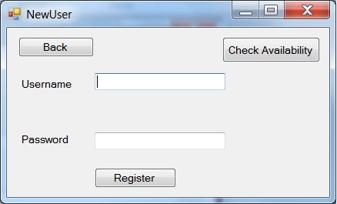

Next, there is the main window which contains two drop-lists, a check-button and four buttons.

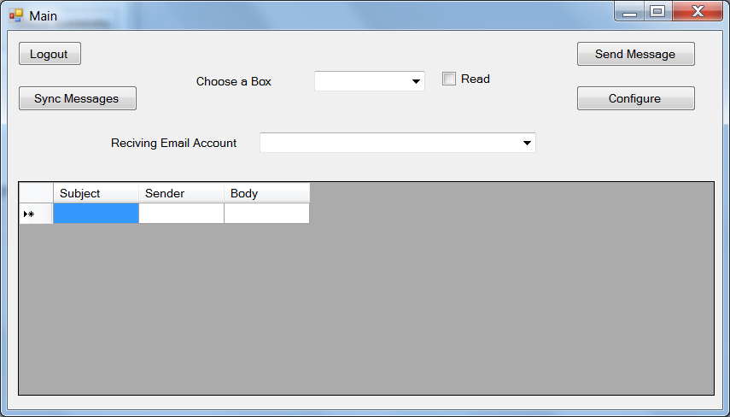

* Drop-lists:
  + In the “Choose a Box” list, the user can choose whether to display the messages from the Outbox or the Inbox.
  + In the “Receiving Email Account”, the user will choose to display the emails which email account.
* Check button:
  + If the “Read” check button is checked the system will display the read messages only. On the other hand, if it is uncheck the system will display the unread messages.
* Buttons:
  + The “Logout” button will logout the user from the system.
  + The “Sync Messages” button will retrieve all the messages from the mail server.
  + The “Send message” button will take the user to the sent window.
  + The “Configure” button will take the user to the configure window.

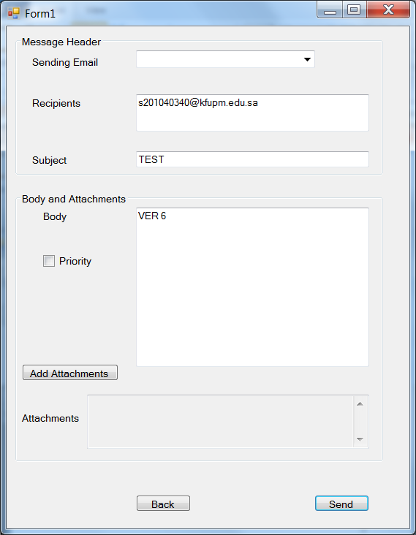Furthermore, there is the send message window in which the user chose the email account from which the message will be sent. Then he’ll provide the system with the recipients names separated by a semicolon “;”, the subject of the message and the body of the message. Next, the user can select the attachments if any by pressing on the “Attachments button”. Finally, the user can set the message as high priority by checking the priority button.

After that, there is the configure window where the user can add a new email account or drop an existing email account.

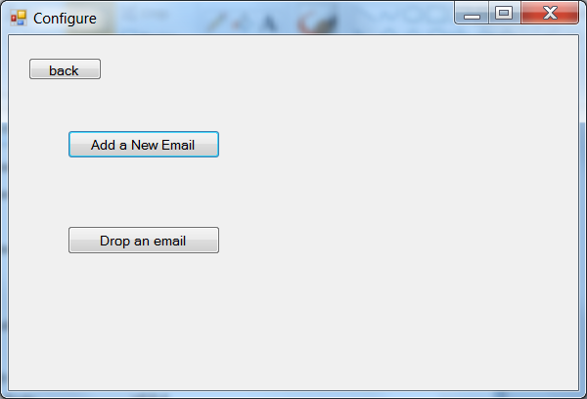

If the user presses the “Add a New Email” button he will be taken to a new window where he will provide the new email account address and the new email account password.

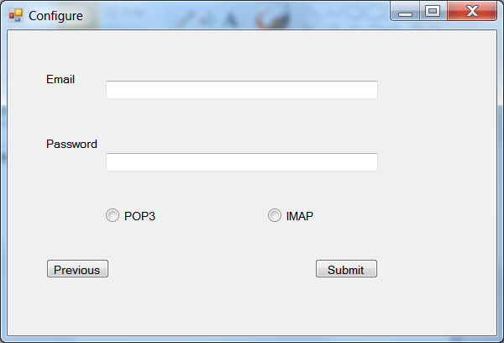

Whereas, if the user presses the “drop an email” button he will be taken to a new window where he will choose the email the he wills to drop.

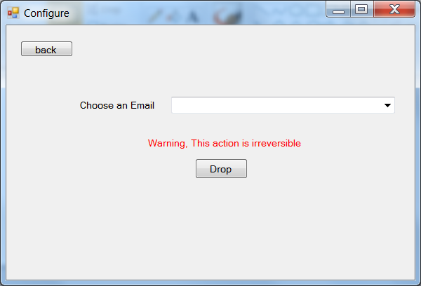

# Conclusion

To conclude, several tools were used to design, create and implement this project. We have learnt a lot from this practical application.

# Distribution of Project Tasks

|  |  |
| --- | --- |
| Task | Member |
| EER – diagram | Hassan Shaaban (Saleh Alghusson & Sultan Alsehibani ed.) |
| Schema – diagram | Sultan Alsehibani |
| DDL statements | Saleh Alghusson |
| User Interfaces | Saleh Alghusson |
| Functions of the User Interfaces | Saleh Alghusson (Sultan Alsehibani ed.) |
| Report | Hassan Shaaban (Sultan Alsehibani ed.) |
| Power point presentation | Sultan Alsehibani |