CORE COMPETENCIES
- AI Inference Platforms & LLM Serving
- GPU Clusters & Distributed Systems
- Cloud-native Infrastructure (Kubernetes, Containers)
- KV Cache & Agent Memory Systems
- Technical Leadership & Team Building
- Global Collaboration & Stakeholder Management
CONTACT DETAILS
Email: huang.qirui@ieee.org
Mobile: +65 8356 3761

LANGUAGES
English (Fluent)
Mandarin (Fluent)

SUMMARY
AI infrastructure and research leader with 15+ years in AI and large-scale systems; Head of Huawei Central Research Institute (2012 Labs) in Singapore. Led development of the LLM training/inference engine for Huawei’s Pangu models (10x faster than DeepSpeed); directs work on GPU clusters, LLM inference serving, KV/state caching in vLLM and agent memory systems. Earlier built hybrid cloud infrastructure (thousands of VMs) and researched optical switching for data centers and supercomputers. Founded the Singapore lab (Singapore region: 40 staff), later handed it over to a Chief Expert; now leads a 5-person core team. 50+ publications, 14 patents, USD 10M+ external funding.

EDUCATION
2011
Ph. D (Electrical and Electronic Engineering)
Nanyang Technological University, SG

2007
Master (Optical Communications)
Huazhong University of Sci & Tech, CN

2004
Bachelor (Optical Communications)
Huazhong University of Sci & Tech, CN

CERTIFICATE/MEMBERSHIP
IEEE Senior Member
OPTICA Senior Member
ACM Member
AAAI Member

Dr. HUANG Qirui

PROFESSIONAL EXPERIENCE
Huawei Technologies Sept. 2018 – Present
Head, Singapore Region — Central Research Institute (2012 Labs)
- Set the technical direction and drive end-to-end R&D across LLMs, multimodal and agentic AI, from distributed training infrastructure to inference deployment;
- Direct research on large GPU clusters for LLM/multimodal training & inference: parallelism, mixed precision, long-context serving and KV/state caching;
- Formulate mid/long-term technology strategy and investment portfolios (AI, HPC); lead Singapore’s R&D within a globally distributed institute (UK, Canada, Switzerland, Japan); hire and mentor researchers.
Key Achievements:
- Led development of the LLM training/inference engine for Huawei’s Pangu models, achieving 10x speed-up over Microsoft’s DeepSpeed.
- Built a unified KV/recurrent-state prefix cache for hybrid LLMs in vLLM, restoring cached state with outputs bitwise-identical to recomputation.
- Lead an agent memory systems program covering all three forms of agent memory: symbolic (cross-agent shared memory with learned write, read and eviction gating), latent (joint management of KV cache and recurrent states for hybrid models) and parametric (promoting and demoting knowledge between text, KV cache and LoRA across GPU, DRAM, SSD and HDD tiers).
- Led R&D of a 1.7B-parameter hybrid Mamba-Transformer MoE model for unified multimodal understanding and generation (0.39B active parameters): 15.8x faster prefill and 26% less memory than Qwen3.5-2B at 1M-token context. Built a Kubernetes-based containerized GPU training cluster for its 6.3B version, with containerized training images and a private image registry.
- Founded and lead a world-model research initiative: long-horizon video generation, real-time interactive world generation and 3D scene generation.
- Founded and built the Singapore lab from the ground up (Singapore region: 40 staff), then handed it over to a Chief Expert; currently lead a 5-person core team.
- Delivered 10+ partner projects (>USD 10M) and filed 14 patents across AI, on-device intelligence, wearables and sensing.

Singapore University of Tech. & Design July 2015 – Sept. 2018
Senior Specialist, Network Security & AI
Led research on network security and AI; designed, built and operated the SUTD AI Lab, a research testbed (tens of racks) and hybrid cloud infrastructure (thousands of VMs).
Key Achievements:
- Delivered a MINDEF-sponsored research project (SGD 4.677M); led the CISDeM project with 7 research tracks and a team of 20 (8 research fellows, 12 research assistants).
- Designed a next-generation Security Operation Center framework combining big data, IDS, SDN, NFV and machine learning.

Institute for Infocomm Research, A*STAR Feb 2011 – June 2015
Scientist, Data Center Networks & SDN Technologies
Research on optical switching for large-scale data centers and supercomputers, SDN and NFV. Delivered 3 industry/research projects and a photonic switch prototype for large-scale data centers; 10 peer-reviewed papers and 1 patent.
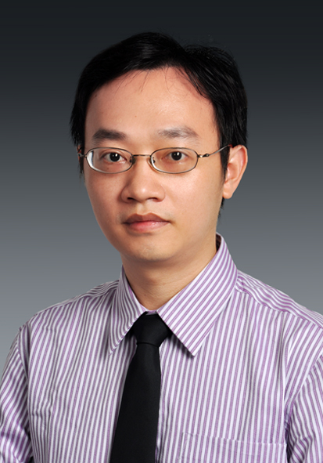

Nanyang Technological University Jan 2007 – Jan 2011
Ph.D Researcher, Fiber-Optics Networks
Architecture design and performance study of IP/MPLS optical transport networks; designed multicast-capable optical packet switches and their scheduling algorithms; developed an open-source optical packet switching simulator in C++; 17 peer-reviewed journal and conference papers.

KNOWLEDGE AND SKILLS
- Inference & serving: vLLM, SGLang, LMCache; KV/state caching and prefix reuse, long-context inference, CUDA graphs, custom Triton kernels, TensorRT.
- Infrastructure: GPU/HPC clusters (H200), Linux, Kubernetes, Docker and private image registries; distributed training and parallelism; InfiniBand/Ethernet, SAN/NAS; OpenStack, VMware ESXi/NSX/vSphere.
- Models: Transformers, Mamba/SSMs, Mixture-of-Experts, diffusion/DiT and unified multimodal models; PyTorch, DeepSpeed, JAX, MindSpore.
- Leadership: technology strategy and roadmapping, building teams from zero, hiring and mentoring, cross-functional, executive and global collaboration, business development.
- Earlier expertise: optical and data-center networks, SDN/NFV and network security.
- Programming: Python, C/C++, Triton, Java, MATLAB.

PUBLICATIONS
50+ publications in peer-reviewed journals, conferences, patents and book chapter, including IEEE/ACM TASLP, ICASSP and an IEEE ICC Best Paper Award. Recent work on efficient unified multimodal models and hybrid-LLM serving targeting ICLR 2027 and ACL 2027.

ADDITIONAL INFORMATION
Awards/Honors
• Excellent Capability Development Team Award, Huawei Technologies 2025
• Future Star, Huawei Technologies 2025
• Workshop Organization Award, Huawei Technologies 2024
• Quality Star, Huawei Technologies 2023
• Outstanding Grass-roots Organization Award, Huawei Technologies 2022
• Outstanding Technology Strategy Development Award, Huawei Technologies 2021
• President Award for Best Technology Innovation, Huawei Technologies 2020
• Future Star, Huawei Technologies 2019
• President Award for Best Organization Building, Huawei Technologies 2019
• Best Paper Award of IEEE International Conference on Communications (ICC 2012) 2012

