CORE COMPETENCIES
- Video Generation & World Models (Diffusion / DiT)
- Multimodal Foundation Models (Transformer, Mamba, MoE)
- Large-scale Distributed Training (GPU / HPC)
- Inference Acceleration & Efficient Models
- AI Research Leadership & Team Building
- Research-to-Product Commercialization
CONTACT DETAILS
Email: huang.qirui@ieee.org
Mobile: +65 8356 3761

LANGUAGES
English (Fluent)
Mandarin (Fluent)

SUMMARY
AI research leader with 15+ years in AI and large-scale systems; Head of Huawei Central Research Institute (2012 Labs) in Singapore. Leads research on world models and generative video, including diffusion (DiT)-based video generation, long-horizon consistency and real-time interactive world generation, backed by deep expertise in distributed training and inference acceleration. Built an LLM training/inference engine 10x faster than DeepSpeed and a hybrid Mamba-Transformer MoE model for unified multimodal understanding and generation. Built the Singapore lab from the ground up (40 members); currently leads a 5-person core research team. 50+ publications, 14 patents, USD 10M+ external funding.

EDUCATION
2011
Ph. D (Electrical and Electronic Engineering)
Nanyang Technological University, SG

2007
Master (Optical Communications)
Huazhong University of Sci & Tech, CN

2004
Bachelor (Optical Communications)
Huazhong University of Sci & Tech, CN

CERTIFICATE/MEMBERSHIP
IEEE Senior Member
OPTICA Senior Member
ACM Member
AAAI Member

Dr. HUANG Qirui

PROFESSIONAL EXPERIENCE
Huawei Technologies Sept. 2018 – Present
Head, Singapore Region — Central Research Institute (2012 Labs)
- Lead research on world models and generative video — diffusion (DiT)-based video generation, long-horizon and temporal consistency, real-time interactive world generation and 3D scene generation;
- Set and drive the roadmap and end-to-end R&D across LLMs, multimodal and agentic AI, world models and on-device AI, from distributed training infrastructure to inference deployment;
- Direct research on large GPU clusters for LLM/multimodal training & inference: parallelism, mixed precision and long-context serving;
- Formulate mid/long-term technology strategy and investment portfolios (AI, HPC); lead Singapore’s R&D within a globally distributed institute (UK, Canada, Switzerland, Japan); hire and mentor researchers.
Key Achievements:
- Founded and lead a world-model research initiative spanning long-horizon video generation, real-time interactive world generation and 3D scene generation, including research on diffusion / DiT-based video models.
- Led development of the LLM training/inference engine for Huawei’s Pangu models, achieving 10x speed-up over Microsoft’s DeepSpeed.
- Led R&D of a 1.7B-parameter hybrid Mamba-Transformer MoE model for unified multimodal understanding and text-to-image generation with only 0.39B active parameters: GenEval 0.70, within 0.03 of Janus-Pro-1B at ~1/4 of its active parameters; 15.8x faster prefill and 26% less memory than Qwen3.5-2B at 1M-token context. A 6.3B version is in training.
- Built a unified KV/recurrent-state prefix cache for hybrid LLMs in vLLM, restoring cached state with outputs bitwise-identical to recomputation.
- Built the Singapore lab from the ground up to 40 members; currently lead a 5-person core team on generative models and world models.
- Delivered 10+ partner projects (>USD 10M) and filed 14 patents across AI, on-device intelligence, wearables and sensing.

Singapore University of Tech. & Design July 2015 – Sept. 2018
Senior Specialist, Network Security & AI
Led research on network security and AI; built the SUTD AI Lab, a research testbed (tens of racks) and hybrid cloud infrastructure (thousands of VMs).
Key Achievements:
- Delivered a MINDEF-sponsored research project (SGD 4.677M); led the CISDeM project with 7 research tracks and a team of 20 (8 research fellows, 12 research assistants).
- Designed a next-generation Security Operation Center framework combining big data, IDS, SDN, NFV and machine learning.

Institute for Infocomm Research, A*STAR Feb 2011 – June 2015
Scientist, Data Center Networks & SDN Technologies
Research on optical switching for large-scale data centers and supercomputers, SDN and NFV. Delivered 3 industry/research projects and a photonic switch prototype for large-scale data centers; 10 peer-reviewed papers and 1 patent.
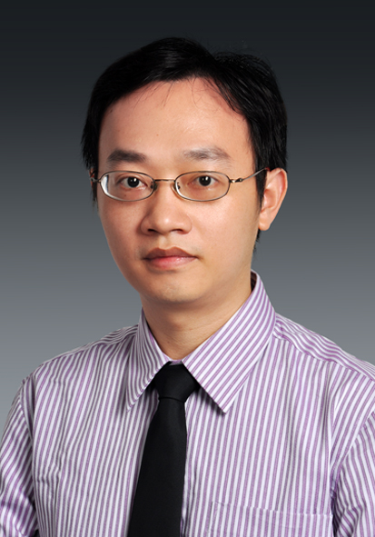

Nanyang Technological University Jan 2007 – Jan 2011
Ph.D Researcher, Fiber-Optics Networks
Architecture design and performance study of IP/MPLS optical transport networks; designed a reconfigurable optical add-drop multiplexer and multicast-capable optical packet switches; 17 peer-reviewed journal and conference papers.

KNOWLEDGE AND SKILLS
- Generative models: diffusion models and DiT, autoregressive (VQ) image generation, classifier-free guidance, unified multimodal models; Transformers, Mamba/SSMs and Mixture-of-Experts.
- Training infrastructure: large-scale GPU/HPC clusters (H200), distributed training and parallelism, mixed precision; PyTorch, DeepSpeed, JAX, MindSpore.
- Inference & efficiency: long-context inference, KV/state caching (vLLM), CUDA graphs, custom Triton kernels, TensorRT, on-device deployment.
- Leadership: technology strategy and roadmapping, building teams from zero, hiring and mentoring, cross-functional and executive communication, business development.
- Earlier expertise: optical and data-center networks, SDN/NFV, cloud infrastructure and network security.
- Programming: Python, C/C++, Triton, MATLAB.

PUBLICATIONS
50+ publications in peer-reviewed journals, conferences, patents and book chapter, including IEEE/ACM TASLP, ICASSP and an IEEE ICC Best Paper Award. Recent work on efficient unified multimodal models and hybrid-LLM serving targeting ICLR 2027 and ACL 2027.

ADDITIONAL INFORMATION
Awards/Honors
• Excellent Capability Development Team Award, Huawei Technologies 2025
• Future Star, Huawei Technologies 2025
• Workshop Organization Award, Huawei Technologies 2024
• Quality Star, Huawei Technologies 2023
• Outstanding Grass-roots Organization Award, Huawei Technologies 2022
• Outstanding Technology Strategy Development Award, Huawei Technologies 2021
• President Award for Best Technology Innovation, Huawei Technologies 2020
• Future Star, Huawei Technologies 2019
• President Award for Best Organization Building, Huawei Technologies 2019
• Best Paper Award of IEEE International Conference on Communications (ICC 2012) 2012

