Here’s my story

I Switched Lives With A Billionaire’s Daughter - Homeless Girl vs Rich Girl

Author Name - Qishe analyzed on November 2, 2021

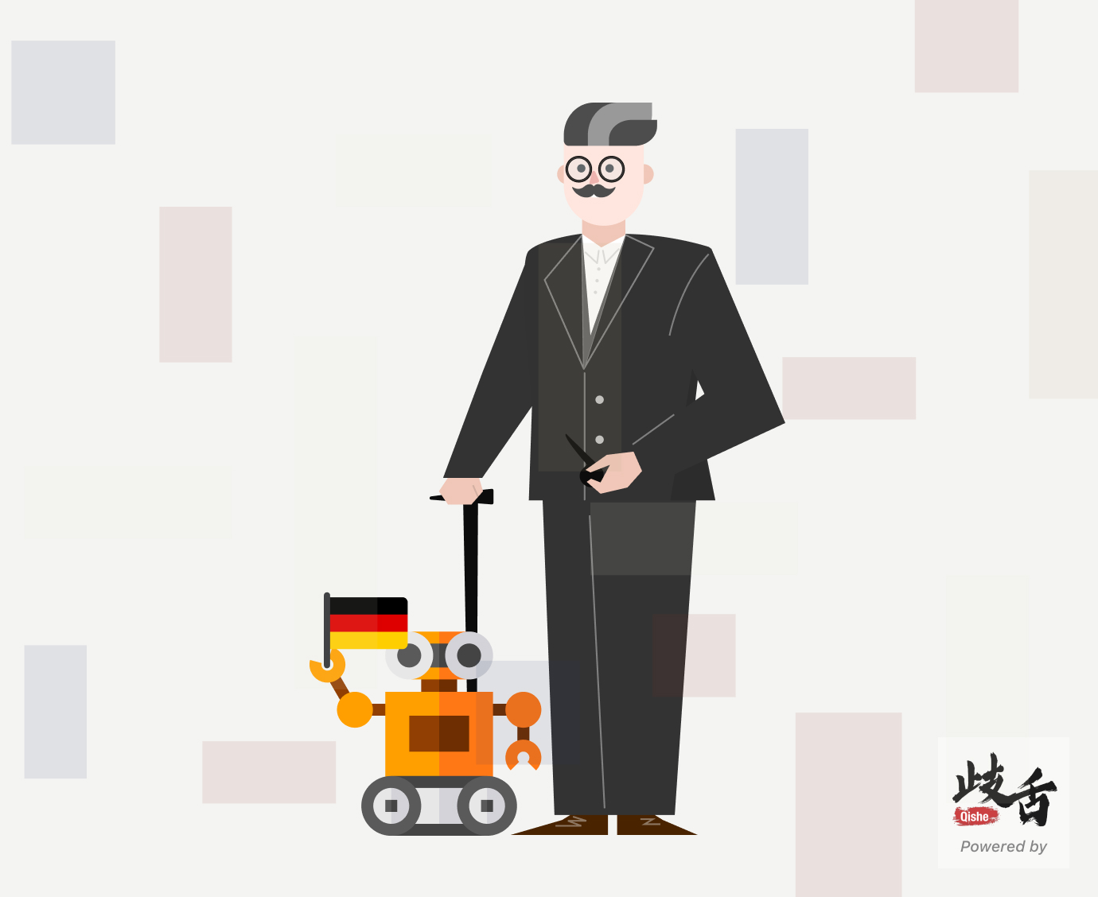

# With her son disappointing, she feels very worried. 随着她的儿子令人失望，她感到非常担心。

## 句型结构

### With her son disappointing (状语) , she (主语) feels (系动词) very worried (表语) .

* With her son disappointing 她的儿子令人失望
* she 她
* feels 感觉
* very worried 非常担心

## 知识点描述

* 名称 Presentation in the sentence
* 名称 Presentation in the sentence

# As we all know, typing is a tiring job. 众所周知，打字是一个累人的工作。

## 句型结构

### As we all know (状语从句) , typing (主语) is (系动词) a tiring job(表语) .

* As we all know 我们都知道
* typing 打字
* is 是
* a tiring job 一个累人的工作

## 知识点描述

* 名称 Presentation in the sentence
* 名称 Presentation in the sentence

