- 课程设计目标
本项目旨在使用 Java 语言开发一款 PacMan GUI 小游戏，实现经典的吃豆人游戏玩法。玩家控制 PacMan 在迷宫中移动，吃掉所有的豆豆，同时避免被 Ghost 消灭。若 PacMan 吃到紫色小方块可获得短暂能力反转，可吃掉 Ghost，经过若干秒后恢复正常。游戏设置多个关卡或持续进行直至玩家失败，以此考验玩家的反应速度与策略规划能力，为玩家带来趣味与挑战并存的游戏体验。

- 分析与设计
系统架构与类设计
（1）PacManGame 类：游戏主面板类，集成了游戏的核心逻辑与界面绘制功能。
①属性：定义了游戏棋盘尺寸（BOARD_WIDTH、BOARD_HEIGHT）、格子大小（TILE_SIZE）、PacMan 坐标与方向、分数（score）、生命数（pacManLives）、幽灵列表（ghosts）、墙壁列表（walls）、能量豆列表（powerBeans）、游戏状态标志（gameStarted、gameOver、ghostEnergized）以及各种游戏元素的图像资源引用。
②方法：构造函数初始化游戏数据、加载图像、设置按键监听器及定时器；paintComponent 方法依据游戏状态绘制封面、游戏界面、游戏结束画面等各类元素；keyPressed 方法处理键盘输入以控制 PacMan 移动及游戏流程；actionPerformed 方法实现游戏的实时逻辑更新，包括 PacMan 移动、吃豆、与幽灵交互、能量豆效果处理及游戏胜利失败判定等；drawPacMan 方法依据 PacMan 移动方向与动画帧选择合适③图像绘制；setWalls 方法基于预设坐标数组构建迷宫墙壁；generatePowerBeans 方法随机生成指定数量的能量豆；isWallAt 与 collisionWithWalls 辅助方法用于墙壁位置检测与碰撞判定。
（2）Ghost 类：代表游戏中的幽灵角色。
①属性：幽灵位置坐标（x、y）、能量状态（energized）、随机数生成器（rand）、游戏棋盘尺寸引用、普通与能量化状态下的图像引用。
②方法：move 方法实现幽灵的随机移动策略；setEnergized 和 isEnergized 方法用于控制与查询幽灵③能量状态；setPosition 方法重置幽灵位置；getX、getY 与 getImage 方法提供幽灵属性获取接口。
（3）Wall 类：描述游戏迷宫中的墙壁元素。
①属性：墙壁坐标（x、y）。
方法：构造函数初始化坐标；drawMergedWalls 静态方法用于绘制相连墙壁组合，内部通过深度优先搜索算法识别相连墙壁并绘制紫色边框与黑色填充的矩形表示；辅助方法 findConnectedWalls 实现墙壁连通性搜索，isWall 判定坐标处是否为墙壁，drawWall 执行单个墙壁的绘制操作。

游戏逻辑设计
（1）PacMan 移动逻辑：玩家通过键盘光标键控制 PacMan 移动方向，在 actionPerformed 方法中依据方向向量更新坐标，同时检测与墙壁碰撞情况以限制移动范围，确保 PacMan 在迷宫通道内合法移动。
（2）吃豆与得分逻辑：PacMan 移动至豆豆位置时触发吃豆动作，对应位置豆豆标记清除，总分值减少，分数变量 score 增加。能量豆处理逻辑类似，吃豆后激活幽灵能量反转状态，设置定时器恢复正常，期间 PacMan 可吃幽灵得分。
（3）幽灵移动与交互逻辑：幽灵以随机方向移动，在 move 方法中依随机数选择上下左右移动一格（边界限制）。碰撞检测在 actionPerformed 中，依幽灵能量状态决定 PacMan 生死或幽灵重置，影响游戏生命数与流程走向。
（4）游戏流程控制逻辑：游戏启动后，定时器定期触发 actionPerformed 推动游戏循环，依 PacMan 存活、豆豆剩余及玩家操作切换游戏阶段，如开始、进行、胜利、失败、下一关，各阶段界面绘制与逻辑处理分离且协作紧密，确保游戏流程顺畅与界面响应及时。

- 测试结果
- 游戏启动画面：游戏启动后呈现封面图像，提示玩家按 “S” 键开始游戏。界面布局合理，图像显示清晰，色彩搭配协调，营造良好视觉开端，激发玩家兴趣。
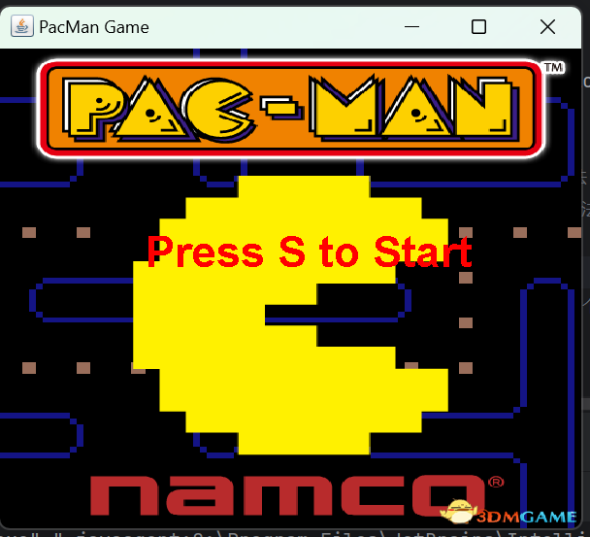

(2)游戏进行画面：游戏开始后，PacMan 在迷宫中穿梭，可灵活控制方向。迷宫墙壁绘制精准，PacMan 动画流畅自然，张嘴闭嘴动画切换及时准确呈现移动状态。豆豆与能量豆分布均匀，颜色区分明显，易于识别。幽灵随机移动符合预期，颜色区分正常与能量化状态。分数与生命值显示于界面固定位置，实时更新，为玩家提供清晰反馈。
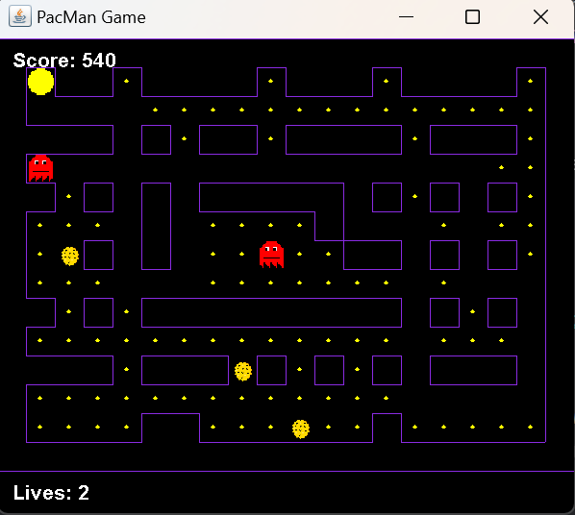 | 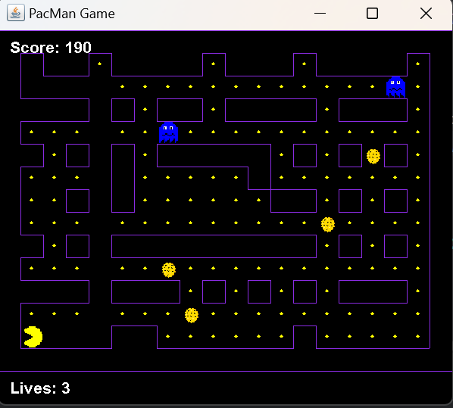
Ghost原形 | Ghost变身

(3)游戏胜利画面：当 PacMan 成功吃掉所有豆豆时进入下一关，下一关结束后若胜利则弹出胜利对话框显示得分，告知玩家获胜，随后游戏正常退出，流程符合设计目标，给予玩家成就反馈。
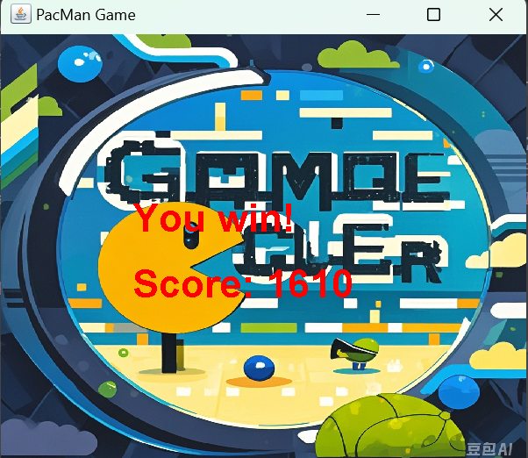

(4)游戏失败画面：PacMan 生命数耗尽时，显示游戏结束画面，展示最终得分，玩家可按 “Q” 键退出。画面切换流畅，得分显示准确，为失败玩家提供明确结果反馈。
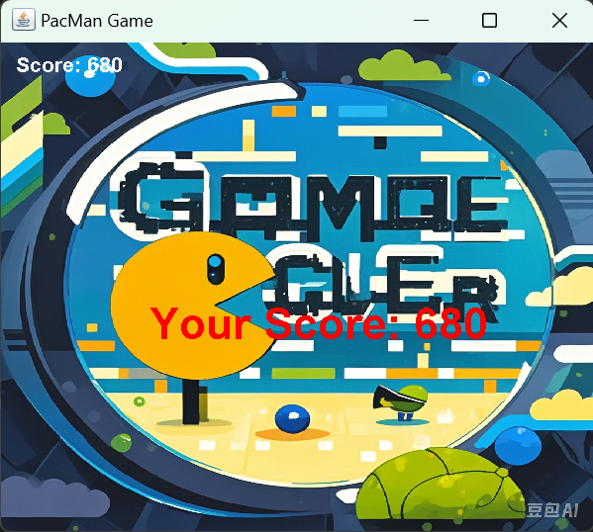

- 总结
通过本次 PacMan 游戏开发，我深入掌握 Java GUI 编程技术与游戏开发流程逻辑。在开发中，遵循代码规范提升可读性与可维护性，类设计与功能划分锻炼模块化编程思维，如 PacManGame 统筹管理、Ghost 与 Wall 独立封装特性与行为。动画实现与交互逻辑处理增强图形编程与事件处理能力，如 PacMan 多帧动画切换、碰撞检测响应。然而开发遇诸多挑战，如幽灵智能移动算法待优化以提升难度层次，游戏性能在复杂迷宫与多元素场景需改进，界面设计可引入更多主题与特效提升沉浸感与吸引力。后续我将深入钻研优化方向，探索高级算法优化游戏元素行为逻辑，学习性能调优技术提升运行效率，关注用户体验改进界面交互与视觉设计，为开发更优质游戏积累经验、提升能力，创造更精彩游戏体验。

- 程序代码实现
Wall.java
import java.awt.*;
import java.util.ArrayList;
public class Wall {
private int x, y;
public Wall(int x, int y) {
this.x = x;
this.y = y;
}
public int getX() {
return x;
}
public int getY() {
return y;
}
public static void drawMergedWalls(Graphics g, ArrayList<Wall> walls,
int boardWidth, int boardHeight, int tileSize) {
boolean[][] visited = new boolean[boardHeight][boardWidth];
for (int i = 0; i < boardHeight; i++) {
for (int j = 0; j < boardWidth; j++) {
if (!visited[i][j] && isWall(j, i, walls)) {
Rectangle boundary = new Rectangle(j, i, 1, 1);
findConnectedWalls(j, i, walls, visited, boundary);
drawWall(g, boundary, tileSize);
}
}
}
}
private static void findConnectedWalls(int x, int y, ArrayList<Wall> walls,
boolean[][] visited, Rectangle boundary) {
if (x < 0 || x >= visited[0].length || y < 0 || y >= visited.length
|| visited[y][x] || !isWall(x, y, walls)) {
return;
}
visited[y][x] = true;
boundary.add(x, y);
findConnectedWalls(x + 1, y, walls, visited, boundary);
findConnectedWalls(x - 1, y, walls, visited, boundary);
findConnectedWalls(x, y + 1, walls, visited, boundary);
findConnectedWalls(x, y - 1, walls, visited, boundary);
}
private static boolean isWall(int x, int y, ArrayList<Wall> walls) {
for (Wall wall : walls) {
if (wall.getX() == x && wall.getY() == y) {
return true;
}
}
return false;
}
private static void drawWall(Graphics g, Rectangle boundary, int tileSize) {
// 画紫色边框
g.setColor(new Color(138, 43, 226));
g.drawRect(boundary.x * tileSize, boundary.y * tileSize,
boundary.width * tileSize, boundary.height * tileSize);
// 画黑色内部
g.setColor(Color.BLACK);
g.fillRect(boundary.x * tileSize, boundary.y * tileSize,
boundary.width * tileSize, boundary.height * tileSize);
}
}
Ghost.java
import java.util.Random;
import java.awt.Image;
import java.awt.Toolkit;
public class Ghost {
private int x, y; // Ghost的位置
private boolean energized; // Ghost 是否被能量豆影响
private Random rand;
private int boardWidth; // 游戏区域宽度
private int boardHeight; // 游戏区域高度
private Image ghostImage; // 普通状态 Ghost 图片
private Image ghostEnergizedImage; // 被能量豆影响时的图片
public Ghost(int startX, int startY, int boardWidth, int boardHeight,
String imagePath, String energizedImagePath) {
this.x = startX;
this.y = startY;
this.energized = false; // 初始状态为普通状态
this.rand = new Random();
this.boardWidth = boardWidth;
this.boardHeight = boardHeight;
// 加载图片
this.ghostImage = Toolkit.getDefaultToolkit().createImage(imagePath);
this.ghostEnergizedImage = Toolkit.getDefaultToolkit().createImage(energizedImagePath);
}
public void move() {
// 随机选择一个方向移动
int direction = rand.nextInt(4); // 0=上, 1=下, 2=左, 3=右
switch (direction) {
case 0: if (y > 0) y--; break; // 向上
case 1: if (y < boardHeight - 1) y++; break; // 向下
case 2: if (x > 0) x--; break; // 向左
case 3: if (x < boardWidth - 1) x++; break; // 向右
}
}
public void setEnergized(boolean energized) {
this.energized = energized;
}
public boolean isEnergized() {
return energized;
}
public void setPosition() {
this.x = 1; // 重新设置Ghost的位置
this.y = 1; // 可以根据需要选择在其他位置
}
public int getX() { return x; }
public int getY() { return y; }
public Image getImage() {
return energized ? ghostEnergizedImage : ghostImage; // 根据状态返回对应图片
}
}
PacManGame.java
import javax.swing.*;
import java.awt.*;
import java.awt.event.*;
import java.util.ArrayList;
import java.util.Random;
public class PacManGame extends JPanel implements ActionListener, KeyListener {
private static final int TILE_SIZE = 20;
private static final int BOARD_WIDTH = 20;
private static final int BOARD_HEIGHT = 15;
private int pacManX, pacManY;
private int pacManDirectionX, pacManDirectionY;
private boolean[][] points;
private ArrayList<Wall> walls;
private ArrayList<Ghost> ghosts;
private ArrayList<Point> powerBeans;
private Timer timer;
private int pacManLives;
private int totalPoints;
private boolean gameStarted;
private boolean ghostEnergized;
private boolean gameOver;
private boolean gameWon;
private int score; // 新增分数
private enum Direction {
LEFT, RIGHT, UP, DOWN, NONE;
}
private Direction pacManDirection = Direction.NONE;
private Image PacMan1; // 静止状态的图片
private Image PacMan2down, PacMan3down,PacMan4down; // 向下移动的两个图片
private Image PacMan2up, PacMan3up,PacMan4up; // 向上移动的两个图片
private Image PacMan2left, PacMan3left,PacMan4left; // 向左移动的两个图片
private Image PacMan2right, PacMan3right,PacMan4right; // 向右移动的两个图片
private Image FrightFruit,coverImage,gameOverImage;
private void loadImages() {
PacMan1 = new ImageIcon("PacManGifs/PacMan1.gif").getImage();
PacMan2down = new ImageIcon("PacManGifs/PacMan2down.gif").getImage();
PacMan3down = new ImageIcon("PacManGifs/PacMan3down.gif").getImage();
PacMan4down = new ImageIcon("PacManGifs/PacMan4down.gif").getImage();
PacMan2up = new ImageIcon("PacManGifs/PacMan2up.gif").getImage();
PacMan3up = new ImageIcon("PacManGifs/PacMan3up.gif").getImage();
PacMan4up = new ImageIcon("PacManGifs/PacMan4up.gif").getImage();
PacMan2left = new ImageIcon("PacManGifs/PacMan2left.gif").getImage();
PacMan3left = new ImageIcon("PacManGifs/PacMan3left.gif").getImage();
PacMan4left = new ImageIcon("PacManGifs/PacMan4left.gif").getImage();
PacMan2right = new ImageIcon("PacManGifs/PacMan2right.gif").getImage();
PacMan3right = new ImageIcon("PacManGifs/PacMan3right.gif").getImage();
PacMan4right = new ImageIcon("PacManGifs/PacMan4right.gif").getImage();
FrightFruit = new ImageIcon("PacManGifs/FrightFruit.png").getImage();
coverImage = new ImageIcon("PacManGifs/coverImage.jpg").getImage(); // 封面图像
gameOverImage = new ImageIcon("PacManGifs/gameOverImage.png").getImage(); // 结算画面图像
}
private void drawWallWithOutline(Graphics g, int x, int y) {
// 填充墙壁的内部
g.setColor(Color.BLACK);
g.fillRect(x * TILE_SIZE, y * TILE_SIZE, TILE_SIZE, TILE_SIZE);
// 设置紫色边框颜色
g.setColor(new Color(138, 43, 226)); // 紫色
// 检查相邻墙壁
boolean leftWall = isWallAt(x - 1, y);
boolean rightWall = isWallAt(x + 1, y);
boolean upWall = isWallAt(x, y - 1);
boolean downWall = isWallAt(x, y + 1);
// 控制边框的绘制
// 上边框
if (!upWall) {
g.drawLine(x * TILE_SIZE, y * TILE_SIZE,
(x + 1) * TILE_SIZE, y * TILE_SIZE);
}
// 下边框
if (!downWall) {
g.drawLine(x * TILE_SIZE, (y + 1) * TILE_SIZE,
(x + 1) * TILE_SIZE, (y + 1) * TILE_SIZE);
}
// 左边框
if (!leftWall) {
g.drawLine(x * TILE_SIZE, y * TILE_SIZE,
x * TILE_SIZE, (y + 1) * TILE_SIZE);
}
// 右边框
if (!rightWall) {
g.drawLine((x + 1) * TILE_SIZE, y * TILE_SIZE,
(x + 1) * TILE_SIZE, (y + 1) * TILE_SIZE);
}
}
// 辅助方法检查是否在指定位置有墙壁
private boolean isWallAt(int x, int y) {
for (Wall wall : walls) {
if (wall.getX() == x && wall.getY() == y) {
return true;
}
}
return false;
}
public PacManGame() {
pacManLives = 3;
totalPoints = 0;
pacManX = 1;
pacManY = 1;
pacManDirectionX = 0;
pacManDirectionY = 0;
score = 0; // 初始化分数
gameOver=false;
points = new boolean[BOARD_HEIGHT][BOARD_WIDTH];
walls = new ArrayList<>();
powerBeans = new ArrayList<>();
for (int i = 0; i < BOARD_HEIGHT; i++) {
for (int j = 0; j < BOARD_WIDTH; j++) {
points[i][j] = true;
totalPoints++;
}
}
setWalls();
ghosts = new ArrayList<>();
ghosts.add(new Ghost(10, 10, BOARD_WIDTH, BOARD_HEIGHT,
"PacManGifs/Ghost1.gif", "PacManGifs/GhostScared1.gif")); // 第一个Ghost的图片
ghosts.add(new Ghost(15, 5, BOARD_WIDTH, BOARD_HEIGHT,
"PacManGifs/Ghost2.gif", "PacManGifs/GhostScared2.gif")); // 第二个Ghost的图片
generatePowerBeans(5);
setPreferredSize(new Dimension(BOARD_WIDTH * TILE_SIZE,
BOARD_HEIGHT * TILE_SIZE + 30)); // 增加高度以显示分数
setBackground(Color.BLACK);
addKeyListener(this);
setFocusable(true);
timer = new Timer(300, this);
gameStarted = false;
loadImages();
}
private boolean collisionWithWalls(int x, int y) {
for (Wall wall : walls) {
if (wall.getX() == x && wall.getY() == y) {
return true;
}
}
return (x < 0 || x >= BOARD_WIDTH || y < 0 || y >= BOARD_HEIGHT);
}
private void setWalls() {
// 添加边界墙
for (int i = 0; i < BOARD_WIDTH; i++) {
walls.add(new Wall(i, 0)); // 上边
walls.add(new Wall(i, BOARD_HEIGHT - 1)); // 下边
}
for (int i = 0; i < BOARD_HEIGHT; i++) {
walls.add(new Wall(0, i)); // 左边
walls.add(new Wall(BOARD_WIDTH - 1, i)); // 右边
}
//墙壁
int[][] wallPositions = {
{2, 1}, {3, 1}, {5, 1}, {6, 1}, {7, 1}, {8, 1},
{10, 1}, {11, 1}, {12, 1}, {14, 1}, {15, 1}, {16, 1}, {17, 1},
{1, 3}, {2, 3}, {3, 3}, {5, 3}, {7, 3}, {8, 3}, {10, 3}, {11, 3},
{12, 3}, {13, 3}, {15, 3}, {16, 3}, {17, 3},
{1, 5}, {3, 5}, {5, 5}, {7, 5}, {8, 5}, {9, 5}, {10, 5}, {11, 5},
{13, 5}, {15, 5}, {17, 5},
{5, 6}, {11, 6},
{3, 7}, {5, 7}, {12, 7}, {13, 7}, {15, 7}, {17, 7},
{1, 9}, {3, 9}, {5, 9}, {6, 9}, {7, 9}, {8, 9}, {9, 9}, {10, 9},
{11, 9}, {12, 9}, {13, 9}, {15, 9}, {17, 9},
{1, 11}, {2, 11}, {3, 11}, {5, 11}, {6, 11}, {7, 11}, {9, 11},
{11, 11}, {13, 11}, {15, 11}, {16, 11}, {17, 11},
{5, 13}, {6, 13}, {13, 13}
};
for (int[] pos : wallPositions) {
walls.add(new Wall(pos[0], pos[1]));
}
}
private void generatePowerBeans(int count) {
Random rand = new Random();
while (powerBeans.size() < count) {
int x = rand.nextInt(BOARD_WIDTH);
int y = rand.nextInt(BOARD_HEIGHT);
if (points[y][x] && !collisionWithWalls(x, y)) {
powerBeans.add(new Point(x, y));
}
}
}
@Override
public void keyPressed(KeyEvent e) {
int key = e.getKeyCode();
if (!gameStarted) {
if (key == KeyEvent.VK_S) {
gameStarted = true;
timer.start();
}
} else if (gameOver) {
if (key == KeyEvent.VK_Q) {
System.exit(0); // 退出游戏
}
} else {
switch (key) {
case KeyEvent.VK_LEFT:
pacManDirectionX = -1;
pacManDirectionY = 0;
pacManDirection = Direction.LEFT;
break;
case KeyEvent.VK_RIGHT:
pacManDirectionX = 1;
pacManDirectionY = 0;
pacManDirection = Direction.RIGHT;
break;
case KeyEvent.VK_UP:
pacManDirectionX = 0;
pacManDirectionY = -1;
pacManDirection = Direction.UP;
break;
case KeyEvent.VK_DOWN:
pacManDirectionX = 0;
pacManDirectionY = 1;
pacManDirection = Direction.DOWN;
break;
default:
pacManDirection = Direction.NONE;
break;
}
}
}
@Override
public void keyReleased(KeyEvent e) {}
@Override
public void keyTyped(KeyEvent e) {}
@Override
public void actionPerformed(ActionEvent e) {
if (!gameStarted) return;
int newX = pacManX + pacManDirectionX;
int newY = pacManY + pacManDirectionY;
if (!collisionWithWalls(newX, newY)) {
pacManX = newX;
pacManY = newY;
if (points[pacManY][pacManX]) {
points[pacManY][pacManX] = false;
totalPoints--;
score += 10; // 吃掉豆豆增加分数
}
for (Point powerBean : new ArrayList<>(powerBeans)) {
if (powerBean.x == pacManX && powerBean.y == pacManY) {
powerBeans.remove(powerBean);
ghostEnergized = true;
for (Ghost ghost : ghosts) {
ghost.setEnergized(true);
}
Timer energizeTimer = new Timer(5000, ae -> {
ghostEnergized = false;
for (Ghost ghost : ghosts) {
ghost.setEnergized(false);
}
});
energizeTimer.setRepeats(false);
energizeTimer.start();
break;
}
}
}
// 检查是否所有可达的豆子都被吃完
boolean allPointsEaten = true;
for (int i = 0; i < BOARD_HEIGHT; i++) {
for (int j = 0; j < BOARD_WIDTH; j++) {
if (points[i][j] &&!isWallAt(j, i)) {
allPointsEaten = false;
break;
}
}
if (!allPointsEaten) break;
}
if (allPointsEaten) {
gameOver = true;
gameWon=true;
repaint();
}
for (Ghost ghost : ghosts) {
ghost.move();
if (ghost.getX() == pacManX && ghost.getY() == pacManY) {
if (ghost.isEnergized()) {
ghost.setPosition(); // 吃掉Ghost，重置位置
} else {
pacManLives--;
if (pacManLives <= 0||(allPointsEaten) ) {
gameOver = true; // 设置游戏结束状态
repaint(); // 刷新界面显示结算画面
} else {
// 生命数减少，重生Pac-Man
pacManX = 1; // 重置位置
pacManY = 1;
pacManDirection = Direction.NONE; // 重置状态为没有嘴巴
pacManDirectionX = 0;
pacManDirectionY = 0;
}
}
}
}
repaint();
}
@Override
protected void paintComponent(Graphics g) {
super.paintComponent(g);
if (!gameStarted) {
// 绘制封面图像
g.drawImage(coverImage, 0, 0, getWidth(), getHeight(), this);
g.setColor(Color.RED);
g.setFont(new Font("Arial", Font.BOLD, 30));
g.drawString("Press S to Start", BOARD_WIDTH * TILE_SIZE / 4,
BOARD_HEIGHT * TILE_SIZE / 2);
} else {
// 绘制所有的小点
for (int i = 0; i < BOARD_HEIGHT; i++) {
for (int j = 0; j < BOARD_WIDTH; j++) {
if (points[i][j]) {
g.setColor(Color.YELLOW);
// 豆豆更小
int smallerBeanSize = TILE_SIZE / 6; // 改小豆豆的尺寸
g.fillOval(j * TILE_SIZE + (TILE_SIZE - smallerBeanSize) / 2,
i * TILE_SIZE + (TILE_SIZE - smallerBeanSize) / 2,
smallerBeanSize, smallerBeanSize);
}
}
}
// 绘制生命值
g.setColor(Color.WHITE);
g.setFont(new Font("Arial", Font.BOLD, 14));
g.drawString("Lives: " + pacManLives, 10, BOARD_HEIGHT * TILE_SIZE + 20); // 显示生命值
// 绘制 Pac-Man
drawPacMan(g);
// 绘制能量豆
g.setColor(Color.MAGENTA);
for (Point powerBean : powerBeans) {
g.drawImage(FrightFruit, powerBean.x * TILE_SIZE,
powerBean.y * TILE_SIZE,TILE_SIZE , TILE_SIZE, this);
}
// 绘制 Ghosts
for (Ghost ghost : ghosts) {
g.drawImage(ghost.getImage(), ghost.getX() * TILE_SIZE,
ghost.getY() * TILE_SIZE, TILE_SIZE, TILE_SIZE, this);
}
// 绘制墙壁
g.setColor(new Color(138, 43, 226)); // 紫色墙壁
// 绘制墙壁
for (Wall wall : walls) {
drawWallWithOutline(g, wall.getX(), wall.getY());
}
// 检查游戏是否结束
if (gameOver) {
// 显示结算画面
g.drawImage(gameOverImage, 0, 0, getWidth(), getHeight(), this);
// 显示分数
g.setColor(Color.RED);
g.setFont(new Font("Arial", Font.BOLD, 30));
g.drawString("Your Score: " + score, BOARD_WIDTH * TILE_SIZE / 4,
BOARD_HEIGHT * TILE_SIZE / 2 + 50);
}
// 绘制分数
g.setColor(Color.WHITE);
g.setFont(new Font("Arial", Font.BOLD, 14));
g.drawString("Score: " + score, 10, 20); // 在左上角显示分数 // 显示分数
}
if (gameWon) {
// 显示结算画面
g.drawImage(gameOverImage, 0, 0, getWidth(), getHeight(), this);
g.setColor(Color.RED);
g.setFont(new Font("Arial", Font.BOLD, 30));
g.drawString("You win!", BOARD_WIDTH * TILE_SIZE / 4, BOARD_HEIGHT * TILE_SIZE / 2);
g.drawString("Score: " + score, BOARD_WIDTH * TILE_SIZE / 4, BOARD_HEIGHT * TILE_SIZE / 2 + 50);
}
}
private int pacManFrame = 0; // 用于控制动画的帧
private long lastTime = 0; // 用于控制动画的刷新速度
private void drawPacMan(Graphics g) {
long currentTime = System.currentTimeMillis();
if (currentTime - lastTime > 200) { // 每150毫秒更新一次帧
pacManFrame = (pacManFrame + 1) % 4; // 切换帧 (0到3)
lastTime = currentTime;
}
Image pacManImage = PacMan1; // 默认使用静止图片
// 根据方向和帧来选择图片
switch (pacManDirection) {
case UP:
if (pacManFrame == 0) pacManImage = PacMan2up;
else if (pacManFrame == 1) pacManImage = PacMan3up;
else if (pacManFrame == 2) pacManImage = PacMan4up;
break;
case DOWN:
if (pacManFrame == 0) pacManImage = PacMan2down;
else if (pacManFrame == 1) pacManImage = PacMan3down;
else if (pacManFrame == 2) pacManImage = PacMan4down;
break;
case LEFT:
if (pacManFrame == 0) pacManImage = PacMan2left;
else if (pacManFrame == 1) pacManImage = PacMan3left;
else if (pacManFrame == 2) pacManImage = PacMan4left;
break;
case RIGHT:
if (pacManFrame == 0) pacManImage = PacMan2right;
else if (pacManFrame == 1) pacManImage = PacMan3right;
else if (pacManFrame == 2) pacManImage = PacMan4right;
break;
default:
pacManImage = PacMan1; // 如果没有移动，使用静止的图片
break;
}
// 绘制 Pac-Man 图片
g.drawImage(pacManImage, pacManX * TILE_SIZE,
pacManY * TILE_SIZE, TILE_SIZE, TILE_SIZE, this);
}
public static void main(String[] args) {
JFrame frame = new JFrame("PacMan Game");
PacManGame gamePanel = new PacManGame();
frame.setDefaultCloseOperation(JFrame.EXIT_ON_CLOSE);
frame.add(gamePanel);
frame.pack();
frame.setVisible(true);
}
}

