Building and Deploying GET IDM Web-Services

TRANS PLM PROGRAM

<GE Transportation>

<Locomotive>

g is a registered trademark of the General Electric Company in the United States and other countries.

**© 2006 General Electric Company**. All rights reserved.

Authors

| Name | Location | Phone | Email |
| --- | --- | --- | --- |
| Viswanathan Rajagopalan | Chennai, TN, India | +91 44 674 35443 | Viswanthan.Rajagopalan@ge.com |

Document Revision History

| Date | Author | Description | Revision # |
| --- | --- | --- | --- |
| 18-Nov-2016 | Viswanathan | Created | 1 |
| 21-Nov-2016 | Viswanathan | Modified the Instructions to help System Administrators deploy the war directly | 2 |

**Building with Ant**

Contents

Pre-Requisites: 5

Build Instructions: 5

Deployment Instructions: 12

# Pre-Requisites:

1. Java (1.7)
2. STS – Spring Tool Suite (An eclipse based tool for developing Spring based Applications)

# Build Instructions:

The below steps are only required for developers who wants to build and run the TcIDMWebservices in their local environment. System Administrators, please skip this section and refer to Deployment Instructions section.

* + Open STS with a default workspace.
  + Import the project ‘TcIDMServices’ from svn repository using the below steps.
    - Go to STS Application and do File -> Import

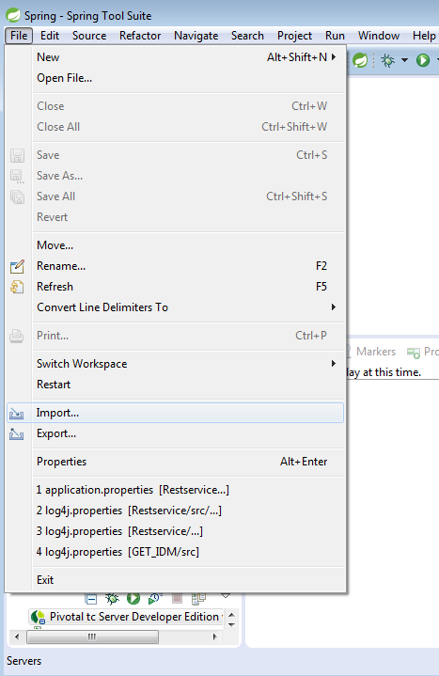

* + - Select “Existing projects into Workspace” and click next

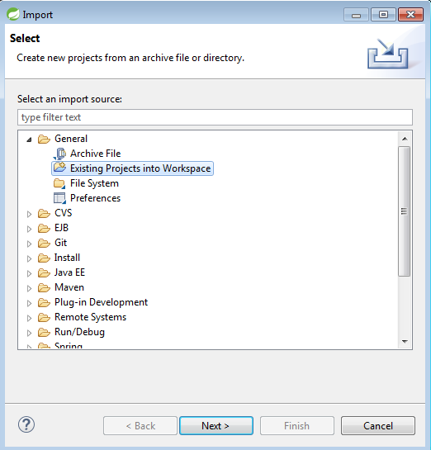

* + - Select the root directory as TcIDMServices folder from the svn repository.

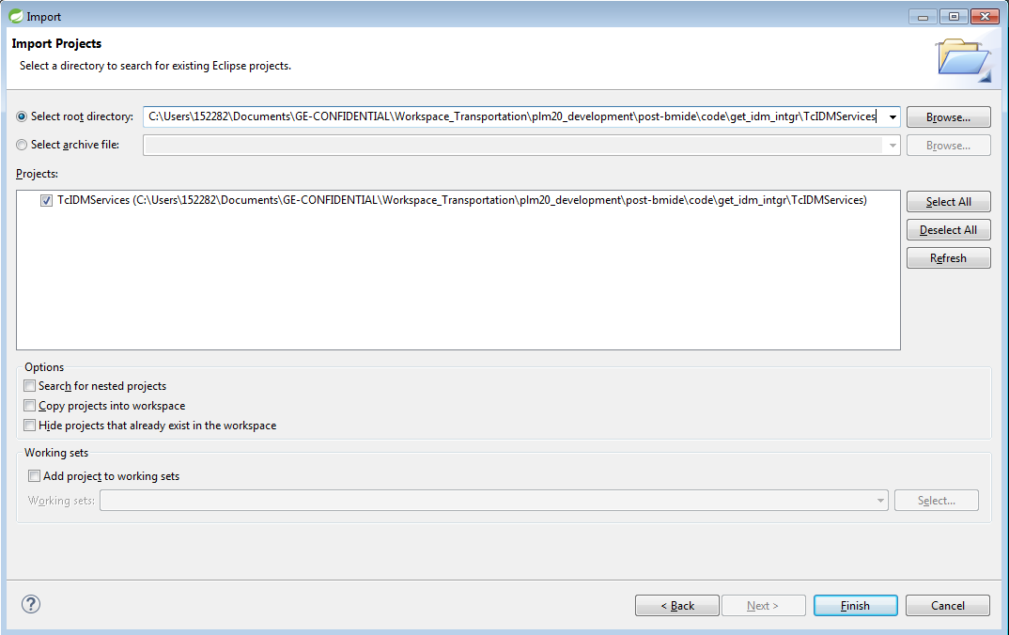

* + - Click Finish.

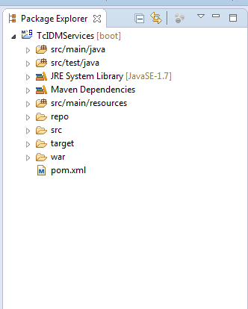

* + - Right Click on the ‘TcIDMServices’ project and invoke maven -> Update Project menu

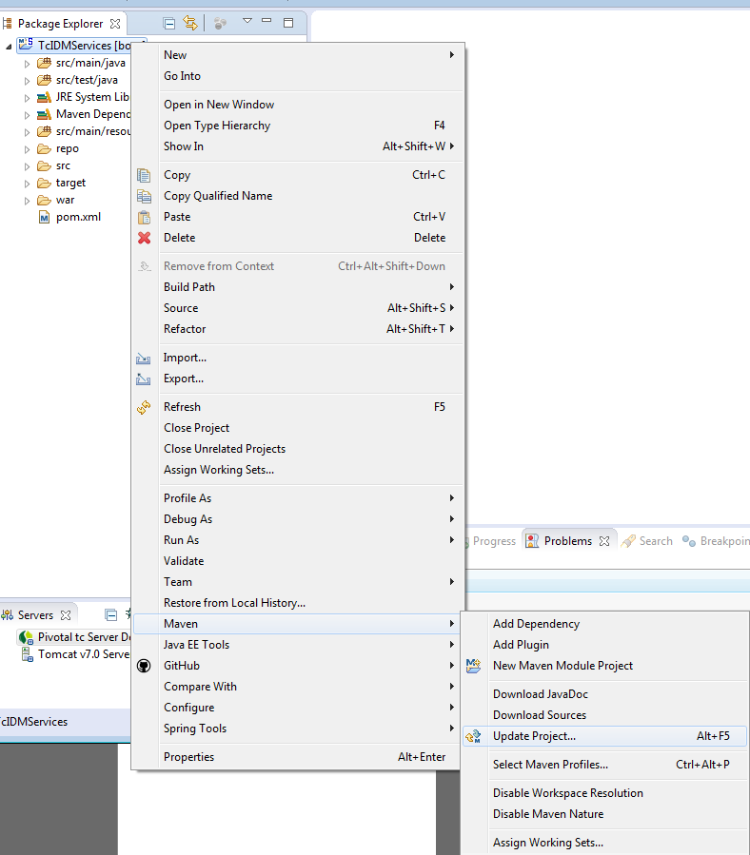

* + - Select “Force Update of Snapshots/Releases” and click ok

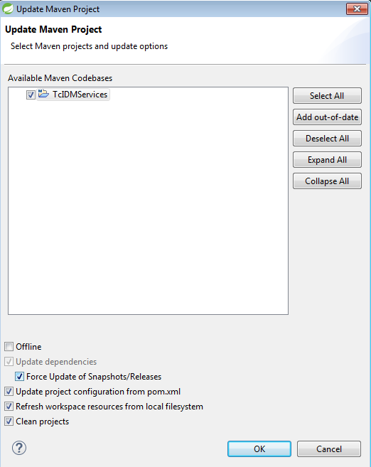

* + - Right click on TcIDMServices and Invoke Run as -> Maven clean.

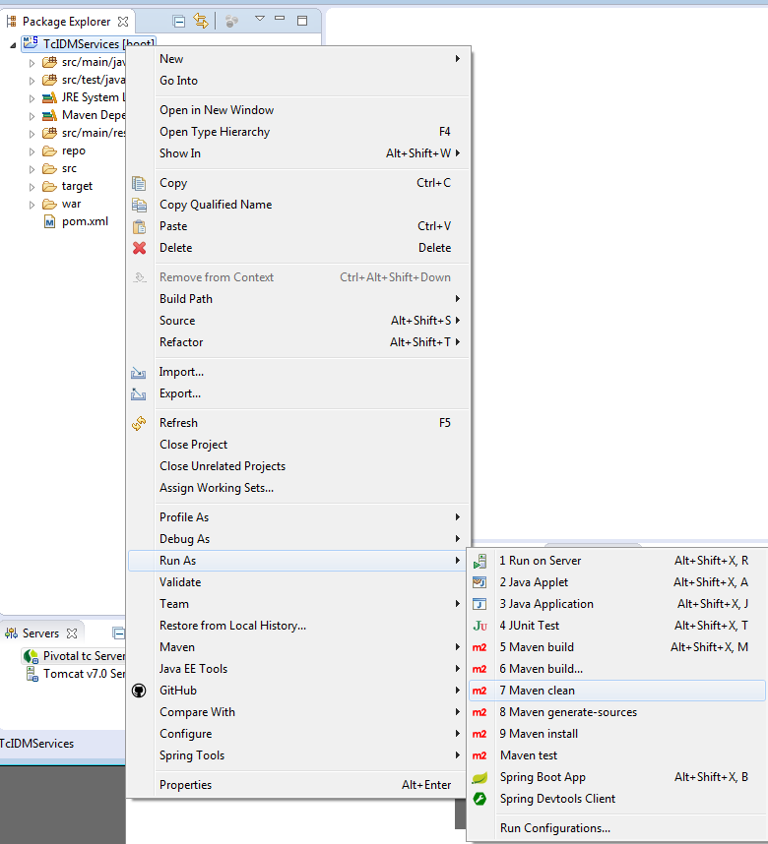

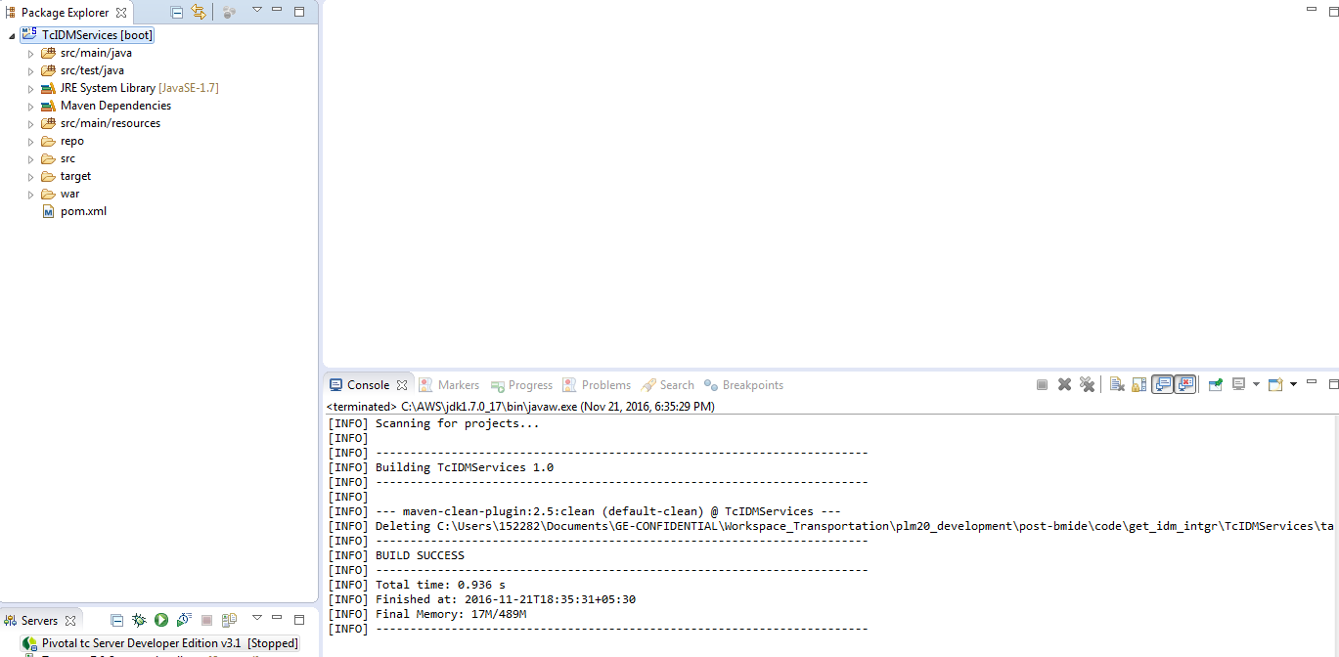

* + - The above message saying Build Success would be observed.
    - Right click on TcIDMServices and Invoke Run as -> Maven install.

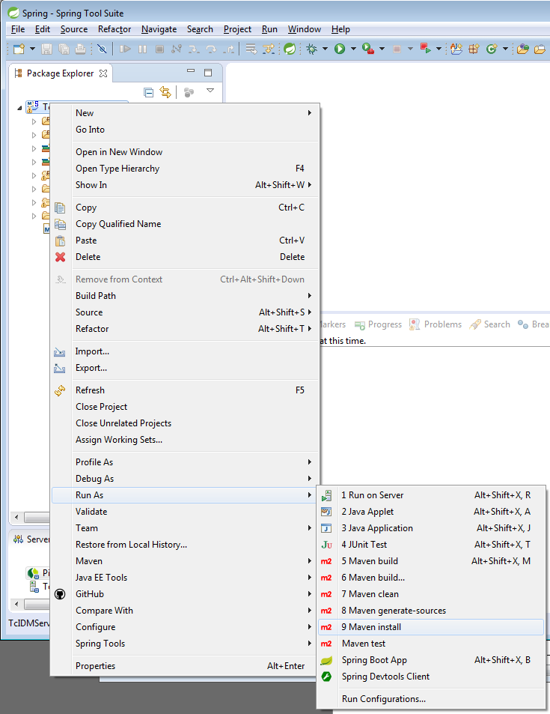

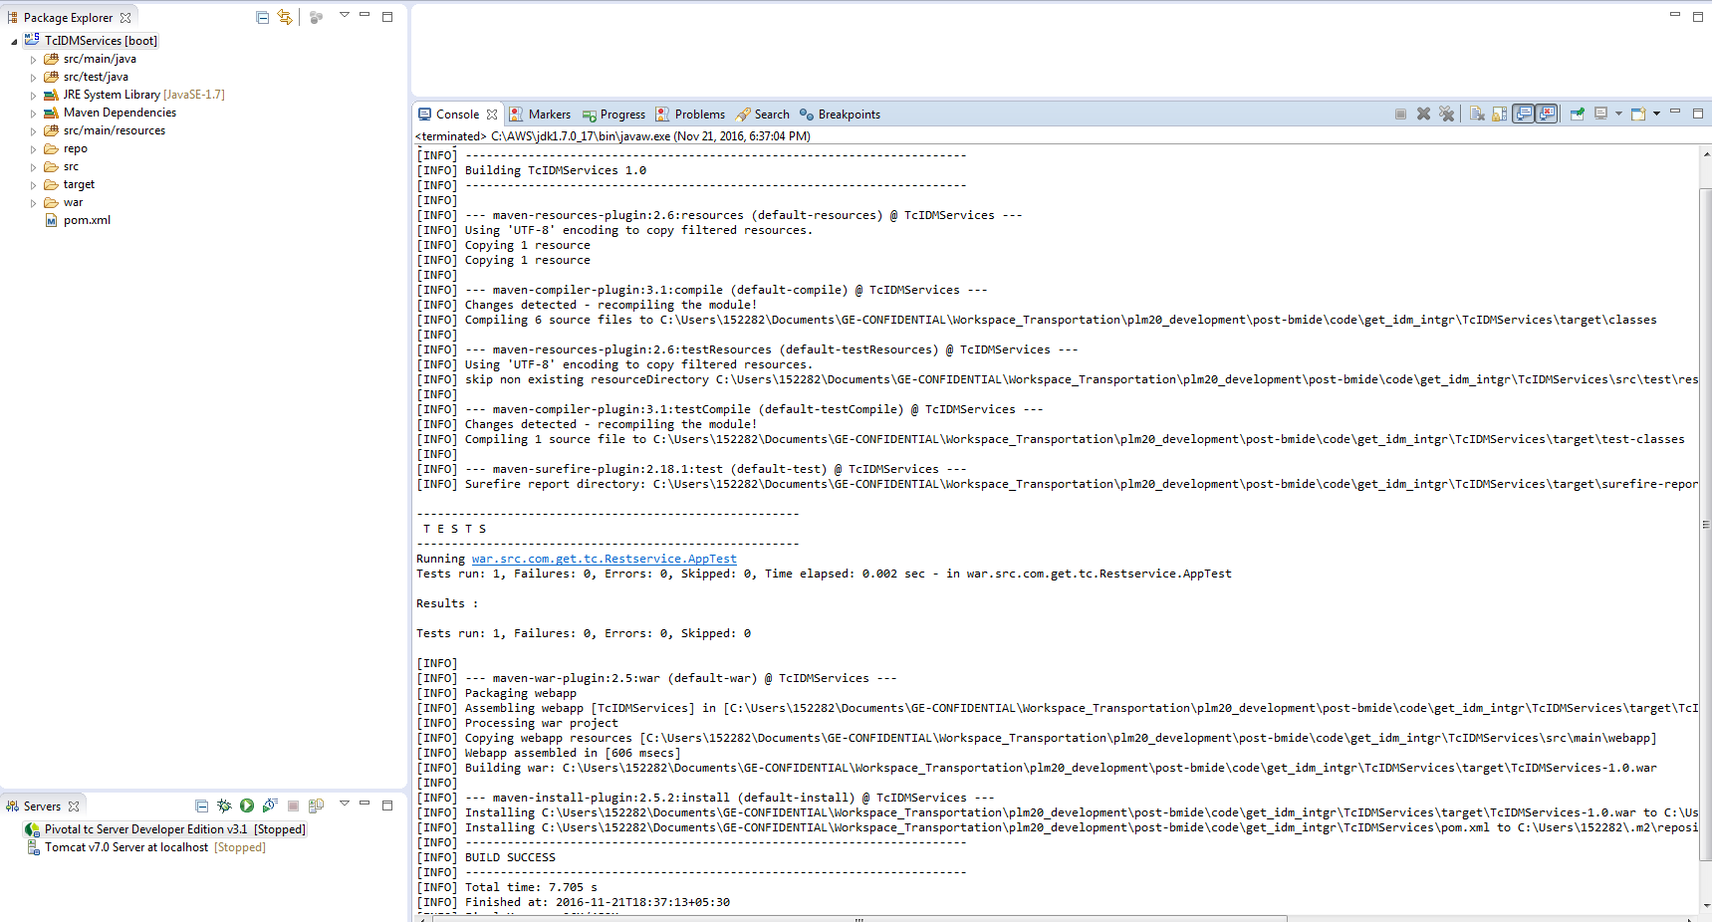

* + - The above message saying Build Success would be observed.

* + - Look out for TcIDMServices-1.0.war under TcIDMServices/target

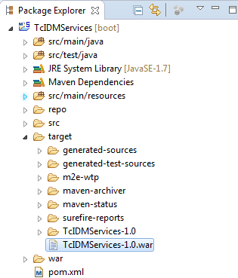

* + - Please deploy the generated TcIDMServices-1.0.war file in the required JBoss Server Instance.
    - Developers have to make sure that the latest copy of the TcIDMServices-1.0.war file is copied to the **“TcIDMServices/war”** folder location before checking-in the changes into SVN

# Deployment Instructions:

* + Locate the TcIDMServices-1.0.war file in the TcIDMServices project under the “war” folder checked-out from the SVN Repository

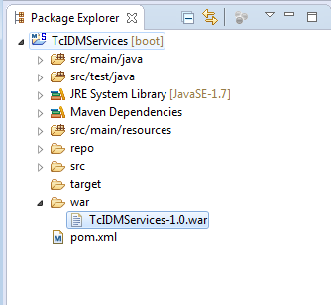

* + Please deploy the TcIDMServices-1.0.war file in the required JBoss Server Instance.