Utilities Reference

TRANS PLM PROGRAM

<GE Transportation>

<Locomotive>

g is a registered trademark of the General Electric Company in the United States and other countries.

**© 2006 General Electric Company**. All rights reserved.

Document Revision History

| Date | Author | Description | Revision # |
| --- | --- | --- | --- |
| 03-Mar-2016 | Qadeer | Created | 1 |
| 24-May-2017 | Anbu | Added instruction to “get_rename_revisionrule” and “get_replace_preference_value” utilities | 2 |
| 26-Oct-2017 | Nisarg | Added instructions for SBOM data migration | 3 |

**Utilities**

Contents

Configuring Environment for ITK Utilities 5

Manually configure UNIX environment 5

Manually configure Windows environment 5

Utilities: 5

GET_ReportGenerator: 5

Get_rename_revisionrule 7

Get_replace_preference_value 8

Utilities for Data Migration for SBOM project 9

# Configuring Environment for ITK Utilities

## Manually configure UNIX environment

Manually configuring the Teamcenter environment on UNIX systems requires sourcing the tc_profilevars script. To manually set the Teamcenter environment, enter the following sets of commands:

export TC_ROOT=<path to tcroot>;

export GET_UTILS_ROOT=<path to GET_UTILS_ROOT>;

export TC_DATA=<path to tcdata>;

. $TC_DATA/tc_profilevars

## Manually configure Windows environment

Manually configuring the Teamcenter environment on Windows systems requires running the tc_profilevars.bat script. This script is called automatically when exiting to an MS-DOS shell from the Teamcenter menu, but the environment can also be set manually. To manually set the Teamcenter environment, enter the following commands:

set TC_ROOT=<path to tcroot>

export GET_UTILS_ROOT=<path to GET_UTILS_ROOT>;

set TC_DATA=<path to tcdata>

call %TC_DATA%\tc_profilevars

# Utilities:

## GET_ReportGenerator:

Generates report for given query in xls format (tilde ‘~’ separated).

Syntax:

GET_ReportGenerator -config=<path to config file> -file=<path to input file containing list of input query files to be processed> -out=<output directory to which output files will be written>

Restrictions:

The output directory must be present and the user executing the utility should have write access to it.

The input files should be formatted based on environment (windows/unix/…)

Arguments:

**-config**

Specifies the input config file. Format of config file -

TC.USERNAME=<teamcenter username>

TC.PASSWORD=<password>

TC.GROUP=<group>

**-file**

Path to input file that contains path to query files to be processed. Example of input file –

D:\Workspace\WS1\get_transplm_trunk\post-bmide\code\get_utils\itk_utils\mfg_attr_form.txt

D:\Workspace\WS1\get_transplm_trunk\post-bmide\code\get_utils\itk_utils\query2.txt

D:\Workspace\WS1\get_transplm_trunk\post-bmide\code\get_utils\itk_utils\query3.txt

…

Format of input query file (Example: mfg_attr_form.txt) –

QUERY.HEADER=FORM.PUID~FORM.NAME~COUNT

QUERY.OUTPUTTYPES=string,string,int

QUERY.SQL=SELECT wso.puid, wso.pobject_name, COUNT(*) count FROM pworkspaceobject wso, pproject_list pl where wso.puid=pl.puid and upper(wso.pobject_type)='GET6MfgAttrForm2' GROUP BY wso.puid, wso.pobject_name Having COUNT(*) > 1

Where,

QUERY.HEADER – Header(column names/heading) to be written to output file

QUERY.OUTPUTTYPES – Output types – Corresponds to output columns of query (should match data type in database ) Following are allowed types – int, double, date, string, logical

QUERY.SQL – SQL query to be executed

**-out**

Path to output directory. Output file name will be same as query input file name

## Get_rename_revisionrule

Utility converts or renames existing revision rule to new revision rule.

Syntax:

get_rename_revisionrule -config=<path to config file> -file=<path to input file>

Restrictions:

The input files should be formatted based on environment (windows/unix/…)

Arguments:

**-config**

Specifies the input config file. Format of config file -

TC.USERNAME=<teamcenter username>

TC.PASSWORD=<password>

TC.GROUP=<group>

**-file**

Path to input file to be processed.

Ex: C:\transplm_main\post-bmide\code\get_utils\itk_utils\RevisionRule_InputFiles\get_rename_revisionrule_input.txt

Example of input file:

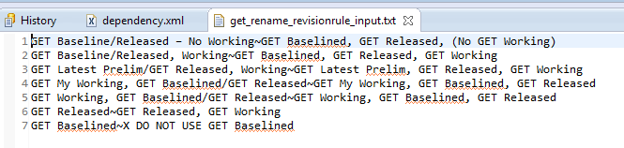

## Get_replace_preference_value

Utility finds the list of user preference which contains list of existing revision rule values and replaces with new revision rule values.

Syntax:

get_replace_preference_value -config=<path to config file> -file=<path to input file>

Restrictions:

The input files should be formatted based on environment (windows/unix/…)

Arguments:

**-config**

Specifies the input config file. Format of config file -

TC.USERNAME=<teamcenter username>

TC.PASSWORD=<password>

TC.GROUP=<group>

**-file**

Path to input file to be processed.

Ex: C:\transplm_main\post-bmide\code\get_utils\itk_utils\RevisionRule_InputFiles\get_replace_preference_value_input.txt

Example of input file:

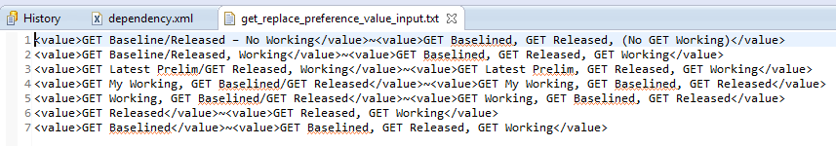

# Utilities for Data Migration for SBOM project

Location:

After the ant compilation, the jars and the executable are generated in

\post-bmide\code\get_utils_bin location.

Please refer following directories under it:

1. Itk_utils
2. sbom_migration_util directory

Utilities:

There are four utilities in total:

1. CreateInputFiles.jar – Creates input files for IPS DATA UPLOAD utility
2. ips_data_upload.exe – Loads data to Teamcenter
3. AddGlobalAlternate.exe – Adds Global Alternate to items
4. migrationSbomReports.jar – Generates a summarized report based on the data load log files.

Users:

Create following users in the system.

1. A migration user- must be a dba. It will be used to perform the migration.
2. sg_migration_user – create this user in SERVICES.TRANSPORTATION.GE TRANSPORTATION group. All the service parts will be given under its ownership.

Below is the complete process to be followed:

1. Copy following files to a directory

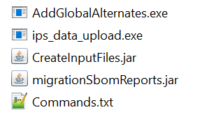

1. Open the file *Commands.txt*. Change username, password and group to the correct values (migration user values).

All the commands have following arguments: -u=username -p=password -g=group

Please change the values for these arguments.

Make sure the user is a dba user and the group is dba.

1. In the data loader file, please make sure the first Worksheet contains the data.

Data entries should be from row: 3. (First two rows are column headers and information).

1. Open TC command prompt and browse to the directory where package was extracted.
2. Run the commands one by one mentioned in the *Commands.txt*.

* The first command will create two directories

Input_Files and Logs.

It will read *DataLoader.xlsx* and generate required input files in the *Input_Files* directory.

It requires following argument:

–i= Data Loader file path

* The subsequent commands will read these input files and load the data to Teamcenter.
* The logs will get generated in the *Logs* directory.
* The last command will read all the log files and will generate a summarized report in the *Logs* directory.

Report name: *sBomReport_DateTimeStamp.xlsx*

The report will have following worksheets containing summary for corresponding object:

Summary_Report, Service_Part_creation, Service_Part_Form_Update, Existing_Engprt_Form_Creation, Service_Part_Relations, Service_Part_Ownership_Change, Alternate_Part_Update, Service_Assembly_Migration_Repo, Summary_Report

Note:

To understand what each command performs, please refer to the attached file: *Data_Migration_Steps.xslx*

Also, the list of commands are mentioned in the file: *Commands.txt*

