TRANS PLM PROGRAM

Manual Configuration changes (Master) - Post Deployment

GE Transportation

g is a registered trademark of the General Electric Company in the United States and other countries.

**© 2006 General Electric Company**. All rights reserved.

Authors

| Name | Location | Phone | Email |
| --- | --- | --- | --- |
| Build and Config Team | Houston, TX | NA | NA |

Document Revision History

| Date | Author | Description | Revision # |
| --- | --- | --- | --- |
| 10-Jul-2017 | Anbu | Initial creation | 1 |
| 17-Oct-2017 | Shilpa | Added multiple sections in this document | 2 |

Contents

1. Teamcenter Manual Configurations 4

1.1 Env Preferences 4

1.2 Excel Template update 7

1.3 Indexer Configuration: 8

2. Active Workspace Configurations (AWC) 9

3. AWC Login Page Configurations 12

4. Control Card – RIN Database Configurations 17

5. Dispatcher Configurations 18

5.1 Dispatcher Scheduler 18

5.2 Dispatcher Module 19

5.2.1 Module1: Cincinnati Module (Server) 19

5.2.2 Module2: Erie Module (Local) 25

5.3 Dispatcher Client 27

5.4 Dispatcher WAR deployment in JBOSS 27

5.5 Starting Dispatcher Services 28

6. Anark Configurations 28

7. CAD2CAM Configurations 32

8. T4O Configurations 33

9. IDM Configurations 34

10. NX Configurations 34

11. LOV Management 36

12. Design Release Configuration and Deployment 38

13. Audit Log Configurations 39

14. Task Manager Configurations 40

15. Automatic ECR Closure - CRON Configurations 42

16. JT Creation 43

17. CAS Disposition Web application 43

18. NX10, MP15 installation 43

19. Teamcenter Mail Logger 44

# Teamcenter Manual Configurations

## Env Preferences

1. Update value of preference – “GET.CAM.RIN.CREDENTIALS”

Preference Name: GET.CAM.RIN.CREDENTIALS

Scope : Site

Category : GET

Value : RIN database credentials for CAM

Example Snapshot for reference:

AS-IS:

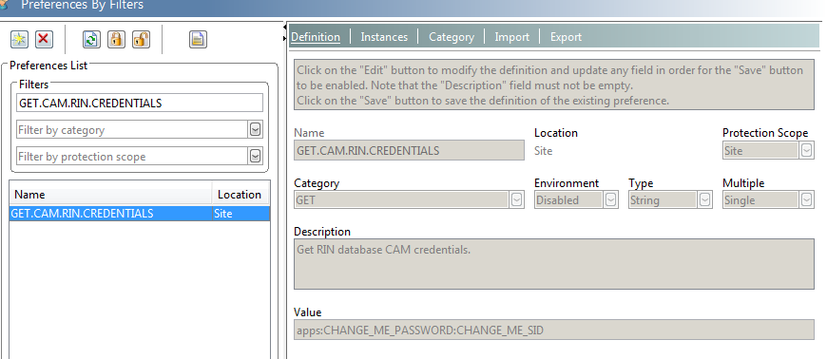

TO-BE:

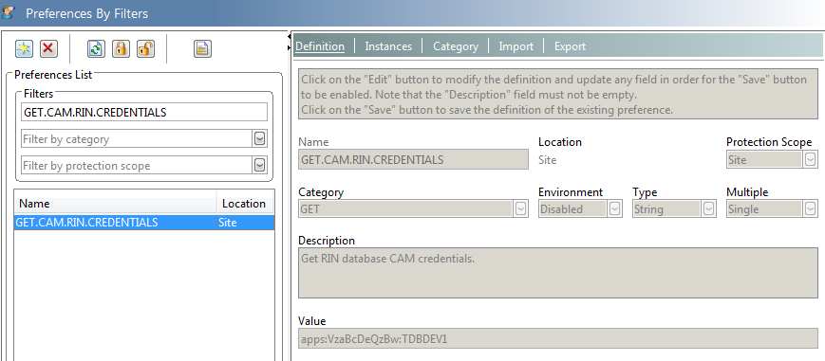

1. Update value of preference – “T4O_EBSLogonSystemList”

Preference Name: T4O_EBSLogonSystemList

Scope : Site

Category : EBS Gateway

Value : Valid Oracle System ID

Example Snapshot for reference:

AS-IS:

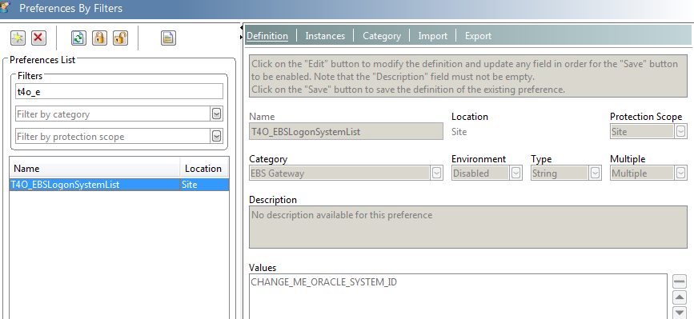

TO-BE:

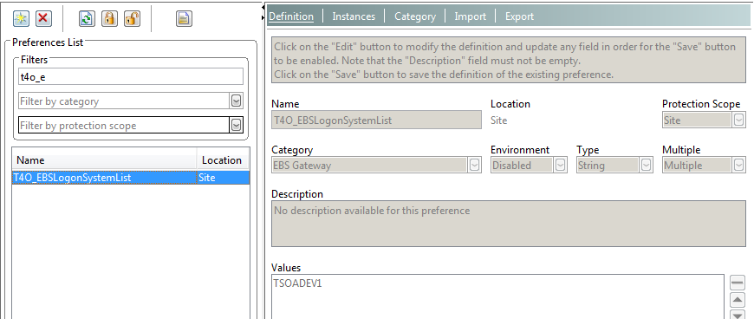

1. Update value of preference – “GET_T4O_Transfer_Decision”

Preference Name: GET_T4O_Transfer_Decision

Scope : Site

Category : EBS Gateway

Valid Values : YES or NO

Description :

YES – Will allow Oracle transfer from Teamcenter.

NO – Will stop Oracle transfer from Teamcenter.

CHANGE_ME_YES_NO – Default value. To be changed by Teamcenter Admin.

Additional Notes: If preference is missing or default value exists – Oracle transfer will stop.

Example Snapshot for Reference:

AS-IS:

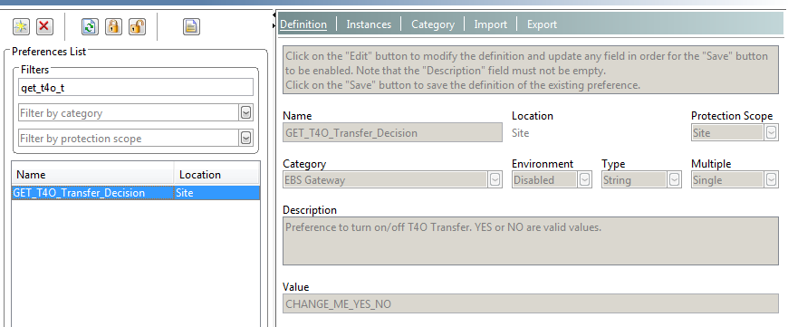

TO-BE:

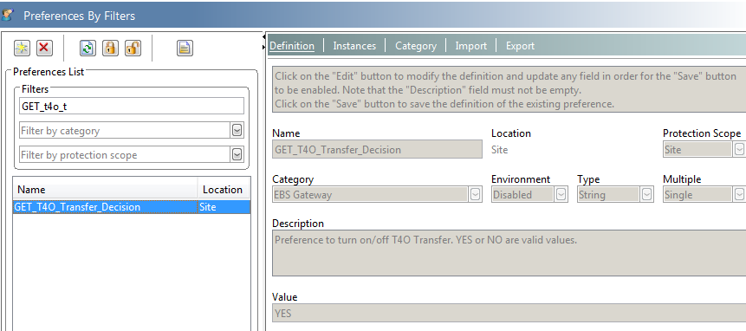

1. Preference for sending email for Release Clerk:

Preference Name: GET_RELEASE_CLERK_DISTRIBUTION_LIST

Scope : Site

Category : GET

Valid Values : [release.clerk@ge.com](mailto:release.clerk@ge.com) (For Production Environment)

[NONPROD.releaseclerk@ge.com](mailto:NONPROD.releaseclerk@ge.com) (For Non-Production Environment)

Description :

Preference for sending ECN information for Release Clerks.

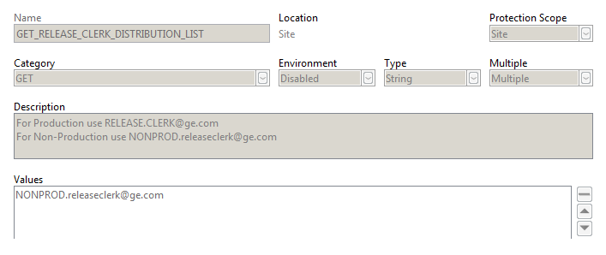

## Excel Template update

Create an excel template ‘GET_PartList_excel_template’ and import the file ‘PartsList_excel_template.xlsm’. This is for Parts list export to excel.

This Excel Template creation will be taken care as part of Ant build process. However during this import it has been noticed that two datasets are getting created under the Excel Template Revision.

Follow below steps after deployment:

1. Login to Teamcenter as Infodba
2. Search for Item ID 3DPDF
3. Expand the Excel Template Revision
4. Notice that there are two datasets exists under the Item Revision
5. Delete the Dataset which has named reference with name REQ_default_excel_template.xlsm

Note: PartsList_excel_template.xlsm is the correct named reference to be maintained

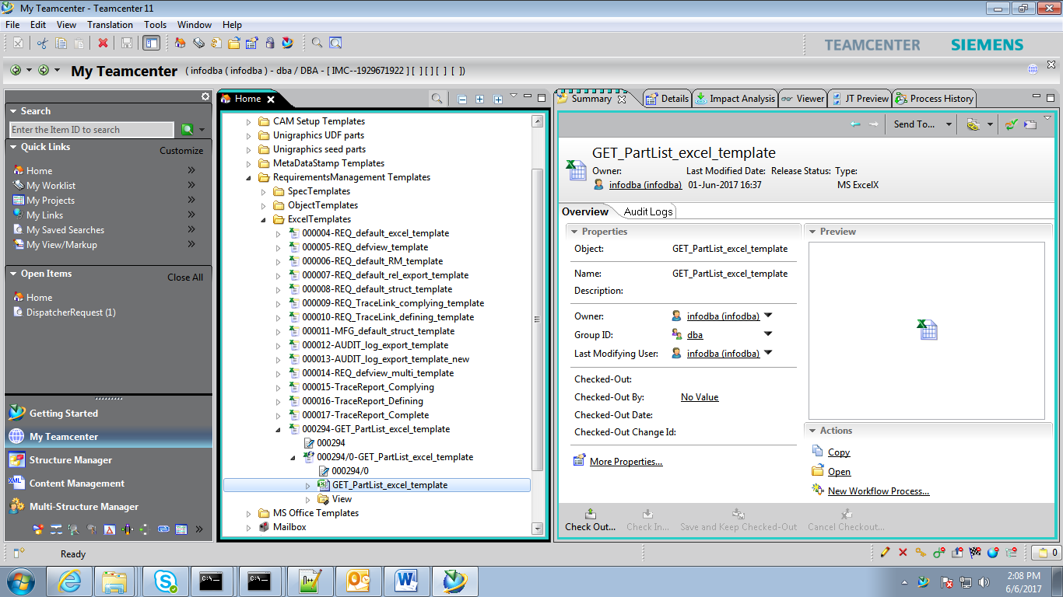

## Indexer Configuration:

This is enable Dataset Full Text Search functionality

1. Open %TC_ROOT%\TcFTSIndexer\conf\TcFtsIndexer_objdata.properties
2. update the value as **indexDatasetFileContent=true**

# Active Workspace Configurations (AWC)

**Tile Configuration:** 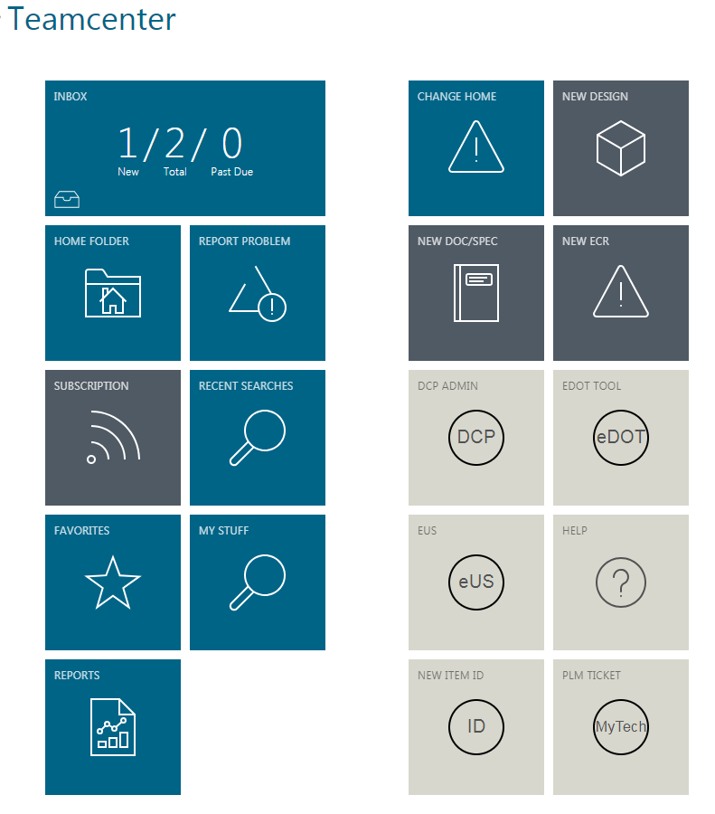

**Config files:**

Tile configuration is available in SVN repository under, get_transplm_trunk\post-bmide\configuration\awctile\get6aws2GatewayTilesCots_Install.xml

SVG image files are available in SVN repository, under get_transplm_trunk\post-bmide\configuration\awctile\icons

**Regenerate awc.war file:**

1. Copy the SVG files from SVN to %TC_ROOT%\aws2\stage\src\image

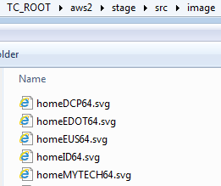

1. Edit module.json file in %TC_ROOT%\aws2\stage\repo\gwt\tc-aw-framework

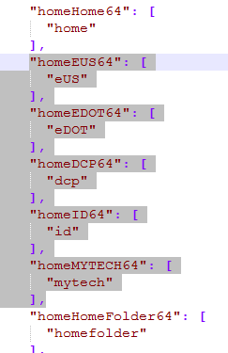

1. Add the below lines in the module.json file.

"homeEUS64": [

"eUS"

],

"homeEDOT64": [

"eDOT"

],

"homeDCP64": [

"dcp"

],

"homeID64": [

"id"

],

"homeMYTECH64": [

"mytech"

],

1. Regenerate the awc.war file by executing below utility.

%TC_ROOT%\aws2\stage\gwtcompile.cmd

1. Copy the awc.war file to JBOSS deployment folder.

**Re-create Tile Collection in Teamcenter:**

1. Search for the type ‘Tile Collection’ in Teamcenter.
2. **Delete** all the Tile collections from the search results.
3. Run the below utility with the attached input file. This utility will recreate the Tile collection with custom definition.

%TC_BIN%\aws2_install_tilecollections.exe -u=infodba -p=<password> -g=dba -mode=add -file= get6aws2GatewayTilesCots_Install.xml

**Update Tile Definition (if required):**

1. Search for the custom Tile Templates

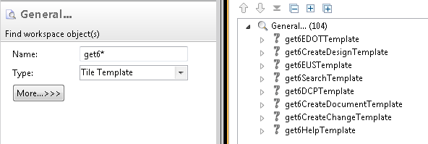

1. Edit the Tile Templates and update the URLs as per the target environment.

Example:

eDOT url: <http://vdcgld02589.ics.cloud.ge.com:8080/GETDesignReleasePLM/> (DEV INT)

eUS url: <https://eus.trans.ge.com/>

DCP url: <http://devssogets.trans.ge.com/DCP/DCPAdmin/DCPAdminMain.jsp>

Help url: <http://sc.ge.com/@getplm>

MyTech URL: <https://mytech.ge.com/help-and-support/business-application-support?q=trans-plm-prod>

New Item ID URL: <http://supportcentral.ge.com/ProcessMaps/form_new_request.asp?prod_id=381658&form_id=998931&node_id=2764210&map_id=&reference_id=&reference_type>

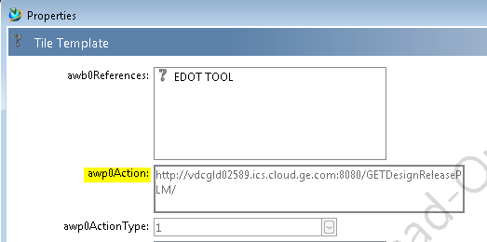

# AWC Login Page Configurations

1. **Replace ssobackground.jpg:**

* Image ssobackground.jpg 
* Open the tc-aw-framework_native.zip in %TC_ROOT%\aws2\ stage\repo\gwt\tc-aw-framework", copy image “ssobackground.jpg” from SVN to “\assets\images" folder in tc-aw-framework_native.zip

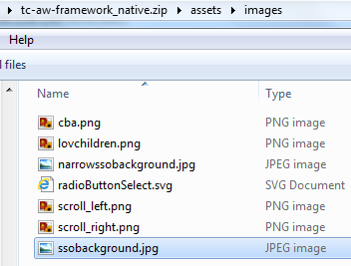

1. **Edit login.html located inside directory “assets\html”**:

* copy the below content

<div class="ge-legal-notice ng-binding">

<hGE>GE TECHNICAL DATA RIGHTS</hGE>

<p>

Technical data(as recorded in any media) and the information they contain are the property of General Electric Company, which reserves all rights therein (including all copyrights). Technical data and information are made available solely on the understanding that you and your company will be acting pursuant to GE's interests in all your uses of technical data and information, and will not use this technical data and information for any purpose detrimental to GE's interest nor disclose the same to others without the prior written permission of GE. You further agree to return this technical data, together with all copies and derivatives incorporating GE information upon request from GE.

</p>

<hGE>INTELLECTUAL PROPERTY STATEMENT</hGE>

<p>

GE Transportation Teamcenter PLM system content includes data that is classified as GE Restricted. You must ensure that you are complying with relevant GE policies that limit the sharing of information (available at http://integrity.ge.com ) including but not limited to Intellectual Property. GE standards for data classification are available at http://security.ge.com/toolkit-protect-ge-information/.

</p>

<hGE>EXPORT COMPLIANCE OF TECHNICAL DATA</hGE>

<p>

Transfer of Technical Data by any means to a Non-US Person(s), whether in the United States or abroad, without the proper U.S. Government authorization (e.g., License, exemption, NLR, etc.), is strictly prohibited.

You must ensure that you are complying with GE policies regarding International Trade Controls laws (available at http://corp.home.ge.com/portal/site/transportation/menuitem.5ebbfa8b2ef96cebc6 ce5a10edc1aa30 ). If you have additional questions, refer to GE Transportation’s - Export Control Compliance Web Page.

</p>

<hGE>TECHNICAL DATA REVISION DISCLAIMER</hGE>

<p>

GE is continually revising its technical data to reflect its current designs and practices, and expects that you (and you agree that you) will monitor this Site for GE's current technical data revisions and rely only on such technical data. Accordingly, GE does not warrant the accuracy or completeness of any previous technical data revisions and expressly disclaims any liability or responsibility for your use of any GE technical data, for which a more current version of that technical data is available at the time of your use of the technical data.

</p>

<hGE>TECHNICAL DATA USAGE TRACKING STATEMENT</hGE>

<p>

To monitor the use of GE's technical data at this Site, GE reserves the right to track and store data relating to the identity of persons accessing technical data in this Site, the time of such access and the technical data accessed. GE further reserves the right to use such information in any legal proceeding to enforce its rights.

By Accessing the GE Transportation Teamcenter PLM system, I hereby agree to GE Transportation Systems above-noted terms and conditions for the viewing and use of GE Technical Data. To Access the GE Transportation Teamcenter PLM system, click the ‘Sign in’ Button.

</p>

</div>

and paste inside class “aw-session-tcLoginView” as shown below

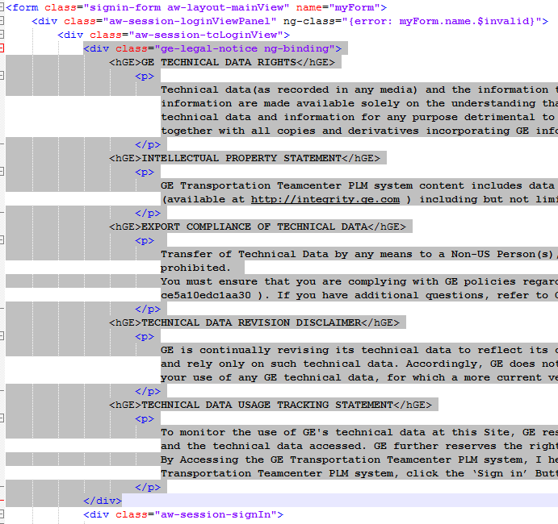

1. **Edit session.css located inside “assets” folder:**

* Make changes in line 42 as highlighted in below screenshot (change left margin from 40% to 63%)

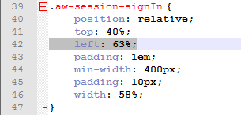

* Copy the below lines

background-size: cover;

background-repeat: no-repeat;

background-position: center center;

and paste inside “aw-session-tcLoginView” as shown below:

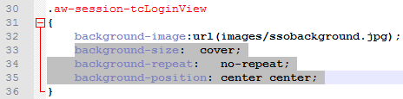

* Copy below lines

.ge-legal-notice

{

position:fixed;

top:0%;

left:0%;

width:25%;

height:100%;

padding: 1em;

color:white;

font-size: 0.71vw;

line-height: 425%;

text-align: justify;

text-justify: inter-word;

}

hGE

{

text-decoration: underline;

color:white;

font-family:serif;

}

p

{ font-family:serif;

color:white;

line-height: 130%;

}

And paste at the position as shown below

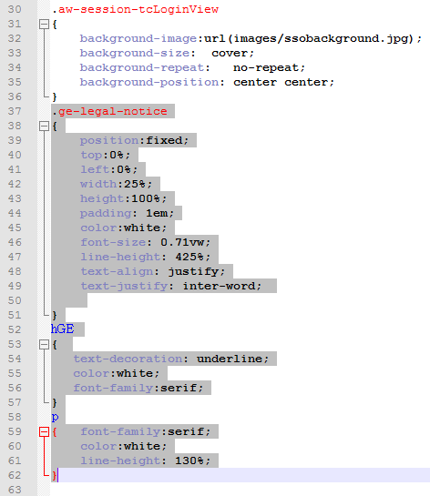

1. **Edit ui-lightTheme.css located inside “assets” folder:**

* Copy below lines

.ge-legal-notice

{

color: #ffffff;

background-color: rgba(2, 2, 2, 0.5);

}

And paste inside ui-lightTheme.css as shown below

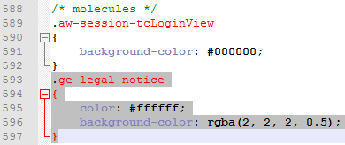

1. Regenerate the awc.war file by executing below utility. %TC_ROOT%\aws2\stage\gwtcompile.cmd

**Deployment Steps:**

* Shut down JBOSS
  + Remove 'awc.war' from %JBOSS_HOME%\standalone\deployments
  + Remove ‘awc.war.deployed’ from %JBOSS_HOME%\standalone\deployments
* Start JBOSS
* Deploy newly generated 'awc.war' by copying and pasting it from “%TC_ROOT%\....\stage\out” into

“%JBOSS_HOME%\standalone\deployments”

**Confirmation:**

* Check on JBOSS Command prompt that 'awc.war' is deployed
* Check directory “%JBOSS_HOME%\standalone\deployments” for ‘awc.war.deployed’
* Delete browser cache and temp files and see result

# Control Card – RIN Database Configurations

**Control card RINS database credentials for DEV-SIT, Training and QA. Below lines need to be added to tcdata\tnsnames.ora file**

tsimdev1 =   
    (DESCRIPTION =   
       (ADDRESS_LIST =    
          (ADDRESS = (PROTOCOL = TCP)(HOST = tsimdev1.tsg.ge.com)(PORT = 1521))  
       )  
       (CONNECT_DATA =      (SERVER = DEDICATED)      (SERVICE_NAME = tsimdev1 )  
       )  
    )

**Control card RINS database credentials for PROD. Below lines need to be added to tcdata\tnsnames.ora file**

tsimprd1 =   
    (DESCRIPTION =   
       (ADDRESS_LIST =    
          (ADDRESS = (PROTOCOL = TCP)(HOST = tsimprd1.tsg.ge.com)(PORT = 1521))  
       )  
       (CONNECT_DATA =      (SERVER = DEDICATED)      (SERVICE_NAME = tsimprd1)  
       )  
    )

**Password Encryption for SIT and QA environments:**

1. Encryption of **GETS_RIN DEV** database password:

* Build the utility from the below SNV location in Linux environment.
* Run the utility in the command prompt as below:

gets_encryption /e <OriginalPassword>

Encrypted password will be printed as an output in the command prompt

1. After Preferences exported, search for below preference in RAC.

GET.INTEGRATION.RIN.CREDENTIALS

The value shows in preference as: gets_rin:<getsRinPwd>:<RINSDEVSID>

Change the above yellow highlighted <getsRinPwd>to step1’s encrypted value

Change the < RINSDEVSID> to tsimdev1

and Save.

**Password Encryption for PROD environment:**

1. Encryption of **GETS_RIN PROD** database password:

* Build the utility from the below SNV location in Linux environment.
* Run the utility in the command prompt as below:

gets_encryption /e <OriginalPassword>

Encrypted password will be printed as an output in the command prompt

1. After Preferences exported, search for below preference in RAC.

GET.INTEGRATION.RIN.CREDENTIALS

The value shows in preference as: gets_rin:<getsRinPwd>:<RINSDEVSID>

Change the above yellow highlighted <getsRinPwd>to step1’s encrypted value

Change the < RINSDEVSID> to tsimprd1

and Save.

# Dispatcher Configurations

## Dispatcher Scheduler

**File to be Copied:** Transscheduler.properties

**SVN Location:** transplm_tag/post-bmide/code/dispatcher/scheduler/conf/

**Dispatcher location:** DISP_ROOT\Scheduler\conf\

Update below proper values for CHANGE_ME in “transscheduler.properties” file.

* LogVolumeLocation=CHANGE_ME
* AdminEmail=CHANGE_ME
* CCEmail=CHANGE_ME

## Dispatcher Module

### Module1: Cincinnati Module (Server)

**Pre-requisites: NX and TcViz**

**Files to be Copied:** translator.xml & transmodule.properties

**SVN Location:** transplm_tag/post-bmide/code/dispatcher/module/conf/CinciModule/

**Dispatcher Location:** DISP_ROOT\Module\conf

#### Custom Translators:

1. **Translator: get6BomIndex**

Copy and paste get6BomIndex folder from SVN to DISP_ROOT\Module\Translators

**SVN Location**: transplm_tag/post-bmide/code/dispatcher/module/translators/CinciModule

* Open get6BomIndex.bat file inside get6BomIndex folder
* Change all “ChangeMe” to appropriate values
  + TC_ROOT
  + TC_DATA
  + BOMIndex utility arguments. Ex: start %TC_ROOT%\bin\bomindex_admin.exe -u=ChangeMe -p=ChangeMe -g=ChangeMe -inputfile=%p% -function=create -logfile=ChangeMe.log

1. **Translator: getpreviewservice**

Copy and paste getpreviewservice folder from SVN to DISP_ROOT\Module\Translators

**SVN Location**: transplm_tag/post-bmide/code/dispatcher/module/translators/CinciModule

* Open getpreviewservice.bat file inside getpreviewservice folder
* Update the values for below parameters
  + LM_LICENSE_FILE
  + TC_VVCP

1. **Translator: GETNxToPvDirect**

Copy and paste getnxtopvdirect folder from SVN to DISP_ROOT\Module\Translators

**SVN Location**: transplm_tag/post-bmide/code/dispatcher/module/translators/CinciModule

* Open getnxtopvdirect.bat file from getnxtopvdirect folder
* Update the values for below parameters
  + UGII_BASE_DIR
  + SPLM_LICENSE_SERVER
  + TC_ROOT
  + TC_DATA

1. **Translator: nxtopvdirect (OOTB)**

This translator is being used by Baseline and quick release workflows and hence few parameters should match with **GETNxToPvDirect** translation.

Copy and paste the below settings in DISP_ROOT\Module\Translators\nxtopvdirect.bat

* + set UGII_PV_TRANS_MODEL_ANN=1
  + set UGII_GENERATE_MULTI_CAD_JT=1
  + set JTK_USE_MASTER_NOTATION_PMI_FORMAT=1
  + set JTK_XLATR_ENABLE_PERSISTED_INSTANCE_ID=1

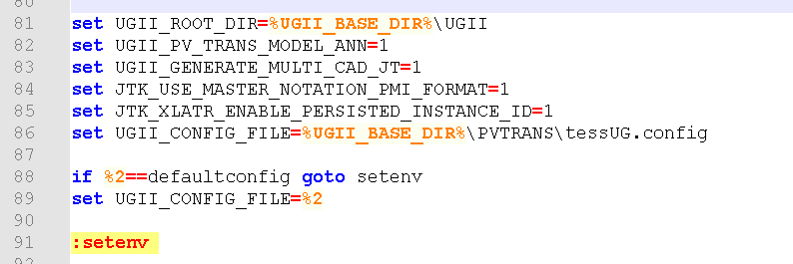

1. **Translator: get6NXPDF**

Copy and paste “acscli” folder from SVN to any standard location in dispatcher module machine (Ex: C:\Install\Anark)

**SVN Location**: /transplm_tag/post-bmide/configuration/anark

* Open ACSCLI.exe.config file under acscli folder
* Update the Servername with Anark Server name.
* DEV: vdcgwd02306.logon.ds.ge.com
* QA : eriget3d001qv.logon.ds.ge.com

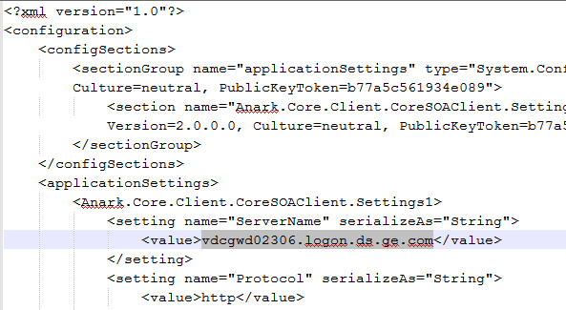

Copy and paste “get6NXPDF” folder from SVN to DISP_ROOT\Module\Translators

**SVN Location**: transplm_tag/post-bmide/code/dispatcher/module/translators/CinciModule

* Open get6NXPDF.bat file from get6NXPDF folder
* Update below Values
* TC_ROOT
* TC_DATA
* SPLM_LICENSE_SERVER
* UGII_BASE_DIR
* TC_LOGIN_STRING – Update with infodba username and password
* ACSCLI_INSTALL_DIR – Anark install Folder
* ACSCLI_COPYTO_DIR - <dsroot>\Stage\DC\
* z_path – Install location 7-zip software - C:\PROGRA~1\7-Zip\
* For Dev
* ACSCLI_PART_RECIPE - A39C9B51-C3B1-4997-9395-F6B868256569
* ACSCLI_ASSY_RECIPE - AD0C0B4A-B4F8-4012-B901-65266B8FDE49
* ASSY_PDF_TEMPLATE - \\VDCGWD02306.logon.ds.ge.com\Anark_Staging\PDFTemplate\GE_Transportation_Assy_Template.pdf
* PART_PDF_TEMPLATE -\\VDCGWD02306.logon.ds.ge.com\Anark_Staging\PDFTemplate\GE_Transportation_Part_Template.pdf
* ACSCLI_OUT_DIR - \\VDCGWD02306.logon.ds.ge.com\Anark_Staging\ScratchFiles\
* ACSCLI_IMPORT_DATA - \\VDCGWD02306.logon.ds.ge.com\Anark_Staging\ScratchFiles\PartsList.xlsx
* zip_output_path - \\VDCGWD02306.logon.ds.ge.com\Anark_Staging\ScratchFiles\
* For QA
* ACSCLI_PART_RECIPE - faf85020-d0b1-4b80-90c0-816d04f74d8a
* ACSCLI_ASSY_RECIPE - 2f5069cd-3488-4e30-ae93-10a16a0ac24a
* ASSY_PDF_TEMPLATE - \\eriget3d001qv.logon.ds.ge.com\Anarak_Staging\PDFTemplate\GE_Transportation_Assy_Template.pdf
* PART_PDF_TEMPLATE -\\eriget3d001qv.logon.ds.ge.com\Anarak_Staging\PDFTemplate\GE_Transportation_Part_Template.pdf
* ACSCLI_OUT_DIR - \\eriget3d001qv.logon.ds.ge.com\Anarak_Staging\ScratchFiles\
* ACSCLI_IMPORT_DATA -\\eriget3d001qv.logon.ds.ge.com\Anarak_Staging\ScratchFiles\PartsList.xlsx
* zip_output_path - \\eriget3d001qv.logon.ds.ge.com\Anarak_Staging\ScratchFiles\

Note: In case of 7 zip s/w not available on the dispatcher server and winzip exists then use winzip_path path to winzip install location

* **Excel Enable Macro**
* Open Excel on Dispatcher server machine (where module configured).
* Go to File - > Options
* Go to Trust Center
* Click Trust Center Settings…
* Macro Settings and Select Enable all macros options 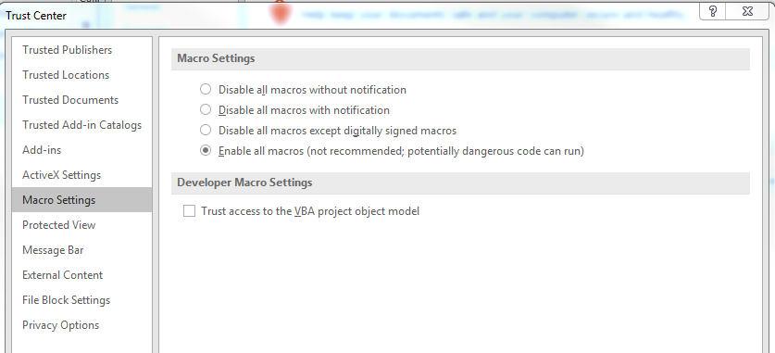

Click OK to save the Settings

1. **Translator: get6UGEXPDF**

Copy and paste “acscli” folder from SVN to any standard location in dispatcher module machine (Ex: C:\Install\Anark)

**SVN Location**: /transplm_tag/post-bmide/configuration/anark

* Open ACSCLI.exe.config file under acscli folder
* Update the Servername with Anark Server name.
* DEV: vdcgwd02306.logon.ds.ge.com
* QA : eriget3d001qv.logon.ds.ge.com



Copy and paste “get6UGEXPDF” folder from SVN to DISP_ROOT\Module\Translators

**SVN Location**: transplm_tag/post-bmide/code/dispatcher/module/translators/CinciModule

* Open get6UGEXPDF.bat file from get6UGEXPDF folder
* Update below Values
* TC_ROOT
* TC_DATA
* SPLM_LICENSE_SERVER
* UGII_BASE_DIR
* TC_LOGIN_STRING – Update with infodba username and password
* ACSCLI_INSTALL_DIR – Anark install Folder
* ACSCLI_COPYTO_DIR - <dsroot>\Stage\DC\
* z_path – Install location 7-zip software - C:\PROGRA~1\7-Zip\
* For Dev
* ACSCLI_PART_RECIPE - A39C9B51-C3B1-4997-9395-F6B868256569
* ACSCLI_ASSY_RECIPE - AD0C0B4A-B4F8-4012-B901-65266B8FDE49
* ASSY_PDF_TEMPLATE - \\VDCGWD02306.logon.ds.ge.com\Anark_Staging\PDFTemplate\GE_Transportation_Assy_Template.pdf
* PART_PDF_TEMPLATE -\\VDCGWD02306.logon.ds.ge.com\Anark_Staging\PDFTemplate\GE_Transportation_Part_Template.pdf
* ACSCLI_OUT_DIR - \\VDCGWD02306.logon.ds.ge.com\Anark_Staging\ScratchFiles\
* ACSCLI_IMPORT_DATA - \\VDCGWD02306.logon.ds.ge.com\Anark_Staging\ScratchFiles\PartsList.xlsx
* zip_output_path - \\VDCGWD02306.logon.ds.ge.com\Anark_Staging\ScratchFiles\
* For QA
* ACSCLI_PART_RECIPE - faf85020-d0b1-4b80-90c0-816d04f74d8a
* ACSCLI_ASSY_RECIPE - 2f5069cd-3488-4e30-ae93-10a16a0ac24a
* ASSY_PDF_TEMPLATE - \\eriget3d001qv.logon.ds.ge.com\Anarak_Staging\PDFTemplate\GE_Transportation_Assy_Template.pdf
* PART_PDF_TEMPLATE -\\eriget3d001qv.logon.ds.ge.com\Anarak_Staging\PDFTemplate\GE_Transportation_Part_Template.pdf
* ACSCLI_OUT_DIR - \\eriget3d001qv.logon.ds.ge.com\Anarak_Staging\ScratchFiles\
* ACSCLI_IMPORT_DATA -\\eriget3d001qv.logon.ds.ge.com\Anarak_Staging\ScratchFiles\PartsList.xlsx
* zip_output_path - \\eriget3d001qv.logon.ds.ge.com\Anarak_Staging\ScratchFiles\

For variable PL_FILE: Set to ugexport.pl if the Dispatcher and Anark Staging locations are different. It has to be set to ugexport_shared_location.pl if the Dispatcher and Anark Staging locations are the same/shared.

Note: In case of 7 zip s/w not available on the dispatcher server and winzip exists then use winzip_path path to winzip install location

* **Excel Enable Macro**
* Open Excel on Dispatcher server machine (where module configured).
* Go to File - > Options
* Go to Trust Center
* Click Trust Center Settings…
* Macro Settings and Select Enable all macros options 
* Click OK to save the Settings

### Module2: Erie Module (Local)

#### Pre-requisites

* Dispatcher module should be configured in separate Windows Box and should be located in Erie (as DRS NAS is located in Erie)
* OS User of the module windows machine should have read/write access to DRS NAS locations (\\emcdm3.trans.ge.com\DWGRET and \emcdm3.trans.ge.com\ugiman\ug\utilities\bct_xml\files_for_drs)
* OS User of the module machine Should have read/Write access to \\toaster4\wip\nest7\dxf to push the DXF files

#### Module Configurations

* Copy the translator.xml & transmodule.properties files from SVN to dispatcher module conf folder
  + **SVN Location:** transplm_tag/post-bmide/code/dispatcher/module/conf/ErieModule
  + **Dispatcher Location:** DISP_ROOT\Module\conf
* Modify below properties in \Disp_root\Module\conf\Transmodule.properties
* Scheduler.URL=rmi://TCSERVER:2001
* FileServer.URL=http://TCSERVER:8080/DispatcherServer/FileServer
* LogVolumeLocation=C:/AWS/GETS_TC11/dispatcher/Logs

#### Custom Translators

1. **Translator: get6BctPush**

Copy and paste “get6BctPush” folder from SVN to DISP_ROOT\Module\Translators

**SVN Location**: transplm_tag/post-bmide/code/dispatcher/module/translators/ErieModule

* Open get6BctPush.sh file from get6BctPush folder
* Update the values (ChangeMe to proper) for below parameters
  + SRCOUTPUTDIR
  + ENVIRONMENT

**Batch Files Modification As per Environment**

**Non-Prod Environments**:

1. SRCOUTPUTDIR variable:

Create a folder called BCT in the module machine for get6BctPush translator and set the location as

set SRCOUTPUTDIR = <new local location>

2. ENVIRONMENT variable:

set ENVIRONMENT = DEVINT or SIT or QA (keep any of the value based on Environment)

**Production**:

set SRCOUTPUTDIR = \\emcdm3.trans.ge.com\ugiman\ug\utilities\bct_xml\files_for_drs\

set ENVIRONMENT= Production

1. **Translator: get6DrsPush**

Copy and paste “get6DrsPush” folder from SVN to DISP_ROOT\Module\Translators

**SVN Location**: transplm_tag/post-bmide/code/dispatcher/module/translators/ErieModule

* Open get6DrsPush.sh file from get6DrsPush folder
* Update the values (ChangeMe to proper) for below parameters
  + SRCOUTPUTDIR
  + ENVIRONMENT

**Batch Files Modification As per Environment**

**Non-Prod Environments**:

1. SRCOUTPUTDIR variable:

Create a folder called DRS in the module machine for get6DrsPush translator and set the location

Set SRCOUTPUTDIR = <new local location>

2. ENVIRONMENT variable:

set ENVIRONMENT = DEVINT or SIT or QA (keep any of the value based on Environment)

**Production**:

set SRCOUTPUTDIR = \\emcdm3.trans.ge.com\DWGRET\

set ENVIRONMENT= Production

1. **Translator: get6DxfPush**

Copy and paste “get6DxfPush” folder from SVN to DISP_ROOT\Module\Translators

**SVN Location**: transplm_tag/post-bmide/code/dispatcher/module/translators/ErieModule

* Open get6DxfPush.sh file from get6DrsPush folder
* Update the values (ChangeMe to proper) for below parameters
  + SRCOUTPUTDIR

**Batch Files Modification As per Environment**

**Non-Prod Environments**:

1. SRCOUTPUTDIR variable:

Create a folder called **DXF** in the module machine for get6DxfPush translator and set the location

Set SRCOUTPUTDIR = <new local location>

**Production**:

set SRCOUTPUTDIR = \\toaster4\wip\nest7\dxf

## Dispatcher Client

1. Copy the Service.properties file from SVN to dispatcher conf folder
   * **SVN Location:** transplm_tag/post-bmide/code/dispatcher/client/conf
   * **Dispatcher Location**: DISP_ROOT\ DispatcherClient\conf
2. Copy the all libraries from SVN to dispatcher library
   * **SVN Location:** transplm_tag/post-bmide/code/dispatcher/client/lib
   * **Dispatcher Location**: DISP_ROOT\ DispatcherClient\lib
3. Open service.properties file and update the values for below parameters
   * Service.Tc.Host=<IPADDRESS of host>
   * Service.Tc.Marker=tc_DispatcherClient
   * Service.Tc.User=dcproxy
   * Service.Tc.Group=dba
   * Service.Tc.Port=<PORT>
   * Service.Email.AdminEmailId=dcproxy@ge.com
   * Service.Email.AdminEmailIdDelimiter=,
   * Service.Email.SMTPServerName=po.ae.ge.com
   * Service.Email.SendUserEmailOnError=1
   * [Service.Email.SenderId=dcproxy@ge.com](mailto:Service.Email.SenderId=dcproxy@ge.com)
4. Add below properties in dsroot\DispatcherClient\conf\DispatcherClient.config
   * FileServer.URL=http://TCSERVER:8080/DispatcherServer/FileServer
   * DispatcherServer.URL=http://TCSERVER:8080/DispatcherServer/DispatcherServer
5. Modify below properties in AdminClient \dsroot\AdminClient\conf\transclient.properties

* FileServer.URL=http://TCSERVER:8080/DispatcherServer/FileServer

## Dispatcher WAR deployment in JBOSS

Changes needed in Jboss server machine

DispatcherServer.config file: Add scheduler IP address, then keep the file in Jboss server where dispatcherserver.war is deployed

The newer versions of JBoss require dependencies defined in JBoss modules. Since we make RMI calls to Scheduler we need to add dependency on

com.sun.jndi.rmi.registry.RegistryContextFactory

To add this dependency

* Open jboss-as-7.1.1.Final\modules\sun\jdk\main\module.xml

Add <path name="com/sun/jndi/rmi/registry"/> as shown below

<dependencies>

<system export="true">

<paths>

<path name="com/sun/jndi/rmi/registry"/>

* Open jboss-as-7.1.1.Final\modules\org\jboss\as\naming\main\module.xml

Add <module name="sun.jdk"/> as shown below

<dependencies>

<module name="javax.api"/>

<module name="sun.jdk"/>

* Start JBoss and run Dispatcher.

## Starting Dispatcher Services

Start the Scheduler, Module and DispatcherClient in sequence to make the Schedule to be prepared for PDF conversion.

* %Dispatcher_Root%\Scheduler\bin\runscheduler.bat
* %Dispatcher_Root%\Module\bin\runmodule.bat
* %Dispatcher_Root%\DispatcherClient\bin\runDispatcherClient.bat

# Anark Configurations

Open Anark Workstation and open the project default or Parts list

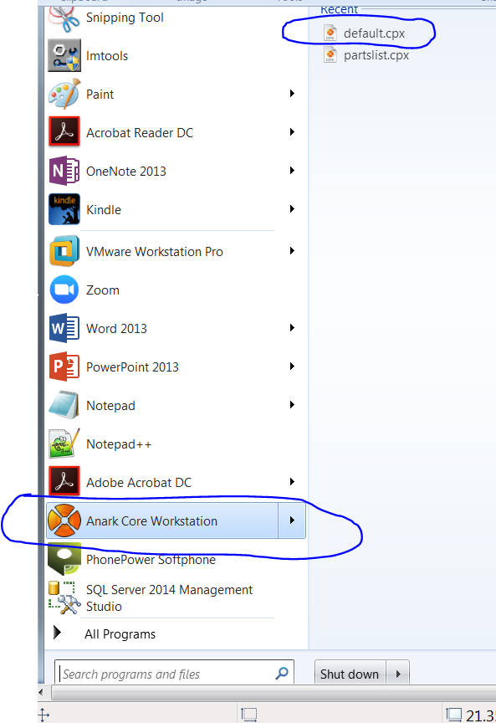

Make sure the server name settings are proper

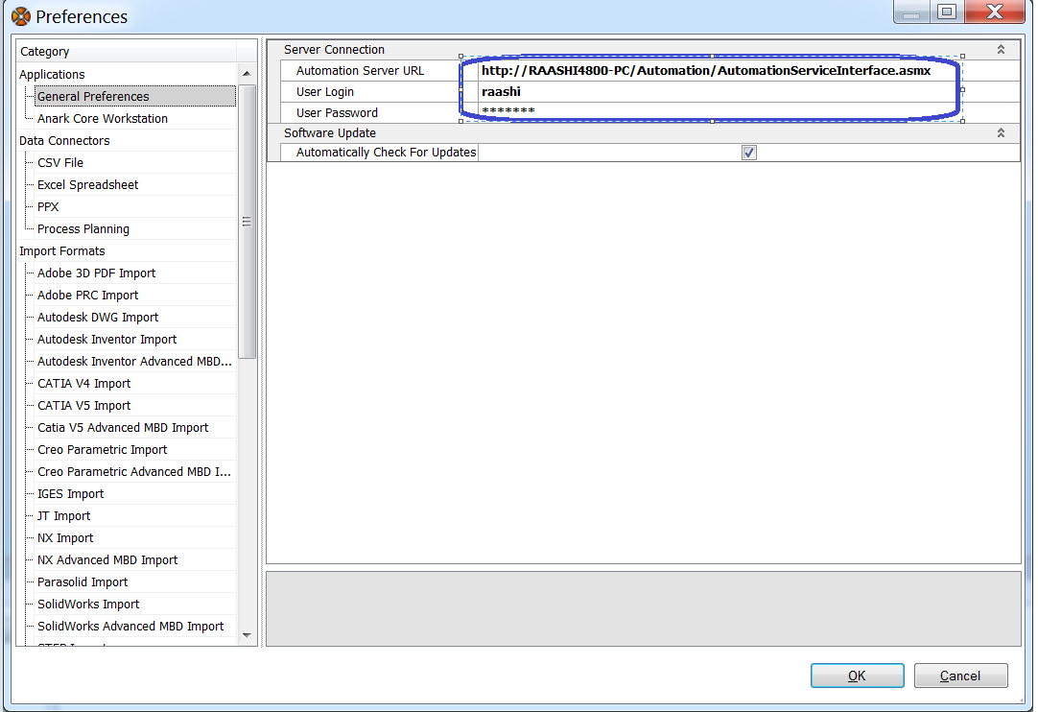

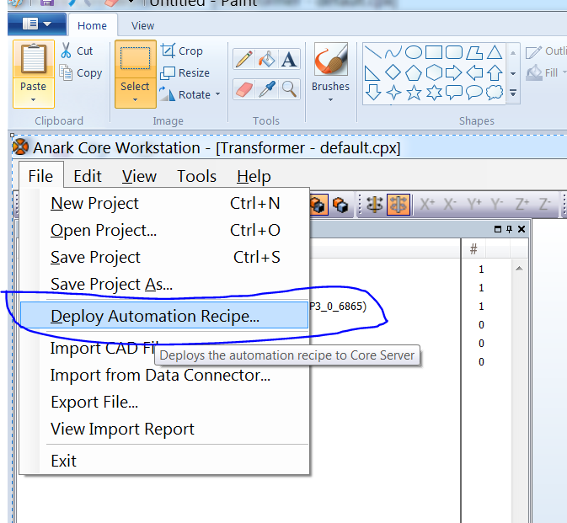

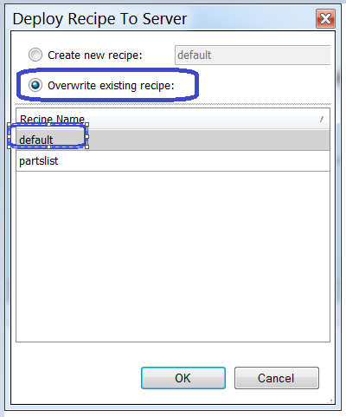

Make sure Anark Core Server is running

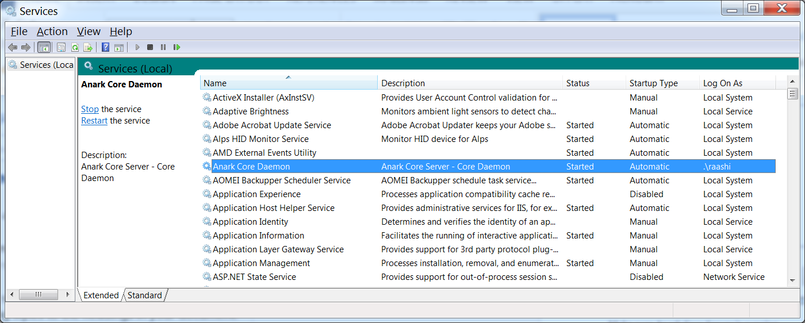

**Query for knowing recipe id’s**

select * from recipes;

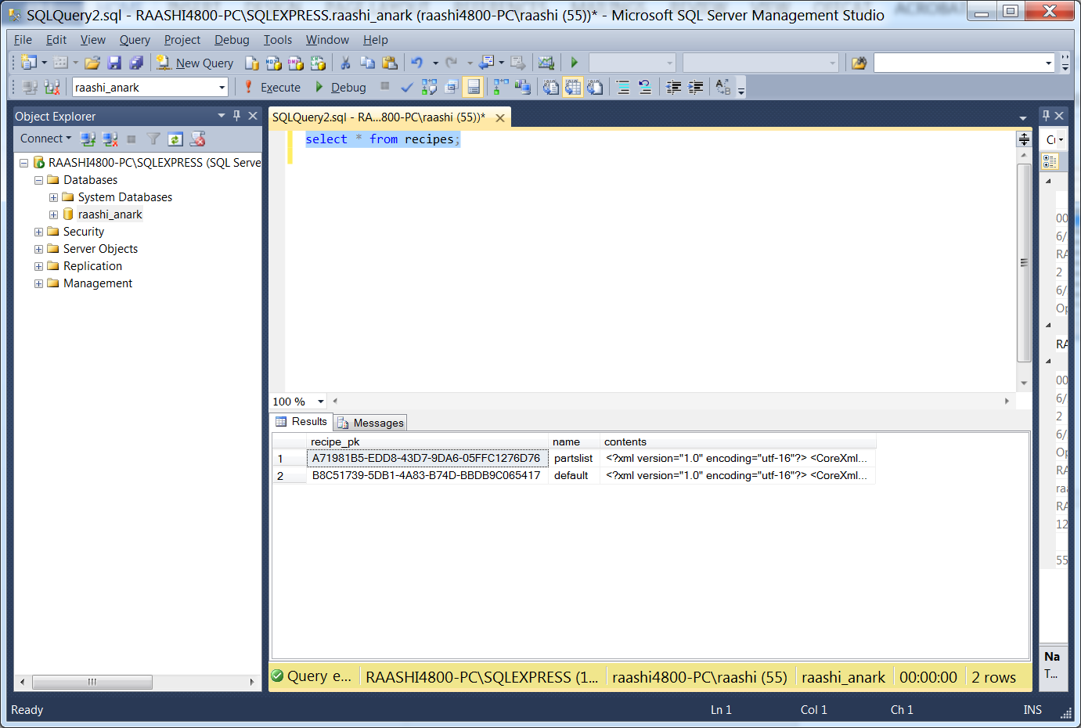

You have option of overwriting or creating new one.

Anark Workstation generates new recipe id when deployed to different environments.

The deployment procedure is also briefed in product documentation file called “Anark Core Workstation User Reference.pdf”

**Anark Templates:**

Copy below templates from SVN Location **post-bmide\configuration\anark\templates** to Anark Staging Area.

* GE_Transportation_Part_Template.pdf
* GE_Transportation_Assy_Template.pdf

**DEV Anark Staging** : \\VDCGWD02306.logon.ds.ge.com\Anark_Staging\PDFTemplate

**QA Anark Staging** : \\eriget3d001qv.logon.ds.ge.com\Anarak_Staging\PDFTemplate

# CAD2CAM Configurations

**4T RAC Client Configuration**

* Prior to distributing the Client install to user make sure below entries to portal.bat file available.

call C:\Siemens\NX100_Cust_tools\NX_Apps_Selector.bat

set UGII_UGMGR_HTTP_URL=CHANGEME_TEAMCENTER_4T_URL

set UGII_UGMGR_COMMUNICATION=HTTP

Example Snapshot for reference:

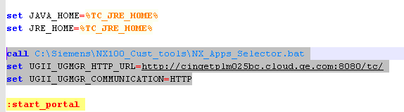

* Check CAM Custom Plugin is available as part of Client install distribution.

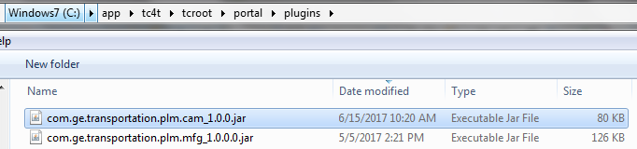

**RIN Database ‘APPS’ User Password Encryption and Preference update**

1. Encryption of **APPS** database password:

* Build the utility **gets_encryption** from the below SNV location in Linux environment.

plm20_development/post-bmide/code/get_utils/Encryption

* Run the utility in the command prompt as below:

**gets_encryption /e <OriginalPassword>**

Encrypted password will be printed as an output in the command prompt

1. Update the Preference with encrypted password (Refer Preference Change section in this document)

# T4O Configurations

**T4O configuration - one time activity**

1. GS – t4xcust.unix -TC variables

Go to /app/t4o/1123/t4o_apps_Linux_86_64/etc then update the values for each environment variables

TC_ROOT=/app/tc11/tcroot/

Export TC_ROOT

TC_DATA=/tc/tcdata

Export TC_DATA

. $TC_DATA/tc_profilevars

**Add below entry:**

TP_T4XINSTL=/app/t4o/1123/t4o_apps_Linux_x86_64

export TP_T4XINSTL

**Enable below entries:**

TP_T4XLIB=$TP_T4XINSTL/lib64

export TP_T4XLIB

TP_UTMP=/tmp

export TP_UTMP

1. Pool Manager entry

Below entry should be added in Pool Manager “ rc.tc.mgr_TransPLM_PROTO10_Pool”

TP_T4XINSTL=/app/t4o/1123/t4o_apps_Linux_x86_64;export TP_T4XINSTL

.$TP_T4XINSTL/etc/t4x_env.sh

$TP_T4XINSTL/bin64/restart

1. Add below entries in tc_profilevars.sh(/tc/tcdata)

TP_T4XINSTL=/app/t4o/1123/t4o_apps_Linux_x86_64;export TP_T4XINSTL. $TP_T4XINSTL/etc/t4x_env.sh

Enable TC_TMP_DIR variable entry: TC_TMP_DIR=/tmp

1. Batch Job configuration – please follow the instructions provided in “Teamcenter_Gateway-JobManagementGuide-V1123.pdf” document.

* Job Server configuration
* Job Agent configuration
* At the end of configuration – all the jobs submitted from Teamcenter should start without delay.

# IDM Configurations

**Purpose:**

Add idm_sysuser as team administrator to appropriate projects.

**Change Required:**

1. Login to Teamcenter as infodba
2. Open Project Administration.
3. Add idm_sysuser to all Engineering/Supply Chain Security projects as Team Administrator. (example shown below, repeat for all appropriate projects)

All engineering security projects – Projects with suffix (C), (R); Supply chain projects – GRR, GRV

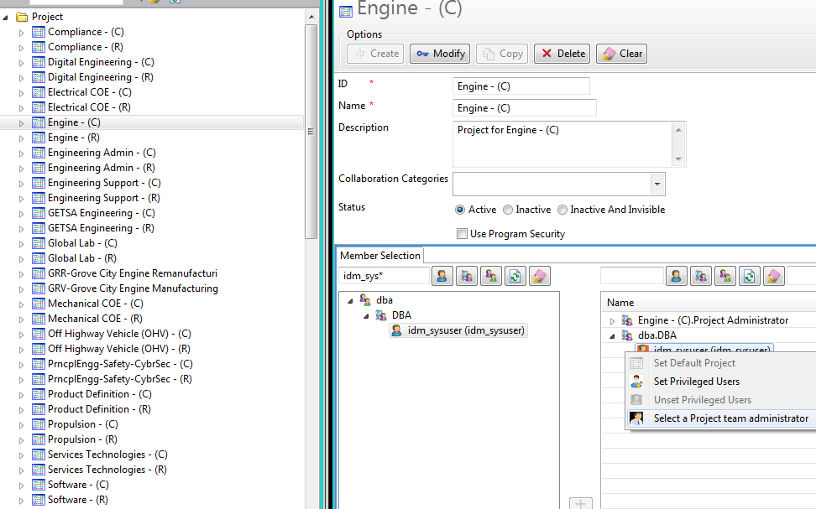

# NX Configurations

UDF STRUCTURE:

GET_UDF folder should be under infodba home folder. This should be done manually with infodba/dba account after seed parts are imported.

1. Login to Teamcenter portal as **infodba** user
2. Using General search, search for the folder **GET_UDF**

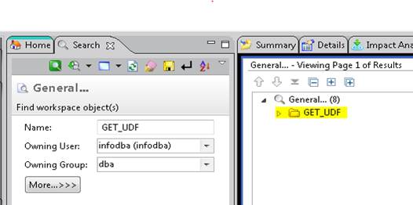

1. From the search results copy the folder **GET_UDF** and paste it under **infodba home** as shown in the image below.

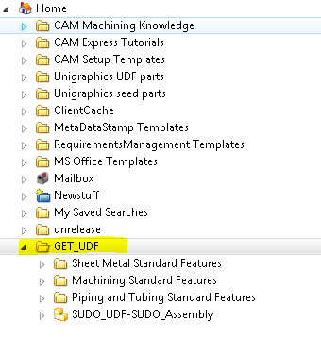

SEED PARTS PREVIEW:

1. Build the below code and run the executable to fix the seed parts preview issue in NX.

Source: update_qaf_ref.c

SVN location: plm20_development/post-bmide/code/get_utils/nx_preview_util

Usage: **update_qaf_ref -u=infodba -p=<infodba password> -g=dba -in_file=seed_preview_input.txt**

Input file: seed_preview_input.txt

SVN location: plm20_development/post-bmide/configuration/nx_seed_preview

1. Copy the folder plm20_development/post-bmide/configuration/nx_seed_preview to any temp location.
2. Go to the folder nx_seed_preview copied in the previous step
3. Run the update_qaf_ref utility as mentioned in the step 1
4. Please check the syslog for any errors.

# LOV Management

**Source code location:**

Utility source code is available in SVN at the below location.

/get_transplm_trunk/post-bmide/code/get_utils/AdminLOVTCXMLCreationUtil

**Jar file Location:**

After compiling the source code using ANT build script, Jar file will be generated at the below location

/post-bmide/code/get_utils/AdminLOVTCXMLCreationUtil/dist/ AdminLOVTCXMLCreationUtil.jar

**Sample Files**

Below Sample Files are included in the **tag/post-bmide/configuration/reference_documents** location.

1. ats_primary_project_table_83.xls (input xls contains list of primary project numbers extracted from ATS database)
2. ats_secondary_project_table_83.xls (input xls contains list of secondary project numbers extracted from ATS database)
3. PrimProjNumbersLOV.xls (sample output file)
4. SecProjNumbersLOV.xls (sample output file)

**Execute JAR:**

Execute the Jar from windows command prompt as explained in the below example.

*Example*:

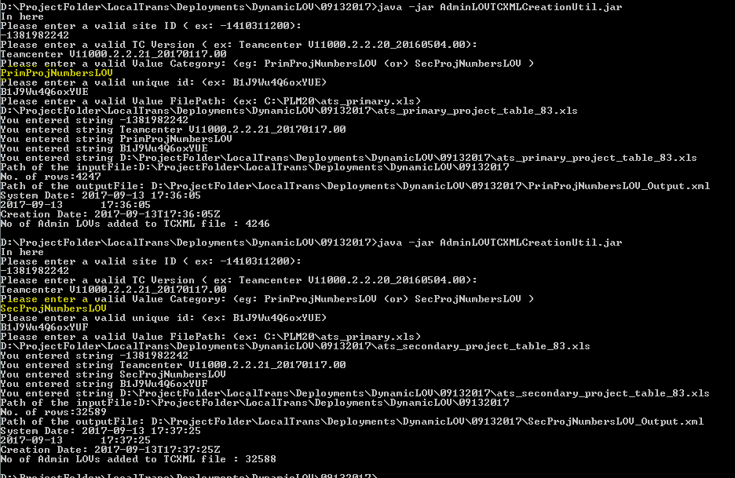

D:\ProjectFolder>java -jar AdminLOVTCXMLCreationUtil.jar

In here

Please enter a valid site ID ( ex: -1410311200):

-1381982242

Please enter a valid TC Version ( ex: Teamcenter V11000.2.2.20_20160504.00):

Teamcenter V11000.2.2.21_20170117.00

Please enter a valid Value Category: (eg: PrimProjNumbersLOV (or) SecProjNumbersLOV )

PrimProjNumbersLOV

Please enter a valid unique id: (ex: B1J9Wu4Q6oxYUE)

B1J9Wu4Q6oxYUE

Please enter a valid Value FilePath: (ex: C:\PLM20\ats_primary.xls)

D:\ProjectFolder\LocalTrans\Deployments\DynamicLOV\09132017\ats_primary_project_table_83.xls

***********************************

D:\ProjectFolder> java -jar AdminLOVTCXMLCreationUtil.jar

In here

Please enter a valid site ID ( ex: -1410311200):

-1381982242

Please enter a valid TC Version ( ex: Teamcenter V11000.2.2.20_20160504.00):

Teamcenter V11000.2.2.21_20170117.00

Please enter a valid Value Category: (eg: PrimProjNumbersLOV (or) SecProjNumbersLOV )

SecProjNumbersLOV

Please enter a valid unique id: (ex: B1J9Wu4Q6oxYUE)

B1J9Wu4Q6oxYUF

Please enter a valid Value FilePath: (ex: C:\PLM20\ats_primary.xls)

D:\ProjectFolder\LocalTrans\Deployments\DynamicLOV\09132017\ats_secondary_project_table_83.xls

***********************************

**Load the dynamic LOVs in Teamcenter:**

Run the below commands from TC command prompt to load the data

${TC_BIN}/tcxml_import -u=infodba -p=<password> -g=dba -file=PrimProjNumbersLOVs.xml

${TC_BIN}/tcxml_import -u=infodba -p=<password> -g=dba -file= SecProjNumbersLOVs.xml

Verify the log file generated in the current directory in case of failure.

**Result Check:**

Login to Teamcenter RAC or AWC and verify the LOV attached to Primary Project Number, Secondary Project attributes on ECR Revision.

Verify the objects created by the above utility using the saved query “*Admin – List of Values*”

# Design Release Configuration and Deployment

**Config Properties Modification Step:**

1. Right Click edot.war and select 7-Zip => Open Archive.
2. Go into GETDesignReleasePLM\WEB-INF\classes folder.
3. Right Click config.properties and select Edit. This will open the file in Text Editor.
4. Add configuration details in the config.properties file.
   1. SSO Integration:
      1. Add Values for TC, SSOURL and APPID as shown below,
      2. TC=http://vdcald04459.ics.cloud.ge.com:8080/tc
      3. SSOURL=http://vdcald04459.ics.cloud.ge.com/tc_sso_login
      4. APPID=Teamcenter
   2. Non-SSO Integration.
      1. Add value for TC only and remove SSOURL and APPID.
      2. TC=http://plmuat.trans.ge.com/tc
5. Save & close config.properties file.
6. Exit 7-Zip application.

**Deployment Steps:**

1. Stop JBOSS server by Ctrl+C at the command prompt.
   1. Delete “edot.war.deployed” from “…\standalone\deployments”
   2. Delete “server.log” from “…\standalone\log”
   3. Delete GETDesignReleasePLM folder from “…\standalone\tmp\work\jboss.web\default-host”
2. Copy & Paste edot.war from SVN to JBOSS.
   1. From WAR Folder from SVN

“…\ post-bmide\code\get_client\GETDesignReleasePLM\WAR”

* 1. To JBOSS => “…\standalone\deployments”

1. Start JBOSS by standalone -b 0.0.0.0 at the command prompt.
2. Confirmation
   1. Command prompt for deployment confirmation
   2. “…\standalone\deployments” for “edot.war.deployed”

# Audit Log Configurations

**Manually configure UNIX environment**

Manually configuring the Teamcenter environment on UNIX systems requires sourcing the tc_profilevars script. To manually set the Teamcenter environment, enter the following sets of commands:

export TC_ROOT=<path to tcroot>;

export TC_DATA=<path to tcdata>;

. $TC_DATA/tc_profilevars

**Manually configure Windows environment**

Manually configuring the Teamcenter environment on Windows systems requires running the tc_profilevars.bat script. This script is called automatically when exiting to an MS-DOS shell from the Teamcenter menu, but the environment can also be set manually. To manually set the Teamcenter environment, enter the following commands:

set TC_ROOT=<path to tcroot>

set TC_DATA=<path to tcdata>

call %TC_DATA%\tc_profilevars

**Utilities**

1. **audit_purge**

OOTB Utility - Archives audit logs in TC XML format based on retention period and audit log type.

This utility also purges audit log records

Refer OOTB utilities reference doc for detailed description.

**Usage for purging Iman File Access audit logs:**

audit_purge -u=<userid> -p=<password> -g=<group> -logtype=Fnd0FileAccessAudit -purge -retentionperiod=<number of days>

**Usage for Archiving Iman File Access audit logs:**

audit_purge -u=<userid> -p=<password> -g=<group> -logtype=Fnd0FileAccessAudit -archive -retentionperiod=<number of days> -archivelocation=<location where archived tc xmls will be stored>

1. **Audit Reports**

Query to generate report on access,

select distinct i.pitem_id AS ITEM_ID, ir.pitem_revision_id AS REV_ID, wso.pip_classification AS IP, fad.pfnd0secondaryobjectname AS DATASET_NAME, fad.poriginal_file_name AS FILE_NAME, fad.pfnd0secondaryobjecttype AS DATASET_TYPE, fad.pfnd0userid AS USER_ID, fad.pfnd0groupname AS USER_GROUP, fad.pfnd0rolename AS USER_ROLE, fad.pfnd0loggeddate AS ACCESSED_DATE, ( COALESCE(vol.punix_path_name, vol.pwnt_path_name) ||NVL2(vol.punix_path_name, '/', '\')||imf.psd_path_name||'/'|| imf.pfile_name) AS FILE_PATH FROM pimanfile imf, pimanvolume vol, pdataset ds, pitem i, pitemrevision ir, pworkspaceobject wso, pfnd0fileaccessaudit fad, pimanrelation rel where

fad.pfnd0secondaryobject like ds.puid || '%' and rel.rsecondary_objectu=ds.puid and rel.rprimary_objectu=ir.puid and ir.ritems_tagu=i.puid and wso.puid=i.puid and fad.pvolume_tag like vol.puid || '%' and fad.pfnd0object like imf.puid || '%'

Filter by accessed date to get reports for a given date or range

# Task Manager Configurations

**Task Manger Service setup for Late Mail Notification**

**Installation**

Install Task **Manager Daemon** using **Teamcenter Environment Manager**.

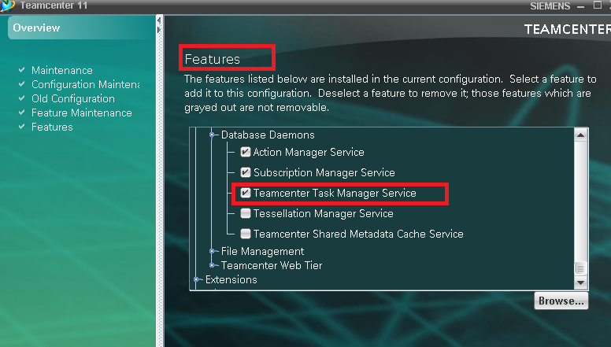

**Teamcenter Services** Start the Teamcenter related services

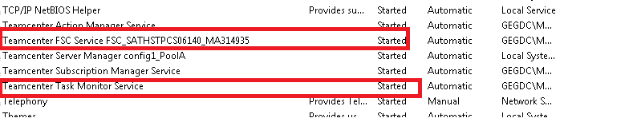

**Preferences**

TASK_MONITOR_SLEEP_TIME=1

        TC_mail_interval =10

        TC_inbox_interval=2

        Mail_server_name=<**enter server name**>

        Mail_server_port=25

        Mail_server_charset=windows-1252

        Mail_OSMail_activated=true



**Syntax to execute:**

preferences_manager -u=username -p=password -g=dba -mode=import -scope=SITE

-file=<filename.xml> -action=OVERRIDE

**Organization**

**Note: All user to have email assigned in TC Org**

Organization->Person->add TC user mail id in email address.

**Example**

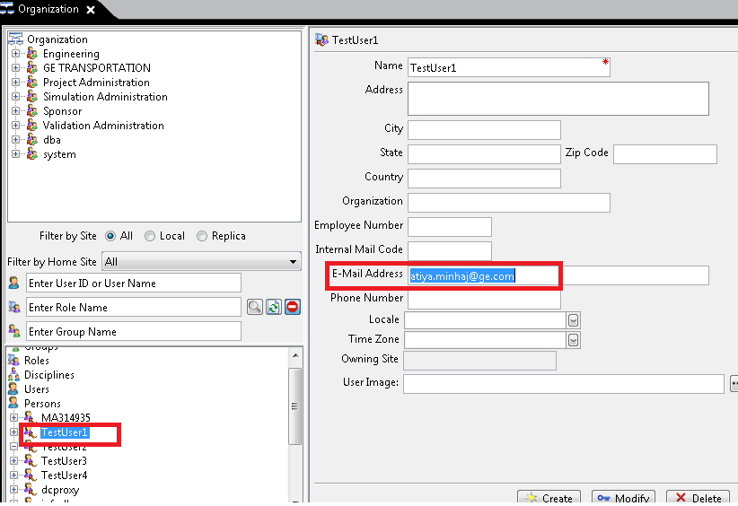

# Automatic ECR Closure - CRON Configurations

1. **Preference settings:**

GET_ECR_ECN_CLOSE_INTERVAL value is default to 7 but the value can be changed as needed

1. **Infodba email ID Change**:

Specify infodba person’s email id to appropriate value (SysAdmin’s email id) in TC, this utility sends the emails to this person.

1. **Cron settings:**

**File locations:**

* *Executable* (get_automatic_ecr_close ) will be generated by ant script under $GET_UTIL S/itk_util/directory
* *Cron (*get_automatic_ecr_close.sh*) is located in the transplm_tag\post-bmide\code\get_utils\itk_utils\ directory*
* Replace CHANGE_ME in the script with the respective values
* Provide credentials in the .sh file.



NOTE: Script cannot be execute using infodba account

1. **Steps to execute the cron:**
   1. Execute get_automatic_ecr_close.sh from command prompt or terminal
2. **When to execute the cron:**
   1. Schedule the cron to Execute daily ( 6pm EST)

0 18 * * * <path_to_script>/get_automatic_ecr_close.sh

# JT Creation

1. Replace all CHANGE_MEs in the GET_generateJT.bat file to appropriate values
2. Create an input text file with the Itemid/Revision entries. Attached the sample text file



1. Open Command prompt(cmd) and cd to the Get_generateJT.bat file location
2. Run the batch file with following arguments

get_generateJT.bat <username> <password> <dba> <filename>

Please note that batch file should run in Teamcenter/NX 2T installed machine.

# CAS Disposition Web application

1. Deploy the GET_CASDataDownloader.war file in Jboss server. War file is located in SVN location: \get_transplm_trunk\post-bmide\code\get_client\GET_CASDataDownloader\WAR
2. Modify the preference GET_CAS_DATA_DOWNLOADER_URL value to <http://CHANGE_ME:8080/GET_CASDataDownloader>
3. CHANGE_ME should be hostname of Jboss webserver

# NX10, MP15 installation

1. **NX10 installation:**

The NX10 installation procedure has been explained in the below enclosed link:

<http://cingetplm099pc.cloud.ge.com:3000/installers/NX10/NX10_User_installation_Guide_v1.pdf>

1. **NX10, MP15 installation:**

The NX10, MP15 installation procedure has been explained in the below enclosed link:

<http://cingetplm099pc.cloud.ge.com:3000/installers/NX10/MP15/ReadMe%20before%20installing%20NX10%20Maintenance%20Patch.txt>

# Teamcenter Mail Logger

1. **Rename Teamcenter mail utility:**

|  |
| --- |
| # cd $TC_ROOT/bin  # mv tc_mail_smtp tc_mail_smtp.REAL |

1. **Copy Mail logger utility:**

|  |
| --- |
| # cd <tag>/post-bmide/code/reloc/bin/tc_mail_smtp $TC_ROOT/bin  # chmod 755 $TC_ROOT/bin/tc_mail_smtp |

1. **Modify tc_mail_smtp script:**

Edit tc_mail_smtp if LOG_DIR is not going to be “/log”

Otherwise the file can be left unmodified.

# Registry Settings on Visualization Server

Execute the **SysRegistrySettingForMeasurementDisplayUnitSettingForAWC.reg** file and merge the settings, on the Server where AWC Viz pool service is installed.

File is in the repository at the location: <tag>\post-bmide\configuration\registry_settings\