# Release Specific (June) Manual Instructions:

## Org and Project Updates

US5273 : New Services and SC Roles and Groups

New Roles per Russ:

1. New Main Group: under SUPPLY CHAIN…..add Sourcing Team as additional Main Group
2. under new Sourcing Team Group add new Role of Sourcing - this new role will utilize the Consumer license for View only access.
3. under Operations Main Group, add new Role of Operator this new role will utilize the Consumer license for View only access.
4. If possible, Under  ENGINEERING delete Main Group  Service Technologies
5. ​under SERVICES …add new Role of Field Service   -  this new role will utilize the Consumer license for View only access.
6. If possible, Change Name of existing Security Groups

                  Service Technologies – (C) 🡪 Services- (C)  
                  Service Technologies – (R) 🡪 Services– (R)

NOTE: Below Manual instructions should be performed before executing the ANT scripts

**Manual Changes to Projects**

Login on Projects Module.

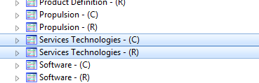

Rename the “Services Technologies” Project to “Services”

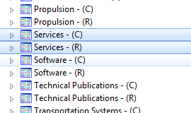

Update the Id, Name and Descriptions accordingly.

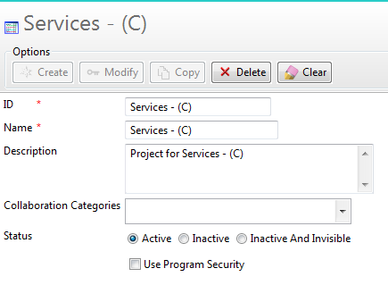

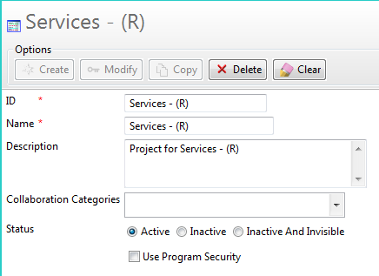

**Manual Changes to Organization:**

* Login to Organization Module
* Manually Delete the group – “Services Technologies”
* First remove the users/roles from the group to cut the references

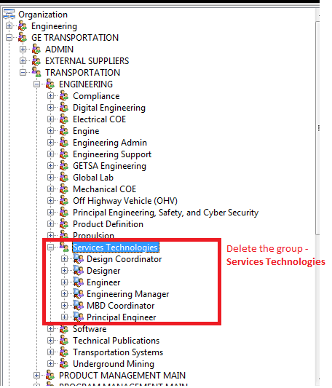

NOTE: Any additions to the Organization will be taken care by the ANT scripts.

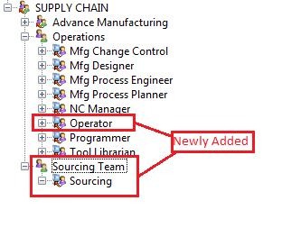

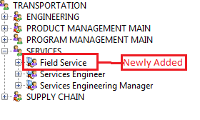

**Dispatcher Module for 3DPDF needs timeout increased**

For transmodule.properties file for the 3D PDF translation module.

Update the **MaximumProgress** value to 200.

Update the **MaximumTasks** value to 1.