Pre Deployment Instructions

TRANS PLM PROGRAM

<GE Transportation>

<Locomotive>

g is a registered trademark of the General Electric Company in the United States and other countries.

**© 2006 General Electric Company**. All rights reserved.

Authors

| Name | Location | Phone | Email |
| --- | --- | --- | --- |
| Qadeer Ahmed Shah | Erie, PA |  | Qadeer.shah@ge.com |
| Anbazhgan E | Houston, TX |  | Anbazhagan.ellappan1@ge.com |

Document Revision History

| Date | Author | Description | Revision # |
| --- | --- | --- | --- |
| 26-Jan-2017 | Anbu | Pre-deployment instruction for T4X config/env files | 1 |
| 02-Feb-2017 | Anbu | Added Pre-Requisites section | 2 |

**Building with Ant**

Contents

Purpose: 4

Pre-Requisites: 4

Changes: 4

T4O Mapping Files 4

# Purpose:

The following updates/changes are essential to be performed prior to deployment through ant script for successful deployment

# Pre-Requisites:

1. Environment is already installed with t4oebs template
2. BGS and GS are installed and up and running with OOTB configuration.
3. Teamcenter client is updated with T4O EBS plugins and T4O Gateway menu is visible in my Teamcenter.
4. Admin should have checklist of the environment details including username, password and other credentials.

# Changes:

## T4O Mapping Files

1. Update value for Active Connection for EBS in t4o_mapping_config.sd file

File location: post-bmide/code/t4x/t4o/t4o_apps/var/mmap/t4o_mapping_config

File Name: t4o_mapping_config.sd

Change: Value of Oracle System ID

AS-IS:

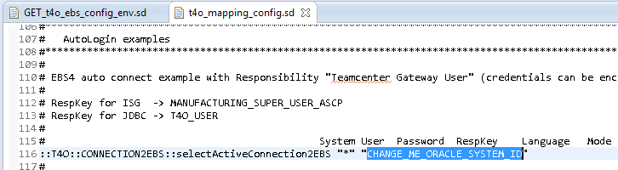

TO-BE(Sample):

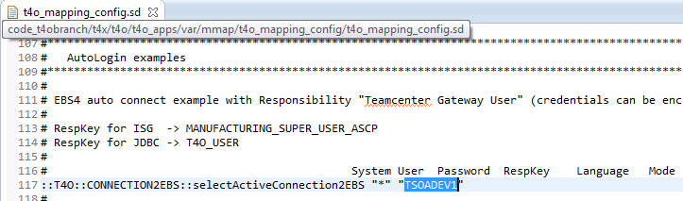

1. Update Connection parameters values with encrypted values.

File location: post-bmide/code/t4x/t4o/t4o_apps/var/mmap/t4o_mapping_config

File Name: t4o_mapping_config.sd

Change: T4O Functional User credentials (User name, password and Group)

Encryption: Encryption can be performed from BGS client. Script name is “T4x Password Crypt”

AS-IS:

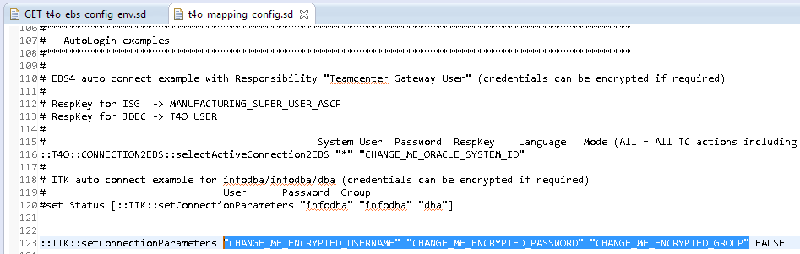

TO-BE(Sample):

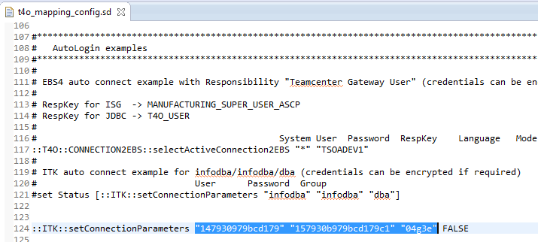

1. Update Oracle System ID value in GET_t4o_ebs_config_env.sd file

File location: post-bmide/code/t4x/t4o/t4o_apps/var/mmap/t4o_mapping_config

File Name: t4o_mapping_config.sd

Change: Value of Oracle System ID

AS-IS:

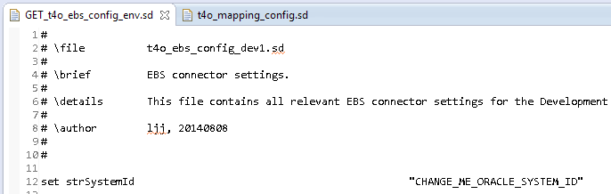

TO-BE(Sample):

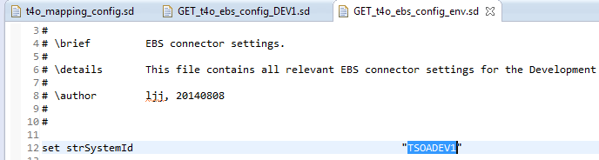

1. Update JDBC URL and respective credential with respect to Oracle System in GET_t4o_ebs_config_env.sd file

File Location: post-bmide/code/t4x/t4o/t4o_apps/var/mmap/t4o_mapping_config

File Name: GET_t4o_ebs_config_env.sd

Change: JDBC URL and its connection parameters

Encryption: Encryption can be performed from BGS client. Script name is “T4x Password Crypt”

AS-IS:

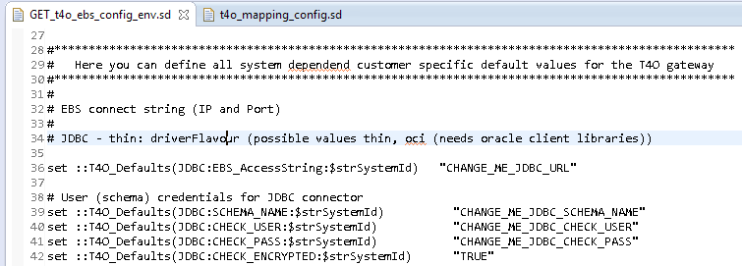

TO-BE(Sample):

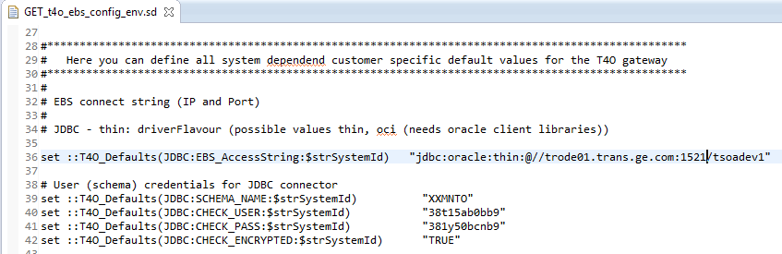

1. Update EBS Oracle connection credentials in GET_t4o_ebs_config_env.sd file

File Location: post-bmide/code/t4x/t4o/t4o_apps/var/mmap/t4o_mapping_config

File Name: GET_t4o_ebs_config_env.sd

Change: Change EBS Connection parameters.

Encryption: Encryption can be performed from BGS client. Script name is “T4x Password Crypt”

AS-IS:

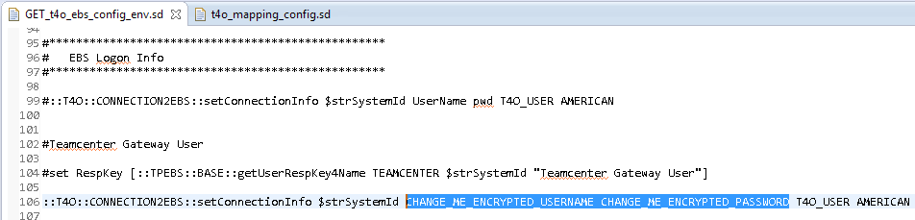

TO-BE(Sample):

