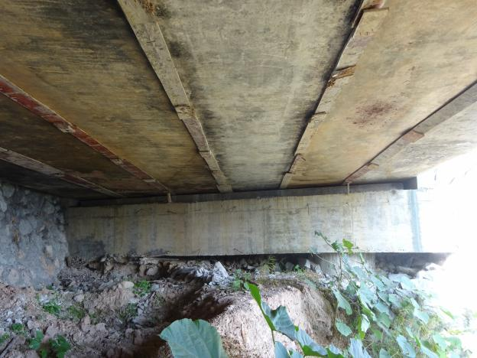参考图片

|  |  |
| --- | --- |
|  |  |
|  | 图 2 0#伸缩缝沉积物阻塞 |
|  |  |
|  |  |