* + 计算机专业的本次读书实践周的实施方案

拟：1. git与代码版本管理、学习笔记（必做）；2. 读书笔记（选做）

1. 已在本地安装git并创建本地仓库。  
   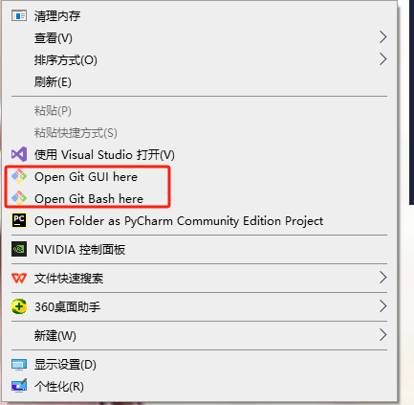  
   安装教程：

https://blog.csdn.net/qq_45305209/article/details/115048823?ops_request_misc=%257B%2522request%255Fid%2522%253A%252298d50de404dbf12f42b2a207816c0dee%2522%252C%2522scm%2522%253A%252220140713.130102334..%2522%257D&request_id=98d50de404dbf12f42b2a207816c0dee&biz_id=0&utm_medium=distribute.pc_search_result.none-task-blog-2~all~sobaiduend~default-1-115048823-null-null.142^v102^pc_search_result_base2&utm_term=%E5%9C%A8%E6%9C%AC%E5%9C%B0%E4%B8%8B%E8%BD%BDgit&spm=1018.2226.3001.4187  
 搭建本地仓库：  
 https://blog.csdn.net/m0_65292176/article/details/140305525?ops_request_misc=%257B%2522request%255Fid%2522%253A%2522f067fe8a4c3fbc21bee8e50417dba277%2522%252C%2522scm%2522%253A%252220140713.130102334..%2522%257D&request_id=f067fe8a4c3fbc21bee8e50417dba277&biz_id=0&utm_medium=distribute.pc_search_result.none-task-blog-2~all~sobaiduend~default-1-140305525-null-null.142^v102^pc_search_result_base2&utm_term=%E5%A6%82%E4%BD%95%E5%9C%A8%E6%9C%AC%E5%9C%B0%E6%90%AD%E5%BB%BAgit%E4%BB%93%E5%BA%93&spm=1018.2226.3001.4187

2、注册远程账号，并搭建多个公开的远程仓库：  
  
  
  
  
  
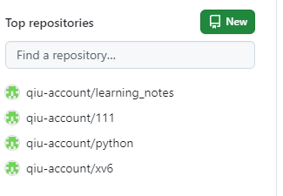

下载xv6的git账号：<https://github.com/qiu-account/xv6>

学习笔记：https://github.com/qiu-account/learning_notes