1. ubuntu允许root进行ssh远程连接

sudo vi /etc/sshd/sshd_config，添加PermitRootLogin yes，重启（reboot）

1. 在windows10上添加hyper-V
   1. 在BIOS中开启CPU的虚拟化支持（机型不同，开启方式不同，自己百度），开启成功后在“任务管理器”中可以看到

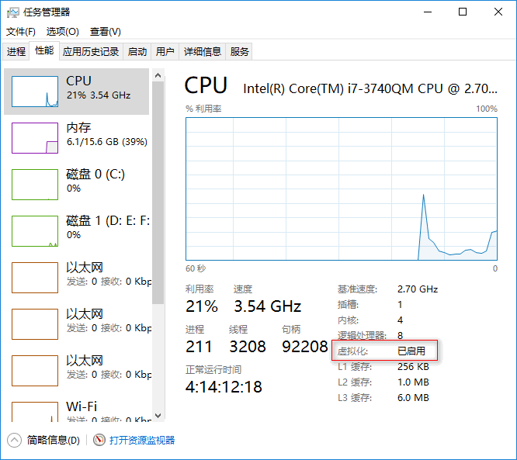

* 1. 启用windows的Hyper-V功能

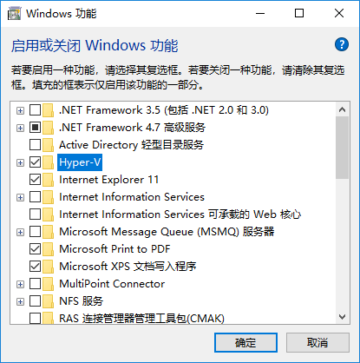

1. 安装宿主机ubuntu-16.04.5
   1. 在Hyper-V中添加新的虚拟机，并加载ubuntu-16.04.5-server-amd64.iso
   2. 正常安装ubuntu-server，网络连接选择默认连接，在软件包选择位置选择openserver，其它部分保持默认即可
   3. 查看新安装的ubuntu-server的ip地址，可以输入命令ifconfig
   4. 设置root密码，sudo passwd，按提示如新的密码，输入su -，尝试新的密码登录
   5. 配置SecureCRT连接ubuntu-server
   6. 配置ubuntu，允许root远程连接，sudo vi /etc/ssh/sshd_config，将PermissionRootLogin的值修改为yes
   7. 修改apt-get的源为163镜像，可以在/etc/apt/sources.list文件中加入如下内容：

*deb http://mirrors.163.com/ubuntu/ artful main restricted universe multiverse*

*deb http://mirrors.163.com/ubuntu/ artful-security main restricted universe multiverse*

*deb http://mirrors.163.com/ubuntu/ artful-updates main restricted universe multiverse*

*deb http://mirrors.163.com/ubuntu/ artful-proposed main restricted universe multiverse*

*deb http://mirrors.163.com/ubuntu/ artful-backports main restricted universe multiverse*

*deb http://mirrors.163.com/ubuntu/ bionic main restricted universe multiverse*

*deb http://mirrors.163.com/ubuntu/ bionic-security main restricted universe multiverse*

*deb http://mirrors.163.com/ubuntu/ bionic-updates main restricted universe multiverse*

*deb http://mirrors.163.com/ubuntu/ bionic-proposed main restricted universe multiverse*

*deb http://mirrors.163.com/ubuntu/ bionic-backports main restricted universe multiverse*

*deb http://mirrors.163.com/ubuntu/ cosmic main restricted universe multiverse*

*deb http://mirrors.163.com/ubuntu/ cosmic-security main restricted universe multiverse*

*deb http://mirrors.163.com/ubuntu/ cosmic-updates main restricted universe multiverse*

*deb http://mirrors.163.com/ubuntu/ cosmic-proposed main restricted universe multiverse*

*deb http://mirrors.163.com/ubuntu/ cosmic-backports main restricted universe multiverse*

*deb http://mirrors.163.com/ubuntu/ disco main restricted universe multiverse*

*deb http://mirrors.163.com/ubuntu/ disco-security main restricted universe multiverse*

*deb http://mirrors.163.com/ubuntu/ disco-updates main restricted universe multiverse*

*deb http://mirrors.163.com/ubuntu/ disco-proposed main restricted universe multiverse*

*deb http://mirrors.163.com/ubuntu/ disco-backports main restricted universe multiverse*

*deb http://mirrors.163.com/ubuntu/ trusty main restricted universe multiverse*

*deb http://mirrors.163.com/ubuntu/ trusty-security main restricted universe multiverse*

*deb http://mirrors.163.com/ubuntu/ trusty-updates main restricted universe multiverse*

*deb http://mirrors.163.com/ubuntu/ trusty-proposed main restricted universe multiverse*

*deb http://mirrors.163.com/ubuntu/ trusty-backports main restricted universe multiverse*

*deb http://mirrors.163.com/ubuntu/ xenial main restricted universe multiverse*

*deb http://mirrors.163.com/ubuntu/ xenial-security main restricted universe multiverse*

*deb http://mirrors.163.com/ubuntu/ xenial-updates main restricted universe multiverse*

*deb http://mirrors.163.com/ubuntu/ xenial-proposed main restricted universe multiverse*

*deb http://mirrors.163.com/ubuntu/ xenial-backports main restricted universe multiverse*

* 1. 更新apt-get， apt-get update
  2. 安装docker， apt-get install docker-io
  3. 启动docker服务， service docker start，查看docker版本， docker version -v
  4. 查看ubuntu-server网卡docker0的ip地址， ifconfig，（我这里是172.18.0.1）
  5. 配置docker容器使用的ip地址段， docker network create –subnet=172.20.0.0/16 mynetwork；验证刚刚创建的网络， docker network ls，另外ifconfig也能够看到刚刚创建的网络虚拟出来的网卡；启动容器时可以通过—net参数为容器指定所属网络，通过—ip参数指定容器的固定的ip地址
  6. 通过fillzila或者其它的sftp工具连接ubuntu-server，上传dokerfiles-master.zip到/docker目录；通过apt-get install unzip安装unzip包；使用unzip dokerfiles-master.zip命令解压文件；修改脚本权限，chmod 755 *.sh。

1. 创建镜像

由于自动脚本中一些路径有问题，这里采用逐步创建的方式进行详细说明，下面的步骤是通过SecureCRT连接到ubuntu-server，在/docker/env10.1目录下执行：

* 1. 创建centos7，

./im-1.sh yi/centos7 n ../src/centos7

* 1. 其它镜像创建的步骤类似，就不再一个个罗列，不少的镜像制作缓慢，主要是通过wget命令在线下载的原因，我的解决方法是直接通过迅雷下载对应的资源，然后复制到Dockerfile文件所在的目录，注释wget命令，添加COPY指令从宿主机直接copy文件到docker，就可以大大的加快镜像的创建速度。