# Lab Report: Installing and Configuring Gitea with and without Docker

## 1. Introduction

This lab report documents the process of installing Docker Desktop and Gitea (both with and without Docker) on Windows and macOS systems. We will explore Gitea's features, including Large File Storage (LFS) support, and demonstrate repository creation and data backup/restore procedures.

## 2. Installing Docker Desktop

### 2.1 Windows Installation

1. **Install WSL (Windows Subsystem for Linux)**

- Open Command Prompt or PowerShell as Administrator

- Execute the following command:



- Restart your computer when prompted

2. **Install Docker Desktop**

- Download Docker Desktop from the official website: https://www.docker.com/products/docker-desktop

- Run the installer and follow the installation wizard

- After installation, launch Docker Desktop and complete the registration process

### 2.2 macOS Installation

1. **Install Homebrew** (if not already installed)

- Download the Homebrew package from: www.futurelei.com/assets/Homebrew.pkg

- Run the installer and follow the instructions

2. **Install Docker Desktop via Homebrew**

- Open Terminal

- Execute the following command:



- Launch Docker from Applications folder and complete registration

## 3. Installing Gitea using Docker

1. **Create a directory for Gitea data**

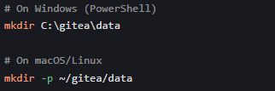

2. **Run Gitea container**

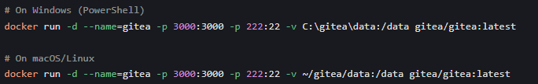

3. **Access Gitea web interface**

- Open browser and navigate to: http://localhost:3000

- Complete the initial configuration (use SQLite for simplicity)

- Create an administrator account

### 3.1 Verifying LFS Support in Gitea

a. **Checking LFS Support**

1. Log in to Gitea as administrator

2. Navigate to "Site Administration" > "Settings"

3. Scroll down to "LFS Settings" section

4. Verify that LFS is enabled (default setting)

5. **Proof of LFS functionality**:

- Install Git LFS on your system:

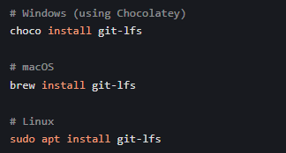

- Initialize Git LFS:



- Create a test repository in Gitea named "lfs-test"

- Clone the repository and add a large file tracked by LFS:

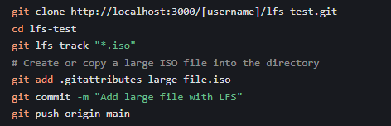

- Check in Gitea web interface that the file is marked as an LFS object

### 3.2 Creating a Repository with a Large File (>1GB)

1. Create a new repository in Gitea named "large-file-test"

2. Clone the repository to your local machine:



3. Configure LFS for the repository:

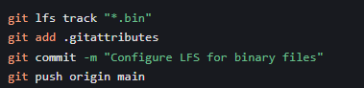

4. Create a test large file (>1GB):

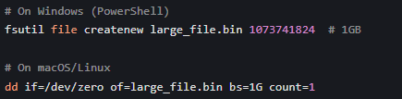

5. Commit and push the large file:

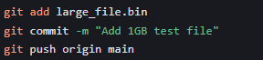

### 3.3 Creating a Repository for the Module

1. In Gitea web interface, click "New Repository"

2. Name the repository "networking-module"

3. Add a description and set appropriate visibility

4. Clone the repository locally:



5. Add your lab work to the repository:

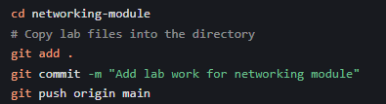

### 3.4 Backup and Restore Gitea Data

**Backup Process:**

1. Stop the Gitea container:



2. Copy the data directory to an external drive (e.g., USB drive):

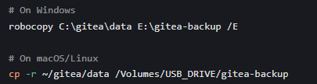

**Restore Process on Another Computer:**

1. Install Docker Desktop on the target computer

2. Copy the backup data to the appropriate location:

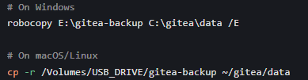 ```

3. Start Gitea container with the same command as before:

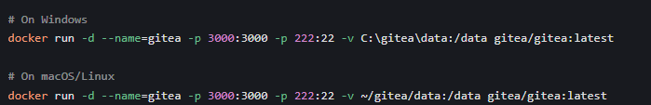

## 4. Installing Gitea without Docker

### 4.1 Prerequisites

- Git

- Database (we'll use SQLite for simplicity)

- Web server (optional, for production)

### 4.2 Installation Steps

1. **Download Gitea binary**

- Visit https://dl.gitea.io/gitea/

- Download the latest version for your OS (e.g., `gitea-1.20.0-windows-4.0-amd64.exe` for Windows)

2. **Create installation directory**

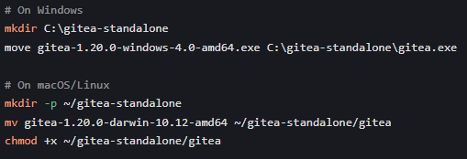

3. **Run Gitea**

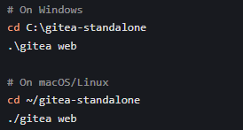

4. **Configure Gitea**

- Access web interface at http://localhost:3000

- Complete setup using SQLite database

- Create administrator account

## 5. Conclusion

In this lab, we successfully:

1. Installed Docker Desktop on both Windows and macOS systems

2. Deployed Gitea using Docker containers

3. Verified Gitea's LFS support and tested it with large files (>1GB)

4. Created repositories for large files and course materials

5. Demonstrated backup and restore procedures for Gitea data

6. Installed and configured Gitea without Docker using SQLite

Gitea proves to be a lightweight yet powerful Git service that supports all essential features including LFS, making it suitable for both personal and organizational use. The Docker installation offers simplicity and portability, while the standalone installation provides more control over the environment.

## 6. GitHub Submission

This lab report, along with all step-by-step screenshots, has been submitted to the designated GitHub repository: