clc

clear

%-------------第一题-------------

x=-10:0.01:10;

sys_res=exp(x);

my_res=myTylor(x);

loss=sys_res-my_res;

figure(1);

plot(x,loss)

plot(x,sys_res,'m')

hold on;

plot(x,my_res,'y');

hold on;

plot(x,loss,'c');

hold on;

legend('sys_res','my_res','loss');

figure(2)

plot(x,loss);

%-------------第二题-------------------

figure(3)

syms x;

y=inline('x^3');

in=-10:0.01:10;

result=my_diff(in,y);

plot(in,result)

hold on

plot(in,3*in.^2);

legend('my_res','3x^2');

figure(4)

loss_2=3*in.^2-result;

plot(in,loss_2);

**MyTylor.m**

function result=myTylor(x)

len=length(x);

result=zeros(1,len);

for i=1:len

ex=1;

result(i)=0;

last_result=1;

while(abs(last_result)>=(1e-6))

result(i)=result(i)+last_result;

last_result=(x(i).^ex)/matrix(ex);

ex=ex+1;

end

end

function res=matrix(n)

if(n<0)

disp('输入参数有误');

elseif(n==0)

res=1;

else

res=1;

for i=1:n

res=i*res;

end

end

**My_diff.m**

function result=my_diff(x,fx)

len=length(x);

result=zeros(1,len);

h=0.0001;

for i=1:len

forward=x(i)+h;

m=fx(forward)-fx(x(i));

result(i)=m/h;

end

**第一题结果：**

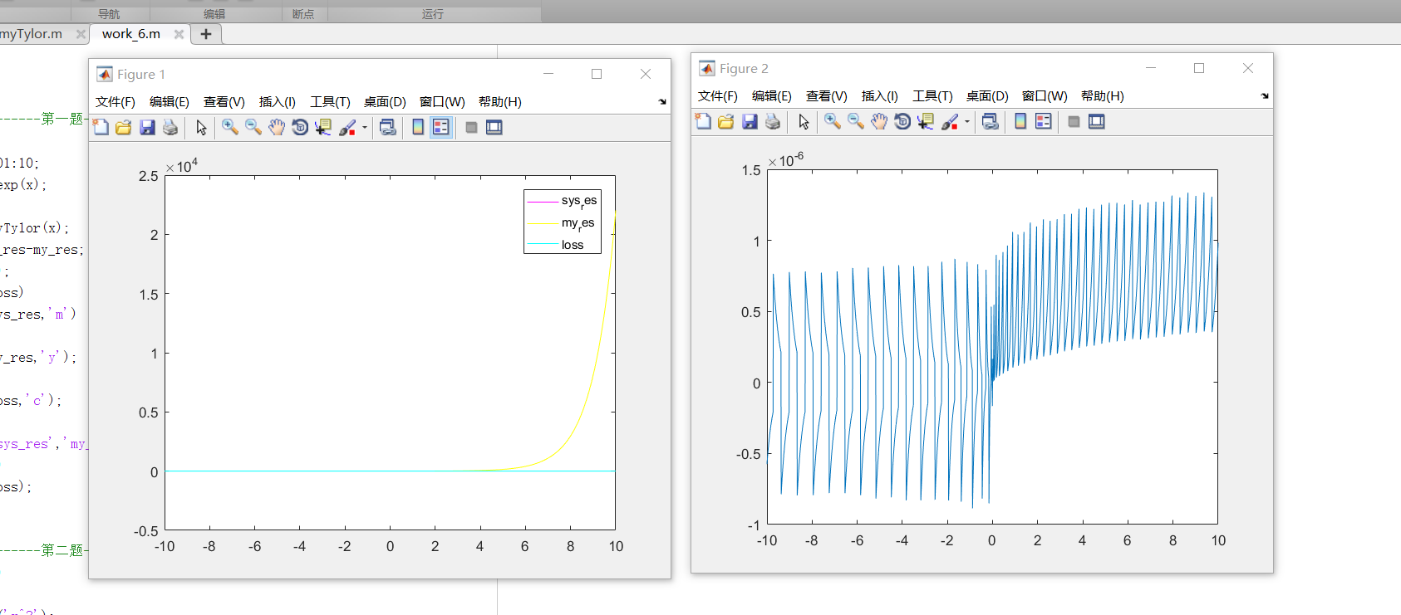

**第二题结果：**

