

**系统设计**

**系统设计说明书**

|  |  |  |  |
| --- | --- | --- | --- |
| 组长姓名 | 吴佳祥 | 学号 | 16203117 |
| 专业 | 软件工程 | 班级 | 162031 |
| 成员 | 谷伟帅16203117 金根有16203111 | | |
| 课题名称 | XX课程管理平台 | | |
| 指导教师 | 张恒峰 | | |
| 开课学期 | 2018~ 2019 第二学期 | | |

Web高级编程大作业设计方案模板

封面（使用课程设计报告封面）

纸张（16开）

目录

1. 需求分析
   1. 系统简介
   2. 用例分析
2. 系统设计
   1. 实体关系建模
   2. 数据库设计
   3. 界面设计
      1. 页面跳转关系
      2. 页面设计
   4. ……

参考文献

字体说明：中文宋体、英文Times New Roman

1级标题 四号加粗

2级标题 小四加粗

3级标题 五号加粗

正文 五号

图号：[章节号]-[序号] [说明]，小五，位于图的下方，例如：图 1-5 用例图

表号：[章节号]-[序号] [说明]，小五，位于表的上方，例如：表 1-5 宠物表

表号：[章节号]-[序号] [说明]，小五，位于表的上方，例如：表 1-5 宠物表

表号：[章节号]-[序号] [说明]，小五，位于表的上方，例如：表 1-5 宠物表

# 1 需求分析

## 1.1 系统简介

The Spring Framework is a collection of small, well-focused, loosely coupled Java frameworks that can be used independently or collectively to build industrial strength applications of many different types. The PetClinic sample application is designed to show how the Spring application frameworks can be used to build simple, but powerful database-oriented applications. It will demonstrate the use of Spring's core functionality. …

Since the purpose of the sample application is tutorial in nature, the implementation presented here will of course provide only a small subset of the functionality that would be needed by a real world version of a PetClinic application. …

需要说明系统的来源、意义以及系统将会涉及哪些社会、法律、健康、安全等因素

## 1.3 用例分析

### 1.3.1 用例与角色

Clinic Employee:

* View a list of veterinarians and their specialties
* View information pertaining to a pet owner
* Update the information pertaining to a pet owner
* Add a new pet owner to the system
* View information pertaining to a pet
* Update the information pertaining to a pet
* Add a new pet to the system
* View information pertaining to a pet's visitation history
* Add information pertaining to a visit to the pet's visitation history
* …

Vet: …

Owner: …

通过上述分析，可得到系统的用例图如下：

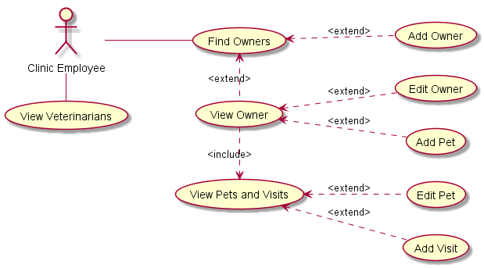

图1.1 宠物医院系统用例图

（每一章都需另取一页）

# 2 系统设计

## 2.1 实体关系建模

实体关系建模是系统设计的第一步，以宠物诊所来说，「宠物」（Pet）和「兽医」（Vet）都是经常出现的名词，它们也都是从需求描述中识别出来的「实体」。……

PetClinic is a fairly simple application with only seven models. The following chart shows all the models and relationships among them. …

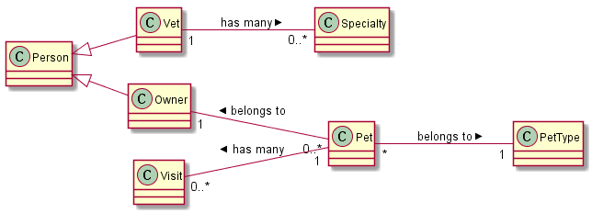

图2.1 宠物医院系统实体关系模型

## 2.2 数据库设计

The sample application uses a relational database for data storage. Support has been provided for a choice of 1 of 2 database selections, MySql or HypersonicSQL. HypersonicSQL version 1.8.0 is the default choice and a copy is provided with the application. It is possible to easily configure the application to use either database. Configuration details are provided in the Developer Instructions section.

The following is an overview of the database schema used in PetClinic. Detailed field descriptions can be found in the "initDB.txt" SQL script files in the database-specific "db" sub-directories. All "id" key fields are of Java type int. …

根据以上给出的实体关系模型可以得到以下数据库物理物理模型。（画出完整的PDM图，参照ORM）

表格详细情况如下：（在下面以表格形式给出数据库结构）

## 2.2 系统开发环境与关键技术

….. The developer will need to obtain the following tools externally, all of which are freely available:

* Java SDK 1.5.x
* Ant 1.7.x
* Tomcat 5.x.x, or some other web application container
* JUnit 4.4 - needed to run the tests
* …

(Optional) MySQL 5.x with MySQL Connector/J 5.x

## 2.3 界面设计

略

## 2.4 ……

对系统的系统的可扩展性、可靠性设计等展开讨论

## 参考资料

[1] ….

[2] …