1. V, Q, VQ distribution against lung height

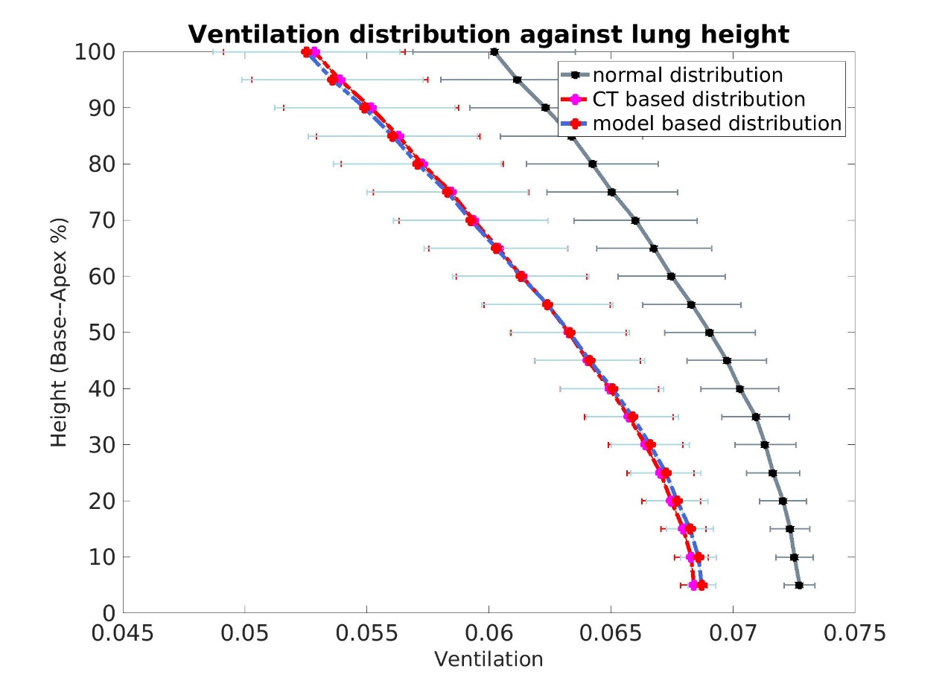

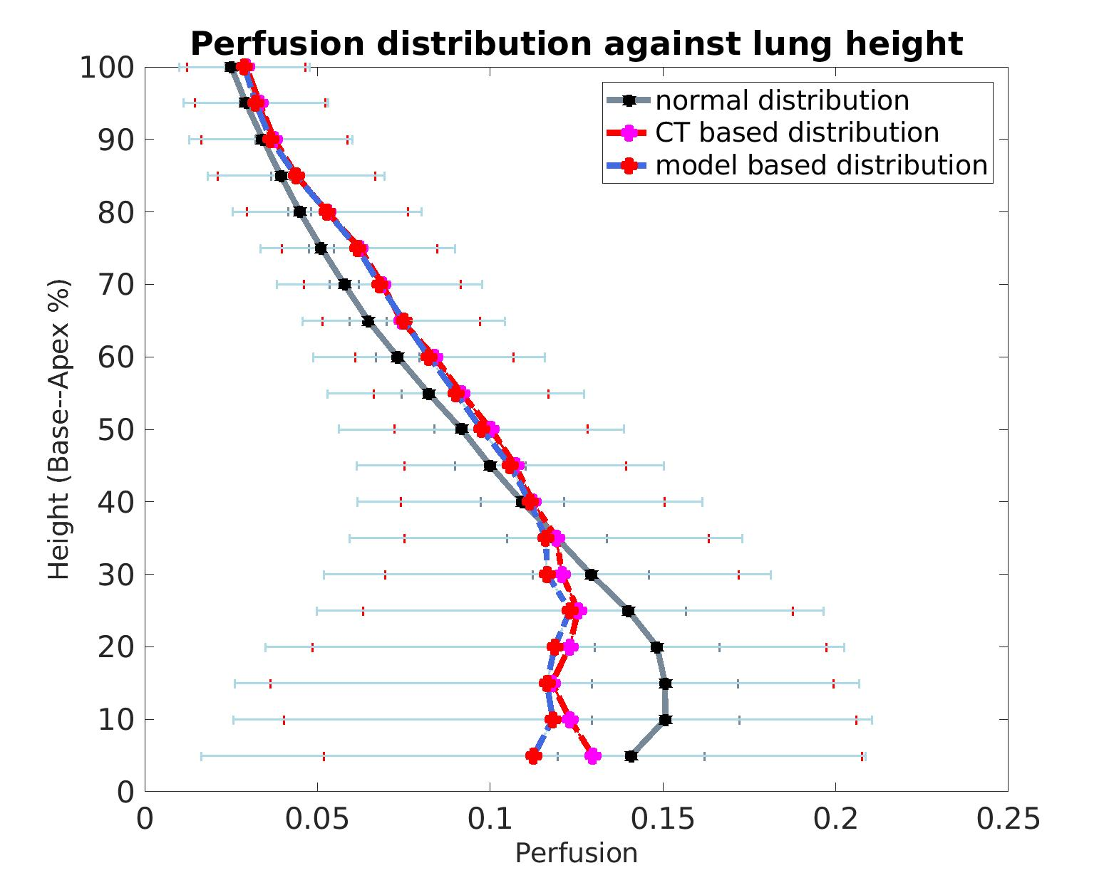

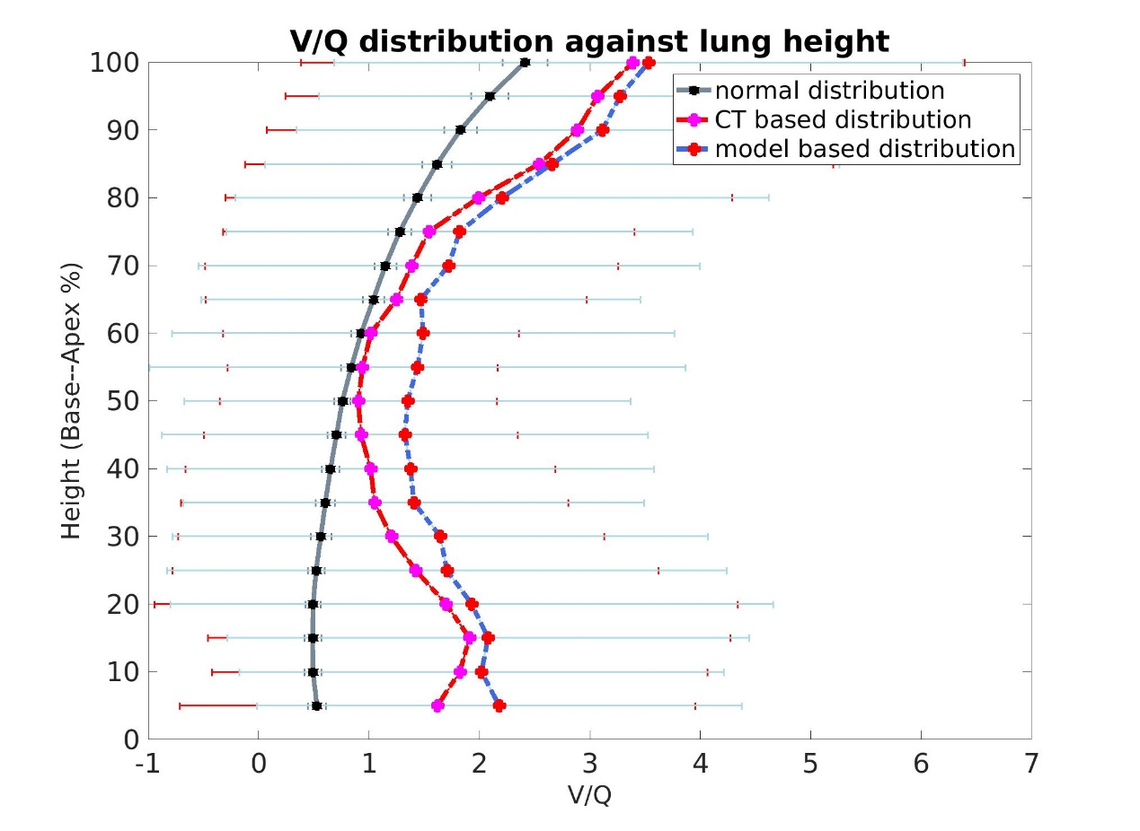

Perfusion of disease model decreases in the basal region (fibrosis mainly distributes in the basal region). The model based V/Q mismatching is more serious than CT based V/Q mismatching, which means CT imaging could not provide enough information, V/Q mismatch could happen in CT ‘normal’ regions.

1. MIGET plot

Normal

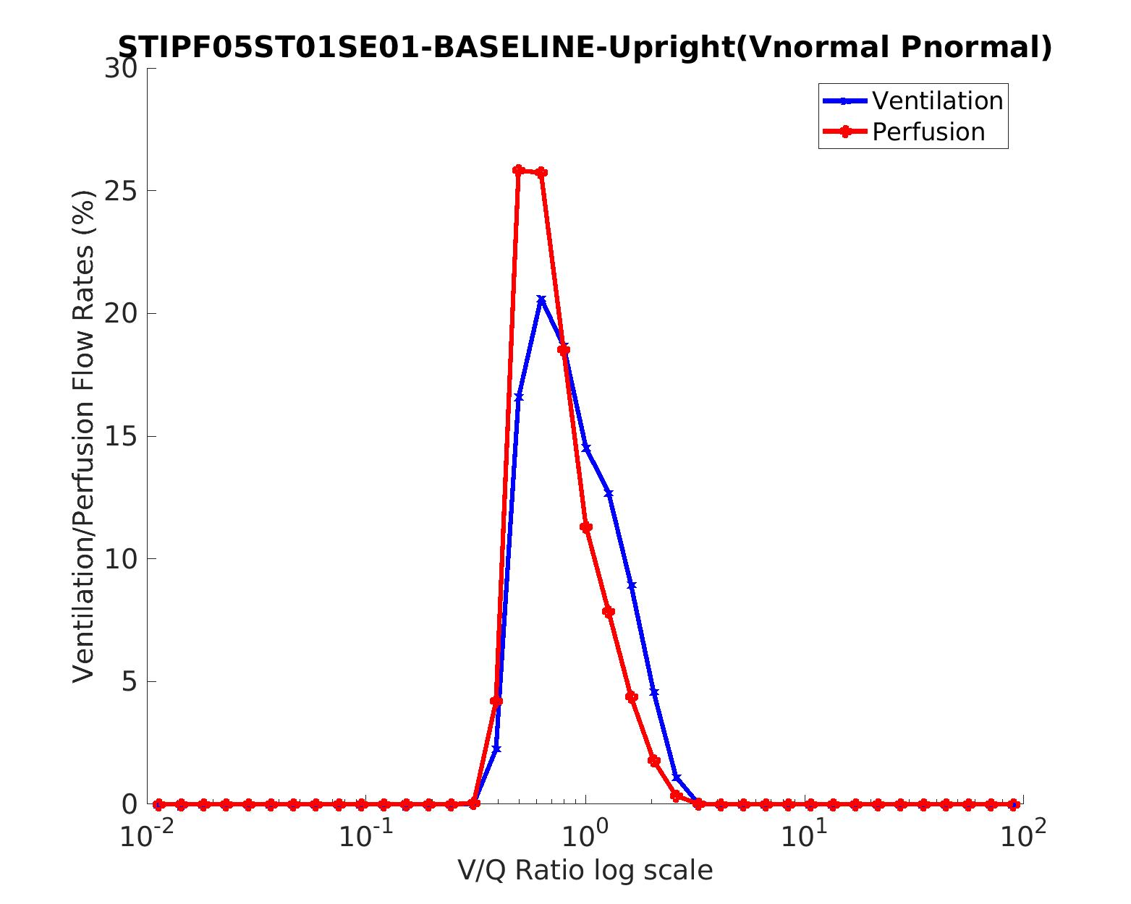

CT based

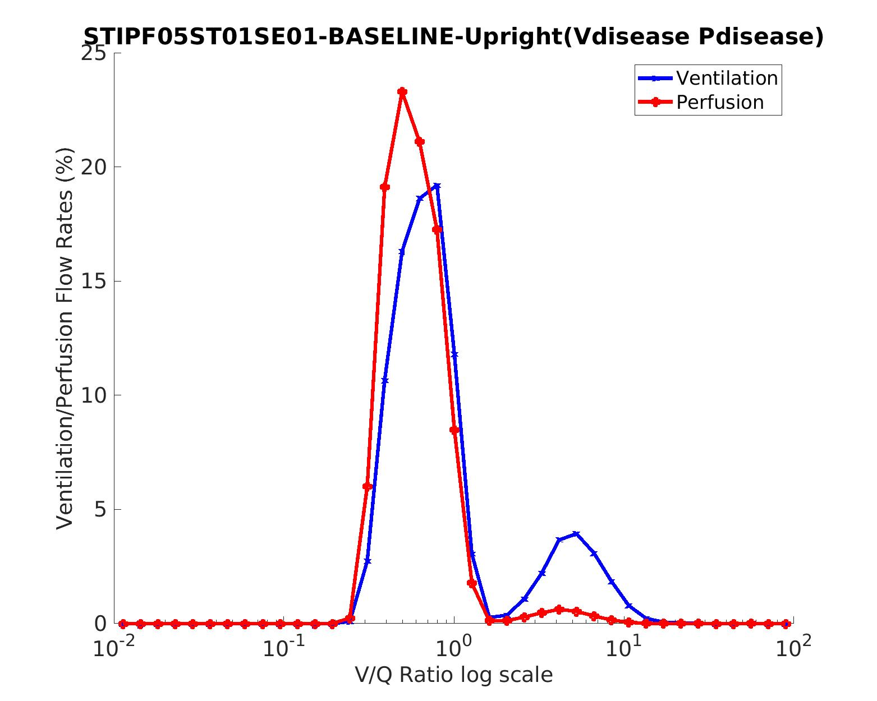

Model based

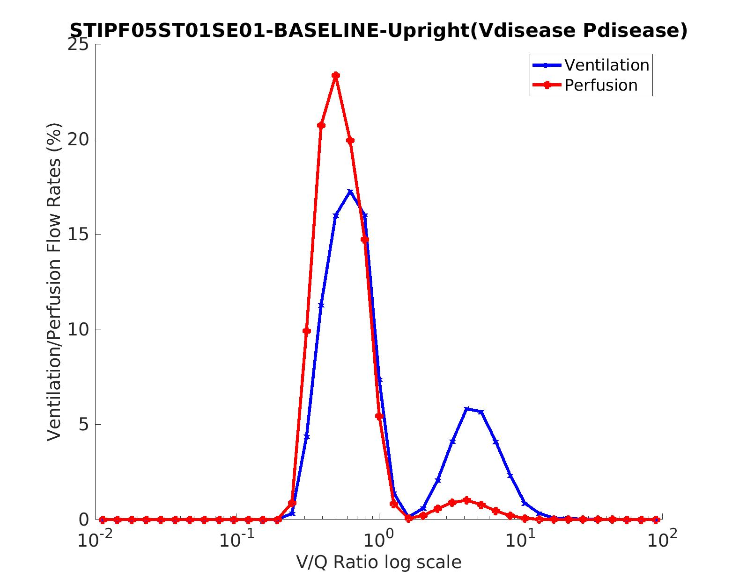

1. PaO2

Normal

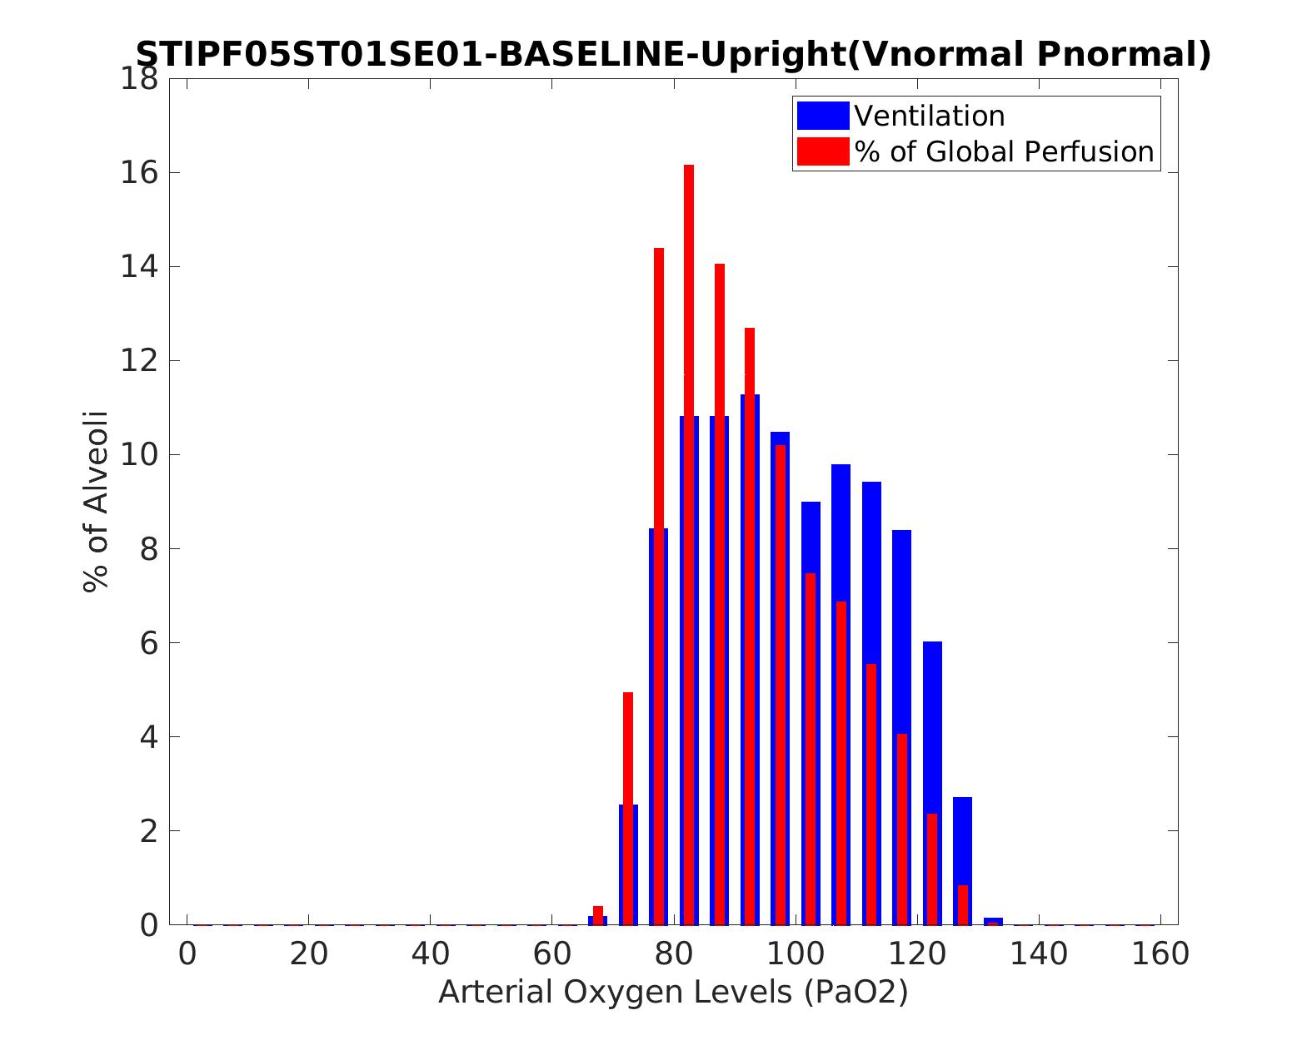

Normal: **PaO2 is 91.2227529131866 mmHg**, PaCO2 is 40.9608532779784 mmHg

From the paper: the mean PaO2 for old people more than 60 years old (median = 71) is 74.3 mm Hg. This patint is female, 156cm, 59kg, 81 years old.

PaO2 = 109-0.43*age, the standard deviation is +4.10 mmHg

CT based

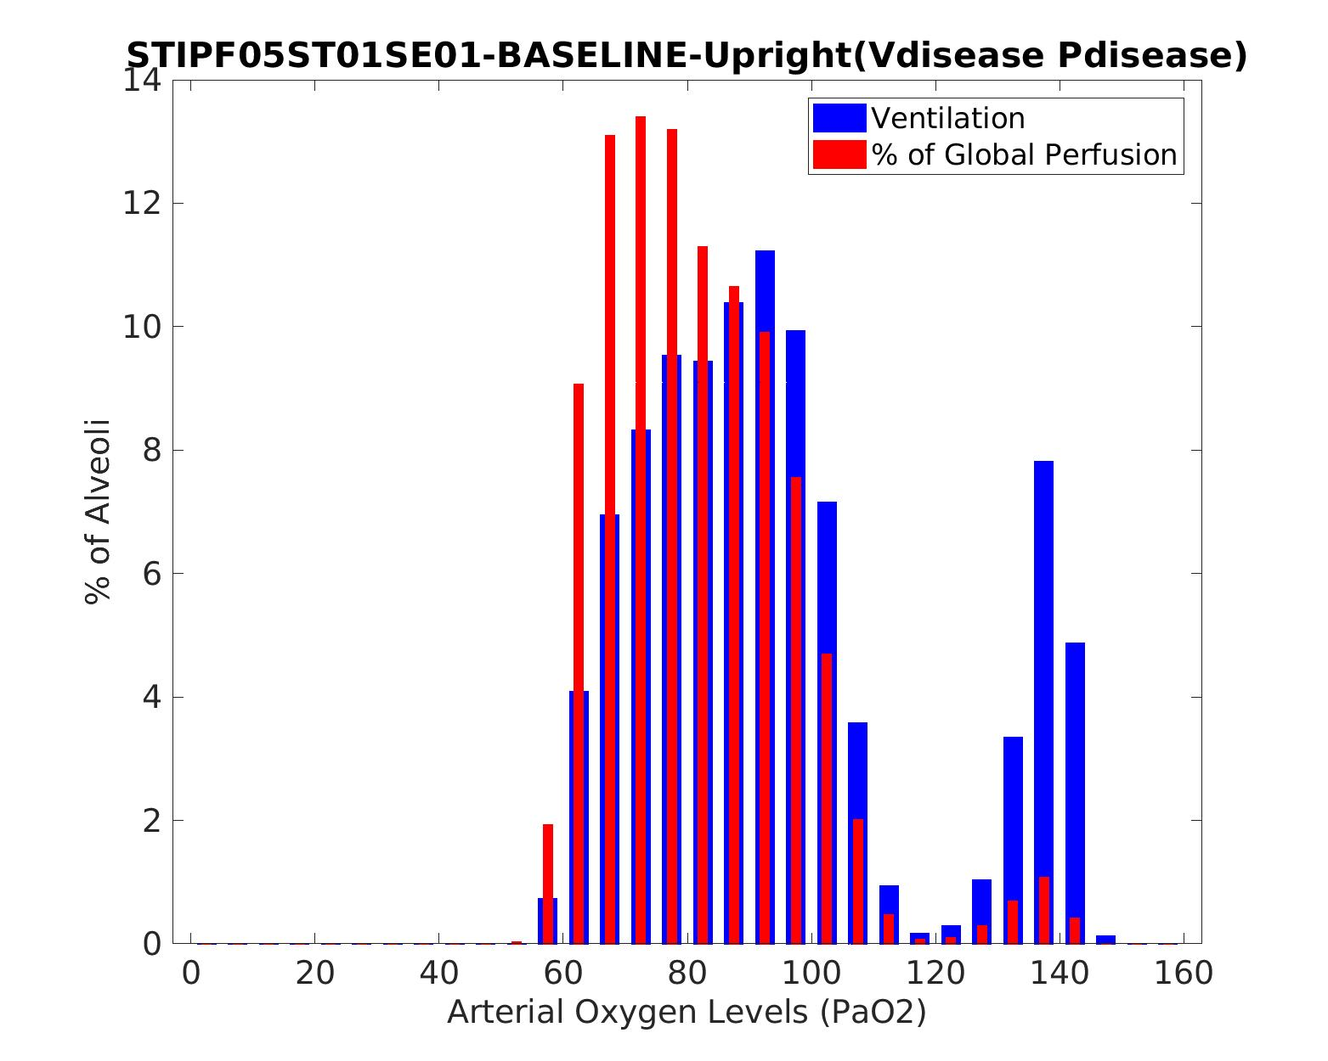

CT based: **PaO2 is 79.8884777612618** mmHg, PaCO2 is 47.4152133077775 mmHg

Model based

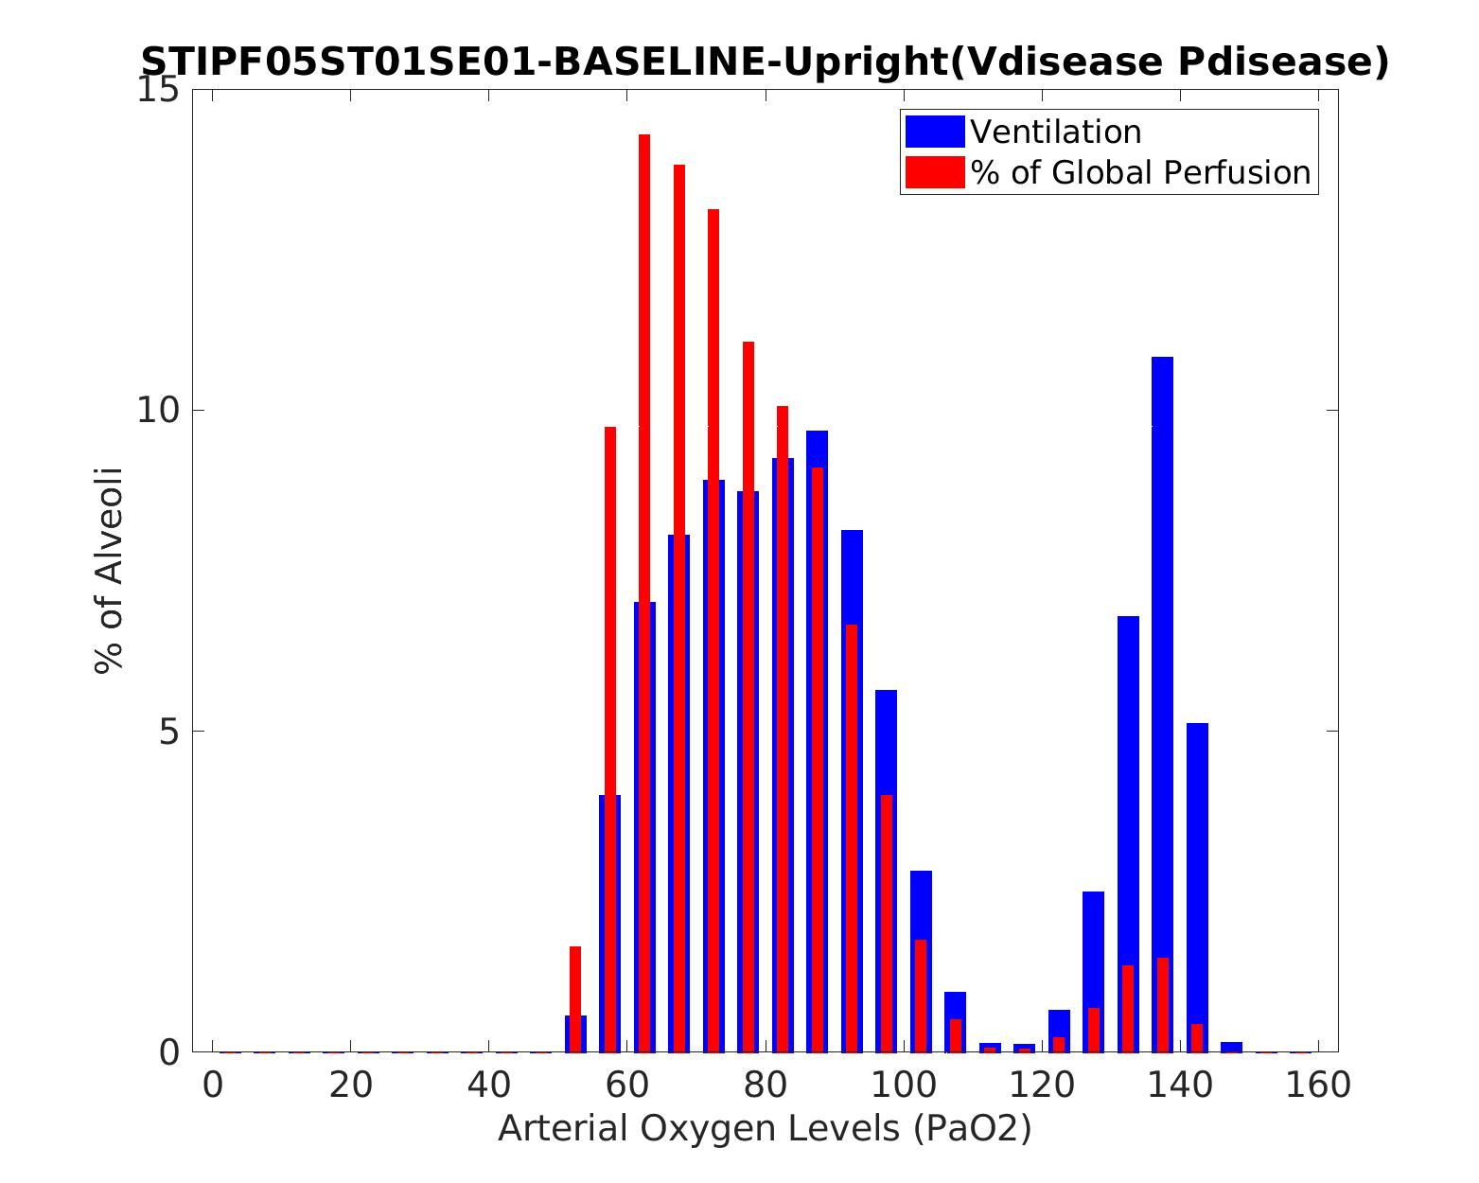

Model based **PaO2 is 74.5180622263334 mmHg**, PaCO2 is 49.0944007865636 mmHg

Normal PaO2 > CT based PaO2 > model based PaO2