1. V, Q, VQ distribution against lung height

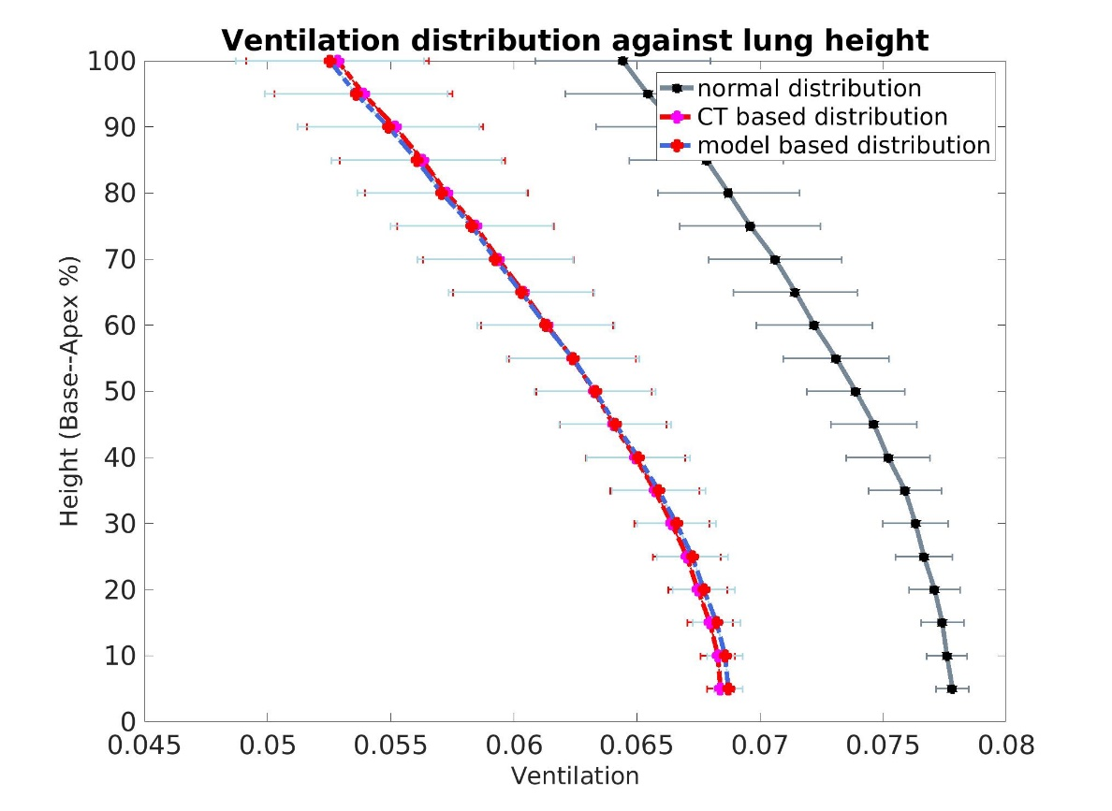

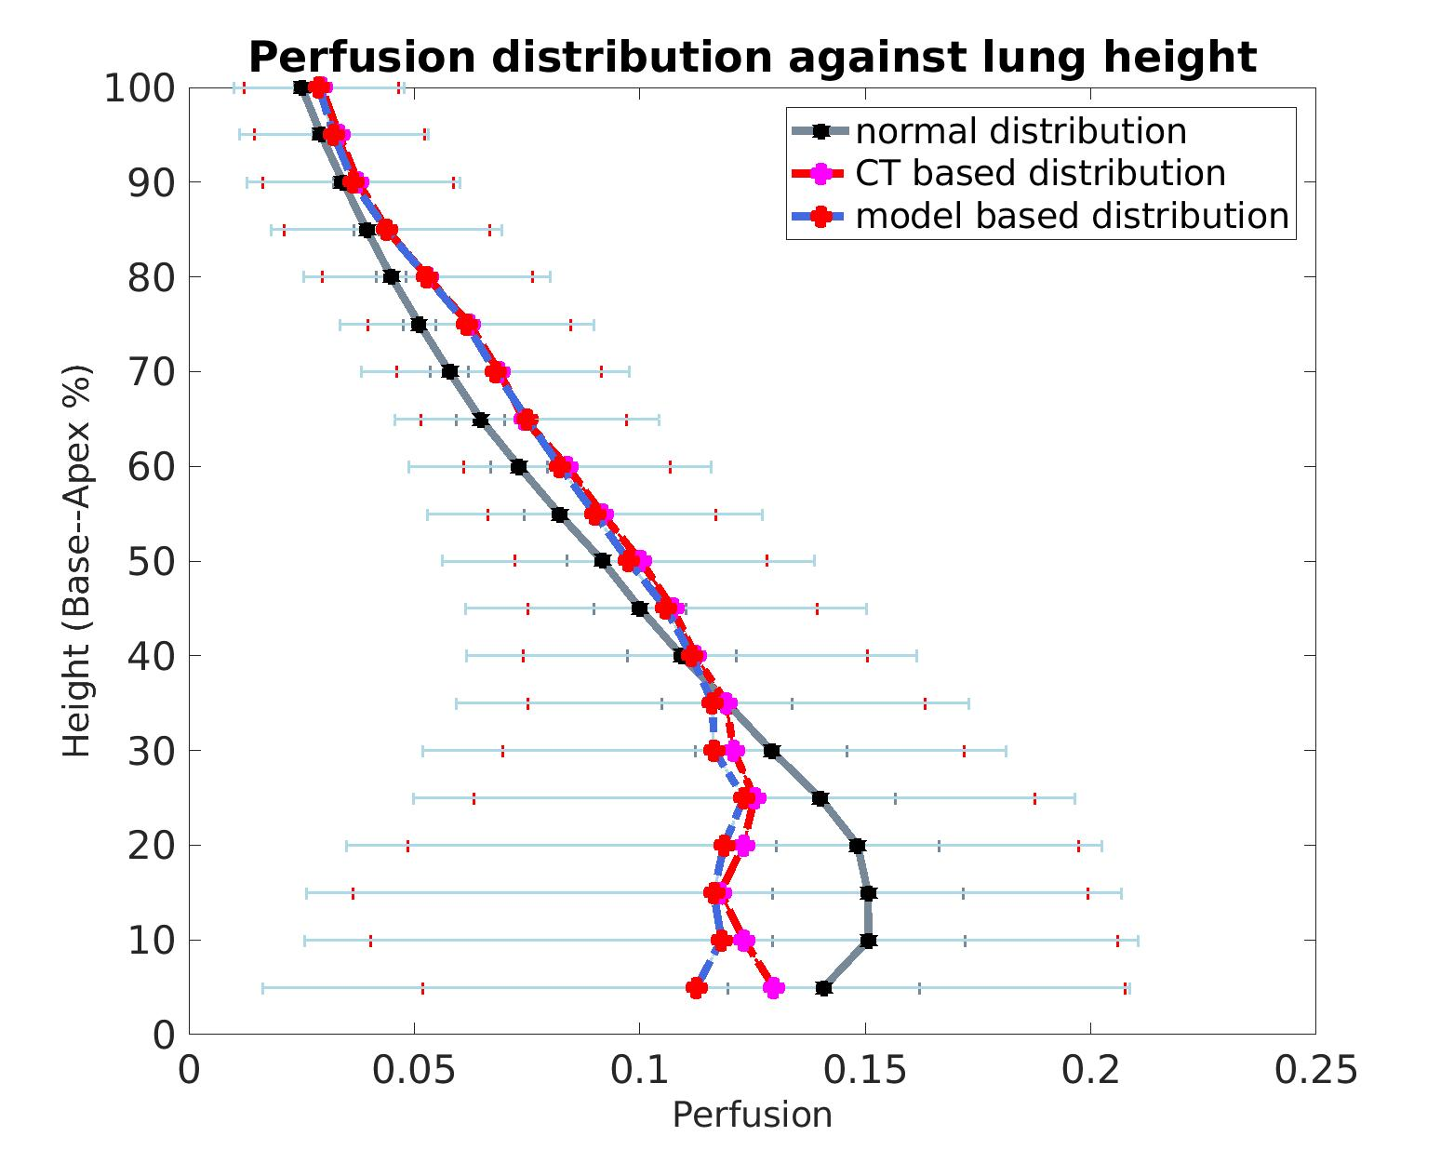

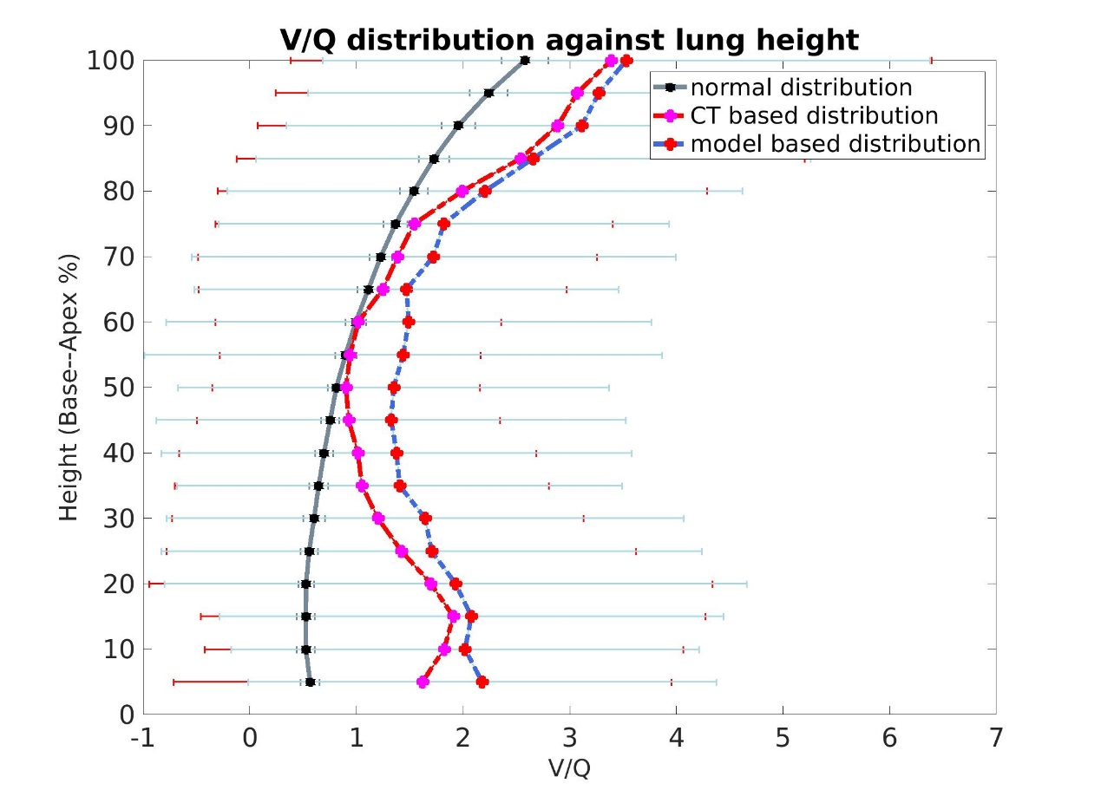

Both Ventilation and perfusion decrease in disease lung, especially for the basal region (fibrosis mainly distributes in the basal region). The model based V/Q mismatching is more serious than CT based V/Q mismatching, CT imaging could not provide enough information, V/Q mismatch can happen in CT ‘normal’ regions.

1. MIGET plot

Normal

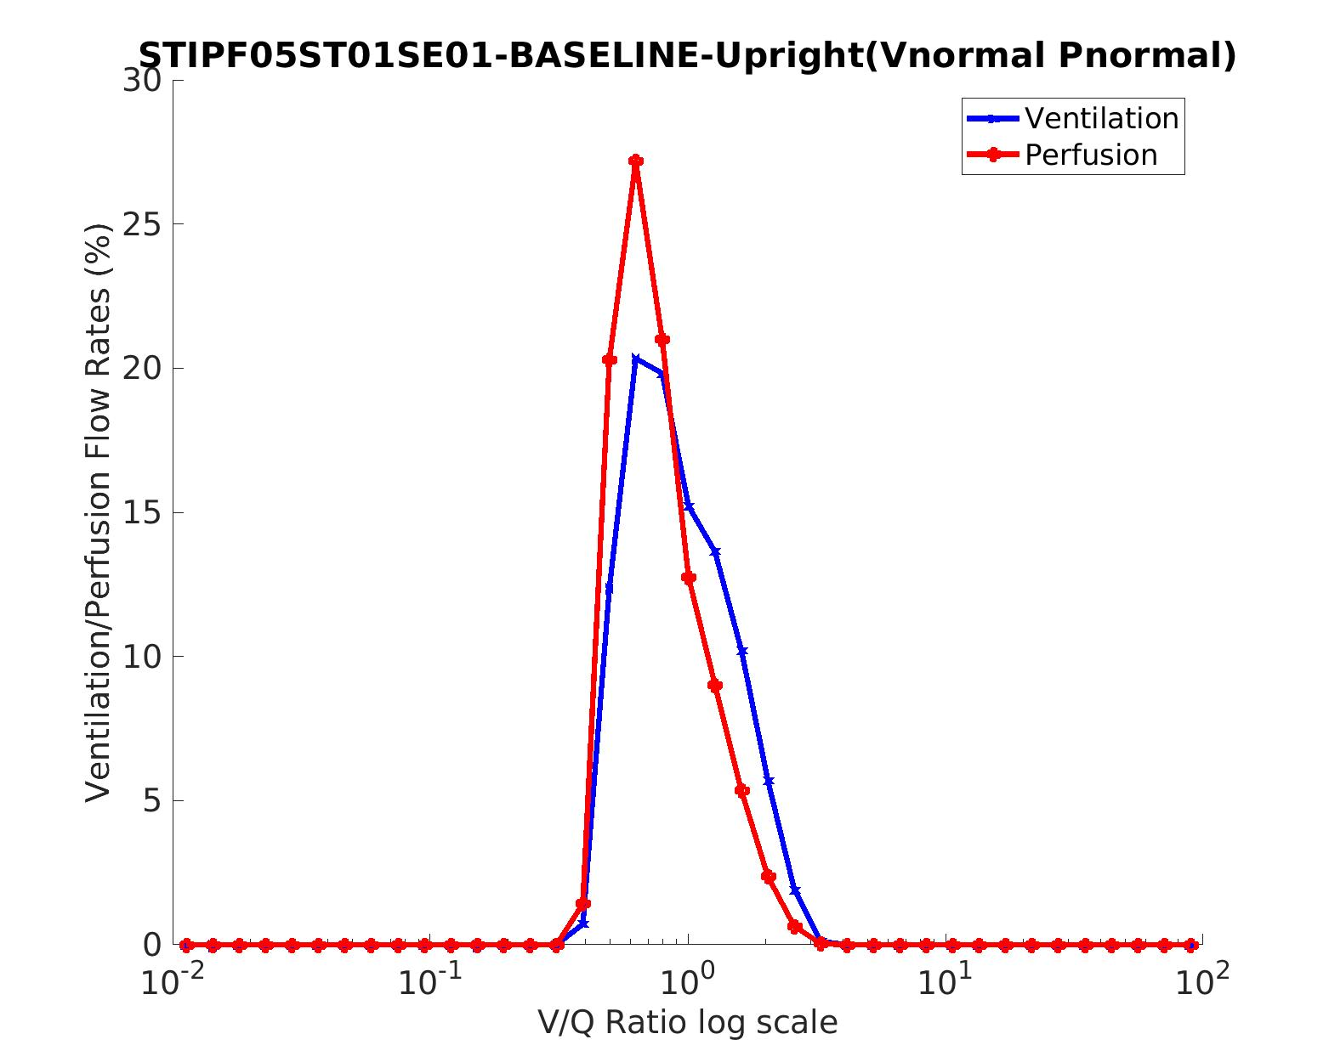

CT based

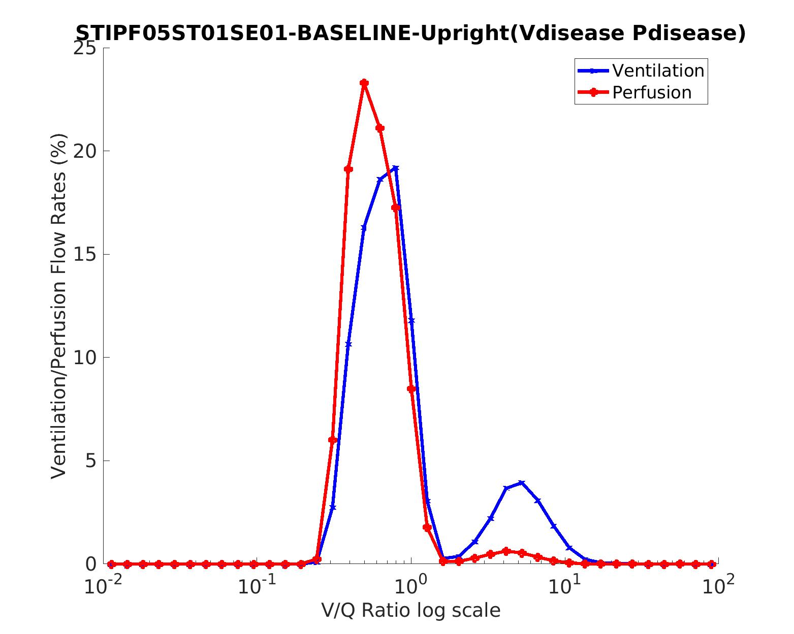

Model based

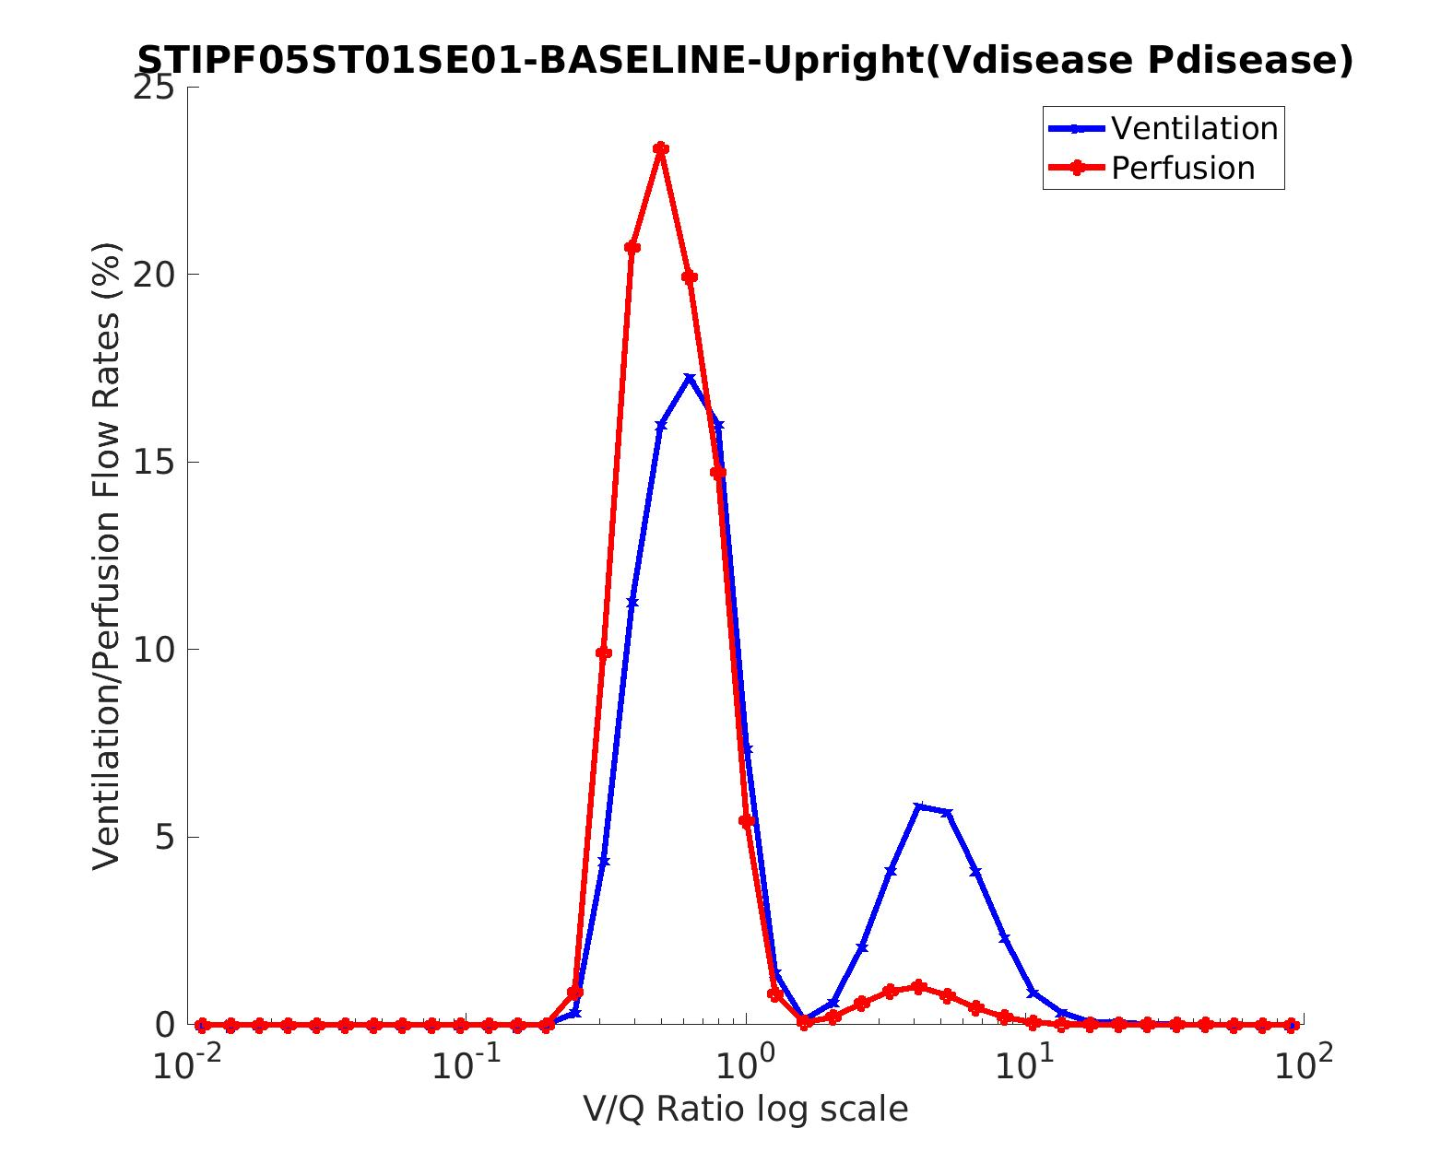

1. PaO2

Normal

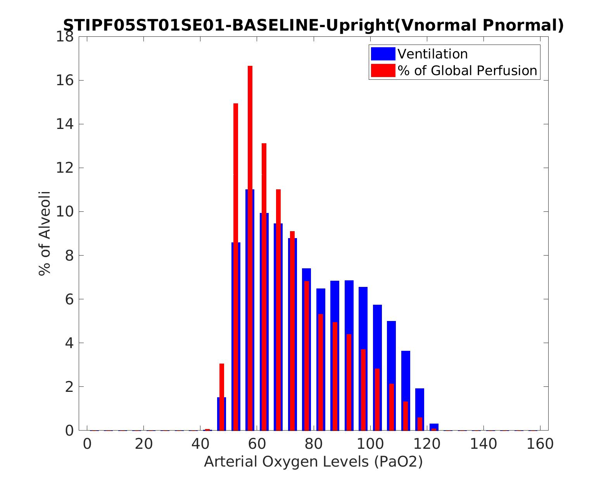

Normal PaO2 66.9509907305109 mmHg (This patient is 81 years old, PaO2 is smaller for old people).

CT based

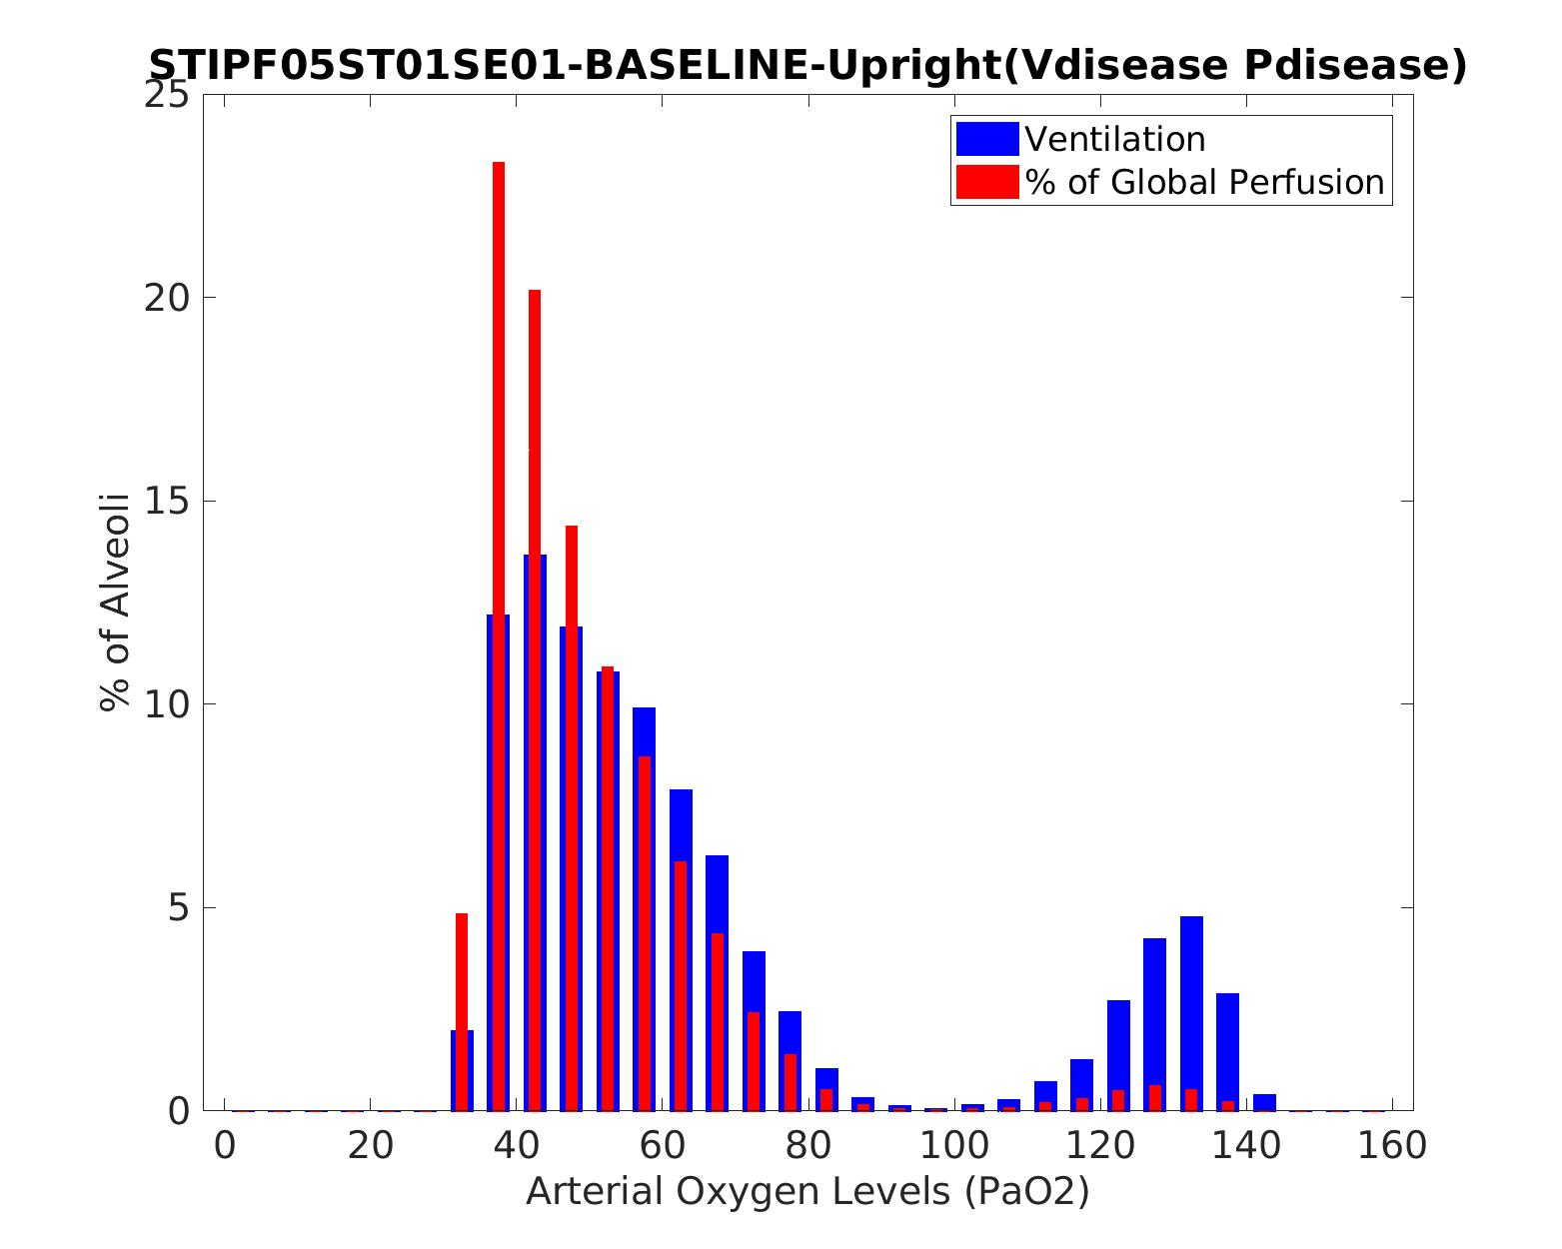

CT based PaO2 46.3024747656738 mmHg

Model based

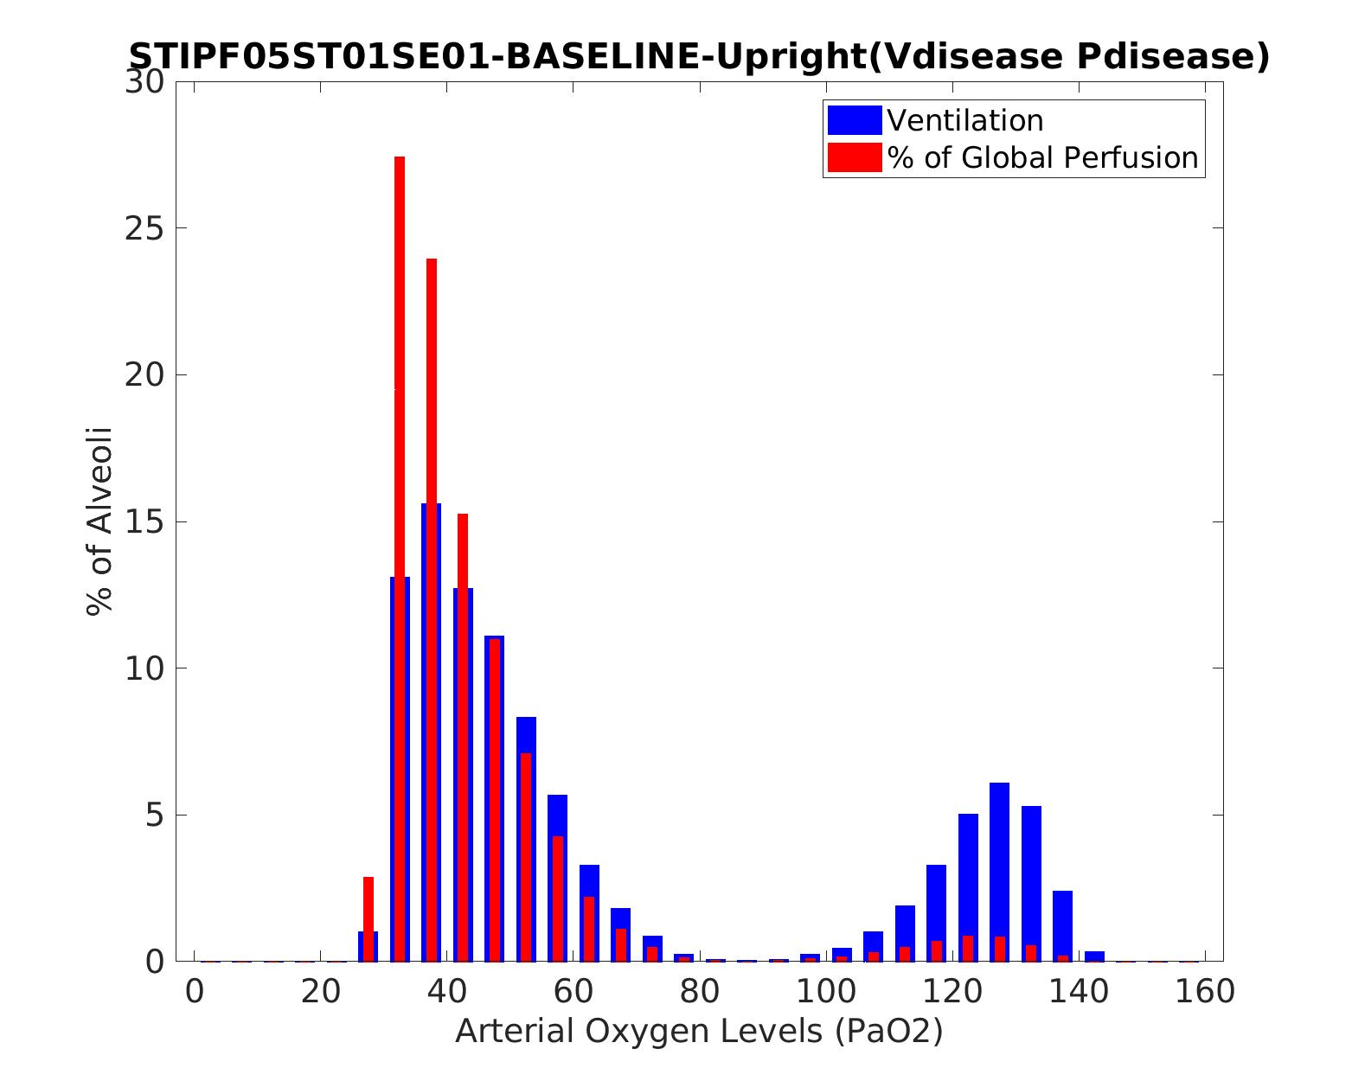

Model based PaO2 40.2576062548577 mmHg

Normal PaO2 > CT based PaO2 > model based PaO2