Lobe Segmentation (Introduction)

**Background**

Human lungs are divided into five distinct anatomical regions, which are called the pulmonary lobes. These lobes separate airways and vessel trees into different branches, and are largely anatomical independent. The separating junctions between these lobes are called the lobar fissures. The left lung consists of the left upper lobe and left lower lobe, which are separated by the left oblique fissure (major fissure). The right lung consists of the right upper lobe, right middle lobe and right lower lobe, which are separated by right oblique fissure (major fissure) and right horizontal fissure (minor fissure) (Sse Figure 1). These fissures contain pleural fluid and provide separation between the lobes while permitting some relative movement. In general, the functions of these lobes are relatively independent with each other since there are no major airways and vessels crossing the lobar fissures (Lassen et al 2010).

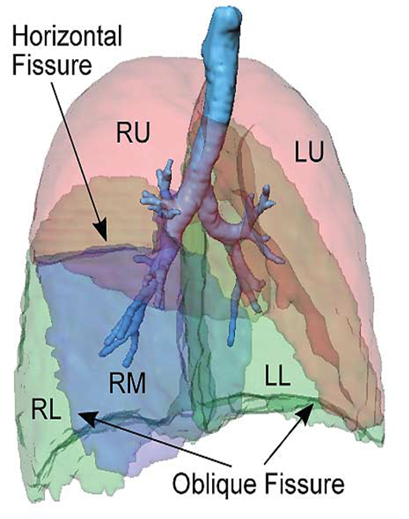

Fig 1. Anatomic structure of pulmonary lobes. Human lungs are divided into left upper lobe (LU), left lower lobe (LL), right upper lobe (LU), right middle lobe (LM), right lower lobe (RL)

The extraction of these lobes is of great importance in applications of lung disease assessment and treatment planning. For clinical applications, the distribution and location of pulmonary disease are beneficial for doctors to recognize pathogenesis, guide therapy and have further value in surgical planning. That is because many pulmonary diseases are more prevalent in specific anatomic regions of the lung, which means that many lung diseases act as a lobar level. For example, emphysema (Jeffery et al 1998), postprimary tuberculosis (Leung et al 1999) and silicosis (Rees et al 2007) usually affect the upper lobes, while idiopathic pulmonary fibrosis is commonly present in the lower lobes. However, there is currently a lack of quantitative and objective methods for the regional assessment of lung disease. Therefore, techniques are really necessary for identifying the location, shape and volume of the lobes so that lung disease could be measured at a lobar level and the severity could be assessed accurately.

Currently, the most traditional method for CT scans lobe segmentation is tracking the lobar boundaries manually by an experienced pulmonary radiologist. However, the process of determining the lobar boundaries is an extremely laborious and time-consuming task, since a 3D high-resolution CT imaging subject may contain a large number of axial sections which makes the manual segmentation very time consuming, typically taking hours for one patient. Therefore, rare doctors use manual lobe segmentation in clinical diagnosis and treatment practice and most clinicians think visual observation subjectively is more effective and convenient. For this reason, an automatic (no user interaction) or semi-automatic (minimal user interaction) lobe segmentation techniques is urgently needed in clinical applications and it has attracted great interest of researchers all over the world.

However, to find an effective and time-saving automatic lobe segmentation method is a challenging task because of anatomical variation and incomplete fissures. On one hand, lobes vary between subjects. The anatomical variation of lobe is usually associated with age, sex and body type. Pathologies of diseased lungs usually deform the lobar shape abnormally and result in some fuzzy appearance of fissures on CT images, in particular in the presence of abnormalities near the fissures, which makes fissure segmentation challenging. On the other hand, even in patients with healthy lung parenchyma the fissures are usually incomplete (Gülsün et al 2006) (see Figure 2).

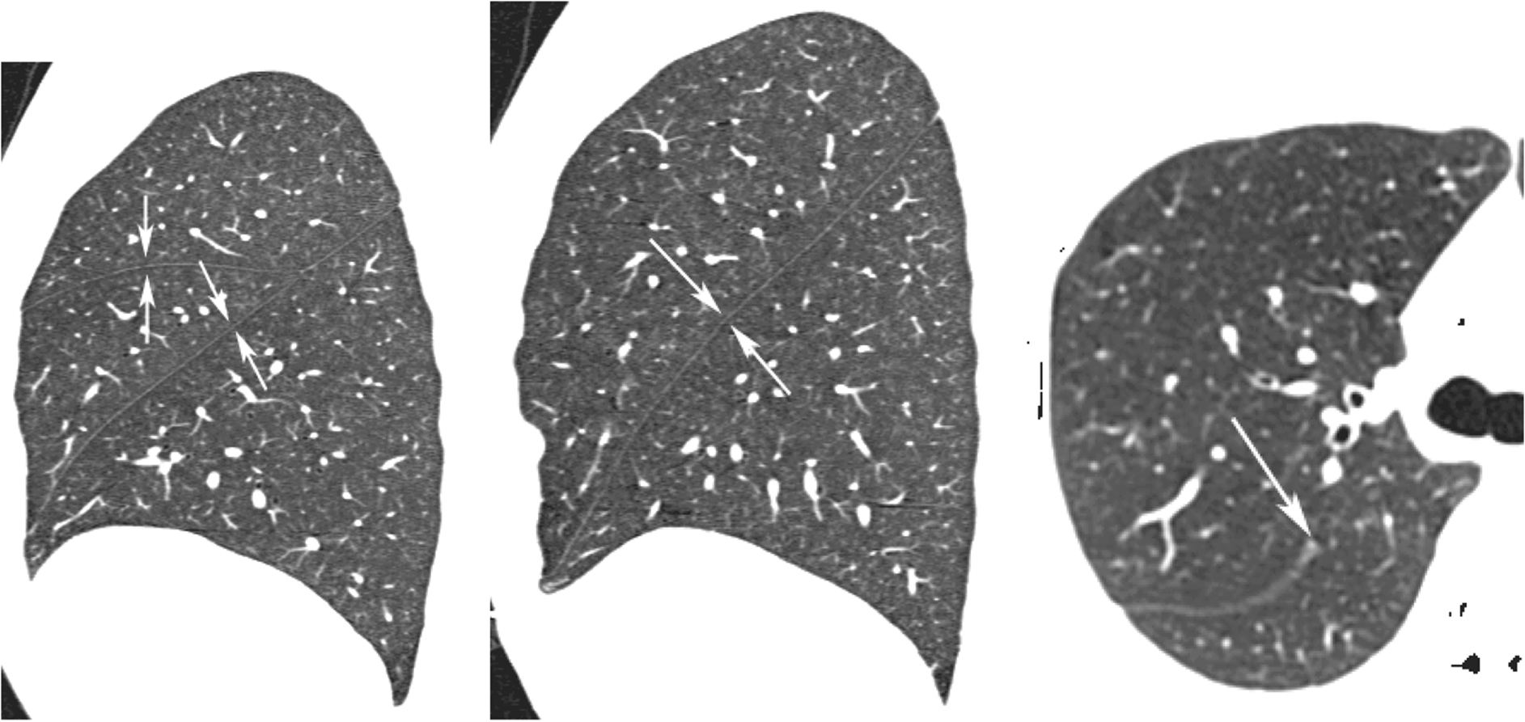

(a) (b) (c)

Fig 2. (a) the right oblique and horizontal fissures (b) the left oblique fissure. (c) an incomplete right oblique fissure.

In a broad sense, the existing computational lobe segmentation methods usually consist of two steps: the segmentation of lungs and the detection of the three main pulmonary fissures which divide the lungs into five lobes. Currently, quite a number of lung segmentation methods are well established to get a reliable result. In contrast, most challenges for automated lobar segmentation lie in the fissure detection. Fissure detection is a hot research field and quite a lot of algorithms has been developed both in 2D and 3D, however, no method has yet been demonstrated to be robust and effective across a wide range of subject especially abnormal subject. To some extent, lung segmentation and fissure detection are two independent parts and can be improved separately. That means it would be possible for us to change lung segmentation to another one without affecting the fissure detecting result dramatically.

**Lung segmentation**

The segmentation of lung is the prerequisite for the accomplishment of lobe segmentation, as it can provide a boundary condition for the subsequent fissure detection, specify the position when extending the fissure surface and allow the estimation of lung volumes and the detection and quantification of abnormalities within the lungs.

So far, a large number of researches have been involved in the hot topic of lung segmentation from CT scans and most of the published methods can perform well. In CT scans from healthy subjects, the air-filled lung parenchyma usually has a different attenuation compared to surrounding tissue. For this reason, quite a lot of conventional lung segmentation algorithms are based on a thresholding approach. Threshold value is acquired from gray level histogram analysis and then the largest connected component region is detected or region growing method working on airways is used to find the lung region initially. Some thresholding algorithms, especially the ones in old papers, are developed in 2D space, which means each axial section of CT imaging need to be calculated separately (e.g. Kalender et al 1991, Kemerink et al 1998, Leader et al 2003, Armato and Sensakovic 2004). But this process may cause incontinuity between slices, hence a further improved 3D processing (Hu et al 2001, Ukil and Reinhardt 2005, Sun et al 2006) is a better choice and has been widely used in a lot of papers. 3D thresholding algorithms avoid inconsistencies between slices and is less time consuming as well.

Although gray-level thresholding information was considered to help with finding the lung boundaries and studying on lung structures from early times (Keller et al 1981, Hedlund et al 1982, Hoffman et al 1983, 1985(a), 1985(b)), these methods usually combined with much manual interaction, such as manually selecting threshold values or seed point for region growing and separating left and right lung manually. That means the whole process may be too time consuming and cause too many personal errors. Hu et al (2001) was the first research group to apply threshold-based algorithm in a fully automatic lung segmentation method. In their study, the lung region was firstly extracted from the CT images by gray-level thresholding processing. The left and right lungs were then separated by identifying the anterior and posterior junctions by dynamic programming. Finally, a sequence of morphological operations was used to smooth the irregular boundary along the mediastinum in order to obtain results consistent with those obtained by manual analysis, in which only the most central pulmonary arteries were excluded from the lung region.

Considering the problem of inconsistent boundaries caused by irregular and inconsistent lung boundary for the regions near the mediastinum, Ukil and Reinhardt (2005) developed a further improved automatic lung segmentation method for the three-dimensional smoothing of the lung boundary using information from the segmented human airway trees. First, a bounding box was defined around the mediastinum for each lung using the information from the segmented human airway trees, and all operations were performed within the bounding box. Then, all generations of the airway tree distal were defined to the right and left main stem bronchi to be part of the respective lungs and all the other segmented structures could be excluded. Finally, a fast morphological closing with an ellipsoidal kernel was performed to smooth the surface of the lung. Sun et al (2006) also presented a 3D-based method for segmenting and visualizing lung volume using CT images. The improved point of this paper is that an anisotropic filtering method was firstly applied on CT slices to enhance the signal-to-noise ratio. A wavelet transform-based interpolation method was subsequently used followed to construct the 3D volumetric CT slice data with volume rendering. After that, an adaptive 3D region-growing algorithm was developed to detect lung region, combined with automatic seed-locating methods. Fuzzy logic algorithms and 3D morphological closing approaches were finally used to refine the lung volume and fill the holes in it. The segmentation method was tested on 20 CT scans and the results showed the segmentation method was effective and robust with an average accuracy rate of 88.5%.

As we mentioned above, though conventional threshold-based methods are fast, robust and accurate for healthy subjects, they may fail to perform well scans containing pathologic abnormalities, and such an approach often results in segmentation errors and requires clinicians to manually edit the results. Currently, the published specially designed lung segmentation methods (e.g. Kitasaka et al 2003, Sluimer et al, 2005, Pu et al, 2008, 2011, Prasad et al 2008, Korfiatis et al 2008, Wang et al, 2009, van Rikxoort et al 2009, Sun et al 2012) mostly aim at one kind of disease and therefore could not get a good result across a large population. To deal with the problem of lesions adjacent to the chest wall and mediastinum, Kitasaka (2003) developed a lung area extraction method using a shape model. A contour shape model using a Bézier surface was fitted to the contour surface of the individual input images with an affine transformation method. Then, an active contour model was utilized to refine the initial segmentation. The results showed that by using the proposed technique to 3D chest X-ray CT images, most lesions could be identified accurately. However, because the lung apex and base were not included in the model, lesions adjacent to the lung apex or diaphragm could result in segmentation errors.

Pu et al (2008) presented a lung segmentation algorithm based on adaptive border marching (ABM) to include juxtapleural nodules in the lung region since these juxtapleural may be excluded from the results calculated by a conventional threshold-based algorithm. The adaptive border marching algorithm could smooth the lung borders after a initial thresholding processing and minimize oversegmentation of adjacent regions such as the abdomen and mediatinum at well. The method was tested on 20 datasets and the results demonstrated that this method could re-included all juxtapleural nodules in the lung regions. An average oversegmentation ratio of this method was 0.43% which was lower than the reference standard average segmentation determined by an expert. The whole calculation process could be completed in a very short time with under 1 min for one subject on a typical PC. In order to deal with the problem of various diseases, image noise or artifacts and individual anatomical variety, Pu et al (2011) developed a shape analysis strategy termed “break-and-repair”. A principle curvature analysis was applied to eliminate the problematic regions and then radial basis function (RBF) based implicit surface fitting was used to get a smooth lung surface.

To overcome the problem of error detection for lung pathologies, Prasad et al (2008) made use of the rib curvature information to help with finding the lung borders. The method was based on a threshold-based algorithm followed by morphologic operation and the core principle of the method was adapt the threshold value to individual subject by making the curvature of lung along the ribs be similar to the curvature of the ribs. The curve of the ribs and lung boundary were both represented by polynomial interpolation even though there was minimal deviation from this representation. The method was evaluated by comparing to conventional lung segmentation techniques on 25 subjects using a volumetric overlap fraction measure and the results showed that the performance of the rib segmentation method was quite different from the conventional one.

Wang et al (2009) proposed a texture analysis-based method for accurate segmentation of lungs with CT scans. The lung region including normal and mild ILD lung parenchyma was first segmented by a CT value thresholding technique and then texture-feature images derived from the co-occurrence matirx was used to identify abnormal lung regions with severe ILD from the initial results. 2D holes filling was applied to smooth the final lung segmentation. The overlap rate, volume agreement, mean absolute distance (MAD), and maximum absolute distance between the automatically segmented lungs and the reference lungs delineated by a medical physicist manually were employed to evaluate the performance of the segmentation method.

On the basis of the previous studies, Sun et al (2012) developed a further approach for segmentation of lung s with high-density pathologies. The method had two main steps. In the first step, a robust active shape model (RASM) matching method was utilized to roughly find the outline of the lungs. To initialize the shape model of RASM, the detected rib information was used subsequently. In the second step, an optimal surface finding approach was applied to further adapt the initial segmentation result to the lung. The method was evaluated on 30 data sets with 40 abnormal (lung cancer) and 20 normal left/right lungs with a result of an average dice coefficient of 0.975 +- 0.0006 and a mean absolute surface distance error of 0.84 +- 0.23 mm.

**Fissure detection**

Fissures are the most visible boundaries between the lobes, and therefore the detection of fissure points is an essential part of any accurate lobe segmentation method. The currently published fissure detection method can be mainly classified into two categories. The first category is named anatomy knowledge based method. This kind of method usually depends on either local or global knowledge of the anatomy of lung structure based on two features of lungs. The first feature is the fact that there should not be any large vessels in the vicinity of lobar fissures, so fissures should be located in the gaps between airway and vessel trees. Another feature is the vessels and bronchi could be classified into five lobe regions using an edge detection method. A number of published papers use the segmentation results of airways and vasculature to help with localizing the fissures. Kuhnigk et al (2003 2005) was early group to present a framework of making use of lobar airways and vasculature into account for automatic fissure detection. A watershed transformation method was used to take an analysis of these anatomical structures and this method was widely used and improved by other researches later, but the results with the simple algorithm was still inaccurate even for some clearly visible fissures. Ukil and Reinhardt (2009) developed Khnigk’s fissure detection method which combined a distance transform to segmented vessels and original chest CT scan as a cost image for a watershed transform guided by airway and vascular markers. The improved watershed transform algorithm could provide a close initial approximation to the lobar fissures and an initial search area for the lobar fissures was determined. Subsequently, a further refinement method was used to construct a region of interest (ROI) encompassing the fissures and a 3D optimal surface detection algorithm combined with a ridgeness measure based on the structure tensor analysis was then applied to enhance the ROI and finally find the optimal surface within the ROI. In the last step, incomplete fissures were smoothly extrapolated using a fast-marching method based segmentation of a projection of the optimal surface. The method was evaluated by comparing the automatic results to manual tracings of the fissures with 12 normal subjects and 17 diseased subjects. The RMS errors for the left oblique fissure, right oblique fissure and right horizontal fissure were 1.81, 1.57, 1.43mm respectively of the normal subjects and 1.71, 1.88, 2.31 respectively of the abnormal subjects. However, some manual operations were still needed for about 20%-25% subjects. ], Lassen et al (2011) also described the fissure detection method by building a cost image for the watershed transformed segmentation which is an extension of the framework of Kuhnigk. The interactive segmentation method was tested on 25 CT scans comparing to a manual segmentation by a human observer and showed an average distance of 1.57+- 0.3mm. In addition, Zhou et al (2004) and Saita et al (2006) took advantage of the linear appearance of fissures to class the vessels and bronchi into five lobe regions using an edge detection method and the Hough transform based curved surface detection method, respectively.

The second category of fissure detection is named shape based analysis method. This kind of method commonly makes use of gray-level information and shape information to detect the fissures. Generally, lobar fissures can be regarded as bright planes crossing the pulmonary volume because of the higher density value of fissures comparing to the surrounding tissues. Based on this information, quite a number of published methods use local filtering algorithm to detect the voxels which lie on these planes, so that these detected voxel points can construct a continuous fissure surface. In 2D space, the fissure appears as a clear curve, therefore some early papers usually detected fissure points based on gray-level information in 2D space (Wang et al 2003, 2006, Kuhnigk et al 2003). For example, Wang et al (2003 2006) presented an approach for segmenting the major fissures on CT scans based on shape information. The fissure was initially denoted as a curve based on the prior knowledge of the shape of the fissure to identify the surrounding region of fissure, called “fissure region” for subsequent automatic segmentation. Next an image transformation called “ridge map” was proposed for enhancing the appearance of initial fissures. The shape-based curve-growing growing method modeled by a Bayesian network could then be applied to this “map” to segment the fissure. The method was applied to segment the fissures of chest CT of 10 patients with pulmonary nodules. The result showed that only 2.4% of the fissures required manual correction and the average distance between the automatic and manual segmented fissures was 1.01 mm.

In 3D space, the most common used method to detect these pulmonary fissure plane structures is taking an eigenvalue analysis of Hessian matrix (Frangi et al 1998, Wiemker et al 2005(a), Kitasaka et al 2006, Ochs et al 2007, van Rikxoot et al 2008, Ukil and Reinhardt 2009, Lassen et al 2011 2013, Ross et al 2010, Doel et al 2012). Frangi et al (1998) was the first to present eigenvalue analysis of Hessian matrix to detect plane structure such as fissure and tube structure such as vessel on CT images. The three eigenvalues of Hessian matrix gives a fissure probability for each voxel and the relation between the eigenvalues of the Hessian matrix describes the local image structure (Wiemker et al 2005(b)). Wiemker et al (2005(b)) was also an early paper to use Hessian matrix for fissure detection and two 3D filter approaches were proposed in this paper. The first filter was based on first derivatives of the image gray values and utilized the eigenvalues of the local structure tensor. The second filter was based on second derivatives and utilized the eigenvalues of the local Hessian matrix. Ochs et al (2007), van Rikxoot et al (2008) both used a pattern recognition approach to detect pulmonary fissures combined with eigenvalue analysis of Hessian matrix as feature and classification was also performed on these fissures. Lassen et al (2011 2013) utilized the eigenvalue analysis of Hessian matrix based on the initial approximation fissures from anatomical structure of airway and vessel trees. This algorithm combined with two types of methods could reduce many false points since the first anatomic-based method could find a region of interest which made the analysis of Hessian matrix only work in the surrounding area of the initial guessing fissure locations. Subsequently, morphological operations such as direction-based connected component analysis were also used to further reduce some non-fissure points. The average distance between automatic fissures and the reference for 55 CT scans were 0.98 mm, 3.97 mm and 3.09 mm for the left oblique fissure, right oblique fissure and right horizontal fissure respectively. Ross et al (2010) proposed a particle system that sampled the image domain combined with Hessian matrix to get a set of candidate fissure locations. A maximum a posteriori (MAP) estimation was followed to eliminate false candidate points and a post-processing operation was applied to remove remaining noise points. A thin plate spline (TPS) interpolating surface fitting method was lasted performed to form the finial fissure surfaces. Doel et al (2012) also made use of both anatomy knowledge based method and Hessian matrix to find a set of fissure candidates and proposed a smooth multi-level B-spline curve through the fissure points and extrapolated to the lung borders to get the fissure surfaces.

In this paper, we propose a principle component analysis model based method to the pulmonary lobar segmentation. We follow a tree-step approach: in the first step, a thresholding based lung segmentation method is developed to get the lung boundary. In the second step, a PCA average model is deformed to get a region of interest of fissure locations. In the third step, the fissures are accurately located using the Hessian matrix combined with some future connected component filters and surface fitting algorithm. This method is able to detect fissures in all subjects, whereas existing segmentation tools failed in several subjects. Our new procedure does not depend on prior segmentation of anatomical structures (airways/vessels) and has promising potential as a clinically useful automatic lobe segmentation procedure. A user-interactive interface is also developed for user to control and visualize the whole segmentation process and do some manual correction on the segmentation results.