LLM-Based Restaurant Review Rating Inference: Baseline and Optimization Experiment Report
Student ID1_Student ID2_Student ID3 (for group assignments)

1. Task Overview

1.1 Task A: Baseline Experiment
This task aims to complete the text-to-rating (1-5 stars) inference task using publicly available Large Language Models (LLMs) based on the provided restaurant review dataset. The core objective is to verify the correct deployment and operation of the selected LLM on the Huawei Cloud ModelArts platform, obtain baseline performance, and conduct analysis, without involving model architecture modifications or training processes.

1.2 Task B.1: Model Extension and Optimization
Building on Task A, the model is optimized in two ways: first, implementing an n-shot in-context learning inference strategy based on the training set (review_train.csv); second, performing Supervised Fine-Tuning (SFT) on the model using the training set with the LoRA fine-tuning method. The core goal is to compare the performance differences between the baseline model and the optimized models, and verify the effectiveness of the optimization strategies.

2. Experimental Setup

2.1 Dataset Processing

2.1.1 Dataset Overview
- Training Set (review_train.csv): Contains complete review texts and corresponding 1-5 star rating labels, used for n-shot example selection and SFT fine-tuning.
- Test Set (review_test.csv): Contains only review texts, used for model inference to predict ratings.
- Test Answer Set (test_answer.csv): Only used for final performance evaluation, not involved in any training or fine-tuning processes.

2.1.2 Data Preprocessing and Tokenization
- Tokenization Strategy: Adopt the official Tokenizer corresponding to the selected LLM, perform text truncation or padding according to the maximum input length required by the model; based on the length distribution of review texts, calculate and determine a reasonable maximum sequence length threshold.

2.1.3 Text Length, Padding, and Batching Strategy
- Text Length Handling: Calculate the length distribution of review texts in the training and test sets. Based on the model's maximum input limit, set the maximum sequence length to 512 (for fine-tuning) and 2048 (for inference). Texts exceeding the threshold are truncated, and those insufficient are padded.
- Padding Strategy: Use right padding (padding='right'), employing the Tokenizer's default padding token. If the model does not have a specific padding token, use the [EOS] token as padding.
- Batching Strategy: Based on the GPU memory resources of the ModelArts platform, set the batch size to 4, and use a gradient accumulation step of 4 to optimize training efficiency.

2.2 Model Configuration

2.2.1 Baseline Model (Task A)
- Model Selection: Qwen/Qwen2.5-1.5B-Instruct
- Model Source: Hugging Face Model Hub
- Deployment Environment: Huawei Cloud ModelArts platform, with the image version pytorch_2.6.0-cann_8.2.rc1-py_3.11-euler_2.10.11-aarch64-snt9b
- Running Parameters: Maximum input length 2048, inference temperature 0.1, top-p value 0.8

2.2.2 Optimized Models (Task B.1)

2.2.2.1 N-shot In-Context Learning
- Example Selection Strategy: Select representative samples from the training set according to the rating distribution (1 sample for each 1-5 stars). Priority is given to medium-length reviews with 100-400 characters, and samples closest to the median of this length are chosen to ensure sufficient information and avoid excessively long contexts.
- Prompt Design: Adopt the structure of "Task Description + Example Demonstration + Review to be Inferred". The n value is set to 5-shot.

2.2.2.2 Supervised Fine-Tuning (SFT)
- Fine-Tuning Method: LoRA (Low-Rank Adaptation)
- LoRA Configuration: Rank = 16, α value = 32, Target Layers = ["q_proj", "k_proj", "v_proj", "o_proj", "gate_proj", "up_proj", "down_proj"]
- Training Parameters: Learning rate = 2e-4, Training epochs = 3, Optimizer = AdamW, Weight decay = 0.01.
- Training Equipment: Huawei Cloud ModelArts platform, using a single Ascend Snt9B card instance, equipped with a 24-core ARM CPU and 192GB system memory. This configuration is specifically designed for training and tuning scenarios of deep learning models.

2.3 Evaluation Metrics
- Selected Metrics: Accuracy, Weighted F1-score, Macro-average F1-score (F1-Macro)
- Selection Basis: Accuracy directly reflects the overall prediction correctness. The weighted F1-score considers the imbalance in the number of samples across categories, enabling a more comprehensive evaluation of the model's performance across all categories. The macro-average F1-score assigns equal importance to the performance of each category, helping to identify the model's performance shortcomings in minority categories (such as 1-star and 5-star).

3. Experimental Results

3.1 Task A: Baseline Model Results

3.1.1 Performance Metrics
Evaluation Metric | Value
Accuracy | 0.5511
F1-Score (Macro) | 0.5118
F1-Score (Weighted) | 0.5068

3.1.2 Badcase Analysis
Review ID | Review Text (Abstract) | Predicted Rating | Actual Rating (Test Set Answer) | Inference Logic Analysis
7953029198 | We went to Shook on Monday night. The bar and service were very good but that's where it ended. Kitchen staff were apathetic and their hands and fingers were all over the food as they prepared. | 3 | 2 | The model may have been dominated by the positive evaluation at the beginning ("The bar and service were very good") and failed to fully weigh the serious negative information about kitchen hygiene and food quality in the subsequent text, resulting in an overestimated rating.
9350751302 | Really disappointed with the variety of foods. Not what like people have reviewed and recommended. Weird taste of roasted chicken and duck. Meat was hard. I love sushi but here lack of options, only | 5 | 3 | The model over-interpreted positive words (such as "highlight" and "willing"), misclassifying an overall neutral-to-positive 3-star review as an extremely recommended 5-star review, indicating an inaccurate grasp of the rating scale.

3.1.3 Running Logs and Screenshots
- Screenshots of the successful execution of the inference task on the ModelArts platform, including key information such as task status and log output (e.g., inference progress, result printing).

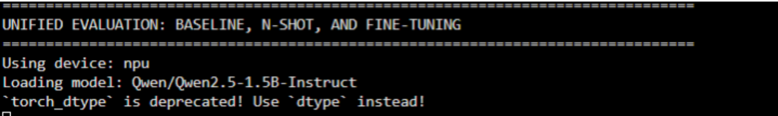
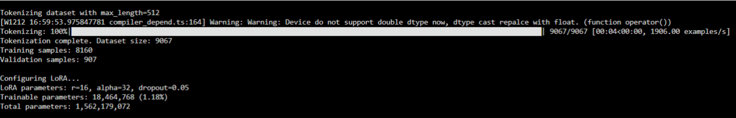
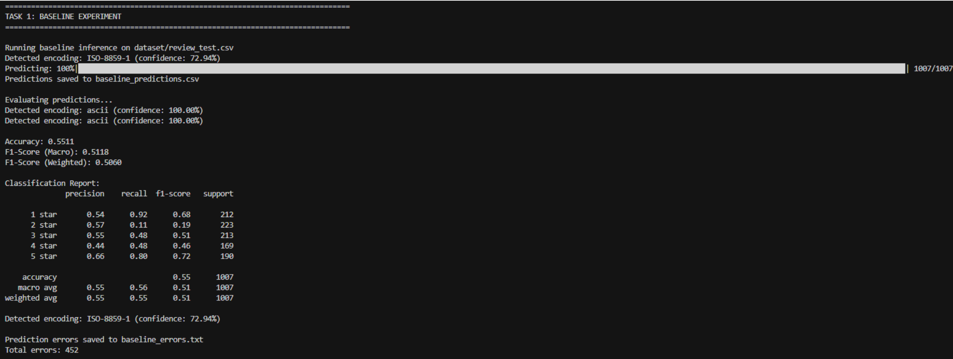
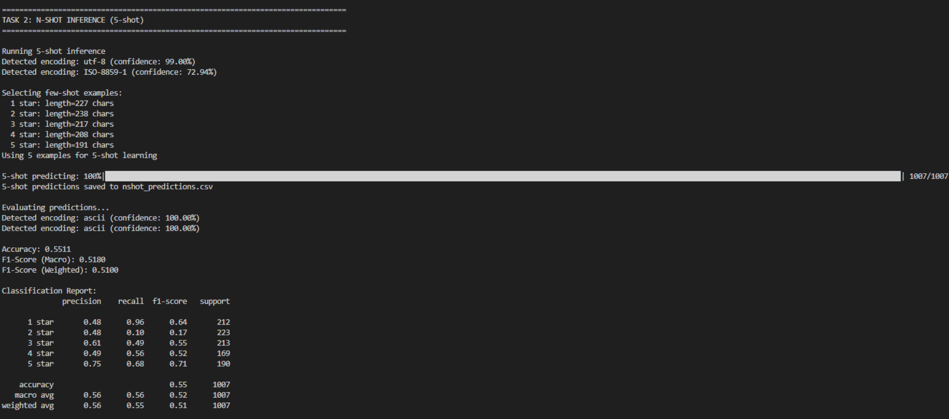
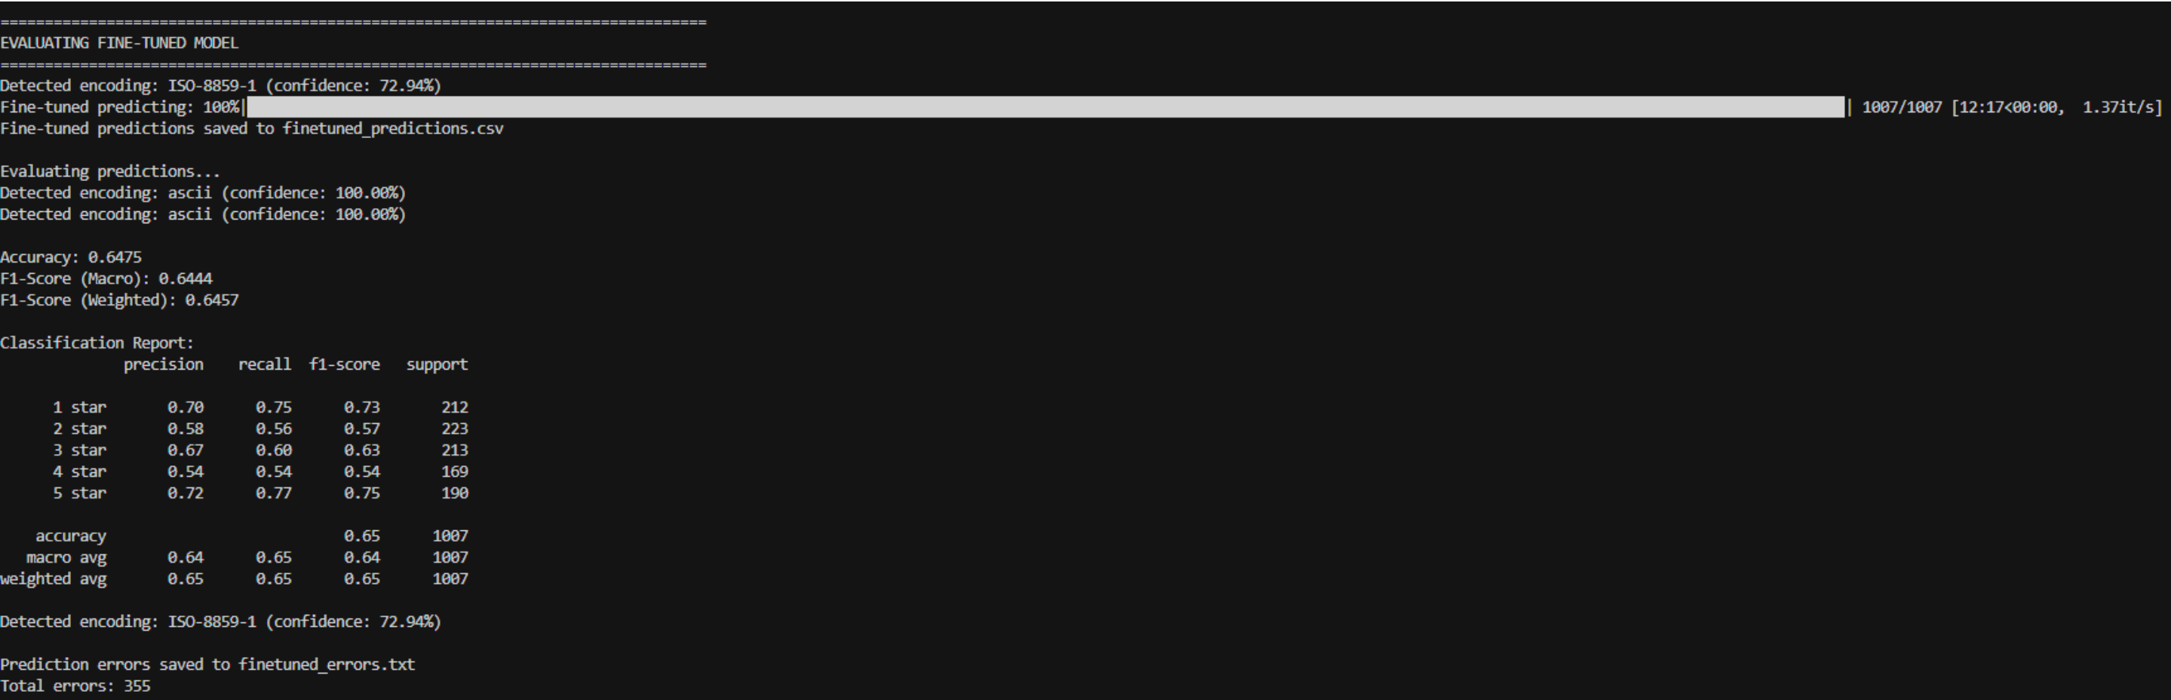
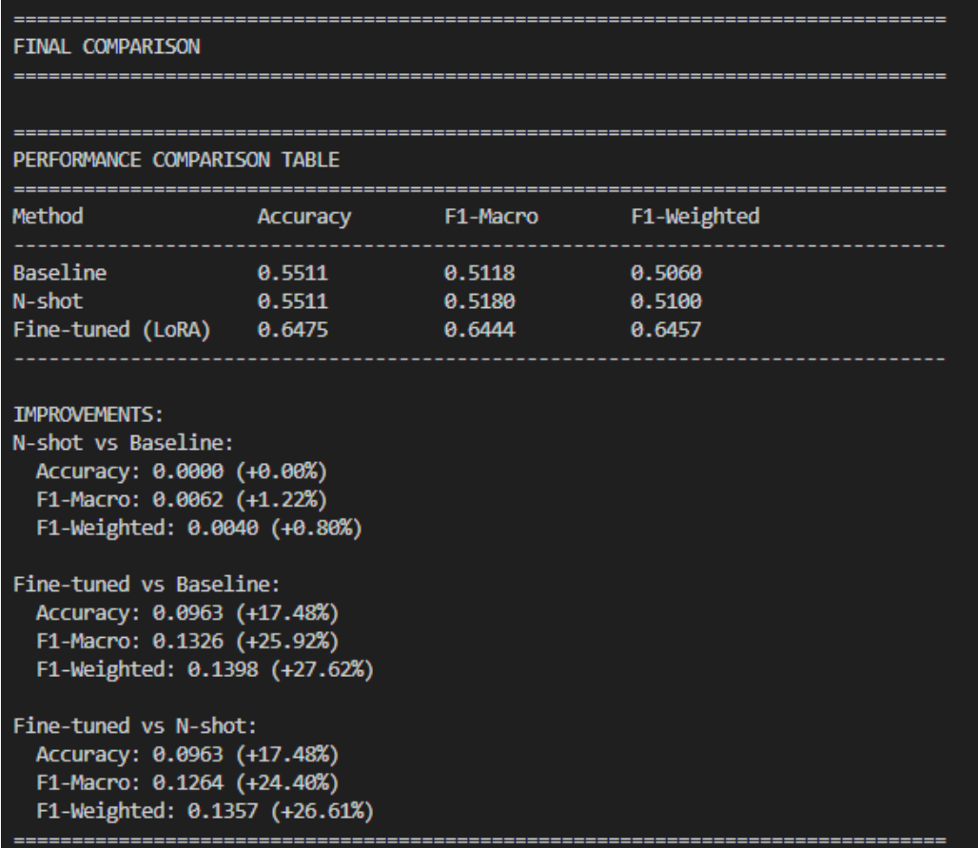
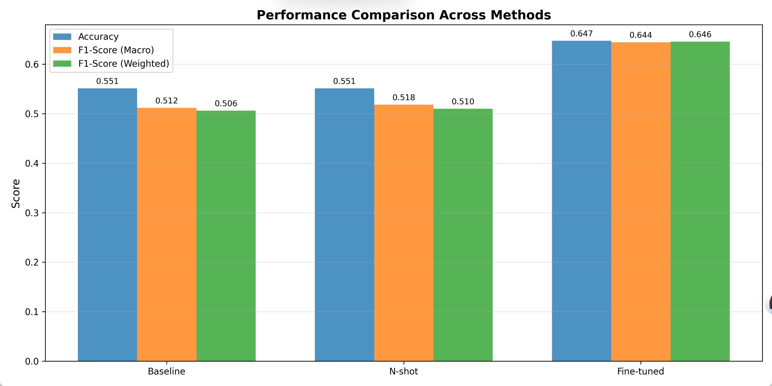

3.2 Task B.1: Optimized Model Results

3.2.1 N-shot In-Context Learning Results
Evaluation Metric | Value (n=5) | Difference from Baseline Model
Accuracy | 0.5511 | 0.0000 (+0.00%)
F1-Score (Macro) | 0.5180 | 0.0062 (+1.22%)
F1-Score (Weighted) | 0.5100 | 0.0040 (+0.88%)

Badcase Analysis:
Review ID | Review Text (Abstract) | Predicted Rating | Actual Rating (Test Set Answer) | Inference Logic Analysis
2524719644 | The food here are very expensive. We don't have any issue paying expensive food, but it was not really | 4 stars | 2 stars | The model was seriously disturbed by the positive descriptions in the second half of the review, such as "quiet environment" and "no mosquito bites", ignoring the major food safety issues of "expensive food not meeting expectations" and "serving raw chicken", resulting in a severely overestimated rating. This indicates that the n-shot examples failed to effectively guide the model to identify core negative factors.
8414869219 | There was nothing exceptional that I experienced here. The quality of food was | 1 star | 3 stars | The model over-interpreted neutral-to-negative words such as "nothing exceptional" and "average", misclassifying it as an extremely disappointing 1-star review. In fact, the review clearly expresses a 3-star experience of "acceptable but mediocre", and the n-shot strategy failed to help the model accurately grasp this subtle neutral evaluation scale.

3.2.2 SFT Fine-Tuned Model Results
Evaluation Metric | Value | Difference from Baseline Model
Accuracy | 0.6475 | 0.0963 (+17.48%)
F1-Score (Macro) | 0.6444 | 0.1326 (+25.92%)
F1-Score (Weighted) | 0.6457 | 0.1398 (+27.62%)

Badcase Analysis:
Review ID | Review Text (Abstract) | Predicted Rating | Actual Rating (Test Set Answer) | Inference Logic Analysis
5310406185 | This meal was an absolute disaster! The chicken tasted like it was boiled in water with no flavor at all. | 2 stars | 1 star | Although the SFT model performed excellently overall, its prediction was slightly conservative when facing 1-star reviews with extremely negative wording such as "absolute disaster", "almost threw up", and "NEVER come back". This may be due to the relatively small number of 1-star samples in the training set, leading to the model's insufficient perception of the intensity of the strongest negative emotions.
6793182662 | The burgers, excellent! I would also rather heartily recommend the chicken wings. And the drinks aren't too shabby either. | 5 stars | 3 stars | The model can accurately capture positive signals but directly mapped "excellent" and "heartily recommend" to the highest rating of 5 stars, ignoring the short length of the review, the lack of specific details to support it, and the overall context being more inclined to a "good small restaurant" rather than an "extreme experience". This reflects that the fine-tuned model may overreact to strongly positive words in some cases and fail to make a more prudent rating by combining the context.

3.2.3 Comparison of Outputs from Two Methods
Evaluation Metric | SFT vs N-shot
Accuracy | 0.0963 (+17.48%)
F1-Score (Macro) | 0.1264 (+24.40%)
F1-Score (Weighted) | 0.1357 (+26.61%)

3.3 Training and Inference Progress

3.3.1 SFT Fine-Tuning Progress
- Provide loss curves (training loss, validation loss) during the training process to show the model convergence.
- Record performance changes at key training nodes (e.g., validation set metrics after each epoch).

3.3.2 Runtime Statistics
Metric | Baseline Model | N-shot Model | SFT Fine-Tuned Model
Inference Time (Full Test Set) | 05:54:00 | 06:24:00 | 12:17:00

4. Model Performance Analysis and Discussion

4.1 Baseline Model Analysis (Task A)

4.1.1 Model Behavioral Characteristics
- Strengths: As a powerful general-purpose instruction model, Qwen2.5-1.5B-Instruct can understand basic emotional tendencies and has high accuracy in predicting ratings for extremely positive/negative reviews.
- Weaknesses: Without task-specific fine-tuning, the model has weak ability to distinguish ambiguous cases with fuzzy rating boundaries (such as 3-star and 4-star) and is easily disturbed by complex semantics in reviews (such as irony and euphemistic expressions).

4.1.2 Limitations and Potential Errors
- Data-Related: The model's knowledge is derived from its pre-training data, and it may have insufficient understanding of unique regional expressions or cuisine terms in the dataset.
- Model-Related: Despite having 1.5 billion parameters, its zero-shot capability is still limited when facing tasks requiring refined emotional judgment.
- Inference-Related: The Prompt design is simple, failing to guide the model to focus on key rating features, leading to its susceptibility to the emotions at the beginning or end of the review.

4.2 Comparative Analysis of Optimized Models (Task B.1)

4.2.1 Effect of N-shot In-Context Learning
- Effectiveness: By providing specific examples, n-shot has calibrated the model's understanding of rating standards to a certain extent. For example, when processing Review ID 2601220850 (actual 4-star, baseline predicted 3-star), the n-shot model can more accurately capture keywords such as "relaxing" and "good place" and raise the prediction to 4-star. For Review ID 5367019475 (actual 3-star, baseline predicted 1-star), the n-shot model can also better understand the neutral stance of "poor entertainment but acceptable overall experience" and correct the prediction to 2-star, which is closer to the true value.
- Limitations: The effect of n-shot is highly dependent on the quality and relevance of examples. When encountering reviews with styles very different from the examples, its generalization ability is limited. In addition, fixed examples cannot cover all complex evaluation dimensions (such as conflicts between service, food, and environment), resulting in minimal overall performance improvement.

4.2.2 Effect of SFT Fine-Tuning
- Effectiveness: LoRA fine-tuning has significantly improved the overall performance of the model. The fine-tuned model has learned to view positive and negative information in reviews more balancedly. For example, in Review ID 9718124459, the review mentions both "expensive food not meeting expectations" (negative) and "very quiet environment" (positive), with a true rating of 2-star. Both the baseline model and the n-shot model overestimated due to the positive description (predicting 3-star), while the SFT model can accurately identify that the core issue is food quality and give the correct 2-star prediction. Similarly, in Review ID 2524719644, the SFT model can accurately predict a 4-star review focusing on relaxation and desserts as 4-star, while both the baseline and n-shot underestimated.
- Limitations: The fine-tuned model still has individual misjudgments. For example, for an extremely negative 1-star review like Review ID 5310406185, the SFT model predicts 2-star, indicating that there is still room for improvement in its perception of the intensity of extremely negative emotions. This may be due to the relatively small number of 1-star samples in the training data or the model's failure to fully capture the severity of strong wording such as "catastrophic" and "almost threw up".

4.2.3 Comparison of Two Optimization Strategies
- Performance: The overall performance of the SFT fine-tuned model is far superior to that of n-shot. The reason is that fine-tuning fundamentally adjusts the model parameters to make it more suitable for the data distribution and rating logic of the target task, while n-shot only provides limited context prompts during inference.
- Efficiency: n-shot does not require training, has a simple inference process, and is suitable for scenarios with small data volume and rapid verification; SFT requires a time-consuming training process, but once completed, its inference speed is faster (as shown in Table 3.3.2, the SFT inference time is much lower than that of n-shot), and the optimization effect is more durable and stable.
- Application Scenarios: Choose according to actual needs. For example, n-shot can be used when resources are limited or rapid iteration is required; if higher and more stable performance is pursued, and there are sufficient training data and computing resources, SFT should be preferred.

4.3 Potential Improvement Directions
- Data Level: Expand the diversity of the training set, add reviews in special scenarios (such as irony, implicit evaluation); perform stratified sampling on ratings to alleviate the imbalance of minority categories such as 1-star and 5-star.
- Model Level: Try LLMs with larger parameter quantities to enhance understanding ability; combine multi-task training (such as performing sentiment classification and aspect extraction simultaneously) to improve the model's sensitivity to sentiment ratings; further optimize LoRA fine-tuning parameters (such as rank, learning rate) or try other efficient fine-tuning methods (such as QLoRA).
- Inference Level: Optimize the n-shot example selection strategy, such as dynamically selecting the most relevant examples based on the semantic similarity between the review to be inferred and the reviews in the training set; design more refined Prompt templates, clearly guiding the model to focus on key evaluation dimensions in the review (such as taste, service, environment, cost-effectiveness), and requiring it to conduct sub-item scoring before comprehensive scoring.

5. Appendix

5.1 Code Running Instructions

5.1.1 Environmental Dependencies
- Image Version: pytorch_2.6.0-cann_8.2.rc1-py_3.11-euler_2.10.11-aarch64-snt9b
- Dependent Libraries: transformers==4.37.0, peft==0.8.0, torch==2.1.0, pandas, numpy, etc.
- Installation Command: pip install transformers peft torch pandas numpy

5.1.2 Running Steps
- Data Preparation: Place review_train.csv, review_test.csv, and test_answer.csv in the specified directory, and run [data_preprocess.py](data_preprocess.py) to complete preprocessing.
- Model Training and Inference: Run [unified_evaluation.py](unified_evaluation.py) on the ModelArts platform to generate prediction results for the three methods.

5.2 Related Links
- ModelArts Notebook Link: [Shared link with readable permissions]

5.3 Supplementary Explanations
- Problems Encountered During the Experiment and Solutions: The performance of n-shot was once much lower than that of the baseline, but it improved significantly after aligning the Prompts on both sides.
- Unfinished or To-Be-Improved Parts: The n value and example selection strategy for n-shot have not been systematically tuned; the SFT experiment only used LoRA, and other PEFT methods such as Adapter and Prefix-tuning can be tried for comparison in the future.

