CHIP722 收发包测试

概述
主要测试在正常模式、WIFI切信道、modem sleep唤醒后、light sleep唤醒后，WIFI收发包是否正常。

测试方法

2.1 测试条件
（1）路由器固定信道10。
（2）DUT模块固定信道10，每次发100个包。
（3）可变衰减器 Gain 按1dB 逐渐变化。
（4）测试date rate：1m、11m、mcs0、mcs7、54m、6m。
（5）灵敏度测试：调节衰减器将DUT的接收功率设置在灵敏度附近，测试收到路由器回的ACK，丢包<10%时的接收灵敏度
（6）分别测试CHIP722A 和CHIP722B模块

2.2 测试结果

2.2.1 CHIP722A测试结果
不同模式灵敏度测试数据和曲线见下图表，其中atten 为固定环境下，衰减器的值：
test_mode | rx_chan | tx_rate | ack_rate | atten | cal_sens
normal | 10 | 1m | 1m | 55 | -95.5
normal | 10 | 11m | 11m | 51 | -91
normal | 10 | 6m | 6m | 49 | -91.5
normal | 10 | 54m | 24m | 31 | -74
normal | 10 | mcs0 | 6m | 41 | -91
normal | 10 | mcs7 | 24m | 27 | -78
set_chan | 10 | 1m | 1m | 55 | -95.5
set_chan | 10 | 11m | 11m | 51 | -91
set_chan | 10 | 6m | 6m | 49 | -91.5
set_chan | 10 | 54m | 24m | 32 | -75
set_chan | 10 | mcs0 | 6m | 41 | -91
set_chan | 10 | mcs7 | 24m | 28 | -79
modem | 10 | 1m | 1m | 55 | -95.5
modem | 10 | 11m | 11m | 51 | -91
modem | 10 | 6m | 6m | 49 | -91.5
modem | 10 | 54m | 24m | 31 | -74
modem | 10 | mcs0 | 6m | 41 | -91
modem | 10 | mcs7 | 24m | 28 | -79
light_sleep  no power down | 10 | 1m | 1m | 55 | -95.5
light_sleep  no power down | 10 | 11m | 11m | 52 | -92
light_sleep  no power down | 10 | 6m | 6m | 49 | -91.5
light_sleep  no power down | 10 | 54m | 24m | 31 | -74
light_sleep  no power down | 10 | mcs0 | 6m | 41 | -91
light_sleep  no power down | 10 | mcs7 | 24m | 28 | -79
light_sleep  no power down | 10 | 1m | 1m | 55 | -95.5
light_sleep  no power down | 10 | 11m | 11m | 51 | -91
light_sleep  no power down | 10 | 6m | 6m | 49 | -91.5
light_sleep  no power down | 10 | 54m | 24m | 31 | -74
light_sleep  no power down | 10 | mcs0 | 6m | 41 | -91
light_sleep  no power down | 10 | mcs7 | 24m | 27 | -78

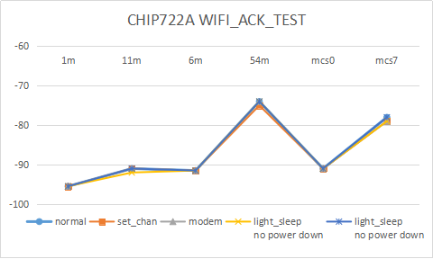

2.2.2 CHIP722B测试结果
不同模式灵敏度测试数据和曲线见下图表，其中atten 为固定环境下，衰减器的值：：
test_mode | rx_chan | tx_rate | ack_rate | atten | cal_sens
normal | 10 | 1m | 1m | 54 | -98.5
normal | 10 | 11m | 11m | 52 | -96
normal | 10 | 6m | 6m | 49 | -95.5
normal | 10 | 54m | 24m | 31 | -77.5
normal | 10 | mcs0 | 6m | 39 | -95
normal | 10 | mcs7 | 24m | 28 | -84
set_chan | 10 | 1m | 1m | 54 | -99
set_chan | 10 | 11m | 11m | 52 | -96
set_chan | 10 | 6m | 6m | 49 | -95.5
set_chan | 10 | 54m | 24m | 32 | -78.5
set_chan | 10 | mcs0 | 6m | 39 | -95
set_chan | 10 | mcs7 | 24m | 29 | -85
modem | 10 | 1m | 1m | 54 | -99
modem | 10 | 11m | 11m | 52 | -96
modem | 10 | 6m | 6m | 49 | -95.5
modem | 10 | 54m | 24m | 33 | -79.5
modem | 10 | mcs0 | 6m | 39 | -95
modem | 10 | mcs7 | 24m | 28 | -84
light_sleep  no power down | 10 | 1m | 1m | 54 | -99
light_sleep  no power down | 10 | 11m | 11m | 52 | -96
light_sleep  no power down | 10 | 6m | 6m | 48 | -94.5
light_sleep  no power down | 10 | 54m | 24m | 33 | -79.5
light_sleep  no power down | 10 | mcs0 | 6m | 39 | -95
light_sleep  no power down | 10 | mcs7 | 24m | 29 | -85
light_sleep  no power down | 10 | 1m | 1m | 52 | -97
light_sleep  no power down | 10 | 11m | 11m | 49 | -93
light_sleep  no power down | 10 | 6m | 6m | 48 | -94.5
light_sleep  no power down | 10 | 54m | 24m | 31 | -77.5
light_sleep  no power down | 10 | mcs0 | 6m | 39 | -96
light_sleep  no power down | 10 | mcs7 | 24m | 28 | -84

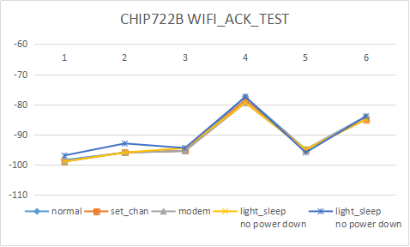

2.3 总结与分析
从测试结果来看，
CHIP722A和CHIP722B，WIFI切信道、modem sleep模式唤醒后、light sleep no power down模式唤醒后，与正常模式下的收发包特性一致，功能正常。light sleep power down模式唤醒后，存在丢包问题，需要研发协助Debug。
CHIP722A和CHIP722B 相比，同样环境同样衰减下，CHIP722B RSSI偏低4~5dB左右。

