CH722_Marlin3 3-Corner

B2 & B3

RF 性能报告


版本 1.0
更新日期 20190810

目录
目录 2
1. TX 基本性能测试 3
1.1 固定gain下对比各个corner 的power 和EVM 3
1.2 Mask Margins 对比结果 7
1.3 Power校准后性能对比 8
1.4 IQ Mismatch 10
2. I2C 遍历 12
3. Power Detector 测试 12
4. P1dB 测试 14
5. TX电流测试 15
6. RX Gain /Noise测试 18
6.1 RX Noise 比较 18
6.2 RX Gain 比较 19
7. RX 基本性能测试 21
7.1 RX 接收灵敏度 21
7.2 RX 最大接收电平 22

TX 基本性能测试

固定gain下对比各个corner 的power 和EVM
- 固定各级gain（pa_gain=0x5f, bb_gain=0x20, digital_gain=11），测试 B2 TT &SS &上一版Marlin3，以及B3 TT &SS &上一版Marlin3 的 TX power 和EVM，结果如下：
- B2 _SS Power比 B2_TT 以及 B2_Marlin3 低 2 dB；
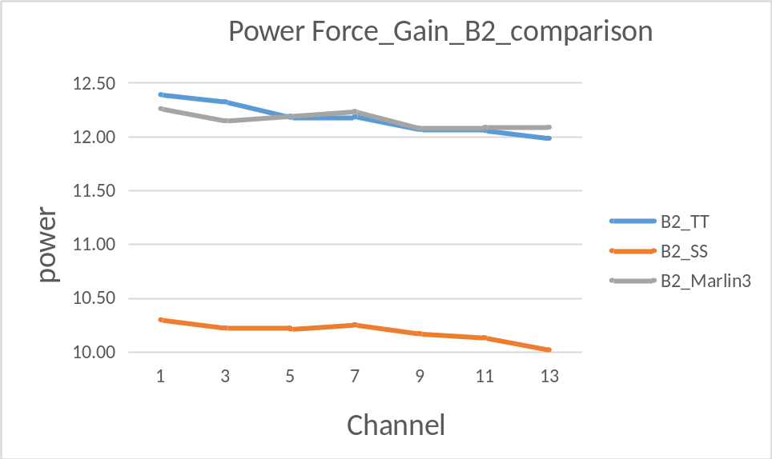
- B2 三种芯片的 EVM 对比结果下图所示，B2_TT EVM 比其他两种芯片好大概0.3dB
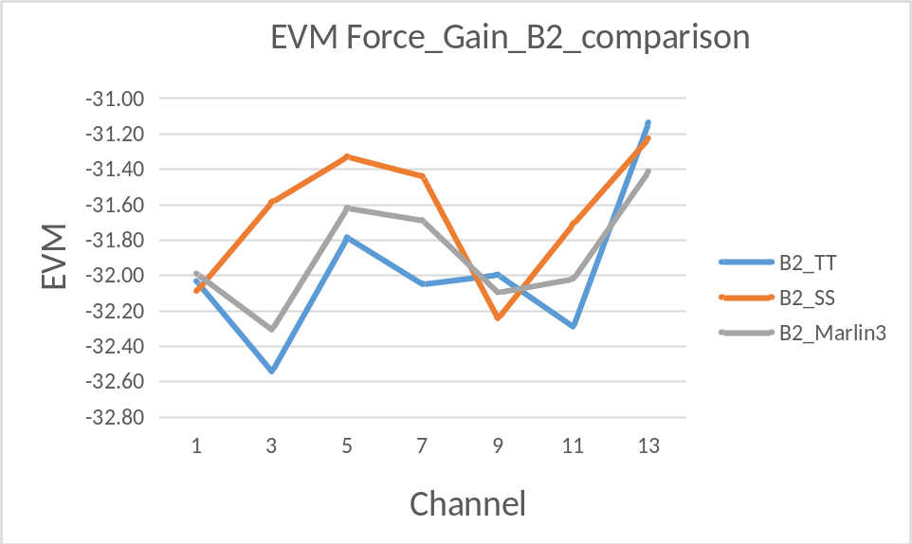
- B3 _SS Power比 B3_TT 以及 B3_Marlin3 低近3 dB；
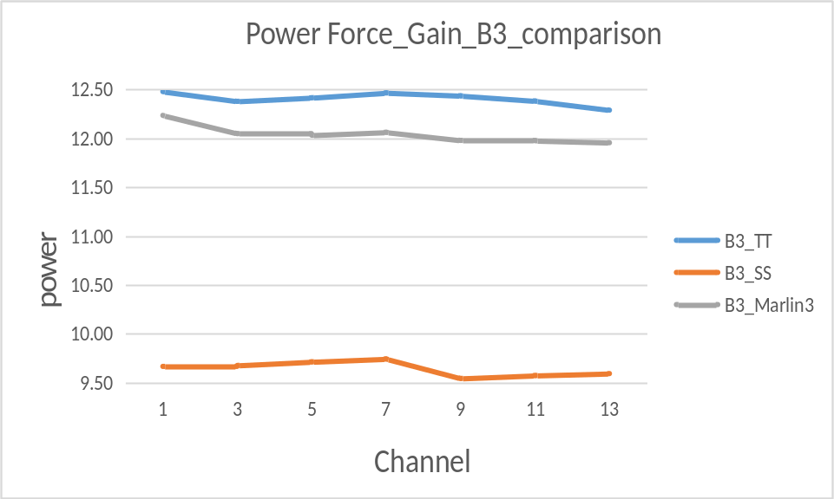

- B3 三种芯片的 EVM 对比结果下图所示，B3_TT EVM明显好于比其他两种芯片，差异性至少0.4dB。
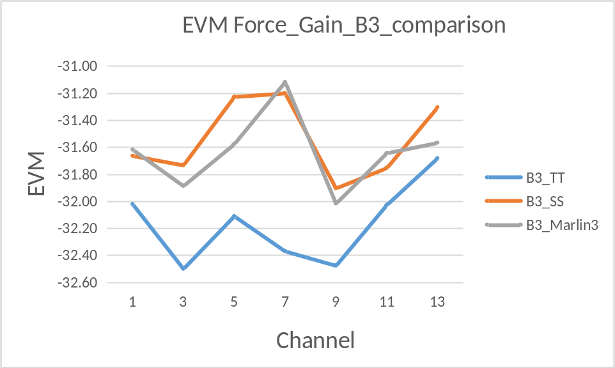

- 对比 B2 B3 TT 以及上一版marlin3芯片的EVM 的测试结果，如下图所示，B3_TT EVM 最好，比上一版marlin3 有0.6dB的差异性；
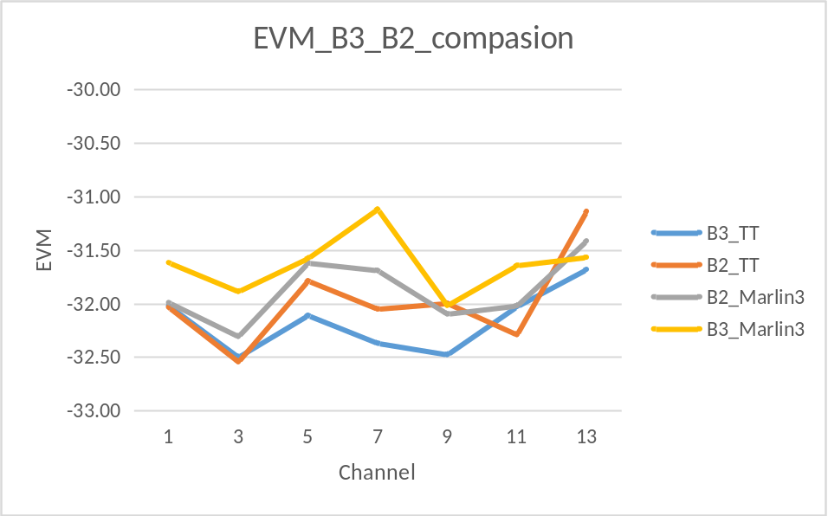
Force_Gain_B2 |  | B2_TT_1592 | B2_TT_1593 | B2_TT_1594 | B2_SS_2530 | B2_SS_2531 | B2_SS_2533 | B2_Marlin3_A7AF | B2_Marlin3_A7D2 | B2_Marlin3_A746
channel | rate | power | power | power | power | power | power | power | power | power
1 | mcs7 | 12.86 | 12.86 | 11.45 | 10.24 | 10.09 | 10.56 | 12.44 | 12.25 | 12.09
3 | mcs7 | 12.74 | 12.9 | 11.33 | 10.15 | 9.97 | 10.54 | 12.27 | 12.19 | 11.98
5 | mcs7 | 12.65 | 12.69 | 11.2 | 10.21 | 10 | 10.42 | 12.29 | 12.29 | 11.99
7 | mcs7 | 12.58 | 12.69 | 11.29 | 10.25 | 10.03 | 10.47 | 12.33 | 12.34 | 12.03
9 | mcs7 | 12.34 | 12.6 | 11.26 | 10.17 | 9.92 | 10.41 | 12.07 | 12.28 | 11.88
11 | mcs7 | 12.36 | 12.55 | 11.26 | 10.14 | 9.9 | 10.35 | 12.11 | 12.25 | 11.90
13 | mcs7 | 12.32 | 12.45 | 11.18 | 10.03 | 9.77 | 10.25 | 12.13 | 12.24 | 11.93
channel | rate | evm | evm | evm | evm | evm | evm | evm | evm | evm
1 | mcs7 | -31.75 | -32.18 | -32.17 | -31.09 | -33.36 | -31.82 | -32.16 | -31.80 | -32.01
3 | mcs7 | -32.04 | -33.4 | -32.19 | -30.43 | -33.04 | -31.29 | -32.16 | -32.52 | -32.24
5 | mcs7 | -31.13 | -32.12 | -32.11 | -30.65 | -32.57 | -30.77 | -32.01 | -31.14 | -31.71
7 | mcs7 | -31.68 | -32.14 | -32.33 | -31.11 | -32.69 | -30.52 | -31.88 | -31.42 | -31.77
9 | mcs7 | -31.61 | -32.32 | -32.06 | -31.32 | -33.25 | -32.16 | -31.95 | -32.21 | -32.13
11 | mcs7 | -31.36 | -33.06 | -32.45 | -31.22 | -32.67 | -31.24 | -32.21 | -31.99 | -31.86
13 | mcs7 | -30.7 | -31.12 | -31.59 | -30.91 | -32.12 | -30.65 | -31.33 | -31.24 | -31.67
channel | rate | evm_std | evm_std | evm_std | evm_std | evm_std | evm_std | evm_std | evm_std | evm_std
1 | mcs7 | 0.79 | 0.89 | 1.04 | 0.51 | 0.55 | 0.92 | 1.12 | 0.82 | 0.76
3 | mcs7 | 0.65 | 0.75 | 0.65 | 0.99 | 0.48 | 1.39 | 0.88 | 0.69 | 0.57
5 | mcs7 | 1.09 | 0.8 | 0.59 | 0.77 | 0.89 | 1.39 | 0.76 | 1.18 | 0.86
7 | mcs7 | 0.77 | 0.72 | 0.66 | 0.27 | 1.02 | 0.91 | 0.83 | 1.08 | 0.95
9 | mcs7 | 1.23 | 0.85 | 1.19 | 0.43 | 0.63 | 0.59 | 0.69 | 0.63 | 0.92
11 | mcs7 | 0.72 | 0.79 | 0.71 | 0.54 | 0.77 | 0.82 | 0.61 | 0.75 | 0.88
13 | mcs7 | 1.33 | 1.37 | 0.62 | 0.63 | 0.72 | 0.75 | 0.95 | 0.88 | 0.69

Force_Gain_B3 |  | B3_TT_197A | B3_TT_197B | B3_TT_197C | B3_SS_291D | B3_SS_291E | B3_SS_2921 | B3_Marlin3_A84E | B3_Marlin3_A845 | B3_Marlin3_A876
channel | rate | power | power | power | power | power | power | power | power | power
1 | mcs7 | 11.9 | 12.85 | 12.69 | 8.88 | 9.89 | 10.23 | 12.57 | 12.62 | 11.52
3 | mcs7 | 11.75 | 12.73 | 12.66 | 8.92 | 9.85 | 10.26 | 12.44 | 12.43 | 11.28
5 | mcs7 | 11.78 | 12.78 | 12.69 | 8.9 | 9.91 | 10.33 | 12.4 | 12.34 | 11.36
7 | mcs7 | 11.89 | 12.83 | 12.68 | 8.93 | 9.95 | 10.35 | 12.47 | 12.40 | 11.32
9 | mcs7 | 11.88 | 12.82 | 12.61 | 8.82 | 9.64 | 10.17 | 12.41 | 12.40 | 11.13
11 | mcs7 | 11.82 | 12.74 | 12.59 | 8.81 | 9.73 | 10.18 | 12.44 | 12.37 | 11.12
13 | mcs7 | 11.64 | 12.64 | 12.59 | 8.73 | 9.84 | 10.21 | 12.41 | 12.36 | 11.10
channel | rate | evm | evm | evm | evm | evm | evm | evm | evm | evm
1 | mcs7 | -32.39 | -31.8 | -31.87 | -31.7 | -31.83 | -31.46 | -31.25 | -31.13 | -32.47
3 | mcs7 | -31.66 | -33.09 | -32.75 | -31.55 | -31.26 | -32.39 | -32.4 | -31.31 | -31.95
5 | mcs7 | -32.2 | -32.17 | -31.96 | -31.09 | -31.14 | -31.45 | -31.79 | -31.18 | -31.76
7 | mcs7 | -32.46 | -32.28 | -32.37 | -30.12 | -31.63 | -31.85 | -31.25 | -30.33 | -31.77
9 | mcs7 | -32.97 | -31.78 | -32.68 | -31.47 | -31.55 | -32.69 | -32.1 | -31.50 | -32.45
11 | mcs7 | -31.47 | -31.86 | -32.75 | -31.99 | -31.33 | -31.94 | -31.81 | -31.39 | -31.73
13 | mcs7 | -31.28 | -31.7 | -32.06 | -31.69 | -30.55 | -31.67 | -31.56 | -31.54 | -31.60
channel | rate | evm_std | evm_std | evm_std | evm_std | evm_std | evm_std | evm_std | evm_std | evm_std
1 | mcs7 | 0.53 | 0.95 | 1.39 | 1.11 | 0.49 | 0.97 | 1.01 | 0.63 | 0.45
3 | mcs7 | 1.11 | 0.42 | 0.66 | 0.93 | 0.79 | 0.78 | 0.92 | 1.22 | 0.73
5 | mcs7 | 0.71 | 0.96 | 0.85 | 1.15 | 0.64 | 0.92 | 0.94 | 0.50 | 1.09
7 | mcs7 | 0.82 | 0.45 | 0.51 | 1.18 | 0.54 | 0.9 | 1.31 | 1.16 | 0.88
9 | mcs7 | 0.4 | 1.28 | 0.63 | 1.08 | 0.62 | 0.39 | 1.04 | 1.23 | 0.78
11 | mcs7 | 1.48 | 0.87 | 0.8 | 0.66 | 0.7 | 0.61 | 0.98 | 0.83 | 0.98
13 | mcs7 | 0.61 | 0.51 | 0.43 | 0.56 | 1.09 | 0.78 | 1.13 | 0.50 | 0.68

Mask Margins 对比结果
- 对比六种芯片的MCS0 lower 4 的余量， B3_TT 和 B2_TT比 上一版Marlin3 B2 B3 好0.5dB，但B3 _SS 的最差， 比 B3_TT 差近2dB。（B3_TT 的功率和 B2_SS 的功率相当）；
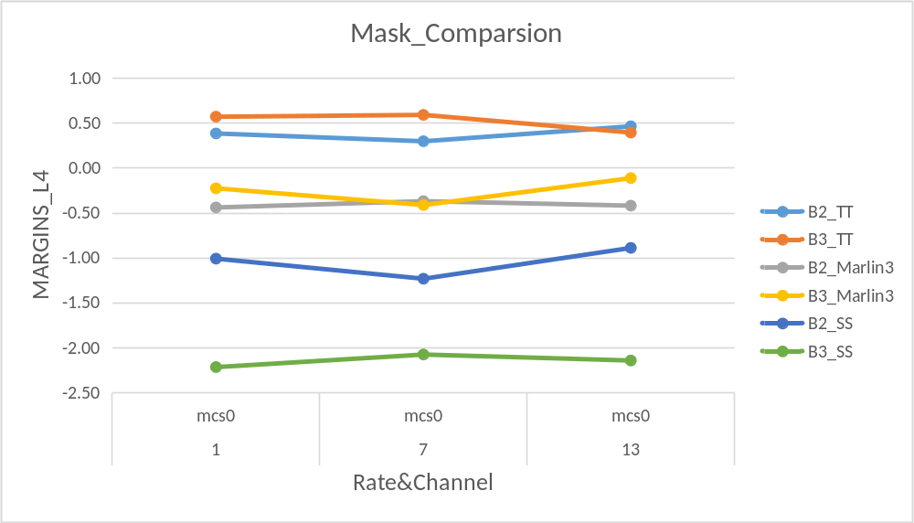
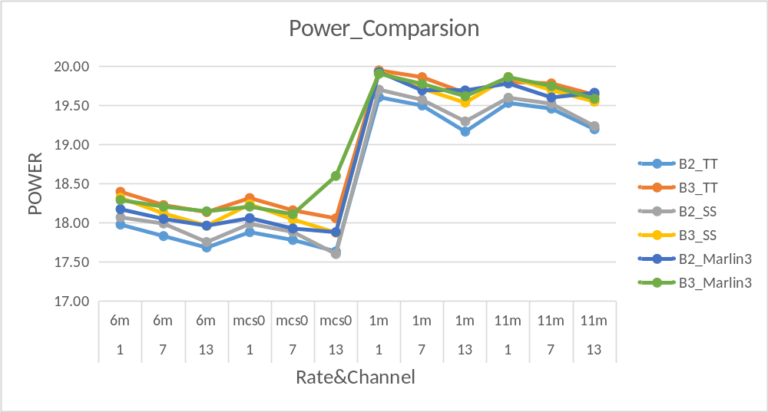

Power校准后性能对比
- 经Power Detector 校准后测得, 功率无明显差异性， 但 B2_SS 比B2_TT EVM 差1 dB左右；

Power_detector_cal |  | B2_TT_1590 | B2_TT_1591 | B2_TT_1592 | B2_TT_1593 | B2_TT_1594 | B2_SS_2530 | B2_SS_2531 | B2_SS_2531_500 | B2_SS_2532 | B2_SS_2533
channel | rate | power | power | power | power | power | power | power | power | power | power
1 | mcs7 | 13.35 | 13.51 | 13.6 | 13.33 | 13.66 | 13.4 | 13.36 | 13.89 | 13.81 | 13.16
3 | mcs7 | 13.38 | 13.56 | 13.59 | 13.25 | 13.61 | 13.34 | 13.41 | 13.81 | 13.85 | 13.17
5 | mcs7 | 13.36 | 13.6 | 13.52 | 13.37 | 13.66 | 13.54 | 13.65 | 13.98 | 13.78 | 13.22
7 | mcs7 | 13.22 | 13.32 | 13.46 | 13.11 | 13.46 | 13.28 | 13.5 | 13.7 | 13.78 | 13.24
9 | mcs7 | 12.86 | 13.08 | 13.29 | 13.04 | 13.43 | 13.19 | 13.25 | 13.6 | 13.67 | 13.18
11 | mcs7 | 13.17 | 12.89 | 13.3 | 13.27 | 13.42 | 13.41 | 13.34 | 13.57 | 13.65 | 13.14
13 | mcs7 | 13.11 | 12.87 | 13.09 | 13.15 | 13.32 | 13.28 | 13.19 | 13.46 | 13.54 | 13.01
channel | rate | evm | evm | evm | evm | evm | evm | evm | evm | evm | evm
1 | mcs7 | -31.61 | -31.85 | -30.2 | -32.19 | -31.75 | -30.88 | -30.98 | -30.14 | -29.57 | -29.94
3 | mcs7 | -31.29 | -32.56 | -31.28 | -32.72 | -31.6 | -30.96 | -31.38 | -29.56 | -30.32 | -30.21
5 | mcs7 | -31.52 | -31 | -30.49 | -31.19 | -30.94 | -30.58 | -30.14 | -29.31 | -29.71 | -30.17
7 | mcs7 | -31.13 | -31.6 | -30.57 | -31.91 | -30.73 | -30.45 | -30.41 | -29.75 | -29.63 | -29.83
9 | mcs7 | -32.33 | -31.42 | -31.43 | -32.47 | -31.17 | -31.39 | -31.3 | -29.86 | -30.39 | -31.32
11 | mcs7 | -32.35 | -31.79 | -30.81 | -32.61 | -30.65 | -31.22 | -30.9 | -30.05 | -30.48 | -30.44
13 | mcs7 | -30.94 | -31.89 | -29.77 | -31.2 | -30.1 | -30.46 | -30.32 | -29.91 | -29.71 | -29.8
channel | rate | evm_std | evm_std | evm_std | evm_std | evm_std | evm_std | evm_std | evm_std | evm_std | evm_std
1 | mcs7 | 0.97 | 0.67 | 1.53 | 1.03 | 0.51 | 0.71 | 0.79 | 0.59 | 0.7 | 1.35
3 | mcs7 | 1 | 0.4 | 0.82 | 0.92 | 0.32 | 0.72 | 0.31 | 1.23 | 0.37 | 1.01
5 | mcs7 | 0.66 | 0.7 | 0.83 | 0.98 | 0.55 | 0.58 | 0.43 | 0.51 | 0.6 | 0.71
7 | mcs7 | 0.74 | 0.62 | 0.56 | 0.54 | 0.6 | 0.68 | 0.86 | 0.32 | 0.87 | 1.01
9 | mcs7 | 0.69 | 0.6 | 0.79 | 0.55 | 0.84 | 0.52 | 0.29 | 0.65 | 0.51 | 0.27
11 | mcs7 | 0.62 | 0.53 | 0.59 | 0.47 | 1.3 | 0.46 | 0.56 | 0.57 | 0.36 | 0.65
13 | mcs7 | 0.88 | 0.35 | 1.24 | 0.62 | 0.78 | 0.63 | 0.49 | 0.58 | 0.46 | 0.72

- 经Power Detector 校准后测得, B3 TT 与 B3_SS 功率无明显差异性， 但 B3_SS 比B3_TT EVM 差1.7~2 dB的差异性；

Power_detector_cal |  | B3_TT_1978 | B3_TT_1979 | B3_TT_197A | B3_TT_197B | B3_TT_197C | B3_SS_2918 | B3_SS_291B | B3_SS_291E | B3_SS_291D | B3_SS_2921
channel | rate | power | power | power | power | power | power | power | power | power | power
1 | mcs7 | 13.65 | 13.59 | 13.91 | 13.95 | 13.73 | 13.85 | 13.79 | 13.65 | 13.84 | 13.47
3 | mcs7 | 13.69 | 13.55 | 13.76 | 13.85 | 13.72 | 13.79 | 13.69 | 13.57 | 13.76 | 13.39
5 | mcs7 | 13.57 | 13.61 | 13.8 | 13.96 | 13.72 | 13.88 | 13.66 | 13.68 | 13.71 | 13.55
7 | mcs7 | 13.64 | 13.42 | 13.53 | 13.8 | 13.53 | 13.54 | 13.63 | 13.38 | 13.44 | 13.32
9 | mcs7 | 13.51 | 13.3 | 13.57 | 13.7 | 13.42 | 13.32 | 13.54 | 13.23 | 13.32 | 13.21
11 | mcs7 | 13.64 | 13.32 | 13.76 | 13.74 | 13.52 | 13.34 | 13.55 | 13.22 | 13.58 | 13.19
13 | mcs7 | 13.65 | 13.25 | 13.72 | 13.69 | 13.53 | 13.27 | 13.48 | 13.11 | 13.48 | 13.07
channel | rate | evm | evm | evm | evm | evm | evm | evm | evm | evm | evm
1 | mcs7 | -32.21 | -32.37 | -31.17 | -31.13 | -31.41 | -29.12 | -29.24 | -29.94 | -29.56 | -29.87
3 | mcs7 | -32.51 | -32.46 | -31.04 | -31.43 | -31.69 | -30.31 | -29.43 | -30.09 | -29.82 | -30.35
5 | mcs7 | -31.91 | -31.71 | -31.04 | -30.79 | -31.4 | -29.11 | -29.21 | -29.51 | -28.65 | -29.74
7 | mcs7 | -30.6 | -32.24 | -30.47 | -31.09 | -31.69 | -30.23 | -29.75 | -29.95 | -29.79 | -30.03
9 | mcs7 | -32.08 | -32.4 | -31.56 | -31.67 | -31.96 | -29.75 | -29.23 | -29.97 | -29.82 | -30.72
11 | mcs7 | -32.39 | -31.37 | -31.01 | -30.98 | -31.92 | -29.74 | -29.27 | -29.92 | -29.84 | -30.37
13 | mcs7 | -31.36 | -31.56 | -29.87 | -30.61 | -31.53 | -29.84 | -29.61 | -29.56 | -29.64 | -29.82
channel | rate | evm_std | evm_std | evm_std | evm_std | evm_std | evm_std | evm_std | evm_std | evm_std | evm_std
1 | mcs7 | 0.51 | 0.49 | 0.48 | 0.42 | 0.72 | 0.81 | 0.32 | 0.46 | 0.54 | 0.74
3 | mcs7 | 0.55 | 0.41 | 0.37 | 0.35 | 0.61 | 0.37 | 0.46 | 0.4 | 0.28 | 0.75
5 | mcs7 | 0.59 | 0.49 | 0.37 | 0.82 | 0.45 | 0.93 | 0.48 | 0.32 | 0.55 | 0.7
7 | mcs7 | 1.15 | 0.54 | 1.01 | 0.4 | 0.6 | 0.42 | 0.32 | 0.51 | 0.31 | 0.58
9 | mcs7 | 0.71 | 0.59 | 0.39 | 0.44 | 0.59 | 0.55 | 0.47 | 0.37 | 0.42 | 0.27
11 | mcs7 | 0.38 | 0.99 | 0.44 | 0.54 | 0.3 | 0.55 | 0.36 | 0.44 | 0.51 | 0.41
13 | mcs7 | 0.45 | 0.8 | 0.64 | 0.38 | 0.54 | 0.59 | 0.48 | 0.46 | 0.29 | 0.75
channel | rate | evm_max | evm_max | evm_max | evm_max | evm_max | evm_max | evm_max | evm_max | evm_max | evm_max
1 | mcs7 | -31.25 | -31.58 | -30.21 | -30.44 | -29.78 | -27.47 | -28.6 | -28.96 | -28.07 | -28.78
3 | mcs7 | -31.33 | -31.97 | -30.23 | -30.66 | -30.56 | -29.7 | -28.21 | -29.12 | -29.43 | -28.83
5 | mcs7 | -30.84 | -30.81 | -30.41 | -29.3 | -30.52 | -27.33 | -28.55 | -28.78 | -27.58 | -28.33
7 | mcs7 | -28.4 | -30.99 | -28.88 | -30.37 | -30.14 | -29.2 | -29.26 | -28.97 | -29.11 | -28.9
9 | mcs7 | -30.72 | -31.34 | -30.67 | -30.77 | -30.62 | -28.43 | -28.39 | -29.2 | -28.79 | -30.13
11 | mcs7 | -31.69 | -29.17 | -30.23 | -29.96 | -31.31 | -28.59 | -28.69 | -29.45 | -29.06 | -29.82
13 | mcs7 | -30.63 | -30.19 | -28.89 | -29.98 | -30.37 | -28.89 | -28.52 | -28.83 | -29.17 | -28.53

IQ Mismatch
- 对比B2_Marlin3、B3_Marlin3、B2_TT、B3_TT、B2_SS、B3_SS 六款芯片 IQ mismatch 的结果，如下图所示，无明显差异。
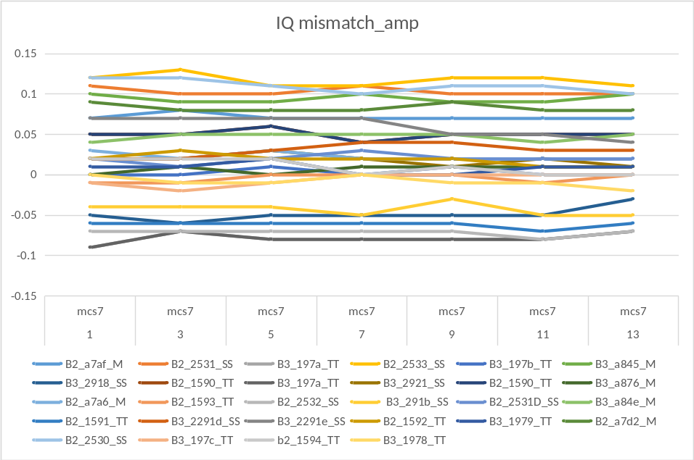

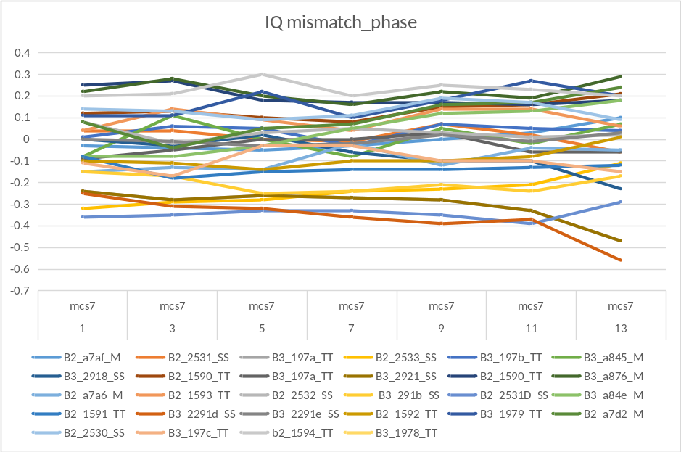

I2C 遍历
用Marlin3 最优配置作为默认配置，遍历寄存器，测试mcs7，目标功率13dBm，得到以下结果：
- B2 TT 与 B3 TT ，当前配置的PA寄存器基本为最优；Bias寄存器 cp1p6_dreg、cp1p2_dreg 最优配置，不同模块表现略有差异。
- 从B3 EVM来看，SS 较 TT ，I2C 最优配置不同，典型参数有：
cp1p6_dreg ( TT为7较优，SS为5较优）,
cp1p2_dreg（TT为7较优，SS为5较优），
PA2G_ICT_STG0（TT为8较优，SS为12较优），
PA2G_STG1_SEL_ICGM_N（TT为1较优，SS为0较优）等

Power Detector 测试
- 对比B2_Marlin3、B3_Marlin3、B2_TT、B3_TT、B2_SS、B3_SS 六款芯片的 Power Detector，从整段的线性度来看，几种芯片基本一致。
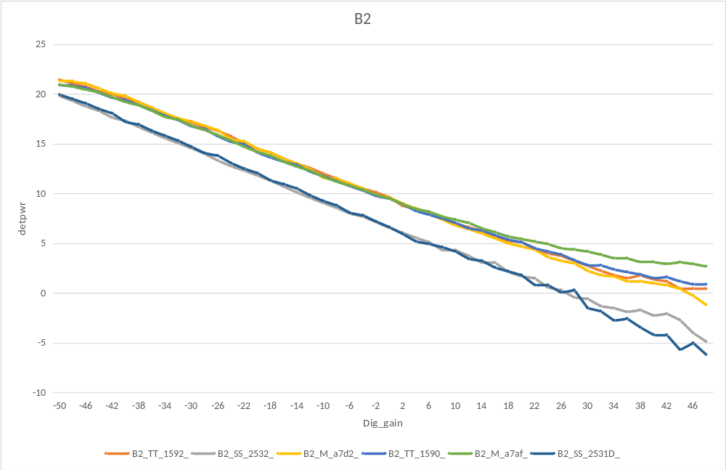
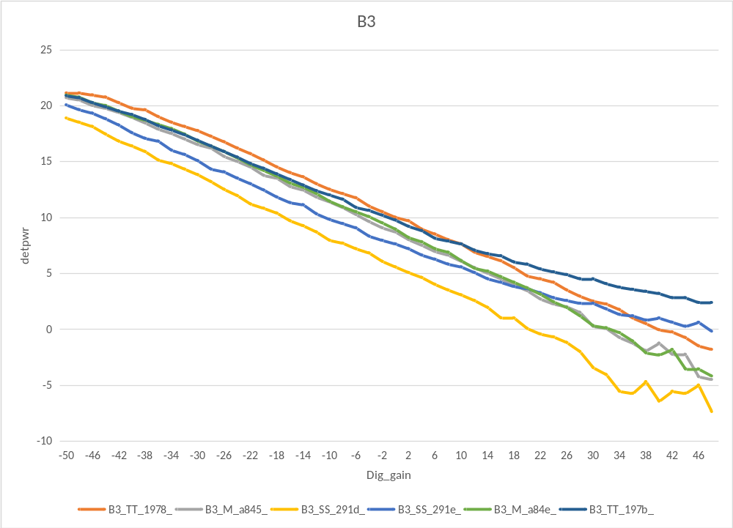
- 从power detector 与 仪器校准的power的差值看来，各种芯片的差异性在[-0.6,0.6]之间，无明显的差异性；
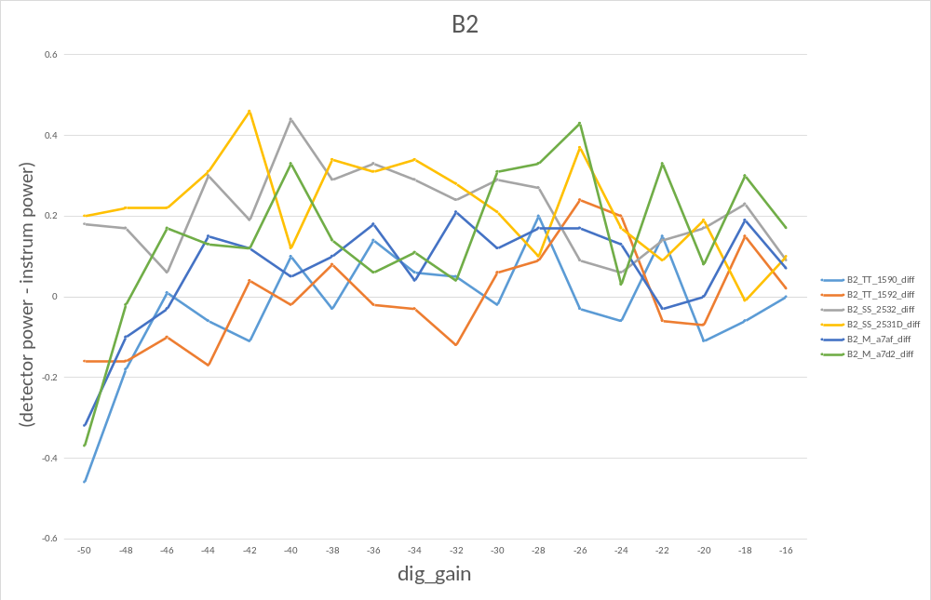
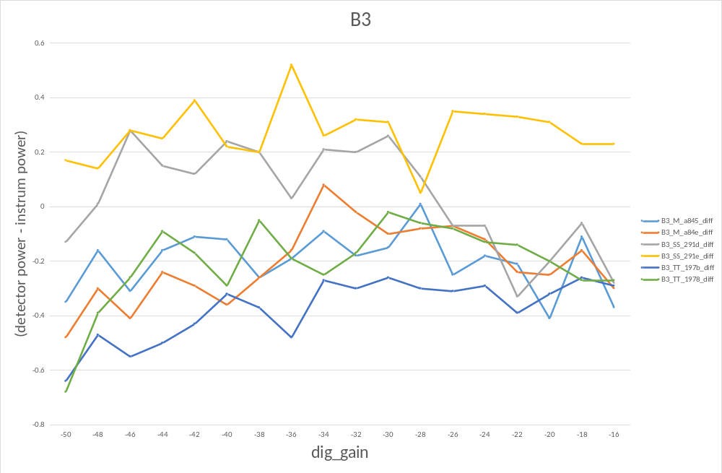

P1dB 测试
- B2_Marlin3、B3_Marlin3、B2_TT、B3_TT、B2_SS、B3_SS的PA 1dB 压缩点结果如下.
使用相同的模组板的情况下，SS 的P1dB 比 TT 和 marlin3 低近 2dB。
IC_type | B2_M | B2_SS | B2_TT | B3_M | B2_SS | B3_TT
P1dB | 22.2dB | 20.5dB | 22.1dB | 22.3dB | 20.6dB | 22.3dB

TX电流测试
- B2_Marlin3、B3_Marlin3、B2_TT、B3_TT、B2_SS、B3_SS 六款类型，各测2块模组，从TX 电流来看，在自校准功率后，达到相同功率的情况下，电流基本相当。

B3_Marlin3 |  |  | A84E |  |  | A845
cbw40m | rate | channel | curr_max | pwr | evm | curr_max | pwr | evm
0 | 1m | 1 | 332.59 | 19.68 | -26.6 | 343.73 | 19.51 | -26.46
0 | 1m | 6 | 334.07 | 19.52 | -26.02 | 343.99 | 19.28 | -25.68
0 | 1m | 11 | 346.48 | 19.5 | -27.06 | 354.08 | 19.11 | -26.59
0 | 11m | 1 | 332.96 | 19.38 | -26.11 | 343.2 | 19.25 | -25.86
0 | 11m | 6 | 335.07 | 19.33 | -25.66 | 343.68 | 19.12 | -25.39
0 | 11m | 11 | 349.33 | 19.4 | -26.28 | 356.09 | 19 | -25.98
0 | 6m | 1 | 285.02 | 17.75 | -20.63 | 293.2 | 17.58 | -20.72
0 | 6m | 6 | 287.23 | 17.72 | -20.34 | 294.47 | 17.48 | -20.6
0 | 6m | 11 | 297.95 | 17.78 | -19.43 | 304.6 | 17.44 | -19.72
0 | 54m | 1 | 236.55 | 15.03 | -27.04 | 242.46 | 14.82 | -27.19
0 | 54m | 6 | 238.08 | 15.02 | -26.75 | 243.57 | 14.75 | -26.94
0 | 54m | 11 | 247.95 | 15.25 | -25.49 | 251.7 | 14.82 | -26.12
0 | mcs0 | 1 | 283.96 | 17.65 | -21.21 | 292.04 | 17.52 | -21.33
0 | mcs0 | 6 | 285.91 | 17.59 | -20.97 | 292.99 | 17.37 | -21.13
0 | mcs0 | 11 | 297.16 | 17.66 | -19.93 | 303.71 | 17.39 | -20.27
0 | mcs7 | 1 | 213.1 | 13.06 | -30.8 | 218.54 | 12.91 | -31.32
0 | mcs7 | 6 | 213.84 | 12.98 | -30.15 | 218.43 | 12.76 | -30.33
0 | mcs7 | 11 | 222.34 | 13.32 | -29.8 | 225.93 | 12.91 | -30.21
B2_Marlin3 |  |  | A7D2 |  |  | A746
cbw40m | rate | channel | curr_max | pwr | evm | curr_max | pwr | evm
0 | 1m | 1 | 321.29 | 19.28 | -25.96 | 342.41 | 19.82 | -26.19
0 | 1m | 6 | 323.93 | 19.17 | -25.6 | 336.65 | 19.41 | -25.63
0 | 1m | 11 | 337.5 | 19.27 | -26.16 | 345.1 | 19.25 | -26.33
0 | 11m | 1 | 322.29 | 19.01 | -25.66 | 342.3 | 19.49 | -25.91
0 | 11m | 6 | 325.2 | 19 | -25.47 | 336.92 | 19.19 | -25.44
0 | 11m | 11 | 340.67 | 19.13 | -25.86 | 347.06 | 19.11 | -25.99
0 | 6m | 1 | 277.47 | 17.4 | -21.93 | 289.98 | 17.77 | -20.88
0 | 6m | 6 | 279.21 | 17.33 | -21.46 | 289.29 | 17.62 | -20.75
0 | 6m | 11 | 291.88 | 17.49 | -20.34 | 295.63 | 17.47 | -20.39
0 | 54m | 1 | 229.95 | 14.49 | -28.02 | 239.45 | 15.01 | -27.24
0 | 54m | 6 | 231.95 | 14.43 | -27.41 | 238.71 | 14.83 | -26.97
0 | 54m | 11 | 241.09 | 14.63 | -26.8 | 244.52 | 14.8 | -26.86
0 | mcs0 | 1 | 276.46 | 17.17 | -22.53 | 288.82 | 17.67 | -21.42
0 | mcs0 | 6 | 278.1 | 17.13 | -21.98 | 287.92 | 17.48 | -21.23
0 | mcs0 | 11 | 290.82 | 17.33 | -20.92 | 294.47 | 17.34 | -21.02
0 | mcs7 | 1 | 207.4 | 12.43 | -30.68 | 214.84 | 12.95 | -30.37
0 | mcs7 | 6 | 209.14 | 12.5 | -30.31 | 214.69 | 12.83 | -30.09
0 | mcs7 | 11 | 216.96 | 12.81 | -30.67 | 219.23 | 12.82 | -30.71
B3_TT |  |  | 197C |  |  | 1978
cbw40m | rate | channel | curr_max | pwr | evm | curr_max | pwr | evm
0 | 1m | 1 | 330.32 | 19.21 | -25.97 | 314.69 | 19.19 | -26.31
0 | 1m | 6 | 332.96 | 19.15 | -25.82 | 318.65 | 19.15 | -26.08
0 | 1m | 11 | 344.31 | 19.13 | -26.35 | 330.05 | 19.17 | -26.44
0 | 11m | 1 | 327.52 | 18.31 | -25.82 | 312.52 | 18.79 | -26.09
0 | 11m | 6 | 333.75 | 18.45 | -25.59 | 318.65 | 18.9 | -25.88
0 | 11m | 11 | 346.48 | 18.34 | -25.97 | 331.06 | 18.98 | -26.2
0 | 6m | 1 | 281.27 | 16.86 | -22.1 | 272.13 | 17.23 | -22.64
0 | 6m | 6 | 286.71 | 16.98 | -21.42 | 276.78 | 17.38 | -21.91
0 | 6m | 11 | 296.26 | 16.89 | -20.81 | 284.17 | 17.36 | -21.38
0 | 54m | 1 | 233.85 | 14.07 | -27.88 | 227.41 | 14.33 | -28.25
0 | 54m | 6 | 238.82 | 14.39 | -27.16 | 231.32 | 14.55 | -27.52
0 | 54m | 11 | 245.63 | 14.51 | -27.23 | 238.39 | 14.65 | -27.19
0 | mcs0 | 1 | 281.06 | 17.11 | -22.83 | 270.97 | 17.1 | -23.52
0 | mcs0 | 6 | 286.86 | 17.25 | -21.94 | 275.88 | 17.23 | -22.59
0 | mcs0 | 11 | 296.21 | 17.26 | -21.35 | 283.64 | 17.23 | -22.13
0 | mcs7 | 1 | 211.57 | 12.49 | -31.01 | 207.66 | 12.37 | -30.88
0 | mcs7 | 6 | 215.48 | 12.72 | -30.17 | 210.88 | 12.6 | -30.46
0 | mcs7 | 11 | 220.49 | 12.75 | -30.83 | 215.79 | 12.7 | -30.92
B2_TT |  |  | 1592 |  |  | 1590
cbw40m | rate | channel | curr_max | pwr | evm | curr_max | pwr | evm
0 | 1m | 1 | 331.69 | 19.33 | -26.37 | 324.77 | 19.21 | -26.17
0 | 1m | 6 | 332.59 | 19.09 | -26.19 | 324.72 | 19.03 | -25.62
0 | 1m | 11 | 334.07 | 18.63 | -26.91 | 329 | 18.87 | -26.61
0 | 11m | 1 | 332.27 | 19.06 | -26.15 | 324.51 | 18.92 | -25.94
0 | 11m | 6 | 335.12 | 18.95 | -25.93 | 325.41 | 18.84 | -25.53
0 | 11m | 11 | 337.13 | 18.53 | -26.31 | 331.53 | 18.74 | -26.09
0 | 6m | 1 | 286.86 | 17.49 | -21.17 | 278.52 | 17.27 | -21.86
0 | 6m | 6 | 288.66 | 17.39 | -20.93 | 280.05 | 17.25 | -21.65
0 | 6m | 11 | 292.88 | 17.1 | -20.79 | 286.44 | 17.21 | -21.21
0 | 54m | 1 | 238.71 | 14.76 | -27.57 | 232.22 | 14.48 | -28.28
0 | 54m | 6 | 240.82 | 14.72 | -27.03 | 234.12 | 14.51 | -27.48
0 | 54m | 11 | 244.47 | 14.46 | -26.98 | 239.08 | 14.53 | -27.26
0 | mcs0 | 1 | 286.44 | 17.44 | -21.8 | 277.62 | 17.17 | -22.85
0 | mcs0 | 6 | 288.34 | 17.32 | -21.51 | 279.21 | 17.13 | -22.25
0 | mcs0 | 11 | 292.72 | 17.03 | -21.34 | 285.39 | 17.09 | -21.83
0 | mcs7 | 1 | 215.58 | 12.77 | -31.11 | 210.15 | 12.42 | -31.56
0 | mcs7 | 6 | 217.75 | 12.76 | -30.14 | 211.78 | 12.52 | -30.4
0 | mcs7 | 11 | 220.34 | 12.52 | -30.23 | 215.74 | 12.55 | -31.05
B2_SS |  |  | 2532 |  |  | 2531
cbw40m | rate | channel | curr_max | pwr | evm | curr_max | pwr | evm
0 | 1m | 1 | 326.94 | 19.68 | -26.01 | 322.87 | 19.27 | -26.15
0 | 1m | 6 | 325.14 | 19.37 | -25.86 | 323.72 | 19.08 | -25.54
0 | 1m | 11 | 333.22 | 19.1 | -26.51 | 334.12 | 19 | -26.4
0 | 11m | 1 | 331.43 | 19.43 | -25.66 | 322.98 | 18.96 | -25.63
0 | 11m | 6 | 330.9 | 19.25 | -25.46 | 323.98 | 18.88 | -25.28
0 | 11m | 11 | 338.24 | 19.01 | -25.88 | 336.76 | 18.87 | -25.69
0 | 6m | 1 | 284.01 | 17.84 | -19.46 | 276.15 | 17.34 | -21.96
0 | 6m | 6 | 282.69 | 17.65 | -19.54 | 278.1 | 17.32 | -21.57
0 | 6m | 11 | 291.3 | 17.53 | -19.01 | 287.71 | 17.31 | -20.77
0 | 54m | 1 | 233.17 | 15.06 | -25.71 | 227.15 | 14.48 | -28.01
0 | 54m | 6 | 234.01 | 14.98 | -25.57 | 228.15 | 14.43 | -27.8
0 | 54m | 11 | 239.45 | 14.87 | -25.25 | 236.07 | 14.56 | -27.31
0 | mcs0 | 1 | 283.38 | 17.74 | -20.14 | 274.93 | 17.24 | -22.71
0 | mcs0 | 6 | 282.69 | 17.51 | -20.32 | 276.99 | 17.19 | -22.29
0 | mcs0 | 11 | 291.25 | 17.4 | -19.66 | 286.18 | 17.19 | -21.43
0 | mcs7 | 1 | 208.56 | 12.98 | -29.39 | 204.6 | 12.47 | -30.87
0 | mcs7 | 6 | 210.25 | 12.99 | -28.72 | 206.08 | 12.51 | -30.37
0 | mcs7 | 11 | 214.26 | 12.86 | -29.08 | 211.73 | 12.6 | -30.49
B3_SS |  |  | 2918 |  |  | 291D
cbw40m | rate | channel | curr_max | pwr | evm | curr_max | pwr | evm
0 | 1m | 1 | 333.17 | 19.42 | -26.31 | 321.55 | 19.1 | -26.24
0 | 1m | 6 | 328.63 | 19 | -25.86 | 327.41 | 19.09 | -25.74
0 | 1m | 11 | 340.03 | 18.88 | -26.67 | 332.27 | 18.76 | -26.44
0 | 11m | 1 | 333.17 | 19.09 | -25.92 | 322.66 | 18.85 | -25.75
0 | 11m | 6 | 329.84 | 18.79 | -25.58 | 329.58 | 18.94 | -25.38
0 | 11m | 11 | 342.52 | 18.74 | -26.08 | 335.6 | 18.68 | -25.76
0 | 6m | 1 | 285.07 | 17.48 | -20.99 | 277.36 | 17.33 | -21.07
0 | 6m | 6 | 282.85 | 17.22 | -21.04 | 283.17 | 17.44 | -20.3
0 | 6m | 11 | 294.04 | 17.22 | -20.07 | 288.61 | 17.18 | -19.97
0 | 54m | 1 | 233.48 | 14.61 | -27.47 | 227.99 | 14.47 | -27.21
0 | 54m | 6 | 232.74 | 14.42 | -27.11 | 231.95 | 14.62 | -26.42
0 | 54m | 11 | 241.14 | 14.5 | -26.37 | 236.86 | 14.47 | -26.19
0 | mcs0 | 1 | 283.48 | 17.36 | -21.59 | 276.88 | 17.23 | -21.71
0 | mcs0 | 6 | 281.06 | 17.09 | -21.65 | 282.32 | 17.31 | -21
0 | mcs0 | 11 | 292.78 | 17.1 | -20.69 | 287.76 | 17.07 | -20.56
0 | mcs7 | 1 | 210.41 | 12.68 | -29.78 | 205.23 | 12.49 | -29.72
0 | mcs7 | 6 | 209.09 | 12.39 | -29.37 | 207.45 | 12.56 | -28.01
0 | mcs7 | 11 | 216.9 | 12.63 | -29.87 | 212.47 | 12.51 | -28.94

RX Gain /Noise测试

RX Noise 比较
- B2_Marlin3、B3_Marlin3、B2_TT、B3_TT、B2_SS、B3_SS 六款类型，各测2块模组，Rx_noise 未见明显差异。

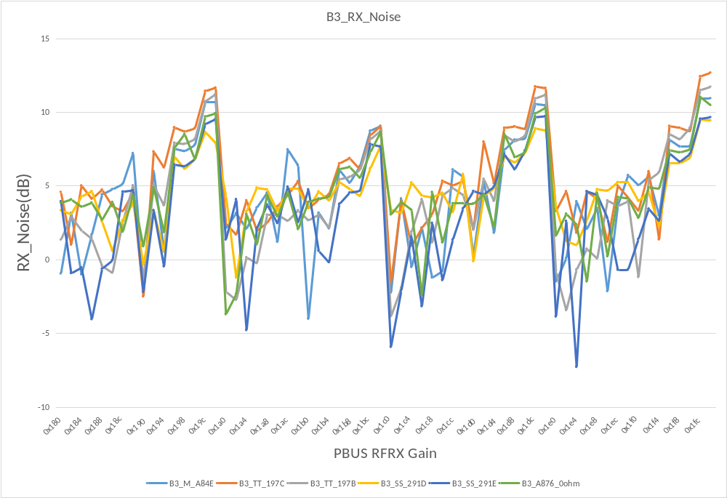
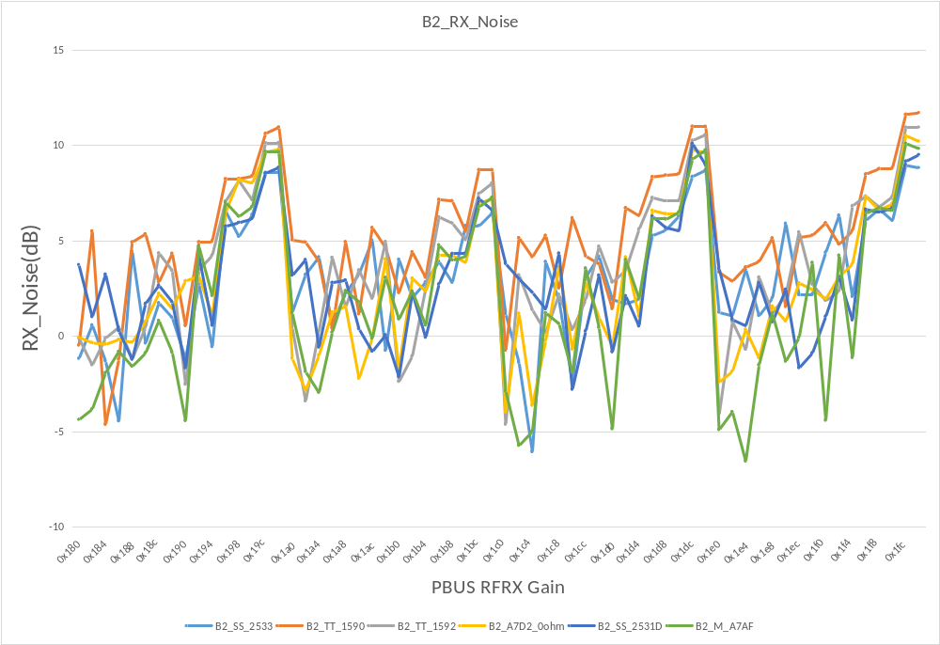

RX Gain 比较
- 测试B2_Marlin3、B3_Marlin3、B2_TT、B3_TT、B2_SS、B3_SS 六款芯片，各测2块模组，SS RX Gain 比 TT 和 Marlin3 低 1.5~2dB。
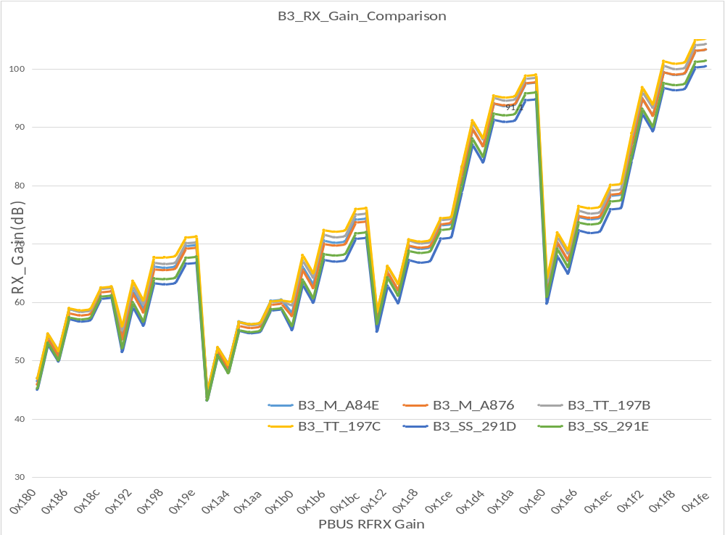

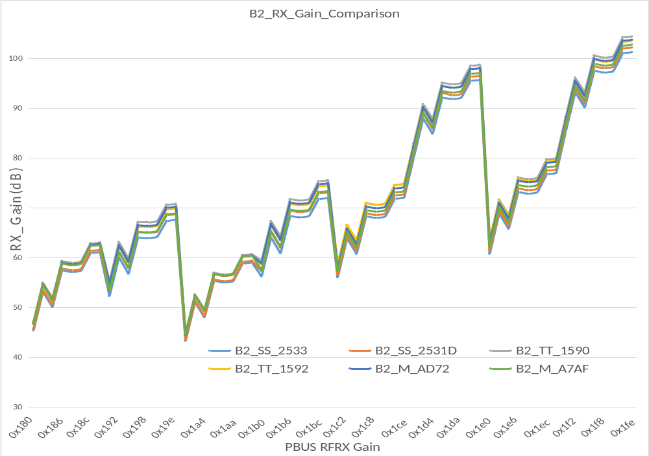

RX 基本性能测试

RX 接收灵敏度
- 测试了B2_Marlin3、B3_Marlin3、B2_TT、B3_TT、B2_SS、B3_SS 六款芯片的Rx_sens，测试结果如下，SS 芯片的Rx_sens 要比 TT 和Marilin3 的低 1~2 dB。
0ohm | B3_M_A84E | B3_M_A876 | B3_TT_197B | B3_TT_197C | B3_SS_291D | B3_SS_291E | B2_SS_2531D | B2_SS_2533 | B2_TT_1590 | B2_TT_1592 | B2_M_A7D2 | B2_M_A7AF
Rate | 1m | 1m | 1m | 1m | 1m | 1m | 1m | 1m | 1m | 1m | 1m | 1m
1 | -97 | -96 | -97 | -97 | -96 | -96 | -96 | -96 | -97 | -97 | -97 | -97
7 | -98 | -97 | -97 | -98 | -96 | -96 | -96 | -97 | -98 | -98 | -97 | -97
14 | -98 | -97 | -98 | -98 | -97 | -96 | -97 | -97 | -98 | -98 | -97 | -97
Rate | 11ml | 11ml | 11ml | 11ml | 11ml | 11ml | 11ml | 11ml | 11ml | 11ml | 11ml | 11ml
1 | -88 | -87 | -88 | -88 | -87 | -88 | -87 | -87 | -88 | -88 | -88 | -87
7 | -89 | -89 | -88 | -89 | -88 | -88 | -88 | -88 | -89 | -89 | -88 | -88
14 | -89 | -88 | -89 | -89 | -88 | -88 | -88 | -89 | -89 | -89 | -89 | -88
Rate | 6m | 6m | 6m | 6m | 6m | 6m | 6m | 6m | 6m | 6m | 6m | 6m
1 | -91 | -91 | -92 | -92 | -92 | -91 | -92 | -91 | -92 | -93 | -92 | -91
7 | -92 | -92 | -93 | -93 | -92 | -92 | -92 | -92 | -92 | -91 | -92 | -91
14 | -92 | -93 | -92 | -93 | -92 | -92 | -91 | -91 | -91 | -92 | -93 | -92
Rate | 54m | 54m | 54m | 54m | 54m | 54m | 54m | 54m | 54m | 54m | 54m | 54m
1 | -75 | -74 | -75 | -74 | -75 | -74 | -74 | -75 | -75 | -75 | -75 | -74
7 | -74 | -75 | -75 | -75 | -75 | -75 | -75 | -75 | -75 | -75 | -75 | -75
14 | -75 | -75 | -76 | -75 | -75 | -75 | -75 | -75 | -75 | -76 | -76 | -74
Rate | mcs0 | mcs0 | mcs0 | mcs0 | mcs0 | mcs0 | mcs0 | mcs0 | mcs0 | mcs0 | mcs0 | mcs0
1 | -92 | -93 | -93 | -91 | -92 | -92 | -92 | -89 | -92 | -92 | -92 | -92
7 | -93 | -91 | -92 | -92 | -92 | -92 | -92 | -92 | -92 | -93 | -92 | -91
14 | -93 | -93 | -93 | -93 | -92 | -92 | -92 | -92 | -92 | -92 | -93 | -93
Rate | mcs7 | mcs7 | mcs7 | mcs7 | mcs7 | mcs7 | mcs7 | mcs7 | mcs7 | mcs7 | mcs7 | mcs7
1 | -73 | -72 | -73 | -73 | -72 | -72 | -71 | -72 | -73 | -71 | -73 | -72
7 | -73 | -73 | -73 | -73 | -72 | -72 | -71 | -72 | -73 | -73 | -73 | -72
14 | -73 | -73 | -73 | -73 | -73 | -72 | -72 | -72 | -73 | -73 | -73 | -73
Rate | mcs0_40 | mcs0_40 | mcs0_40 | mcs0_40 | mcs0_40 | mcs0_40 | mcs0_40 | mcs0_40 | mcs0_40 | mcs0_40 | mcs0_40 | mcs0_40
1 | -87 | -89 | -88 | -87 | -88 | -88 | -88 | -88 | -87 | -88 | -86 | -89
7 | -88 | -88 | -89 | -89 | -88 | -88 | -88 | -88 | -88 | -88 | -87 | -89
14 | -87 | -88 | -89 | -89 | -89 | -86 | -89 | -88 | -89 | -89 | -89 | -88
Rate | mcs7_40 | mcs7_40 | mcs7_40 | mcs7_40 | mcs7_40 | mcs7_40 | mcs7_40 | mcs7_40 | mcs7_40 | mcs7_40 | mcs7_40 | mcs7_40
1 | -68 | -69 | -67 | -68 | -68 | -69 | -69 | -69 | -69 | -69 | -68 | -69
7 | -69 | -69 | -70 | -69 | -69 | -69 | -69 | -69 | -69 | -70 | -70 | -68
14 | -70 | -69 | -68 | -69 | -70 | -69 | -69 | -69 | -70 | -70 | -70 | -70

RX 最大接收电平
- 测试了B2_Marlin3、B3_Marlin3、B2_TT、B3_TT、B2_SS、B3_SS 六款芯片各3 pcs 的Rx_maxlevel，经对比，11b 各个芯片基本一致，在54M和MCS7 时，SS 芯片的Rx_sens 要比 TT 和Marilin3 的高 1 dB。
Ch14 | B3_M_A84E | B3_M_A876 | B3_M_A845 | B3_TT_197B | B3_TT_197C | B3_TT_1978 | B3_SS_291D | B3_SS_291E | B3_SS_291B | B2_SS_2531D | B2_SS_2533 | B2_SS_2531 | B2_TT_1590 | B2_TT_1592 | B2_TT_1591 | B2_M_A7D2 | B2_M_A7AF | B2_M_A7A6
1m | 10 | 10 | 10 | 10 | 10 | 10 | 10 | 10 | 10 | 10 | 10 | 10 | 10 | 10 | 10 | 10 | 10 | 10
11m | 10 | 10 | 10 | 10 | 10 | 10 | 10 | 10 | 10 | 10 | 10 | 10 | 10 | 10 | 10 | 10 | 10 | 10
54m | 1 | 2 | 1 | 1 | 1 | 1 | 3 | 3 | 2 | 2 | 2 | 2 | 1 | 2 | 3 | 1 | 1 | 1
mcs7 | 4 | 5 | 4 | 5 | 4 | 5 | 6 | 6 | 6 | 5 | 5 | 5 | 5 | 5 | 6 | 4 | 4 | 5
mcs0_40 | 10 | 10 | 10 | 10 | 10 | 10 | 10 | 10 | 10 | 10 | 10 | 10 | 10 | 10 | 10 | 10 | 10 | 10
mcs7_40 | 5 | 5 | 5 | 5 | 5 | 5 | 6 | 6 | 6 | 6 | 6 | 6 | 5 | 6 | 7 | 5 | 5 | 5

