ESP32 ECO Version3 IC 测试

TX 基本性能测试

测试条件
- 测试使用5pcs ESP32 Wrover-B 模组
- 分别测试5pcs ESP32 D0WD以及ESP32_ECO 芯片

测试结果
- ESP32 ECO 芯片功率比ESP32 D0WD功率高[0.2, 0.4] dB;
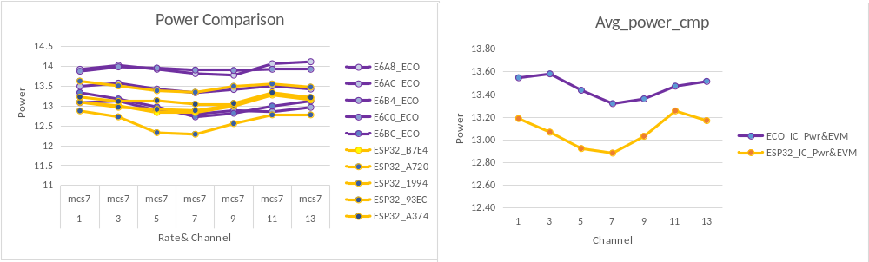
- ESP32 ECO 芯片 EVM 比 ESP32 D0WD高[0.2, 0.7] dB;
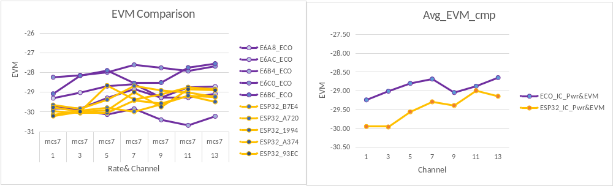

- ESP32 ECO 芯片和 ESP32 D0WD EVM 的波动性差异不大；
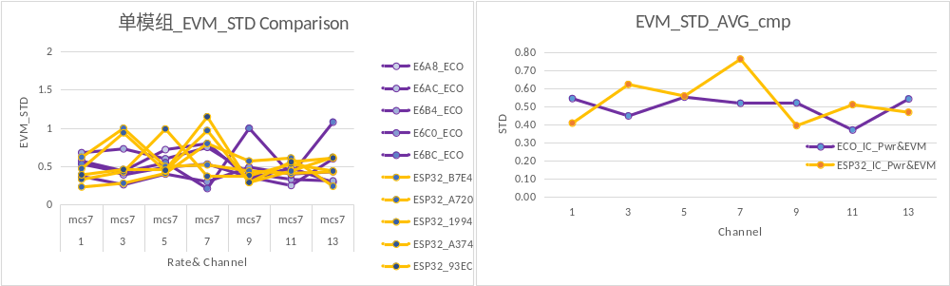
- 从5pcs 模组的power 和 EVM 分布情况来看，ESP32 ECO 芯片的一致性没有ESP32_D0WD 好；
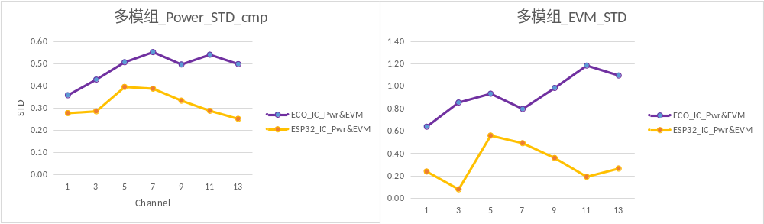

RX 测试结果

2.1 测试条件
- 测试使用5pcs ESP32 Wrover-B 模组
- 分别测试5pcs ESP32 D0WD以及ESP32_ECO 芯片

2.2 测试结果
- Rx Sens 和 Rx Maxlevel 未见明显差异性

ECO_IC_Pwr&EVM |  | E6A8_ECO | E6AC_ECO | E6B4_ECO | E6C0_ECO | E6BC_ECO
Chan | rate | Sens | Sens | Sens | Sens | Sens | AVG
14 | mcs7 | -71 | -73 | -72 | -72 | -72 | -72
14 | mcs0 | -91 | -92 | -92 | -92 | -91 | -92
14 | 54m | -75 | -76 | -75 | -74 | -75 | -75
14 | 6m | -92 | -92 | -93 | -91 | -91 | -92
14 | 11m | -88 | -88 | -89 | -89 | -89 | -89
14 | 1m | -97 | -97 | -98 | -97 | -96 | -97
14 | rate | MaxLevel | MaxLevel | MaxLevel | MaxLevel | MaxLevel | AVG
14 | mcs7 | -10 | -10 | -9 | -10 | -10 | -10
14 | mcs0 | 2 | 4 | 3 | 3 | 2 | 3
14 | 54m | -10 | -10 | -9 | -10 | -10 | -10
14 | 6m | 2 | 2 | 3 | 0 | 2 | 2
14 | 11m | 6 | 8 | 10 | 8 | 6 | 8
14 | 1m | 10 | 10 | 10 | 10 | 10 | 10

ESP32_IC_Pwr&EVM |  | ESP32_B7E4 | ESP32_A720 | ESP32_1994 | ESP32_A374 | ESP32_93EC
Chan | rate | Sens | Sens | Sens | Sens | Sens | AVG
14 | mcs7 | -72 | -72 | -73 | -72 | -73 | -72
14 | mcs0 | -91 | -92 | -91 | -92 | -92 | -92
14 | 54m | -74 | -75 | -74 | -75 | -75 | -75
14 | 6m | -92 | -93 | -92 | -92 | -93 | -92
14 | 11m | -88 | -88 | -88 | -89 | -88 | -88
14 | 1m | -98 | -98 | -97 | -98 | -97 | -98
14 | rate | MaxLevel | MaxLevel | MaxLevel | MaxLevel | MaxLevel | AVG
14 | mcs7 | -10 | -10 | -9 | -10 | -10 | -10
14 | mcs0 | 3 | 3 | 4 | 1 | 3 | 3
14 | 54m | -10 | -10 | -9 | -11 | -10 | -10
14 | 6m | 3 | 3 | 4 | 0 | 1 | 2
14 | 11m | 10 | 8 | 10 | 6 | 7 | 8
14 | 1m | 10 | 10 | 10 | 10 | 10 | 10

版本 1.0
版权 © 2019

