CHIP724

RFTX性能报告

## 

版本 1.0

更新日期 20200229

# 目录

目录 2

1. CHIP724 TX 性能总结 3

1.1 PA部分 3

1.2 RFPLL部分 3

2. PA2G_CCT_STG1 寄存器异常 3

2.1 对 EVM 的影响 3

3. TX GAIN 5

3.1 Digital Gain vs EVM 5

3.2 BB Gain vs EVM 6

3.3 TX PA Gain 的增益和EVM 6

4. RFPLL IR_CAP_EXT VS EVM 8

5. RF 匹配与 P1dB压缩点 10

6. Mark Margins测试结果 11

7. 电流测试 12

7.1 TX 电流测试 12

7.2 RX 电流测试 13

8. TX 一致性初测结果 14

# **CHIP724 TX 性能总结**

## PA部分

* CHIP724 的 PA2G_CCT_STG1 值得变化对 EVM 影响较大。
* PA 电源处的 0.1 uF电容拿掉，或减小（47nF），EVM 恶化
* 在 PA Gain 由 0x4f 或 0x5f 改为 0x4e 或 0x5e的条件下，以上异常情况消失
* PA Gain 在 0x4f 情况下 MASK Margins 余量在 6.5dB左右，优于CHIP723

## RFPLL部分

* 目前未校到最优的 ir_cap_ext值，最优值较CHIP723靠下限，接近失锁的边缘
* CHIP723 的最优vco_bias 在 1 V 左右， EVM 都能达到较好的性能，CHIP724 目前较优 vco_bias 在 1.25 V附近

# PA2G_CCT_STG1 寄存器异常

## 对 EVM 的影响

* CHIP724 的 PA2G_CCT_STG1 值得变化对 EVM 影响较大。
* 同时 PA2G_RCT_STG2=0， PA2G_ICT_STG1=0、PA2G_VCT_CSC_STG0=15 EVM 都会严重恶化，与 CHIP723 不同
* 在 PA Gain 由 0x4f 或 0x5f 改为 0x4e 或 0x5e的条件下，以上寄存器异常情况消失

|  |  |  |  |  |  |  |  |
| --- | --- | --- | --- | --- | --- | --- | --- |
| i2c_ctrl_name | i2c_data | CHIP724 PA_Gain = 0x4e, bb_gain = 0xa0 | | CHIP724 PA_Gain = 0x5f, bb_gain = 0x20 | | CHIP724 PA_Gain = 0x5f, bb_gain = 0x20 | |
| power(dBm) | evm(dB) | power(dBm) | evm(dB) | power(dBm) | evm(dB) |
| PA2G_CCT_STG1 | 0 | 13.97 | -28.99 | 12.31 | -16.42 | 13.78 | -32.2 |
| PA2G_CCT_STG1 | 1 | 14.08 | -29.45 | 13.15 | -18.25 | 14.18 | -32 |
| PA2G_CCT_STG1 | 2 | 13.96 | -30.08 | 13.22 | -17.39 | 13.99 | -32.2 |
| PA2G_CCT_STG1 | 3 | 13.84 | -30.37 | 13.75 | -23.57 | 14.17 | -31.95 |
| PA2G_CCT_STG1 | 4 | 14.05 | -30.43 | 12.37 | -17.66 | 14.01 | -32.11 |
| PA2G_CCT_STG1 | 5 | 14.01 | -29.95 | 13.79 | -21.17 | 13.96 | -32.17 |
| PA2G_CCT_STG1 | 6 | 13.95 | -30.57 | 13.72 | -20.28 | 13.85 | -32.33 |
| PA2G_CCT_STG1 | 7 | 13.94 | -30.38 | 14.18 | -29.96 | 14.03 | -32.1 |
| PA2G_CCT_STG1 | 8 | 13.98 | -30.36 | 12.1 | -17.78 | 14.01 | -32.29 |
| PA2G_CCT_STG1 | 9 | 13.94 | -30.09 | 13.65 | -20.25 | 14.12 | -32.17 |
| PA2G_CCT_STG1 | 10 | 13.98 | -30.43 | 13.69 | -19.1 | 14.07 | -32.18 |
| PA2G_CCT_STG1 | 11 | 14.1 | -30.05 | 13.91 | -29.91 | 14.03 | -32.2 |
| PA2G_CCT_STG1 | 12 | 13.9 | -30.36 | 14.1 | -17.65 | 14 | -32.58 |
| PA2G_CCT_STG1 | 13 | 14.08 | -29.69 | 13.95 | -29.44 | 14.09 | -32.07 |
| PA2G_CCT_STG1 | 14 | 14.13 | -29.78 | 13.89 | -28.56 | 14.05 | -32.67 |
| PA2G_CCT_STG1 | 15 | 13.89 | -29.82 | 14.04 | -29.5 | 14.06 | -32.63 |
| PA2G_ICT_STG1 | 0 | 13.49 | -18.99 | 14.88 | -4.71 | 13.59 | -18.62 |
| PA2G_ICT_STG1 | 1 | 14.06 | -21.99 | 8.94 | -14.48 | 14.02 | -21.27 |
| PA2G_ICT_STG1 | 2 | 14.01 | -25.25 | 9.8 | -17.94 | 13.98 | -24.41 |
| PA2G_ICT_STG1 | 3 | 13.74 | -28.11 | 11.86 | -18.65 | 13.8 | -27.65 |
| PA2G_ICT_STG1 | 4 | 13.77 | -29.83 | 12.93 | -19.7 | 14.2 | -30.36 |
| PA2G_ICT_STG1 | 5 | 14.01 | -30.57 | 14.15 | -20.02 | 14.06 | -31.89 |
| PA2G_ICT_STG1 | 6 | 13.9 | -29.87 | 13.94 | -30.43 | 13.97 | -32.85 |
| PA2G_ICT_STG1 | 7 | 14.01 | -30.41 | 13.9 | -29.6 | 14.07 | -32.83 |
| PA2G_ICT_STG1 | 8 | 14.09 | -30.12 | 13.91 | -29.79 | 14.1 | -32.61 |
| PA2G_ICT_STG1 | 9 | 14.06 | -29.56 | 14 | -29.47 | 13.81 | -31.96 |
| PA2G_ICT_STG1 | 10 | 13.83 | -29.62 | 14 | -29.69 | 14.01 | -32.07 |
| PA2G_ICT_STG1 | 11 | 14.05 | -29.03 | 13.97 | -29.24 | 14.18 | -31.51 |
| PA2G_ICT_STG1 | 12 | 14.12 | -29.33 | 13.87 | -28.83 | 14.07 | -31.22 |
| PA2G_ICT_STG1 | 13 | 14.04 | -29.21 | 14.06 | -29.2 | 13.9 | -31.05 |
| PA2G_ICT_STG1 | 14 | 13.92 | -29.16 | 14.13 | -28.82 | 13.94 | -31.07 |
| PA2G_ICT_STG1 | 15 | 14 | -29.27 | 14.04 | -28.6 | 14.02 | -31.13 |
| PA2G_RCT_STG2 | 0 | 14.09 | -30.01 | 15.11 | -15.34 | 13.87 | -32.15 |
| PA2G_RCT_STG2 | 1 | 14.05 | -30.02 | 13.92 | -30.02 | 14 | -32.4 |
| PA2G_RCT_STG2 | 2 | 13.99 | -30.28 | 13.91 | -30.02 | 14.04 | -32.78 |
| PA2G_RCT_STG2 | 3 | 13.89 | -30.44 | 14 | -30.41 | 13.88 | -32.94 |
| PA2G_RCT_STG2 | 4 | 13.88 | -30.58 | 14.18 | -29.93 | 14.12 | -33.18 |
| PA2G_RCT_STG2 | 5 | 13.92 | -30.34 | 14.16 | -30.91 | 13.91 | -33.18 |
| PA2G_RCT_STG2 | 6 | 14.17 | -30.37 | 13.92 | -30.13 | 13.98 | -32.93 |
| PA2G_VCT_CSC_STG0 | 0 | 11.07 | -14.58 | 12.3 | -15.65 | 12.05 | -15.48 |
| PA2G_VCT_CSC_STG0 | 1 | 12.41 | -15.93 | 13.19 | -16.84 | 13.05 | -16.69 |
| PA2G_VCT_CSC_STG0 | 2 | 13.3 | -17.03 | 13.79 | -17.87 | 13.62 | -17.83 |
| PA2G_VCT_CSC_STG0 | 3 | 13.6 | -17.76 | 13.97 | -19.57 | 13.85 | -19.28 |
| PA2G_VCT_CSC_STG0 | 4 | 13.75 | -19.98 | 13.91 | -23.59 | 14.15 | -22.28 |
| PA2G_VCT_CSC_STG0 | 5 | 13.82 | -22.23 | 13.97 | -26.24 | 13.92 | -25.99 |
| PA2G_VCT_CSC_STG0 | 6 | 13.98 | -25.21 | 13.91 | -28.98 | 13.77 | -29.82 |
| PA2G_VCT_CSC_STG0 | 7 | 13.99 | -27.29 | 13.71 | -29.94 | 14.08 | -30.82 |
| PA2G_VCT_CSC_STG0 | 8 | 13.9 | -29.07 | 14.08 | -30.34 | 13.97 | -32 |
| PA2G_VCT_CSC_STG0 | 9 | 13.97 | -29.75 | 14.12 | -30.24 | 13.92 | -32.55 |
| PA2G_VCT_CSC_STG0 | 10 | 14.04 | -29.75 | 13.9 | -30.07 | 14.02 | -32.34 |
| PA2G_VCT_CSC_STG0 | 11 | 13.96 | -29.73 | 13.92 | -27.18 | 14.03 | -32.32 |
| PA2G_VCT_CSC_STG0 | 12 | 13.94 | -29.84 | 14.37 | -21.01 | 13.98 | -31.88 |
| PA2G_VCT_CSC_STG0 | 13 | 13.93 | -29.46 | 14.38 | -20.04 | 13.93 | -31.47 |
| PA2G_VCT_CSC_STG0 | 14 | 13.75 | -29.45 | 14.36 | -19.33 | 14.04 | -31.11 |
| PA2G_VCT_CSC_STG0 | 15 | 13.89 | -29.01 | 14.09 | -19.32 | 14.16 | -30.95 |

# TX GAIN

## Digital Gain vs EVM

* 设置PA_Gain = 0x1f，BB_Gain=0x100，确保不是因为后级饱和而影响测试结果；遍历 Digital_Gain（即衰减值）从[ 60, -38]（4代表 -1 dB），得到如下曲线，对比 CHIP723 EVM 变化趋势看出，看出 EVM 受到噪声的影响，Digital Gain 在较小时，EVM 较差

## BB Gain vs EVM

* 设置PA_Gain = 0xf，Digital_Gain= 24~-20（4代表 -1 dB），遍历BB_Gain 从 0x0 ~ 0xb0(0 ~ 14dB)，测试结果表明Digital_gain 和 BB_Gain 增益相加小于13dB时，对EVM影响较小，趋势与CHIP723 一致。

## TX PA Gain 的增益和EVM

* 设置BB_Gain = 0x20，Digital_Gain = 12，遍历PA Gain，，测试得到以下PA Gain table。

|  |  |  |  |  |  |
| --- | --- | --- | --- | --- | --- |
| stg2 | | stg1 | | stg0 | |
| Index | Gain(dB) | Index | Gain(dB) | Index | Gain(dB) |
| 0x0 | 0 | 0x0 | 0 | 0x0 | 0 |
| 0x1 | 6 | 0x1 | 6 | 0x1 | 6 |
| 0x2 | 9.5 | 0x2 | 10 | 0x2 | 9 |
| 0x3 | 12 | 0x3 | 12.75 | 0x3 | 10.25 |
| 0x4 | 14 |  |  |  |  |
| 0x5 | 15.5 |  |  |  |  |
| 0x6 | 17 |  |  |  |  |
| 0x7 | 18 |  |  |  |  |

* 在固定较小的 BB Gain 和 Digital Gain 时，遍历所用PA Gain，发现PA Gain 在 0x2f、0x3f、0x4f、0x5f、0x6f、0x7f 比 0x2e、0x3e、0x4e、0x5e、0x6e、0x7e 差 2~3 dB

|  |  |  |  |  |  |  |  |  |
| --- | --- | --- | --- | --- | --- | --- | --- | --- |
| pa_gain | bb_gain | dig_atten | channel | rate | power（dBm） | evm（dB） | evm_std | evm_max |
| 0x2e | 0x0 | 12 | 1 | mcs7 | 0.79 | -30.46 | 1.26 | -26.27 |
| 0x2f | 0x0 | 12 | 1 | mcs7 | 2.66 | -28.2 | 0.9 | -25.56 |
| 0x3e | 0x0 | 12 | 1 | mcs7 | 3.32 | -30.11 | 1.82 | -23.32 |
| 0x3f | 0x0 | 12 | 1 | mcs7 | 5.33 | -27.3 | 0.89 | -23.59 |
| 0x4e | 0x0 | 12 | 1 | mcs7 | 5.38 | -29.33 | 0.9 | -26.29 |
| 0x4f | 0x0 | 12 | 1 | mcs7 | 7.21 | -26.44 | 0.48 | -25.17 |
| 0x5e | 0x0 | 12 | 1 | mcs7 | 6.93 | -30.11 | 1.09 | -27.12 |
| 0x5f | 0x0 | 12 | 1 | mcs7 | 8.77 | -26.39 | 0.67 | -23.46 |
| 0x6e | 0x0 | 12 | 1 | mcs7 | 8.3 | -30.25 | 0.88 | -27.46 |
| 0x6f | 0x0 | 12 | 1 | mcs7 | 9.93 | -26.87 | 0.69 | -24.24 |
| 0x7e | 0x0 | 12 | 1 | mcs7 | 9.54 | -30.03 | 0.95 | -27.48 |
| 0x7f | 0x0 | 12 | 1 | mcs7 | 10.84 | -27.54 | 0.73 | -25.08 |

* PA 电源处的 0.1 uF电容拿掉，或减小（47nF），EVM 恶化
* 在 PA Gain 从 0x4f、0x5f 改为 0x4e 或 0x5e， 0.1uF 拿掉对 EVM 不会起到明显作用

|  |  |  |  |  |  |  |  |  |
| --- | --- | --- | --- | --- | --- | --- | --- | --- |
| NO89 | PA电源引脚处并 0.1uF 电容 | | | | | | | |
| rftx | bbgain | dig_atten | channel | rate | power(dBm) | evm(dB) | evm_std | evm_max |
| 0x4f | 0x20 | 13 | 2412 | mcs7 | 13.46 | -30.7 | 1.26 | -26.02 |
| 0x4e | 0xa0 | 11 | 2412 | mcs7 | 13.38 | -31.23 | 1.66 | -26.44 |
| NO89 | PA电源引脚处电容拿掉 | | | | | | | |
| rftx | bbgain | dig_atten | channel | rate | power(dBm) | evm(dB) | evm_std | evm_max |
| 0x4f | 0x20 | 5 | 2412 | mcs7 | 13.08 | -18.57 | 0.1 | -18.17 |
| 0x4e | 0xa0 | 13 | 2412 | mcs7 | 13.44 | -30.97 | 1.38 | -26.03 |

# RFPLL IR_CAP_EXT VS EVM

* 遍历多颗芯片的 rfpll ir_cap 与 EVM 的关系，发现目前校准cap值下的 EVM 并不是最优值，而最优的 cap值比较靠下限，接近失锁的边缘
* 使用最优的校准cap值，对比default 值下测试的 EVM 和EVT std 均有明显提升。



* CHIP723 的 最优vco_bias 在 **1 V** 左右， EVM 都能达到较好的性能，CHIP724 目前较优 vco_bias 在 **1.25 V**附近

|  |  |  |  |  |  |  |  |  |  |
| --- | --- | --- | --- | --- | --- | --- | --- | --- | --- |
| Test board | | CHIP723_4ceb | | | | CHIP723_4fab | | | |
| channel | rate | ir_cap_ext | vco_bias | power | evm | ir_cap_ext | vco_bias | power | evm |
| 1 | mcs7 | 183 | 0.38 | 13.87 | -29.29 | 190 | 0.36 | 13.32 | -29.59 |
| 1 | mcs7 | 184 | 0.5 | 13.85 | -31.12 | 191 | 0.48 | 13.3 | -31.98 |
| 1 | mcs7 | 185 | 0.64 | 13.83 | -31.73 | 192 | 0.64 | 13.29 | -32.56 |
| 1 | mcs7 | 186 | 0.81 | 13.84 | -31.8 | 193 | 0.79 | 13.27 | -32.83 |
| 1 | mcs7 | **187** | **0.94** | **13.84** | **-32.05** | **194** | **0.94** | **13.27** | **-32.82** |
| 1 | mcs7 | 188 | 1.08 | 13.83 | -32.36 | 195 | 1.06 | 13.27 | -33.22 |
| 1 | mcs7 | 189 | 1.21 | 13.83 | -32.57 | 196 | 1.21 | 13.26 | -32.42 |
| 1 | mcs7 | 190 | 1.4 | 13.83 | -29.71 | 197 | 1.35 | 13.26 | -31.08 |
| 1 | mcs7 | 191 | 1.48 | 13.85 | 0 | 198 | 1.47 | 13.28 | 0 |
| 1 | mcs7 | 192 | 1.48 | 13.87 | 0 | 199 | 1.47 | 13.27 | 0 |
| 1 | mcs7 | 193 | 1.47 | 13.87 | 0 | 200 | 1.47 | 13.26 | 0 |
| 1 | mcs7 | 194 | 1.47 | 13.87 | 0 | 201 | 1.47 | 13.25 | 0 |
| Test board | | CHIP724_NO89 | | | | CHIP724_NO92 | | | |
| channel | rate | ir_cap_ext | vco_bias | power | evm | ir_cap_ext | vco_bias | power | evm |
| 1 | mcs7 | 173 | 0.23 | 13.2 | -26.06 | 176 | 0.2 | 12.73 | -29.74 |
| 1 | mcs7 | 174 | 0.33 | 13.16 | -26.23 | 177 | 0.28 | 12.72 | -24.89 |
| 1 | mcs7 | 175 | 0.44 | 13.15 | -28.75 | 178 | 0.38 | 12.72 | -27.93 |
| 1 | mcs7 | 176 | 0.54 | 13.13 | -29.32 | 179 | 0.5 | 12.71 | -29.93 |
| 1 | mcs7 | **177** | **0.69** | **13.13** | **-30.19** | **180** | **0.67** | **12.71** | **-30.44** |
| 1 | mcs7 | 178 | 0.86 | 13.12 | -29.68 | 181 | 0.81 | 12.71 | -30.32 |
| 1 | mcs7 | 179 | 0.98 | 13.15 | -29.94 | 182 | 0.96 | 12.71 | -30.46 |
| 1 | mcs7 | 180 | 1.12 | 13.12 | -30.39 | 183 | 1.08 | 12.71 | -30.77 |
| 1 | mcs7 | 181 | 1.25 | 13.11 | -30.94 | 184 | 1.22 | 12.72 | -31.57 |
| 1 | mcs7 | 182 | 1.46 | 13.11 | -29.14 | 185 | 1.37 | 12.72 | -31.56 |
| 1 | mcs7 | 183 | 1.55 | 13.12 | 0 | 186 | 1.52 | 12.71 | 0 |
| 1 | mcs7 | 184 | 1.54 | 13.08 | 0 | 187 | 1.51 | 12.69 | 0 |

# RF 匹配与 P1dB压缩点

* 调试了几组匹配，测试结果如下。从目前的调试结果看起来，按照目前的结果，匹配点基保持与CHIP723 一致。待ir_cap校准方式和寄存器的配置优化后，需要再做匹配优化，确认最优点。

|  |  |  |  |  |  |  |  |  |  |
| --- | --- | --- | --- | --- | --- | --- | --- | --- | --- |
| Matching | rftx | bbgain | dig_atten | channel | rate | power | evm | evm_std | evm_max |
| 2.4-1.8-3.0(34+j5) | 0x4e | 0xa0 | 12 | 2412 | mcs7 | 13.21 | -30.52 | 0.97 | -27.48 |
| 2.4-1.5.3.0 | 0x4e | 0xa0 | 12 | 2412 | mcs7 | 12.89 | -30.12 | 0.65 | -28.38 |
| 2.4-2.0-3.0 | 0x4e | 0xa0 | 12 | 2412 | mcs7 | 13.28 | -30.13 | 1.01 | -26.38 |
| 2.4/2.0/2.7(35-j3) | 0x4f | 0x20 | 12 | 2412 | mcs7 | 13.96 | -30.26 | 0.71 | -27.88 |
| 2.2/2.0/2.7(41-j0) | 0x4f | 0x20 | 12 | 2412 | mcs7 | 13.91 | -30.49 | 0.82 | -27.98 |
| 2.7-1.6-3.3(30+j8) | 0x5f | 0x20 | 14 | 2412 | mcs7 | 13.58 | -29.83 | 0.97 | -27.4 |
| 3.0-1.6-3.3(29+j6) | 0x5f | 0x20 | 15 | 2412 | mcs7 | 13.51 | -30.17 | 0.8 | -28.32 |

* CHIP724_VS_CHIP723 P1 dB压缩点如下图所示, CHIP724 P1dB 压缩点比 CHIP723 差0.7dB左右。

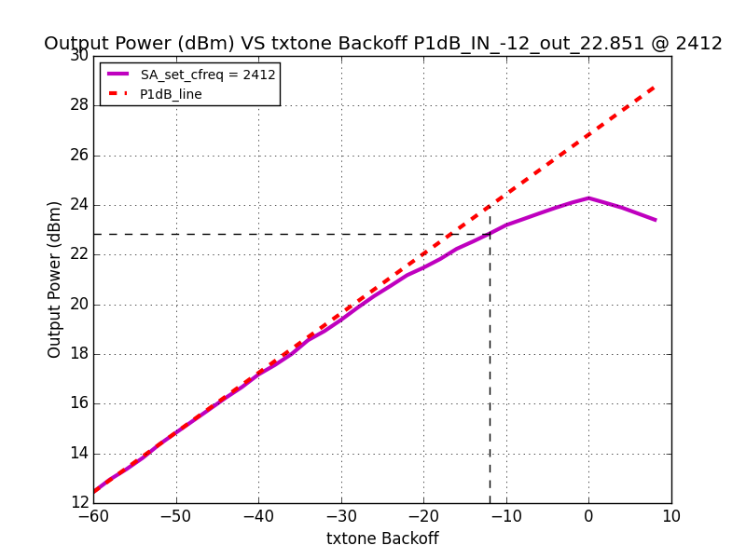

**CHIP724**

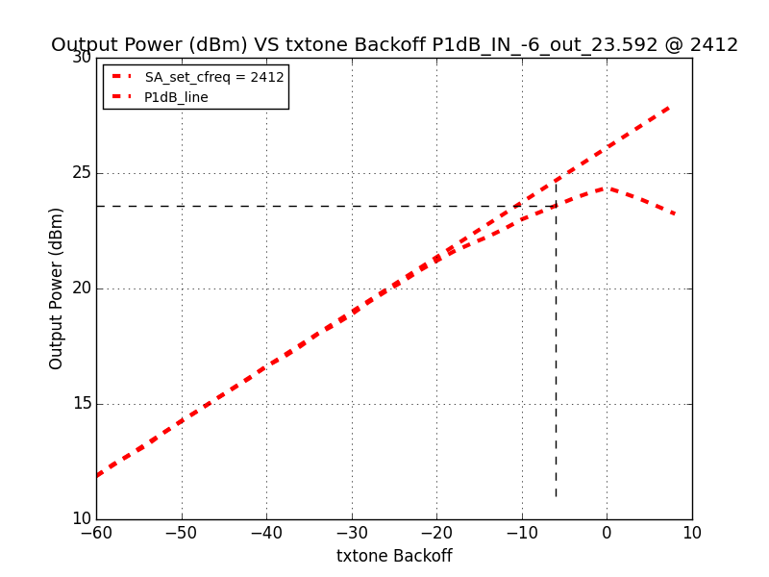

**CHIP723**

# Mark Margins测试结果

* 18dB下，使用 0x5e 的pa_gain 下测试 MCS0 Mask Margins 的结果如下；

|  |  |  |  |  |  |  |  |  |  |  |  |  |  |  |  |
| --- | --- | --- | --- | --- | --- | --- | --- | --- | --- | --- | --- | --- | --- | --- | --- |
|  | rftx | bbgain | dig_atten | channel | rate | power | evm | L4 | L3 | L2 | L1 | U1 | U2 | U3 | U4 |
| 60FF | 0x5e | 0x20 | -12 | 2412 | mcs0 | 17.9 | -19.92 | 4.28 | 4.63 | 6.44 | 7.74 | 6.64 | 6.15 | 6.76 | 7.75 |
| 0x5e | 0x20 | -11 | 2442 | mcs0 | 17.89 | -19.68 | 3.63 | 4.88 | 5.83 | 7.26 | 6.44 | 5.94 | 6.46 | 6.92 |
| 0x5e | 0x20 | -11 | 2472 | mcs0 | 17.76 | -19.93 | 3.88 | 4.25 | 6.02 | 7.24 | 6.66 | 6.10 | 6.69 | 6.76 |
| 5FD7 | 0x5e | 0x20 | -7 | 2412 | mcs0 | 17.86 | -20.77 | 5.06 | 6.28 | 7.02 | 8.25 | 7.25 | 6.46 | 7.57 | 7.98 |
| 0x5e | 0x20 | -7 | 2442 | mcs0 | 17.95 | -20.44 | 4.53 | 5.67 | 6.58 | 7.75 | 6.73 | 6.33 | 7.23 | 8.14 |
| 0x5e | 0x20 | -8 | 2472 | mcs0 | 17.96 | -20.33 | 4.13 | 4.89 | 6.30 | 7.57 | 6.89 | 6.43 | 7.18 | 7.81 |
| 6097 | 0x5e | 0x20 | -14 | 2412 | mcs0 | 17.99 | -19.45 | 2.96 | 3.57 | 5.33 | 6.64 | 6.14 | 5.57 | 5.98 | 5.80 |
| 0x5e | 0x20 | -16 | 2442 | mcs0 | 18.03 | -19.11 | 2.73 | 3.52 | 5.01 | 6.50 | 5.87 | 5.57 | 5.73 | 5.79 |
| 0x5e | 0x20 | -17 | 2472 | mcs0 | 17.73 | -19.55 | 2.79 | 3.78 | 5.71 | 6.97 | 6.53 | 6.27 | 6.40 | 6.30 |
|  |  |  |  |  |  | 2412 | Average | 4.10 | 4.83 | 6.26 | 7.54 | 6.68 | 6.06 | 6.77 | 7.18 |
|  |  |  |  |  |  | 2442 | Average | 3.63 | 4.69 | 5.81 | 7.17 | 6.34 | 5.95 | 6.47 | 6.95 |
|  |  |  |  |  |  | 2472 | Average | 3.60 | 4.31 | 6.01 | 7.26 | 6.69 | 6.27 | 6.76 | 6.96 |

* 使用不同的PA gain，对Mark Margins 存在影响，如将 pa_gain 修改为 0x4f，mask margins 改善2.5dB。

|  |  |  |  |  |  |  |  |  |  |
| --- | --- | --- | --- | --- | --- | --- | --- | --- | --- |
| Samples | rftx | bbgain | dig_atten | channel | rate | power | evm | L4 | delta |
| NO90 | 0x4f | 0x20 | -6 | 2412 | mcs0 | 17.95 | -24.18 | 6.88 | 2.57 |
| 0x5e | 0x20 | -11 | 2412 | mcs0 | 18.05 | -19.9 | 4.31 |
| NO89 | 0x4f | 0x20 | -6 | 2412 | mcs0 | 17.96 | -24.95 | 7.46 | 2.86 |
| 0x4e | 0xa0 | -9 | 2412 | mcs0 | 17.88 | -20.79 | 4.61 |

# 电流测试

## TX 电流测试

* 测试条件：常温 25度，电源电压为 3.3V，采样速率0.1ms，采样个数512，TX 占空比为 50%，与 CHIP723 电流相当。

|  |  |  |  |  |  |  |  |  |
| --- | --- | --- | --- | --- | --- | --- | --- | --- |
| Test board | | | NO89 | | | NO92 | | |
| cbw40m | rate | channel | max | avg | pwr | max | avg | pwr |
| 0 | 1m | 1 | 290.14 | 179.02 | 19.33 | 312.26 | 195.13 | 19.91 |
| 0 | 1m | 6 | 299.8 | 184.09 | 19.68 | 320.76 | 199.1 | 20.15 |
| 0 | 1m | 11 | 301.65 | 189.03 | 19.68 | 321.45 | 199.86 | 20.07 |
| 0 | 11m | 1 | 293.83 | 181.29 | 19.32 | 317.33 | 198.21 | 19.95 |
| 0 | 11m | 6 | 304.97 | 190.55 | 19.71 | 326.57 | 202.96 | 20.22 |
| 0 | 11m | 11 | 307.51 | 191.73 | 19.73 | 328.1 | 203.34 | 20.15 |
| 0 | 6m | 1 | 254.97 | 165.5 | 17.56 | 274.14 | 176.35 | 18.22 |
| 0 | 6m | 6 | 263.21 | 169.55 | 18 | 282.16 | 180.06 | 18.55 |
| 0 | 6m | 11 | 265.74 | 171.01 | 18.03 | 283.38 | 180.79 | 18.5 |
| 0 | mcs0 | 1 | 253.12 | 166.24 | 17.47 | 271.82 | 177.02 | 18.14 |
| 0 | mcs0 | 6 | 261.47 | 170.39 | 17.9 | 280.21 | 181.11 | 18.46 |
| 0 | mcs0 | 11 | 264 | 171.89 | 17.93 | 281.43 | 181.97 | 18.4 |
| 1 | mcs0_40 | 1 | 250.01 | 165.77 | 17.14 | 268.17 | 176.21 | 17.82 |
| 1 | mcs0_40 | 6 | 258.19 | 165.64 | 17.58 | 276.09 | 180.24 | 18.15 |
| 1 | mcs0_40 | 11 | 260.52 | 166.88 | 17.6 | 277.68 | 181.54 | 18.09 |
| 0 | 54m | 1 | 210.94 | 144.31 | 14.32 | 226.3 | 152.95 | 15.21 |
| 0 | 54m | 6 | 217.85 | 143.74 | 14.89 | 233.22 | 156.64 | 15.65 |
| 0 | 54m | 11 | 219.75 | 144.57 | 14.97 | 234.43 | 157.2 | 15.63 |
| 0 | mcs7 | 1 | 202.38 | 137.12 | 13.44 | 216.9 | 149.19 | 14.32 |
| 0 | mcs7 | 6 | 208.3 | 143.79 | 14 | 222.76 | 152.41 | 14.81 |
| 0 | mcs7 | 11 | 210.2 | 144.81 | 14.09 | 223.93 | 152.94 | 14.8 |
| 1 | mcs7_40 | 1 | 201.06 | 137.52 | 13.03 | 214.9 | 149.49 | 13.93 |
| 1 | mcs7_40 | 6 | 206.4 | 140.01 | 13.59 | 220.55 | 152.43 | 14.41 |
| 1 | mcs7_40 | 11 | 208.35 | 141.05 | 13.7 | 221.71 | 153.04 | 14.39 |

## RX 电流测试

* 测试条件：常温 25度，电源电压为 3.3V，采样速率0.1ms，采样个数512，TX 占空比为 50%，**RX 电流比 CHIP723偏大 7~8 mA ，待确定**。

|  |  |  |  |  |
| --- | --- | --- | --- | --- |
| Test board | | | NO89 | NO92 |
| cbw40m | rate | channel | curr_avg | curr_avg |
| 0 | 1m | 1 | 74.42 | 76.87 |
| 0 | 1m | 6 | 74.25 | 76.73 |
| 0 | 1m | 11 | 74.6 | 77.88 |
| 0 | 11m | 1 | 74.22 | 76.76 |
| 0 | 11m | 6 | 74.31 | 76.68 |
| 0 | 11m | 11 | 74.4 | 77.94 |
| 0 | 6m | 1 | 74.16 | 76.78 |
| 0 | 6m | 6 | 74.26 | 76.58 |
| 0 | 6m | 11 | 74.4 | 77.79 |
| 0 | mcs0 | 1 | 74.25 | 76.92 |
| 0 | mcs0 | 6 | 74.45 | 76.65 |
| 0 | mcs0 | 11 | 74.55 | 77.77 |
| 1 | mcs0_40 | 1 | 77.75 | 80.42 |
| 1 | mcs0_40 | 6 | 77.97 | 80.83 |
| 1 | mcs0_40 | 11 | 77.84 | 80.06 |
| 0 | mcs7 | 1 | 74.36 | 76.98 |
| 0 | mcs7 | 6 | 74.41 | 76.9 |
| 0 | mcs7 | 11 | 74.44 | 78.01 |
| 1 | mcs7_40 | 1 | 78.05 | 80.28 |
| 1 | mcs7_40 | 6 | 78.26 | 80.12 |
| 1 | mcs7_40 | 11 | 77.7 | 80.87 |

# TX 一致性初测结果

* 在相同 Gain （RF_Gain=0x4f）下测试 10pcs 的TX 性能（ir_cap_ext 未优化）,结果如下：
  + Power 波动2 dB，芯片一致性不太好:
  + IC 之间EVM差异很大，其中有1pcs 异常，EVM 只有-23dB左右。

进一步查看该异常芯片， 使用 0x4f 的 pa_gain发包时，频谱异常，修改为0x5e后，异常的spur 消失，且EVM 也恢复正常。

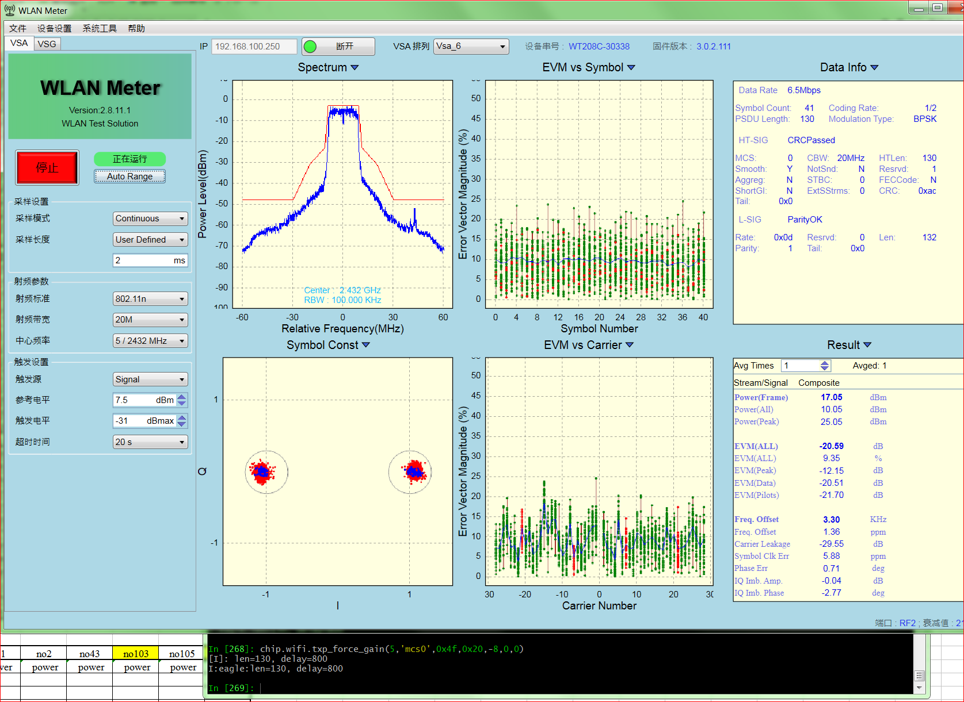

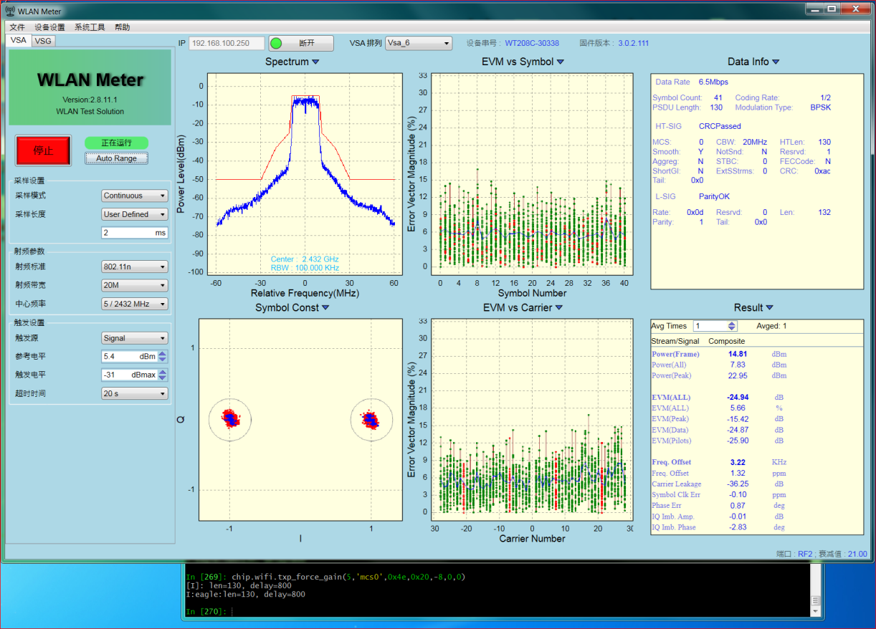

* + EVM 波动 在 【0.4,1.8】之间，较CHIP723 稍差。