UPEI Robertson Library
Guide on the Side
Administrator Guide
Installation, Configuration & Administration for Pressbooks
pb-split-guide WordPress Plugin
Version 0.5.0 — April 24, 2026

Table of Contents
Part 1: Local Testing Setup
1. Overview
2. Prerequisites
3. Install Docker Desktop
4. Install Lando
5. Get the Project Files
6. Configure the Environment
7. Start the Environment
8. Install Plugin Dependencies
9. Verify the Setup
10. Daily Commands
11. Local Setup Troubleshooting
Part 2: Production Deployment
12. Production Prerequisites
13. Upload the Plugin
14. Install H5P
15. Activate the Plugins
16. Verify Activation
Part 3: Configuration & Administration
17. Plugin Settings
18. Managing Librarian Accounts
19. Analytics Dashboard
20. H5P Quiz Content
21. Export & Import Tutorials
22. Upload File Size Limits
23. Accessibility Features

Overview
This guide covers three things:
- Local Testing — Set up the full Guide on the Side environment on your desktop to evaluate the plugin before deploying it
- Production Deployment — Install the plugin on your library’s existing Pressbooks server
- Configuration & Administration — Manage settings, librarian accounts, analytics, and content
The local testing setup uses Lando, a Docker-based tool that creates an isolated WordPress + Pressbooks environment on your computer. This is the same setup the development team uses, so what you see locally will match production behavior.

Part 1: Local Testing Setup

Prerequisites
Before starting, you need:
- A computer running macOS or Windows (Linux also works)
- At least 8 GB of RAM (Docker and Lando run multiple containers)
- ~5 GB of free disk space (for Docker images and the project)
- An internet connection (for initial download of Docker images)
You will install two tools:
- Docker Desktop — runs containers (lightweight virtual machines) on your computer
- Lando — orchestrates the containers into a working WordPress + Pressbooks environment

Step 1: Install Docker Desktop
Download and install Docker Desktop for your operating system:
- macOS: https://www.docker.com/products/docker-desktop/ — download the .dmg, open it, drag Docker to Applications
- Windows: https://www.docker.com/products/docker-desktop/ — download the .exe installer, follow the wizard. Requires WSL2 (the installer will prompt you to enable it)
- Linux (Ubuntu/Debian):
sudo apt update
sudo apt install -y docker.io docker-compose-plugin
sudo systemctl enable --now docker
sudo usermod -aG docker $USER
Note: Log out and back in after running these commands for the group change to take effect.
- Linux (other distros): Follow the official Docker Engine install guide for your distro: https://docs.docker.com/engine/install/
After installing, open Docker Desktop (macOS/Windows) or verify the Docker service is running (Linux).
Verify it’s working — open a terminal and run:
docker --version
You should see something like Docker version 27.x.x.

Step 2: Install Lando
Download the Lando installer for your operating system:
- macOS: https://lando.dev/download/ — download the .dmg, open it, drag to Applications
- Windows: https://lando.dev/download/ — download the .exe installer, follow the wizard
- Linux (Ubuntu/Debian):
wget https://files.lando.dev/installer/lando-x64-stable.deb
sudo dpkg -i lando-x64-stable.deb
- Linux (other distros): See https://docs.lando.dev/install/linux.html for your package manager
Verify it’s working:
lando version
You should see something like v3.21.x.

Step 3: Get the Project Files
You can get the project files in two ways:
Option A — Clone with Git (if you have Git installed):
git clone https://github.com/qixiang03/guide-on-the-side.git
cd guide-on-the-side
Option B — Download a zip from the development team. Extract it and open a terminal in the extracted folder.

Step 4: Configure the Environment
4a. Create environment files:
cp .env.example .env
cp config_services/.env.example config_services/.env
Note: If you’re on Windows (PowerShell), use: Copy-Item .env.example .env and Copy-Item config_services\.env.example config_services\.env
4b. Generate security keys:
- Visit https://roots.io/salts.html in your browser
- Copy the generated keys
- Open the .env file in a text editor
- Replace each ‘generateme’ value with the corresponding generated key
The lines to replace look like this:
AUTH_KEY='generateme'
SECURE_AUTH_KEY='generateme'
LOGGED_IN_KEY='generateme'
NONCE_KEY='generateme'
AUTH_SALT='generateme'
SECURE_AUTH_SALT='generateme'
LOGGED_IN_SALT='generateme'
NONCE_SALT='generateme'
4c. Set your computer’s architecture:
Open config_services/.env in a text editor and set:
- Apple Silicon Mac (M1/M2/M3/M4): ARCHITECTURE=arm64
- Intel Mac or Windows: ARCHITECTURE=amd64
4d. Obtain the database dump:
Ask the development team (Enzo or Daniel) for the file pb_local_db.sql. Place it in the project root folder:
guide-on-the-side/
├── pb_local_db.sql ← place it here
├── .env
├── .lando.yml
└── ...
This file contains a pre-configured WordPress + Pressbooks database so you don’t have to set up everything from scratch. It is automatically imported when you start the environment.
Tip: Don’t have the database dump? You can still set up WordPress manually — see Local Setup Troubleshooting at the end of Part 1.

Step 5: Start the Environment
From the project folder, run:
lando start
This will take 5–10 minutes on first run. Lando is downloading and building:
- PHP 8.3 with Nginx (web server)
- MariaDB 10.5 (database)
- Redis 5.0 (caching)
- Mailhog (email capture for testing)
- Node.js (frontend tooling)
- WordPress 6.9 with Pressbooks and H5P
It also installs all PHP dependencies via Composer and imports the database dump automatically.
When it finishes, you’ll see output like:
APPSERVER NGINX URLS
https://pressbooks.test
http://pressbooks.test
Important: The local site runs at pressbooks.test, NOT localhost:8080. Lando sets up a proxy domain automatically.
Note: SSL warning: Your browser will show a security warning because Lando uses a self-signed certificate. Click Advanced → Proceed (or “Accept the Risk” in Firefox) to continue. This is normal for local development.

Step 6: Install Plugin Dependencies
The pb-split-guide plugin uses TCPDF for generating PDF certificates. Install its dependencies:
lando composer install --working-dir=web/app/plugins/pb-split-guide

Step 7: Verify the Setup
Open these URLs in your browser to confirm everything is working:
What | URL
Pressbooks home | https://pressbooks.test
WordPress Admin | https://pressbooks.test/wp/wp-admin/
Network Admin | https://pressbooks.test/wp/wp-admin/network/
Mailhog (email) | http://localhost:8026
Quick test — create a tutorial:
- Go to WordPress Admin for a book site
- Go to Pages → Add New
- In the Page Attributes panel on the right, set the Template to “Split Guide”
- You should see the Split Guide Steps metabox appear below the editor
- Add a step with some text and an embed URL
- Publish and view the page — you should see the split-screen layout
If all of this works, your local testing environment is ready.

Daily Commands
Run these from the project folder:
Command | What it does
lando start | Start the environment
lando stop | Stop the environment (preserves all data)
lando restart | Restart all services
lando rebuild | Rebuild from scratch (re-installs dependencies)
lando info | Show all service URLs and ports
lando mysql | Open a MySQL shell to the database
lando ssh | Open a shell inside the web server container

Local Setup Troubleshooting

“pressbooks.test” doesn’t load in the browser
Lando usually configures the domain automatically. If it doesn’t resolve, add it manually:
- macOS/Linux: Open Terminal and run:
echo "127.0.0.1 pressbooks.test" | sudo tee -a /etc/hosts
- Windows: Open PowerShell as Administrator and run:
Add-Content C:\Windows\System32\drivers\etc\hosts "127.0.0.1 pressbooks.test"

Browser won’t accept the SSL certificate
Use Firefox — it lets you add a permanent exception. Or use incognito/private mode.

Cookies aren’t sticking / can’t stay logged in
The environment forces HTTPS. If your browser rejects the self-signed certificate’s cookies, try:
- Use Firefox (most permissive with self-signed certs)
- Use an incognito/private window
- Clear your browser cookies for pressbooks.test

Lando start fails or hangs
lando rebuild
If that doesn’t work:
lando destroy
lando start
Warning: lando destroy deletes all database data. You’ll need to re-import pb_local_db.sql (it happens automatically on next lando start if the file is still in the project root).

No database dump available (manual WordPress setup)
If you don’t have pb_local_db.sql, you can set up WordPress manually after lando start:
- Visit https://pressbooks.test and complete the WordPress installation wizard
- The Bedrock configuration already has Multisite enabled, so Pressbooks should work immediately
- Go to Network Admin → Plugins and network-activate Pressbooks and H5P
- Go to Network Admin → Sites → Add New to create a test book site
- Activate the pb-split-guide plugin on your test site
- Install plugin dependencies: lando composer install --working-dir=web/app/plugins/pb-split-guide
This gives you a clean environment but without the team’s shared test content.

Part 2: Production Deployment
This section covers installing the plugin on your library’s existing Pressbooks server. Since Pressbooks is already running, this is a straightforward plugin installation.

Production Prerequisites
Before installing, confirm your server has:
☐ PHP 8.2 or higher — check with your server admin or run php -v
☐ WordPress Multisite — required by Pressbooks (if Pressbooks is running, you have this)
☐ Pressbooks — active and working
☐ HTTPS — the plugin requires a secure connection for analytics tracking
☐ Server write access — FTP, SFTP, or SSH to upload plugin files

Step 1: Upload the Plugin
Upload the entire pb-split-guide/ folder to your server’s WordPress plugins directory:
your-pressbooks-server/
└── wp-content/
└── plugins/
└── pb-split-guide/
├── pb-split-guide.php
├── class-pbsg-analytics.php
├── class-pbsg-analytics-dashboard.php
├── includes/
├── templates/
├── assets/
├── accessibility-dashboard/
├── vendor/ ← important: include this (TCPDF)
└── composer.json
Methods:
- FTP/SFTP: Use an FTP client (e.g., FileZilla, Cyberduck) to upload the folder
- SSH: Use scp or rsync to copy the folder to the server
- WP Admin: Zip the pb-split-guide/ folder and upload via Network Admin → Plugins → Add New → Upload Plugin
Important: Make sure the vendor/ directory is included. It contains TCPDF, which is needed for PDF certificate generation.

Step 2: Install H5P
If H5P is not already installed on your Pressbooks server:
- Go to Network Admin → Plugins → Add New
- Search for “H5P”
- Install and Network Activate the H5P plugin
Or via WP-CLI (if available):
wp plugin install h5p --activate-network --allow-root

Step 3: Activate the Plugins
- Go to Network Admin → Plugins
- Find “PB Split Guide” in the plugin list
- Click Network Activate
On activation, the plugin automatically:
- Creates the pbsg_librarian role with appropriate capabilities
- Creates 3 database tables for analytics (pbsg_tutorial_stats, pbsg_question_stats, pbsg_daily_stats)
- Registers the Split Guide page template
- Adds admin menu items (My Tutorials, Tutorial Analytics, Guide Settings, Manage Librarians)

Step 4: Verify Activation
Check the admin menu: Log in as a network admin. You should see these new menu items in the sidebar:
- My Tutorials
- Tutorial Analytics
- Guide Settings
- Manage Librarians
Check the librarian role: Go to Network Admin → Users → Add New. In the Role dropdown, you should see “GOTS Librarian” as an option.
Check the template: Go to any book site → Pages → Add New. In the Page Attributes panel, you should see “Split Guide” as a template option.
Check the database (optional): If you have phpMyAdmin or database access, confirm these 3 tables were created:
- wp_pbsg_tutorial_stats
- wp_pbsg_question_stats
- wp_pbsg_daily_stats
(Table names use your WordPress table prefix — wp_ by default. If your site uses a different prefix, substitute accordingly.)
Note: No database migration needed: This is a fresh plugin install on your existing Pressbooks database. The plugin creates its own tables automatically on activation.
Note: Deactivation is safe: If you deactivate the plugin, it removes the pbsg_librarian role but preserves the database tables and all tutorial content. Re-activating restores everything.

Part 3: Configuration & Administration

Plugin Settings
Location: My Tutorials → Guide Settings (admin only — requires manage_options capability)
This page controls site-wide defaults that apply to all tutorials. Librarians can override some of these settings per-tutorial in the tutorial editor.
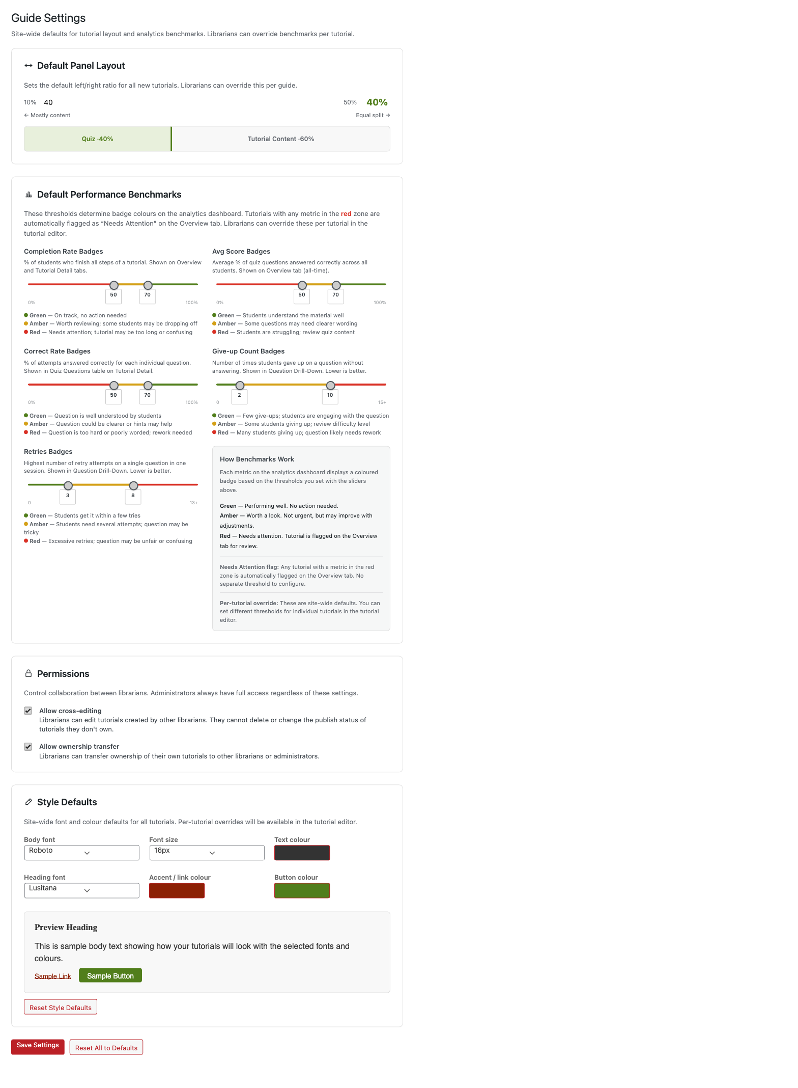
Figure 1: Guide Settings — Default Panel Layout and Performance Benchmarks

Default Layout Ratio
Controls the left/right pane split for the tutorial split-screen view.
- Range: 10% to 50% (left pane)
- Default: 40% left / 60% right
- Librarians can override this per-tutorial in the tutorial editor’s metabox

Benchmark Thresholds
Sets the amber and green cutoff values for 5 performance metrics. These thresholds determine the badge colors (red / amber / green) shown on the analytics dashboard.
Metric | What it measures | Scale
Completion Rate | % of students who finish the tutorial | 0–100%
Average Score | Mean quiz score across all students | 0–100%
Correct Rate | % of quiz answers that were correct | 0–100%
Give-up Count | Number of students who gave up on a question | 0–15 (lower is better)
Retries | Number of retry attempts on questions | 0–15 (lower is better)
Each metric has two thresholds:
- Below amber → red badge (needs attention)
- Between amber and green → amber badge (acceptable)
- Above green → green badge (performing well)
Give-up Count and Retries use an inverse scale — lower numbers are better.
Librarians can override benchmarks per-tutorial in the tutorial editor.

Cross-Editing
- Default: Enabled
- When on: Librarians can view and edit tutorials created by other librarians, but cannot delete or publish them
- When off: Librarians only see their own tutorials

Ownership Transfer
- Default: Enabled
- When on: A “Transfer Ownership” bulk action appears on the Tutorials list, allowing admins to reassign tutorials between librarians
- When off: The bulk action is hidden

Managing Librarian Accounts
Location: My Tutorials → Manage Librarians (admin only — requires pbsg_manage_librarians capability)
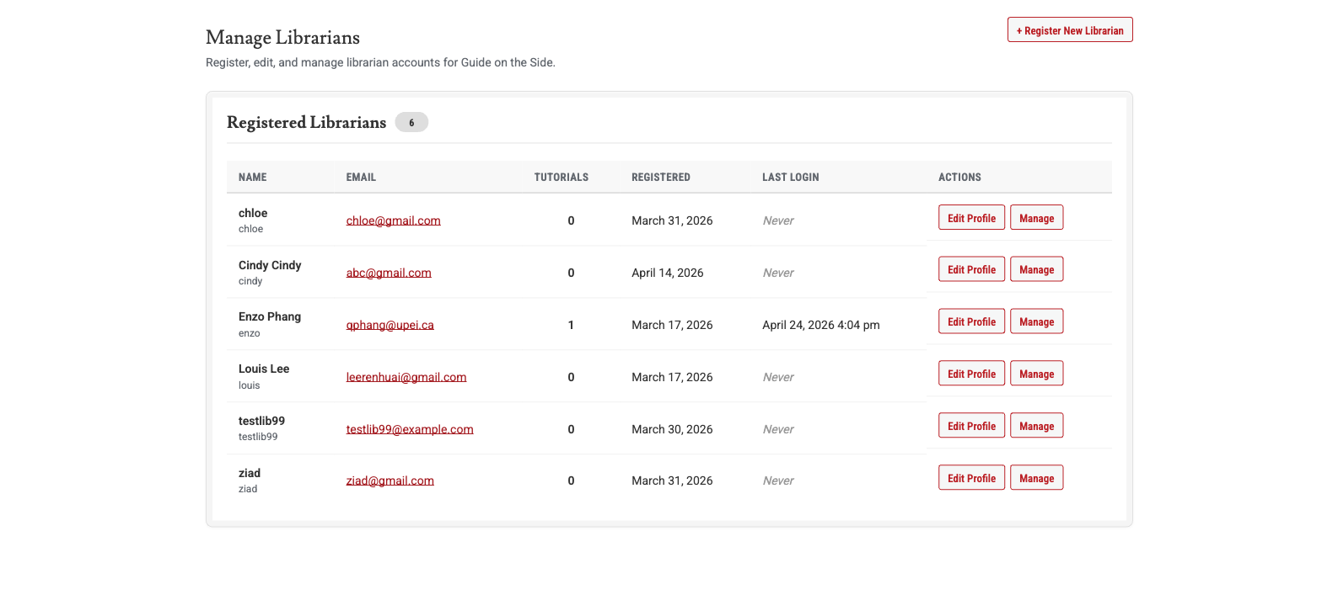
Figure 2: Manage Librarians — Registered librarian accounts with Edit Profile and Manage actions

Creating a Librarian
- Go to Manage Librarians
- Fill in the registration form: username, email, first name, last name
- Click Register Librarian
- The new librarian receives a welcome email with login instructions

What Librarians Can Do
The pbsg_librarian role is designed for content creators who build tutorials. They have access to:
Can Do | Cannot Do
Create, edit, and publish tutorials | Install or manage H5P libraries
Use H5P quiz content (Multiple Choice, Fill-in-the-Blank) | Access Plugins, Settings, or Appearance
View analytics and export CSV | Manage other WordPress users
Upload media (images, PDFs) | See other WP admin areas (Posts, Comments, Tools)
Edit their own profile | Delete or publish other librarians’ tutorials (when cross-editing is on)
When they log in, librarians are taken directly to My Tutorials instead of the WordPress dashboard. Their admin sidebar only shows relevant menu items.

Deactivating a Librarian
- Go to Manage Librarians
- Find the librarian and click Deactivate
- You’ll be prompted to reassign their tutorials to another librarian
- The account is disabled but not deleted — it can be reactivated later

Reactivating a Librarian
- Go to Manage Librarians
- Find the deactivated librarian and click Reactivate
- Their pbsg_librarian role is restored and they can log in again

Analytics Dashboard
Location: Tutorial Analytics (visible to librarians and admins — requires pbsg_view_analytics capability)
The dashboard shows aggregate tutorial performance data. All analytics are privacy-first: no individual student is ever identified, no cookies are stored, and no login is required from students. This complies with PIPEDA privacy requirements.
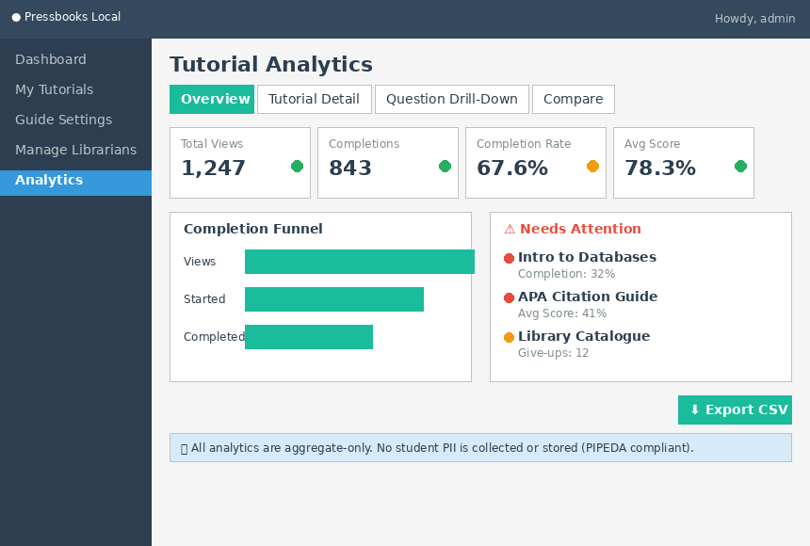
Figure 3: Tutorial Analytics — Overview tab with KPI cards, Views & Completions chart, and Needs Attention alerts

Tabs
Overview — High-level KPIs across all tutorials: total views, completions, and completion rate; aggregate metrics with benchmark badges (red/amber/green).
Tutorial Detail — Deep dive into a single tutorial: funnel analysis (views → completions), average dwell time per step, question-level statistics.
Question Drill-Down — Per-question analysis: attempt distribution, first-attempt success rate, give-up and retry counts.
Compare Tutorials — Side-by-side metrics for multiple tutorials.

Filtering
- Date range: Filter data by start and end date
- Device type: Filter by desktop, tablet, or mobile

CSV Export
Click Export CSV on any tab to download the current view’s data as a spreadsheet. Useful for reporting or offline analysis.

Privacy Notes
- Analytics track aggregate events only (e.g., “Tutorial X was viewed 50 times”), never “Student Y viewed Tutorial X”
- Rate limiting prevents abuse: 60 events per minute per visitor
- No cookies, session IDs, or personally identifiable information is stored
- IP addresses are hashed for rate limiting only and never stored in the database

H5P Quiz Content
The plugin uses H5P for interactive quizzes embedded in tutorials. H5P is a separate WordPress plugin that provides the quiz engine; pb-split-guide integrates with it for creating quizzes and tracking results.

Supported Quiz Types
Type | Description
Multiple Choice | Single-select or multi-select questions with feedback
Fill-in-the-Blank | Text input questions where students type the answer

Admin Responsibilities
As an admin, you manage H5P at the network level:
- Install H5P content types: Go to H5P Content → Libraries to install or update the Multiple Choice and Fill-in-the-Blank content types. This only needs to be done once — all librarians across the network can then use them.
- Librarians create quiz content: Librarians can create and edit H5P quiz items through the tutorial editor. They do not need access to H5P library management.

How It Works
When a librarian adds a quiz to a tutorial step, the plugin:
- Creates H5P content via the H5P API
- Embeds it in the tutorial’s left pane via iframe
- Listens for xAPI events (quiz completion, correct/incorrect answers)
- Records aggregate results in the analytics tables
Students interact with quizzes directly — no login required. Their answers are ephemeral (not saved per-student), and only aggregate statistics are recorded.

Export & Import Tutorials
Tutorials can be exported as portable packages and imported on other Pressbooks servers. This is useful for sharing tutorials between institutions (e.g., UPEI → Dalhousie).
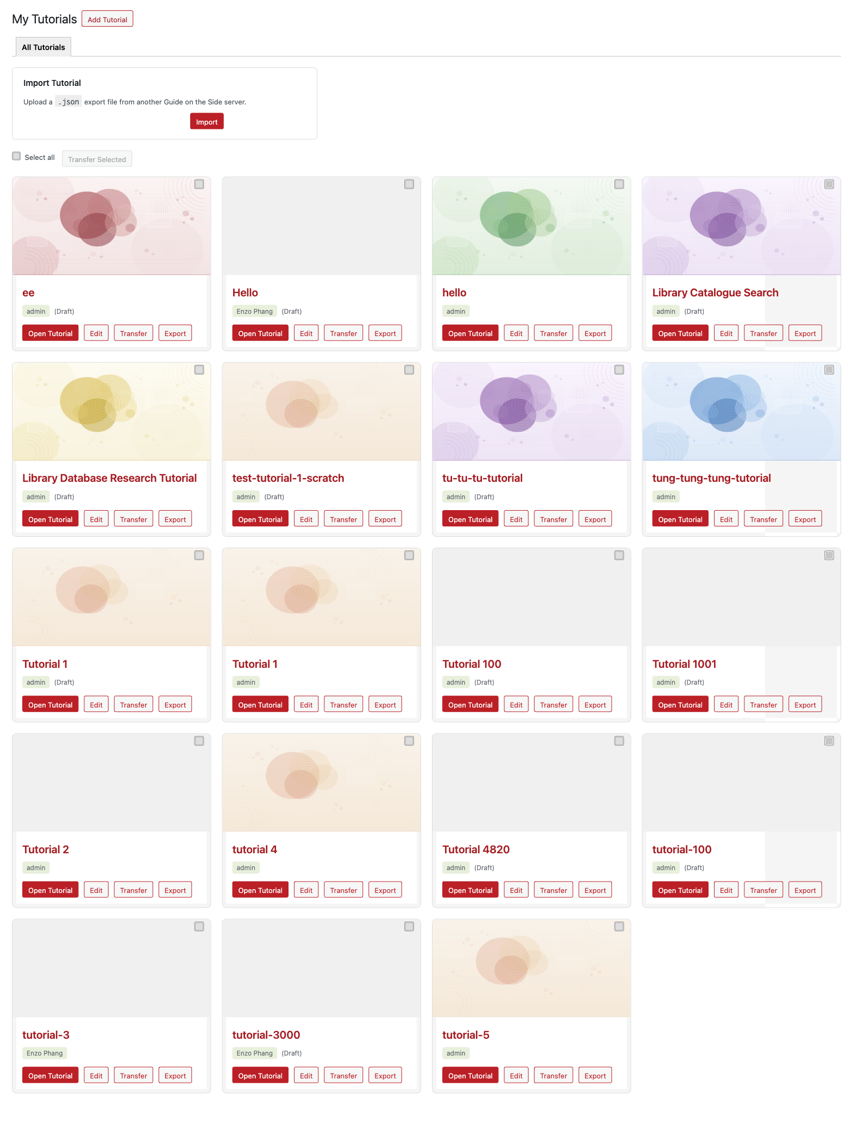
Figure 4: My Tutorials — Tutorial cards with Open, Edit, Transfer, and Export actions; Import Tutorial panel at top

Exporting a Tutorial
- Go to My Tutorials
- Find the tutorial you want to export
- Click Export
- A .json file is downloaded (named {tutorial-title}-guide-on-the-side.json)
The export package includes:
- Tutorial title and content
- All steps (text, embed URLs, H5P references)
- Header note and intro fields
- Attached media (images, PDFs) encoded as base64 within the package

Importing a Tutorial
- Go to My Tutorials
- Click Import Tutorial
- Upload the .json file
- A new tutorial is created with all the original content and media
Note: H5P quiz content references are included in the export, but the target server must have the same H5P content types installed (Multiple Choice, Fill-in-the-Blank) for quizzes to work after import.

Upload File Size Limits
File uploads (PDFs, images, audio, video) are governed by a chain of limits. The effective maximum is the smallest of these three values:
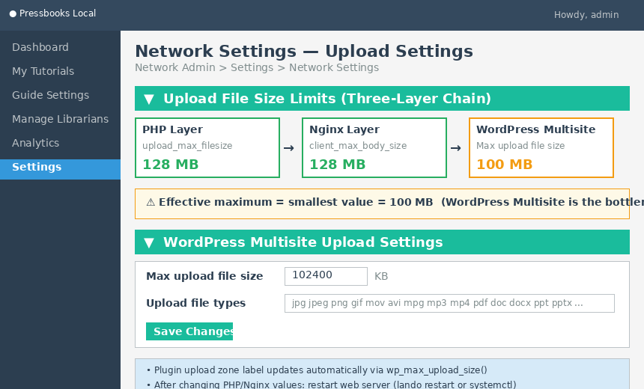
Figure 5: Upload File Size Limits — Three-layer chain (PHP, Nginx, WordPress Multisite) and Network Settings configuration
Layer | Setting | Default | Where to Change
PHP | upload_max_filesize | 128M | config_services/php.ini (local) or /etc/php/php.ini (production)
Nginx | client_max_body_size | 128M | config_services/nginx.conf line 27 (local) or /etc/nginx/nginx.conf (production)
WordPress Multisite | Max upload file size | 100 MB (102400 KB) | Network Admin > Settings > Upload Settings
The WordPress Multisite setting is typically the bottleneck. To change it:
- Log in as a Network Admin (Super Admin)
- Go to Settings > Network Settings
- Scroll to Upload Settings
- Change Max upload file size from 102400 to the desired value in KB (e.g., 131072 for 128 MB)
- Click Save Changes
The plugin’s upload zone label (“Max file size: X MB”) updates automatically — it reads wp_max_upload_size() which returns the effective minimum of all three layers.
Important: After changing PHP or Nginx values, restart the web server (lando restart locally, or sudo systemctl restart php-fpm nginx on production). WordPress Multisite changes take effect immediately.

Allowed File Types
The allowed file types for upload are also controlled in Network Settings under Upload file types. The default list includes common formats: jpg jpeg png gif mov avi mpg mp3 mp4 pdf doc docx ppt pptx xls xlsx wav webm ogv flv.
To add new file types (e.g., .svg), append them to the space-separated list in the same Network Settings panel.

Accessibility Features
The plugin includes accessibility enhancements for the admin interface, following WCAG 2.1 AA standards.

Admin Color Schemes
Two custom color schemes are available in each user’s profile:
- UPEI Library — Matches the UPEI Library brand colors (greens, greys, dark reds)
- Colorblind-Friendly — High-contrast variant designed for users with color vision deficiency
To change: Go to Profile → select a color scheme under Admin Color Scheme.

Fonts
The plugin uses the following fonts across admin interfaces:
Font | Used For
Lusitana | Headings
Roboto | Body text
Roboto Condensed | Buttons and labels
These fonts are bundled with the plugin to avoid external CDN dependencies. If fonts don’t load, the browser falls back to system fonts.

Keyboard Shortcuts
Users can configure custom keyboard shortcuts in their profile settings for common actions.

Contrast Compliance
All admin interface elements meet WCAG 2.1 AA contrast requirements:
- 4.5:1 minimum contrast ratio for normal text
- 3:1 minimum for large text
- 44 × 44px minimum touch/click target size

