Guide on the Side
Project Plan

UPEI Robertson Library
Interactive Tutorial System

Version | 1.0
Date | April 2026
Audience | Students and Staff
Status | Final
Date | April 2026
Team | 8
Members | Yang Guo  Qi Xiang Phang  Xiaohan Yu  Daniel McGrath  Caleb Jones  Tanguy Merrien

Vision Statement 8
Statement of Scope 9
System Scope – Technical Description 10
Project Community 11
Key Technical & Operational Requirements 12
• Key Technical Requirements 12
• Key Operational Requirements 12
System Acceptance Tests 13
Use Cases 14
Use Case Name: Create Interactive Tutorial 14
Use Case Name: Create Interactive Tutorial Template 16
Use Case Name: Edit/Update Tutorial 18
Use Case Name: Student Completes Tutorial 21
Use Case Name: Create Branching Tutorial Linked to Other Tutorial 23
Use Case Name: Generate Certificate Upon Successful Completion of Tutorial 25
Use Case Name: Manage Access and Permissions 26
Use Case Name: Analytics Dashboard 27
Use Case Name: Recover Lost Password 29
Use Case Diagram 30
Feature List 31
1. Core Tutorial System 31
1.1 Split-Screen Layout Implementation 31
1.2 Tutorial Storage & Database Schema 31
1.3 Page Template Registration 31
1.4 Tutorial Navigation System 31
1.5 Progress Indicator 32
2. Embedded Content Management 32
2.1 Multi-Source Embedding System 32
2.2 Iframe Error Handling & Fallback 32
2.3 Content Scaling & Aspect Ratio Handling 32
3. Quiz & Assessment System 33
3.1 H5P Quiz Integration 33
3.2 Instant Feedback Display System 33
3.3 Quiz Validation & Answer Evaluation 33
3.4 Question State Management 33
3.5 Retry Mechanism & Attempt Tracking 34
4. Layout & Responsiveness 34
4.1 Adjustable Split Panel Ratio 34
4.2 User-Adjustable Layout 34
4.3 Responsive Multi-Device Support 34
5. Certificate & Completion System 35
5.1 Certificate PDF Generation 35
5.2 Certificate Storage System 35
5.3 Completion Summary & End Screen 35
6. Tutorial Authoring Interface 35
6.1 Tutorial Creation Admin Panel 35
6.2 Tutorial Attributes & Configuration 36
6.3 Tutorial Overview & Management Dashboard 36
6.4 Tutorial Step/Slide Editor 36
6.5 Right Panel Embedded Content Configuration 36
6.6 H5P Quiz Linking & Creation 37
6.7 Tutorial Preview Mode 37
6.8 Tutorial Publishing Workflow 37
7. Template System 37
7.1 Template Application 37
7.2 Save Tutorial as Template 38
8. User Roles & Access Control 38
8.1 Role-Based Access Control 38
8.2 Tutorial Ownership & Edit Access 38
8.3 Librarian Account Deactivation 38
9. Analytics System 39
9.1 Anonymous Usage Tracking 39
9.2 Quiz Performance Analytics 39
9.3 Analytics Dashboard 39
9.4 Comparative Analytics 39
10. Branching & Conditional Tutorials 40
10.1 Branching Question Configuration 40
10.2 Branching Logic System 40
10.3 Branching UI & Pop-Up Display 40
10.4 Branching State Management 40
11. Tutorial Reuse & Portability 41
11.1 Tutorial Import/Export System 41
11.2 Cross-Server Tutorial Sharing 41
12. Accessibility & Compliance 41
12.1 Keyboard Navigation Implementation 41
12.2 Focus Management & Visible Indicators 41
12.3 Screen Reader Compatibility 42
12.4 Color Contrast Compliance 42
12.5 Custom Accessibility Settings & Dashboard 42
13. CI/CD & Testing Infrastructure 42
13.1 Testing Framework Setup 42
13.2 Automated Testing & CI/CD Pipeline 43
13.3 Test Suite for Core Functionality 43
RMMM Plan (Risk Mitigation, Monitoring, and Management) 44
Dependency Chart (Task Network) 48
Activity Diagrams 67
State Diagram 76
Sequence Diagrams 77
Project Testing Log - UPEI Guide-on-the-Side 86
Log Entry: 001 87
1. Component Information 87
2. Black-Box Tests Performed 88
3. Verification Evidence 88
Log Entry: 002 88
1. Component Information 88
2. Black-Box Tests Performed 89
3. Verification Evidence 89
Log Entry: 003 89
1. Component Information 89
2. Black-Box Tests Performed 90
3. Verification Evidence 90
Log Entry: 004 90
1. Component Information 90
2. Black-Box Tests Performed 91
3. Verification Evidence 92
Log Entry: 005 92
1. Component Information 92
2. Black-Box Tests Performed 93
3. Verification Evidence 94
Log Entry: 006 95
1. Component Information 95
2. Black-Box Tests Performed 96
3. Verification Evidence 97
Log Entry: 007 97
1. Component Information 97
2. Black-Box Tests Performed 98
3. Verification Evidence 99
Log Entry: 008 99
1. Component Information 99
2. Black-Box Tests Performed 100
3. Verification Evidence 101
Log Entry: 009 101
1. Component Information 101
2. Failures Diagnosed and Fixed 102
A. PBSGH5PAjaxTest — RBAC permission gate (3 failures) 102
B. PBSplitGuidePluginSmokeTest — Hook count mismatch (1 failure) 103
C. PBSplitGuidePluginSmokeTest — Missing WP function stubs (1 failure) 103
3. Verification Evidence 104
Log Entry: 010 104
1. Component Information 104
2. Black-Box Tests Performed 105
3. Verification Evidence 107
Log Entry: 011 107
1. Component Information 107
2. Black-Box Tests Performed 108
3. Verification Evidence 111
Log Entry: 012 111
1. Component Information 111
2. Black-Box Tests Performed 113
3. Verification Evidence 113
Log Entry: 013 114
1. Component Information 114
2. Black-Box Tests Performed 115
3. Verification Evidence 115
Log Entry: 014 116
1. Component Information 116
2. Black-Box Tests Performed 117
3. Verification Evidence 119
Log Entry: 015 119
1. Component Information 119
2. Black-Box / Unit Tests Performed 120
3. Verification Evidence 120
Log Entry: 016 121
1. Component Information 121
2. Black-Box / Unit Tests Performed 121
H5P Usage Map (6 tests) 122
H5P Ownership Endpoints (6 tests) 122
Enriched H5P List (1 new test) 123
CSV Export Fix (1 test updated) 123
3. Verification Evidence 123
Log Entry: 017 124
1. Component Information 124
2. Unit Tests Performed 125
Branch H5P Conversion Helpers (6 tests) 125
Bug Fix Verification 126
3. Verification Evidence 126
Log Entry: 018 126
1. Component Information 126
2. Bug Fix — Network Admin Menu Visibility 127
3. Verification Evidence 128

Vision Statement
The goal of this project is to create interactive tutorials that help students learn how to use library databases through direct, visual operation, and hands-on experience. This will be achieved by developing a web-based system that allows instructional content and self-paced questions to be presented on one side of the screen, while a live, interactive library database, catalogue, or instructional media is displayed on the other side. Because visual and hands-on experiences help students gain a deeper understanding and strengthen their memory, the system allows students to try real searches and actions while following guided instructions, thus supporting an active learning approach that emphasizes practical and interpretive input.

This system will enable librarians and tutors to create any number of interactive tutorials they need, without requiring technical expertise because of the WYSIWYG design. Tutorials will ensure a consistent “look and feel” through reusable design templates, while still allowing for flexible page-by-page customization. Developed within a Pressbooks or Drupal 10-supported environment, this system does not rely on expensive commercial products and ensures long-term maintainability. Through this system, UPEI Libraries aims to deliver a consistent, engaging, and easy-to-use teaching experience that builds students' confidence and independence in using academic research tools.

Statement of Scope
The system is a web-based application. It is designed to support the creation and delivery of interactive tutorials that guide students through live research tools. The system allows librarians to define tutorials composed of a series of pages, where each page presents instructional text and optional self-paced questions, as well as an embedded, interactive resource, such as library catalogue, one-search database, or instructional media. The system presents these elements in a side-by-side layout to enable users to follow instructions while directly interacting with the referenced resource.
There is no limit to the number of pages in a tutorial, but each tutorial must contain at least two pages. Each page may contain formatted text, embedded web page content, videos, or other supported media. Embedded content is displayed in the tutorial interface and scales according to the available display area. Question elements may be included to prompt user reflection or reinforce understanding; however, user responses are only processed in the current session and are not stored for grading or long-term assessment purposes.
The system provides a task-relevant, WYSIWYG editing interface, allowing librarians and tutors to create, modify, and publish tutorials without requiring advanced technical skills. Librarians can apply predefined visual templates to ensure a consistent look and style of all tutorials and can override template settings page by page. Administrators can update tutorial content and manage instructional materials as library resources update, without relying on external commercial services.
The scope of this project includes the tutorial creation interface, the student viewing interface, and the back-end services required for storing, retrieving, and rendering tutorial content within the content management system. Optional extensions to the system may include generating completion reports and conditional branching tutorials based on user interaction. Functionality related to formal assessment, grading, or long-term tracking of student performance is excluded from this project's scope.

System Scope – Technical Description
The Guide-on-the-Side Interactive Tutorial Builder is a web-based system that will allow librarians to design, publish, and manage interactive tutorials within the UPEI Library’s digital environment. The system is implemented as a plugin for use withing the Pressbooks environment, leveraging existing content management, user authentication, and theming capabilities.
Within the system, librarians act as content creators. They can design, organize, and publish interactive tutorials using a built-in WYSIWYG editor. Each tutorial consists of multiple slides containing text, images, quiz questions, and embedded web content. Librarians can save drafts, apply layout templates, and publish tutorials for student access.
Students are the primary learners who interact with these tutorials through a split-screen interface. The left panel displays the librarian’s instructions and quiz questions, while the right panel loads live resources such as library databases, catalogues, or instructional videos. Students follow the guided steps, complete quizzes, and receive immediate feedback without logging in or sharing personal data. This design promotes self-paced learning while maintaining full user anonymity.
Administrators manage librarian accounts, permissions, and overall system access. UPEI IT Services or the UPEI Library will oversee hosting and ensure system reliability and security. The system also connects to external web resources—including academic databases and other educational sites—through iframe embedding or new-window links, depending on each site’s embedding policy.
The boundaries of the system are limited to the creation, delivery, and interaction of tutorials, with general success/completion analytics being logged. It will not include advanced analytics, user tracking, or third-party authentication. Inputs to the system include librarian-authored tutorial content and student interactions within the tutorials. Outputs consist of accessible, web-based tutorials integrated with live library resources and accessible through the UPEI Library website or course pages.

Project Community
UPEI Library (Client / Stakeholders)
The client for this project is the UPEI Library. The primary stakeholders provide project vision, requirements, and feedback.

Librarians/Tutors (End Users)
Librarians validate that the system supports instructional goals, usability, and real library workflows.

Students (End Users)
The system's users. Their needs validate the system's usability and whether it meets their requirements, ensuring the tool supports intuitive, self-guided learning.

Team Members
The project planning team consisted of the six students completing CS-4810:
Caleb Jones
Daniel McGrath
Qi Xiang Phang
Tanguy Merrien
Xiaohan Yu
Yang Guo
This team is responsible for requirements analysis, system design, and the creation of the project plan, including the vision, scope, use cases, feature lists, and risk analysis.
The development team consists of five students continuing into CS-4820, which means the team will be losing Tanguy Merrien. Early in the project, the development team nominated key leadership roles, including a Project Lead (Caleb Jones) and a Technical Lead (Daniel McGrath), to coordinate development activities and oversee technical decision-making.

Additionally, the development team will also be under the guidance of Dr. David LeBlanc, who will serve in an advisory role throughout the project. Regular meetings and progress reviews will be conducted to ensure that the project remains aligned with academic expectations for project management and stakeholder requirements.

Key Technical & Operational Requirements

Key Technical Requirements
This project will be developed as a web-based system using Pressbooks. Development will require knowledge of PHP for backend customization, as well as JavaScript, HTML, and CSS for user interface construction. Source code will be managed through GitHub, providing version control and supporting collaborative development. The system must support iframe embedding to display live web resources such as databases, catalogues, and videos. When embedding is restricted, an “Open in New Window” option will serve as a fallback. The interface will use responsive web design to ensure accessibility on desktops and tablets, with optional mobile support for later development. All tutorial content must comply with WCAG 2.1 AA accessibility standards, including appropriate color contrast, keyboard navigation, and screen-reader compatibility.

Key Operational Requirements
The project will be hosted and maintained by UPEI IT Services or the UPEI Library after deployment to ensure long-term stability and integration within the university’s infrastructure. The production environment will run securely over HTTPS with a valid SSL certificate, configured and managed through the library rather than the development team. This arrangement ensures that system security, performance monitoring, and server maintenance remain consistent with UPEI’s institutional standards. The hosting environment will be equipped to support multiple librarians creating and publishing tutorials simultaneously, while also accommodating large numbers of students accessing tutorials at the same time. Regular system backups and updates will be handled according to UPEI IT policies to minimize downtime and prevent data loss.
The system will allow anonymous usage, meaning students will not need to log in or provide any personal data. No user-specific analytics or activity tracking will be performed to comply with the client’s privacy expectations. Instead, the system will provide general completion analytics, enabling comparison between individual tutorials. The project will be distributed under the MIT open-source license, allowing other academic institutions to freely adapt and extend it. The application must also remain compatible with major browsers such as Chrome, Firefox, Safari, and Edge to ensure consistent functionality across different devices and operating systems.

System Acceptance Tests
- The system allows librarians and tutors to create interactive tutorials that display instructional text and questions on the left side of the interface and a live, interactive library resource on the right side.

- The system provides a task-relevant WYSIWYG editing interface, enabling librarians to create and modify tutorials without requiring advanced technical skills.

- The system supports the creation of multiple tutorials, with no fixed limit on the number of pages or tutorials that can be created.

- The system supports reusable visual templates that provide a consistent look and feel across tutorials, with the option for librarians to override styling on a page-by-page basis.

- The system provides a preview function that allows librarians to view tutorials exactly as students will see them before publishing.

- The system allows tutorials to embed live library resources, including the library catalogue, One-search database, external websites, and instructional media.

- The system presents tutorials to students through a web-based interface, allowing students to interact with embedded resources while following instructions.

- The system includes a quiz question feature that provides immediate feedback to students during the tutorial experience.

- The system treats quizzes as self-paced learning interactions and does not record or store student responses for grading or assessment.

- The system operates using an open-source licensing model that permits future modification and extension by the institution.

- The development team provides deployment documentation sufficient for the client to install, configure, and maintain the system.

Use Cases

Use Case Name: Create Interactive Tutorial
Summary: An instructor or librarian creates a new guided tutorial with slides, embedded content, and optional quiz elements.
Actors:
- Librarian (content creator, authenticated)
- Guide-on-the-Side System (authoring UI + runtime)
- CMS / Hosting Platform (Pressbooks instance hosting the tutorial)
- Embedded Content Providers (library catalog, Newsbank, other web resources)
- Admin (organization role for managing librarian accounts and high-level configuration)
Triggers:
- The librarian elects to create a new tutorial or edit an existing tutorial using the Guide-on-the-Side authoring interface.
Preconditions:
- The librarian has valid credentials and appropriate authoring permissions (managed by Admin).
- Hosting platform and required modules for embedded content and authoring are available and configured (Pressbooks modules or confirmed third-party modules approved).
- The librarian has content resources (text, images, embedded URLs/iframe snippets) and quiz content (questions, answer keys, remediation text).
- The administrator/maintenance contacts are available if access or service issues arise.
Post-conditions:
- A tutorial draft is saved in the authoring system and can be previewed.
- The tutorial is published to the hosting platform (if the librarian chooses to publish).
- Embedded right-side content is linked/embedded and previewable (subject to external provider policies).
- Quizzes are configured for self‑paced use with local validation; branching is optional and saved in tutorial configuration.
Normal Flow:
- The librarian authenticates to the Guide-on-the-Side authoring interface.
- The librarian selects “Add Tutorial” (or opens an existing tutorial to edit).
- The system presents a structured authoring UI with slide list (no limit on slide count), left-pane content editor (WYSIWYG/markdown), and configuration options for the right pane (embed URL, iframe, object).
- The librarian creates slide content on the left: instructional text, images, and quiz items. For quiz items, the librarian selects question type (MCQ, checkbox, multiple, short answer) and provides validation rules, correct answers, and remediation text.
- The librarian configures the right pane for each slide by entering an embed URL, selecting an embedded library resource (catalog, Newsbank), or pasting embed code. The system validates the embed format and checks for CORS/embedding policies.
- The librarian optionally configures branching logic for quiz outcomes (simple branch to remediation slide or alternate path).
- The librarian previews the tutorial in the authoring UI (desktop and tablet viewport presets) to ensure left/right panes render correctly and quizzes behave as expected.
- The librarian saves the tutorial as a draft.
- If ready, the librarian selects “Publish” and the system attempts to deploy the tutorial to the configured CMS/hosting platform (Pressbooks).
- The CMS confirms deployment and returns a published URL.
- The system records the published state and presents the librarian with the shareable link and basic analytics (session counts only if enabled; by default no personal user tracking).
- The librarian exits the authoring interface.
Alternate Flows:
2A1: Librarian lacks permission to create or publish tutorials (policy/enforced role).
- The system notifies the librarian of insufficient permissions and offers to request elevated permissions or route the publish to an approver.
- If a request is made, Admin receives the request; upon approval, the use case resumes at step 10. If denied, the use case ends.
5A1: Embed validation fails (unsupported embed type, blocked by provider, or CORS/iframe restrictions).
- The system displays a diagnostic explaining the failure and suggests remedies: use a different embed method, request provider to allow embedding, or provide a direct link as fallback.
- The librarian may replace the embed or mark the slide to use fallback content.
- The use case returns to step 6.
6A1: Branching configuration is invalid or too complex (beyond branching limits).
- The system validates branching and warns when complexity exceeds supported patterns (encourage simple branching only).
- The librarian reduces complexity as suggested.
- The use case continues at step 8.
9A1: Librarian cancels before saving (decides not to keep changes).
- The system prompts to save a draft or discard changes.
- On discard, the system restores prior saved version (if any) and the use case ends.
10A1: Publishing fails due to missing CMS module or hosting error (third-party module not installed or not approved).
- The system displays the error and identifies the missing module or hosting issue.
- The librarian may: a) save the tutorial as draft and notify Admin/hosting contact; b) remove the affected embed and attempt to publish again; or c) request Admin to install/approve the module.
- If Admin installs the module and the librarian republishes, the use case resumes at step 11. Otherwise, it ends as a draft.

Use Case Name: Create Interactive Tutorial Template
Summary: An author designs a reusable template with predefined slide structures, components, and styling for future tutorials.
Actors:
- Librarian (content creator, authenticated)
- Guide-on-the-Side System (authoring UI + runtime)
- CMS / Hosting Platform (Pressbooks instance hosting the tutorial)
- Embedded Content Providers (library catalog, Newsbank, other web resources)
- Admin (organization role for managing librarian accounts and high-level configuration)
Triggers:
- The librarian elects to create a new tutorial template or edit an existing tutorial template using the Guide-on-the-Side authoring interface.
Preconditions:
- The librarian has valid credentials and appropriate authoring permissions (managed by Admin).
- Hosting platform and required modules for embedded content and authoring are available and configured (Pressbooks/Drupal modules or confirmed third-party modules approved).
- The librarian has content resources (text, images, embedded URLs/iframe snippets) and quiz content (questions, answer keys, remediation text).
- The administrator/maintenance contacts are available if access or service issues arise.
Post-conditions:
- A tutorial template is saved in the authoring system and can be previewed.
- The template is published to the hosting platform (if the librarian chooses to publish).
- Embedded right-side content is linked/embedded and previewable (subject to external provider policies).
- Template is available for authors to instantiate new tutorials.
- Quizzes are configured for self‑paced use with local validation; branching is optional and saved in tutorial configuration.
- Changes to the template do not retroactively alter published tutorials unless explicitly applied.
Normal Flow:
- The librarian authenticates to the Guide-on-the-Side authoring interface.
- The librarian selects “Add Tutorial” (or opens an existing template to edit).
- The system presents a structured authoring UI with slide list (no limit on slide count), left-pane content editor (WYSIWYG/markdown), and configuration options for the right pane (embed URL, iframe, object).
- The librarian creates slide content on the left: instructional text, images, and quiz items. For quiz items, the librarian selects question type (MCQ, checkbox, multiple, short answer) and provides validation rules, correct answers, and remediation text.
- The librarian configures the right pane for each slide by entering an embed URL, selecting an embedded library resource (catalog, Newsbank), or pasting embed code. The system validates the embed format and checks for CORS/embedding policies.
- The librarian optionally configures branching logic for quiz outcomes (simple branch to remediation slide or alternate path).
- The librarian previews the tutorial in the authoring UI (desktop and tablet viewport presets) to ensure left/right panes render correctly and quizzes behave as expected.
- The librarian saves the tutorial as a template.
- The librarian exits the authoring interface.
Alternate Flows:
2A1: Librarian lacks permission to create tutorial templates (policy/enforced role).
- The system notifies the librarian of insufficient permissions and offers to request elevated permissions or route the publish to an approver.
- If a request is made, Admin receives the request; upon approval, the use case resumes at step 10. If denied, the use case ends.
5A1: Embed validation fails (unsupported embed type, blocked by provider, or CORS/iframe restrictions).
- The system displays a diagnostic explaining the failure and suggests remedies: use a different embed method, request provider to allow embedding, or provide a direct link as fallback.
- The librarian may replace the embed or mark the slide to use fallback content.
- The use case returns to step 6.
6A1: Branching configuration is invalid or too complex (beyond branching limits).
- The system validates branching and warns when complexity exceeds supported patterns (encourage simple branching only).
- The librarian reduces complexity as suggested.
- The use case continues at step 8.
9A1: Librarian cancels before saving (decides not to keep changes).
- The system prompts to save a draft or discard changes.
- On discard, the system restores prior saved version (if any) and the use case ends.

Use Case Name: Edit/Update Tutorial
Summary: An author updates content, slides, media, or settings of an existing tutorial with draft/publish workflow and versioning.
Actors:
- Librarian (content creator, authenticated)
- Guide-on-the-Side System (authoring UI + runtime)
- CMS / Hosting Platform (Pressbooks instance hosting the tutorial)
- Embedded Content Providers (library catalog, Newsbank, other web resources)
- Admin (organization role for managing librarian accounts and high-level configuration)
Triggers:
- The author selects an existing tutorial or template and clicks “Edit.”
Preconditions:
- The librarian has valid credentials and appropriate authoring permissions (managed by Admin).
- At least one tutorial exists in the system and is accessible
- Hosting platform and required modules for embedded content and authoring are available and configured (Pressbooks/Drupal modules or confirmed third-party modules approved).
- The librarian has content resources (text, images, embedded URLs/iframe snippets) and quiz content (questions, answer keys, remediation text).
- The administrator/maintenance contacts are available if access or service issues arise.
Post-conditions:
- A tutorial or tutorial template is saved in the authoring system and can be previewed.
- The tutorial/template is published to the hosting platform (if the librarian chooses to publish).
- Embedded right-side content is linked/embedded and previewable (subject to external provider policies).
- System maintains logs of modifications (librarian ID/name, timestamp, changes made)
- Updated tutorial or template is available for authors to instantiate new tutorials.
- Quizzes are configured for self‑paced use with local validation; branching is optional and saved in tutorial configuration.
Normal Flow:
- The librarian authenticates to the Guide-on-the-Side authoring interface.
- The librarian selects edit on an existing tutorial or tutorial template.
- The system presents a structured authoring UI with slide list (no limit on slide count), left-pane content editor (WYSIWYG/markdown), and configuration options for the right pane (embed URL, iframe, object).
- The librarian creates new or changes existing slide content on the left: instructional text, images, and quiz items. For quiz items, the librarian selects question type (MCQ, checkbox, multiple, short answer) and provides validation rules, correct answers, and remediation text.
- The librarian configures the right pane for each slide by entering or updating an embed URL, selecting an embedded library resource (catalog, Newsbank), or pasting embed code. The system validates the embed format and checks for CORS/embedding policies.
- The librarian optionally alters or configures branching logic for quiz outcomes (simple branch to remediation slide or alternate path).
- The librarian previews the tutorial in the authoring UI (desktop and tablet viewport presets) to ensure left/right panes render correctly and quizzes behave as expected.
- The librarian saves any changes made to the tutorial or template.
- If updating a visible tutorial, the librarian selects “Publish” and the system attempts to deploy the tutorial to the configured CMS/hosting platform (Pressbooks).
- The CMS confirms deployment and returns a published URL.
- The system records the published state and presents the librarian with the shareable link and basic analytics (session counts only if enabled; by default no personal user tracking).
- The librarian exits the authoring interface.
Alternate Flows:
2A1: Librarian lacks permission to edit tutorial/templates (policy/enforced role).
- The system notifies the librarian of insufficient permissions and offers to request elevated permissions or route the publish to an approver.
- If a request is made, Admin receives the request; upon approval, the use case resumes at step 10. If denied, the use case ends.
2A2: Another librarian is currently editing the same tutorial (concurrent edit disabled).
- The system displays the tutorial in the list with an indicator showing it is locked for editing (e.g. lock icon, “Currently being edited by [Librarian’s name]” message when hovering around the button)
- The “Edit Tutorial” button is disable/not clickable for this tutorial
- The librarian may refresh the website to check if the tutorial becomes available
- The use case returns to step 2.
5A1: Embed validation fails (unsupported embed type, blocked by provider, or CORS/iframe restrictions).
- The system displays a diagnostic explaining the failure and suggests remedies: use a different embed method, request provider to allow embedding, or provide a direct link as fallback.
- The librarian may replace the embed or mark the slide to use fallback content.
- The use case returns to step 6.
6A1: Branching configuration is invalid or too complex (beyond branching limits).
- The system validates branching and warns when complexity exceeds supported patterns (encourage simple branching only).
- The librarian reduces complexity as suggested.
- The use case continues at step 8.
9A1: Librarian cancels changes before saving.
- The system prompts to save a draft or discard changes.
- On discard, the system restores prior saved version (if any) and the use case ends.
9A2: Validation error prevents saving (missing required fields, invalid embedded URLs, incomplete quiz configuration).
- The system displays specific error messages with guidance for correction
- The librarian corrects the identified issues
- The use case returns to step 9
10A1: Publishing fails due to missing CMS module or hosting error (third-party module not installed or not approved).
- The system displays the error and identifies the missing module or hosting issue.
- The librarian may: a) save the tutorial as draft and notify Admin/hosting contact; b) remove the affected embed and attempt to publish again; or c) request Admin to install/approve the module.
- If Admin installs the module and the librarian republishes, the use case resumes at step 11. Otherwise, it ends as a draft.

Use Case Name: Student Completes Tutorial
Summary: A student takes a quiz within a tutorial, receives immediate feedback, and may generate a certificate upon completion.
Actors:
- Student (end user, no login required for normal use)
- Guide-on-the-Side System (main system that presents left-side tutorial + quiz and right-side embedded content)
- Embedded Content Provider (external: library catalog, Newsbank, other web resource)
- Optional Certificate Generator (internal component that produces a downloadable PDF when a student enters their name)
Triggers:
- The student opens a tutorial that includes a quiz and indicates they want to begin the quiz or proceed to a quiz slide.
Preconditions:
- The tutorial page (left pane + right embedded content) is reachable by the student (network connection).
- The Guide-on-the-Side System has loaded the tutorial content for the student’s device (desktop, laptop, or tablet minimum).
- Embedded content URL/iframe is configured and allowed by the hosting environment (CORS/embedding policy).
Post-conditions:
- The student receives immediate feedback for quiz items (correct/incorrect and remediation).
- The student may receive a session-only score and completion summary (no external persistent tracking by default).
- If the student provides a name and requests a certificate, a downloadable PDF is produced for the student (stored client-side or provided as a one-time download); no persistent storage of student identity occurs.
- Any local session state (answers in the current browser session) is available until the session ends, or the student exits.
Normal Flow:
- The student navigates to the tutorial URL and the system loads the tutorial: left pane (text/quiz) and right pane (embedded interactive content).
- The student reads the left-pane instruction or slide and interacts with any interactive object on the right pane as needed (search the catalog, play a demo, etc.).
- The student reaches a quiz slide and the system displays the question and allowed response types (MCQ, checkbox/multiple select, short answer).
- The student submits an answer.
- The system validates the answer locally (client-side) using the question’s configured validation rules.
- The system presents immediate feedback: confirmation for correct answers; for incorrect answers, a short explanation and one or more remediation slides or hints.
- If branching is configured and the answer warrants it, the system navigates the student to the appropriate remedial or extension slide(s).
- The student can retry the question (if allowed by the tutorial author) or continue to the next slide.
- When the student finishes the quiz section (or the final slide), the system displays a completion summary with score and feedback for reviewed items.
- If the tutorial offers a downloadable certificate and the student opts in, the system prompts for a name and produces a downloadable PDF certificate.
- The student downloads the certificate (optional) and exits the tutorial.
Alternate Flows:
2A1: Embedded content on the right fails to load (network/CORS/blocking).
- The system displays a clear warning message and fallback content (static screenshot, alternate instructions, or link to the resource).
- The student may continue the tutorial with the fallback content or attempt to reload the embedded content.
- The use case continues at step 3.
4A1: Student abandons the session mid-quiz (closes tab, navigates away).
- By default: session-only answers are not persisted; the student will restart the quiz on next visit.
- The use case ends.
6A1: Student requests further explanation after an incorrect answer (branching remediation).
- The system presents a targeted remediation slide, example, or hint.
- The student revisits the question and may resubmit an answer.
- The use case returns to step 4.
10A1: PDF certificate generation fails (service outage or client-side error).
- The system notifies the student of failure and offers troubleshooting steps (retry, download via alternate link) or suggests the student copy the completion summary for proof.
- The use case may end without issuing a certificate.

Use Case Name: Create Branching Tutorial Linked to Other Tutorial
Summary: An author configures conditional paths so students receive targeted content and remediation based on their actions or quiz answers.
Actors:
- Librarian (content creator, authenticated)
- Guide-on-the-Side System (authoring UI + runtime)
- CMS / Hosting Platform (Pressbooks instance hosting the tutorial)
- Embedded Content Providers (library catalog, Newsbank, other web resources)
- Admin (organization role for managing librarian accounts and high-level configuration)
Triggers:
- The librarian selects branching options while editing a tutorial.
Preconditions:
- Tutorial exists in draft state.
- The librarian has valid credentials and appropriate authoring permissions (managed by Admin).
- Another separate tutorial exists in draft or published state to be linked to.
- Hosting platform and required modules for embedded content and authoring are available and configured (Pressbooks modules or confirmed third-party modules approved).
- The librarian has content resources (text, images, embedded URLs/iframe snippets) and quiz content (questions, answer keys, remediation text).
- The administrator/maintenance contacts are available if access or service issues arise.
Post-conditions:
- A tutorial draft is saved in the authoring system and can be previewed.
- Tutorial contains branching rules mapped to slides and outcomes.
- Preview confirms navigational integrity.
- The tutorial is published to the hosting platform (if the librarian chooses to publish).
Normal Flow:
- The librarian opens the branching editor for the tutorial.
- The librarian defines decision points (quiz results, interactions, choices).
- The librarian maps each decision to target slides, embedded content, or separate tutorials (remediation, advanced content, alternative activity).
- The librarian sets retry and exit conditions (e.g., must pass remediation before proceeding).
- The librarian previews the tutorial in the authoring UI (desktop and tablet viewport presets) to ensure there are no dead ends or loops present within the branches.
- The librarian saves the tutorial as a draft.
- If ready, the librarian selects “Publish” and the system attempts to deploy the tutorial to the configured CMS/hosting platform (Pressbooks).
- The CMS confirms deployment and returns a published URL.
- The system records the published state and presents the librarian with the shareable link and basic analytics (session counts only if enabled; by default no personal user tracking).
- The librarian exits the authoring interface.
Alternate Flows:
1A1: Librarian lacks permission to create or publish tutorials (policy/enforced role).
- The system notifies the librarian of insufficient permissions and offers to request elevated permissions or route the publish to an approver.
- If a request is made, Admin receives the request; upon approval, the use case resumes at step 1 or 8. If denied, the use case ends.
3A1: Branching configuration is invalid or too complex (beyond branching limits).
- The system validates branching and warns when complexity exceeds supported patterns (encourage simple branching only).
- The librarian reduces complexity as suggested.
- The use case continues at step 4.
3A2: Alternative linked tutorial does not exist (has been deleted or is linked improperly).
- The system verifies that the secondary tutorial that is being referenced does not exist in either a draft or published state.
- The librarian links to a different tutorial or creates a new tutorial to link to.
- The use case continues at step 4.
7A1: Librarian cancels before saving (decides not to keep changes).
- The system prompts to save a draft or discard changes.
- On discard, the system restores prior saved version (if any) and the use case ends.
8A1: Publishing fails due to missing CMS module or hosting error (third-party module not installed or not approved).
- The system displays the error and identifies the missing module or hosting issue.
- The librarian may: a) save the tutorial as draft and notify Admin/hosting contact; b) remove the affected embed and attempt to publish again; or c) request Admin to install/approve the module.
- If Admin installs the module and the librarian republishes, the use case resumes at step 9. Otherwise, it ends as a draft.

Use Case Name: Generate Certificate Upon Successful Completion of Tutorial
Summary: A student requests and downloads a completion certificate after finishing a tutorial or quiz section.
Actors:
- Student (end user, no login required for normal use)
- Guide-on-the-Side System (main system that presents left-side tutorial + quiz and right-side embedded content)
- Embedded Content Provider (external: library catalog, Newsbank, other web resource)
- Certificate Generator (internal component that produces a downloadable PDF when a student enters their name)
Triggers:
- Student clicks “Get Certificate” from completion summary or certificate slide.
Preconditions:
- Tutorial offers certificate generation.
- Student has reached completion criteria.
- Certificate generator components are available.
Post-conditions:
- A downloadable PDF certificate is produced.
- No persistent storage of student identity occurs by default.
- Student receives client-side file or one-time download link.
Normal Flow:
- System prompts for name and optional details (if configured).
- Student clicks “Generate Certificate”
- System organizes certificate data (name, tutorial title, date, signature).
- Certificate generator produces a PDF and returns it to the student.
- Student downloads the certificate; system logs event (non-identifying analytics by default).
- Student exits the tutorial.
Alternate Flows:
4A1: Certificate generation fails.
- System offers retry, alternate download link, or text proof with validation.
- Flow ends.

Use Case Name: Manage Access and Permissions
Summary: An admin or instructor configures roles, visibility, and permissions for tutorials, templates, and editing capabilities.
Actors:
- Administrator
- Instructor/Librarian
- Guide-on-the-Side System (role/ACL manager)
Triggers:
- Admin opens the “Access & Permissions” settings.
Preconditions:
- Admin authenticated with sufficient privileges.
- Role/permission model defined (Admin, Author, Reviewer, Viewer).
Post-conditions:
- Permissions updated and enforced across authoring and viewing.
- Visibility settings applied (public, private, restricted).
- System logging captures changes.
Normal Flow:
- Admin selects a tutorial or template and opens permissions.
- Admin assigns roles to users or groups (Author, Reviewer, Viewer).
- Admin sets visibility (public URL, restricted to course/cohort, private).
- Admin configures advanced rights (publish, delete, branch linking).
- Admin saves changes; system updates access control list and propagates to delivery endpoints.
- System logs changes with timestamp and actor.
Alternate Flows:
5A1: Permission conflict detected (e.g., multiple roles).
- System proposes conflict resolution (such as removing conflicting role assignments).
- Admin confirms; flow resumes at step 6.
2A1: User/Group does not exist.
- System allows creation of a new user group for role/visibility management.
- If the actor does not have sufficient permission to create new user groups, they will be instructed to contact an administrator who has the appropriate authoring permission.
- Flow resumes at step 3.

Use Case Name: Analytics Dashboard
Summary: Stakeholders view tutorial usage, engagement, and performance metrics to improve content and measure outcomes.
Actors:
- Administrator
- Instructor/Librarian
- Guide-on-the-Side System (analytics collector/renderer)
Triggers:
- User opens the analytics dashboard for a tutorial or set of tutorials.
Preconditions:
- Tutorials have usage data.
- Analytics components are enabled.
- Data aggregation respects privacy settings (no PII by default).
Post-conditions:
- User views dashboards with metrics (views, completion rate, average quiz score, slide dwell time).
- User can export anonymized reports.
Normal Flow:
- User selects tutorial(s) and opens analytics.
- System loads metrics and visualizations (charts, tables).
- User filters by date range, device type, or cohort (if available).
- User inspects quiz item performance and remediation paths effectiveness.
- User exports anonymized summary (CSV/PDF) or shares dashboard link (role-limited).
- User identifies improvement opportunities based on completion/clickthrough rate and optionally creates follow-up tasks.
Alternate Flows:
2A1: Insufficient data for statistical significance.
- System displays warning message informing the user that they may want to extend date range.
- Flow resumes at step 3.
5A1: Export fails to generate.
- Error message is displayed and the user is informed of alternative export methods or is advised to try again.
- Flow ends.

Use Case Name: Recover Lost Password
Summary: A registered user initiates a password reset flow to regain access to authoring or administrative features.
Actors:
- Registered User (author/admin)
- Guide-on-the-Side System (authentication service)
- Email Service (outbound mail)
Triggers:
- User clicks “Forgot Password” on the login page.
Preconditions:
- User account exists in the system.
- User’s email client is able to receive a reset email.
- Security policies (rate limiting, token expiry) are configured.
Post-conditions:
- A secure, time-limited reset link is sent to the user’s email.
- On successful reset, the user can log in with the new password.
- System logs record the reset event.
Normal Flow:
- User selects “Forgot Password” and enters their email or username.
- System verifies account existence without revealing sensitive information.
- System generates a time-limited reset token and sends a secure link via email.
- User clicks the link, sets a new password meeting any policy requirements.
- System confirms reset and invalidates the token.
- User logs in with the new password.
Alternate Flows:
3A1: Email delivery failure or throttling.
- System notifies user to retry later, adjust settings within their email client, or contact support; rate limits are enforced.
- Flow ends.
4A1: Token expired or already used.
- System denies reset and offers to send a new link.
- Flow resumes at step 3.
4A2: Password does not meet requirements.
- System provides feedback to user, informing them that the provided password does not meet the predetermined requirements.
- User updates their new password to meet any requirements.
- Flow resumes at step 5.

Use Case Diagram
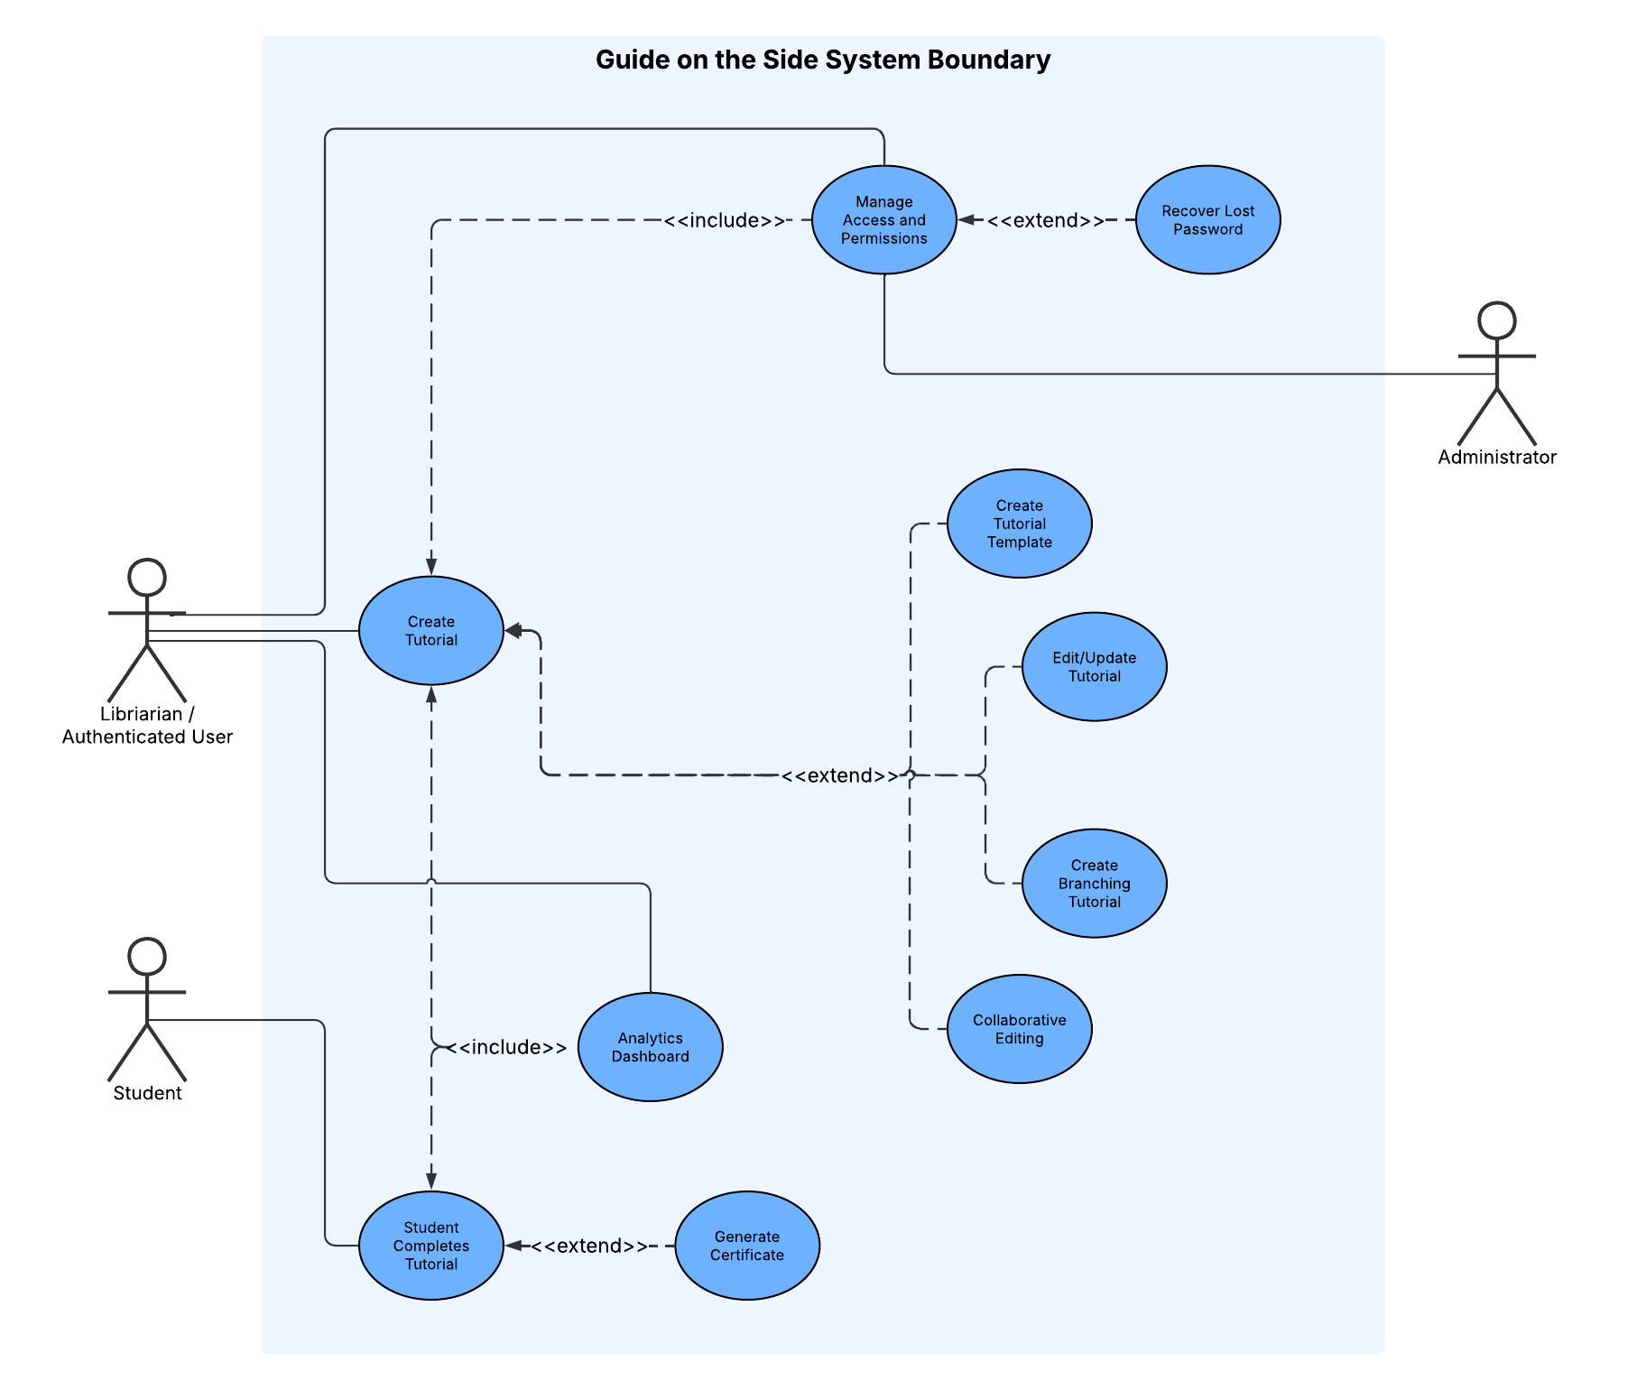

Feature List

Core Tutorial System

1.1 Split-Screen Layout Implementation
Description: Implement a responsive two-pane layout with tutorial/quiz content on the left and embedded resources on the right. Must support internal scrolling per pane while maintaining navigation controls.
Priority: 1 (Very High)
Acceptance Criteria: Left pane displays tutorial steps/quizzes; right pane displays embedded resources; both panes scroll independently; layout is responsive across devices.

1.2 Tutorial Storage & Database Schema
Description: Design and implement database tables to store tutorial structure, including tutorial metadata, steps/slides, quiz configurations, and media references. Support creation, retrieval, updating, and deletion of tutorials.
Priority: 1 (Very High)
Acceptance Criteria: Custom database tables created (wp_tutorials, wp_tutorial_steps); full CRUD operations functional; data integrity maintained across operations.

1.3 Page Template Registration
Description: Register a custom Pressbooks/WordPress page template ("Split Guide Template") that renders pages using the split-screen layout and integrates with the plugin's core system.
Priority: 1 (Very High)
Acceptance Criteria: Template appears in WordPress page editor; pages assigned this template render correctly; template works within Pressbooks multisite environment.

1.4 Tutorial Navigation System
Description: Implement Previous/Next buttons and optional slide navigation menu allowing students to move between tutorial steps sequentially or non-linearly. Priority: 1 (Very High)
Acceptance Criteria: Prev/Next buttons function correctly; optional slide menu displays all steps; progress indicator shows current position; navigation state is managed correctly.

1.5 Progress Indicator
Description: Implement a visual progress indicator showing the current step number and total number of steps within a tutorial.
Priority: 1 (Very High)
Acceptance Criteria: Progress display shows "Step X of Y"; updates correctly during navigation; remains visible during scrolling.

Embedded Content Management

2.1 Multi-Source Embedding System
Description: Implement support for embedding various content types on the right panel: YouTube videos (with format conversion), external URLs via iframe, uploaded PDF files, and direct video file uploads.
Priority: 1 (Very High)
Acceptance Criteria: YouTube URLs automatically converted to embed format; external URLs load in iframe with fallback; PDFs display inline; uploaded videos play using HTML5 player.

2.2 Iframe Error Handling & Fallback
Description: Implement detection and graceful handling of iframe loading failures (X-Frame-Options restrictions, network errors, timeouts). Provide fallback option to open content in new tab/window.
Priority: 1 (Very High)
Acceptance Criteria: Failed iframe loads display user-friendly error message; "Open in new tab" fallback button provided; error state clearly distinguishable from loading state.

2.3 Content Scaling & Aspect Ratio Handling
Description: Implement intelligent scaling of embedded content to fit within the right panel regardless of native aspect ratio. Support responsive sizing across different screen sizes.
Priority: 2 (High)
Acceptance Criteria: Wide content scales to fit panel width; tall content scrollable without distortion; author can preview content at different sizes; aspect ratio maintained.

Quiz & Assessment System

3.1 H5P Quiz Integration
Description: Integrate H5P library for creating interactive quizzes. Support multiple question types through H5P: multiple choice, fill-in-the-blank, checkboxes, and other H5P-supported formats.
Priority: 1 (Very High)
Acceptance Criteria: H5P quizzes embed correctly in left pane; all question types render properly; xAPI event tracking enabled for analytics; quiz interaction does not interfere with embedded content.

3.2 Instant Feedback Display System
Description: Implement display of immediate feedback to students after submitting answers, showing correct/incorrect status with author-defined feedback messages.
Priority: 1 (Very High)
Acceptance Criteria: Correct answers display success feedback; incorrect answers display custom feedback; feedback is visually distinct; messages configurable by librarians through H5P.

3.3 Quiz Validation & Answer Evaluation
Description: Implement backend logic to validate student answers against expected responses, supporting multiple correct answers and case-sensitivity options (where applicable with question type).
Priority: 1 (Very High)
Acceptance Criteria: Single-answer questions validated correctly; multiple-answer questions require all correct options; text answers support case sensitivity toggling; validation triggered on answer submission.

3.4 Question State Management
Description: Implement state tracking for each question during a tutorial session, maintaining unanswered/answered/correct/incorrect status across slide navigation.
Priority: 2 (High)
Acceptance Criteria: Question state persists when navigating away and returning; correctly answered questions show as complete; previously submitted answers visible when revisiting question.

3.5 Retry Mechanism & Attempt Tracking
Description: Implement retry system allowing students to resubmit answers with configurable attempt limits. Track attempt count for analytics purposes.
Priority: 1 (Very High)
Acceptance Criteria: Students can retry incorrect answers up to configured limit; attempt count displayed; when exhausted, appropriate message shown; attempt data tracked for analytics.

Layout & Responsiveness

4.1 Adjustable Split Panel Ratio
Description: Implement adjustable horizontal ratio between left (tutorial) and right (embedded content) panels. Allow librarians to set default ratio with min/max constraints (10%-90% left/right split recommended).
Priority: 2 (High)
Acceptance Criteria: Librarians can configure default ratio during setup; ratio enforces min/max constraints; slider UI allows fine-tuning; layout renders correctly at all configured ratios.

4.2 User-Adjustable Layout
Description: Implement optional user-facing slider allowing students to adjust panel ratio during tutorial playback if librarian enables this feature.
Priority: 3 (Medium)
Acceptance Criteria: Librarians can enable/disable user adjustment per tutorial; visible slider divider between panes when enabled; dragging slider changes ratio; ratio preference persists during session.

4.3 Responsive Multi-Device Support
Description: Ensure split-screen layout renders correctly across devices (desktop, tablet, mobile). Implement responsive breakpoints and mobile-friendly adjustments.
Priority: 1 (Very High)
Acceptance Criteria: Layout readable and functional on mobile, tablet, and desktop; embedded content scales appropriately; touch-friendly navigation on mobile devices.

Certificate & Completion System

5.1 Certificate PDF Generation
Description: Implement PDF certificate generation upon tutorial completion, including student name (optional), tutorial title, completion date, and library branding.
Priority: 2 (High)
Acceptance Criteria: Certificates generated as PDF files; include configurable template fields; downloadable upon completion; can be emailed if configured.

5.2 Certificate Storage System
Description: Implement temporary storage and token-based retrieval system for generated certificates, allowing students to view/download certificates with expiry policy.
Priority: 2 (High)
Acceptance Criteria: Certificates stored with secure token; students retrieve with unique link; expiry policy enforced; database schema supports certificate metadata.

5.3 Completion Summary & End Screen
Description: Implement end-of-tutorial summary page displaying attempt statistics, quiz performance, and completion status before certificate generation.
Priority: 2 (High)
Acceptance Criteria: Summary displays score, attempts per question, completion status; visual clear distinction between quiz questions and branching attempts; "Close Tutorial" button returns to home.

Tutorial Authoring Interface

6.1 Tutorial Creation Admin Panel
Description: Implement admin interface allowing librarians to create new tutorials, configure metadata (title, description, tags), and set initial configuration options.
Priority: 1 (Very High)
Acceptance Criteria: Librarians can create tutorials via admin interface; tutorials stored in database; metadata configurable; created tutorials appear in tutorial list with draft status.

6.2 Tutorial Attributes & Configuration
Description: Implement UI for librarians to modify tutorial attributes including title, description, featured image/cover, layout ratio defaults, and completion settings.
Priority: 1 (Very High)
Acceptance Criteria: Tutorial attributes editable through admin interface; changes persist; featured images display correctly; layout ratio configured per tutorial.

6.3 Tutorial Overview & Management Dashboard
Description: Implement dashboard displaying all tutorials authored by current librarian (or all tutorials for admins), with filtering/search, edit/delete/publish controls.
Priority: 1 (Very High)
Acceptance Criteria: Dashboard lists all authored tutorials; search/filter functionality works; edit/delete buttons functional; status (draft/published) displayed; bulk actions available.

6.4 Tutorial Step/Slide Editor
Description: Implement UI for librarians to add, delete, reorder, and configure individual tutorial steps (slides). Each step contains quiz and embedded content configuration.
Priority: 1 (Very High)
Acceptance Criteria: Librarians can add/delete steps with confirmation; reorder steps via UI; each step maintains independent configuration; changes save correctly.

6.5 Right Panel Embedded Content Configuration
Description: Implement UI allowing librarians to configure embedded content for each slide: URL input for websites/databases, video embed (YouTube/Vimeo), or file upload for PDFs/videos.
Priority: 1 (Very High)
Acceptance Criteria: Librarians specify URL, select video, or upload file; preview shows configured content; domain locking toggleable per slide; configuration persists.

6.6 H5P Quiz Linking & Creation
Description: Implement UI for librarians to create new H5P quizzes or link to existing H5P content for each tutorial step. Display H5P quiz list with refresh/sync capability.
Priority: 1 (Very High)
Acceptance Criteria: Librarians can create new H5P quizzes or select existing ones; quiz list displays available quizzes; "Edit H5P" option allows configuration; selection persists.

6.7 Tutorial Preview Mode
Description: Implement preview functionality allowing librarians to view tutorial exactly as students experience it, from any starting point, without saving changes.
Priority: 2 (High)
Acceptance Criteria: Preview button launches tutorial in student view; preview renders all content correctly; navigation functional; changes do not persist; can exit without saving.

6.8 Tutorial Publishing Workflow
Description: Implement publish/unpublish workflow allowing librarians to control when tutorials are visible to students.
Priority: 1 (Very High)
Acceptance Criteria: Published tutorials visible to students; draft tutorials hidden; librarians can toggle publish status; published state persists correctly.

Template System

7.1 Template Application
Description: Implement ability to apply templates to tutorials during creation.
Priority: 2 (High)
Acceptance Criteria: Template selector shows available templates; "Apply Template" updates tutorial styling; templates can be switched.

7.2 Save Tutorial as Template
Description: Implement ability for librarians to save current tutorial styling configuration as a new reusable template.
Priority: 3 (Medium)
Acceptance Criteria: "Save as Template" option in tutorial settings; modal prompts for template name/description; template created and available for other tutorials; author becomes template owner.

User Roles & Access Control

8.1 Role-Based Access Control
Description: Implement role-based permissions system distinguishing between Student (read published tutorials), Librarian (create/edit tutorials), and Admin (manage all tutorials, users, settings).
Priority: 1 (Very High)
Acceptance Criteria: Students see only published tutorials; librarians can create/edit tutorials; admins have full control; unauthorized access blocked; menu items hidden based on role.

8.2 Tutorial Ownership & Edit Access
Description: Implement tutorial ownership model where tutorials are assigned to a librarian author. Implement admin-configurable setting controlling whether librarians can edit each other's tutorials.
Priority: 1 (Very High)
Acceptance Criteria: Each tutorial has assigned author; admins can transfer ownership via dropdown; admin toggle controls cross-editing; deactivated librarians cannot edit; ownership persists.

8.3 Librarian Account Deactivation
Description: Implement account deactivation workflow for librarians where deactivated users cannot create/manage tutorials but existing tutorials are preserved.
Priority: 1 (Very High)
Acceptance Criteria: Admin can deactivate librarian accounts; deactivated users cannot access tutorial editor; existing tutorials preserved; ownership transfer optional during deactivation.

Analytics System

9.1 Anonymous Usage Tracking
Description: Implement anonymous data collection tracking tutorial views, completions, quiz attempts, and performance metrics without capturing personally identifiable information.
Priority: 2 (High)
Acceptance Criteria: Tutorial view counts tracked; completion rates recorded; quiz attempt/success rates tracked; no PII collected; data PIPEDA-compliant.

9.2 Quiz Performance Analytics
Description: Implement analytics tracking for quiz performance including per-question success rates, average attempts, and common incorrect answers.
Priority: 2 (High)
Acceptance Criteria: Per-question success rate calculated; average attempt count tracked; incorrect answer patterns identifiable; metrics accurate and aggregated.

9.3 Analytics Dashboard
Description: Implement admin/librarian-facing dashboard displaying tutorial analytics including completion rates, quiz performance, usage trends, and performance benchmarks.
Priority: 2 (High)
Acceptance Criteria: Dashboard displays completion rates, quiz metrics, usage graphs; librarians see only their tutorials; admins see all tutorials; benchmarking thresholds configurable.

9.4 Comparative Analytics
Description: Implement ability to compare analytics across multiple tutorials simultaneously for trend identification.
Priority: 3 (Medium)
Acceptance Criteria: Dashboard supports multi-tutorial comparison; comparative charts/tables display metrics side-by-side; filtering/selection controls functional.

Branching & Conditional Tutorials

10.1 Branching Question Configuration
Description: Implement UI allowing librarians to configure sub-tutorials that display when students answer questions incorrectly or reach a threshold of errors.
Priority: 3 (Medium)
Acceptance Criteria: Librarians can assign sub-tutorial to each question; error threshold configurable (e.g., "show after 2 errors"); optional/mandatory toggle per question; configuration persists.

10.2 Branching Logic System
Description: Implement backend evaluation of branching conditions based on student answers and attempt counts, determining when sub-tutorials should display.
Priority: 3 (Medium)
Acceptance Criteria: System correctly evaluates error thresholds; sub-tutorials display when conditions met; logic handles optional/mandatory branches; no false positives/negatives.

10.3 Branching UI & Pop-Up Display
Description: Implement student-facing pop-up modal displaying sub-tutorial content when branching conditions are met, with clear navigation back to main tutorial.
Priority: 3 (Medium)
Acceptance Criteria: Pop-up displays sub-tutorial content; clear indication of mandatory vs optional completion; navigation back to main tutorial functional; pop-up styled consistently.

10.4 Branching State Management
Description: Implement state tracking for branching tutorials to maintain completion status across navigation and ensure students can return to correct point in main tutorial.
Priority: 3 (Medium)
Acceptance Criteria: Branching state persists during session; students return to correct question after completing sub-tutorial; completion status tracked per branch; no data loss.

Tutorial Reuse & Portability

11.1 Tutorial Import/Export System
Description: Implement import/export functionality allowing tutorials to be downloaded as packages and uploaded on different servers or Pressbooks installations.
Priority: 3 (Medium)
Acceptance Criteria: Tutorials export as complete packages (metadata, steps, embedded content URLs); import preserves all structure and configuration; import/export error handling robust.

11.2 Cross-Server Tutorial Sharing
Description: Implement package format supporting transfer of tutorials between different servers or installations, with URL remapping where necessary.
Priority: 3 (Medium)
Acceptance Criteria: Exported packages transferable between servers; URLs remappable during import; templates/resources preserved; metadata correct after import.

Accessibility & Compliance

12.1 Keyboard Navigation Implementation
Description: Ensure all interactive elements (buttons, navigation, quiz interactions) fully navigable and operable using keyboard only.
Priority: 1 (Very High)
Acceptance Criteria: All interactive elements reachable via Tab key; buttons can be activated via Enter/Space; no keyboard traps; skip links provided; logical tab order.

12.2 Focus Management & Visible Indicators
Description: Implement clear, visible focus indicators for all interactive elements; manage focus appropriately when dynamic content changes.
Priority: 1 (Very High)
Acceptance Criteria: Focus indicator visible with sufficient contrast (3:1 minimum); focus moves logically after dynamic changes; focus not lost during content updates.

12.3 Screen Reader Compatibility
Description: Ensure student and authoring interfaces work correctly with screen readers (NVDA, JAWS, VoiceOver); implement appropriate ARIA labels, roles, and live regions.
Priority: 1 (Very High)
Acceptance Criteria: All content readable in logical order; interactive elements have ARIA roles/labels; dynamic changes announced via live regions; tested with actual screen readers.

12.4 Color Contrast Compliance
Description: Ensure all text and visual elements meet WCAG 2.1 AA contrast requirements (4.5:1 normal text, 3:1 large text/UI components).
Priority: 1 (Very High)
Acceptance Criteria: All text passes contrast requirements; UI components have sufficient contrast; no information conveyed by color alone; accessibility audit completed.

12.5 Custom Accessibility Settings & Dashboard
Description: Implement user-configurable accessibility features including custom focus indicators, color schemes for colorblind users, font family selection, and custom keyboard shortcuts.
Priority: 2 (High)
Acceptance Criteria: Users can customize focus color/width; UPEI-Library and colorblind-friendly color scheme available; font family selection functional; custom keyboard shortcuts configurable for tutorial navigation.

CI/CD & Testing Infrastructure

13.1 Testing Framework Setup
Description: Research and implement testing framework compatible with WordPress/Pressbooks (PHPUnit for backend, JavaScript testing for frontend).
Priority: 2 (High)
Acceptance Criteria: PHPUnit configured and functional; test suite structure defined; unit and integration tests can run; CI/CD integration verified.

13.2 Automated Testing & CI/CD Pipeline
Description: Implement GitHub Actions workflow for automated testing, including unit tests, integration smoke tests, and automated reporting.
Priority: 2 (High)
Acceptance Criteria: Tests run automatically on commits; results displayed in CI logs; passing/failing tests identified; coverage reports generated; pipeline stable.

13.3 Test Suite for Core Functionality
Description: Write comprehensive test suite covering tutorial CRUD operations, quiz validation, role-based access control, analytics data collection, and branching logic.
Priority: 2 (High)
Acceptance Criteria: Unit tests for business logic; integration tests for workflows; permission tests for access control; quiz validation tests; branching logic tests all passing.

RMMM Plan (Risk Mitigation, Monitoring, and Management)
- CMS selection uncertainty
- Risk Description: At the early stage of development, the team must decide whether to implement the system using Pressbooks or Drupal 10. Each platform offers different advantages and limitations. Pressbooks provides simplicity and fast setup, while Drupal offers greater flexibility but requires more configuration. Uncertainty or delays in selecting the CMS could impact technical planning, development timelines, and compatibility with client infrastructure.
- Probability: Medium
- Impact: High
- Mitigation Strategy: Conduct a short comparative study in the first development sprint to test key requirements—such as embedding capabilities, quiz functionality, and user permissions—on both platforms. The team will consult with UPEI IT and the client to confirm hosting support and long-term maintenance preferences before finalizing the choice.
- Monitoring Approach: Track CMS evaluation progress. Assign one member to document test results and update the client on findings.
- Contingency Plan: If the selected CMS proves technically unsuitable after initial implementation, the team will pivot to the alternative platform using the existing design documentation and prototypes. The project timeline will be adjusted to accommodate reconfiguration and testing within the following sprint.

- Iframe embedding restrictions
- Risk Description: The system relies on iframe embedding to display live library resources such as databases, catalogues, and videos. Some third-party websites may block embedding due to security settings or Content Security Policy restrictions. This could prevent key instructional materials from being displayed directly within the tutorial interface, reducing functionality and user experience.
- Probability: Medium
- Impact: High
- Mitigation Strategy: Identify and test all major library databases and external resources early in development to confirm embedding compatibility. For any sites that block embedding, implement an “Open in New Window” fallback feature. Document which resources require this alternative and confirm with the client that it meets instructional needs.
- Monitoring Approach: Maintain a resource compatibility log that records the embedding status of each target website. Review and update this log during each sprint and share findings with the client for transparency.
- Contingency Plan: If critical resources cannot be embedded and no workaround exists, the team will adapt the tutorial flow to include screenshots or video demonstrations instead of live content. The client will be notified immediately if such a design change is required.

- WCAG 2.1 AA compliance complexity
- Risk Description: The system must meet WCAG 2.1 AA accessibility standards for all user-facing components, including text contrast, keyboard navigation, and screen-reader compatibility. Ensuring full compliance may be technically complex, especially within the Drupal or Pressbooks CMS environments, which use prebuilt themes and modules that may not fully support accessibility out of the box.
- Probability: Medium
- Impact: Medium to High
- Mitigation Strategy: Adopt accessibility testing tools early in development. Choose CMS themes with verified WCAG 2.1 AA compliance and limit custom styling that could reduce accessibility. Conduct iterative testing after each major interface update to ensure ongoing compliance.
- Monitoring Approach: Assign one team member as the accessibility reviewer for each sprint. Use an accessibility checklist to track compliance progress and address any violations as part of regular code reviews.
- Contingency Plan: If full compliance cannot be achieved within project constraints, document all remaining accessibility limitations clearly for the client. Provide recommendations for post-deployment improvements that can be implemented by UPEI IT or future development teams.

- Team coordination (multiple teams)
- Risk Description: The project involves collaboration between multiple development sub-teams working on different components such as tutorial creation, testing, and deployment. Without consistent communication and version control practices, the team may face merge conflicts, duplicated work, or inconsistent implementation across modules. Misalignment between sub-teams could lead to integration issues and schedule delays.
- Probability: Medium
- Impact: High
- Mitigation Strategy: Establish clear communication channels (e.g., weekly progress meetings and a shared project tracker) to synchronize tasks between teams. Use GitHub with a defined branching and pull request workflow to manage changes and prevent code overwrites. Assign a project coordinator to monitor inter-team dependencies and ensure all updates follow a unified structure.
- Monitoring Approach: Review GitHub commits and pull requests weekly to identify merge conflicts early. Use short status updates after each sprint to verify that task dependencies are aligned across sub-teams. The project coordinator will document issues and communicate them to all members.
- Contingency Plan: If major coordination problems occur, the team will temporarily consolidate development work into a single shared sprint under one lead developer until all components are synchronized. The schedule will be adjusted to prioritize integration testing and code consistency before resuming normal task distribution.

- UPEI IT or UPEI Library deployment constraints
- Risk Description: The project depends on UPEI IT Services or the UPEI Library to provide the hosting environment, SSL certification, and long-term maintenance after deployment. Delays in server configuration, limited access permissions, or institutional security policies may restrict the team’s ability to deploy and test the system on time. These constraints could impact the final delivery schedule or limit certain technical features, such as iframe embedding or plugin installation.
- Probability: Medium
- Impact: High
- Mitigation Strategy: Communicate with UPEI IT or the library early in the project to confirm server availability, access credentials, and security requirements. Establish clear timelines for staging and production setup. Keep deployment configuration lightweight and compatible with the university’s existing infrastructure to minimize approval delays.
- Monitoring Approach: Designate one team member as the technical liaison to maintain regular contact with UPEI IT and library contacts. Track progress on hosting setup in the shared project timeline, and raise any delays or access issues during weekly meetings.
- Contingency Plan: If the university server is not ready in time, use a temporary local or cloud-based staging environment for internal testing and client review. Once the official server becomes available, migrate all content and configurations following the documented deployment guide.

- Browser compatibility issues
- Risk Description: The system will be accessed through different web browsers and devices by both librarians and students. Variations in how browsers such as Chrome, Firefox, Safari, and Edge interpret HTML, CSS, and JavaScript may cause layout inconsistencies, display errors, or functional issues. These differences could affect quiz interactions, embedded iframes, or the overall usability of tutorials, especially if responsive design is not properly implemented.
- Probability: Medium
- Impact: Medium to High
- Mitigation Strategy: Apply responsive design principles and follow cross-browser compatibility standards during development. Use widely supported frameworks and avoid browser-specific features. Conduct iterative testing on all major browsers and operating systems throughout the development cycle rather than waiting until final deployment.
- Monitoring Approach: Maintain a browser testing checklist and document all test results at each sprint milestone. Assign one team member to perform browser regression testing after any major UI or CSS update. Record and resolve issues through GitHub issue tracking.
- Contingency Plan: If a critical feature fails on a specific browser and cannot be fixed within schedule, provide a functional workaround (e.g., simplified layout or separate instructional link). Clearly note any known browser limitations in the user documentation and recommend preferred browsers for optimal performance.

- Third-party dependency changes
- Risk Description: The project relies on several third-party components and modules provided by the selected CMS, including plugins for embedding, theming, and quiz functionality. These dependencies may change, become deprecated, or lose compatibility with future CMS updates. Such changes could cause system instability or require significant redevelopment effort to restore functionality after deployment.
- Probability: Medium
- Impact: High
- Mitigation Strategy: Use only officially supported or well-maintained modules from trusted sources within the CMS ecosystem. Document all third-party dependencies, including version numbers and installation sources, to ensure traceability. Avoid relying on experimental or unmaintained plugins that may not be compatible with future updates.
- Monitoring Approach: Review dependency versions at the start of each sprint and before deployment. Subscribe to relevant CMS or plugin update notifications to stay informed about changes. The technical lead will periodically check compatibility reports and update documentation accordingly.
- Contingency Plan: If a critical dependency becomes incompatible or discontinued, the team will identify an alternative module or develop a lightweight custom replacement. Any replacement will be tested in a staging environment before being applied to the production server. If the issue arises post-deployment, UPEI IT Services or the UPEI Library will follow the provided documentation to restore system functionality using the previous stable version.

- Time constraints
- Risk Description: The project must be completed within a limited academic term, leaving little flexibility for delays. Unexpected technical challenges—such as CMS integration issues, embedding limitations, or accessibility testing—may require more time than anticipated. Competing course deadlines or limited availability among team members could further impact productivity, resulting in unfinished features or reduced testing before delivery.
- Probability: High
- Impact: High
- Mitigation Strategy: Break the project into smaller, clearly defined milestones with realistic deadlines for each development phase. Prioritize core functionality—such as tutorial creation, quiz interaction, and embedding—before implementing secondary or stretch features. Conduct regular progress reviews and adjust the scope early if the timeline becomes tight.
- Monitoring Approach: Track task completion using a shared project management tool. The project coordinator will review progress during weekly meetings and flag any delays that threaten milestone completion.
- Contingency Plan: If major delays occur, the team will de-scope lower-priority features (such as advanced layout customization or certificate generation) to ensure that the main deliverables are functional and ready for submission. The schedule will be updated to allocate additional time for final testing and client review before deployment.

Dependency Chart (Task Network)
Abstracted Overview Diagram
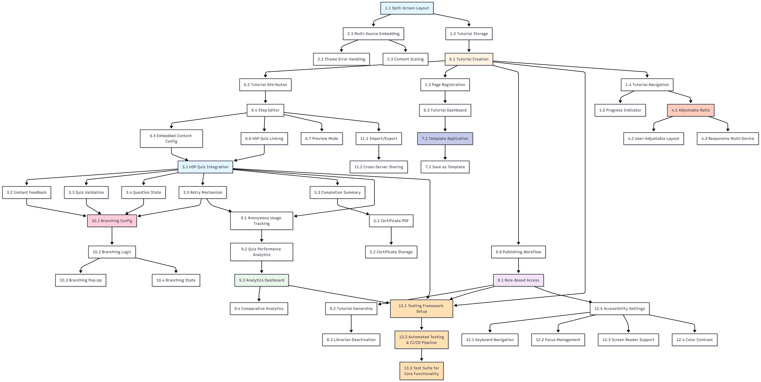

- Core Tutorial System + Embedded Content Management

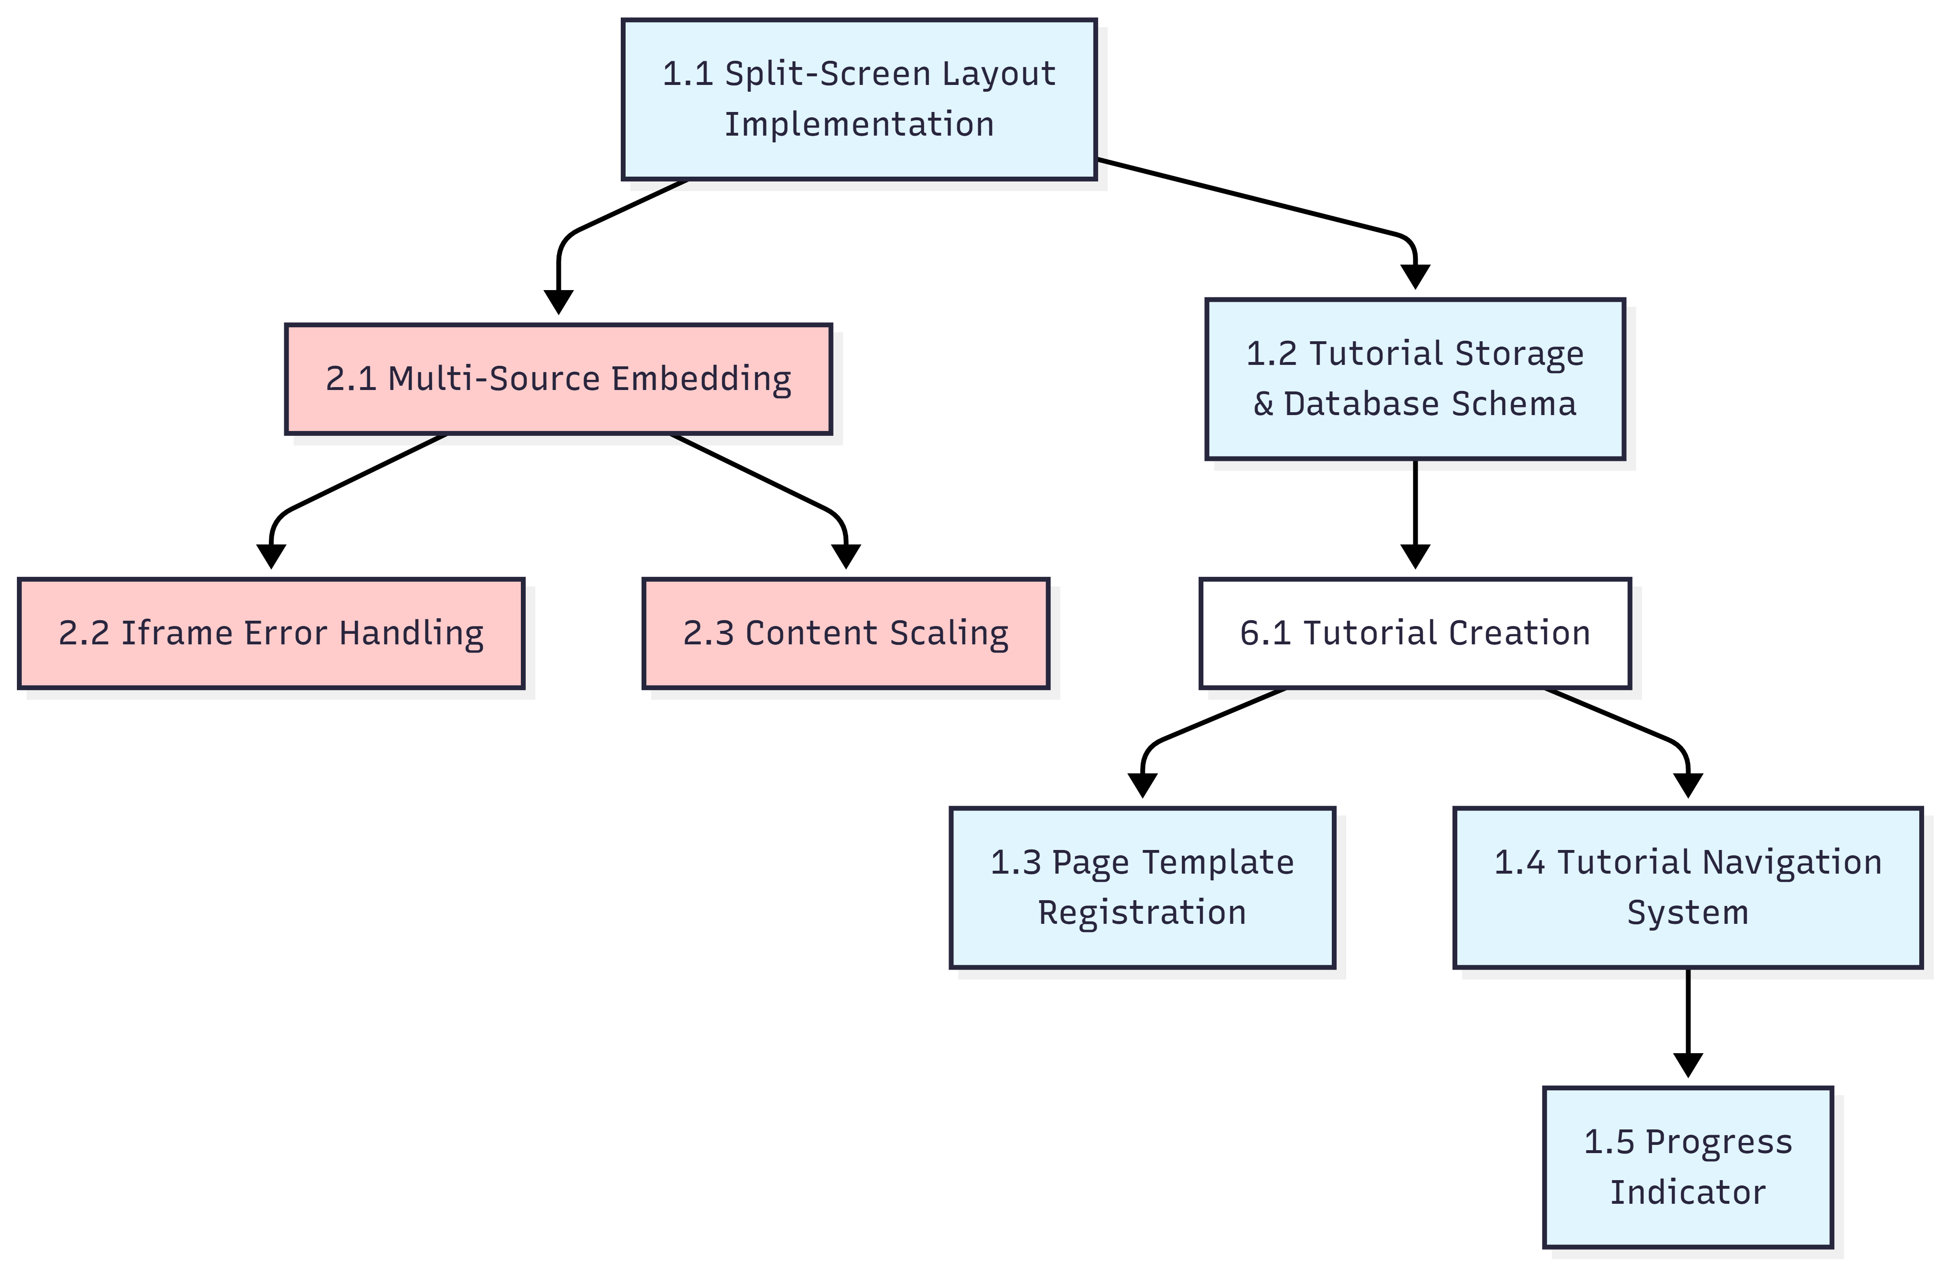

- Quiz & Assessment System

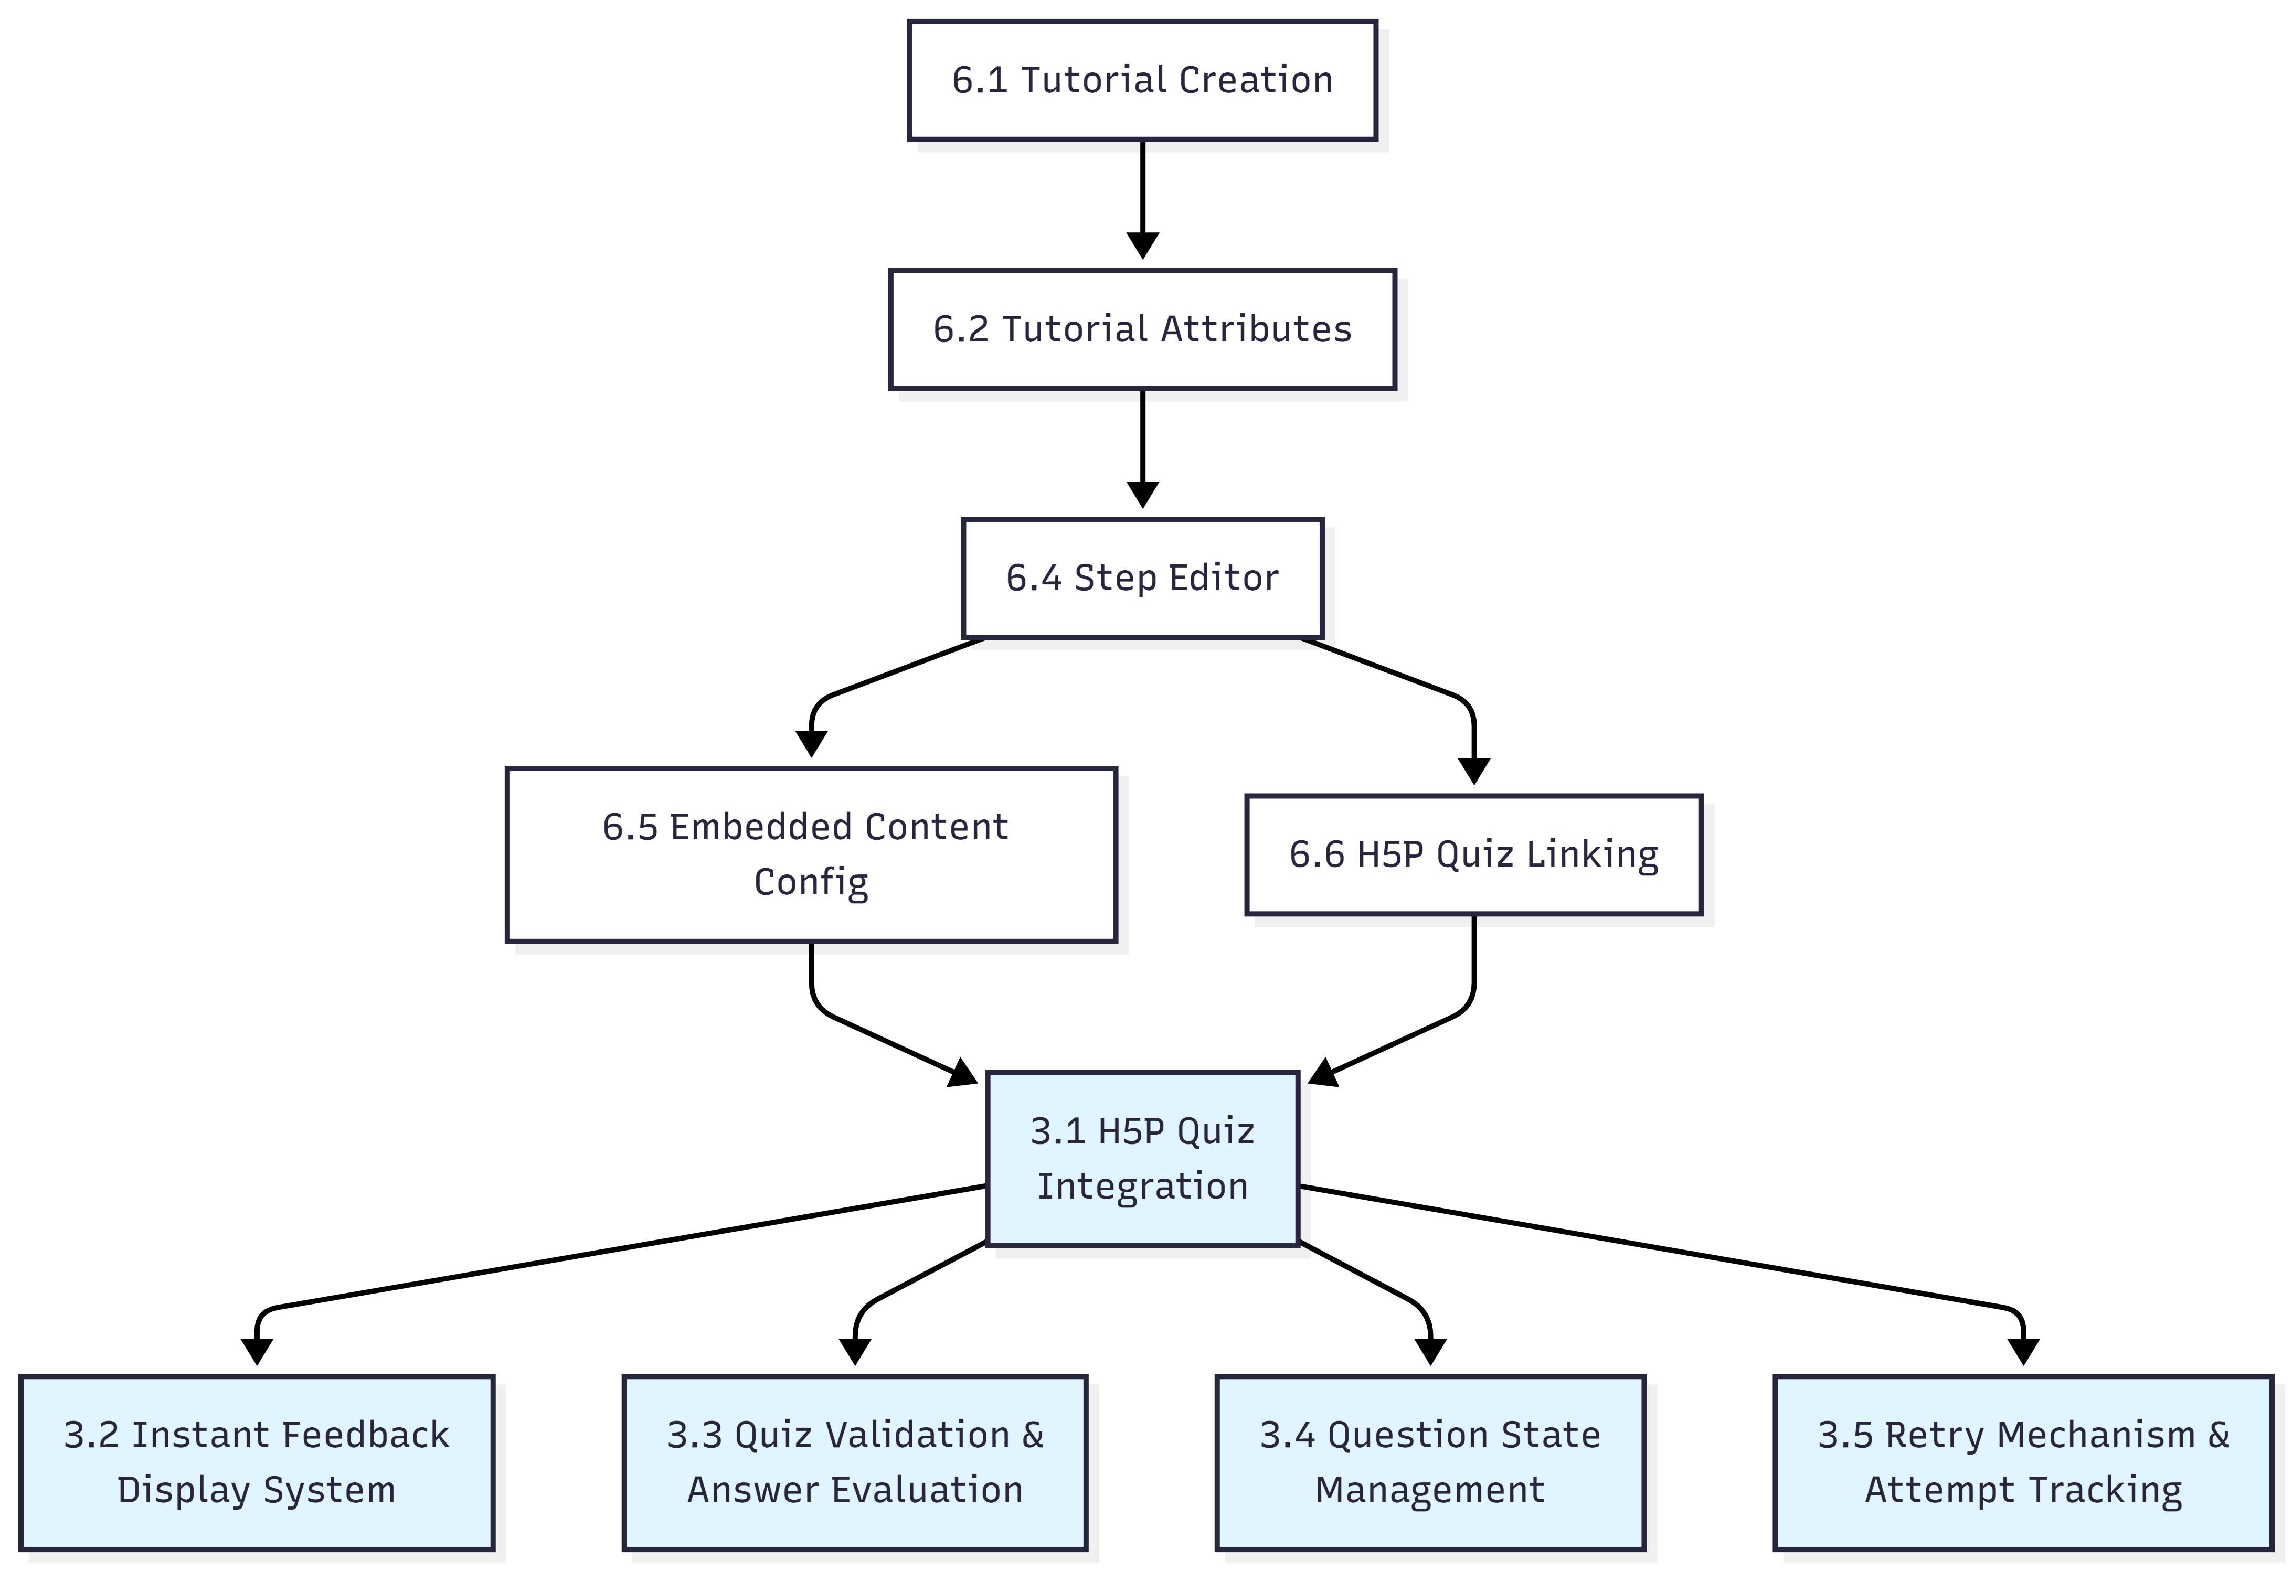

- Layout & Responsiveness

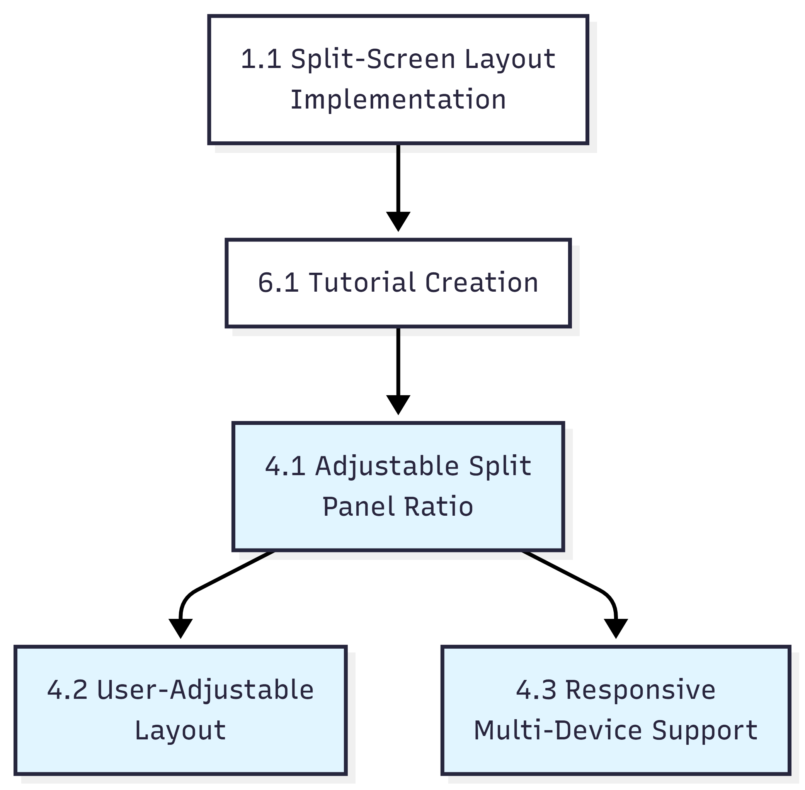

- Certificate & Completion System

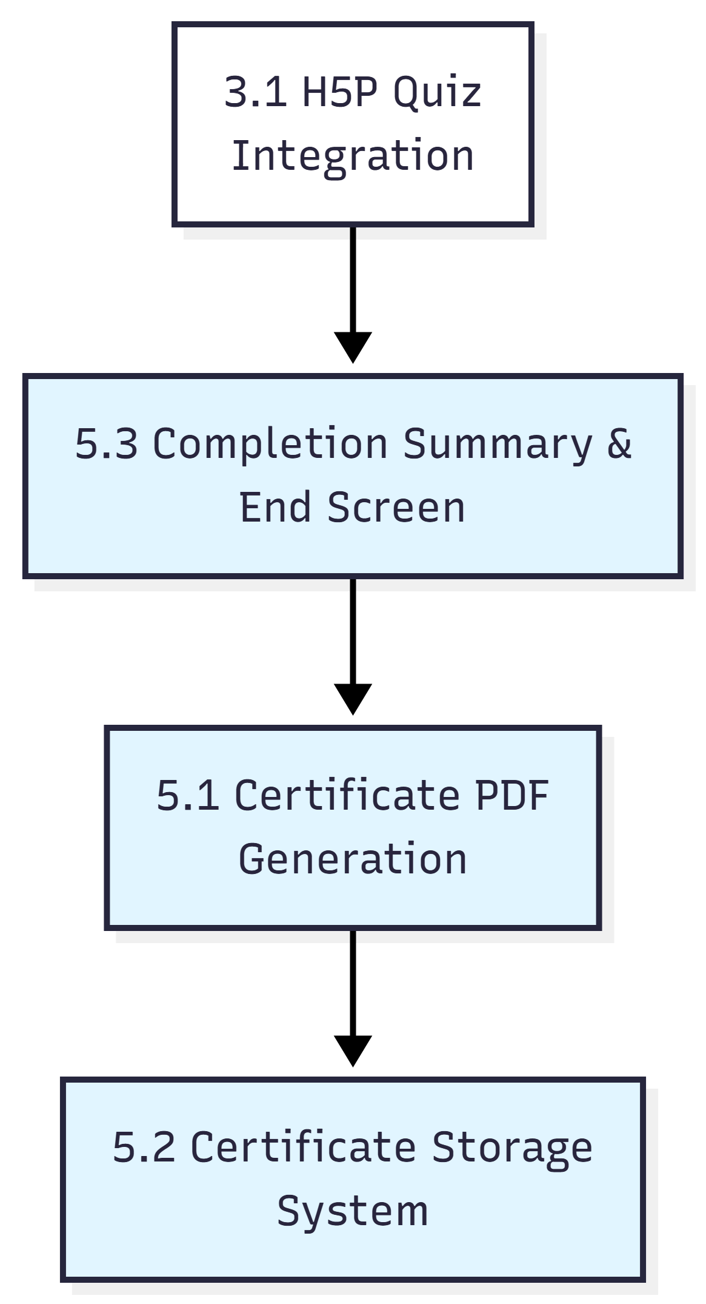

- Tutorial Authoring Interface

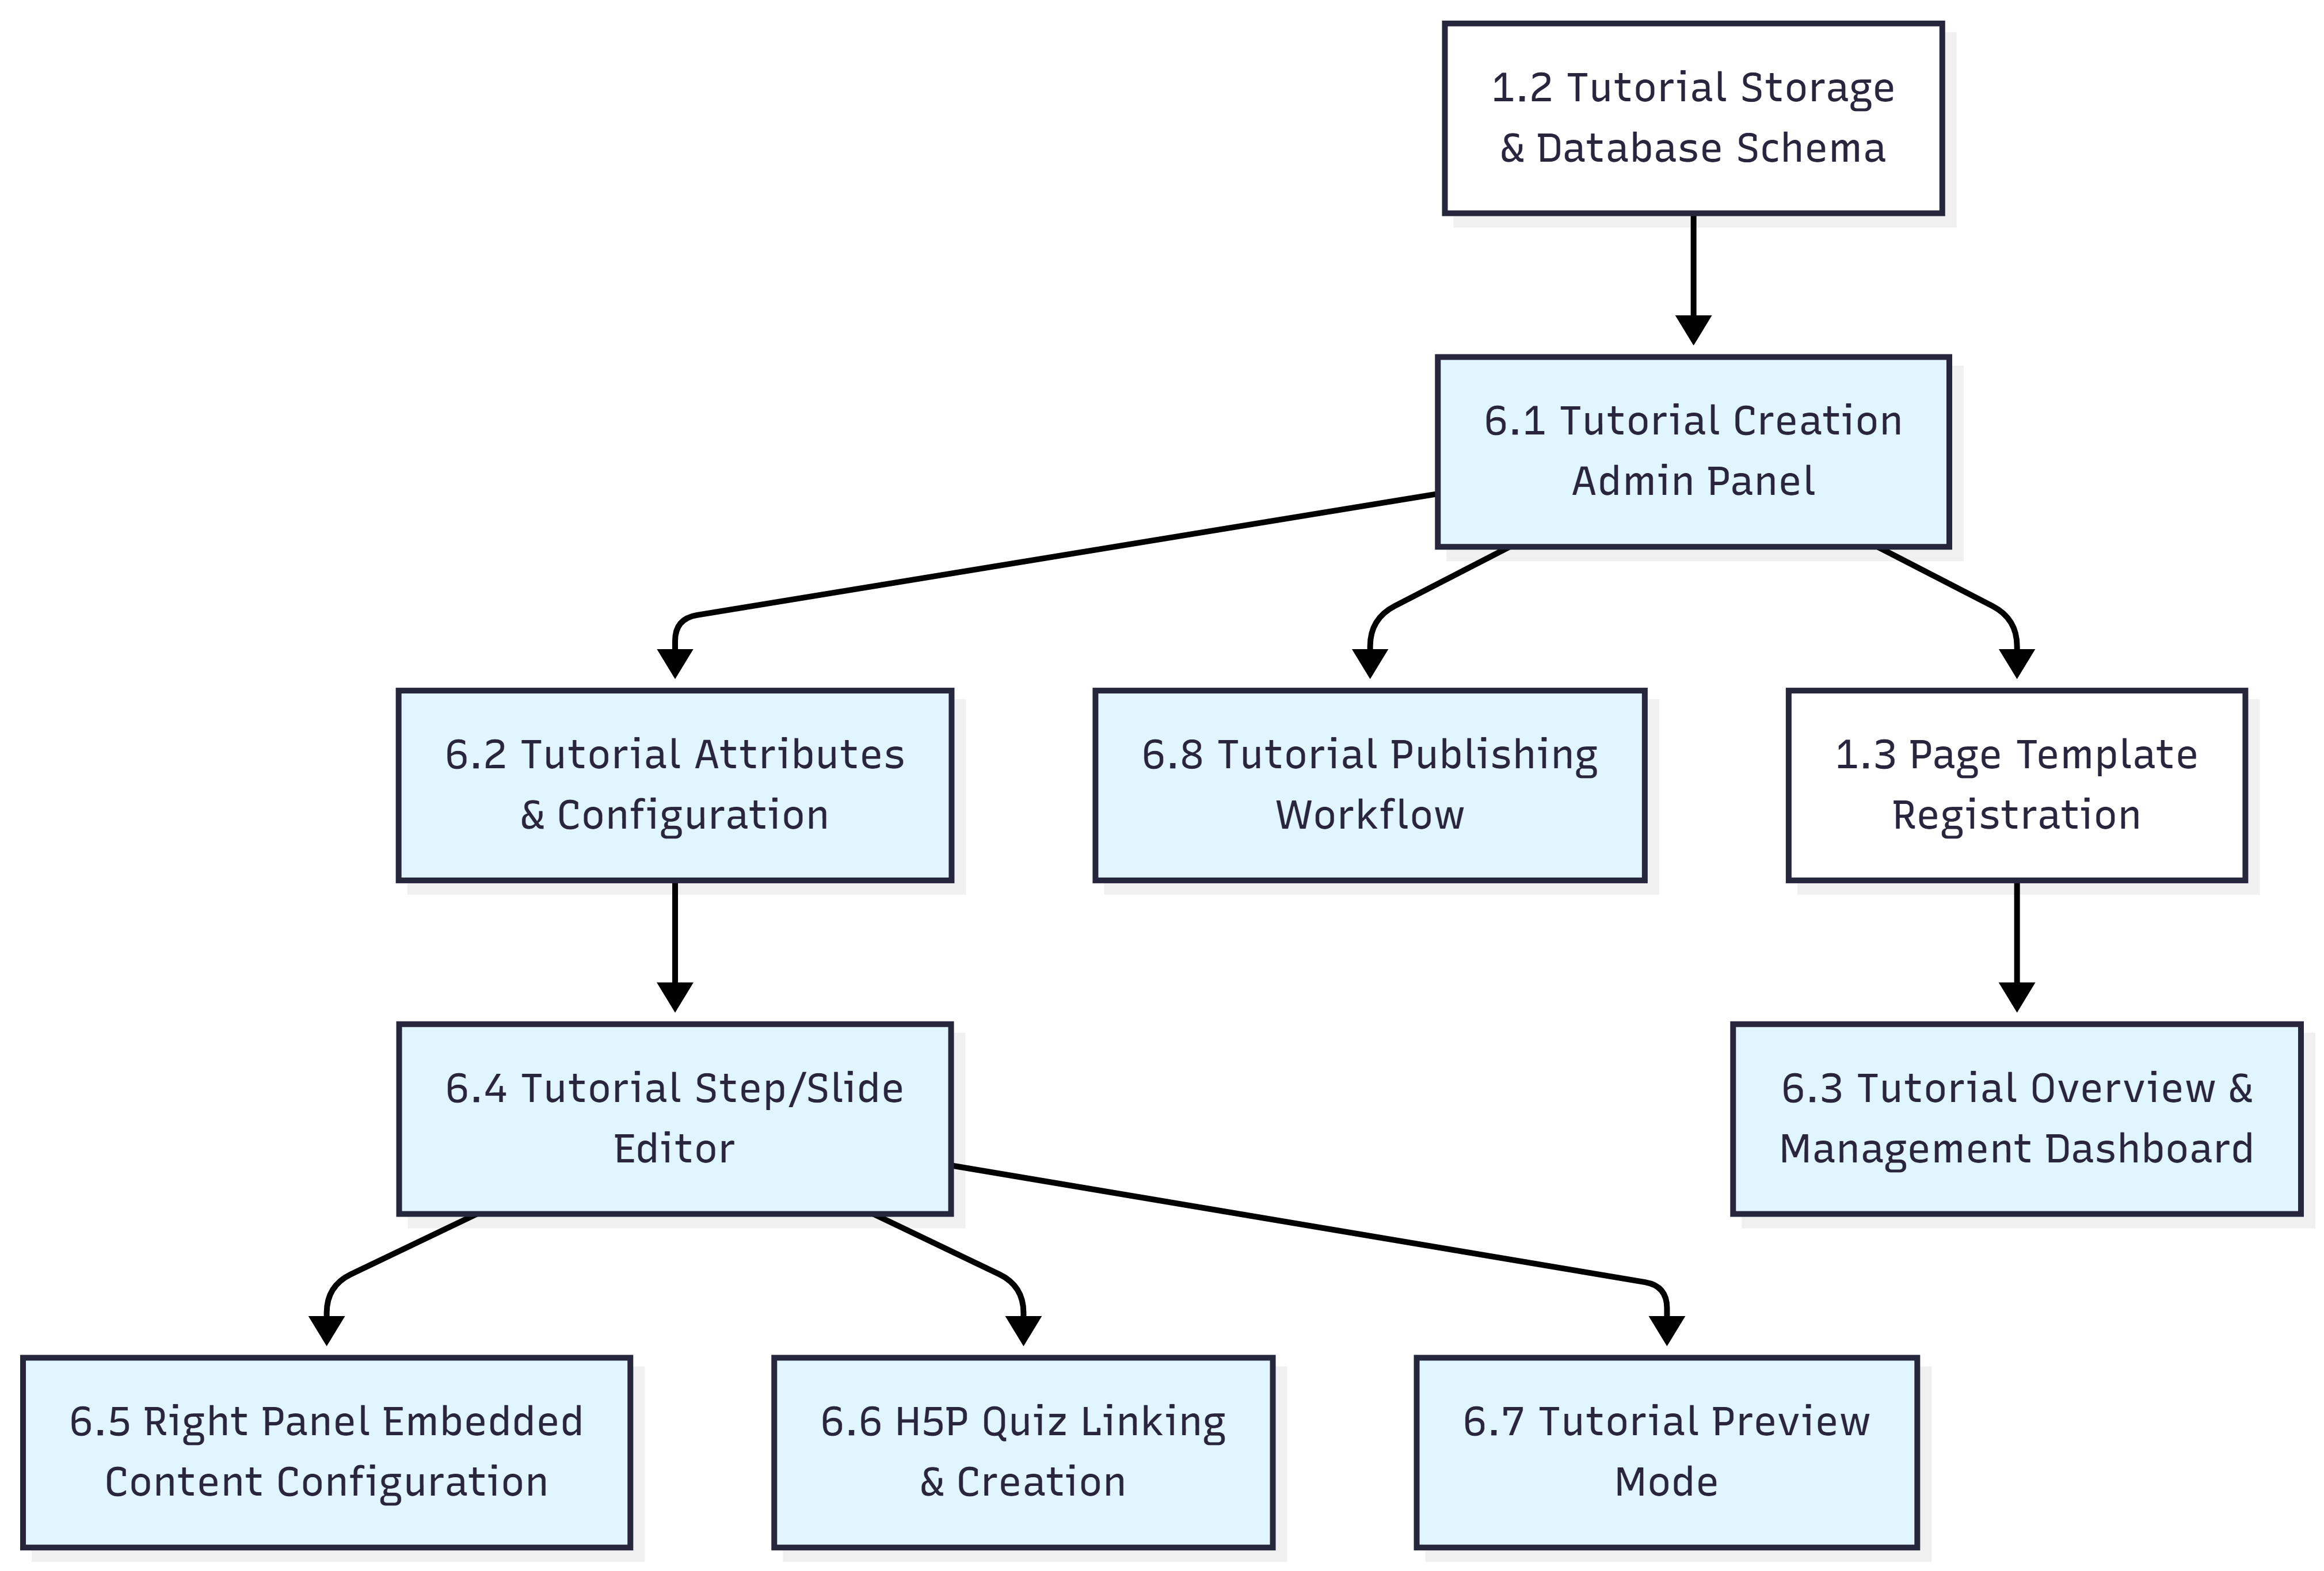

- Template System

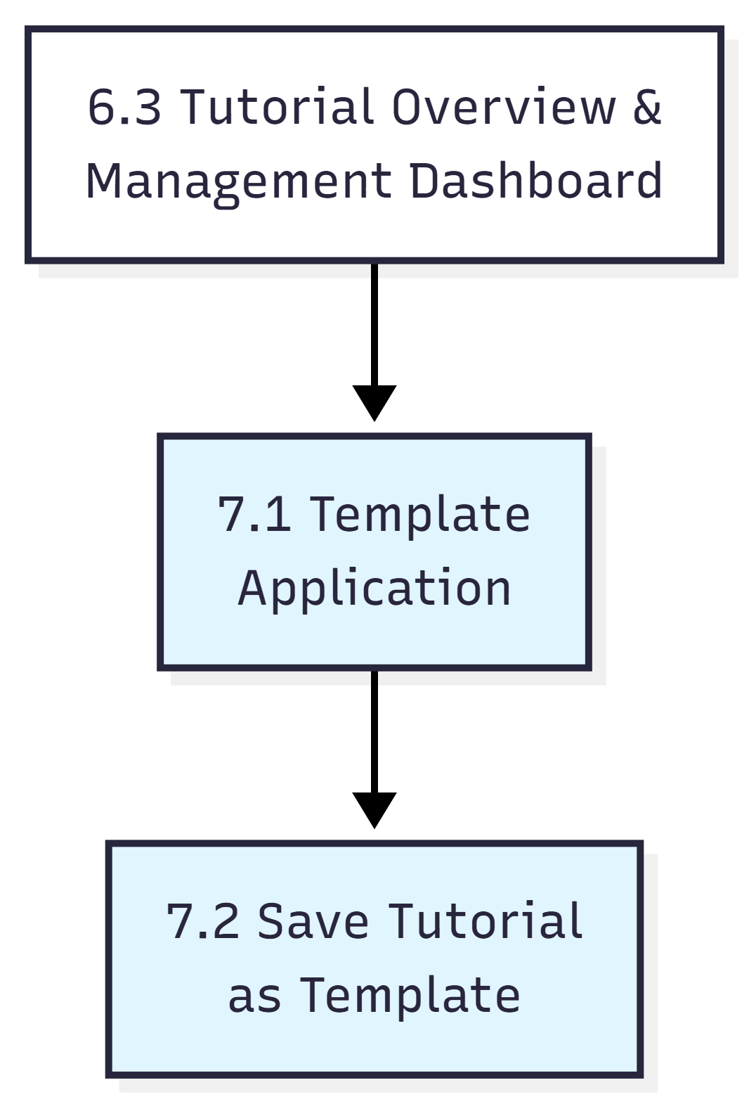

- User Roles & Access Control

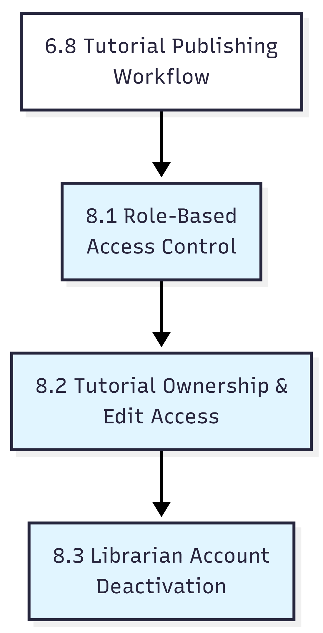

- Analytics System

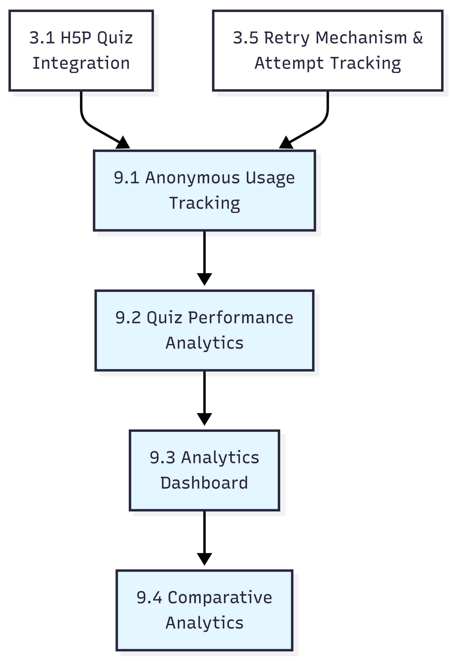

- Branching & Conditional Tutorials

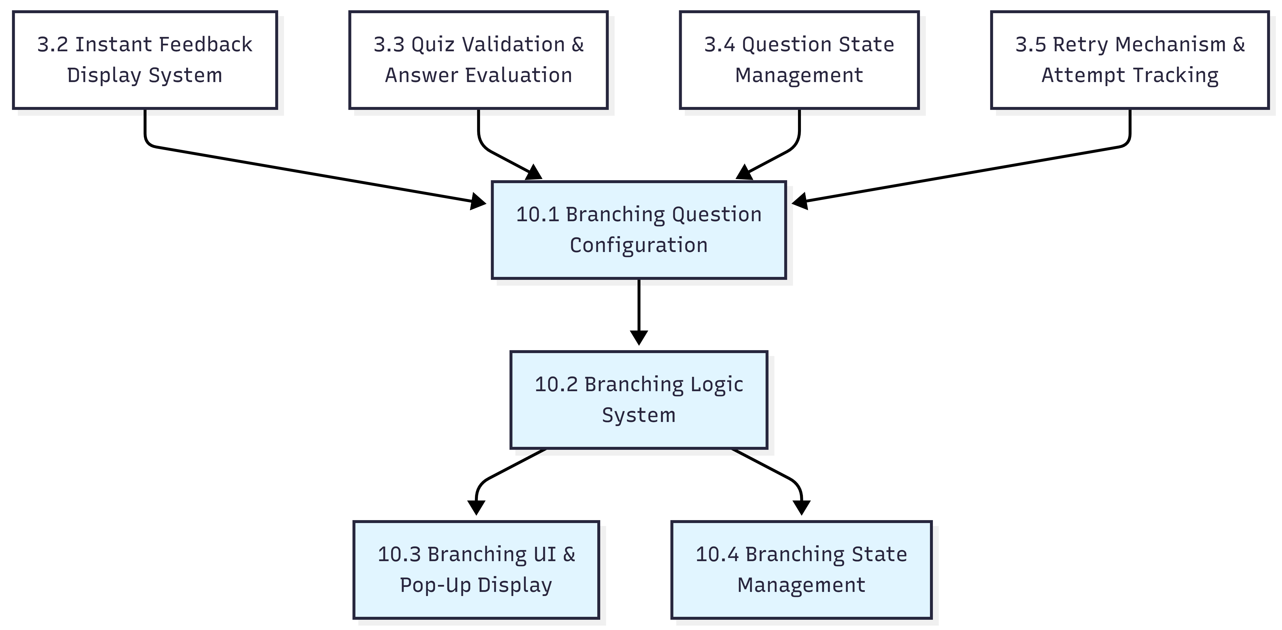

- Tutorial Reuse & Portability

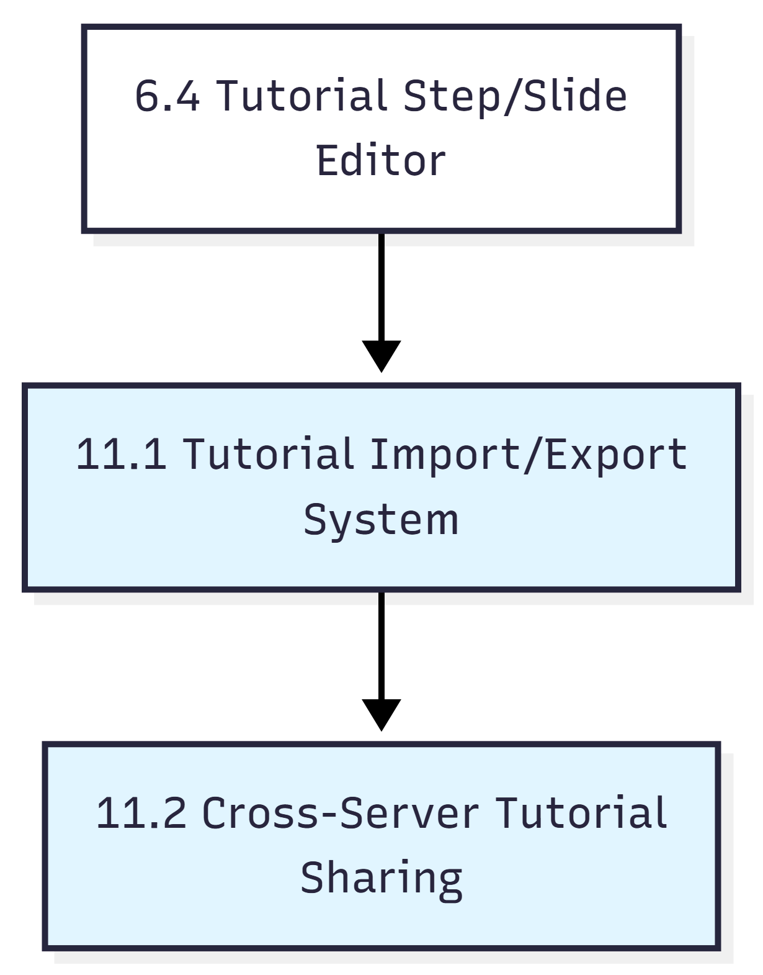

- Accessibility & Compliance

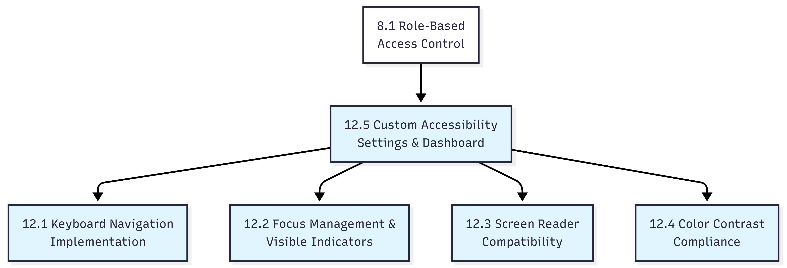

- CI/CD & Testing Infrastructure

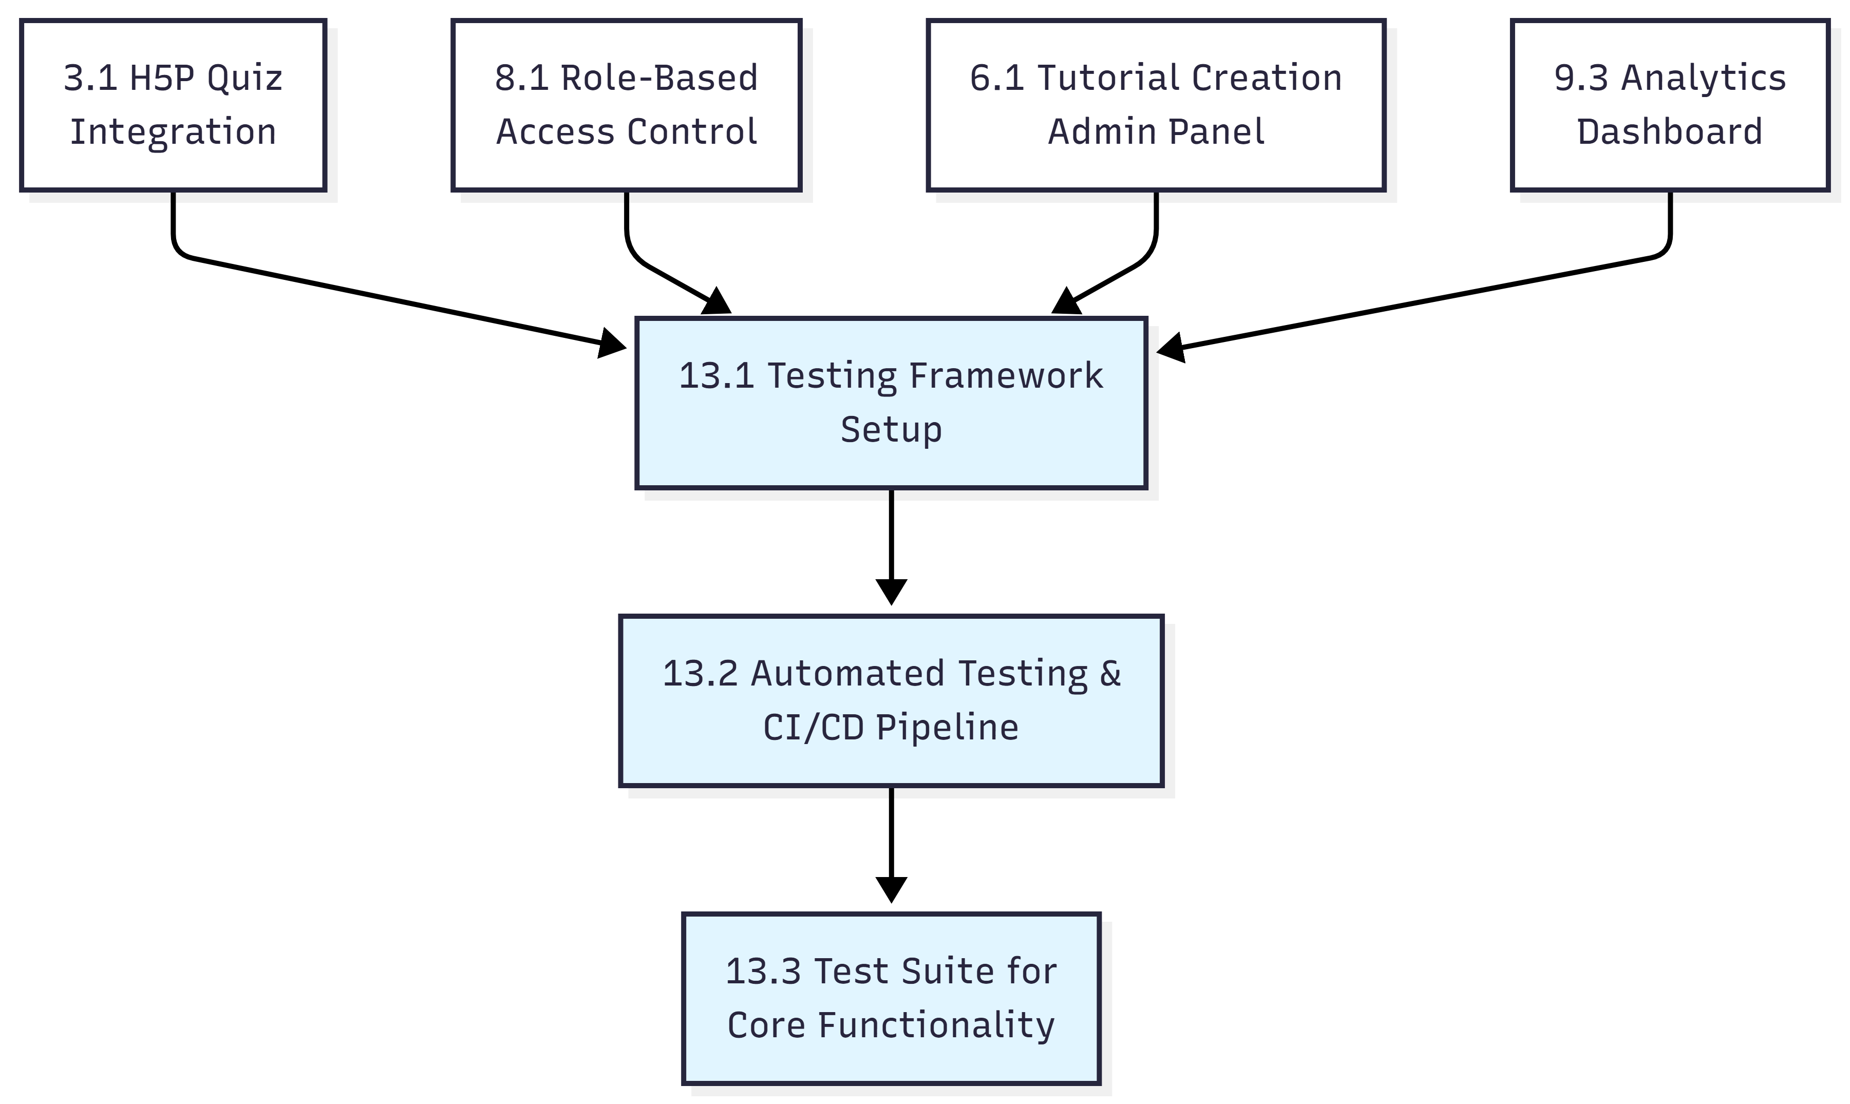

Activity Diagrams
1. Create Interactive Tutorial
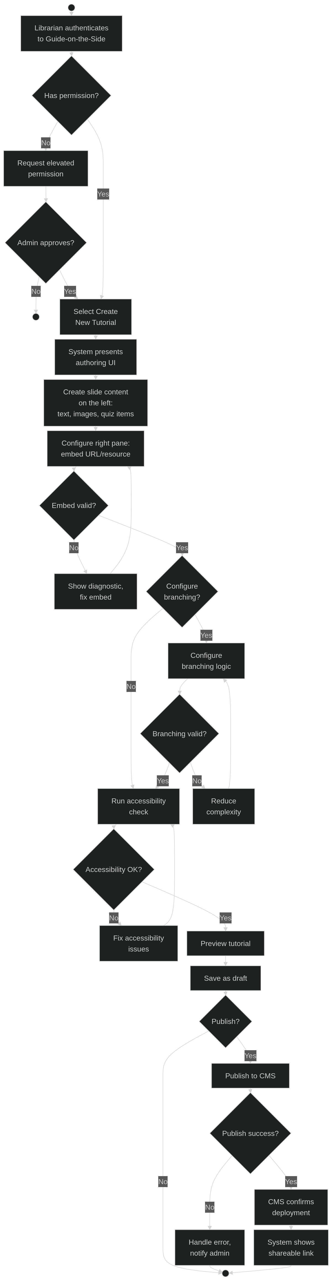
2. Create Interactive Tutorial Template
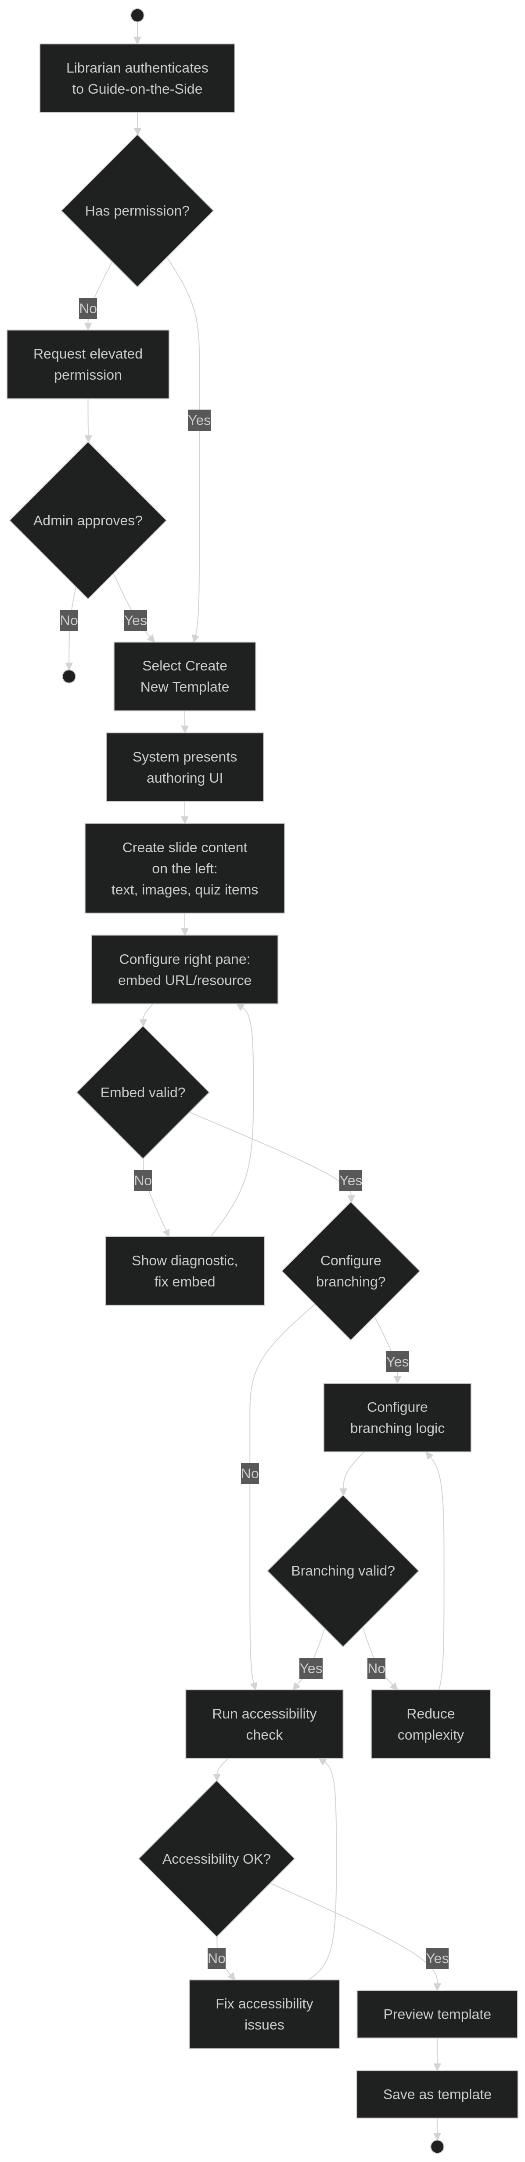
3. Edit/Update Tutorial
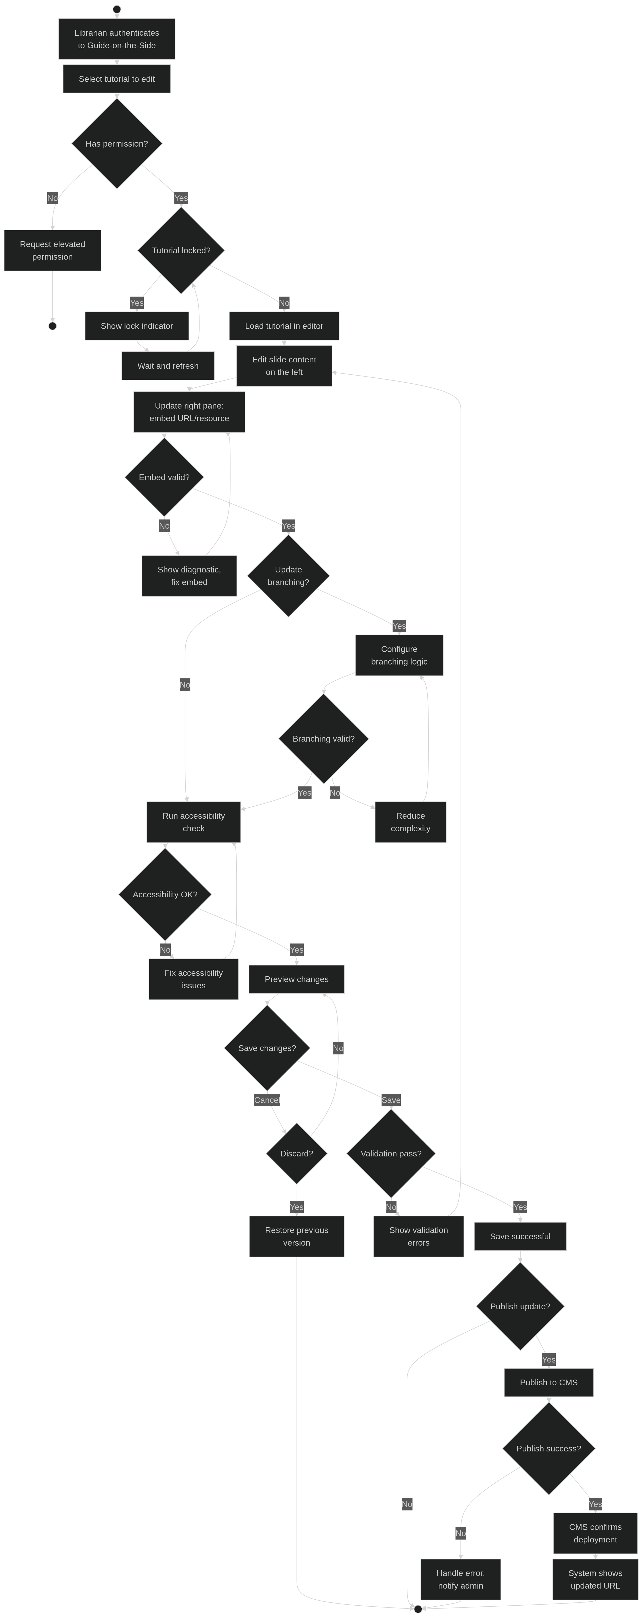
4. Student Completes Tutorial
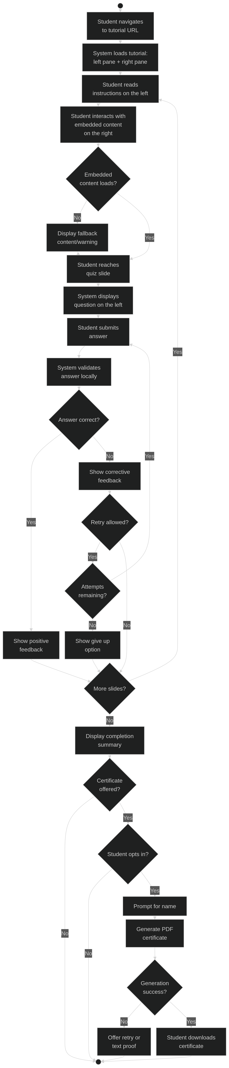
5. Create Branching Tutorial Linked to Other Tutorial
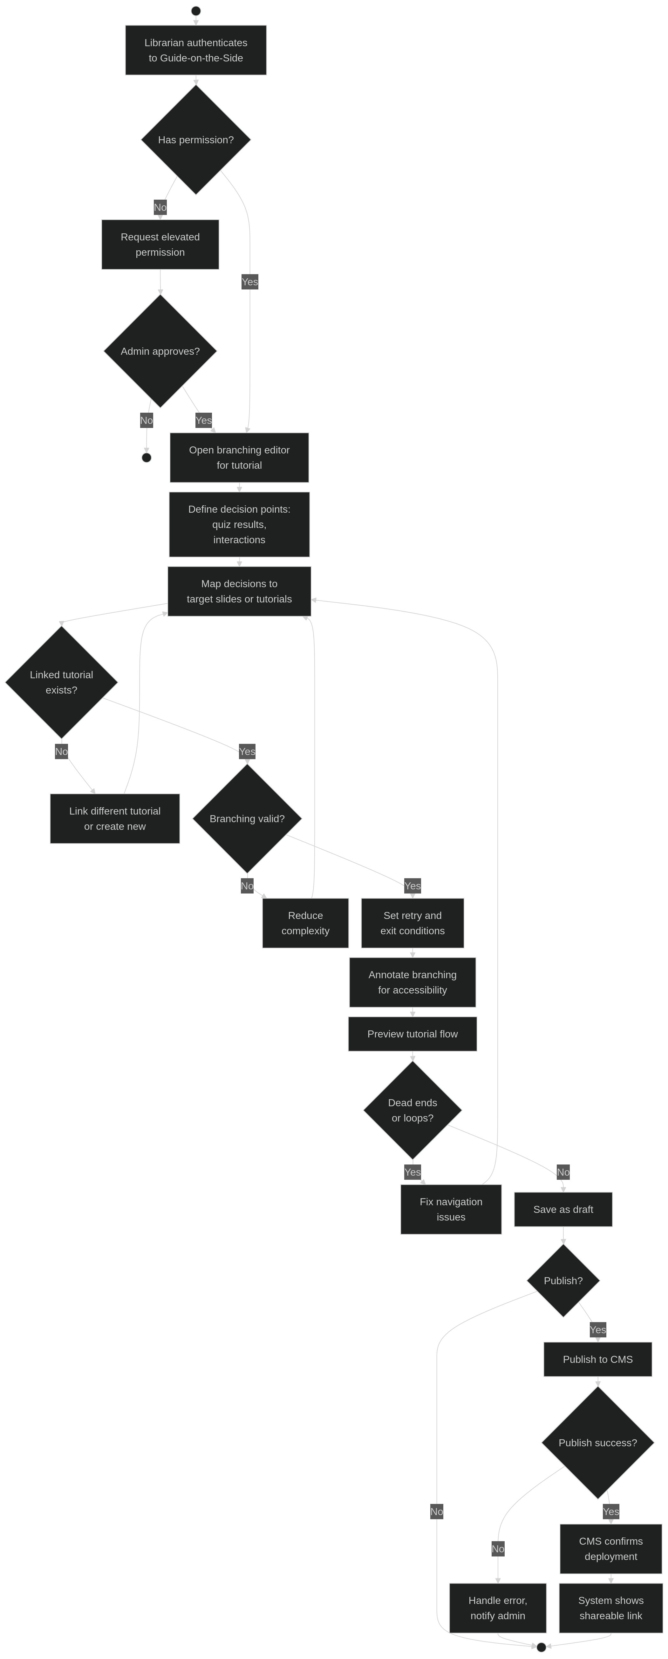
6. Generate Certificate Upon Successful Completion
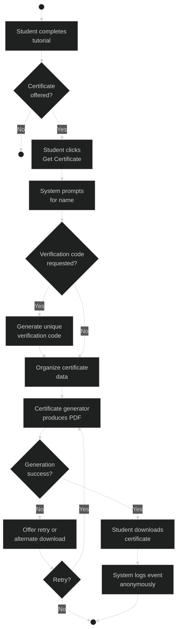
7. Manage Access and Permissions
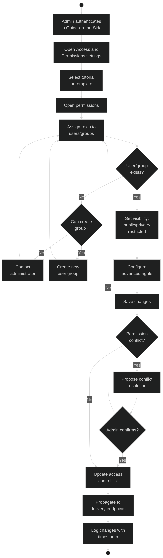
8. Analytics Dashboard
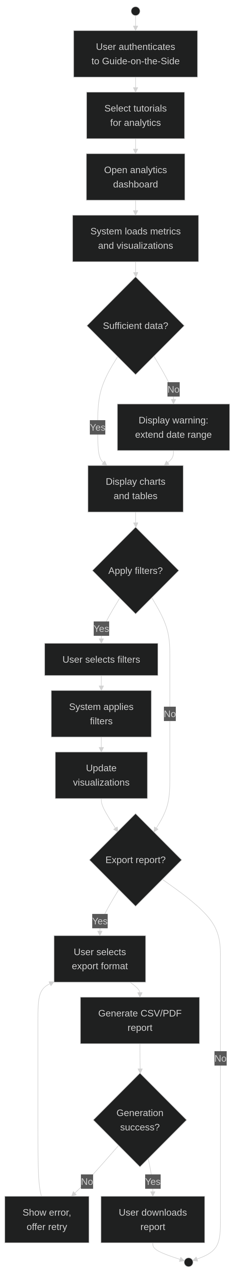
9. Recover Lost Password
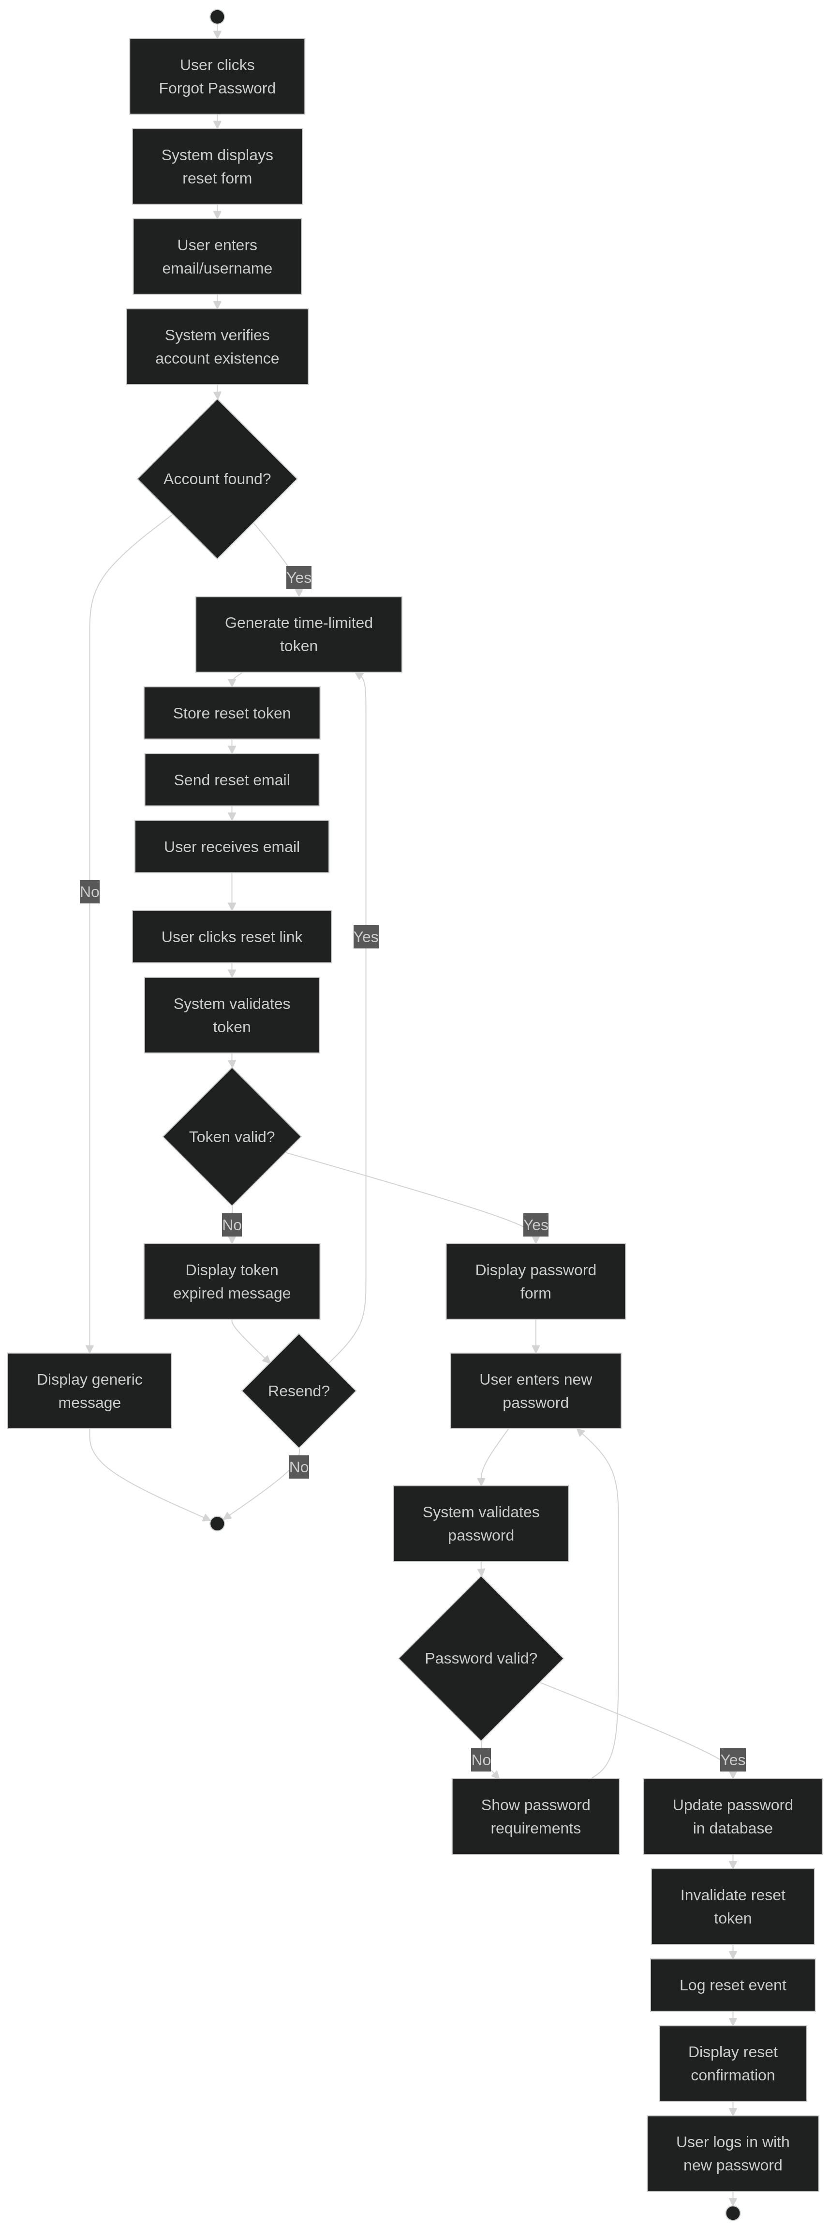

State Diagram
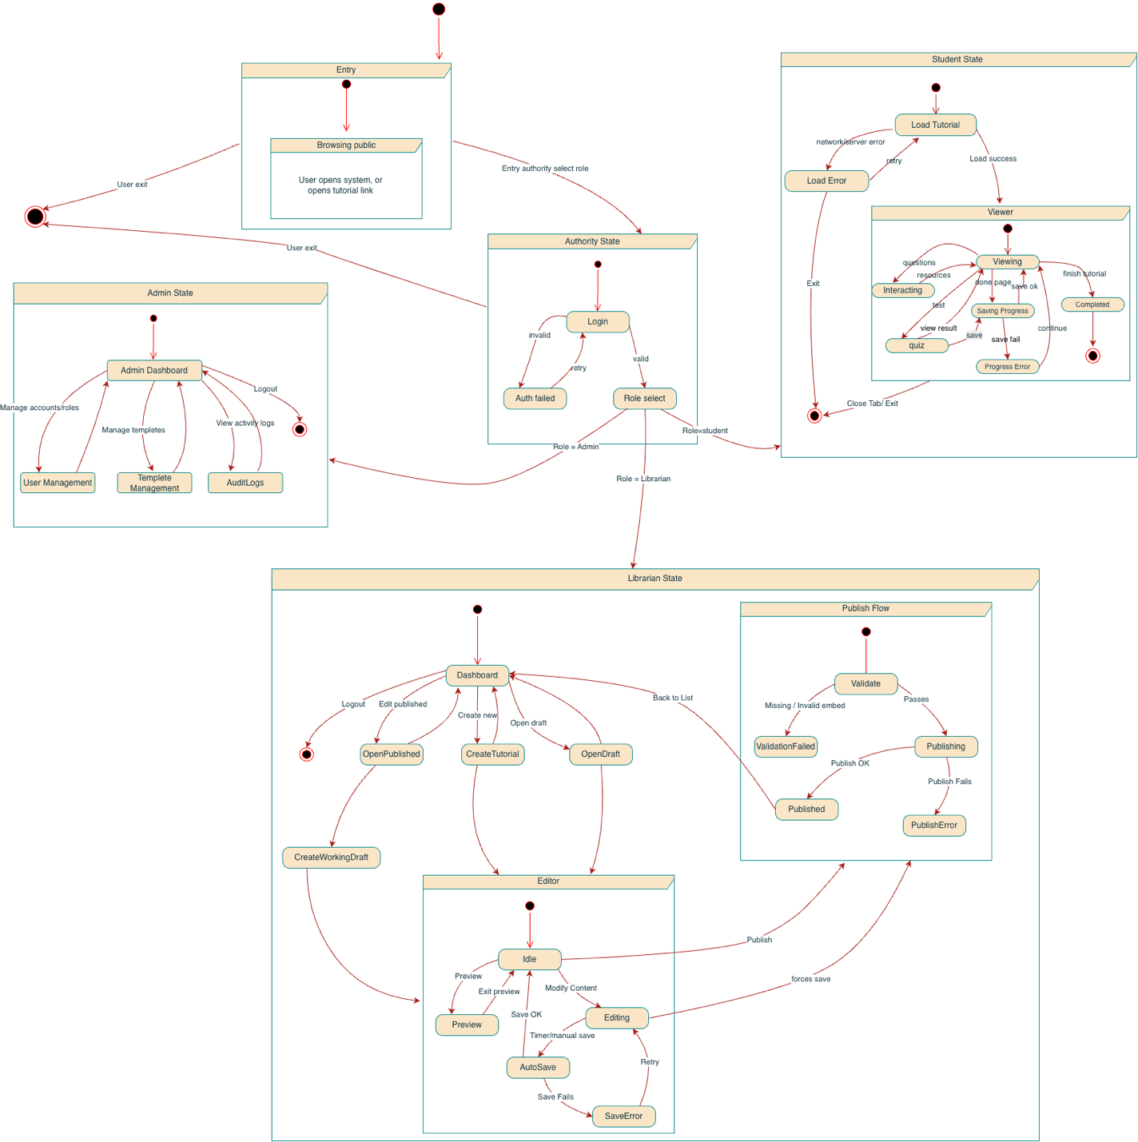

Sequence Diagrams
- Create Interactive Tutorial
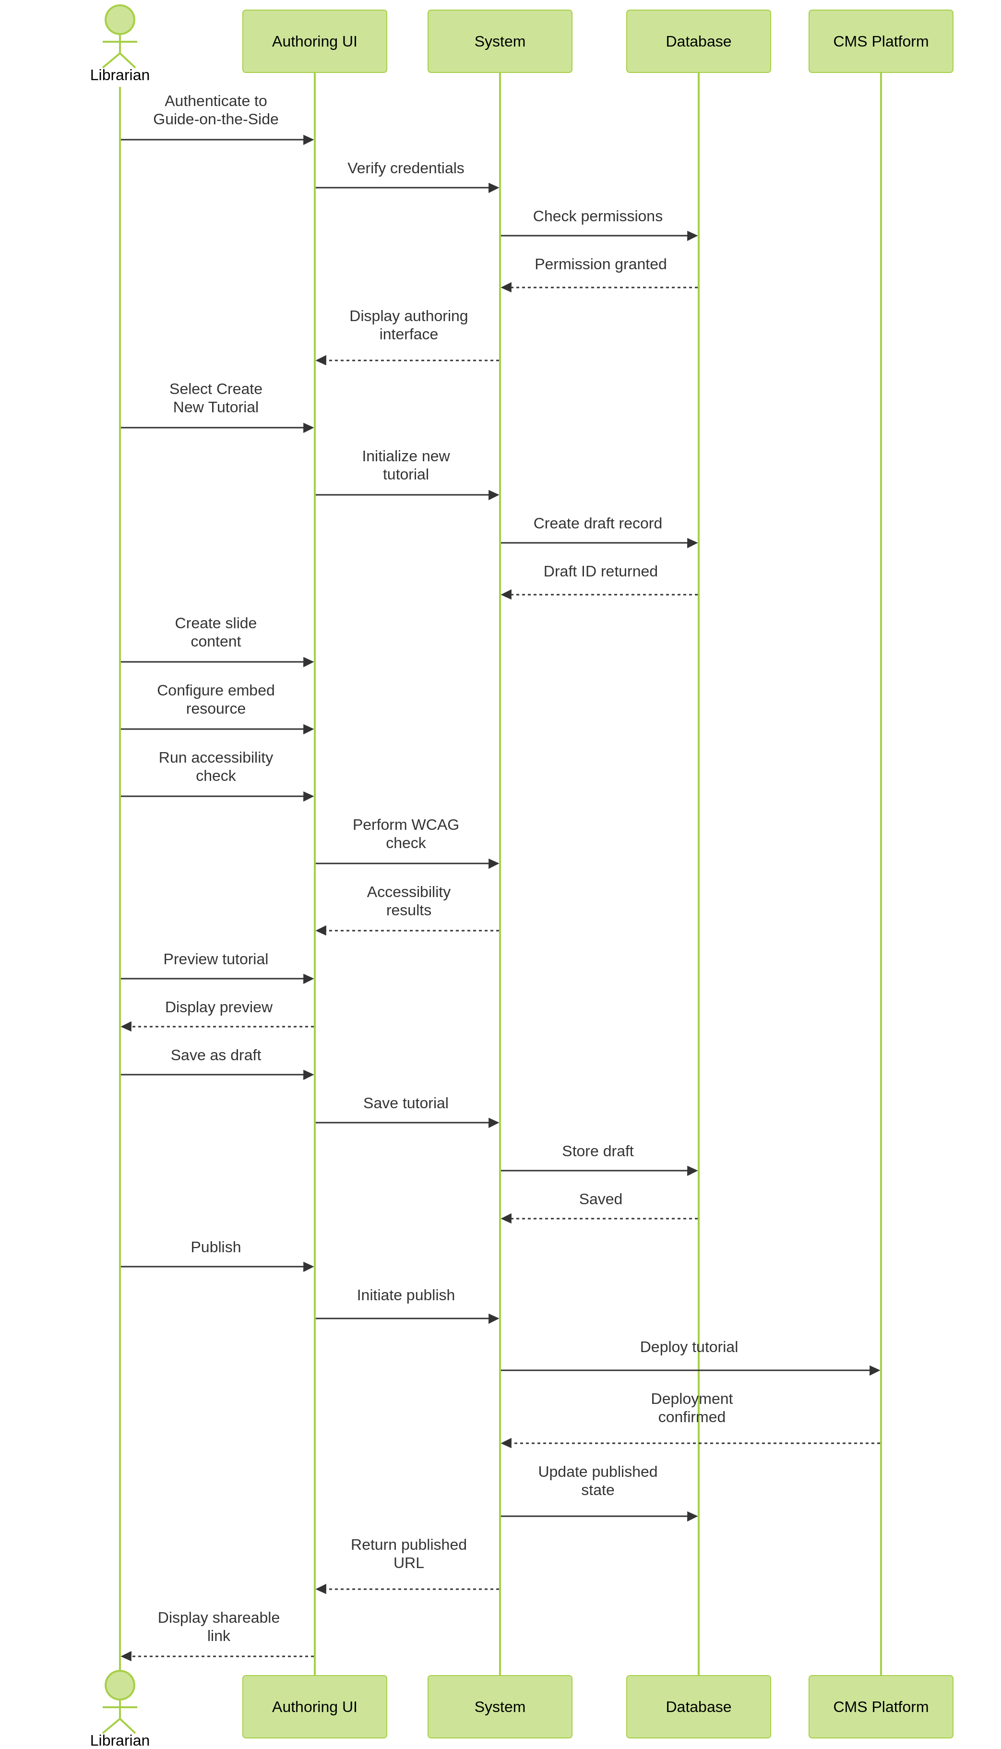
- Create Interactive Tutorial Template
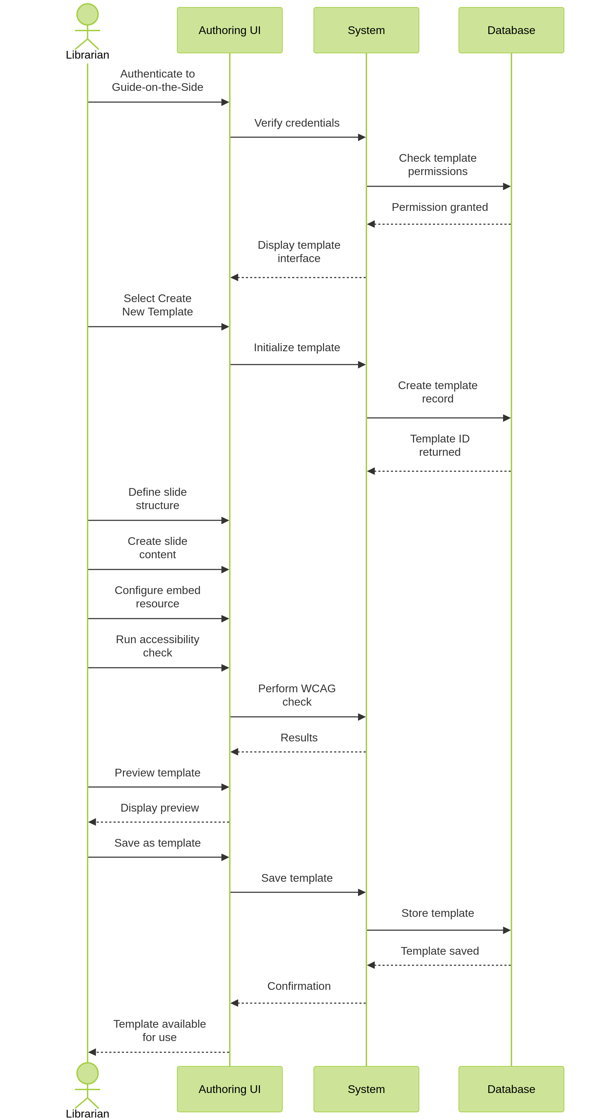
- Edit/Update Tutorial
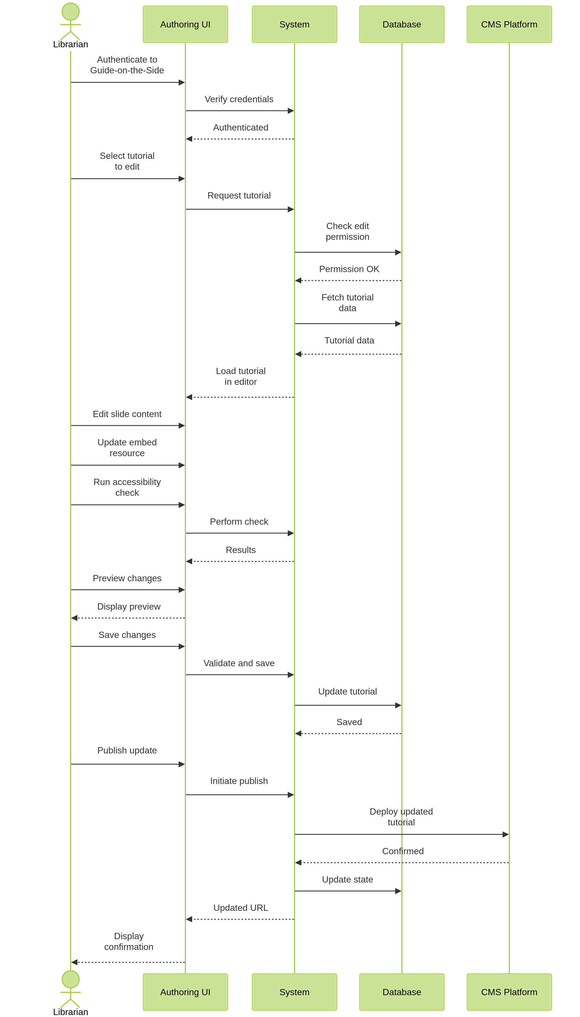
- Student Completes Tutorial
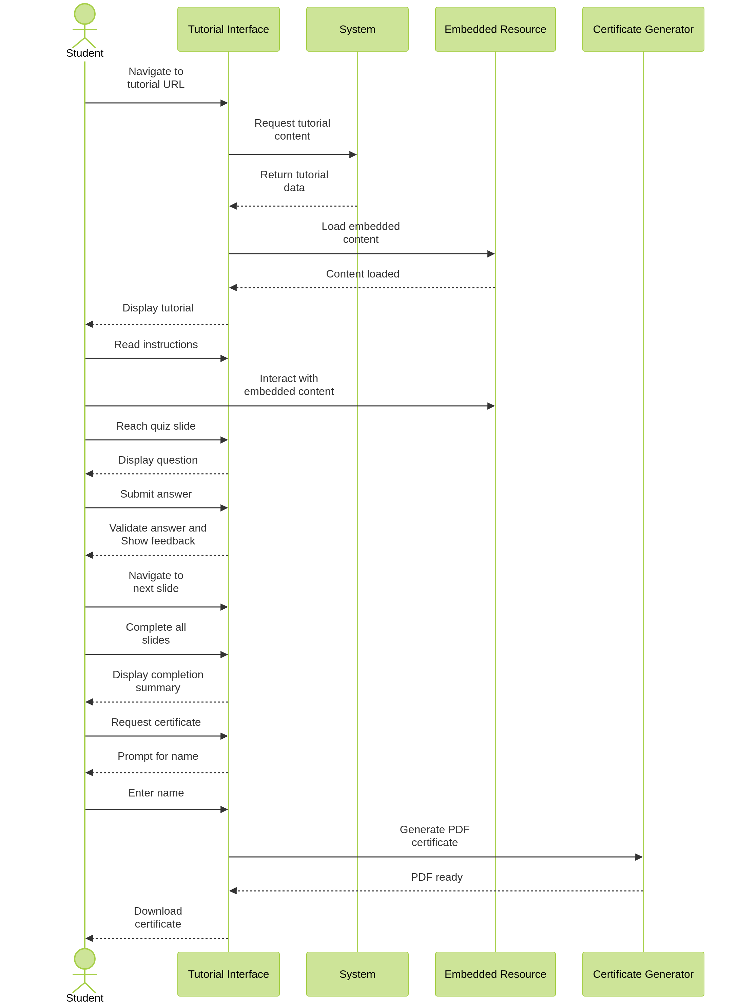
- Create Branching Tutorial Linked to Other Tutorial
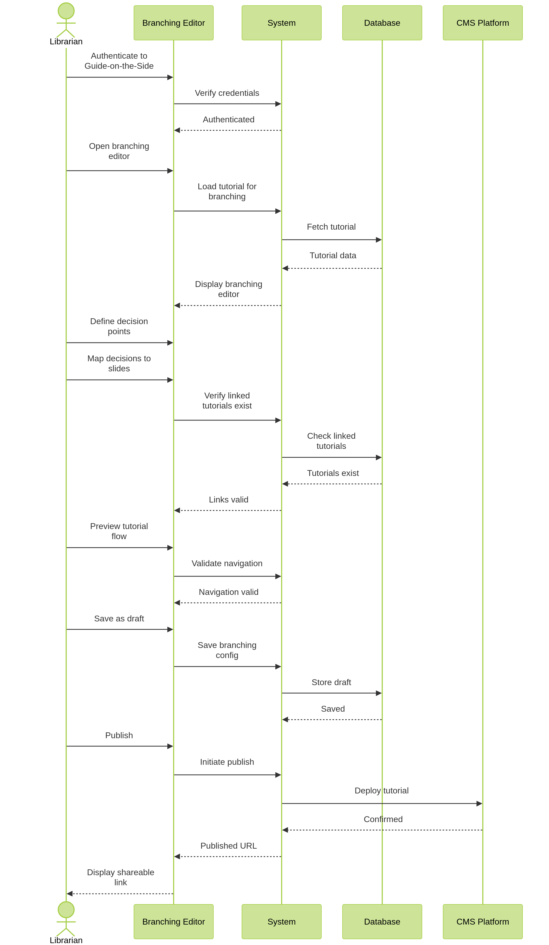
- Generate Certificate Upon Successful Completion of Tutorial
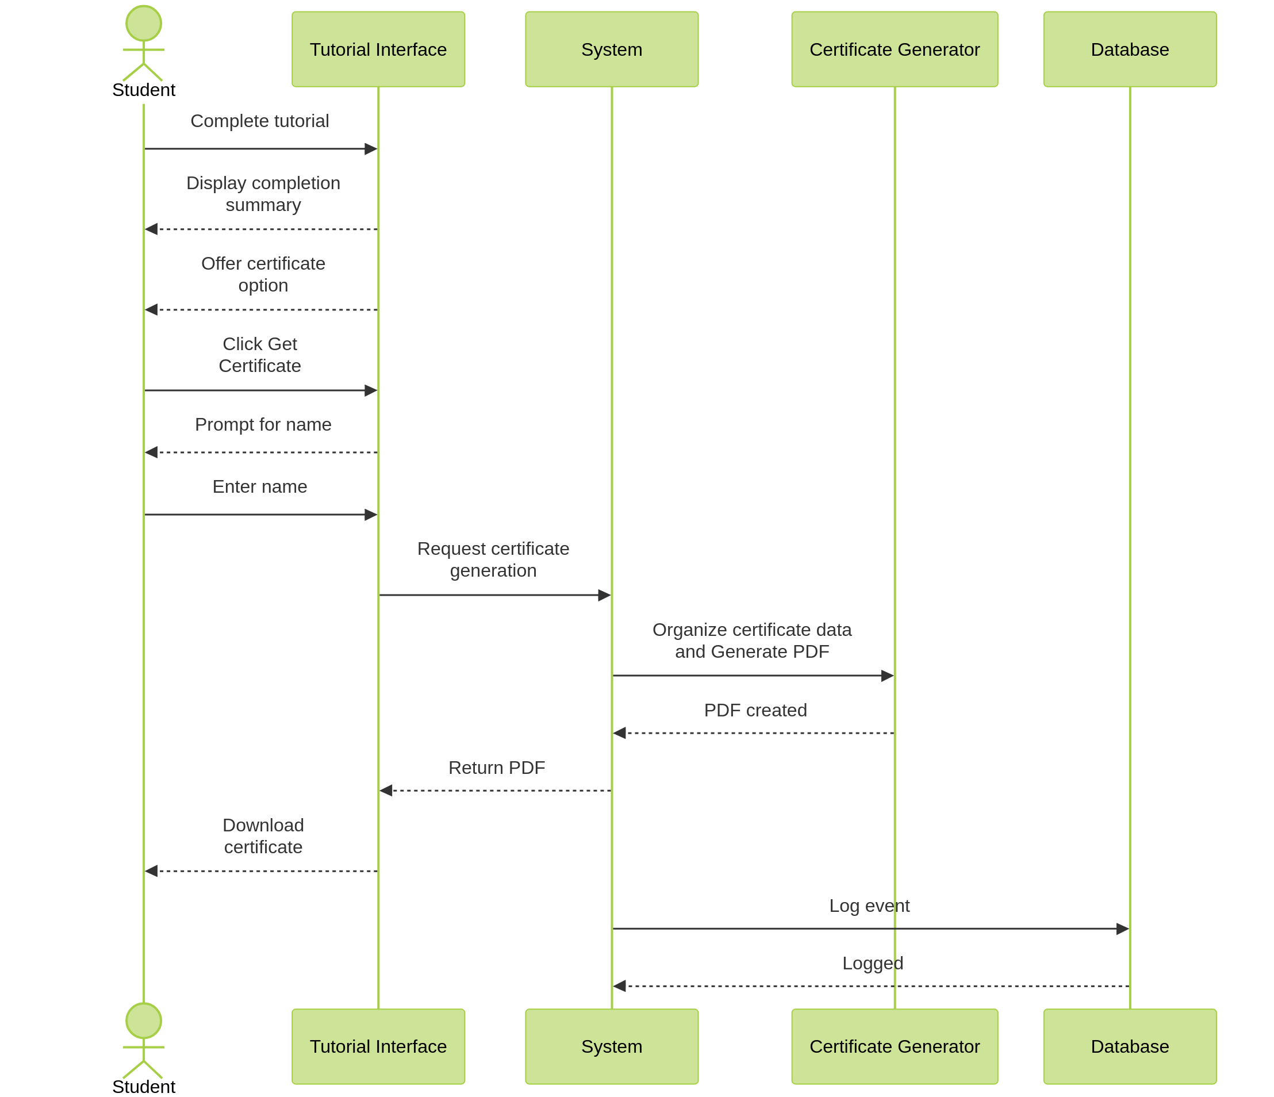

- Manage Access and Permissions
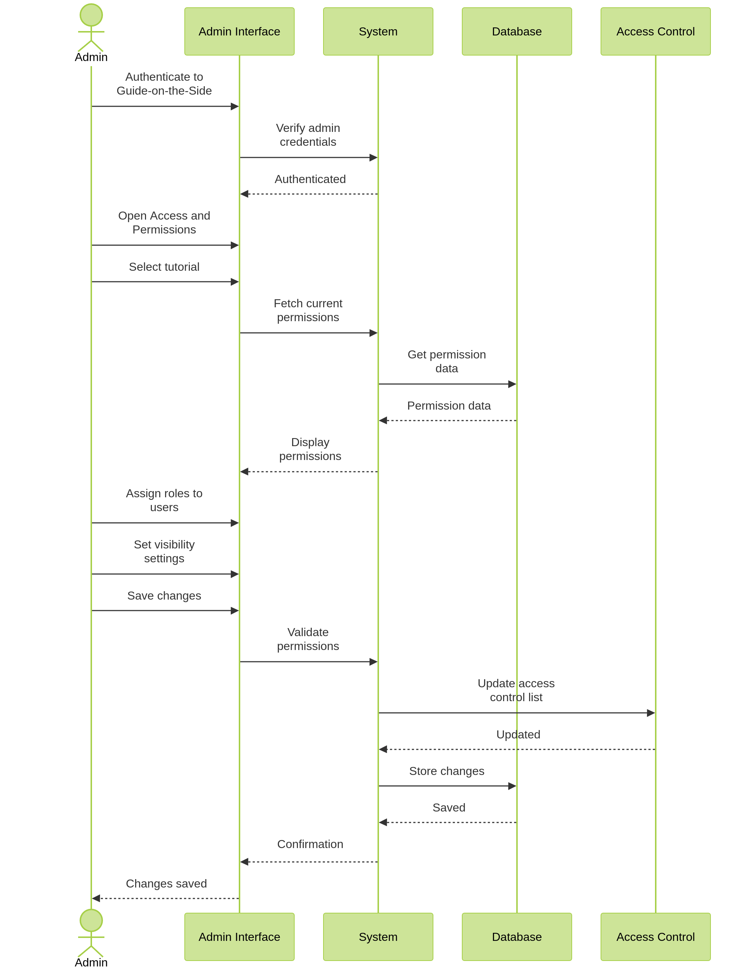

8. Analytics Dashboard
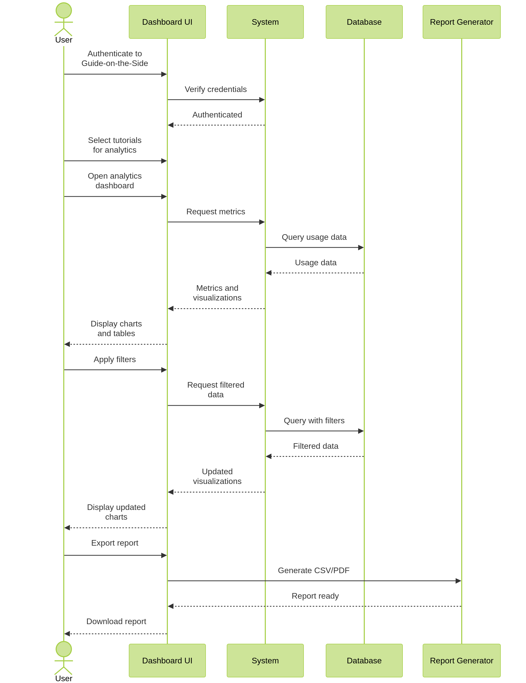

9. Recover Lost Password
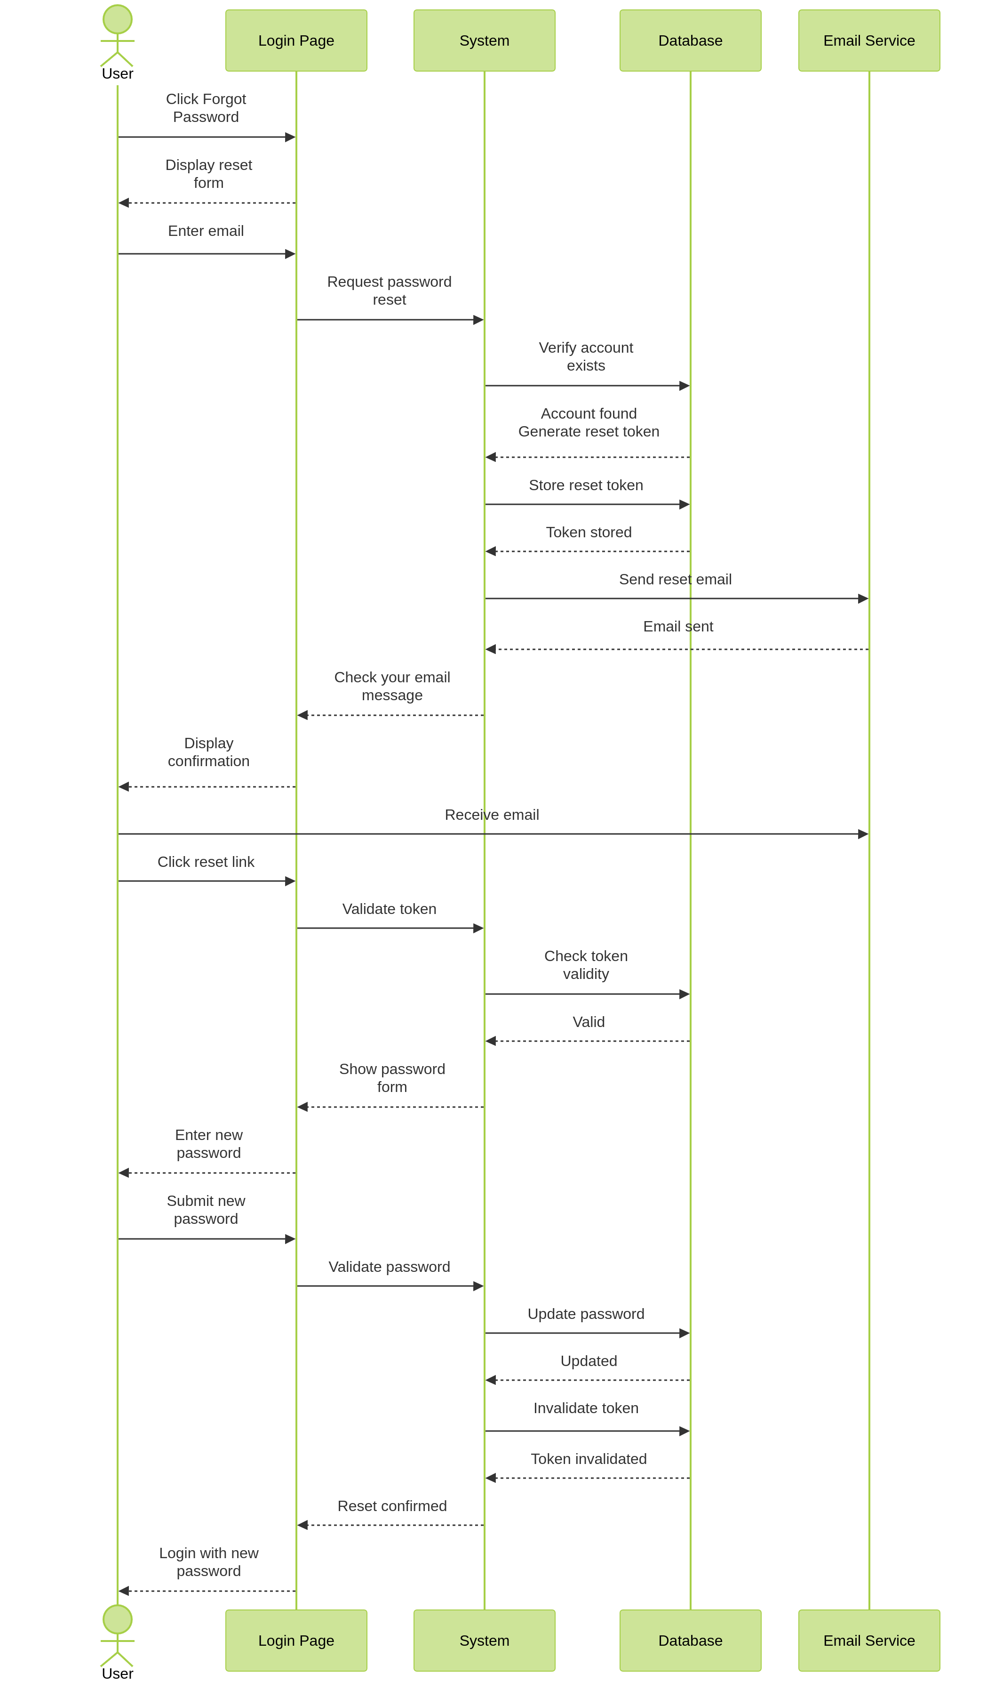

Project Testing Log - UPEI Guide-on-the-Side
This document maintains a history of development, peer reviews, and functional testing for the Pressbooks tutorial project.

Entry | Component | Date | Author | Reviewer
001 | CI Infrastructure | 2026-02-09 | Xiaohan
002 | CI Auto Stub | 2026-02-22 | Xiaohan
003 | Steps Data Normalization Unit Tests | 2026-02-22 | Xiaohan | Yang
004 | Integration Smoke Tests | 2026-03-02 | Xiaohan | Caleb
005 | Analytics Subsystem Unit Tests | 2026-03-04 | Enzo | Xiaohan
006 | README Refactor, Analytics Tracking & Code Cleanup | 2026-03-09 | Enzo | Xiaohan
007 | Certificate, H5P AJAX, Dashboard & JS Tests, Black-Box TC-11–TC-13 | 2026-03-10 | Xiaohan | Yang
008 | Template Picker & Export/Import Test Coverage | 2026-03-23 | Xiaohan | Daniel
009 | Merge main→develop: Test Fixes for RBAC + Template Picker + Upload Stubs | 2026-03-24 | Enzo | Xiaohan
010 | Accessibility Dashboard, Custom Themes, Keyboard Shortcuts & ARIA Labels | 2026-03-29 | Enzo
011 | Branch Sub-Tutorial Frontend Restoration (Cindy's lost merge code) | 2026-03-29 | Enzo
012 | pb-split-guide Test Gap Closure — Template/Export/H5P AJAX/A11y + Smoke Hook Strategy | 2026-03-30 | Xiaohan
013 | pb-split-guide Specific Confirmation Dialogs (delete step, leave page, librarian deactivate/reactivate) | 2026-03-30 | Xiaohan
014 | Analytics Audit Fixes — Branch Quiz Exclusion, Draft Filtering, Device Detection, Normalizer Bug | 2026-04-06 | Enzo
015 | PBSG_Certificate — mark_completed always latest timestamp + unit test alignment | 2026-04-06 | Xiaohan
016 | H5P Ownership, Template Duplication, Inline Name Editing + Benchmark Sliders + CSV Export Fix | 2026-04-09 | Enzo
017 | Tutorial Intro Layout, Branch H5P Conversion, Quiz Typography Refresh, H5P Edit Bug Fix | 2026-04-12 | Enzo
018 | Network Admin Menu Visibility Fix + Admin Guide + Dev Setup Guide Update | 2026-04-13 | Enzo

Log Entry: 001

1. Component Information
- Component Name: Automated Testing Infrastructure & Lightweight CI/CD Pipeline
- History (Date): February 9, 2026
- Generated By (Code Developer): Xiaohan Yu (Reagan)
- Reviewed By (Independent Reviewer): Peer review must be conducted by someone other than the developer.
Traceability
- Commit SHA: c3331ae
- Branch: testing-ci-setup → main

2. Black-Box Tests Performed
(Functional verification from a user/system perspective. No internal implementation details.)
- CI Workflow Trigger
- Input/Action: Push changes to testing-ci-setup and open a PR to main.
- Expected Result: GitHub Actions runs automatically for the PR.
- Actual Result: PASS
- Environment Configuration & Dependency Installation
- Input/Action: Run CI using .github/workflows/ci.yml.
- Expected Result: PHP version(s) configured in CI start successfully and dependencies install without conflicts.
- Actual Result: PASS
- Automated Test Execution & Report Generation
- Input/Action: Execute composer test in CI.
- Expected Result: PHPUnit completes and generates a JUnit XML report; report is uploaded as an artifact.
- Actual Result: PASS
- System Smoke Test (Minimal)
- Input/Action: Start the Pressbooks environment (Lando) and load the plugin/page related to the change.
- Expected Result: No fatal error; page renders; expected UI elements load.
- Actual Result: PASS

3. Verification Evidence
- CI Execution Run: https://github.com/qixiang03/guide-on-the-side/actions/runs/21838680073
- Artifacts (Actions → Run → Artifacts):
  - Artifact Name: phpunit-test-log
  - Contents/Path: build/junit.xml (JUnit XML test report)

Log Entry: 002

1. Component Information
- Component Name: CI Testing Log Auto-Stub Integration
- Date: February 22, 2026
- Generated By: Xiaohan Yu (Reagan)
- Reviewed By: Peer review must be conducted by someone other than the developer.
Traceability
- Commit SHA: 28fb28d
- Branch: testing-ci-setup → main

2. Black-Box Tests Performed
- Automatic Stub Generation
- Input/Action: Open a pull request targeting main.
- Expected Result: CI completes and automatically posts a testing-log stub comment in the PR.
- Actual Result: PASS
- CI Evidence Validation
- Input/Action: Navigate to the CI run page from the PR.
- Expected Result: The run page contains a downloadable artifact (phpunit-test-log) with build/logs/junit.xml.
- Actual Result: PASS

3. Verification Evidence
- CI Execution Run: https://github.com/qixiang03/guide-on-the-side/actions/runs/22287486178
- Artifacts (Actions → Run → Artifacts):
  - Artifact Name: phpunit-test-log
  - Contents/Path: build/logs/junit.xml

Log Entry: 003

1. Component Information
- Component Name: Steps Data Normalization Unit Tests
- Date: 2026-02-22
- Generated By: Xiaohan
- Reviewed By: Yang
Traceability
- Commit SHA: 14db22f
- Branch: testing-ci-setup → main

2. Black-Box Tests Performed
- Input: Legacy step with "url" only.
- Expected: Automatically migrated to tutorial_type = "url".
- Result: PASS
- Input: Invalid tutorial_type value.
- Expected: Normalized to "file" if attachment_id present.
- Result: PASS
- Input: Completely empty step row.
- Expected: Skipped during normalization.
- Result: PASS

3. Verification Evidence
- CI Run: https://github.com/qixiang03/guide-on-the-side/actions/runs/22289489877
- Artifact: phpunit-test-log
- JUnit Path: build/logs/junit.xml

Log Entry: 004

1. Component Information
- Component Name: Integration Smoke Tests (Plugin ↔ WordPress Wiring)
- Date: 2026-03-02
- Generated By: Xiaohan
- Reviewed By: Caleb
Traceability
- Commit SHA: 927b636
- Branch: testing-ci-setup → main
Approach: Lightweight WordPress function stubs that record hook registrations and function calls, allowing verification of plugin ↔ WP integration without a real WordPress runtime or database. H5P internals are explicitly excluded.

2. Black-Box Tests Performed
- Hook Registration (7 tests)
  - Input: Instantiate PB_Split_Guide_Plugin.
  - Expected: All 2 filters and 5 actions registered with correct WordPress hook names.
  - Result: PASS
- Template Registration (2 tests)
  - Input: Call register_page_template() with empty and pre-existing template arrays.
  - Expected: split-guide-template.php key added, existing templates preserved.
  - Result: PASS
- Template Loading (3 tests)
  - Input: Call load_page_template() under matching, non-page, and wrong-template conditions.
  - Expected: Returns plugin template path when matched; passes through original otherwise.
  - Result: PASS
- Meta Save Guards (5 tests)
  - Input: Call save_meta() with missing nonce, invalid nonce, autosave, insufficient capability, and valid conditions.
  - Expected: update_post_meta only called when all guards pass; normalizer applied to steps data.
  - Result: PASS
- Asset Enqueue — Frontend (3 tests)
  - Input: Call enqueue_assets() when not a page, wrong template, and correct template.
  - Expected: CSS only enqueued when template matches.
  - Result: PASS
- Asset Enqueue — Admin (3 tests)
  - Input: Call enqueue_admin_assets() for non-editor hooks, wrong post type, and page editor.
  - Expected: Scripts/styles/media/thickbox/localization only loaded on page editor.
  - Result: PASS
- AJAX Handler (1 test)
  - Input: Call ajax_list_h5p().
  - Expected: check_ajax_referer called with pbsg_h5p_picker before any DB access.
  - Result: PASS

3. Verification Evidence
- Local Run: 30 tests, 69 assertions, 0 failures (PHPUnit 9.6.34, PHP 8.3)
- CI Run: https://github.com/qixiang03/guide-on-the-side/actions/runs/22629367601
- Artifact: phpunit-test-log
- JUnit Path: build/logs/junit.xml

Log Entry: 005

1. Component Information
- Component Name: Analytics Subsystem Unit Tests
- Date: 2026-03-04
- Generated By: Enzo (Qi Xiang Phang)
- Reviewed By: Xiaohan
Traceability
- Commit SHA: 950572f
- Branch: develop → main
- Test Files:
  - tests/Unit/PBSGAnalyticsSchemaTest.php (17 tests)
  - tests/Unit/PBSGAnalyticsEventIngestionTest.php (31 tests)
  - tests/Unit/PBSGAnalyticsAggregationTest.php (23 tests)
  - tests/Unit/PBSGAnalyticsPrivacyTest.php (13 tests)
  - tests/Unit/PBSGAnalyticsDashboardApiTest.php (30 tests)
  - tests/Unit/PBSGAnalyticsCsvExportTest.php (16 tests)
  - tests/Unit/PBSGAnalyticsEdgeCaseTest.php (31 tests)
  - tests/Unit/Helpers/MockWpdb.php (test helper)
Approach: Lightweight WordPress function stubs (WPStubs) and MockWpdb that record function calls and SQL queries without a real WordPress runtime. Private/static methods tested via ReflectionMethod. Features requiring real WP infrastructure (dbDelta, header/exit) verified via source-code inspection. WPDieException simulates die() behavior in wp_send_json_* and wp_die stubs.

2. Black-Box Tests Performed
- Schema & Migration (17 tests)
  - Input: Inspect PBSG_Analytics source for CREATE TABLE statements.
  - Expected: 3 tables (pbsg_tutorial_stats, pbsg_question_stats, pbsg_daily_stats) with correct columns, types, unique keys, indexes, charset collation, and $wpdb->prefix usage.
  - Result: PASS
- Event Ingestion (31 tests)
  - Input: Call handle_track_event() with various HTTP methods, payloads, rate-limit states, and event types.
  - Expected: GET/PUT rejected (405), empty payload rejected (400), rate-limited requests blocked, valid events dispatched to correct recorder methods. 6 event types validated: tutorial_view, tutorial_complete, slide_view, quiz_attempt, quiz_giveup, session_flush. AJAX hooks registered for both nopriv and authenticated users.
  - Result: PASS
- Aggregation Logic (23 tests)
  - Input: Invoke private recorder methods (record_tutorial_view, record_tutorial_complete, record_quiz_attempt, record_quiz_giveup, record_session_flush, record_slide_view) with various data payloads.
  - Expected: SQL uses INSERT ... ON DUPLICATE KEY UPDATE upsert pattern. Counters increment correctly (total_views = total_views + 1). Time values accumulate. Daily stats bucketed by date. Device type included in queries. Step dwell times merged as JSON. format_time() produces correct Xm YYs output.
  - Result: PASS
- Privacy Compliance — PIPEDA (13 tests)
  - Input: Trigger rate limiting, tutorial view recording, quiz attempt recording, session flush with known IP addresses and user-agent strings.
  - Expected: Rate-limit transient keys use MD5 hash prefix (not raw IP). No IP address, user_id, session_id, cookie, username, email, or user_agent appears in any SQL query. CREATE TABLE schemas contain no PII columns. Device detection uses only HTTP_USER_AGENT header. Missing REMOTE_ADDR falls back to 'unknown'. Rate-limit TTL is 60 seconds.
  - Result: PASS
- Dashboard Data API (30 tests)
  - Input: Call handle_get_analytics() with unauthorized user, various view types (overview, tutorial, question, compare, unknown), date ranges, and tutorial IDs.
  - Expected: Unauthorized users receive 403 via wp_die. Overview returns totals, tutorials, daily_trend, device_breakdown, date_scope. Tutorial detail returns stats, daily_views, step_dwell, questions, giveup_rate. Question detail returns attempt_distribution, correct_rate, all_time scope. Date inputs sanitized against SQL injection and XSS. Dashboard hooks register on admin_menu. Assets conditionally enqueued only on analytics page.
  - Result: PASS
- CSV Export (16 tests)
  - Input: Call handle_export_csv() without admin capability; inspect source for CSV structure.
  - Expected: Unauthorized users rejected with wp_die('Unauthorized'). Source verifies edit_pages capability. 4 export types supported (overview, questions, question_detail, compare). Correct CSV headers for each type. Content-Type, Content-Disposition, and Cache-Control headers set. Uses fputcsv() for proper escaping. Writes to php://output. Default export type is overview.
  - Result: PASS
- Edge Cases & Regression (31 tests)
  - Input: Zero-tutorial states, empty tutorial lists, comparison with empty/zero/non-numeric IDs, question text exceeding 500 chars, absint() with negative/float/string/non-numeric values, zero and missing H5P content IDs, large time values (9000s), negative time input, rate-limit boundary (59 vs 60 requests), missing/empty step dwell times, zero-attempt division safety, negative third_plus_correct clamping.
  - Expected: All edge cases handled gracefully without errors or data corruption. Question text truncated at 500 chars. absint() returns 0 for invalid inputs. format_time() handles boundary values correctly. Rate limit blocks at exactly 60 requests. Division by zero avoided in percentage calculations.
  - Result: PASS

3. Verification Evidence
- Local Run: 206 tests (181 new + 25 existing), 418 assertions, 0 failures (PHPUnit 9.6.34, PHP 8.3, 0.105s)
- Test command: docker exec -w /app osspblocal_appserver_1 ./vendor/bin/phpunit
- CI Run: https://github.com/qixiang03/guide-on-the-side/actions/runs/22691597832
- Commit SHA: 950572f
- Artifact: phpunit-test-log
- JUnit Path: build/logs/junit.xml

Log Entry: 006

1. Component Information
- Component Name: README Refactor, Analytics Step Tracking Improvements & Code Cleanup
- Date: 2026-03-09
- Generated By: Enzo (Qi Xiang Phang)
- Reviewed By: Xiaohan
Traceability
- Commit SHA: d969ca6
- Branch: develop → main
- Changed Files:
  - README.md (documentation rewrite)
  - web/app/plugins/pb-split-guide/assets/split-guide-tracker.js (step tracking logic)
  - web/app/plugins/pb-split-guide/class-pbsg-analytics.php (backend analytics)
  - web/app/plugins/pb-split-guide/assets/analytics-dashboard.js (step name display)
  - web/app/plugins/pb-split-guide/pb-split-guide.php (legacy code removal)
  - web/app/plugins/pb-split-guide/assets/admin/admin-split-guide.css (stale CSS cleanup)
  - web/app/plugins/pb-split-guide/assets/split-guide.css (stale CSS cleanup)
  - tests/Unit/PBSGAnalyticsAggregationTest.php (removed format_time tests)
  - tests/Unit/PBSGAnalyticsEdgeCaseTest.php (removed format_time edge case tests)
  - tests/Integration/Helpers/WPStubs.php (stub updates)
  - tests/Unit/Helpers/MockWpdb.php (mock insert method)
Approach: Refactored analytics step tracking to use MutationObserver on actual DOM elements instead of unreliable hashchange events. Removed deprecated format_time() server-side utility (now client-side). Cleaned up legacy code and stale CSS rules.

2. Black-Box Tests Performed
- Step Tracking — MutationObserver Detection
  - Input/Action: Navigate between steps in a split-guide tutorial using Prev/Next buttons.
  - Expected: split-guide-tracker.js detects step changes via MutationObserver on #pbsgProgress element, matching both X / Y and X of Y progress text formats.
  - Result: PASS (local verification)
- Step Tracking — Button Click Interception
  - Input/Action: Click #pbsgPrev, #pbsgNext, and .pbsg-menu-item elements.
  - Expected: Tracker intercepts clicks on correct DOM IDs (not legacy .split-guide-prev/.split-guide-next class selectors).
  - Result: PASS (local verification)
- Analytics Backend — Device-Agnostic Daily Stats
  - Input/Action: Record a slide view when no daily stats row exists for the current day.
  - Expected: record_slide_view() fetches the row with highest view_count for the current day/tutorial (device-agnostic), and inserts a fallback row if none exists.
  - Result: PASS
- Analytics Backend — Step Names in Tutorial Detail
  - Input/Action: Call get_tutorial_detail() for a tutorial with named steps in _pbsg_steps_json.
  - Expected: Response includes step_names array with human-readable step labels from post meta.
  - Result: PASS
- Deprecated Code Removal — format_time()
  - Input/Action: Run full PHPUnit suite after removing format_time() from PBSG_Analytics and its associated tests.
  - Expected: All remaining tests pass. No references to format_time() in test files.
  - Result: PASS (195 tests, 407 assertions, 0 failures)
- Legacy Code Cleanup
  - Input/Action: Verify pb-split-guide.php no longer contains commented-out step-saving code, orphan meta constants, or unused role/permission methods.
  - Expected: Plugin file contains only active, used code. No stale CSS rules in asset files.
  - Result: PASS

3. Verification Evidence
- Local Run: 195 tests, 407 assertions, 0 failures (PHPUnit 9.6.34, PHP 8.3, 0.145s)
- Test command: lando phpunit --configuration phpunit.xml --testdox
- CI Run: https://github.com/qixiang03/guide-on-the-side/actions/runs/22822834296
- Commit SHA: d969ca6
- Artifact: phpunit-test-log
- JUnit Path: build/logs/junit.xml
- CI Status: FAIL (3 integration smoke test failures due to git auto-merge re-introducing removed code from main — see item 7 above)

Log Entry: 007

1. Component Information
- Component Name: Certificate, H5P AJAX, Dashboard Render & JS Tests; Black-Box TC-11–TC-13
- Date: 2026-03-10
- Generated By: Xiaohan
- Reviewed By: Yang
Traceability
- Commit SHA: 6e8d7cf
- Branch: main
- Test / doc changes:
  - New: tests/Unit/PBSGCertificateTest.php, tests/Unit/PBSGH5PAjaxTest.php, tests/Integration/Helpers/MockTCPDF.php, tests/js/ (Jest: admin-step-utils, split-guide-tracker), package.json
  - Modified: tests/Integration/Helpers/WPStubs.php (user stubs, nocache_headers, esc_html__), tests/Unit/Helpers/MockWpdb.php (get_var), tests/bootstrap.php (MockTCPDF), tests/Integration/PBSplitGuidePluginSmokeTest.php (Certificate init, activation hook), tests/Unit/PBSGAnalyticsDashboardApiTest.php (render_dashboard), tests/black-box-test-cases.md (TC-11–TC-13), tests/regression-checklist.md (Analytics & Certificate section)
Approach: Unit tests for PBSG_Certificate (ajax_mark_completed, ajax_download_certificate) and PB_Split_Guide_Plugin::ajax_list_h5p with MockWpdb; smoke tests for Certificate init and register_activation_hook; render_dashboard $_GET sanitization and data attributes; Jest tests for admin pure functions and tracker tutorial_view payload; black-box cases for Analytics Dashboard, certificate completion, and PDF download; regression checklist updated.

2. Black-Box Tests Performed
- Certificate — auth, nonce, tutorial validation (11 tests)
  - Input: ajax_mark_completed / ajax_download_certificate with not logged in, bad nonce, invalid tutorial_id, wrong template, not completed.
  - Expected: 401/403/400 and wp_send_json_error or wp_die as appropriate; valid flow updates user meta and returns success.
  - Result: PASS
- H5P AJAX — table existence and items (4 tests)
  - Input: ajax_list_h5p with table missing vs present, empty rows; referer check.
  - Expected: wp_send_json_error when table missing; wp_send_json_success with correct items structure; check_ajax_referer called.
  - Result: PASS
- Smoke — Certificate init and activation hook (2 tests)
  - Input: PBSG_Certificate::init(); plugin load in separate process.
  - Expected: wp_ajax_pbsg_mark_completed and wp_ajax_pbsg_download_certificate registered; register_activation_hook called with PBSG_Analytics::create_tables.
  - Result: PASS
- Dashboard render_dashboard — $_GET and data attributes (6 tests)
  - Input: render_dashboard() with various $_GET (tab, tutorial_id, h5p_id, q_index).
  - Expected: data-view, data-tutorial-id, data-h5p-id, data-q-index in output; tab/tutorial_id absint and sanitized.
  - Result: PASS
- JS — admin utils and tracker (15 tests)
  - Input: Jest tests for escapeHtml, safeParseJson, normalizeStep, tutorialSummary; tracker load with mocked fetch and pbsgTracker.
  - Expected: Pure functions match spec; tutorial_view event sent with correct payload and tutorial_page_id.
  - Result: PASS
- Black-box and regression docs
  - Input: TC-11 (Analytics Dashboard), TC-12 (Certificate completion), TC-13 (PDF download) in black-box-test-cases.md; Analytics & Certificate section in regression-checklist.md.
  - Expected: Manual regression can be run against these cases.
  - Result: DOC UPDATED

3. Verification Evidence
- PHP: 218 tests, 471 assertions, 0 failures (PHPUnit 9.6.34) — e.g. lando phpunit --configuration phpunit.xml --testdox
- JS: 15 tests, 2 suites (Jest) — e.g. npm run test:js
- CI Run: https://github.com/qixiang03/guide-on-the-side/actions/runs/22888090786
- Commit SHA: 6e8d7cf
- Artifact: phpunit-test-log; JUnit path: build/logs/junit.xml

Log Entry: 008

1. Component Information
- Component Name: Sprint 7 Template Picker & Export/Import Test Coverage
- Date: 2026-03-24
- Generated By: Xiaohan
- Reviewed By: Daniel
Traceability
- Branch: testing-ci-setup (local post-pull updates)
- Test / doc changes:
  - New: tests/Unit/PBSGTemplateManagerSchemaTest.php
  - New: tests/Unit/PBSGTemplateExportImportSourceTest.php
  - New: tests/Integration/PBSGSprint7AjaxSmokeTest.php
  - Modified: tests/black-box-test-cases.md (added TC-20 ~ TC-24; fixed "Librain" -> "Librarian")
  - Modified: tests/regression-checklist.md (added "Template Picker & Export/Import (Sprint 7)" section)
Approach: Added source-contract unit tests and integration smoke tests for Sprint 7 authoring features. Focused on schema/constants, token substitution contract, export/import package contract, AJAX guard/error paths, and manual black-box/regression coverage alignment with Sprint 7 checklist.

2. Black-Box Tests Performed
- Template Manager Schema Contract (4 tests)
  - Input: Inspect class-pbsg-template-manager.php constants and create-table source fragments.
  - Expected: Correct table constants (TABLE, DB_VER, OPT_VER), expected columns, dbDelta usage, schema version update, default seeded template metadata.
  - Result: PASS
- Template / Export-Import Source Contract (4 tests)
  - Input: Inspect class-pbsg-template-manager.php and class-pbsg-export-import.php source contract strings.
  - Expected: Template token placeholders ({{TUTORIAL_TITLE}}, {{AUTHOR_NAME}}, {{CURRENT_DATE}}, {{LIBRARY_CATALOG_URL}}) present; export package keys (pbsg_version, title, steps, attachments, etc.) present; attachment token mapping contract (att_<id>) present; invalid import file message present.
  - Result: PASS
- Sprint 7 AJAX Smoke (8 tests)
  - Input: Call ajax_get_templates, ajax_save_as_template, ajax_create_from_template, and PBSG_Export_Import::handle_import under WPStubs with capability/nonce/file permutations.
  - Expected: New hooks registered; nonce checks executed; forbidden access returns JSON 403; validation errors returned for missing template params / missing upload / invalid JSON package.
  - Result: PASS
- Black-box / Regression Documentation Alignment
  - Input: Compare Sprint 7 checklist to existing manual test docs.
  - Expected: Add missing manual cases for template-picker selection/title validation and import error/draft behavior.
  - Result: DOC UPDATED

3. Verification Evidence
- PHPUnit (new tests):
  - ./vendor/bin/phpunit tests/Unit/PBSGTemplateManagerSchemaTest.php -> PASS (4 tests)
  - ./vendor/bin/phpunit tests/Unit/PBSGTemplateExportImportSourceTest.php -> PASS (4 tests)
  - ./vendor/bin/phpunit tests/Integration/PBSGSprint7AjaxSmokeTest.php -> PASS (8 tests)
- JS baseline sanity run:
  - npm run test:js -- tests/js/admin-step-utils.test.js -> PASS
- Notes:
  - Vendor/php deprecation warnings appear during test execution but do not affect pass/fail outcomes.

Log Entry: 009

1. Component Information
- Component Name: Merge main→develop — Test Fixes for RBAC Gates, Hook Count, and Upload Stubs
- Date: 2026-03-24
- Generated By: Enzo (Qi Xiang Phang)
- Reviewed By: Xiaohan (Reagan)
Traceability
- Commit SHA: dc9442c
- Branch: main → develop (merge conflict resolution)
- Changed Files (test-side only — no production code changes):
  - tests/Unit/PBSGH5PAjaxTest.php (RBAC capability stub)
  - tests/Integration/PBSplitGuidePluginSmokeTest.php (action count 25→29)
  - tests/Integration/Helpers/WPStubs.php (wp_max_upload_size + size_format stubs)
Context: This merge combined two non-overlapping feature sets:
- develop: RBAC roles, inline H5P quiz factory (multichoice/blanks/singlechoice), dirty-state tracking, resizable split panes, performance benchmarks, file uploads, guide settings, structured intro fields
- main: Template picker with save-as-template, branch/sub-tutorial system for wrong-answer remediation, export/import, cover image, accessibility labels
Conflicts were resolved across 5 production files by preserving both sides. The 5 CI failures below were all test-side gaps caused by tests not yet accounting for features from the opposite branch.

2. Failures Diagnosed and Fixed

A. PBSGH5PAjaxTest — RBAC permission gate (3 failures)
- Root cause: develop added current_user_can('view_h5p_contents') to ajax_list_h5p() (line 1691 of pb-split-guide.php). The unit tests were written on main before this gate existed and did not stub the capability.
- Symptom: All 3 DB-level tests hit 'Insufficient permissions' before reaching table-existence or query logic.
Test | Pre-fix | Post-fix
test_returns_error_when_h5p_table_does_not_exist | FAIL — expected "H5P table not found", got "Insufficient permissions" | PASS
test_returns_success_with_items_when_h5p_table_exists | FAIL — assertFalse is true (wp_send_json_success never called) | PASS
test_returns_empty_items_when_table_exists_but_no_rows | FAIL — Trying to access array offset on null | PASS
test_checks_referer_before_db_access | PASS (unaffected) | PASS
- Fix: Added WPStubs::$returns['current_user_can'] = true; in setUp().
- Rationale: Test-side fix. The RBAC gate is correct production behavior from develop's security hardening.

B. PBSplitGuidePluginSmokeTest — Hook count mismatch (1 failure)
- Root cause: The merge added 4 new add_action calls from main's template picker system (lines 126–128: 3 AJAX handlers + line 131: admin_init for table creation). The expected count was still 25 from the previous merge.
- Symptom: Expected 25 actions but actual size 29.
Test | Pre-fix | Post-fix
test_total_hook_count_matches_expected | FAIL — 29 ≠ 25 | PASS
- Fix: Updated assertion from assertCount(25, ...) to assertCount(29, ...).
- Full constructor audit: See tests/logs/TEST-LOG-integration-SmokeTest-hookcount.md for the complete 29-action, 4-filter line-by-line breakdown.

C. PBSplitGuidePluginSmokeTest — Missing WP function stubs (1 failure)
- Root cause: develop added file-upload support to enqueue_admin_assets(), which calls wp_max_upload_size() and size_format() (lines 1534–1535). Neither was stubbed in WPStubs.php.
- Symptom: Call to undefined function wp_max_upload_size() when the smoke test invokes enqueue_admin_assets('post.php').
Test | Pre-fix | Post-fix
test_enqueue_admin_assets_loads_for_page_editor | FAIL — fatal: undefined function | PASS
test_enqueue_admin_assets_skips_non_editor_pages | PASS (unaffected) | PASS
test_enqueue_admin_assets_skips_non_page_post_type | PASS (unaffected) | PASS
- Fix: Added wp_max_upload_size() stub (returns 2097152 / 2 MB default, configurable via WPStubs::$returns) and size_format() stub (log-based unit conversion matching WP core behavior) to WPStubs.php.

3. Verification Evidence
- Local Run: 335 tests, 833 assertions, 0 failures (PHPUnit 9.6.34, PHP 8.3, 0.313s, 16.00 MB)
- Test command: lando phpunit --configuration phpunit.xml --testdox
- CI Run: https://github.com/qixiang03/guide-on-the-side/actions/runs/23476477137
- Artifact: phpunit-test-log
- JUnit Path: build/logs/junit.xml
- Detailed per-failure logs: tests/logs/TEST-LOG-unit-PBSGH5PAjaxTest.md, tests/logs/TEST-LOG-integration-SmokeTest-hookcount.md, tests/logs/TEST-LOG-integration-SmokeTest-enqueue.md

Log Entry: 010

1. Component Information
- Component Name: Accessibility Dashboard — Custom Admin Color Schemes, Keyboard Shortcuts & ARIA Labels
- Date: 2026-03-29
- Generated By: Enzo (Qi Xiang Phang)
- Code Developer: Caleb
- Reviewed By: Peer review must be conducted by someone other than the developer.
Traceability
- Commit SHA: 8a4b827
- Source Commits: 5f5b76b (feature, Caleb), b5847b3 (style cleanup, Caleb)
- Branch: develop
- Changed Files:
  - New: accessibility-dashboard/class-pbsg-accessibility-dashboard.php (622 lines — full dashboard class)
  - New: accessibility-dashboard/assets/accessibility-dashboard.js (121 lines — frontend toggle/persistence logic)
  - New: accessibility-dashboard/assets/accessibility-dashboard-profile.js (76 lines — profile page preview)
  - New: accessibility-dashboard/styles/admin-colors-colorblind.css (919 lines — colorblind-friendly admin theme)
  - New: accessibility-dashboard/styles/admin-colors-upei.css (915 lines — UPEI-branded admin theme)
  - New: accessibility-dashboard/styles/profile.css (186 lines — profile settings UI)
  - New: accessibility-dashboard/README.md (63 lines — feature documentation)
  - Modified: assets/split-guide.js (+34 lines — tutorial-active body class, ARIA label on tutorial iframe, custom keyboard shortcut handler via window.aeShortcuts)
  - Modified: templates/split-guide-template.php (+6 lines — ARIA landmark roles)
  - Modified: pb-split-guide.php (+1 line — require accessibility dashboard class)
  - Modified: assets/analytics-dashboard.css (-80 lines — removed hardcoded colors for theme compatibility)
  - Modified: assets/analytics-dashboard.js (+8 lines — empty title fallback, semantic button class)
  - Modified: assets/split-guide.css (-13 lines — removed hardcoded background/color values from menu, focus buttons, and step items)
  - Modified: class-pbsg-analytics-dashboard.php (-9 lines — replaced inline styles with semantic classes)
Approach: Added a full accessibility settings dashboard to the WordPress user profile page, allowing users to select custom admin color schemes (UPEI branded, colorblind-friendly), font families, font sizes, and keyboard shortcut bindings. A follow-up commit removed hardcoded color values from the split-guide and analytics dashboard CSS/JS so that all UI elements respect the active admin color scheme rather than overriding it.

2. Black-Box Tests Performed
- Admin Color Scheme Registration
  - Input/Action: Navigate to Users → Profile in WP Admin.
  - Expected: Two new color schemes appear: "UPEI Library" and "Colorblind Friendly", in addition to WordPress defaults.
  - Result: PASS
- Accessibility Profile Settings Section
  - Input/Action: Scroll to "Accessibility Enhancer" section on the user profile page.
  - Expected: Settings fields render for: Font Family (dropdown), Font Size (range), Custom Keyboard Shortcuts (prev/next/focus quiz/focus tutorial), with live preview.
  - Result: PASS
- Profile Save & Persistence
  - Input/Action: Change font to "UPEI Library Default", set font size to 18px, change shortcut keys, and save profile.
  - Expected: All settings persist via update_user_meta() and apply on next page load. Shortcuts saved as individual user meta keys (ae_shortcut_prev, ae_shortcut_next, etc.).
  - Result: PASS
- Custom Keyboard Shortcuts on Frontend Tutorial
  - Input/Action: Open a split-guide tutorial page. Press the configured shortcut keys for prev/next/focus quiz/focus tutorial.
  - Expected: window.aeShortcuts object populated from wp_localize_script(). Keydown handler skips when focus is in INPUT/TEXTAREA/SELECT or contentEditable. Prev/Next buttons clicked programmatically. Focus toggles work.
  - Result: PASS
- ARIA Labels & Landmark Roles
  - Input/Action: Inspect the split-guide template HTML output.
  - Expected: Tutorial iframe has aria-label="Tutorial Frame". Template includes ARIA landmark attributes on main content areas.
  - Result: PASS
- Body Class for Tutorial Pages
  - Input/Action: Load a split-guide tutorial page. Inspect document.body.classList.
  - Expected: tutorial-active class added immediately on script execution.
  - Result: PASS
- Theme Compatibility — Hardcoded Color Removal
  - Input/Action: Switch between "Default", "UPEI Library", and "Colorblind Friendly" admin color schemes. View the split-guide tutorial, menu dropdown, focus buttons, and analytics dashboard.
  - Expected: No hardcoded background, color, or :hover background values override the active theme. Menu buttons, step items, focus buttons, and analytics export button all inherit theme colors.
  - Result: PASS
- Analytics Dashboard — Empty Title Fallback
  - Input/Action: Create a tutorial with no title. Open the analytics dashboard comparison view.
  - Expected: Tutorial dropdown shows "(no title)" instead of an empty option.
  - Result: PASS
- Colorblind-Friendly Theme Contrast
  - Input/Action: Activate "Colorblind Friendly" color scheme. Navigate across WP admin pages.
  - Expected: All UI elements meet WCAG AA contrast ratios. No reliance on color alone for state indication.
  - Result: PASS

3. Verification Evidence
- Tested on: Pressbooks Local (Lando), PHP 8.3, WordPress 6.x
- Browser: Google Chrome (latest)
- Source commits: 5f5b76b (feat), b5847b3 (style)
- Verification method: Manual browser testing + DOM inspection via Chrome DevTools
- No automated tests added in this commit (frontend-only feature, tested manually)

Log Entry: 011

1. Component Information
- Component Name: Branch Sub-Tutorial Frontend Restoration — Cindy's Code Lost in Merge 8f14a70
- Date: 2026-03-29
- Generated By: Enzo (Qi Xiang Phang)
- Code Developer: Cindy (original branch code), Enzo (restoration)
- Reviewed By: Peer review must be conducted by someone other than the developer.
Traceability
- Commit SHA: 1401a68
- Source Commit: 9d5e740 (restoration by Enzo), original code from 634d035 (Cindy's branch), images from 7482705
- Branch: develop
- Implementation Plan: docs/PLAN-restore-cindy-branch-subtutorials.md
- Changed Files:
  - Modified: assets/split-guide.js (+388/-17 lines — 10 branch functions, branch DOM refs, state variables, branch-aware updatePassState, mandatory branch blocking in render(), state clearing in resetTutorialToStart(), branch button event handlers, Vimeo/Dailymotion/TED embed URL parsers, removed pre-existing duplicate functions)
  - Modified: templates/split-guide-template.php (+40 lines — branch data assembly in PHP step enrichment loop, branch modal HTML with accessible dialog markup)
  - Restored: assets/images/tutorial cover 1.png (11,813 bytes)
  - Restored: assets/images/tutorial cover 2.png (8,618 bytes)
  - Restored: assets/images/tutorial cover 3.png (123,363 bytes)
Context: During the merge of main→develop at commit 8f14a70, conflict resolution favored the develop side for split-guide.js and split-guide-template.php, which dropped Cindy's entire branch sub-tutorial frontend system (~430 lines). The admin-side code (admin-split-guide.js branch picker UI, split-guide.css branch modal styles, steps-normalizer.php branch field validation) was NOT lost and remained intact on develop. This restoration extracted Cindy's exact code verbatim from commit 634d035 and inserted it into the current develop HEAD, alongside Enzo's additions (resize handle, structured intro, accessibility shortcuts) that didn't exist in Cindy's version.

2. Black-Box Tests Performed
- Branch Modal DOM Elements Resolve
  - Input/Action: Load a split-guide tutorial page with branch-configured steps. Run document.getElementById() for all 7 branch DOM refs (pbsgBranchModal, pbsgBranchText, pbsgBranchOpen, pbsgBranchReturn, pbsgBranchComplete, pbsgBranchSkip, pbsgBranchClose).
  - Expected: All 7 elements resolve (not null) when branch modal HTML is present in template.
  - Result: PASS
- Branch Detection — hasBranch(step)
  - Input/Action: Inspect steps array via browser console. Steps 1 and 2 have branch.mode set to "optional" and "mandatory" respectively; Step 3 has "none".
  - Expected: hasBranch() returns true for Steps 1 and 2, false for Step 3.
  - Result: PASS
- Optional Branch Triggering (Step 1 — trigger after 1 wrong attempt)
  - Input/Action: Answer the fill-in-the-blank quiz incorrectly once on Step 1.
  - Expected: Branch modal appears with title, intro text, "Start" button, "Skip" button, and Close (×) button. NEXT remains locked.
  - Result: PASS
- Optional Branch — Skip Button
  - Input/Action: Click "Skip" on the optional branch modal.
  - Expected: Modal dismisses. Quiz resets to allow retry. NEXT remains locked until correct answer.
  - Result: PASS
- Optional Branch — Close Button
  - Input/Action: Trigger optional branch again. Click the Close (×) button.
  - Expected: Modal dismisses. Same behavior as Skip.
  - Result: PASS
- Optional Branch — Correct Answer Clears Branch
  - Input/Action: After triggering optional branch, answer the quiz correctly.
  - Expected: Branch UI resets (no modal, no banner). NEXT unlocks.
  - Result: PASS
- Mandatory Branch Triggering (Step 2 — trigger after 2 wrong attempts)
  - Input/Action: Navigate to Step 2. Trigger mandatory branch (wrong answers reach threshold).
  - Expected: Mandatory branch modal appears with title "Need a mandatory helpful review?", intro text, and enforcement message "You can continue only after you finish this sub-tutorial and answer the main quiz correctly."
  - Result: PASS
- Mandatory Branch — No Skip, No Close
  - Input/Action: Inspect the mandatory branch modal UI.
  - Expected: No "Skip" button visible. No Close (×) button visible. Only "Start" and "I Finished This Sub-Tutorial" buttons present.
  - Result: PASS (verified via zoomed screenshot)
- Mandatory Branch — "I Finished" Flow
  - Input/Action: Click "I Finished This Sub-Tutorial" on the mandatory branch modal.
  - Expected: Modal dismisses. Branch marked as completed. NEXT remains locked (quiz not yet answered correctly).
  - Result: PASS
- Mandatory Branch — Dual Gate Unlock
  - Input/Action: After completing mandatory branch, answer the quiz correctly ("bonjour").
  - Expected: NEXT unlocks only when BOTH conditions are met (branch completed AND quiz correct).
  - Result: PASS
- No Branch Step (Step 3 — branch mode "none")
  - Input/Action: Navigate to Step 3. Answer incorrectly.
  - Expected: Standard wrong-answer behavior (0/1, Retry). No branch modal appears regardless of wrong answer count.
  - Result: PASS
- Branch Data Assembly in PHP
  - Input/Action: Inspect steps array in browser console (JSON.parse(document.querySelector('[data-steps]')...)).
  - Expected: Each step contains branch object with mode, trigger_attempts, title, intro, and tutorial sub-object (type, url, file_url, mime).
  - Result: PASS
- Vimeo URL Embed Conversion
  - Input/Action: Call toEmbeddableUrl() with https://vimeo.com/123456789, https://vimeo.com/channels/staffpicks/987654, https://player.vimeo.com/video/111222333.
  - Expected: All convert to https://player.vimeo.com/video/{id}.
  - Result: PASS
- Dailymotion URL Embed Conversion
  - Input/Action: Call toEmbeddableUrl() with https://www.dailymotion.com/video/x8abcde and https://dai.ly/x8abcde.
  - Expected: Both convert to https://www.dailymotion.com/embed/video/x8abcde.
  - Result: PASS
- TED URL Embed Conversion
  - Input/Action: Call toEmbeddableUrl() with https://www.ted.com/talks/sir_ken_robinson_do_schools_kill_creativity and https://embed.ted.com/talks/already_embedded.
  - Expected: First converts to https://embed.ted.com/talks/sir_ken_robinson_do_schools_kill_creativity. Second passes through unchanged.
  - Result: PASS
- Duplicate Function Cleanup
  - Input/Action: Run node -c split-guide.js and grep for getFinalGradePercent and hasIntroScreen.
  - Expected: Zero syntax errors. Each function appears exactly once (pre-existing duplicates at former lines 1081/1090 removed).
  - Result: PASS
- No Regressions — Existing Features
  - Input/Action: Verify menu dropdown, Focus Quiz/Tutorial buttons, structured intro screen, progress bar, keyboard shortcuts, and navigation (Prev/Next) all still function.
  - Expected: All existing features work as before. Resize handle correctly not rendered (gated behind $user_resizable PHP flag, not enabled on test tutorial).
  - Result: PASS

3. Verification Evidence
- Tested on: Pressbooks Local (https://pressbooks.test), PHP 8.3, WordPress 6.x
- Browser: Google Chrome (latest) via Chrome + manual DOM inspection
- JS syntax check: node -c split-guide.js — 0 errors
- Source commit: 9d5e740 (restoration from 634d035 verbatim)
- Implementation plan: docs/PLAN-restore-cindy-branch-subtutorials.md — all 10 insertion steps executed
- Verification checklist: 12/12 items from plan's verification section confirmed
- No automated tests added (frontend-only feature; admin branch picker already on develop)

Log Entry: 012

1. Component Information
- Component Name: pb-split-guide automated test gap closure (unit + integration smoke strategy + Jest)
- Date: 2026-03-30
- Generated By: Xiaohan
- Reviewed By: Peer review must be conducted by someone other than the developer.
Traceability
- Branch: (current develop / feature branch as applicable)
- Test / infrastructure changes:
  - Modified: tests/Integration/PBSplitGuidePluginSmokeTest.php — replaced fragile exact hook counts with test_constructor_registers_expected_plugin_hooks (asserts required filter/action tags + minimum admin_init / admin_menu callbacks).
  - Modified: tests/Integration/Helpers/WPStubs.php — WP_Error / is_wp_error, upload constants, post/media helpers (wp_insert_post, get_edit_post_link, media_handle_upload, get_attached_file, get_posts, get_permalink, wp_get_current_user), sanitization helpers, optional current_user_can_resolver callable for per-capability tests.
  - Modified: tests/Unit/Helpers/MockWpdb.php — delete() for template row removal tests.
  - New: tests/Unit/PBSGTemplateManagerTest.php — PBSG_Template_Manager (maybe_create_tables no-op when version matches, CRUD-ish paths, create_from_template blank + missing template).
  - New: tests/Unit/PBSGExportImportTest.php — PBSG_Export_Import::init, export permission/missing post (wp_die), import permission/upload/invalid JSON/minimal successful package.
  - New: tests/Unit/PBSGH5PFactoryTest.php — invalid quiz types, reverse() round-trips via reflected build_params, generate_title via reflection.
  - New: tests/Unit/PBSGPluginAjaxHandlersTest.php — ajax_get_templates, ajax_save_as_template, ajax_create_from_template, ajax_upload_file, ajax_create_h5p, ajax_get_h5p_content, ajax_list_tutorials (guards + selected success paths).
  - New: tests/Unit/PBSGAccessibilityEnhancerTest.php — Pressbooks_Accessibility_Enhancer::add_pdf_accessibility / add_epub_accessibility via ReflectionClass::newInstanceWithoutConstructor().
  - New (Jest): tests/js/analytics-dashboard-compare-url.test.js — compare-view ids query parsing (mirrors analytics-dashboard.js init).
  - New (Jest): tests/js/split-guide-menu.test.js — menu open/close DOM + aria-expanded (aligned with split-guide.js menu helpers).
  - Docs: docs/TESTING_LOG.md, tests/black-box-test-cases.md, tests/regression-checklist.md (this entry and manual TC alignment).
Approach: Close gaps called out in the pb-split-guide test plan: template manager, export/import, H5P factory logic without a live H5P core, extended plugin AJAX coverage, minimal a11y export-hook tests, and small Jest targets where the production files are large IIFEs. Smoke tests no longer depend on a fixed action/filter count when the constructor grows.

2. Black-Box Tests Performed
- Manual regression (recommended after pull)
  - Input: Run tests/regression-checklist.md including new Template Picker & Export/Import items (TC-14–TC-17) and existing Analytics/Certificate items.
  - Expected: No regressions in authoring, import/export, analytics, or tutorial play.
  - Result: To be filled on next manual run
- Automated — PHPUnit (tests/Unit)
  - Input: ./vendor/bin/phpunit tests/Unit
  - Expected: All unit tests pass (includes new PBSG* test classes above).
  - Result: PASS (local; count varies with suite growth)
- Automated — Jest
  - Input: npm test
  - Expected: All tests/js/**/*.test.js pass (including new compare-url and split-guide-menu suites).
  - Result: PASS (local)
- Known limitation — full phpunit suite
  - Input: ./vendor/bin/phpunit (entire project including @runInSeparateProcess smoke cases).
  - Note: Two tests in PBSplitGuidePluginSmokeTest (test_save_meta_bails_during_autosave, test_activation_hook_registered_with_create_tables) may error in subprocess runs when PHP deprecations from vendor/bootstrap are promoted to exceptions by PHPUnit. Unit suite (tests/Unit) and the updated hook-tag smoke test pass in-process. Track under CI/php.ini if subprocess strictness must be fixed.

3. Verification Evidence
- Commands:
  - ./vendor/bin/phpunit tests/Unit
  - ./vendor/bin/phpunit tests/Integration/PBSplitGuidePluginSmokeTest.php --filter test_constructor_registers_expected
  - npm test
- JUnit (when run via project config): build/logs/junit.xml (path per phpunit.xml)

Log Entry: 013

1. Component Information
- Component Name: pb-split-guide — specific confirmation / navigation guard copy (user-visible dialogs)
- Date: 2026-03-30
- Generated By: Xiaohan
- Reviewed By: Peer review must be conducted by someone other than the developer.
Traceability
- Production changes:
  - Modified: web/app/plugins/pb-split-guide/pb-split-guide.php — wp_localize_script( 'pbsg_admin_js', 'PBSG_ADMIN', … ) extended with postTitle and strings (confirmRemoveStep with %1$d / %2$s, untitledStep, leaveWithTitle with %s, leaveGeneric); admin script handle version 0.7.0 → 0.7.1 (cache bust).
  - Modified: web/app/plugins/pb-split-guide/assets/admin-split-guide.js — remove-step confirm() uses step index + title (truncated for dialog length); beforeunload message names the tutorial when postTitle is non-empty; helpers pbsgAdminI18n(), truncateForConfirm().
  - Modified: web/app/plugins/pb-split-guide/includes/class-pbsg-librarian-manager.php — pbsgLibrarians localized with confirmDeactivateFmt / confirmReactivateFmt (%1$s display name, %2$s login) plus fallbacks; script version 1.0.0 → 1.0.1.
  - Modified: web/app/plugins/pb-split-guide/templates/admin-manage-librarians.php — data-display-name / data-user-login on deactivate form; reactivate forms use class pbsg-reactivate-form and the same data-* attributes.
  - Modified: web/app/plugins/pb-split-guide/assets/admin/admin-librarians.js — formatUserConfirm(); deactivate confirm reads template data-*; new submit handler for form.pbsg-reactivate-form with confirm before POST.
Approach: Replace generic “Remove this step?” / “this librarian” / static leave warnings with strings that state which step, which tutorial (when known), and which user (display name + login). Strings remain translatable in PHP; JS performs placeholder substitution. No new automated tests in this pass (browser confirm() / beforeunload are manual or E2E candidates).

2. Black-Box Tests Performed
- Tutorial editor — remove step
  - Input: Open a Split Guide page editor with multiple steps; click remove (×) on a step with a title and on a step with an empty title.
  - Expected: confirm text includes Step N and title (or translated “untitled” fallback); Cancel leaves steps unchanged; OK removes the correct row.
  - Result: To be filled on next manual run
- Tutorial editor — leave with unsaved changes
  - Input: Change steps or intro fields without saving; attempt to close tab or navigate away.
  - Expected: Browser prompt mentions tutorial title when the post has a saved title; generic “this tutorial” copy when title is empty (e.g. new post).
  - Result: To be filled on next manual run
- Manage Librarians — deactivate
  - Input: Open Manage → librarian profile (manage sub-action); submit Deactivate Librarian.
  - Expected: confirm names display name and username (login); Cancel aborts; OK proceeds.
  - Result: To be filled on next manual run
- Manage Librarians — reactivate
  - Input: From deactivated list, click Reactivate for a former librarian.
  - Expected: confirm names that user; Cancel aborts; OK proceeds.
  - Result: To be filled on next manual run

3. Verification Evidence
- Automated: existing PHPUnit / Jest suites unchanged by requirement (no new test files for dialog copy).
- Manual: run scenarios in §2 in Pressbooks admin (Chrome or equivalent).
- Related product spec: specific confirmations for delete step, deactivation, and parity for reactivation; plugin-wide inventory showed no additional confirm() calls beyond these paths at time of change.

Log Entry: 014

1. Component Information
- Component Name: Analytics Audit Fixes — Branch Quiz Exclusion, Draft Filtering, Device Detection, Normalizer Bug
- Date: 2026-04-06
- Generated By: Enzo (Qi Xiang Phang)
- Reviewed By: Peer review must be conducted by someone other than the developer.
Traceability
- Branch: feature/sprint9-analytics-dashboard-fixes → main
- Commit SHAs: 75bbbb1, 9692a77, 7ca9489, 020b62f, 77aa3a6, 9355ad5, e5bc7ac
- Production changes:
  - Modified: class-pbsg-analytics.php — Added get_post_status() guard in handle_track_event() returning 410 Gone for non-published tutorials; rewrote detect_device() to accept $touch_points parameter combining UA string with navigator.maxTouchPoints for iPadOS/Android tablet detection; updated caller to extract touch_points from event payload.
  - Modified: includes/steps-normalizer.php — Defined $has_per_question_resource variable (was undefined at line 203), restoring per_question branch resource mode so each sub-question can have its own right-panel iframe.
  - Modified: assets/split-guide.js — Exposed window.pbsgInBranch() read-only accessor for the internal inBranch navigation state.
  - Modified: assets/split-guide-tracker.js — Added branch quiz guards (skip quiz_attempt/quiz_giveup when pbsgInBranch() is true); added touch_points: navigator.maxTouchPoints || 0 to sendEvent() and sendBeaconEvent() payloads; added .then() handler on fetch to detect 410 response and redirect to /?pbsg-error=410.
  - Modified: templates/split-guide-template.php — Wrapped tracker script enqueue and wp_localize_script in get_post_status() === 'publish' check.
  - Modified: pb-split-guide.php — Added template_redirect hook and handle_error_page() method rendering PBSG-410 error page (UPEI Design System styling, Close Page button with window.close() fallback, WCAG AA accessible).
- Test changes:
  - Modified: tests/Integration/Helpers/WPStubs.php — Added get_post_status(), status_header() stubs; fixed nullable parameter deprecation on get_header()/get_footer() stubs.
  - Modified: tests/Unit/PBSGStepsNormalizerTest.php — Added 2 tests: test_per_question_branch_resource_mode_preserves_branch, test_per_question_branch_without_any_resources_strips_branch.
  - Modified: tests/Unit/PBSGAnalyticsEventIngestionTest.php — Added 2 draft filtering tests and 12-case @dataProvider deviceDetectionProvider covering Chrome desktop, Safari macOS, iPadOS Safari/Chrome (touch=5), iPhone, Android phone, Android tablet, legacy iPad UA, MacBook trackpad (touch=1), Kindle Silk, iPod touch, and empty UA.
Approach: Full code review of the analytics pipeline (client → AJAX → DB → dashboard) identified 4 bugs and 1 missing feature. TDD for PHP changes; JS changes verified via node -c syntax checks. Defense-in-depth pattern for draft filtering (client-side conditional enqueue + server-side post_status guard). Two-signal device detection (UA string + touch capability hint).

2. Black-Box Tests Performed
- Branch Quiz Exclusion
  - Input: Navigate a tutorial with branch/remediation sub-questions. Answer a main quiz incorrectly to trigger a branch. Answer branch sub-questions.
  - Expected: Analytics dashboard shows only the 10 main quiz questions, not the branch sub-questions. quiz_attempt and quiz_giveup events are not sent during branch navigation.
  - Result: To be verified on next manual run
- Draft Tracking Prevention — Template Layer
  - Input: Create a tutorial in draft status. Preview it in the browser. Check browser DevTools Network tab for pbsg_track_event requests.
  - Expected: No tracker JS loaded (split-guide-tracker.js not in page source). No analytics AJAX requests fired.
  - Result: To be verified on next manual run
- Draft Tracking Prevention — Server Layer
  - Input: Using a REST client (curl/Postman), POST a tutorial_view event with a tutorial_page_id pointing to a draft post.
  - Expected: Server responds with HTTP 410 Gone and body {"success":false,"data":"tutorial_unavailable"}.
  - Result: To be verified on next manual run
- Mid-Session Tutorial Unpublish
  - Input: Open a published tutorial in one browser tab. In another tab (admin), change the tutorial status to Draft and save. Return to the student tab and click Next.
  - Expected: The next analytics event triggers a 410 response. Student is redirected to /?pbsg-error=410. PBSG-410 error page renders with "Tutorial Unavailable" heading, "Close Page" button, and error code. Clicking "Close Page" attempts window.close(); if blocked, fallback text appears.
  - Result: To be verified on next manual run
- Device Detection — iPadOS Safari
  - Input: Access a published tutorial from an iPad running iPadOS 13+ using Safari. Check analytics dashboard device breakdown after interaction.
  - Expected: Device logged as tablet, not desktop. Verified by checking pbsg_daily_stats.device_type in the database.
  - Result: To be verified on next manual run
- Device Detection — Android Tablet
  - Input: Access a published tutorial from an Android tablet (e.g., Samsung Galaxy Tab) using Chrome. Check analytics dashboard device breakdown.
  - Expected: Device logged as tablet, not mobile.
  - Result: To be verified on next manual run
- Device Detection — Desktop and Phone Unchanged
  - Input: Access a published tutorial from a desktop browser (Chrome/Safari/Firefox on Windows/macOS) and from an iPhone.
  - Expected: Desktop logged as desktop. iPhone logged as mobile. No regressions from prior behavior.
  - Result: To be verified on next manual run
- Per-Question Branch Resource Mode
  - Input: In the admin editor, create a step with a branch set to per_question resource mode. Assign different URLs to each branch sub-question. Save the tutorial. Reload the editor.
  - Expected: Branch data preserved on save — resource mode remains per_question, each sub-question retains its assigned URL. Previously this data was silently stripped.
  - Result: To be verified on next manual run
- PBSG-410 Error Page Accessibility
  - Input: Navigate to /?pbsg-error=410. Use keyboard only (Tab, Enter). Run screen reader.
  - Expected: Card has role="alert". Button is focusable with visible focus ring (outline: 2px solid #517E1B). Warning icon has aria-hidden="true". Close button has aria-label. Touch target meets 44x44px minimum.
  - Result: To be verified on next manual run
- Existing Analytics Unaffected
  - Input: Complete a full tutorial (published) on a desktop browser. Check analytics dashboard — Overview, Tutorial Detail, Question Drill-Down, and Compare tabs.
  - Expected: All metrics display correctly. Date range and device filters apply to daily_stats views. Question stats show all-time badges. Benchmarks color-code correctly. No regressions.
  - Result: To be verified on next manual run

3. Verification Evidence
- Automated: 430 tests, 1021 assertions (16 new). 2 pre-existing errors from vendor deprecation warnings (apereo/phpcas, wp-browser) — unrelated to this PR.
  - vendor/bin/phpunit --configuration phpunit.xml --testdox
- JS syntax: node -c passed on split-guide.js and split-guide-tracker.js
- CI Run: https://github.com/qixiang03/guide-on-the-side/actions/runs/24020137768
- Commit SHA: 622645d
- Manual: Run scenarios in §2 on Pressbooks (Lando), Chrome and Safari, desktop and tablet viewports.
- New unit tests:
  - PBSGStepsNormalizerTest::test_per_question_branch_resource_mode_preserves_branch
  - PBSGStepsNormalizerTest::test_per_question_branch_without_any_resources_strips_branch
  - PBSGAnalyticsEventIngestionTest::test_rejects_events_for_draft_tutorials
  - PBSGAnalyticsEventIngestionTest::test_accepts_events_for_published_tutorials
  - PBSGAnalyticsEventIngestionTest::test_device_detection (12 data provider cases)

Log Entry: 015

1. Component Information
- Component Name: PBSG_Certificate — ajax_mark_completed completion timestamp contract & unit test
- Date: 2026-04-06
- Generated By: Xiaohan
- Reviewed By: Peer review must be conducted by someone other than the developer.
Traceability
- Production: web/app/plugins/pb-split-guide/includes/class-pbsg-certificate.php — PBSG_Certificate::ajax_mark_completed()
- Tests: tests/Unit/PBSGCertificateTest.php
Contract (documented in code): Each successful ajax_mark_completed call always writes the latest completion timestamp via current_time('timestamp') and update_user_meta(), then returns that value in wp_send_json_success as integer completed_ts. Prior stored values are not preserved when the learner completes again.

2. Black-Box / Unit Tests Performed
- mark_completed — first completion (unchanged)
  - Input: Logged-in user, valid nonce, valid split-guide tutorial_id, stubbed current_time.
  - Expected: update_user_meta called with pbsg_completed_{id} and the stubbed timestamp string; JSON success includes matching integer completed_ts.
  - Result: PASS — test_mark_completed_stores_meta_and_returns_success
- mark_completed — repeat completion overwrites meta
  - Input: user_meta_storage already contains pbsg_completed_42 => 999; stub current_time to '1234567890'.
  - Expected: update_user_meta still runs and stores '1234567890'; success payload completed_ts is 1234567890 (not 999).
  - Result: PASS — test_mark_completed_always_stores_latest_timestamp
- Regression note — superseded expectation
  - Previously a unit test asserted that an existing completion meta would cause the handler to return the old timestamp without overwriting. That contradicted the production rule above. The test was replaced to match “always latest timestamp.”

3. Verification Evidence
- Command: lando phpunit --configuration phpunit.xml tests/Unit/PBSGCertificateTest.php --testdox
- Result: 11 tests, 34 assertions, 0 failures (PHPUnit 9.6.34)

Log Entry: 016

1. Component Information
- Component Name: H5P Ownership, Template Duplication, Inline Name Editing + Benchmark Sliders + CSV Export Fix
- Date: 2026-04-09
- Generated By: Enzo
- Reviewed By: Peer review must be conducted by someone other than the developer.
Traceability
- Production:
  - web/app/plugins/pb-split-guide/pb-split-guide.php — ajax_list_h5p(), ajax_rename_h5p(), ajax_duplicate_h5p(), save_meta(), wp_localize_script additions
  - web/app/plugins/pb-split-guide/includes/class-pbsg-h5p-usage-map.php — PBSG_H5P_Usage_Map (new)
  - web/app/plugins/pb-split-guide/includes/class-pbsg-h5p-factory.php — generate_title() and get_h5p_core() visibility changed to public
  - web/app/plugins/pb-split-guide/assets/admin-split-guide.js — card rendering, lock/unlock, ownership warning, picker redesign, template duplication, metadata pre-loading
  - web/app/plugins/pb-split-guide/assets/admin/admin-split-guide.css — lock/unlock states, warning banner, picker badges
  - web/app/plugins/pb-split-guide/class-pbsg-analytics.php — compare CSV dynamic tutorial headers
- Tests:
  - tests/Unit/PBSGH5PUsageMapTest.php (new — 6 tests)
  - tests/Unit/PBSGH5POwnershipTest.php (new — 6 tests)
  - tests/Unit/PBSGH5PAjaxTest.php (updated — 1 new test, 3 updated)
  - tests/Unit/PBSGAnalyticsCsvExportTest.php (fixed — test_compare_csv_source_has_metric_column)
Branch: feature/sprint9-analytics-dashboard-fixes → merged to main

2. Black-Box / Unit Tests Performed

H5P Usage Map (6 tests)
- Builds map from postmeta when transient is cold
  - Input: No cached transient, two tutorials with step JSON referencing H5P IDs 42 and 87.
  - Expected: Map built as {42: [101, 205], 87: [101]}, h5p_id=0 excluded, set_transient called.
  - Result: PASS — test_builds_map_from_postmeta_when_transient_cold
- Returns cached transient when warm
  - Input: Pre-populated transient with usage map.
  - Expected: Returns cached map, no DB queries executed.
  - Result: PASS — test_returns_cached_transient_when_warm
- Count returns tutorial count for H5P ID
  - Input: Cached map {42: [101, 205, 310], 87: [101]}.
  - Expected: count(42)=3, count(87)=1, count(999)=0.
  - Result: PASS — test_count_returns_tutorial_count_for_h5p_id
- Invalidate deletes transient
  - Input: Call invalidate().
  - Expected: delete_transient('pbsg_h5p_usage_map') called.
  - Result: PASS — test_invalidate_deletes_transient
- Handles empty postmeta
  - Input: No _pbsg_steps_json rows in postmeta.
  - Expected: Returns empty map [].
  - Result: PASS — test_handles_empty_postmeta
- Handles malformed JSON in postmeta
  - Input: One row with invalid JSON, one valid row with H5P #42.
  - Expected: Invalid row skipped, map returns {42: [205]}.
  - Result: PASS — test_handles_malformed_json_in_postmeta

H5P Ownership Endpoints (6 tests)
- Rename succeeds for owner
  - Input: Current user ID 5 matches H5P owner, title "New Quiz Name".
  - Expected: wp_send_json_success called, $wpdb->update sets title and ID correctly.
  - Result: PASS — test_rename_succeeds_for_owner
- Rename rejects non-owner
  - Input: Current user ID 5, H5P owned by user 99.
  - Expected: wp_send_json_error with message containing "owner".
  - Result: PASS — test_rename_rejects_non_owner
- Rename rejects empty title
  - Input: Whitespace-only title " ".
  - Expected: wp_send_json_error called.
  - Result: PASS — test_rename_rejects_empty_title
- Rename checks referer
  - Input: Valid rename request.
  - Expected: check_ajax_referer called with action pbsg_h5p_picker.
  - Result: PASS — test_rename_checks_referer
- Duplicate returns error for missing source
  - Input: H5P ID 999, source not found in DB (get_row returns null).
  - Expected: wp_send_json_error with message containing "not found".
  - Result: PASS — test_duplicate_returns_error_for_missing_source
- Duplicate checks referer and capability
  - Input: Valid duplicate request.
  - Expected: check_ajax_referer called with action pbsg_h5p_picker.
  - Result: PASS — test_duplicate_checks_referer_and_capability

Enriched H5P List (1 new test)
- List H5P includes ownership and usage data
  - Input: Two H5P items (user 5 owns #42, user 3 owns #87), current user is 5, usage map cached.
  - Expected: Item #42 has is_owner=true, usage_count=3, author_name='Cindy Guo'. Item #87 has is_owner=false, usage_count=1, author_name='Unknown user'.
  - Result: PASS — test_list_h5p_includes_ownership_and_usage_data

CSV Export Fix (1 test updated)
- Compare CSV source has metric column (fixed)
  - Root cause: Commit 107c5bd changed compare CSV from hardcoded 'Tutorial 1', 'Tutorial 2', 'Tutorial 3' headers to dynamic headers using $t['name']. Test still asserted old hardcoded strings.
  - Fix: Updated assertion to check for $t['name'] instead of hardcoded tutorial column names.
  - Result: PASS — test_compare_csv_source_has_metric_column

3. Verification Evidence
- CI Run: https://github.com/qixiang03/guide-on-the-side/actions/runs/24220746721
- Commit SHA: 63d2bec
- Command: vendor/bin/phpunit --configuration phpunit.xml --testdox
- Result: 443 tests, 1048 assertions, 0 failures
- New tests added: 13 (6 usage map + 6 ownership + 1 enriched list)
- Tests updated: 4 (3 existing AJAX tests for new response shape + 1 CSV export fix)

Log Entry: 017

1. Component Information
- Component Name: Tutorial Intro Layout, Branch Sub-Quiz H5P Conversion, Quiz Typography Hierarchy Refresh, H5P Edit Bug Fix
- Date: 2026-04-12
- Generated By: Enzo
- Reviewed By: Peer review must be conducted by someone other than the developer.
Traceability
- Production:
  - web/app/plugins/pb-split-guide/templates/split-guide-template.php — two-column intro layout, "TUTORIAL" eyebrow + title, pbsg-intro-card--no-cover modifier, "Generate Certificate" / "Generate" button class upgrade to pbsg-btn-primary
  - web/app/plugins/pb-split-guide/assets/split-guide.css — intro flexbox two-column rules, --pbsg-primary updated to #8C2004, all button harmonization (MENU, FOCUS QUIZ, PREV, NEXT, Start, btn-outline, btn-primary, Learn More), cert modal/input refinement, summary card typography, dead branch inline CSS deleted, new .pbsg-branch-h5p-iframe / .pbsg-branch-error rules
  - web/app/plugins/pb-split-guide/assets/split-guide.js — getH5PStyleCSS() extracted for shared injection, injectH5PStyle() for branch iframes, renderInlineBranchQuestion() rewritten as H5P iframe loader, attachBranchH5PxAPI() added, bindInlineBranchCheck() deleted, page progress denominator changed to totalPages
  - web/app/plugins/pb-split-guide/pb-split-guide.php — branch_question_to_quiz(), get_h5p_library_name() helpers, save_meta() branch H5P loop with type-change defense
  - web/app/plugins/pb-split-guide/includes/class-pbsg-h5p-factory.php — get_library_for_type() public accessor
  - web/app/plugins/pb-split-guide/includes/steps-normalizer.php — _editing_h5p flag preservation through whitelist
  - web/app/plugins/pb-split-guide/assets/admin-split-guide.js — syncBranchQuestion() sets _editing_h5p flag
- Tests:
  - tests/Unit/PBSGBranchH5PTest.php (new — 6 tests)
Branch: feature/intro-layout-redesign → merged to main

2. Unit Tests Performed

Branch H5P Conversion Helpers (6 tests)
- branch_question_to_quiz — multichoice translates correctly
  - Input: Branch question with type multichoice, question text, 3 answers (1 correct, 2 incorrect).
  - Expected: Returns quiz schema with type='multichoice', question preserved, answers array with correct text and correct flags.
  - Result: PASS — test_branch_multichoice_translates_correctly
- branch_question_to_quiz — singlechoice translates correctly
  - Input: Branch question with type singlechoice, question text, correct answer, 2 wrong answers.
  - Expected: Returns quiz schema with type='singlechoice', correct_answer and wrong_answers preserved.
  - Result: PASS — test_branch_singlechoice_translates_correctly
- branch_question_to_quiz — blanks translates correctly
  - Input: Branch question with type blanks, sentence with *Ottawa*, case_sensitive=true, accept_typos=false.
  - Expected: Returns quiz schema with type='blanks', sentence preserved, boolean flags preserved.
  - Result: PASS — test_branch_blanks_translates_correctly
- branch_question_to_quiz — unsupported type returns null
  - Input: Branch questions with type dragndrop, empty string, and missing type key.
  - Expected: All three return null (unsupported types are skipped by the H5P creation loop).
  - Result: PASS — test_branch_unsupported_type_returns_null
- get_library_for_type — known types
  - Input: multichoice, singlechoice, blanks.
  - Expected: H5P.MultiChoice, H5P.MultiChoice, H5P.Blanks respectively.
  - Result: PASS — test_get_library_for_known_types
- get_library_for_type — unknown type returns null
  - Input: dragndrop, empty string.
  - Expected: Both return null.
  - Result: PASS — test_get_library_for_unknown_type_returns_null

Bug Fix Verification
- _editing_h5p flag preserved through normalizer
  - Root cause: PBSG_Steps_Normalizer::normalize() uses a whitelist pattern that stripped _editing_h5p, so save_meta() never reached the PBSG_H5P_Factory::update() path. Quiz edits were silently discarded.
  - Fix: Added _editing_h5p to the normalizer's output when present in input. The flag is transient — save_meta() strips it with unset() after use, so it never persists to the database.
  - Verification: Manual test — edit H5P inline, click Update, reload page → changes persist.

3. Verification Evidence
- CI Run: https://github.com/qixiang03/guide-on-the-side/actions/runs/24301357605
- Commit SHA: 884a9ea
- Artifact: phpunit-test-log (Actions run → Artifacts)
- JUnit path: build/logs/junit.xml
- Command: vendor/bin/phpunit --configuration phpunit.xml --testdox
- Result: 451 tests, 1082 assertions, 0 failures
- New tests added: 6 (4 branch_question_to_quiz + 2 get_library_for_type)
- Files changed: 13 files, +1188 / -485

Log Entry: 018

1. Component Information
- Component Name: Network Admin Menu Visibility Fix + Admin Guide + Dev Setup Guide Update
- Date: 2026-04-13
- Generated By: Enzo
- Reviewed By: Peer review must be conducted by someone other than the developer.
Traceability
- Production:
  - web/app/plugins/pb-split-guide/pb-split-guide.php — added network_admin_menu hooks for My Tutorials, Guide Settings, and Template Picker so all plugin menus appear in both Site Admin and Network Admin
- Documentation:
  - docs/ADMIN-GUIDE.md (new) — Administrator Installation & Configuration Guide for client handoff (local testing via Lando, production deployment, plugin settings, librarian management, analytics, H5P, export/import, accessibility)
  - docs/DEV-SETUP-GUIDE.md (rewritten) — updated from outdated Jan 2026 Docker Compose guide to current Lando-based setup with correct domain (pressbooks.test), services, testing, XDebug, CI/CD, troubleshooting
Branch: feature/sprint9-analytics-dashboard-fixes

2. Bug Fix — Network Admin Menu Visibility
Root Cause:
- register_admin_menu() (My Tutorials), register_guide_settings_page() (Guide Settings), and register_template_picker_page() (Template Picker) were only hooked to admin_menu, which registers menus in Site Admin only.
- The network_admin_menu hook was missing, so these items did not appear in the Network Admin dashboard.
- Other plugin components (Manage Librarians, Tutorial Analytics) already used both hooks and appeared correctly.
Fix:
- Added add_action('network_admin_menu', ...) alongside the existing admin_menu hooks for all three menu registrations.
- Access remains capability-gated: Guide Settings requires manage_options, Template Picker requires edit_pages, My Tutorials requires read.
Verification:
- Manual: Reloaded Network Admin → confirmed My Tutorials, Guide Settings, and Template Picker now appear in sidebar alongside existing Manage Librarians and Tutorial Analytics items.

3. Verification Evidence
- CI Run: https://github.com/qixiang03/guide-on-the-side/actions/runs/24371161243
- Commit SHA: 3b500df
- Artifact: phpunit-test-log (Actions run → Artifacts)
- JUnit path: build/logs/junit.xml
- Command: vendor/bin/phpunit --configuration phpunit.xml --testdox
- New tests added: 0 (menu hook registration — no unit test coverage for WP hook wiring)
- Documentation: 2 files (1 new, 1 rewritten)

