Guide on the Side
User Workflow Guide

UPEI Robertson Library
Interactive Tutorial System

Version | 1.0 (MVP)
Date | March 2026
Audience | Students and Staff
Status | Final

Note: This is Version 1 of the documentation. The interface and features described here reflect the current MVP build and may change in future releases.

Introduction
The Guide on the Side is an interactive tutorial system built for UPEI Robertson Library. It helps students learn how to use library databases, catalogues, and research tools through guided, self-paced tutorials.
Each tutorial features a split-screen layout: quiz questions and instructions appear on the left side, while a relevant resource (such as a library database, video, or webpage) is embedded on the right side. Students work through each step at their own pace, answering questions and receiving immediate feedback as they go.
Upon completing all questions correctly, a downloadable PDF certificate is generated as proof of completion.
Who is this guide for? This guide is intended for students completing assigned or self-directed tutorials, as well as library staff and instructors who may need to walk students through the process.

How Students Access Tutorials
There are two main ways a student will come across a tutorial:

Assigned by a professor or librarian
An instructor may assign a specific tutorial as part of coursework. In this case, the student will receive a direct link to the tutorial, typically shared via the course LMS (e.g. Moodle), email, or in-class materials. The student simply clicks the link to begin.

Self-directed learning
Students who want to improve their understanding of the library’s databases and catalogue tools can find general tutorials made available by the library. These may be listed on the library’s website or within Pressbooks. No login or account is required to access a tutorial.
Tip
Tutorials are accessed entirely through a web link. There is no login, no account creation, and no software to install. Students just need a modern web browser and an internet connection.

Device Compatibility
The tutorial interface is designed to work on desktops, laptops, tablets, and mobile phones. The split-screen layout adapts to screen size:
- On desktop and laptop screens, the quiz panel appears on the left and the embedded content on the right, side by side.
- On tablets in landscape mode, the layout remains side by side. In portrait mode, the panels may stack vertically.
- On mobile phones, the panels stack vertically — the quiz appears above the embedded content.
Tip
For the best experience, a desktop or laptop with a screen width of at least 900 pixels is recommended. This ensures both the quiz and embedded content are comfortably visible at the same time.

Tutorial Walkthrough: Step by Step

Step 1: Opening the Tutorial Link
Click or paste the tutorial link into your browser. The page will load and display the tutorial interface. No login is required.

Step 2: Understanding the Tutorial Layout
When the tutorial loads, you will see a split-screen interface. The diagram below shows the main components of the tutorial page, with numbered annotations corresponding to the descriptions that follow.
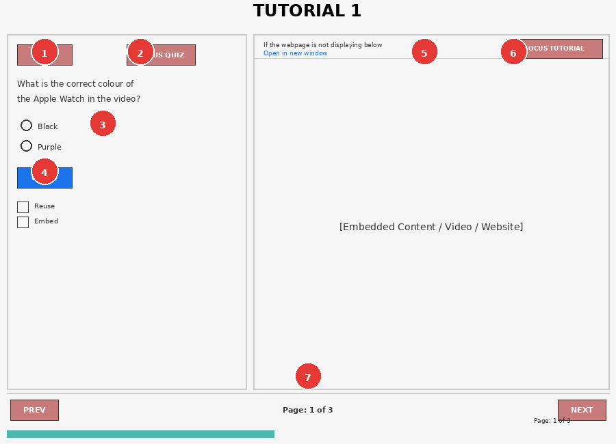
Figure 1: Tutorial layout overview with annotated interface elements

Adjusting the Panel Size
Some tutorials allow you to resize the quiz and content panels. If enabled by the librarian, you will see a vertical divider bar between the two panels. Click and drag this bar left or right to adjust the panel widths to your preference. This is especially useful if you need more space to read embedded content or to focus on quiz questions.
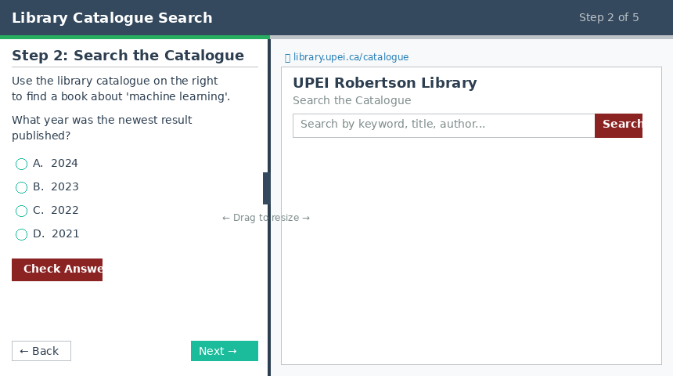
Figure 2 — Split-screen view with draggable panel divider between quiz and content panels

Types of Right Panel Content
The right panel can display different types of content depending on how the librarian configured each step:
Websites and library databases: Loaded as live, interactive pages you can browse and search.
YouTube and Vimeo videos: Displayed as an embedded video player you can watch directly.
PDF documents: Shown in a built-in PDF viewer with scroll and zoom controls.
Images: Displayed directly in the panel.
Audio files: Rendered with a playback bar for listening.
Other files: A download link is provided for you to save the file.
# | Element | Description
1 | MENU | Opens a dropdown showing all questions in the tutorial. You can jump directly to any page from here. The current page is highlighted.
2 | FOCUS QUIZ | Expands the quiz panel to fill most of the screen, dimming the embedded content. Useful when you want to concentrate on the question. Click EXIT FOCUS to return.
3 | Quiz Area | Displays the current question, answer options (radio buttons), and the Check button. After answering, feedback and your score appear here.
4 | Check Button | Submit your selected answer to see if it is correct. You must click Check before you can proceed to the next page.
5 | Open in New Window | If the embedded content on the right is not loading properly, click this link to open the resource in a new browser tab.
6 | FOCUS TUTORIAL | Expands the embedded content panel to fill most of the screen, hiding the quiz. Useful for exploring the embedded resource in detail. Click EXIT FOCUS to return.
7 | Navigation Bar | PREV and NEXT buttons to move between pages. The current page number (e.g. Page: 1 of 3) is shown between them. A progress bar at the very bottom tracks your position.

Step 3: Answering Questions
Each page of the tutorial presents a question on the left panel. To answer:
- Read the question carefully. If the question relates to the embedded content on the right (a video, webpage, or database), interact with that content first to find the answer.
- Select your answer by clicking on one of the radio button options.

Branching: Additional Help for Incorrect Answers
In some tutorials, answering a question incorrectly may open a branching sub-tutorial. This is an additional set of steps designed to give you more guidance on the topic before returning to the main tutorial. The branching content appears in the same split-screen interface and works identically to the main tutorial steps.
Once you complete the branching steps, you are automatically returned to the main tutorial at the point where you left off. Your score on branching questions is tracked separately and does not affect your main tutorial Final Score.
- Click the Check button to submit your answer.
- Review the feedback that appears.

If Your Answer Is Correct
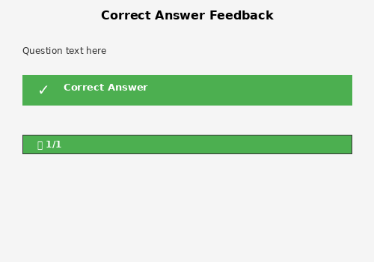
Figure 3: Correct answer feedback display
When you select the correct answer, the option highlights in green with a checkmark. A green progress bar fills, a gold star appears, and the score shows (e.g. 1/1). The NEXT button becomes active and you can proceed to the next page.

If Your Answer Is Incorrect
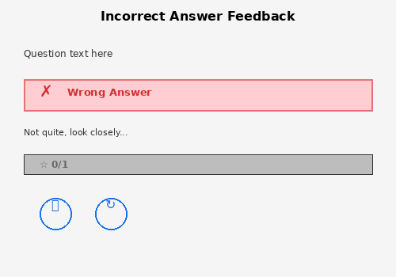
Figure 4: Incorrect answer feedback display
When you select an incorrect answer, the option highlights in pink/red with an X mark. A feedback message may appear (e.g. "Not quite, look closely...") to guide you. The score shows 0/1. Two icons appear next to the score:
- Eye icon (Show Solution): Reveals the correct answer so you can learn from the question.
- Circular arrow icon (Retry): Resets the question so you can try again with a fresh attempt.
Tip
Getting a question wrong does not prevent you from completing the tutorial. You can use the retry button to try again or view the solution and move on. However, all questions must be answered correctly (across all pages) before the certificate becomes available.

Step 4: Navigating Between Pages
Use the navigation bar at the bottom of the tutorial to move between pages:
- NEXT: Moves to the next page. This button is disabled (faded) until you have answered the current question. Once you submit an answer, it becomes active.
- PREV: Returns to the previous page. You can revisit earlier questions at any time.
- Page indicator: Shows your current position, e.g. "Page: 2 of 3".
- Progress bar: A coloured bar at the very bottom of the page fills as you advance through the tutorial.
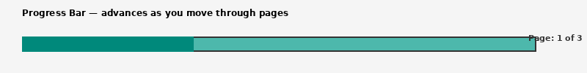
Figure 5: Progress bar at the bottom of the tutorial page

Using the MENU to jump between pages
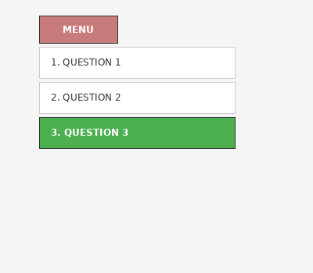
Figure 6: MENU dropdown showing all tutorial questions
Click the MENU button at the top-left of the quiz panel to see a list of all questions in the tutorial. The current page is highlighted in green. You can click any question to jump directly to that page.

Step 5: Using Focus Modes
The tutorial provides two focus modes to help you concentrate on either the quiz or the embedded content.

Focus Quiz Mode
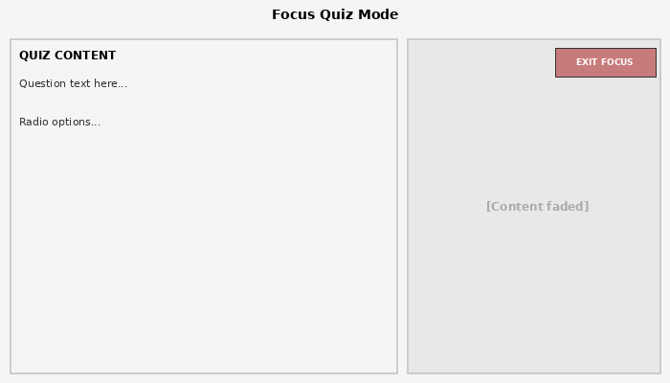
Figure 7: Focus Quiz mode expands the quiz panel
Click FOCUS QUIZ to expand the left quiz panel. The embedded content on the right fades into the background. The button changes to EXIT FOCUS. Click it to return to the normal split-screen view.

Focus Tutorial Mode
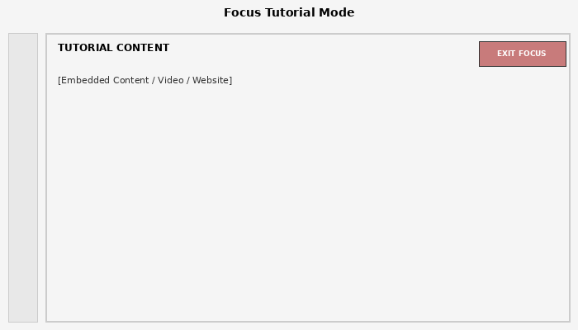
Figure 8: Focus Tutorial mode expands the embedded content
Click FOCUS TUTORIAL to expand the right content panel, hiding the quiz. This is helpful when you need to explore a database, watch a video, or read a webpage without the quiz panel taking up space. Click EXIT FOCUS to return to the normal view.

Step 6: Completing the Tutorial and Downloading Your Certificate
When you reach the last page of the tutorial, a Certificate section appears below the embedded content area.
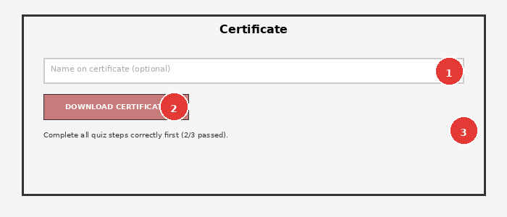
Figure 9: Certificate download section on the final tutorial page
To download your certificate:
- Answer all quiz questions correctly across every page of the tutorial. The status message below the certificate section shows your progress (e.g. "2/3 passed").
- If you have answered a question incorrectly, use the PREV button or MENU to navigate back, retry the question, and answer it correctly.
- Once all questions are answered correctly, the DOWNLOAD CERTIFICATE (PDF) button becomes fully active.
- Optionally, type your name in the "Name on certificate" field. This name will appear on the generated PDF.
- Click DOWNLOAD CERTIFICATE (PDF) to download your certificate as a PDF file.
Important
If your professor has assigned this tutorial, save the downloaded PDF certificate and submit it as instructed (e.g. upload to Moodle, email to your professor). The certificate serves as proof of completion.

Troubleshooting
Below are solutions to common issues you may encounter while using the tutorial.

Embedded content is not loading (blank or broken right panel)
Some websites block being displayed inside another page (this is a security feature called "X-Frame-Options"). If the right-side content appears blank, grey, or shows a broken icon:
- Click the "Open in new window" link at the top of the right panel. This opens the resource in a separate browser tab where it will load normally.
- Use that new tab alongside the tutorial tab to follow along with the quiz questions.
- You can also try clicking FOCUS TUTORIAL to see if the content loads in the expanded view.
Note
This is a known limitation of web embedding technology, not a bug. Certain library databases and external websites may not permit embedding. The "Open in new window" link is the intended workaround.

The NEXT button is disabled / will not work
The NEXT button is intentionally disabled until you answer the current question. To proceed:
- Select an answer option by clicking on it.
- Click the Check button to submit your answer.
- Once feedback appears (correct or incorrect), the NEXT button will become active.

I answered a question wrong — am I stuck?
No. An incorrect answer does not prevent you from continuing through the tutorial. You have two options after a wrong answer:
- Retry: Click the circular arrow icon next to the score to reset the question and try again.
- Show Solution: Click the eye icon to reveal the correct answer, then proceed.
However, to download the completion certificate, all questions across all pages must be answered correctly. You can navigate back to earlier pages at any time using PREV or the MENU to correct your answers.

The page looks cramped or content is cut off
If the interface feels cramped, particularly on smaller screens:
- Try widening your browser window or switching to full-screen mode (usually F11 on Windows/Linux or Ctrl+Cmd+F on Mac).
- Use the FOCUS QUIZ or FOCUS TUTORIAL buttons to temporarily expand the panel you need.
- If on a mobile device, try rotating to landscape orientation for more horizontal space.

The certificate button does not work or says steps are missing
The certificate requires all quiz questions to be answered correctly. The status message (e.g. "Complete all quiz steps correctly first (2/3 passed)") tells you how many you have completed. Navigate back through the tutorial using PREV or the MENU to find and correct any unanswered or incorrectly answered questions.

YouTube or video content is not playing
If a YouTube video embedded in the tutorial is not playing:
- Ensure your browser is up to date (Chrome, Firefox, Safari, or Edge recommended).
- Check that your internet connection is stable.
- Try clicking the play button directly on the video.
- If the video still does not load, click "Open in new window" to watch it in a separate tab.

Quick Reference Summary
Action | How To
Access a tutorial | Click the link provided by your instructor or the library website
Answer a question | Select a radio button option, then click Check
Retry a wrong answer | Click the circular arrow (retry) icon next to the score
See the correct answer | Click the eye (show solution) icon next to the score
Go to the next page | Click the NEXT button (active after answering)
Go to a previous page | Click PREV or use the MENU dropdown
Jump to any page | Click MENU, then select the question you want
Expand the quiz panel | Click FOCUS QUIZ (then EXIT FOCUS to return)
Expand the content panel | Click FOCUS TUTORIAL (then EXIT FOCUS to return)
Fix broken embedded content | Click "Open in new window" above the right panel
Download certificate | Answer all questions correctly, enter your name (optional), click DOWNLOAD CERTIFICATE (PDF)

Version History
Version | Date | Changes
1.0 | March 2026 | Initial MVP documentation. Covers student-facing tutorial workflow, answer feedback, navigation, focus modes, certificate generation, and troubleshooting.

