UPEI Robertson Library
Guide on the Side
Librarian User Guide
Interactive Tutorial Builder for Pressbooks
pb-split-guide WordPress Plugin

Version 1.0 — April 2026
CS4810/CS4820 Capstone Project — Team 8

Table of Contents
Table of Contents 2
1. Introduction 4
1.1 Purpose 4
1.2 Key Features 4
1.3 Terminology 5
1.4 User Roles 5
2. Getting Started 7
2.1 Logging In 7
2.2 Navigating the Dashboard 7
3. Creating a New Tutorial 9
3.1 Starting a New Tutorial 9
Template Selection 9
Tutorial Title 9
4. Editing a Tutorial 11
4.1 Tutorial Introduction 11
4.2 Layout Settings 12
Quiz Panel Width 12
User Adjustable 12
4.3 Benchmark Settings 13
4.4 Steps (Tutorial Pages) 13
Step Card Structure 14
Adding a New Step 14
Configuring the Left Panel (Quiz Content) 14
Configuring the Right Panel (Embedded Resource) 15
4.5 Branching Sub-Tutorials 15
Branch Configuration 15
How Branching Works for Students 16
4.6 Publishing 16
Tutorial Owner and Transfer 16
4.7 Navigation Logic 16
5. Administration Features 18
5.1 Guide Settings 18
Default Panel Layout 18
Performance Benchmarks 18
5.2 Managing Librarians 18
Creating a Librarian Account 19
Account Deactivation 19
5.3 Tutorial Analytics 19
5.4 Accessibility Settings 20
6. Templates 23
6.1 Saving as Template 23
6.2 Creating from Template 23
7. Export and Import 24
7.1 Exporting a Tutorial 24
7.2 Importing a Tutorial 24
8. The Student Experience 25
8.1 Introduction Screen 25
8.2 Split-Screen View 25
8.3 Completing a Tutorial 26
9. Feature Status Overview 27
10. Appendix 28
10.1 Keyboard Shortcuts and Tips 28
10.2 Troubleshooting 28
10.3 Technical Notes 28

1. Introduction
Guide on the Side is an interactive tutorial system built as a WordPress/Pressbooks plugin (pb-split-guide) for the UPEI Robertson Library. It allows librarians to create split-screen tutorials that pair instructional content and quiz questions on the left panel with live, embedded library resources on the right panel.
This guide covers the complete authoring workflow: from logging in to the Pressbooks administration dashboard, through creating and configuring tutorials, to publishing them for student access.

1.1 Purpose
The system replaces the discontinued University of Arizona Guide on the Side and provides an open-source alternative to the commercial LibWizard product from SpringShare. Tutorials are self-paced learning tools; quiz answers are not saved server-side or graded by instructors.

1.2 Key Features
- Split-screen layout with configurable panel ratio (10%–50% quiz panel)
- Multiple question types: Single Selection, Multiple Selection, and Fill in the Blanks
- Branching sub-tutorials triggered by incorrect answers
- H5P integration for rich interactive quiz content
- Template system for consistent tutorial design
- Export/Import for cross-server tutorial migration
- Aggregate analytics dashboard (PIPEDA-compliant, no personal data collected)
- PDF completion certificates for students
- Student-adjustable panel divider (per-tutorial opt-in)
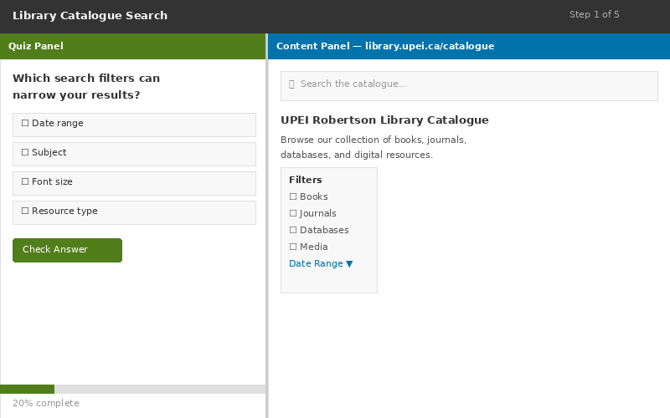
Figure 1 — The split-screen tutorial interface as seen by students

1.3 Terminology
Term | Definition
Step | A single page/slide within a tutorial. Each step has a left panel (quiz/content) and a right panel (embedded resource).
Quiz Panel | The left side of the split-screen, containing instructions, questions, and navigation controls.
Content Panel | The right side of the split-screen, displaying the embedded website, video, or uploaded file.
Branch | A conditional sub-tutorial that appears when a student answers a question incorrectly. Can be Optional or Mandatory.
Final Score | The summary displayed at the end of a tutorial showing the student’s performance.
Single Selection | A question type where only one answer is correct (radio buttons).
Multiple Selection | A question type where more than one answer may be correct (checkboxes).
Close Tutorial | The action a student takes after completing a tutorial (closes the browser tab).

1.4 User Roles
The system defines two roles with capability-based access control:
Role | Capabilities | Menu Access
Administrator | Full access: create/edit/delete all tutorials, manage librarians, configure site-wide settings, view all analytics. | All menu items including Guide Settings, Manage Librarians, Tutorial Analytics, and Network Admin features.
Librarian | Create and edit own tutorials, use templates, export/import tutorials. Cannot edit others’ tutorials (unless cross-editing is enabled by admin). | My Tutorials, Tutorials list, H5P Content. Guide Settings and Manage Librarians are hidden (not shown as disabled).
⚠ Note: The system uses an “invisible over blocked” UI pattern: menu items that a librarian cannot access are hidden entirely, rather than shown in a disabled state.

2. Getting Started

2.1 Logging In
Access the Pressbooks administration dashboard by navigating to your site’s login page. Your administrator will provide your credentials when your librarian account is created. A welcome email with your username and a password-reset link is sent automatically upon account creation.
- Open your web browser and navigate to your Pressbooks site’s admin URL (e.g., https://pressbooks.upei.ca/wp/wp-admin/).
- Enter your username and password.
- Click Log In. You will be directed to the Pressbooks dashboard.

2.2 Navigating the Dashboard
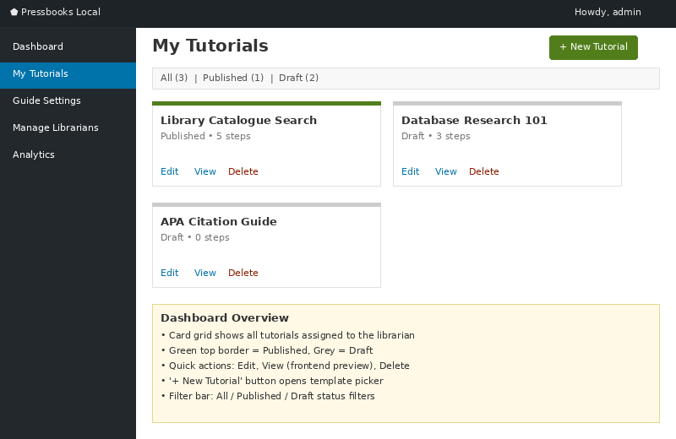
Figure 2 — My Tutorials dashboard showing tutorial cards with status indicators
After logging in, the left sidebar contains the Guide on the Side navigation items:
Menu Item | Description | Access
My Tutorials | Card-based grid view of all your tutorials with quick actions (Open, Edit, Transfer). | Admin, Librarian
Tutorials | WordPress-style list view of all tutorials with bulk actions and status filters. | Admin, Librarian
Tutorial Analytics | Aggregate performance dashboard with completion rates, scores, and device data. | Admin only
Guide Settings | Site-wide defaults for panel ratio, performance benchmarks, and cross-editing toggle. | Admin only
Manage Librarians | Create, view, and manage librarian accounts. | Admin only
H5P Content | Manage H5P interactive content items used in quiz steps. | Admin, Librarian

3. Creating a New Tutorial

3.1 Starting a New Tutorial
There are two ways to create a new tutorial:
- From My Tutorials: Click the Add New Tutorial button at the top of the page.
- From Tutorials list: Click the Add New Tutorial link next to the page heading.
Both routes take you to the New Tutorial page, where you choose a starting template and enter a title.
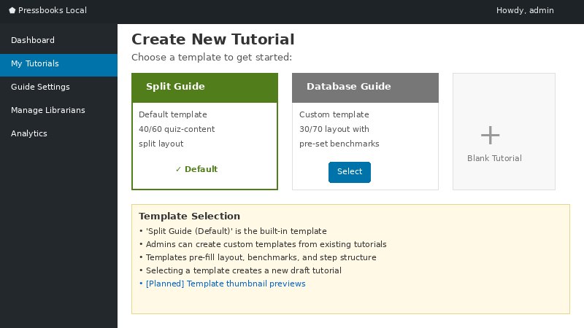
Figure 3 — Template picker when creating a new tutorial

Template Selection
The New Tutorial page presents available templates as cards:
- Start from scratch — Creates an empty tutorial with no steps pre-filled. Choose this if you want full control from the beginning.
- Split Guide (Default) [BUILT-IN] — Creates a tutorial with one empty step pre-configured. This is the recommended starting point for most tutorials.
If you or other librarians have saved custom templates (see Section 7), they also appear here as additional options.

Tutorial Title
Enter a descriptive title for your tutorial in the title field. This title is displayed to students on the tutorial introduction screen and is used to generate the tutorial’s URL slug. You can edit the slug separately after creation if needed by clicking the Edit button next to the permalink.
- Select a template card.
- Type your tutorial title (e.g., “Library Catalogue Search”).
- Click Create Tutorial. You are redirected to the Edit Tutorial screen.

4. Editing a Tutorial
The Edit Tutorial screen is divided into several collapsible sections within the Split Guide Settings metabox. Scroll down past the WordPress content editor area to find these sections.

4.1 Tutorial Introduction
This section defines what students see before they begin the tutorial. It appears as a welcome/landing screen with a Start Tutorial button.
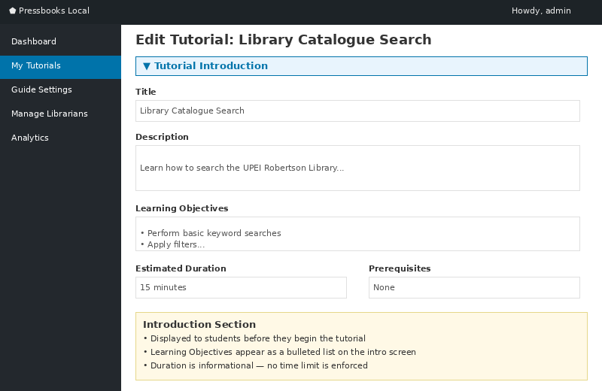
Figure 4 — Tutorial Introduction editor with fields for description, objectives, and duration
Field | Description
Description | A brief overview of what the tutorial covers. This is the main text students read before starting.
Cover Image | Optional. A wide landscape image (recommended 16:9, around 1600×900 px, under 1 MB). Displayed on the tutorial card in My Tutorials and the introduction screen.
What Students Will Learn | A list of learning objectives. Click + Add Objective to add items. Each objective appears as a checkmark-prefixed item on the introduction screen.
Header Note | Optional. A banner message displayed prominently to students (e.g., “This tutorial requires Chrome”).
Estimated Duration | A text field for the expected time (e.g., “15 minutes”). Shown to students on the introduction screen.
Prerequisites | Optional. Any requirements students should meet before starting (e.g., “A valid UPEI library account”).

4.2 Layout Settings
This collapsible section controls the split-screen panel ratio for the tutorial. Click the section header to expand or collapse it.
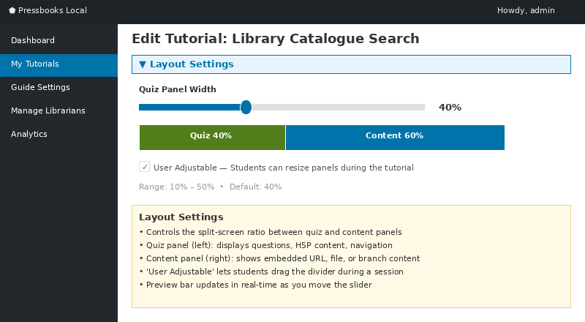
Figure 5 — Layout Settings with quiz panel width slider and visual preview bar

Quiz Panel Width
A slider control that sets the width of the left (quiz) panel as a percentage of the total width. The content panel automatically fills the remaining space.
- Range: 10% to 50%
- Default: 40% (set by the site administrator in Guide Settings)
- Use site default checkbox: When checked, the tutorial inherits the site-wide default ratio. Uncheck to set a custom ratio for this tutorial.
A visual preview bar below the slider shows the current split, labelled “Quiz — 40%” and “Content — 60%” (or whatever the current values are).

User Adjustable
An optional checkbox: Allow students to resize panels. When enabled, students can drag the divider bar between the quiz and content panels to adjust the layout during the tutorial. The ratio resets on page reload, and the 10%–50% range is always enforced.

4.3 Benchmark Settings
This collapsible section controls the colour-coded performance thresholds used in the Tutorial Analytics dashboard. These thresholds determine when a tutorial’s performance metrics are flagged as Red (needs attention), Amber (borderline), or Green (performing well).
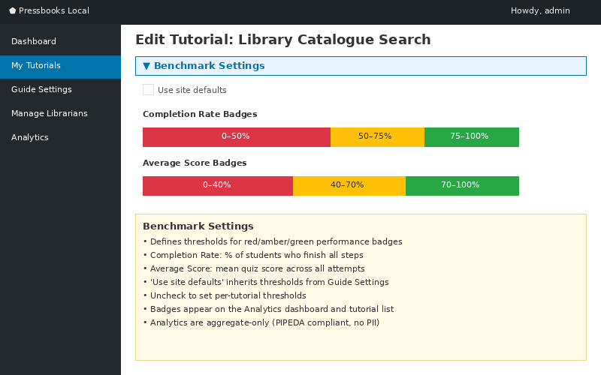
Figure 6 — Benchmark Settings with dual-slider controls for completion rate and score thresholds
- Use site defaults checkbox: When checked, inherits values from Guide Settings. Uncheck to set custom thresholds for this tutorial.
There are two sets of dual-slider controls:
- Completion Rate Badges: Sets the threshold boundaries for tutorial completion rate. The slider has two handles that define three zones: Red (below lower threshold), Amber (between thresholds), and Green (above upper threshold).
- Avg Score Badges: Sets the threshold boundaries for average quiz score, using the same three-zone pattern.

4.4 Steps (Tutorial Pages)
Steps are the core content of your tutorial. Each step represents one page that students navigate through. The steps section appears below the Benchmark Settings and contains a list of step cards that can be reordered by dragging.
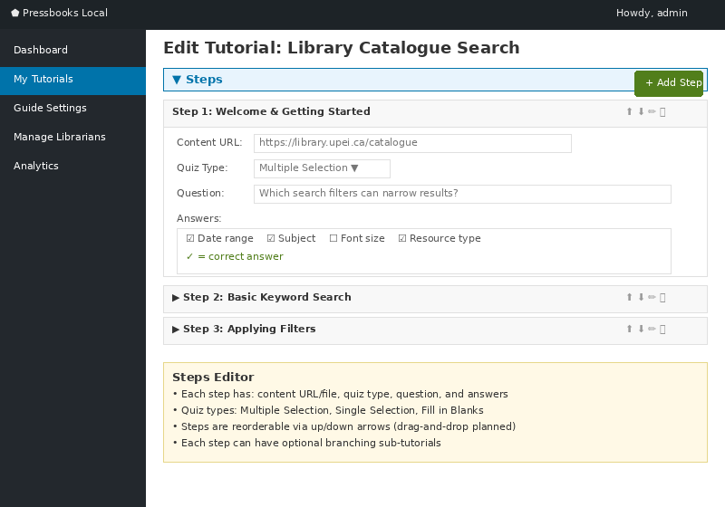
Figure 7 — Steps editor showing an expanded step with quiz configuration and collapsed steps below

Step Card Structure
Each step card has a header bar showing the step number (a green circle with the number), an optional page title field, a collapse/expand toggle, and a delete button. When expanded, a step card contains two main areas:
- Left Panel Configuration (Quiz/Content): Where you configure what appears on the left side of the split-screen for this step.
- Right Panel Configuration (Embedded Resource): Where you specify the URL, uploaded file, or branch resource to embed on the right side.

Adding a New Step
Click the Add Quiz Step button at the bottom of the steps list. A new step card is appended with default empty configuration.

Configuring the Left Panel (Quiz Content)
For each step, you can add quiz questions using the H5P integration. The system supports three question types:
Question Type | Description
Single Selection | One correct answer from multiple options. Displayed as radio buttons. Students select one option and click Check to verify their answer.
Multiple Selection | One or more correct answers. Displayed as checkboxes. Students select all that apply and click Check.
Fill in the Blanks | Students type their answer in a text field. Authors can specify multiple correct answers and toggle case sensitivity.
To add a quiz question to a step, use the H5P picker within the step’s configuration. You can select an existing H5P content item or create a new one. The quiz question is rendered within the left panel alongside any instructional text.

Configuring the Right Panel (Embedded Resource)
The right panel of each step displays embedded content. Three resource types are available:
Type | Usage
URL | Enter a web address to embed in an iframe (e.g., the UPEI Library Catalogue, EBSCO databases, YouTube videos). The content is interactive and navigable within the frame.
File | Upload a file (PDF, image, etc.) to be displayed in the right panel. The file is stored on the server and served directly.
Branch | Used for branching sub-tutorials. The right panel resource is determined by the branch configuration (see Section 4.5).
⚠ Note: Some websites may not embed properly in iframes due to security headers (X-Frame-Options or Content-Security-Policy). If content does not display, a fallback “Open in new window” link is automatically provided. Students can click this to view the resource in a separate browser tab while keeping the tutorial instructions visible on the left.

4.5 Branching Sub-Tutorials
Branching allows you to create conditional detour content that appears when a student answers a question incorrectly. This provides targeted remediation without interrupting the main tutorial flow.

Branch Configuration
To enable branching on a step, set the step’s resource type to Branch. The branch configuration panel then appears with these options:
Setting | Description
Mode | Optional: Students are offered the branch but can skip it and return to the main tutorial.  Mandatory: Students must complete the branch content before proceeding.
Trigger Attempts | The number of incorrect attempts that triggers the branch. Default is 1 (branch appears after the first incorrect answer).
Resource Mode | Main/Shared: The branch shares the same right-panel resource as the main step.  Per Question: Each branch question can have its own dedicated right-panel resource.

How Branching Works for Students
When a student answers a question incorrectly (after the configured number of attempts), the tutorial automatically navigates to the branch content. The page counter updates to show the branch position (e.g., “Page 1A, 1B”). After completing the branch, the student returns to the main tutorial at the step where they left off.
⚠ Note: Branch performance is tracked separately and does not affect the main tutorial’s Final Score.

4.6 Publishing
The Publish metabox on the right side of the Edit Tutorial screen controls the tutorial’s visibility:
- Save Draft: Saves your work without making it accessible to students. Draft tutorials return a 404 if accessed directly.
- Preview: Opens a preview of the tutorial as students would see it, without changing its status.
- Publish: Makes the tutorial live. Students can access it via its permalink URL.
You can also set the tutorial status back to Draft from a published state by clicking the Edit link next to Status.

Tutorial Owner and Transfer
Each tutorial has a designated owner, shown in the Tutorial Owner metabox. The owner is the librarian who created the tutorial (or who it was transferred to). To transfer ownership:
- Click the Transfer Ownership button in the Tutorial Owner metabox.
- Select the new owner from the dropdown list of registered librarians.
- Confirm the transfer.

4.7 Navigation Logic
Understanding how students navigate through a tutorial is important for designing effective step sequences:
- Students cannot proceed to the next step until they have clicked the Check button on the current step’s quiz question.
- Unanswered questions are treated as incorrect for the purpose of branch logic.
- The Next button is disabled until the Check action is completed.
- A page counter (e.g., “Page: 1 of 10”) and running score (e.g., “3/5 ✓”) are shown in the navigation bar.
- Focus Quiz and Focus Tutorial buttons allow students to temporarily expand one panel to full width.

5. Administration Features
The following features are available only to administrators.

5.1 Guide Settings
Access via the Guide Settings link in the left sidebar. This page configures site-wide defaults that individual tutorials inherit unless overridden.
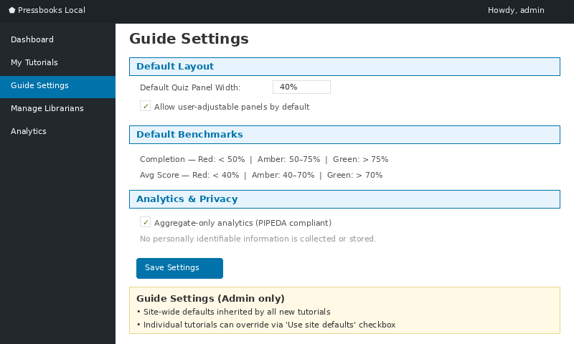
Figure 8 — Guide Settings page with site-wide defaults for layout, benchmarks, and privacy

Default Panel Layout
Sets the default quiz panel width for all new tutorials. Uses the same slider interface as the per-tutorial Layout Settings (10%–50% range). The default is 40%.

Performance Benchmarks
Sets the default Red/Amber/Green threshold values for Completion Rate and Average Score badges displayed in the Tutorial Analytics dashboard. Individual tutorials can override these values in their Benchmark Settings.

5.2 Managing Librarians
Access via Manage Librarians in the left sidebar. This page provides a table of all registered librarian accounts.
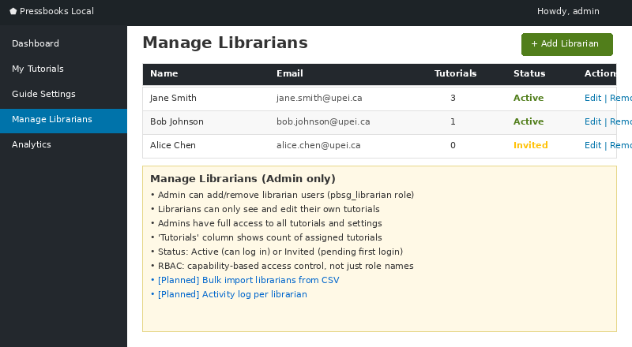
Figure 9 — Manage Librarians page with user table and role management

Creating a Librarian Account
- Click the Add Librarian button.
- Enter the librarian’s username, email address, and display name.
- Click Create. The system creates a WordPress account with the pbsg_librarian role and sends a welcome email with a password-reset link.

Account Deactivation
Deactivating a librarian account prevents login but preserves all tutorials they created. Tutorials remain accessible to students and can be transferred to another librarian by an administrator.

5.3 Tutorial Analytics
Access via Tutorial Analytics in the left sidebar. The dashboard presents aggregate performance data across all published tutorials.
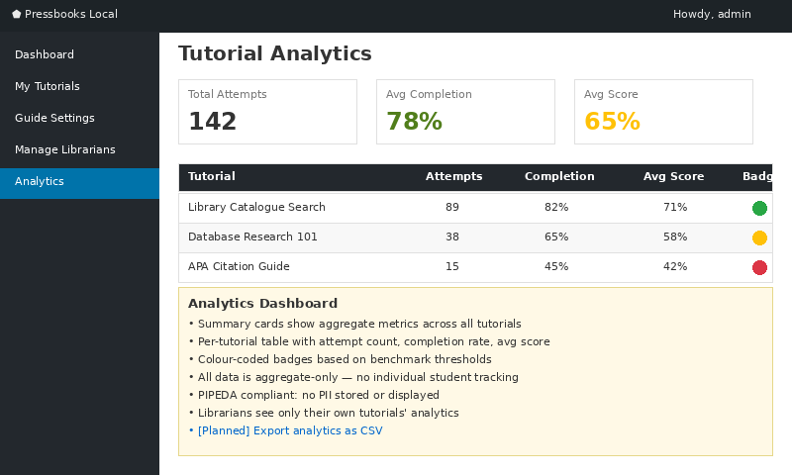
Figure 10 — Tutorial Analytics dashboard with KPI cards and performance badges
The analytics overview includes:
- KPI cards showing total tutorials, total views, average completion rate, and average score.
- Charts for completion trends and score distributions over time.
- A “Needs Attention” section highlighting tutorials that fall below the Red benchmark thresholds.
- Device type breakdown (desktop vs. mobile vs. tablet).
⚠ Note: Analytics are fully PIPEDA-compliant. No personal information is collected or stored. All data is aggregate-only, using ephemeral hashed-IP transients for session tracking. No cookies or localStorage are used.

5.4 Accessibility Settings
Accessibility Settings unique to the Guide on the Side plugin can be found within the user profile (located within the admin header on the top right of most pages). These settings are intended for librarians and administrators but can be utilized by anyone who has an account registered within the system. Administrators will be able to manage and modify librarian accounts, enabling them to make changes to a users profile (Users are still able to change these settings themselves).
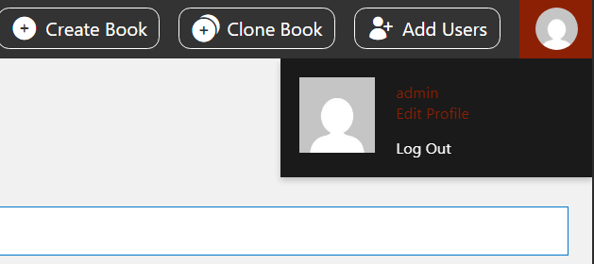
Figure 11 — User profile access location
Within the user profile page, the Guide on the Side plugin enables users to select custom administration color schemes (Default schemes include Pressbooks and Pressbooks a11y, custom schemes includes Colorblind Friendly and UPEI Library).

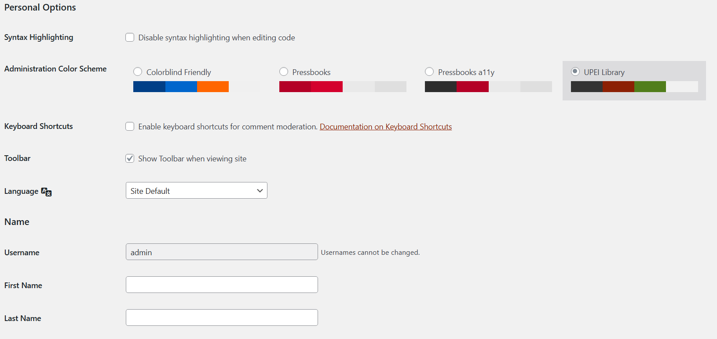
Figure 12 — Custom per-user administration color schemes available under the ‘Personal Options’ section
At the bottom of the user profile page, users can change their preferred focus indicator color and outline width. Additionally, the sitewide font family option provides custom font choices from the system default to the UPEI Library standard (alongside some generic options such as Arial, Verdana, and Tahoma).

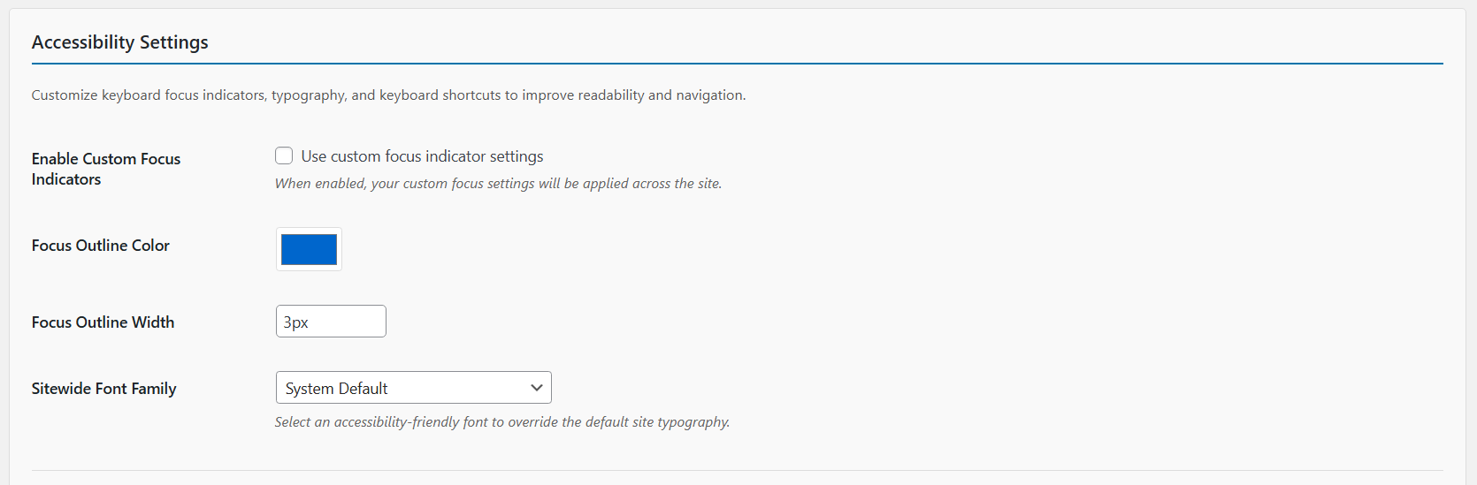
Figure 13 — Custom focus indication and fonts available under the ‘Accessibility Settings’ section
Below the focus indicators and fonts section, users can enable custom keyboard shortcuts for use while navigating Guide on the Side tutorials, as well as testing any custom focus settings using mock inputs.

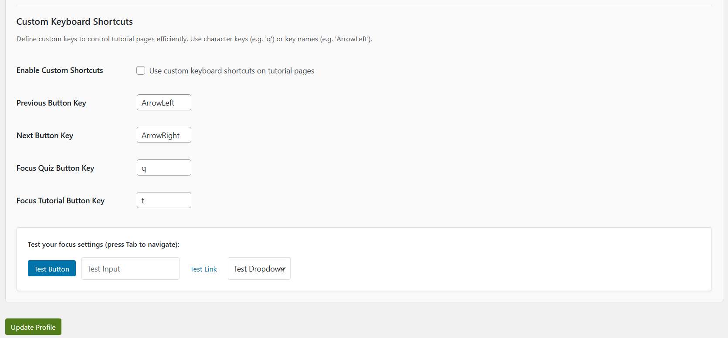
Figure 14 — Custom keyboard shortcuts for tutorials and a preview section for focus changes
Once a user has adjusted their accessibility settings as they prefer, clicking the ‘Update Profile’ button will save the configuration to the account, automatically loading anytime the user is signed into the account within the platform.

6. Templates
Templates allow you to save a tutorial’s configuration as a reusable starting point for new tutorials.

6.1 Saving as Template
From the Edit Tutorial screen, you can save any tutorial as a template:
- Open the tutorial you want to use as a template basis.
- Look for the Save as Template option in the tutorial’s action menu.
- Provide a template name and optional description.
- Click Save. The template now appears in the New Tutorial template picker.
Templates capture the tutorial’s step structure, layout settings, and question configuration. They do not copy actual quiz answers or student analytics data.

6.2 Creating from Template
When creating a new tutorial, select any available template from the New Tutorial page. The new tutorial starts with the template’s pre-configured steps, which you can then customise. The template and the new tutorial are independent copies: changes to one do not affect the other.

7. Export and Import
The Export/Import system enables tutorial portability across different Pressbooks installations.

7.1 Exporting a Tutorial
Exporting a tutorial creates a JSON file containing the complete tutorial configuration, including all steps, quiz content, and any uploaded file attachments (encoded as base64). This file can be shared with other institutions.
To export: from the Tutorials list or Edit Tutorial screen, use the Export action. The browser downloads a .json file.

7.2 Importing a Tutorial
To import a previously exported tutorial:
- Navigate to the Import section (available from the Tutorials management area).
- Select the exported .json file from your computer.
- Click Import. The system creates a new tutorial with all the configuration and content from the file.
⚠ Note: Imported tutorials are created as Drafts. You should review the content and publish when ready. H5P content items are recreated during import, so H5P IDs will differ from the original.

8. The Student Experience
Understanding how students interact with your tutorials helps you design effective learning experiences.

8.1 Introduction Screen
When a student opens a tutorial URL, they first see the Introduction Screen with the tutorial title, description, learning objectives (shown as a checklist), estimated duration, and prerequisites. A Start Tutorial button begins the tutorial.
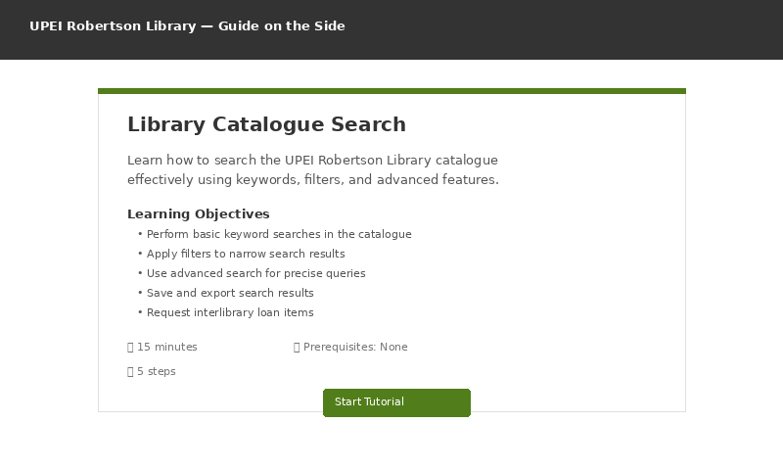
Figure 15 — Student-facing introduction screen with learning objectives and Start Tutorial button

8.2 Split-Screen View
Once the tutorial starts, the screen is divided into two panels:
- Left Panel (Quiz Panel): Displays the step’s instructional text and quiz question. Navigation controls appear at the bottom: Prev/Next buttons, a page counter, and a running score.
- Right Panel (Content Panel): Displays the embedded resource (website, video, or file). Students can interact with the embedded content freely.
Additional controls:
- Focus Quiz: Temporarily expands the left panel to full width, hiding the right panel.
- Focus Tutorial: Temporarily expands the right panel to full width, hiding the left panel.
- Open in new window: Opens the right-panel resource in a separate browser tab (fallback for sites that block iframe embedding).

8.3 Completing a Tutorial
After answering the last step’s question, students see a summary page showing their Final Score. From there, they can:
- Click Close Tutorial to close the browser tab and return to wherever they came from.
- Download a PDF completion certificate (if enabled) by entering their name and clicking the download button.

9. Feature Status Overview
The following table summarises the implementation status of all planned features as of April 2026:
Feature | Status | Sprint
Core Tutorial Builder (MVP) | Complete | S1–S6
Split-Screen Layout | Complete | S1–S6
Quiz Questions (Single/Multiple/Fill-in) | Complete | S1–S6
RBAC (Admin + Librarian roles) | Complete | S7–S8
SG1 — PDF Certificate | In Progress | —
SG2 — Branching Sub-tutorials | Complete | S7–S8
SG3 — Slide Templates | Complete | S7
SG4 — Export/Import | Complete | S7
SG5a — Admin Default Ratio | Complete | S7
SG5b — Student-Adjustable Divider | Complete | S8
SG6 — Google/MS Embeds | Not Started | —
SG7 — Callout Annotations | Not Started | —
Cross-Editing Toggle | In Progress | S9
Ownership Transfer | In Progress | S9

10. Appendix

10.1 Keyboard Shortcuts and Tips
- Use Tab to navigate between form fields in the step editor.
- Drag step cards by their header to reorder steps.
- Click the collapse arrow on any step card to minimise it for a cleaner editing view.

10.2 Troubleshooting
Issue | Solution
Right panel shows blank or error | The target website may block iframe embedding. Use the “Open in new window” fallback. Contact your IT team if the library’s own resources are blocked.
Tutorial shows 404/Page Not Found | Ensure the tutorial is Published, not in Draft status. Check the permalink URL.
Quiz question not appearing | Verify that the H5P content item is properly linked to the step. Check the H5P Content area for any creation errors.
Students cannot proceed past a step | Students must click Check before the Next button becomes active. This is by design to ensure engagement with quiz content.
Analytics not updating | Analytics use aggregate data with ephemeral session tracking. Allow a few minutes for data to appear. Only published tutorials generate analytics.

10.3 Technical Notes
- Local Development URL: pressbooks.test (via Lando/Docker)
- CSS Namespace: All plugin styles use the --gots-* CSS custom property prefix.
- Privacy: Zero PII storage, no cookies or localStorage, ephemeral hashed-IP transients for session aggregation only.
- License: MIT Open Source
- Default Split Ratio: 40/60 (quiz/content)
- H5P Integration: Uses xAPI via iframe.contentWindow.H5P.externalDispatcher (same-origin, served through admin-ajax.php)

