TEAM C

JAVA ASSIGNMENT -1

Team Members:

Harshit Oberoi

Tanya Khullar

Yi Qi

zhenzhou yu

Yu Gong

Xiurui Hou

Xuan zhang

b) Circle Calculator

In this we are ask user to input the radius of the circle then we call printResult() function to display the Diameter, circumference and area of the circle.

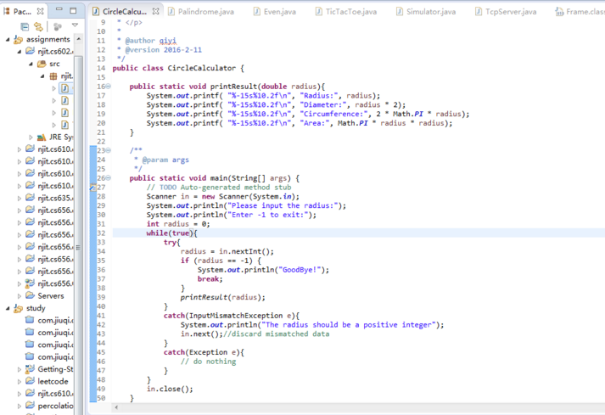

OUTPUT:

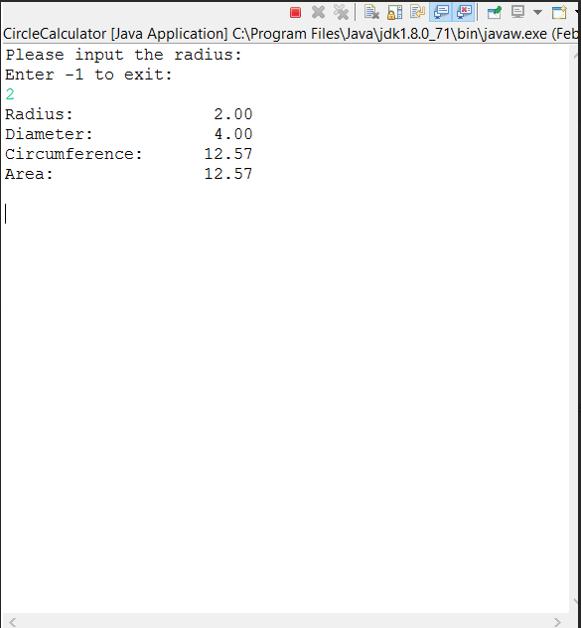

d. Global warming Quiz:

In this we asks user 5 questions and ask him to answer them and based on number of correct answers we display the message.

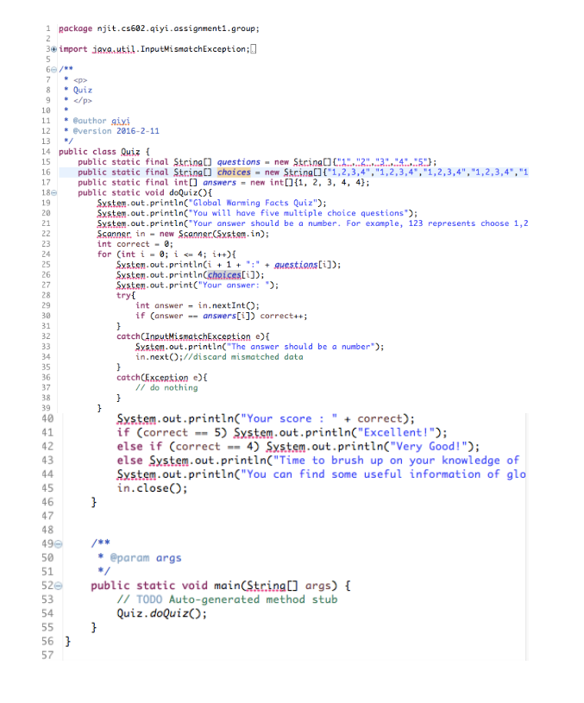

OUTPUT:

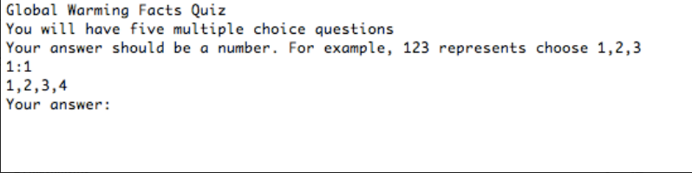

f. Dice Rolling

The task is to simulate several dice rolling and make a statistic for the distribution of all dice rolling.

We can use “Random” class to simulate a dice rolling and then output the result.

Implementation:

rollDice() – this function simulates rolling of two dices and returns the sum of two rolls as output.

In main method() we call this function 36000000 times in a loop and store the output in an array and display the result in tabular format.

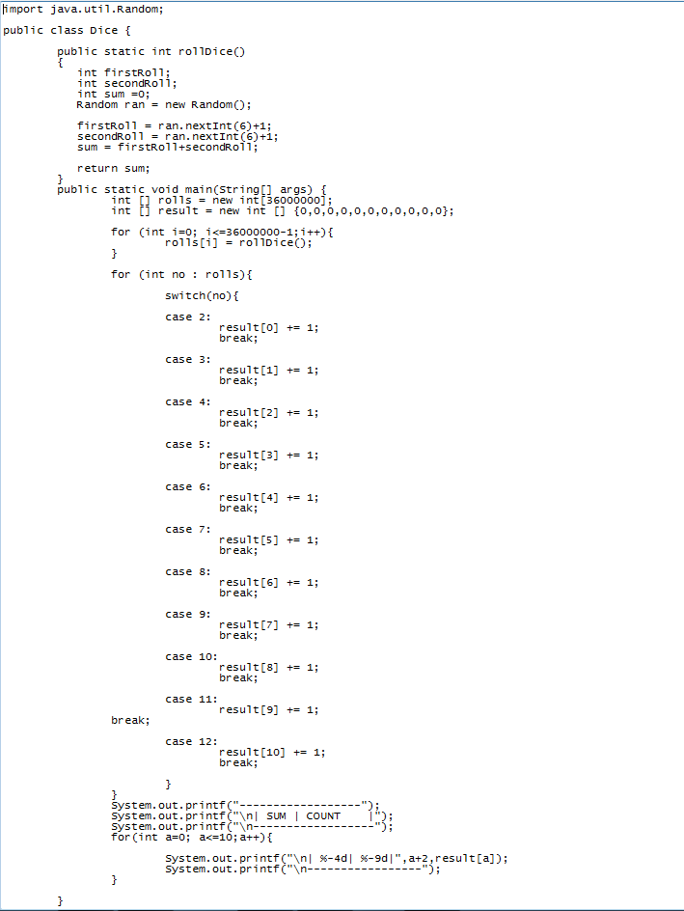

OUTPUT:

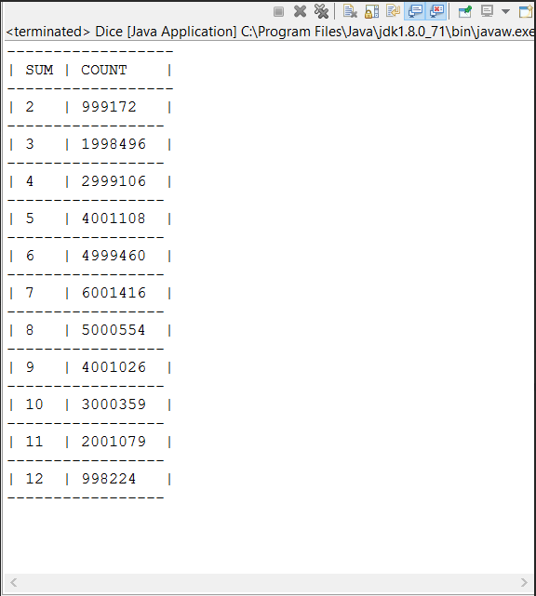

h. TicTacToe

The Task is to simulate a game which includes interaction between player and player or player and computer. To make this process more convenient, we build a client to play this game.

Also, to support play with a computer, we made a simple AI.

Initiate UI and AI setting. Here we need user to decide whether use a computer as a player and if it has a computer, we also need the user to decide who moves first.

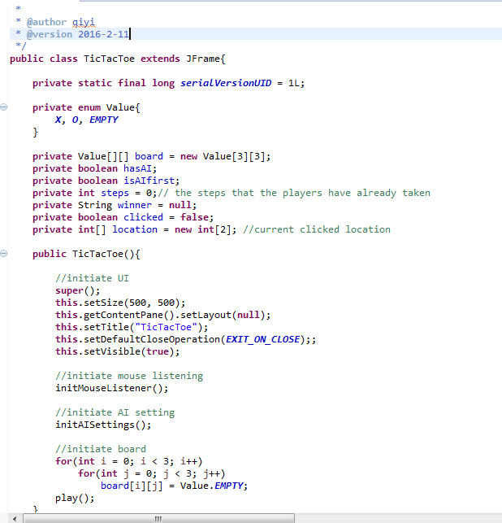

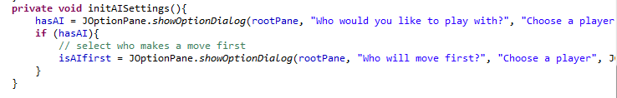

Keep playing until someone wins or the board is full.

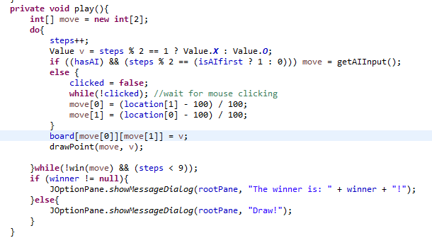

Check whether we have a winner now, if so, set the winner.

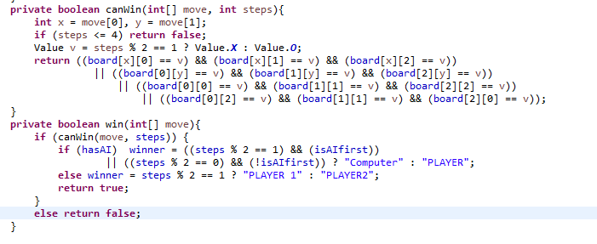

AI

1. Check whether AI can win after a move, if so, do that move

2. Check whether the opponent can win after a move, if so, try to prevent its opponent

3. If the center is empty, make a move here

4. Otherwise, return the first empty position

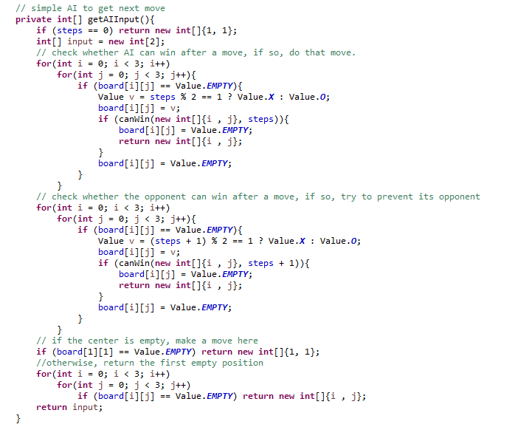

Draw point and mouse listening, discard the invalid clicking

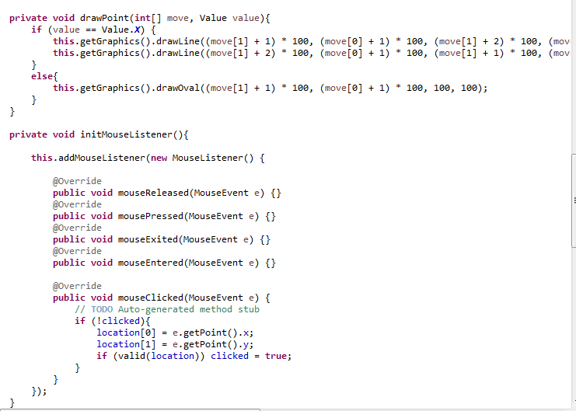

Running Screenshots:

