1. Payroll system

This problem is to ask us to add a new kind of employee to the original payroll system. We need to create a new subclass for that employee and implement its own unique earning behavior, string representation and corresponding auxiliary attributes and methods. Also we need modify the original test class to test the new employee. This problem can be done by the following steps.

1. We need to create a new subclass for piece worker which extends the super class Employee

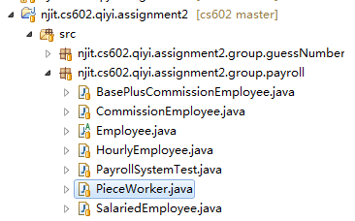

1. We need to create some private attributes for this class and also do the validation in the constructor

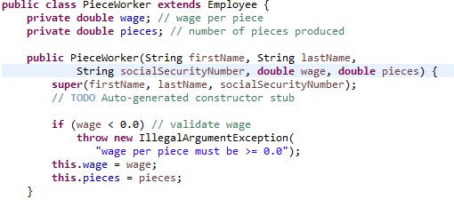

1. Implement corresponding get and set method. Note that the set method also need do validation.

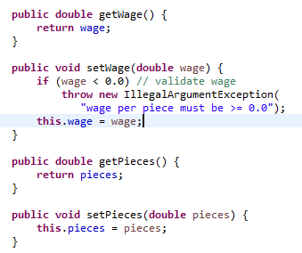

1. Implement the earnings and toString method, in the toString method, we first call its parent’s toString method and then add its own information behind that.

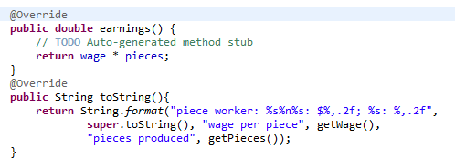

1. In the test class, we also need to add our new employee.

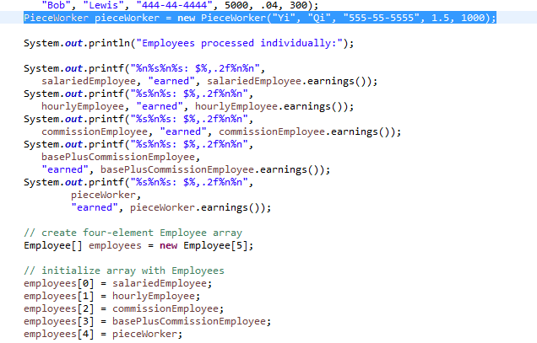

1. Make a small modification for the last print, so that we won’t print the package name

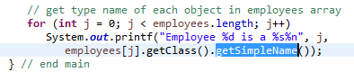

1. The final running result:

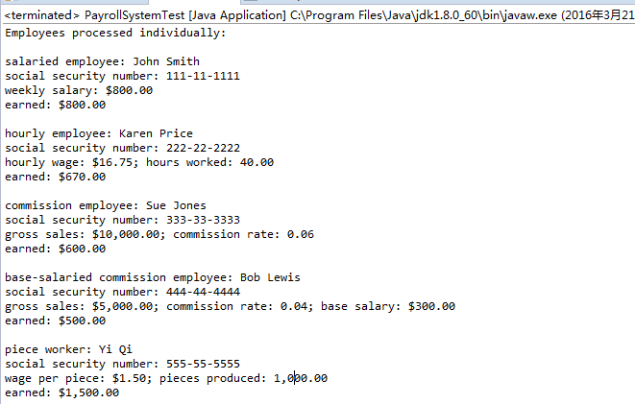

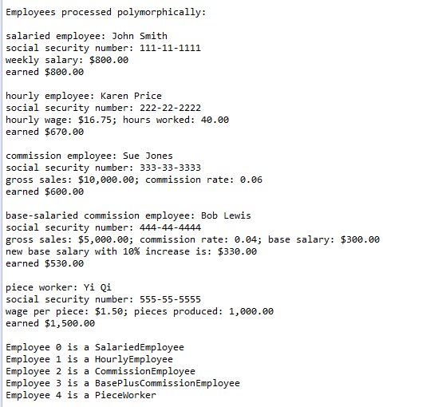

1. Guess Number

This problem is asking us to implement a simple guess number game. The rule of the game is very simple, for each round, we just need to generate a number to guess and after each guessing we need to make a comparison and give corresponding hint and change the color of background. This problem can be done by the following steps.

1. Create a class for this game and extends JFrame. To make this game a little general, we do not limit the upper bound of the number to 1000, we allow the caller to pass an upper bound to this class although we have a default upper bound 1000.

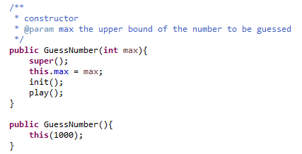

1. Define all the attributes. We need to store the upper bound, the current secret number and last number the player guessed (so that we can give a better hint). Also, we divide the Jframe into two JPanels, one is for show the hint and restart button, and the other one is for input guessing number.

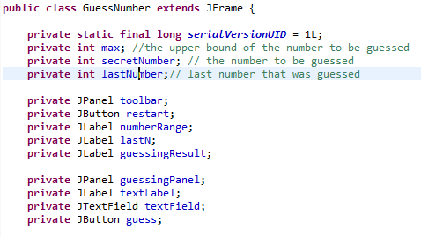

1. For the first panel, we add all the components to it, including a “restart” button and corresponding action, a “number range” label to show the number range of the guessing number, a “lastN” label to show the last guessing number, and a “guessing result” label to show last guessing result.

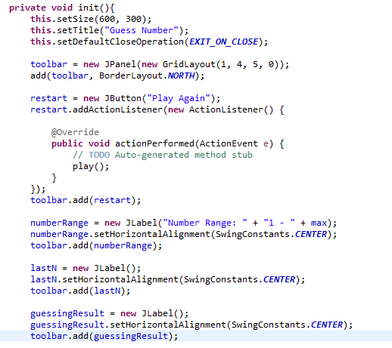

1. For the second panel, we need to add the input text field and corresponding label and button. For the “guess” button, we need to add corresponding actions: first we need to validate the user input and then check the guessing result and update the corresponding label and the color of background. If the player gets the correct answer, we also need to set the input field not editable and unable the button.

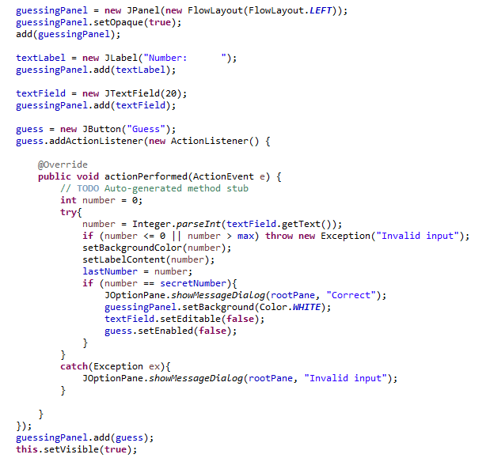

1. When restarting the game, we need get a new random number and reset all the information including background, labels, and make the input field editable and enable the button.

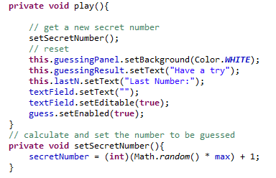

1. Some details for setting the background and labels. If the guessing number is closer to the secret number than the last guessing, change the color of the background of the guessing panel to red; otherwise change it to blue.

For the result label, just make a simple comparison, and update the text of the label.

If the input number is valid guessing number, update the last number label. (The only situation that this method can get an invalid input is in the initiation phase, in which we don’t have a last number)

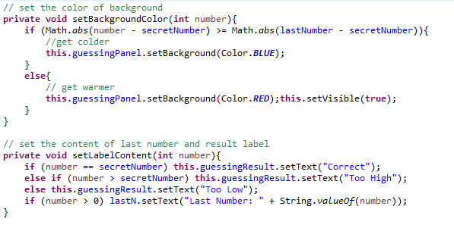

1. The final running result

When starting, it will like this:

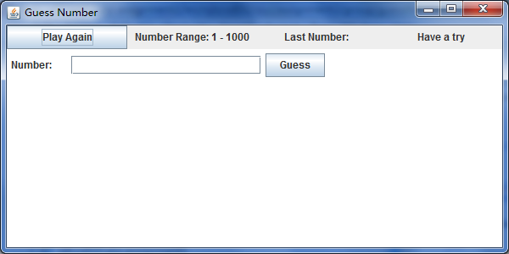

Input an invalid number

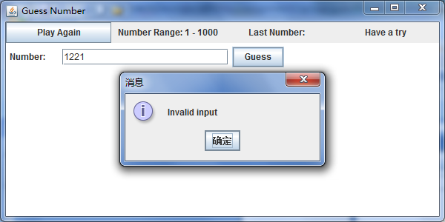

Input a valid number, the color of background changed and we also get the result:”Too low”

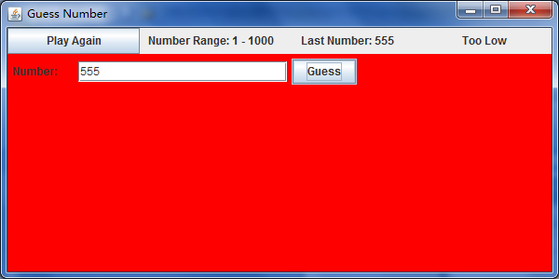

If we guess a smaller number, it will even stray from the correct answer.

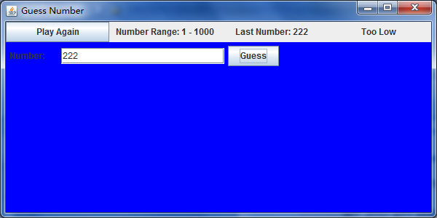

If we guess a bigger number, it will closer to the correct answer.

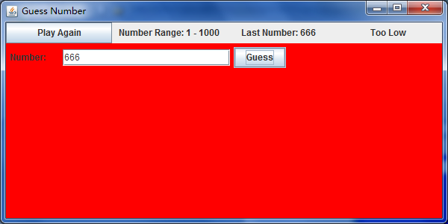

Keep guessing and we get the correct answer and after clicking the button, the status of the input field and guessing button will change

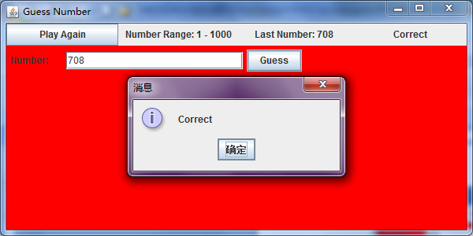

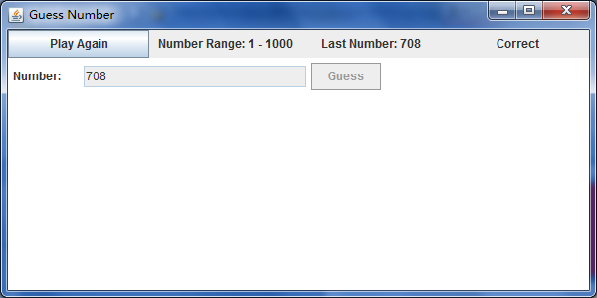

Clicking play again, it will restart

