The idea is to create a ER model for retailers to more efficiently manage their data. As it’s a OLTP for relational database, we try to minimize redundancies as much as we can. The model requires one information in only one table, and when editing one table no other table will be affected.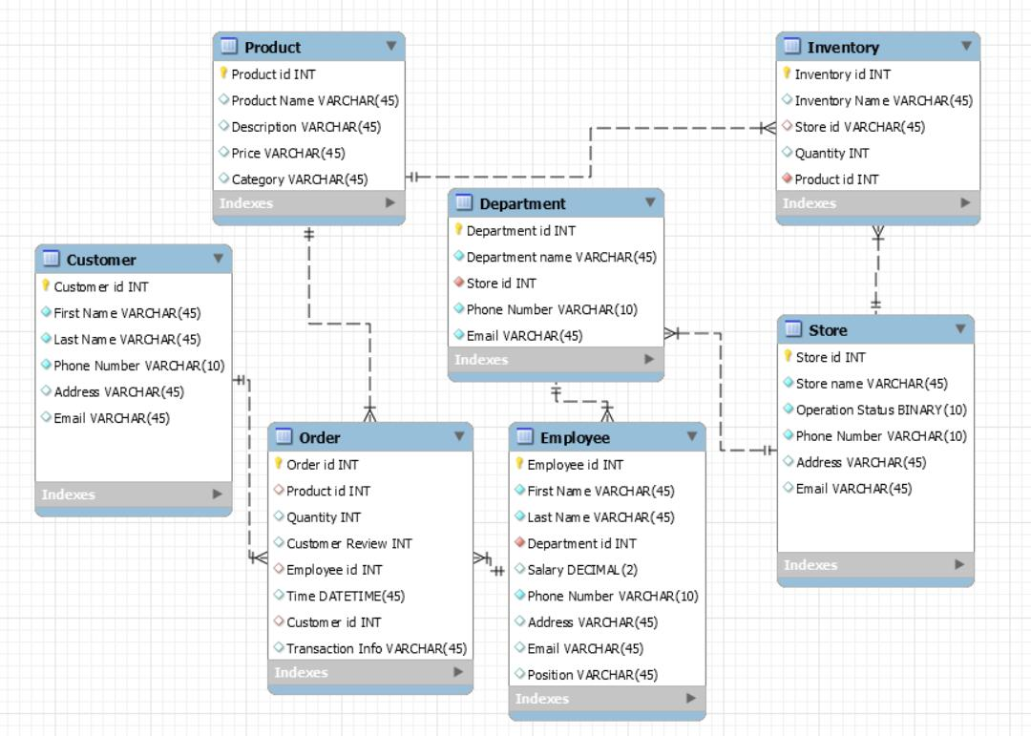

Questions we want to answer:

1. How’s the performance by employee/department/store/order?
2. What’s the management structure for each store/department/inventory?

Therefore, two fact tables are created, and corresponding dimensional tables are created. By having this OLAP, we are able to figure out the performance/management by each entity without calling multiple tables.