**信号与系统实验2—连续时间信号与系统的频域分析**

**梁芮槐-2019302789**

**实验内容**

1. **非周期信号的频谱实验**
2. 求f1

理论：

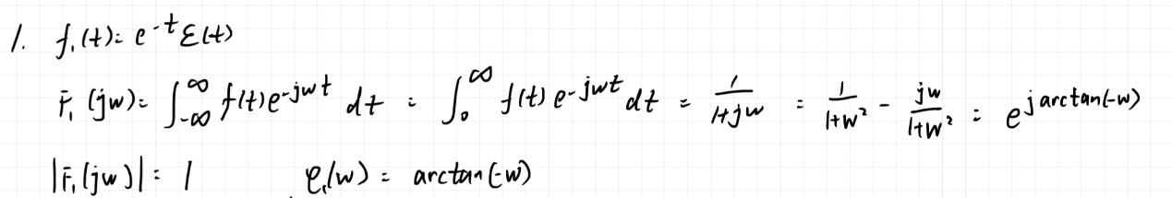

代码：

clear all;

clc;

T = 0.01;

t = -10 : T : 10;

N = 500;

W = 10 * pi;

n = -N : N;

w = n * W / N;

f = exp(-t).*stepfun(t, 0);

F = T * f * exp(-1i * t'* w);

F_w = abs(F);

P_w = angle(F);

subplot(1, 3, 1)

plot(t, f, 'b'), axis([(min(t)) (max(t)) (min(f)) (max(f))]), title('f1原函数'), xlabel('t'), ylabel('f');

subplot(1, 3, 2)

plot(w, F_w, 'b'), axis([(min(w)) (max(w)) (min(F_w)) (max(F_w))]), title('F1_w幅频'), xlabel('w'), ylabel('F');

subplot(1, 3, 3)

plot(w, P_w, 'b'), axis([(min(w)) (max(w)) (min(P_w)) (max(P_w))]), title('F1_w相频'), xlabel('w'), ylabel('P');

效果：

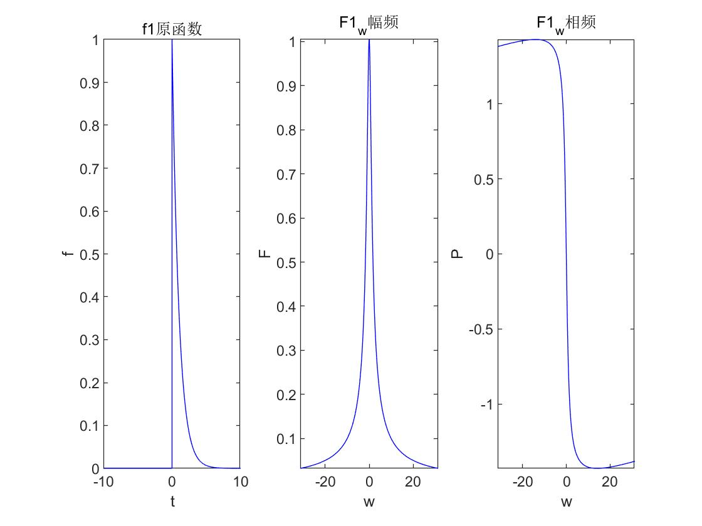

1. 求f2

理论：

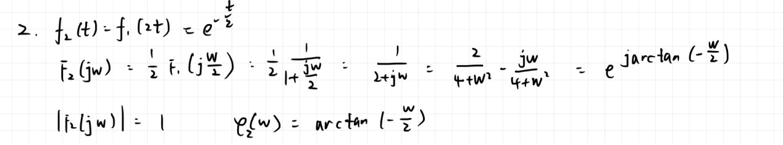

代码：

clear all;

clc;

T = 0.01;

t = -10 : T : 10;

N = 500;

W = 10 * pi;

n = -N : N;

w = n * W / N;

f = exp(-t / 2.0).*stepfun(t, 0);

F = T * f * exp(-1i * t'* w);

F_w = abs(F);

P_w = angle(F);

subplot(1, 3, 1)

plot(t, f, 'b'), axis([(min(t)) (max(t)) (min(f)) (max(f))]), title('f2原函数'), xlabel('t'), ylabel('f');

subplot(1, 3, 2)

plot(w, F_w, 'b'), axis([(min(w)) (max(w)) (min(F_w)) (max(F_w))]), title('F2_w幅频'), xlabel('w'), ylabel('F');

subplot(1, 3, 3)

plot(w, P_w, 'b'), axis([(min(w)) (max(w)) (min(P_w)) (max(P_w))]), title('F2_w相频'), xlabel('w'), ylabel('P');

效果：

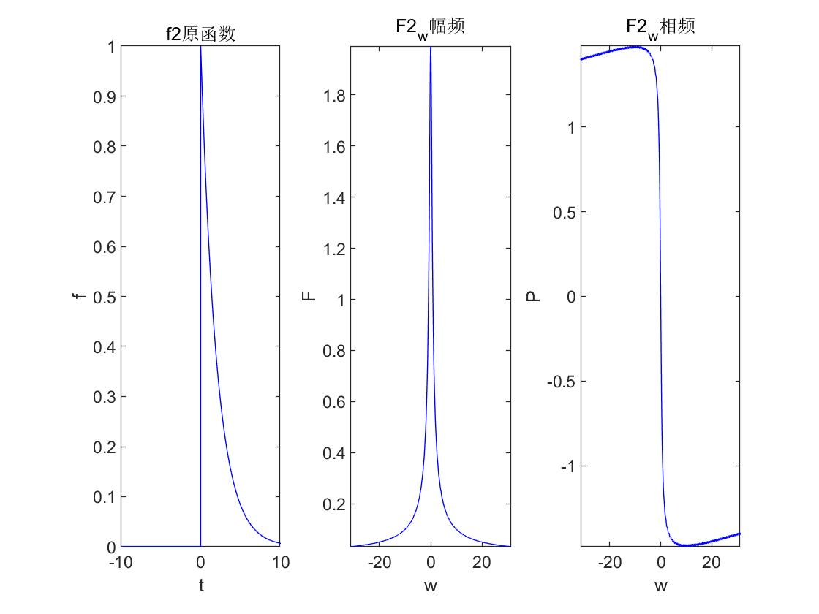

原函数和幅频曲线被拉伸两倍

1. 求f3

理论：

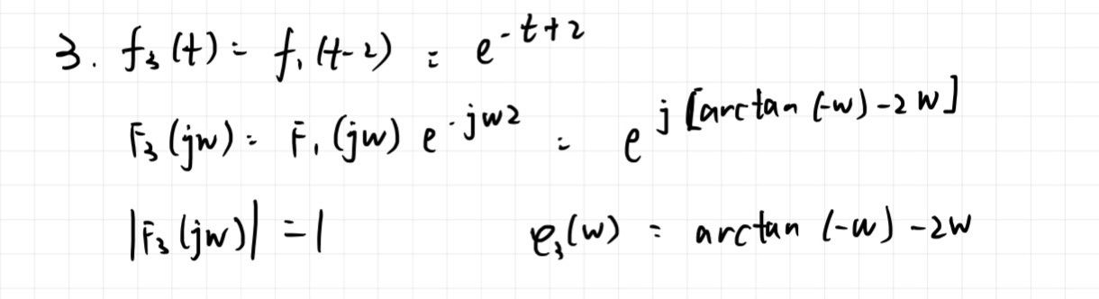

代码：

clear all;

clc;

T = 0.01;

t = -10 : T : 10;

N = 500;

W = 10 * pi;

n = -N : N;

w = n * W / N;

f = exp(-t + 2.0).*stepfun(t - 2.0, 0);

F = T * f * exp(-1i * t'* w);

F_w = abs(F);

P_w = angle(F);

subplot(1, 3, 1)

plot(t, f, 'b'), axis([(min(t)) (max(t)) (min(f)) (max(f))]), title('f3原函数'), xlabel('t'), ylabel('f');

subplot(1, 3, 2)

plot(w, F_w, 'b'), axis([(min(w)) (max(w)) (min(F_w)) (max(F_w))]), title('F3_w幅频'), xlabel('w'), ylabel('F');

subplot(1, 3, 3)

plot(w, P_w, 'b'), axis([(min(w)) (max(w)) (min(P_w)) (max(P_w))]), title('F3_w相频'), xlabel('w'), ylabel('P');

效果：

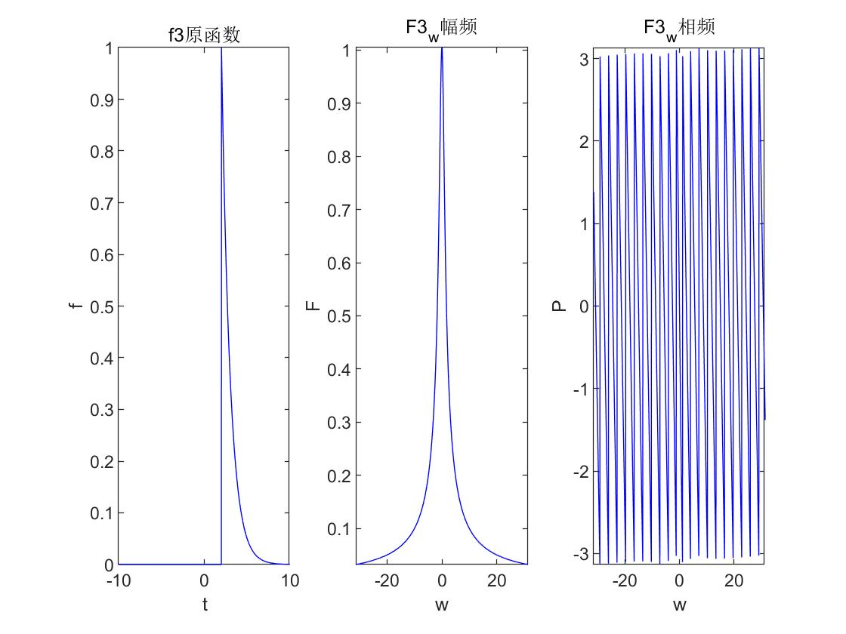

原函数右移2

1. 求f4

理论：

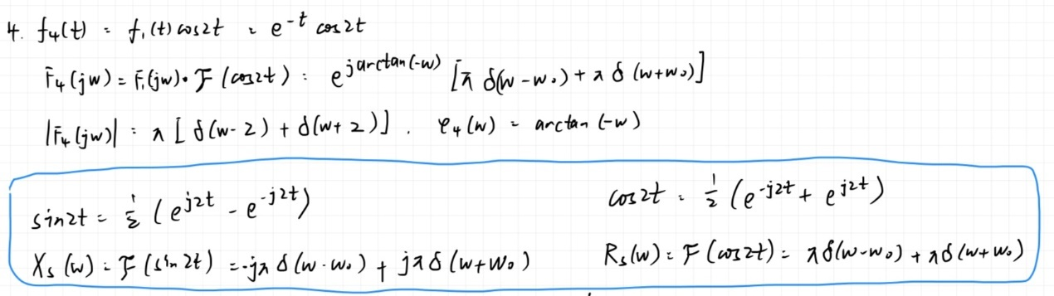

代码：

clear all;

clc;

T = 0.01;

t = -10 : T : 10;

N = 500;

W = 10 * pi;

n = -N : N;

w = n * W / N;

f = exp(-t).*stepfun(t, 0).*cos(2.0 * t);

F = T * f * exp(-1i * t'* w);

F_w = abs(F);

P_w = angle(F);

subplot(1, 3, 1)

plot(t, f, 'b'), axis([(min(t)) (max(t)) (min(f)) (max(f))]), title('f4原函数'), xlabel('t'), ylabel('f');

subplot(1, 3, 2)

plot(w, F_w, 'b'), axis([(min(w)) (max(w)) (min(F_w)) (max(F_w))]), title('F4_w幅频'), xlabel('w'), ylabel('F');

subplot(1, 3, 3)

plot(w, P_w, 'b'), axis([(min(w)) (max(w)) (min(P_w)) (max(P_w))]), title('F4_w相频'), xlabel('w'), ylabel('P');

效果：

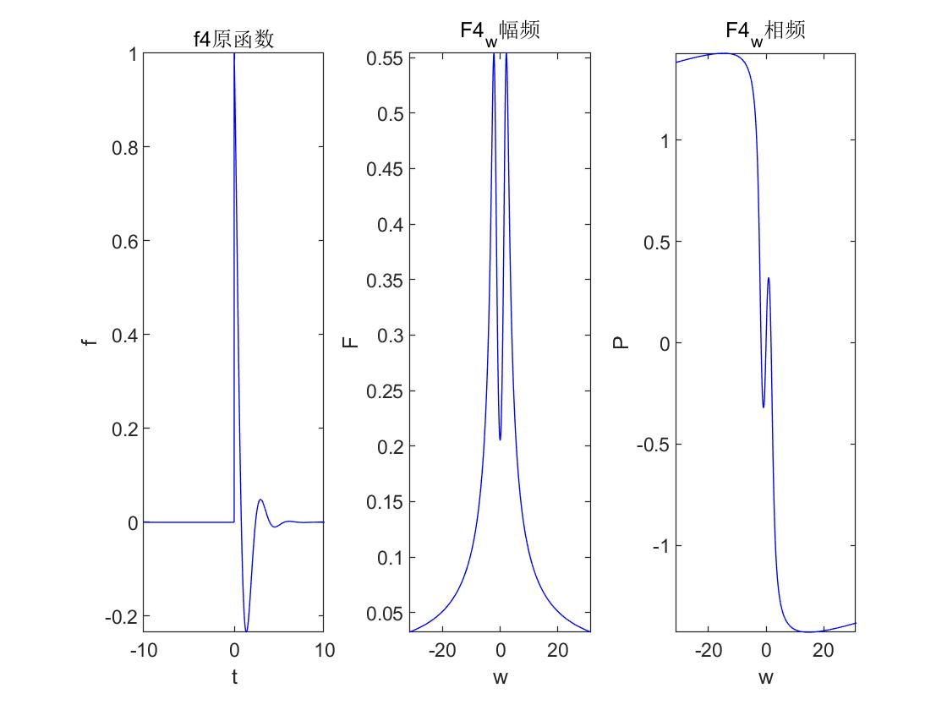

1. 求f5

理论：

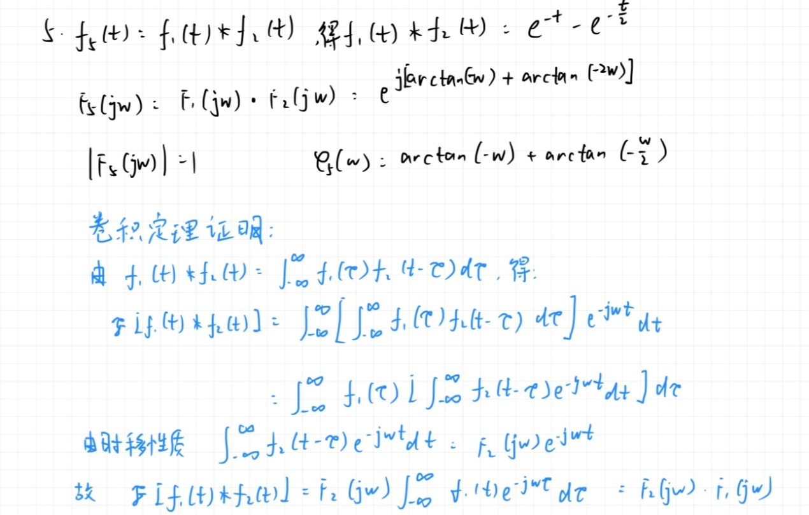

代码：

clear all;

clc;

T = 0.01;

t = -10 : T : 10;

N = 500;

W = 10 * pi;

n = -N : N;

w = n * W / N;

f1 = exp(-t).*stepfun(t, 0);

f2 = exp(-t / 2.0).*stepfun(t, 0);

conv_f = conv(f1, f2);

t1 = linspace(-10, 10, length(conv_f));

f = (exp(-t) - exp(-t / 2.0)).*stepfun(t, 0);

F = T * f * exp(-1i * t'* w);

F_w = abs(F);

P_w = angle(F);

% 绘制调用conv计算出的卷积

% 进行拉伸和压缩之后画出

subplot(1, 4, 1)

plot(t1 * 2, -conv_f * 0.005, 'b'), axis([(min(t1)) (max(t1)) (min(-conv_f * 0.005)) (max(-conv_f * 0.005))]), title('conv-f5原函数'), xlabel('t'), ylabel('f');

subplot(1, 4, 2)

plot(t, f, 'b'), axis([(min(t)) (max(t)) (min(f)) (max(f))]), title('f5原函数'), xlabel('t'), ylabel('f');

subplot(1, 4, 3)

plot(w, F_w, 'b'), axis([(min(w)) (max(w)) (min(F_w)) (max(F_w))]), title('F5_w幅频'), xlabel('w'), ylabel('F');

subplot(1, 4, 4)

plot(w, P_w, 'b'), axis([(min(w)) (max(w)) (min(P_w)) (max(P_w))]), title('F5_w相频'), xlabel('w'), ylabel('P');

效果：

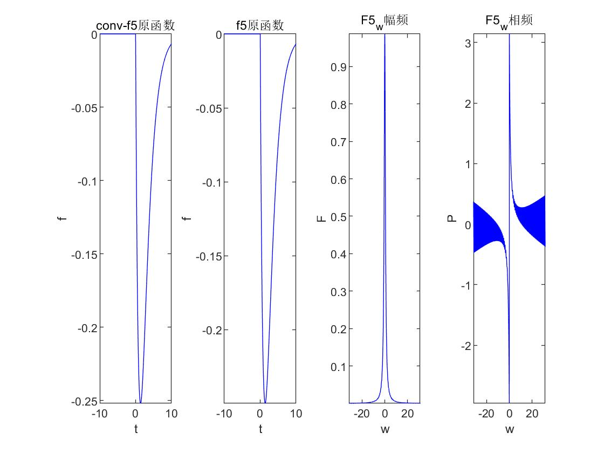

理论结果与conv结果一致

1. **连续信号的频谱分析实验**
2. 画图并验证是否是无失真系统

理论：

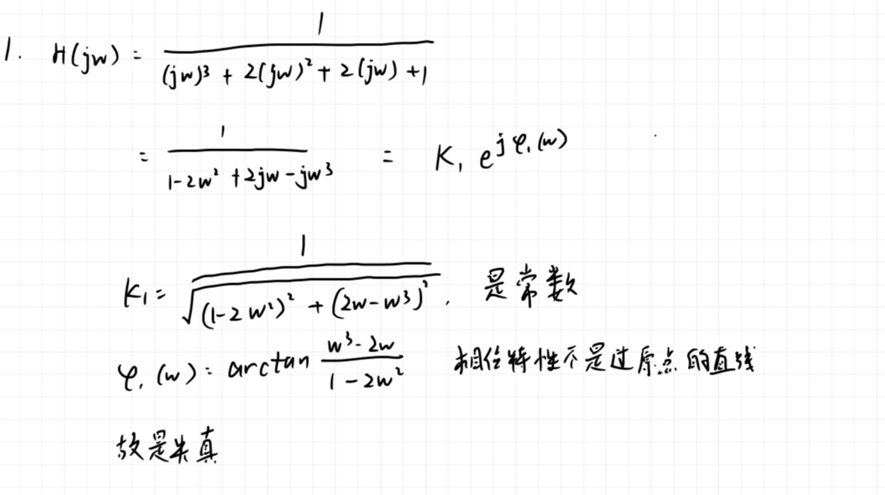

代码：

a = [-1i -2 2i 1];

b = [1];

w = logspace(-1, 1);

freqs(b, a, w);

效果：

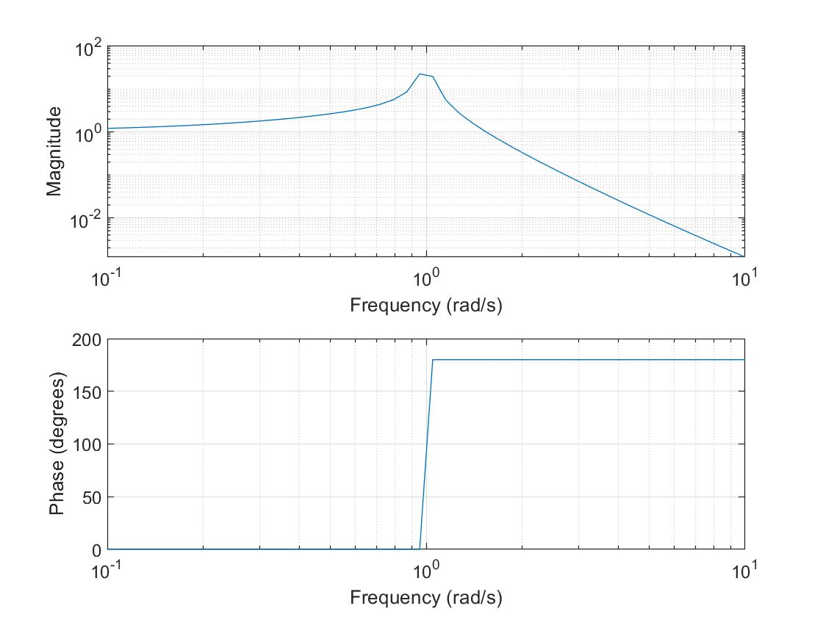

1. 求系统频响函数及y(t)

理论：

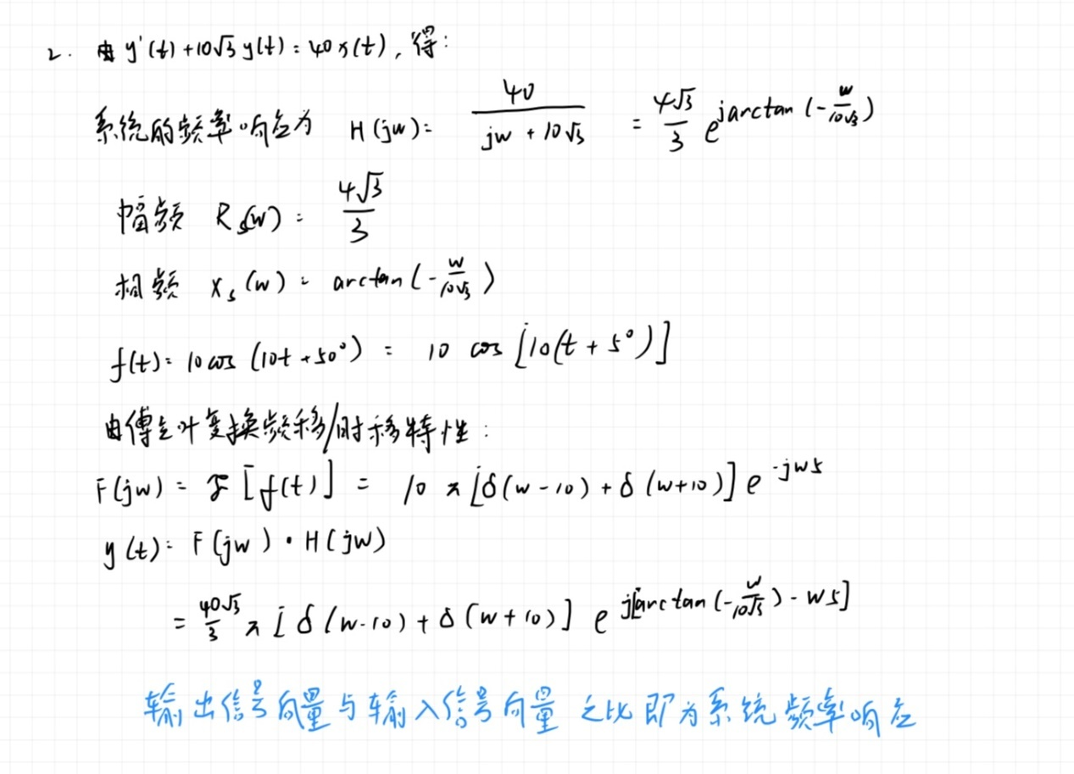

代码：

clear all;

clc;

T = 0.01;

t = -10 : T : 10;

N = 500;

W = 10 * pi;

n = -N : N;

w = n * W / N;

H = 40 ./ (1i.*w + 10 * sqrt(3));

F_w = abs(H);

P_w = angle(H);

subplot(1, 2, 1)

plot(w, F_w, 'b'), axis([(min(w)) (max(w)) (min(F_w)) (max(F_w))]), title('H_w幅频'), xlabel('w'), ylabel('F');

subplot(1, 2, 2)

plot(w, P_w, 'b'), axis([(min(w)) (max(w)) (min(P_w)) (max(P_w))]), title('H_w相频'), xlabel('w'), ylabel('P');

效果：

