Qi Yuan Fang

Assignment 3 SQL Assignment

10A)

**CREATE TABLE STATEMENTS**

create table product(

productId int primary key auto_increment,

productName varchar(25),

sellingPrice numeric(10,2),

manufacturerName varchar(25)

);

create table client(

clientId int primary key auto_increment,

clientName varchar(25),

clientAddress varchar(100),

city varchar(50),

pinCode int,

state varchar(10),

totalBalance numeric(10,2)

);

create table salesMan(

salesManID int primary key auto_increment,

name varchar(25),

address varchar(25),

city varchar(10),

pinCode int,

state varchar(10),

salary numeric(10,2),

deliveryDate date,

totalQuantityOrdered int,

productRate numeric(10,2)

);

create table orders(

orderID int primary key auto_increment,

saleDate date,

clientId int,

salesmanId int ,

billedWholePayment boolean,

deliveryDate date,

Foreign Key(clientId) references Client(clientID),

Foreign Key(salesmanId) references SalesMan(salesManID)

);

Q10(Contd.)

a)

select clientName, city from client;

B)

select * from product;

C)

select clientName from client where clientName like '_a%';

D)

select * from client where city = 'Pune';

E)

select * from product where sellingPrice > 2000 and sellingPrice <= 5000;

F)

alter table product add NEW_PRICE numeric(10,2);

G)

alter table salesMan rename column productRate to new_product_rate;

H)

select * from product order by productName asc;

I)

select orderID, saleDate from orders order by saleDate asc;

J)

delete from orders where saleDate < '2008-08-25';

K)

update orders set deliveryDate = '2008-08-16' where orderID = 'ON1008';

L)

update client set totalBalance = 1200 where clientID = 'CN01003';

M)

select * from product where productName = 'HDD1034' or productName = 'DVDRW';

N)

select clientName, city, state from client where state != 'Maharashtra';

O)

Question is unclear.

Question 11)

Table Create statements (Queries based on said structure):

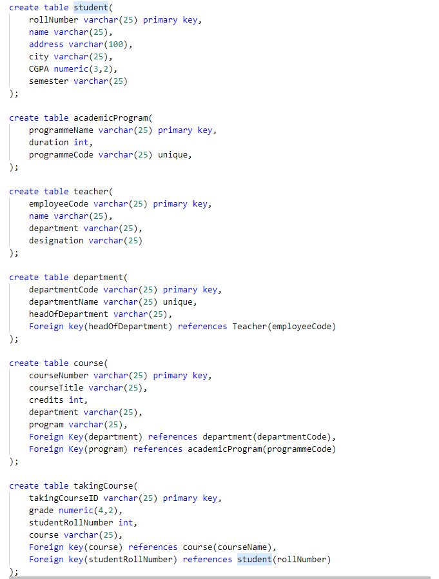

11A

select s.name, s.city, c.courseTile

from student s, course c, takingCourse t

where s.rollNumber = t.studentRollNumber and t.takingCourseID = c.courseNumber and c.department = 'CSE';

11B

select count(*) teacher where department = 'CSE';

11C

select * from courses where department = 'CSE';

11D

select * from student where semester = 1;

11E

select * from student where CGPA>=8.5;

11F

select count(*) from takingCourse where student = 'studentid';

11G

Unclear question.

11H

select count(*) from takingCourse where course = 'DBMS';

11I

select semester from student right join

11J

select name from student order by name asc;

11K

update student set address = Pune where rollNumber = 'COURSENUMBER';

11L

Unclear Question.

11M

select * from course where department = 'CSE';

11N

select * from student where address like '%pune%';

11O

select count(*) from department;

Question 8

Based on Table structure defined in question. Therefore, SQL create statements not provided.

//1

select a.aname

from Aircraft a

where a.aid in (

select c.aid

from Certified c , Employee e

where c.eid = e.eid and exists(

select * from Employees e2

where e2.eid = e.eid and e2.salary > 80000

)

);

//2

select c.eid, max(a.cruisingrange) from Certified c, Aircraft a

where c.aid = a.aid

group by c.eid

having count(*) > 3;

//3

select e.ename

from Employees e

where e.salary < (

select min(f.price)

from Flights f

where f.to = 'Honolulu' and f.from = 'Los Angeles'

);

//4

//5

select e.ename

from Employees e , Certified c, Aircract a

where c.eid = a.aid and e.eid = c.eid and a.aname like '%Boeing%';

//6

select a.aid

from Aircraft a

where a.cruisingrange >= (

select f.distance

from Flights f

where f.from = 'Los Angeles' and f.to = 'Chicago'

);

//7

select distinct f.from, f.to

from Fights f

where exists(

select *

from Employees e

where e.salary > 100000 and not exists(

select *

from Aircraft a, Certified c

where a.cruisingrange > f.distance

and e.eid = c.eid and a.aid = c.eid

)

);

//8

select distinct e.ename

from Emplyees e

where e.eid in (select c.eid

from Certified c

where exists(select a.aid from Aircraft a

where a.aid = c.aid and a.cruisingrange>3000) and not exists(select a2.aid

from Aircraft a2

where a2.aid = c.aid and a2.aname LIKE '%Boeing%'

));

//9

//10

select pilot.avg - allemployees.avg

from (select avg(e.salary) as avg

from Employees e

where e.eid in (select distinct c.eid from

Certified c )) as pilot ,

(select avg(e2.salary) as avg

from Employees e2) as allemployees;

//11

select e.ename, e.salary

from employees e

where e.eid not in (

select c.eid from Certified c

) and e.salary >

(select avg(e2.salary)

from employees e2

where e2.eid in (select c2.eid from certified c2));

//12

select e.ename

from Employees e, Aircraft a, Certified c

where e.eid = c.eid and c.aid = a.aid

having every(a.cruisingrange > 1000);

//13

select e.ename

from Employees e, Aircraft a, Certified c

where c.aid = a.aid and e.eid = c.eid

having every(a.cruisingrange > 1000) and count(*) > 1;

//14

select e.ename

from Employees e, Aircraft a, Certified c

where c.aid = a.aid and e.eid = c.eid

having every(a.cruisingrange > 1000) and a.aname like '%Boeing%';