The gTrackBar
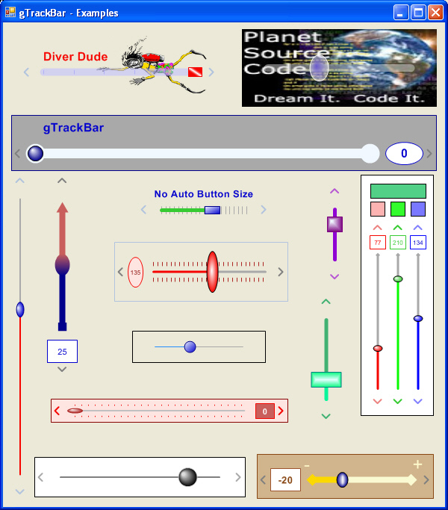

Introduction
I must have OCD (Obsessive Control Disorder). The standard TrackBar has annoyed me for a long time, but I just put up with it until now. I finally got tired of the boring appearance, having to code a TextBox or Label with it to display the value, and a Label for what it is. So, here is the TrackBar I needed, hope it helps you too. There are too many properties to just list them out like I normally would, so I decided to list the function of the property groups and a screenshot of the whole list.
- The Control Group contains the control's Border, Value, and Orientation properties.
- FloatValue is the value that appears as the slider is moved with the mouse.
- Label is the text that appears above the TrackBar.
- Slider is the line, tick marks, and the slider button itself.
- UpDownButtons are the buttons at each end of the TrackBar to increment the value by one.
- ValueBox is the box displaying the value.

Properties
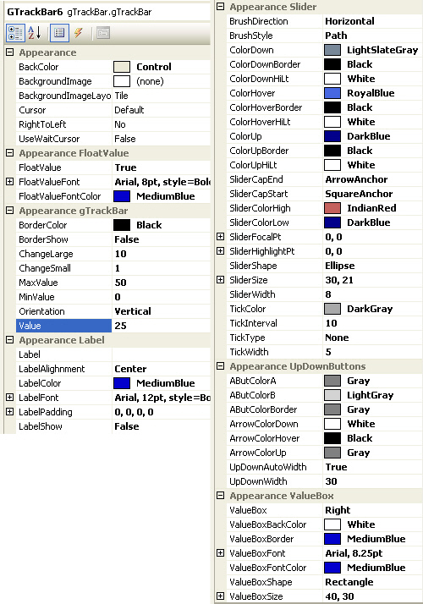

Building
The Building Region contains the routines to setup the layout, size, and positions for all parts of the control.

Painting
Override the Paint event to custom draw each piece of the control in the right place with the correct orientation.
Collapse Copy Code
Protected Overrides Sub OnPaint( ByVal e As System.Windows.Forms.PaintEventArgs)
MyBase.OnPaint(e)

'Setup the Graphics
Dim g As Graphics = e.Graphics
g.SmoothingMode = SmoothingMode.AntiAlias
g.TextRenderingHint = Drawing.Text.TextRenderingHint.AntiAlias

'Draw a Border around the control if requested
If _BorderShow Then
g.DrawRectangle(New Pen(_BorderColor), _
0, 0, Me.Width - 1, Me.Height - 1)
End If

'Add the value increment buttons
DrawUpDnButtons(g)

'Add the Line and Tick Marks
DrawSliderLine(g)

'Draw the Label Text if requested
If _LabelShow Then
DrawLabel(g)
End If

'Add the Slider button
DrawSlider(g)

'Draw the Value above the Slider if requested
If _FloatValue AndAlso IsOverSlider _
AndAlso MouseState = eMouseState.Down Then
DrawFloatValue(g)
End If

'Draw the Box displaying the value if requested
If Not _ValueBox = eValueBox.None Then
DrawValueBox(g)
End If

'Draw Focus Rectangle around control if requested
If _ShowFocus AndAlso Me.Focused _
Then ControlPaint.DrawFocusRectangle(g, New Rectangle( _
2 + CInt(Not _BorderShow), 2 + CInt(Not _BorderShow), _
Me.Width - ((2 + CInt(Not _BorderShow)) * 2), _
Me.Height - ((2 + CInt(Not _BorderShow)) * 2)), Color.Black, Me.BackColor)

End Sub
I used basic GDI+ functions to draw each piece of the control. I will highlight some of the better parts.
In DrawUpDnButtons, I basically have a button that needs to be drawn one of four ways depending on the Orientation and which side of the control it is on. The button itself is just a rectangle with a gradient color fill. The trick was the arrow. I could have calculated each arrow position and points to create a separate GraphicsPath for each, but I used a Matrix instead to Rotate and/or Translate a simple GraphicsPath to the right position.
Collapse Copy Code
Dim gp As New GraphicsPath
Dim pts() As Point
Dim mx As New Matrix
pts = New Point() { _
New Point(5, 0), _
New Point(0, 5), _
New Point(5, 10)}
gp.AddLines(pts)
For the left hand button, the GraphicsPath is oriented correctly so it just needs to be translated (moved) to the right position.
Collapse Copy Code
With rectDownButton
mx.Translate(5, CSng((rectDownButton.Y _
+ (rectDownButton.Height / 2)) - 6))
gp.Transform(mx)
g.DrawPath(pn, gp)
End With
For the right hand button, the GraphicsPath needs to be flipped, but there isn't a built-in function for flipping. Use this to flip the image horizontally instead: New Matrix(-1, 0, 0, 1, image width here, 0).
Collapse Copy Code
With rectUpButton
mx = New Matrix(-1, 0, 0, 1, 5, 0)
mx.Translate(.X + 9, 0, MatrixOrder.Append)
gp.Transform(mx)
g.DrawPath(pn, gp)
End With
For the upper button, the GraphicsPath needs to be rotated 90 degrees. Find the center point and RotateAt that point.
Collapse Copy Code
With rectDownButton
mx.RotateAt(90, New PointF(gp.GetBounds.Width / 2, _
gp.GetBounds.Height / 2))
mx.Translate(CSng((rectDownButton.X + _
(rectDownButton.Width / 2)) - 3), 2, MatrixOrder.Append)
gp.Transform(mx)
g.DrawPath(pn, gp)
End With
For the lower button, the GraphicsPath needs to be flipped again. Use this to flip the image vertically: New Matrix(1, 0, 0, -1, 0, image height here).
Collapse Copy Code
With rectUpButton
mx = New Matrix(1, 0, 0, -1, 0, 10)
mx.Translate(0, .Y + 4, MatrixOrder.Append)
gp.Transform(mx)
g.DrawPath(pn, gp)
End With
The CenterPoint and FocusScales used in the slider brushes are of type PointF. When you create a new property of type PointF, you will notice that it is grayed out in the PropertyGrid, but if a property is of type Point, it will edit correctly in the PropertyGrid. The problem is that there is no built-in TypeConverter for PointF. This is actually pretty easy to fix.
A PointF type property without a custom TypeConverter: it works in code, but you cannot edit it in the PropertyGrid.
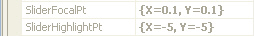
With the PointFConverter, it performs just like the Point property in the PropertyGrid.
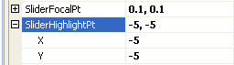
Create a property and add the TypeConverter attribute referencing the PointFConverter class we are about to add.
Collapse Copy Code
Private _SliderHighlightPt As PointF = New PointF(-5.0F, -2.5F)
<Category("Appearance Slider")> _
<Description("Point on the Slider for the Highlight Color")> _
<TypeConverter(GetType(PointFConverter))> _
Public Property SliderHighlightPt() As PointF
Get
Return _SliderHighlightPt
End Get
Set(ByVal value As PointF)
_SliderHighlightPt = value
Me.Invalidate()
End Set
End Property
The PointFConverter class inherits ExpandableObjectConverter, and overrides the CanConvertFrom, ConvertFrom, and ConvertTo functions.
Collapse Copy Code
Friend Class PointFConverter : Inherits ExpandableObjectConverter

Public Overloads Overrides Function CanConvertFrom( _
ByVal context As System.ComponentModel.ITypeDescriptorContext, _
ByVal sourceType As System.Type) As Boolean

If (sourceType Is GetType(String)) Then
Return True
End If
Return MyBase.CanConvertFrom(context, sourceType)

End Function

Public Overloads Overrides Function ConvertFrom( _
ByVal context As System.ComponentModel.ITypeDescriptorContext, _
ByVal culture As System.Globalization.CultureInfo, _
ByVal value As Object) As Object

If TypeOf value Is String Then
Try
Dim s As String = CType(value, String)
Dim ConverterParts(2) As String
ConverterParts = Split(s, ",")
If Not IsNothing(ConverterParts) Then
If IsNothing(ConverterParts(0)) Then ConverterParts(0) = "-5"
If IsNothing(ConverterParts(1)) Then ConverterParts(1) = "-2.5"
Return New PointF(CSng(ConverterParts(0).Trim), _
CSng(ConverterParts(1).Trim))
End If
Catch ex As Exception
Throw New ArgumentException("Can not convert '" & _
CStr(value) & "' to type Corners")
End Try
Else
Return New PointF(-5.0F, -2.5F)
End If

Return MyBase.ConvertFrom(context, culture, value)

End Function

Public Overloads Overrides Function ConvertTo( _
ByVal context As System.ComponentModel.ITypeDescriptorContext, _
ByVal culture As System.Globalization.CultureInfo, _
ByVal value As Object, ByVal destinationType As System.Type) As Object

If (destinationType Is GetType(System.String) _
AndAlso TypeOf value Is PointF) Then

Dim ConverterProperty As PointF = CType(value, PointF)
' build the string representation
Return String.Format("{0}, {1}", _
ConverterProperty.X, _
ConverterProperty.Y)
End If
Return MyBase.ConvertTo(context, culture, value, destinationType)

End Function

End Class 'PointFConverter Class

Mouse Events
Here is where we check what part of the control the cursor is over and if the mouse button is pressed. Based on this information, the Value is adjusted accordingly.

Key Events
I wanted to be able to adjust the Value by pressing the arrow keys. That sounded simple. I figured I would just check the e.KeyValue in the KeyUp event and adjust the Value accordingly. Well, not so simple. The problem is that the UserControl Inherits Button, which automatically handles the arrow keys differently. After the KeyUp event, the focus jumps to the next control in the Tab Order, even if you use e.Handled and e.SuppressKeyPress. I couldn't stop the focus change. Then, I thought I would use the KeyDown event, but guess what, the arrows are automatically ignored there. To fix this behavior, I override the IsInputKey function to allow the arrow keys. After this, the focus will not jump away anymore.
Collapse Copy Code
Protected Overrides Function IsInputKey( _
ByVal keyData As System.Windows.Forms.Keys) As Boolean
'Because a Usercontrol ignores the arrows in the KeyDown Event
'and changes focus no matter what in the KeyUp Event
'This is needed to fix the KeyDown problem
Select Case keyData And Keys.KeyCode
Case Keys.Up, Keys.Down, Keys.Right, Keys.Left
Return True
Case Else
Return MyBase.IsInputKey(keyData)
End Select
End Function

Private Sub gTrackBar_KeyUp(ByVal sender As Object, _
ByVal e As System.Windows.Forms.KeyEventArgs) Handles Me.KeyUp

Dim adjust As Integer = _ChangeSmall
If e.Shift Then
adjust = _ChangeLarge
End If

Select Case e.KeyValue
Case Keys.Up, Keys.Right
Me.Value += adjust

Case Keys.Down, Keys.Left
Me.Value -= adjust
End Select
End Sub

History
- Version 1.0 - March 2009
- Version 1.2 - April 2009
  - Added Focus Rectangle
  - Separated the Label into its own Rectangle area for better layout and sizing
  - General Layout Fixes
- Version 1.3 - April 2009
  - Handles Negative ranges

