

Final Exam - Theory (10%)

Course Identification
Name of programs – Codes: | COMPUTER SCIENCE TECHNOLOGY – ARTIFICIAL INTELLIGENCE AND MACHINE LEARNING– LEA.DQ
Course title: | machine learning & neural networks
Course number: | 420-A16-AS
Group:
Teacher’s name: | Mona Taghvi
Duration: | 1.5 hours
Semester: | Summer 2026
Student Identification
Name: ______________________________________ Student number: ______________

Date: 29 / 06 / 2026 Result: ______________

☐ I declare that this is an original work, and that I credited all content sources of which I am not the author (online and printed, images, graphics, films, etc.), in the required quotation and citation style for this work.

Standard of the Evaluated Competency
Statement of the evaluated competency – Code
Program Development – KP54

Evaluated elements of the competency
5. Evaluate the solution
6. Carryout the plan

Instructions

The teacher will not answer questions during the exam.

You must not share the exam questions and answers during and after the exam.

It is the teacher’s responsibility to identify language errors. If such errors are found, teachers may apply a penalty of up to 5% of the grade (IPEL – Article 5.7).

Plagiarism, attempts at plagiarism or complicity in plagiarism during a summative evaluation results in a mark of zero (0). In the case of recidivism, in the same course or in another course, the student will be given a grade of '0' for the course in question. (IPEL – Article 5.16).

Please write clearly.

- You may use your lecture notes, but you CANNOT use AI.
Mark Breakdown

This evaluation is on 10 points, distributed as follows:

TOTAL: 10 POINTS

Predictive Maintenance System
A manufacturing company deploys a small neural network to predict whether a machine requires maintenance or is operating normally. The model receives two input features:
- x1 : Vibration intensity (normalized)
- x2 : Temperature deviation (normalized)
The network has 2 input nodes,1 hidden node, and 2 bias nodes:
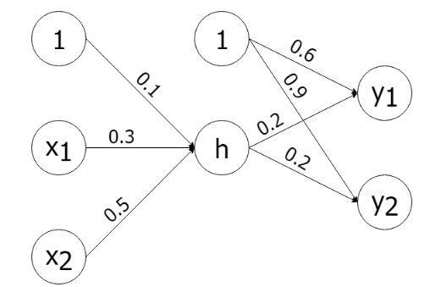

The hidden layer uses activation ReLU and the 2 output nodes use sigmoid activation:
y1 : probability the machine is operating normally
y2 : probability the machine requires maintenance
Consider the above details and answer the following questions.
(a) Forward propagation (3 points)
Compute y1 and y2 when the network receives the input x = (1, 0).
solution:
Z_h = 0.3X1 + 0.5X2 + 0.1 = 0.3* 1+0.1 = 0.4
A_h = relu(Z_h) = 0.4
Z_y1 = 0.2 A_h + 0.6 = 0.2 * 0.4 + 0.6 = 0.68
Z_y2 = 0.2 A_h + 0.9 = 0.98
A_y1 = sigmoid(Z_y1) = 1/1-e^-x = 1/(1-e^(-0.68)) = 2.02
A_y2 = sigmoid(Z_y2) = 1/1-e^-x = 1/(1-e^(-0.98)) = 1.6
y1 = 2.02/(2.02 + 1.6) = 2.02/3.6 = 0.56
y2 = 0.44

(b) Backpropagation update (5 points)
Assume the expected output for this machine is t = (0, 1). Using learning rate η = 0.1, compute the updated weights after one backpropagation step.
Derivative of ReLU:
ReLU' (h_in) = 1 if h_in > 0,
otherwise 0.
solution:
delta_O = (y1 – 0, y2 -1) = (0.56 , 0.44 -1) = (0.56,-0.56)
delta_y1 = sigmoid’(Z_y1) *( O-T)= A_y1*(1-A_y1)*0.56 = 2.02*(-1.02)*0.56 = -1.15
delta_y2 = sigmoid’(Z_y2)*(O-T) = A_y2*(1-A_y2)*(-0.56) = 1.6*(-0.6)*(-0.56) = 0.54

delta_w_y1 = - η *delta_y1 * A_h = -0.1 * (-1.15)*0.4 = 0.046
delta_w_y2 = - η *delta_y2 * A_h = -0.1 *(0.54)*0.4 = -0.022
delta_w_b1 = - η *1 = -0.1 *1*(delta_y1 + delta_y2) = 0.061
w_y1 = 0.2 + 0.046 = 0.246
w_y2 =0.2 -0.022 = 1.978
b1 = 0.6 +0.061 = 0.661
b2 = 0.9 + 0.061 = 0.961

delta_h = relu’(Z_h) *(0.2 *delta_y1 + 0.2 *delta_y2) = 1* 0.2*(-0.61) = -0.122
delta_w_x1 = - η *delta_h *x1 = - 0.1 * (-0.122) *1 = 0.012
delta_w_x2 = 0
delta_b = 0.012
w_x1 = 0.3 + 0.012 = 0.312
w_x2 = 0.5 +0 = 0.5

b =0.1 +0.012 = 0.112

(c) Evaluation metrics (2 points)
After training on 40 machines, the confusion matrix is:
 | Predicted Normal (0) | Predicted Maintenance (1)
Actual Normal (0) | 14 | 6
Actual Maintenance (1) | 4 | 16

Compute the Accuracy, Precision, recall, and F1-score for each class.
solution:
tp = 16
fp = 6
tn = 14
fn = 4
Accuracy = (14+16)/(14+16+10) = 30/40 = 75%
Precision = tp/(tp +fp) = 16/22 = 72.7%
recall = tp/(tp+fn) = 16/(20) = 80%
f1 = 2/(1/p+1/r) = 76%

