EDA and Policy inference from Observational Data

Dataset cleaning and validation

Shape of dataset
(2500,15)

The 10 rows of the dataset
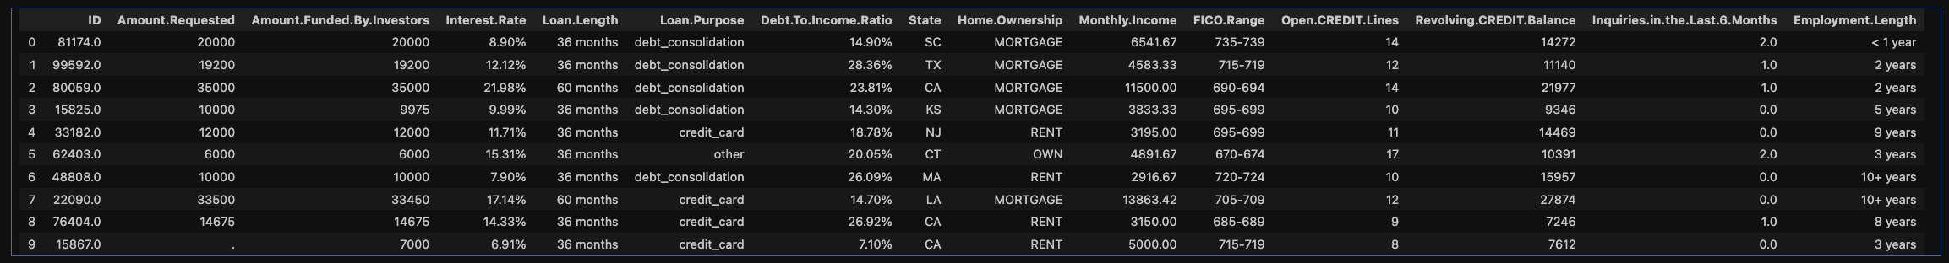

Main info about the raw dataset

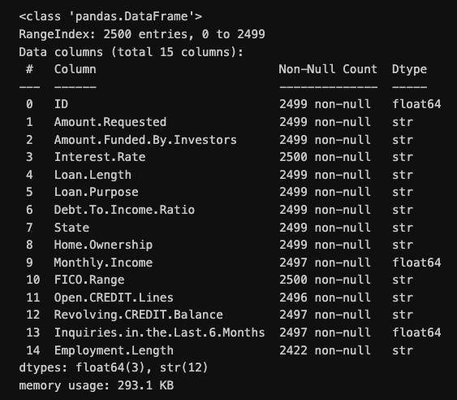

Data preprocessing
Clean the records with missing values, then convert the features to appropriate data types.
- remove missing records, including the data non-available
- convert datatype
- prepare features
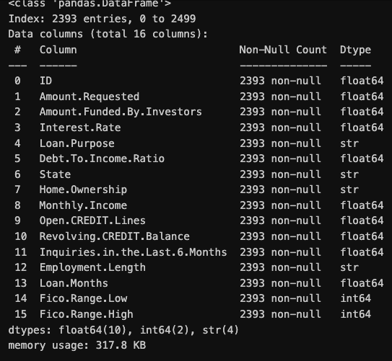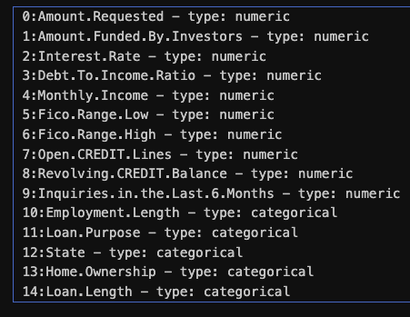

EDA

Target
Objective is to infer lending policy by analyzing how borrower characteristics influence assigned interest rates using observational data.
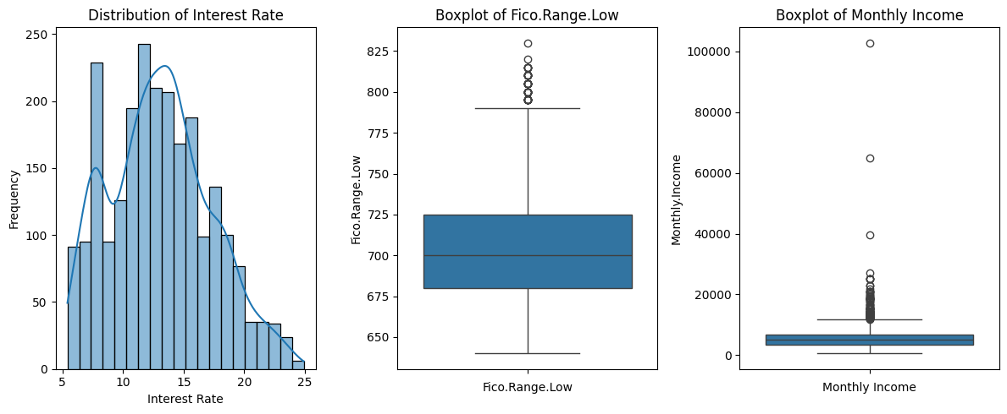

Numerical variables
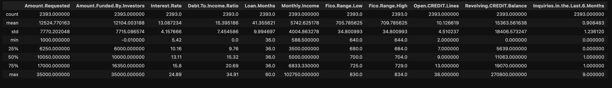




correlations
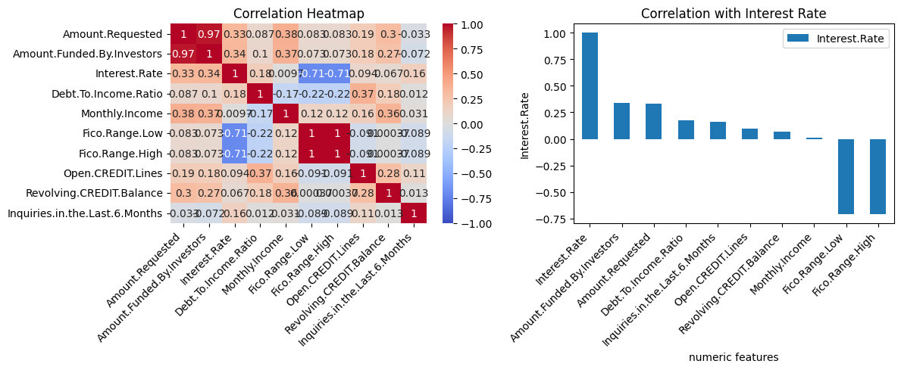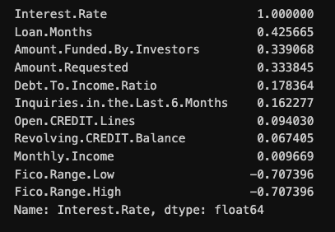

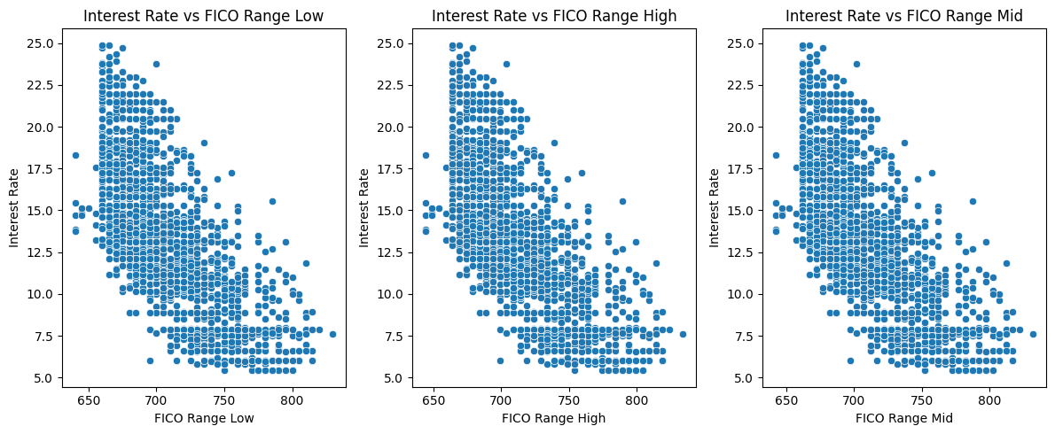
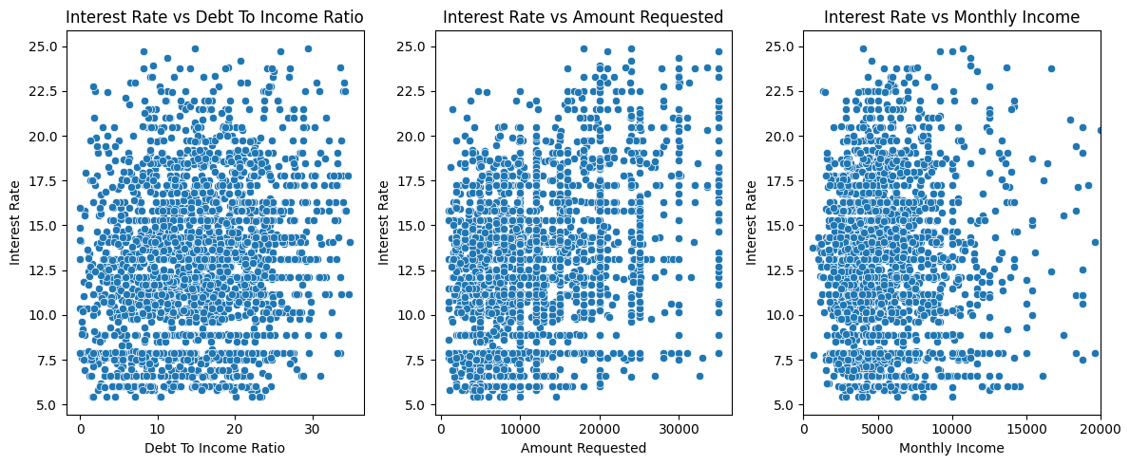
Among numerical variables, FICO score shows the strongest and approximately linear relationship with interest rate.

Categorical variables
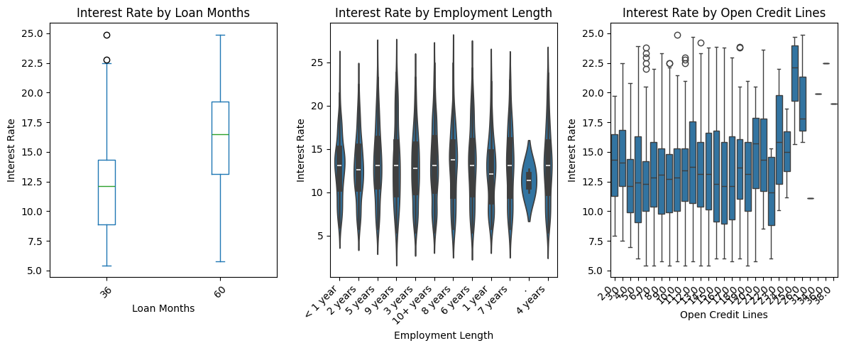
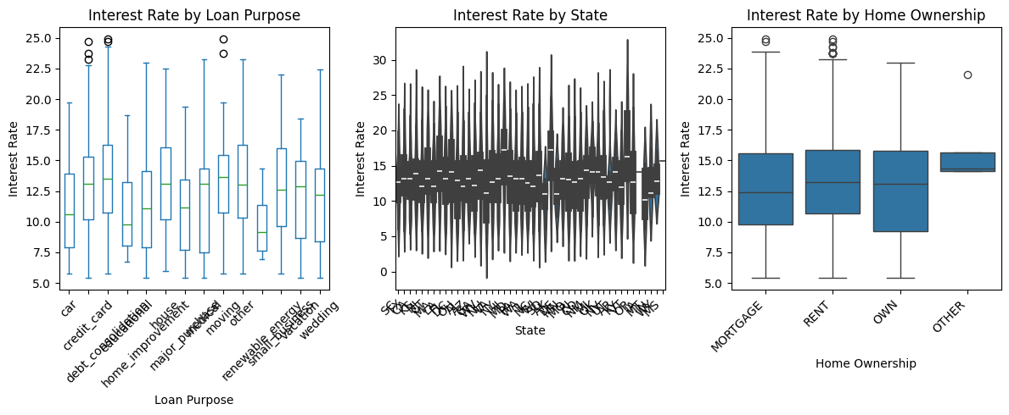

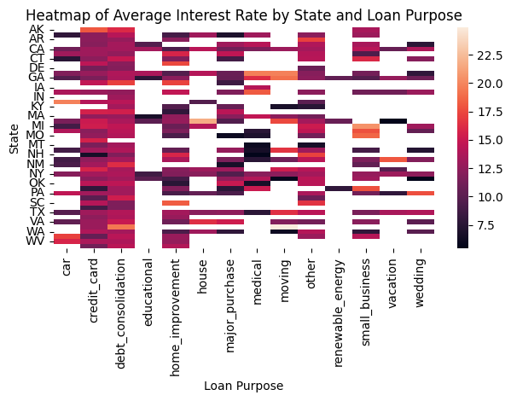
Average:
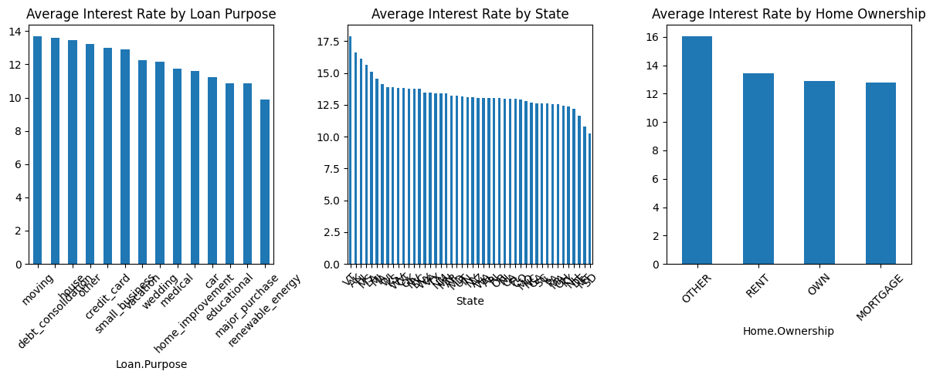
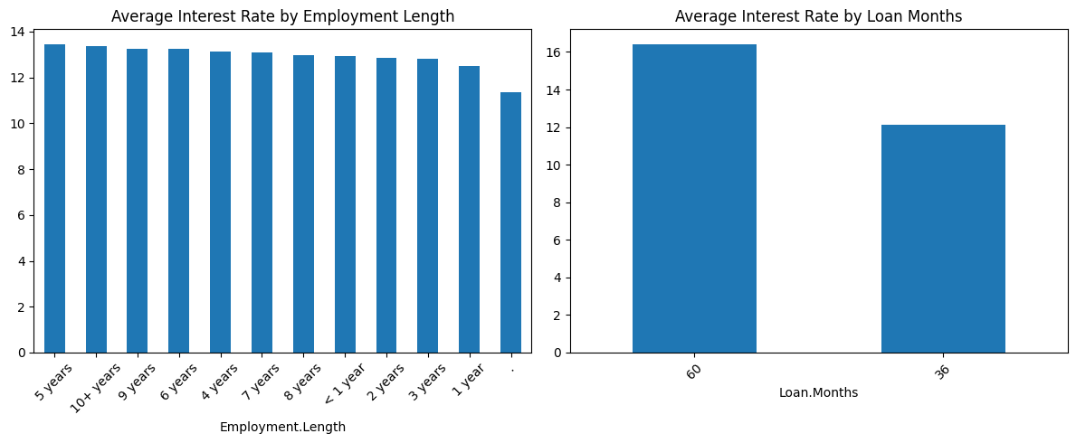
Categorical variables such as loan purpose and state exhibit differences in average interest rates across groups. However, the patterns are less consistent compared to numerical risk indicators, and substantial overlap in distributions suggests a weaker influence on pricing decisions.

Policy intuition from EDA
The exploratory analysis suggests that the lender does not rely on all borrower attributes equally.
Instead, interest rate assignment appears to be primarily driven by:
- credit score (FICO)
- loan duration
Although a clear negative trend exists between FICO score and interest rate, substantial dispersion is observed around the linear relationship.
This suggests that while credit score is a major determinant of pricing, interest rate is influenced by additional factors such as loan duration, loan amount, and borrower financial characteristics.

