Progress Report

Space–Time Trade-offs in Graph Traversal under a Fixed Graph Model
Student: Qiyun Ge
Course: 420-A10-AS C2 — Introduction aux structures de donnée
Instructor: Ali Moridnejad
Date: March 2026

Project Overview
This project studies the space–time trade-offs in graph traversal algorithms, focusing on the behavior of Breadth-First Search (BFS) and Depth-First Search (DFS) under a fixed graph and computation model.
Although BFS and DFS share the same asymptotic time complexity T (V, E) = O(V+E), their practical performance differs significantly, particularly in terms of auxiliary memory usage and traversal order.
The traversal algorithms are implemented as interchangeable strategies in a traversal engine, enabling systematic comparison of time–space trade-offs. The main objective of this project is to experimentally analyze these differences and determine how algorithm design and graph representation influence the observed space–time trade-offs.
The study is conducted under a consistent model to distinguish algorithmic behavior from implementation-specific effects.
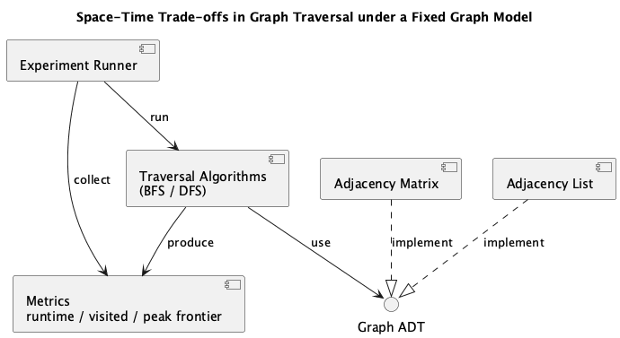
Figure 1: Experimental System Architecture
The system separates graph representations, traversal algorithms, and experiment execution to ensure fair comparison of space–time trade-offs in graph traversal.

Work Completed So Far
The following components of the project have been completed or designed:
- Graph Abstraction
- Graph Representation
- Traversal Algorithms (BFS/DFS)
- Experimental Design

Difficulties Encountered and Proposed Solutions
The main challenge encountered so far concerns ensuring fair comparisons between algorithms and representations.
Different graph representations may introduce constant-factor differences in runtime and memory access patterns. To address this issue, the project uses a consistent Graph ADT so that traversal algorithms interact with the graph through the same interface.
Another challenge involves isolating algorithmic effects from language-specific implementation details. To mitigate this, a minimal C++ implementation will be developed to validate that the observed trends are not specific to Python.

Next Steps
The remaining work will focus on completing the experimental study and producing the final report.
The project is progressing according to plan.
The core graph abstraction and traversal framework have been designed, and the next phase will focus on empirical analysis and validation of the theoretical space–time trade-offs between BFS and DFS.

