IDE

WebStorm

Search everywhere 

Search for project elements

Ctrl + n for class

Ctrl + shift + n for a file

Ctrl + shift + alt + n for a symbol

Search for code elements ctrl + f

To view file structure view Alt + 7

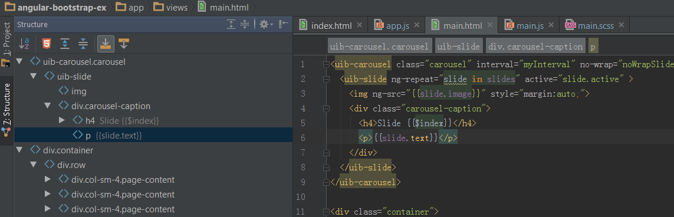

Navigate across the IDE ctrl + tab

Edit and write code

Code completion ctrl + space



Auto-create a new method that you have not yet declared