The earth is **49 times the size** of the moon

The grain output is **8 percent higher** this year than last year

The production of goods has been **increased by four times** this year

1/3 one third (或者读 one over three)

1.25 one point two five

2+2=4 two plus two equals four

10-3=7 ten minus three is seven

9*6=54 nine multiplied by six is fifty-four

20/4 twenty divided by four is five

3:2 the ratio of three to two

新加坡数学

Learning Maths

nursery [ˈnɜːsəri] adj 幼儿教育的；n 婴儿室，（供游戏的）儿童室， 苗圃（卖花草的店）

infant 一岁以下 Toddler 1-2岁 Twos 2-3岁

preschool 3岁 pre-kindergarten 4岁 primary 1-6

kindergarten 学前班，一年级之前那一年，接近国内的幼儿园大班

Shapes: circle, square, triangle, rectangle, star(五角星), diamond(菱形), oval [ˈəʊvl] (椭圆形), heart心形

Colors: red, brown (棕色的), purple, yellow, orange, blue, green

In each row

The tall (short) boy the big (small) cake

The long (short) ruler out of the cage 笼子

Hard (soft) 硬的(软的) heavy (light)

The book weighs about 3 blocks

Count and write(identify) numbers up to 10

Circle(color) the correct number

Color the circles red

Cross out 打叉，划掉 take away 带走

Sarah picks 7 flowers, she then picks 3 more flowers

Sarah has 3 balloons at first, 2 balloons have **burst**, only 1 balloon is left.

There are 4 candles at first, 2 candles have **melted**, 2 candles are left.

There are 4 towels at first, 3 towels are torn, 1 tower is left.

John has 6 stickers, but he gives 2 stickers away, John has 4 stickers left

1 sweet 一颗糖果 2 balls (蓝球，康乐)球 3 strawberries 草莓

4 carrots 胡萝卜 5 ballons 气球 6 dresses 连衣裙，衣服

7 lollipops 棒棒糖 8 icecream cones 甜筒 9 buttons 钮扣

10 ice cubes 冰块 10 doughnuts 甜甜圈 11 plates 盘子，碟子

12 cupcakes 纸杯蛋糕 13 marbles 弹珠

strawberry 草莓 carrot 胡萝卜 cherry 樱桃

Rabbit 兔子 bee 蜜蜂

shirt (尤指男式的)衬衫 dresses 连衣裙，衣服 skirt 女裙，短裙

short skirt are back in style.

cap (尤指男用有帽舌的)便帽 hat (常指女式带檐的)帽子

Table lamps台灯 desk lamps桌面灯 toothbrush ruler尺子

Towel n毛巾；抹布；vt 用毛巾擦干 candle 蜡烛 vase 花瓶

Kite 风筝 rocket 火箭

A special set of stamps 一套邮票

Biscuit [ˈbɪskɪt] 饼干 cookies 曲奇饼

Sticker n 贴纸；粘贴标签;

Give away 丧失；赠送；泄露（秘密）；（基督教婚礼上）将新娘交给新郎

John has 6 stickers, but he gives 2 stickers away

Ribbon n（用于捆绑或装饰的）带子；勋带

Thread n 丝线 v 串在一起

No, but we have a red ribbon, blue thread 没有，不过我们有红带子、蓝丝线

numeracy [ˈnjuːmərəsi] n 识数

penmanship [ˈpenmənʃɪp] n 书写技巧，书法

view on carrying out the outside class activities – Penmanship 论书法课外活动的开展

a head start 有一个良好的开端

give your children a head start by sending them to nursery school

make a fresh start 重新开始，重振旗鼓

I hope Jim and I can get back together and make a fresh start

Blown away 吹走

The newspaper was blown away by the wind 报纸被风吹走了

2 balloons are blown away

vivid and interesting pictures accompanying the digits allow the children to learn number effectively.

Vivid and interesting pictures are used to engage the children to read, construct and interpret bar graphs more effectively

Advance n (尤指武装部队的)前进；预付款；v (为了进攻)前进；(知识，技术等)推动，发展；adj 预先的，事先的；先遣队

The general gave the order to advance 将军下令前进

K1 advances the learning of Mathematics by introducing addition and subtraction of numbers

SAT 数学词汇

代数

add, plus 加 subtract 减 difference 差

multiply, times 乘 product 积

divide 除 divisible [dɪˈvɪzəbl] 可视整除的

dividend [ˈdɪvɪdend] 被除数 divisor [dɪˈvaɪzə(r)] 除数，因子

**quotient** [ˈkwəʊʃnt] 商 remainder 余数

factorial 阶乘 power 乘方

radical sign, root sign 根号

proper fraction 真分数 improper fraction 假分数 mixed number 带分数

**vulgar** [ˈvʌlɡə(r)] fraction, common fraction 普通分数

simple fraction 简分数 complex fraction 繁分数

numerator 分子 **denominator** [dɪˈnɒmɪneɪtə(r)] 分母

least common denominator 最小公分母

decimal [ˈdesɪml] fraction 纯小数 infinite decimal 无穷小数 recurring decimal 循环小数

exponent 指数，幂 base 乘幂的底数，底边 cube 立方数，立方体

square root 平方根 cube root 立方根

common logarithm 常用对数

constant 常数 variable 变量 digit 数字

natural number 自然数 integer, whole number 整数

real number实数 rational number 有理数 irrational number 无理数

positive number 正数 negative number 负数 non-negative 非负的

positive whole number 正整数 negative whole number 负整数

odd integer, odd number 奇数 even integer, even number 偶数

consecutive number 连续整数

prime number 质数 composite number 合数

common divisor公约数 multiple 倍数 least common multiple 最小公倍数

prime factor 质因子 common factor 公因子 common ratio 公比

ordinary scale, decimal scale 十进制

tenths unit 十分位 tens十位 units 个位 unit 单位

absolute value 绝对值 inverse, reciprocal 倒数

round to, round off, to the nearest 四舍五入

Arithmetic progression sequence 等差数列

Geometric progression sequence 等比数列

arithmetic mean 算术平均值 weighted average 加权平均值 geometric mean 几何平均值

mode 众数 median 中数

linear function 一次函数 quadratic function 二次函数 parabola抛物线

direct proportion 正比 proportional function 正比例函数

proportion 比例 inverse proportional function 反比例 函数

exponential function 指数函数 logarithmic function 对数函数

trigonometric function 三角函数

odd function 奇函数 even function 偶函数

inverse 反函数 complementary 余函数

Coordinate system 坐标系 rectangular coordinate 直角坐标系

Origin 原点 abscissa横坐标 ordinate 纵坐标

Number line 数轴 quadrant 象限 slope 斜率

Tangent 切线的 transversal 截线 intercept截距

Intersect 相交 vertical, perpendicular垂直 parallel 平行

Union 并集 proper subset 真子集 solution set 解集

factorization 因式分解

algebraic term [ˌældʒɪˈbreɪɪk] 代数项 like terms, similar terms 同类项

literal coefficient 字母系数

inequality 不等式 triangle inequality 三角不等式

range 值域

original equation 原方程 equivalent equation 同解方程，等价方程 linear equation线性方程

linear equation with one unknown 一元一次等式 linear inequality with one unknown

Approximate 近似 estimation 估计，近似

clockwise （逆）顺时针方向 anti-clockwise 逆时针方向

cardinal 基数 ordinal 序数

distinct 不同的

parentheses 括号

permutation 排列 combination 组合

table 表格

Complex plane 复平面

几何

Alternate angle 内错角 Corresponding angle 同位角

Vertical angle 对顶角 central angle 圆心角

Interior angle 内角 exterior angle 外角

Supplementary angles 补角 complementary angle余角

Adjacent angle 邻角

Acute angle 锐角 right angle 直角 obtuse angle 钝角

Rectangle 长方形 regular polygon 正多边形 rhombus 菱形 trapezoid 梯形

Semicircle 半圆 concentric circles 同心圆

quadrilateral 四边形 pentagon 五边形 hexagon 六边形 heptagon 七边形

octagon 八边形 nonagon 九边形 decagon 十边形 polygon 多边形

parallelogram 平行四边形 equilateral 等边形 plane 平面 square 正方形，平方

Arc 弧 line, straight line 直线 line segment 线段 parallel lines 平行线

Segment of a circle 弧形 cube 立方体，立方数

Rectangular solid 长方体 regular solid, regular polyhedron 正多面体

Circular cylinder 圆柱体 cone 圆锥 sphere 球体 solid 立体的

Altitude 高 depth 深度 side 边长 circumference, perimeter 周长

Radian 弧度 surface area 表面积 volume 体积

Arm 直角三角形的股 cross section 横截面 center of a circle 圆心

Chord 弦 radius 半径 angle bisector 角平分线

Diagonal 对角线 diameter 直径 edge 棱

Face of a solid立体的面 hypotenuse 斜边

Included side 夹边 leg 三角形的直角边 median of a triangle 三角形的中线

Base 底边，底数 opposite 直角三角形中的对边

Midpoint中点 endpoint端点 vertex 顶点

Plane geometry 平面几何 trigonometry 三角学

Bisect 平分 circumscribe外切 inscribe内切

intersect 相交 perpendicular垂直 Pythagorean theorem 勾股定理

congruent 全等的 multilateral 多边的

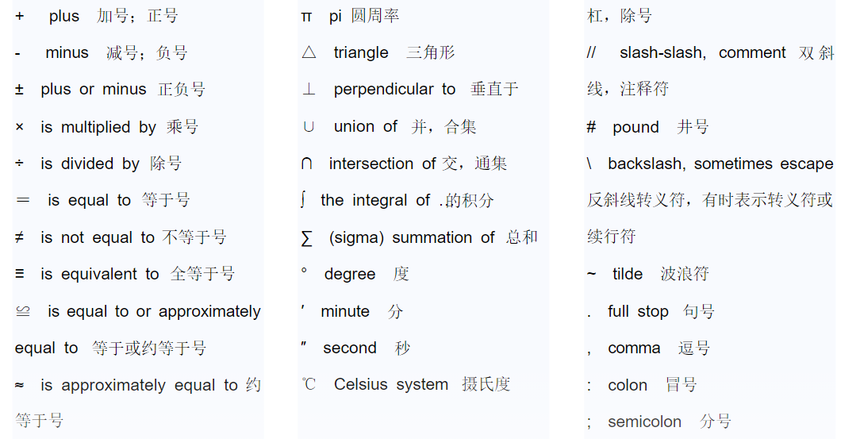

$<$ is less than $>$ is more than $≥$ is less than or equal to

{ open brace, open curly } close brace, close curly

? question mark 问号 ! exclamation mark, exclamation point

0.125 point one two five 0.012 zero point O one two

8.004: eight point OO four 33.33 thirty-three point three recurring

7, 236, 400 seven million, two hundred and thirty-six thousand, four hundred

1,709,000,000 one billion, seven hundred and nine million

1/2 one half 1/3 one-third 2/3 two-thirds 1/4 a quarter

比较复杂的分数可以用介词in, out of, over等 如

24/729 twenty four **over** seven hundred and eighty nine

5/7 five-sevenths, five **in** seven, five **out of** seven, five **over** seven

$2\frac{1}{2}$ two **and** one half

$4\frac{3}{5}$ four and three-fifths

x+1: x plus one x-1: x minus one x±1: x plus or minus one

xy: x multiplied by y

(x-y)(x+y) : x minus y, x plus y

x = 5 : x equals 5, x is equals to 5

$x≡y:$ x is equivalent to y, x is identical with y

x > y: x is greater than y

$x≥y$: x is greater than or equal to y

0<x<1: zero is less than x is less than 1

$x^{y}:$ x to the power of y

$x^{2}:$ x squared, x to the power of 2

$x^{3}:$ x cubed, x to the power of 3

$x^{-n}:$ x to the power of minus n

$\sqrt[2]{x}:$ square root x, the square root of x $\sqrt[3]{x}:$ cube root x

$\sqrt[n]{x}:$ the nth root of x

${(x+y)}^{2}:$ x plus y all squared ${(x/y)}^{2}:$ x over y all squared

n!: n factorial

$\hat{x}$: x hat $\overline{x}$: x bar

$x_{i}:$ x i, x sub i, x subscript i, x suffix i

$\sum_{i=1}^{n}{a_{i}:}$ the sum from I equals one to n $a_{i}$, the sum as i runs from 1 to n of the $a_{i}$

$\left|\left|X\right|\right|:$ the norm of X

AT: A transpose, the transpose of A

A-1: A inverse, the inverse of A

f(x): fx, f of x, the function f of x

f: S->T: a function f from S to T

x -> y: x maps to y

$f^{'}\left(x\right):$ f prime x, f dash x, the first derivative of f with respect to x

$f^{''}\left(x\right):$ f double-prime x, f double-dash x, the second derivative of f with respect to x

$f^{'''}\left(x\right):$ f triple-prime x, f triple-dash x, the third derivative of f with respect to x

$f^{(4)}\left(x\right)$: f four x, the fourth derivative of f with respect to x

$\frac{∂y}{∂x}:$ the partial derivative of y with respect to x

$\int_{0}^{∞}{}$: the integral from zero to infinity

$\lim_{x→0}{}$: the limit as x approaches zero

$\lim_{x→0+}{}$: the limit as x approaches zero from above

$\lim_{x→0-}{}$: the limit as x approaches zero from below

$\log_{e}{y}, lny:$ log y to the base e, log to the base e of y , natural log of y

$∃$ there exist $∀$ for all

p => q: p implies q, if p then q p <=> q: p if and only if q

$x∈A$: x belongs to A $x⊄A$: x doesn’t belongs to A

$A⊂B$: A is contained in B

$A∩B$: A cap B, A intersection B $A∪B$: A cup B, A union B

A – B: A minus B, the difference between A and B

AxB: A cross B, the cartesian [kɑːˈtiːziən] product of A and B