Shaft

P4-shaft-corrected-static

Changed on | 30.10.2026, 21:27:49
Changed by | AAA
Description | P4 candidate - STATIC PREP ONLY - loads/supports must be verified before calculation
 | 2o2dy (5416)
 | KISSsoft Release 2026

Contents

1 Messages
 | Calculation is consistent.
2 Input data

Coordinate system shaft: see picture W-002

2.1 Shafts
2.1.1 Shaft 'Shaft'
Drawing W-007
Initial position (mm) -10.000
Length (mm) 170.000
Speed (1/min) 900.000
Direction of rotation: clockwise

Material, own Input P4 custom DIN743 1000/800/500/400/300
Young's modulus (N/mm²) 206000.000
Poisson's ratio nu 0.300
Density (kg/m³) 7830.000
Coefficient of thermal expansion (10^-6/K) 11.500
Temperature (°C) 20.000
Mass of shaft (kg) 0.982
Mass of shaft, including additional masses (kg) 0.982
Mass moment of inertia (kg*mm²) 122.100
Momentum of mass GD2 (Nm²) 0.005

2.2 Weight force
The direction of the weight is not considered
2.3 Shaft modeling
2.4 Shear deformations
Consider deformations due to shearing
Shear correction factor 1.100
2.5 Rolling bearings
Rolling bearing stiffness is calculated from inner bearing geometry
Tolerance field: Mean value
2.6 Housing
Reference temperature (°C) 20.000
2.7 Load applications
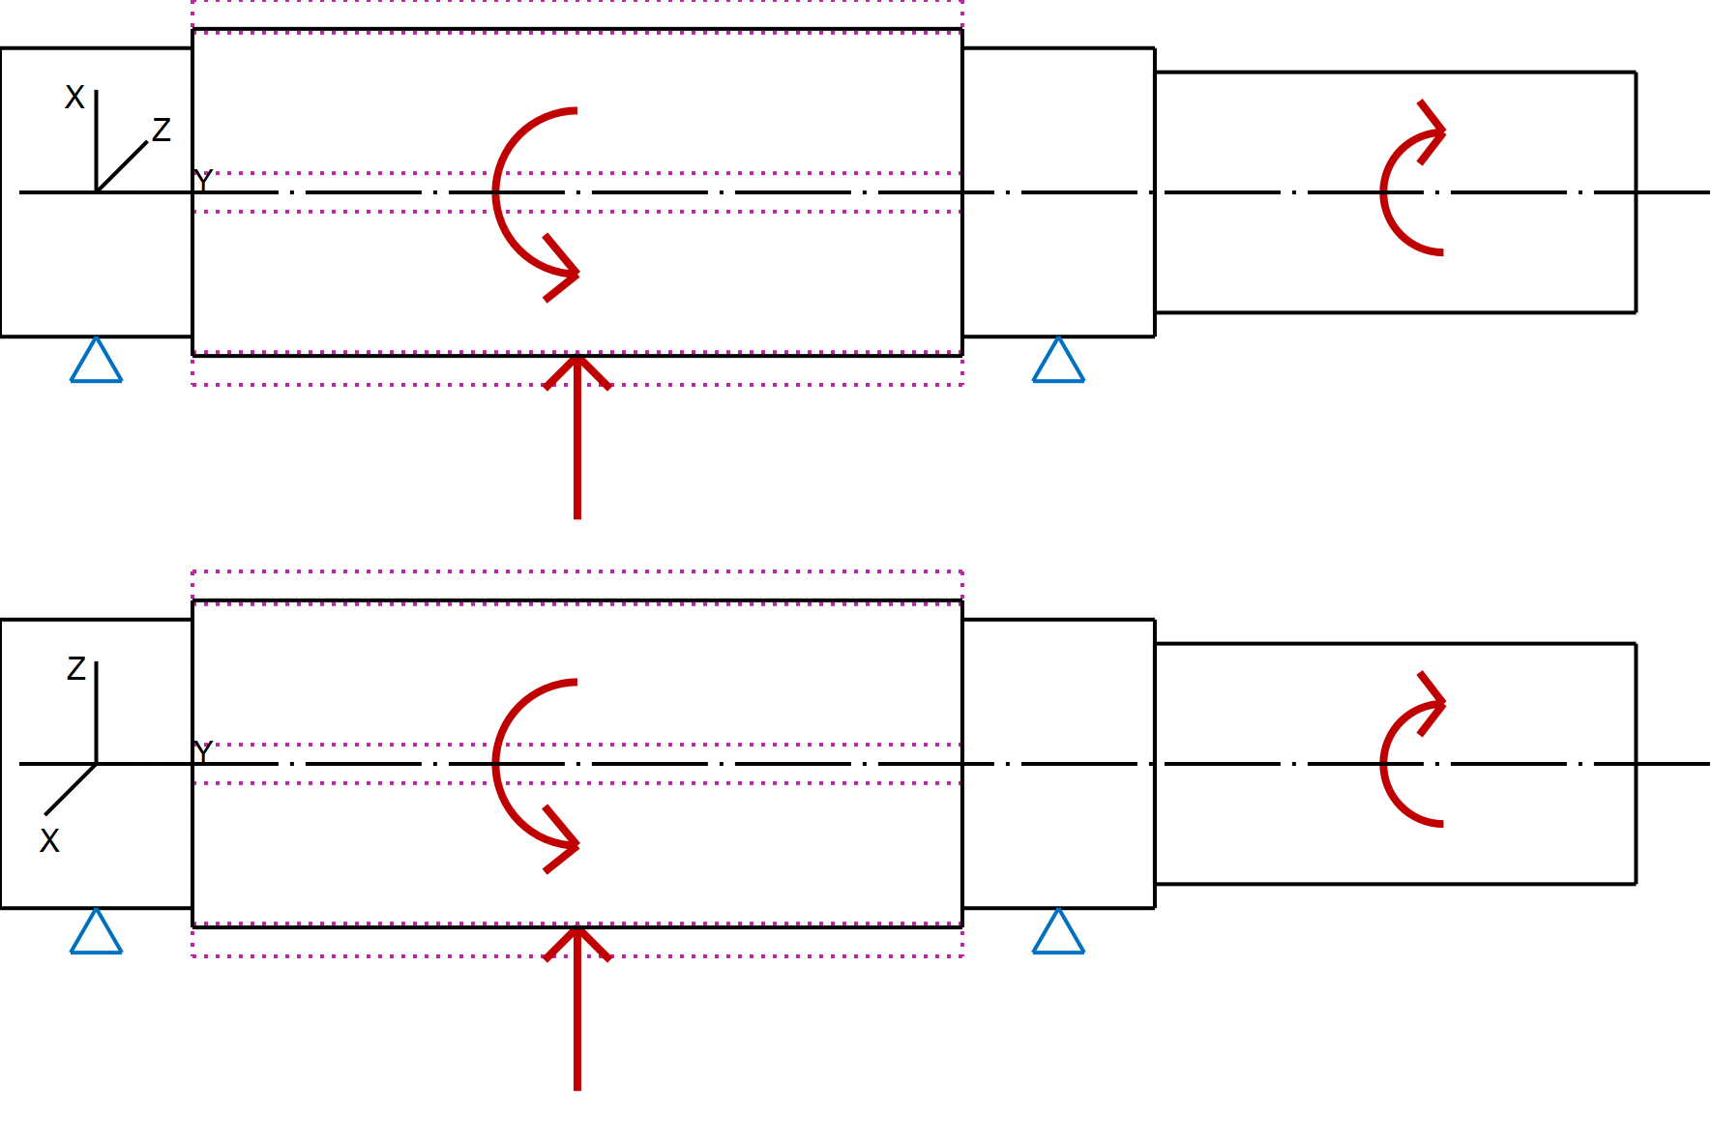
Figure: Load applications

3 Shaft definition (Shaft)
3.1 Outer contour
3.1.1 Cylinder (Cylinder 1), 0.000mm ...20.000mm
Diameter (mm) [d] 30.0000
Length (mm) [l] 20.0000
Surface roughness (µm) [Rz] 4.8000
3.1.2 Cylinder (Cylinder 2), 20.000mm ...100.000mm
Diameter (mm) [d] 34.0000
Length (mm) [l] 80.0000
Surface roughness (µm) [Rz] 16.0000
3.1.3 Cylinder (Cylinder 3), 100.000mm ...120.000mm
Diameter (mm) [d] 30.0000
Length (mm) [l] 20.0000
Surface roughness (µm) [Rz] 4.8000
3.1.4 Cylinder (Cylinder 4), 120.000mm ...170.000mm
Diameter (mm) [d] 25.0000
Length (mm) [l] 50.0000
Surface roughness (µm) [Rz] 4.8000

3.2 Forces
3.2.1 Coupling (Coupling / Motor)

Position on shaft (mm) [y_{local}] 150.0000
Position in global system (mm) [y_{global}] 140.0000
Effective diameter (mm) [d] 0.0000
Radial force factor (-) [K₂] 0.0000
Direction of the radial force (°) [ρ] 0.0000
Axial force factor (-) [K₃] 0.0000
Length of load application (mm) [l] 40.0000
Power (kW) [P] 2.3562 driving (output)
Torque (Nm) [T] -25.0000
Axial force (N) [F_{y}] 0.0000
Radial force X (N) [F_{x}] 0.0000
Radial force Z (N) [F_{z}] 0.0000
Bending moment X (Nm) [M_{x}] 0.0000
Bending moment Z (Nm) [M_{z}] 0.0000
Mass (kg) [M] 0.0000
Mass moment of inertia (kg*m²) [J_{p}] 0.0000e+00
Mass moment of inertia around X-axis (kg*m²) [J_{xx}] 0.0000e+00
Mass moment of inertia around Z-axis (kg*m²) [J_{zz}] 0.0000e+00

3.2.2 Cylindrical gear (Cylindrical gear)

Position on shaft (mm) [y_{local}] 60.0000
Position in global system (mm) [y_{global}] 50.0000
Operating pitch diameter (mm) [d_{w}] 40.0000
Spur gear
Gear geometry: symmetric
Working pressure angle at normal section (°) [α_{wn}] 20.0000
Position of contact (°) [α_{pos}] 180.0000
Length of load application (mm) [l] 80.0000
Power (kW) [P] 2.3562 driven (input)
Torque (Nm) [T] 25.0000
Axial force (N) [F_{y}] 0.0000
Radial force X (N) [F_{x}] 454.9628
Radial force Z (N) [F_{z}] 1250.0000
Bending moment X (Nm) [M_{x}] -0.0000
Bending moment Z (Nm) [M_{z}] -0.0000

3.3 Bearing
3.3.1 P4 Support A (Own input)

Bearing position (mm) [y_{lokal}] 10.000
Bearing position (mm) [y_{global}] 0.000
Degrees of freedom
X: fixed; Y: fixed; Z: fixed;
Rx: free; Ry: free; Rz: free;
3.3.2 P4 Support B (Own input)

Bearing position (mm) [y_{lokal}] 110.000
Bearing position (mm) [y_{global}] 100.000
Degrees of freedom
X: fixed; Y: free; Z: fixed;
Rx: free; Ry: free; Rz: free;

4 Gears
Gears are considered only as load application.

5 Results
5.1 Shafts
Maximum deflection (μm) 2.999
Position of the maximum (mm) 160.000
Mass center of gravity (mm) 76.630
Total axial load (N) 0.000
Torsion of the shaft under torque (°) -0.024
(Difference between left and right shaft end)

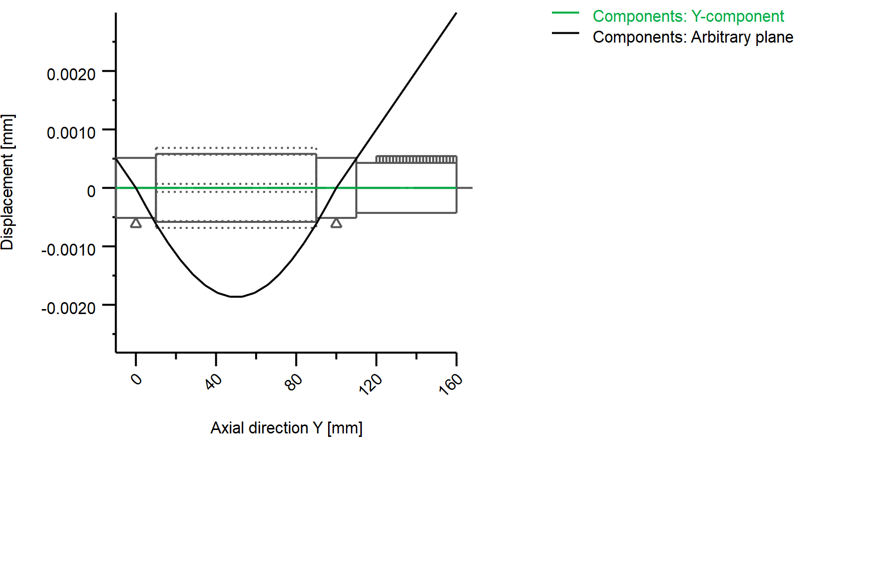
Figure: Deformation (bending etc.) (Arbitrary plane 250 136)

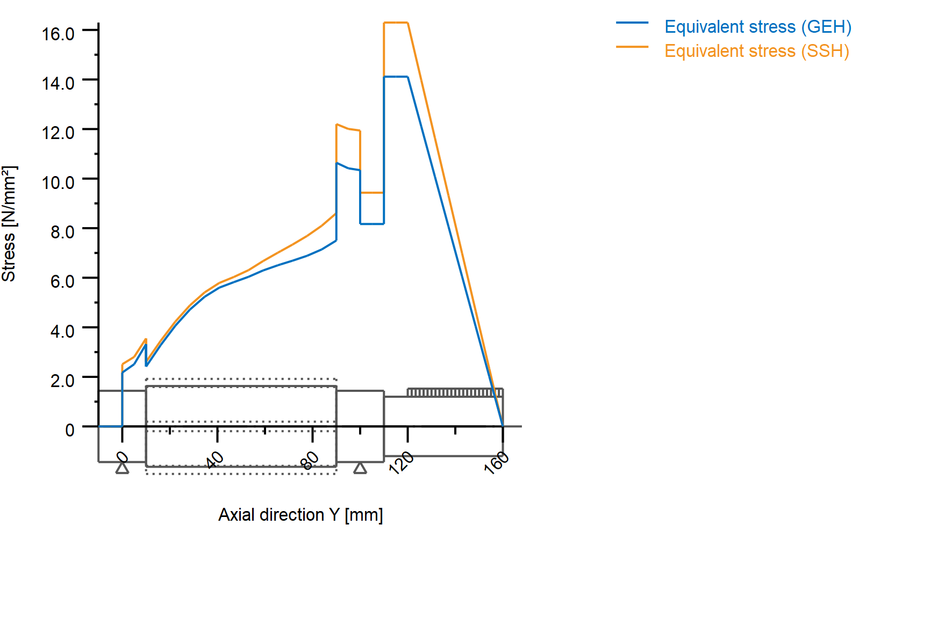
Nominal stresses, without taking into account stress concentrations
GEH(von Mises): sigV = ((sigB+sigZ,D)^2 + 3*(tauT+tauS)^2)^1/2
SSH(Tresca): sigV = ((sigB-sigZ,D)^2 + 4*(tauT+tauS)^2)^1/2

Figure: Equivalent stress

5.2 Bearing

5.3 'Shaft' Bearing 'P4 Support A'
Position (Y-coordinate) [y] 10.00 mm
Bearing reaction force [F_{x}] -0.227 kN
Bearing reaction force [F_{y}] -0.000 kN
Bearing reaction force [F_{z}] -0.625 kN
Bearing reaction force [F_{r}] 0.665 kN
Inclination angle [α_{Fr}] -110.000 °
Displacement of bearing [u_{x}] 0.000 µm
Displacement of bearing [u_{y}] 0.000 µm
Displacement of bearing [u_{z}] 0.000 µm
Displacement of bearing [u_{r}] 0.000 µm
Misalignment of bearing [r_{x}] 0.047 mrad
Misalignment of bearing [r_{z}] -0.017 mrad
Misalignment of bearing [r_{r}] 0.050 mrad

5.4 'Shaft' Bearing 'P4 Support B'
Position (Y-coordinate) [y] 110.00 mm
Bearing reaction force [F_{x}] -0.227 kN
Bearing reaction force [F_{y}] 0.000 kN
Bearing reaction force [F_{z}] -0.625 kN
Bearing reaction force [F_{r}] 0.665 kN
Inclination angle [α_{Fr}] -110.000 °
Displacement of bearing [u_{x}] 0.000 µm
Displacement of bearing [u_{y}] -0.000 µm
Displacement of bearing [u_{z}] 0.000 µm
Displacement of bearing [u_{r}] 0.000 µm
Misalignment of bearing [r_{x}] -0.047 mrad
Misalignment of bearing [r_{z}] 0.017 mrad
Misalignment of bearing [r_{r}] 0.050 mrad

End of report (lines: 215)

