Shaft

P4-shaft-load-mapped

Changed on | 30.10.2026, 21:19:14
Changed by | AAA
Description | P4 candidate - STATIC PREP ONLY - loads/supports must be verified before calculation
 | 2o2dy (5416)
 | KISSsoft Release 2026

Contents

1 Messages
 | Calculation is consistent.
2 Input data

Coordinate system shaft: see picture W-002

2.1 Shafts
2.1.1 Shaft 'Shaft'
Drawing W-007
Initial position (mm) -10.000
Length (mm) 170.000
Speed (1/min) 980.000
Direction of rotation: clockwise

Material, own Input P4 custom DIN743 1000/800/500/400/300
Young's modulus (N/mm²) 206000.000
Poisson's ratio nu 0.300
Density (kg/m³) 7830.000
Coefficient of thermal expansion (10^-6/K) 11.500
Temperature (°C) 20.000
Mass of shaft (kg) 0.982
Note: mass stands for the shaft only without considering the gears
Mass of shaft, including additional masses (kg) 1.201
Mass moment of inertia (kg*mm²) 197.351
Momentum of mass GD2 (Nm²) 0.008

2.2 Weight force
Position in space (°) [β] 0.000
2.3 Shaft modeling
Gears mounted with stiffness according to ISO
2.4 Shear deformations
Consider deformations due to shearing
Shear correction factor 1.100
2.5 Rolling bearings
Rolling bearing stiffness is calculated from inner bearing geometry
Tolerance field: Mean value
2.6 Housing
Reference temperature (°C) 20.000
2.7 Load applications
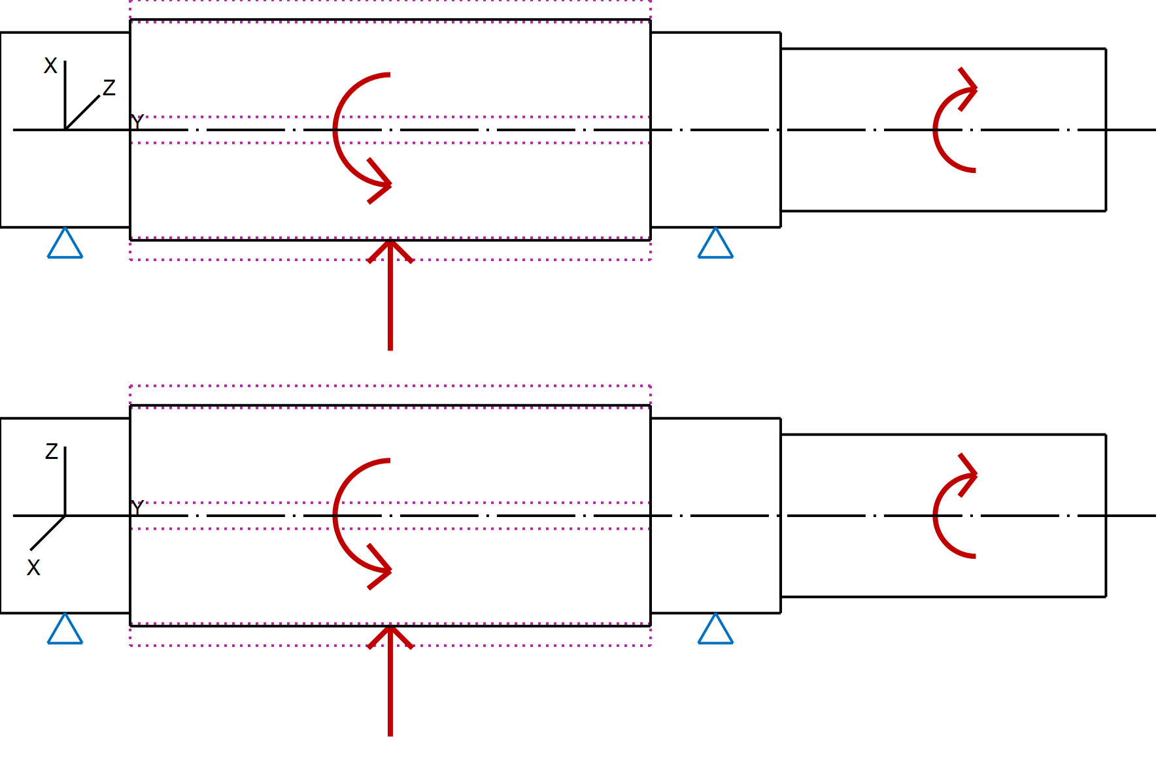
Figure: Load applications

3 Shaft definition (Shaft)
3.1 Outer contour
3.1.1 Cylinder (Cylinder 1), 0.000mm ...20.000mm
Diameter (mm) [d] 30.0000
Length (mm) [l] 20.0000
Surface roughness (µm) [Rz] 4.8000
3.1.2 Cylinder (Cylinder 2), 20.000mm ...100.000mm
Diameter (mm) [d] 34.0000
Length (mm) [l] 80.0000
Surface roughness (µm) [Rz] 16.0000
3.1.3 Cylinder (Cylinder 3), 100.000mm ...120.000mm
Diameter (mm) [d] 30.0000
Length (mm) [l] 20.0000
Surface roughness (µm) [Rz] 4.8000
3.1.4 Cylinder (Cylinder 4), 120.000mm ...170.000mm
Diameter (mm) [d] 25.0000
Length (mm) [l] 50.0000
Surface roughness (µm) [Rz] 4.8000

3.2 Forces
3.2.1 Coupling (Coupling / Motor)

Position on shaft (mm) [y_{local}] 150.0000
Position in global system (mm) [y_{global}] 140.0000
Effective diameter (mm) [d] 0.0000
Radial force factor (-) [K₂] 0.0000
Direction of the radial force (°) [ρ] 0.0000
Axial force factor (-) [K₃] 0.0000
Length of load application (mm) [l] 40.0000
Power (kW) [P] 25.0000 driving (output)
Torque (Nm) [T] -243.6045
Axial force (N) [F_{y}] 0.0000
Radial force X (N) [F_{x}] 0.0000
Radial force Z (N) [F_{z}] 0.0000
Bending moment X (Nm) [M_{x}] 0.0000
Bending moment Z (Nm) [M_{z}] 0.0000
Mass (kg) [M] 0.0000
Mass moment of inertia (kg*m²) [J_{p}] 0.0000e+00
Mass moment of inertia around X-axis (kg*m²) [J_{xx}] 0.0000e+00
Mass moment of inertia around Z-axis (kg*m²) [J_{zz}] 0.0000e+00

3.2.2 Cylindrical gear (Cylindrical gear)

Position on shaft (mm) [y_{local}] 60.0000
Position in global system (mm) [y_{global}] 50.0000
Operating pitch diameter (mm) [d_{w}] 40.0000
Spur gear
Gear geometry: symmetric
Working pressure angle at normal section (°) [α_{wn}] 20.0000
Position of contact (°) [α_{pos}] 180.0000
Length of load application (mm) [l] 80.0000
Power (kW) [P] 25.0000 driven (input)
Torque (Nm) [T] 243.6045
Axial force (N) [F_{y}] 0.0000
Radial force X (N) [F_{x}] 4433.2394
Radial force Z (N) [F_{z}] 12180.2252
Bending moment X (Nm) [M_{x}] -0.0000
Bending moment Z (Nm) [M_{z}] -0.0000

3.3 Bearing
3.3.1 P4 Support A (Own input)

Bearing position (mm) [y_{lokal}] 10.000
Bearing position (mm) [y_{global}] 0.000
Degrees of freedom
X: fixed; Y: free; Z: fixed;
Rx: fixed; Ry: fixed; Rz: fixed;
3.3.2 P4 Support B (Own input)

Bearing position (mm) [y_{lokal}] 110.000
Bearing position (mm) [y_{global}] 100.000
Degrees of freedom
X: fixed; Y: free; Z: fixed;
Rx: fixed; Ry: fixed; Rz: fixed;

4 Gears
Gears are considered as mass and as stiffness according to ISO 6336-1 (interference fit).
4.1 Shaft 'Shaft': Cylindrical gear 'Cylindrical gear'
Center point [y] 60.000 mm
Left side of the gear
Position (Y-coordinate) [y] 20.000 mm
Second moment of area [I_{zz}] 91997.663 mm⁴
Product E·I [E·I_{zz}] 18951.519 Nm²
Right side of the gear
Position (Y-coordinate) [y] 100.000 mm
Second moment of area [I_{zz}] 91997.663 mm⁴
Product E·I [E·I_{zz}] 18951.519 Nm²
Mass [m] 0.218 kg
Center of mass [y_{S}] 60.000 mm
Polar mass moment of inertia [J_{p}] 7.5251e-05 kg·m²
Mass moment of inertia [J_{xx}] 1.5412e-04 kg·m²
Mass moment of inertia [J_{zz}] 1.5412e-04 kg·m²

5 Results
5.1 Shafts
Maximum deflection (μm) 5.946
Position of the maximum (mm) 46.923
Mass center of gravity (mm) 76.630
Total axial load (N) 0.000
Torsion of the shaft under torque (°) -0.160
(Difference between left and right shaft end)

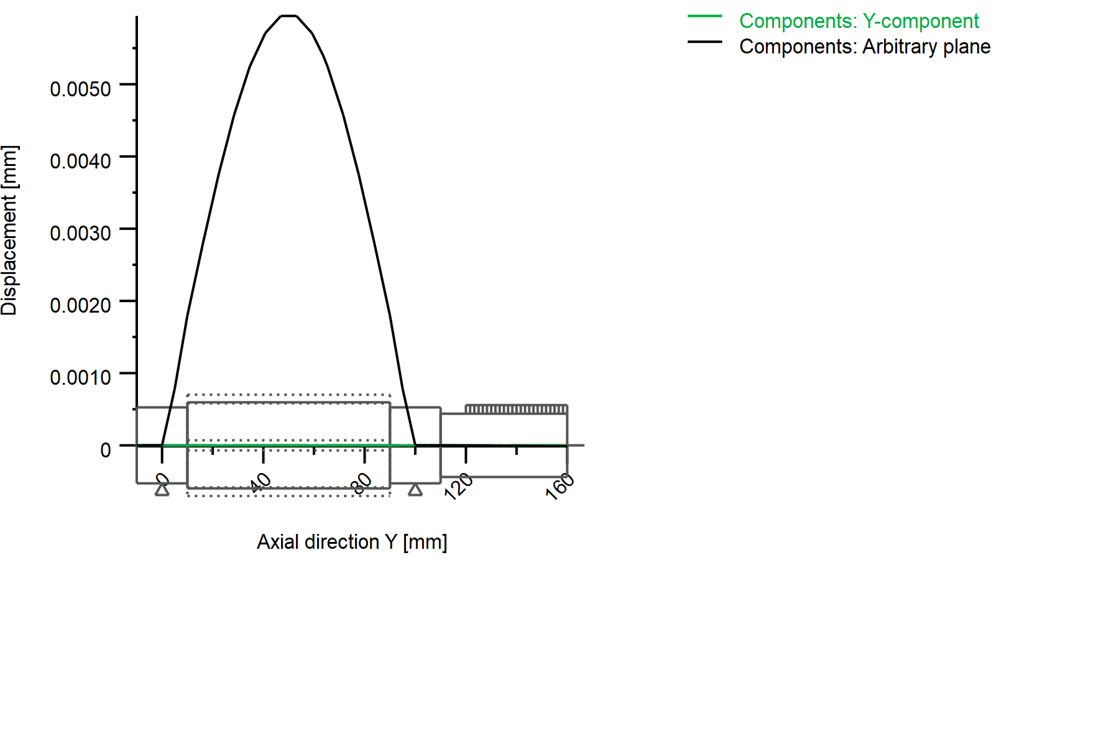
Figure: Deformation (bending etc.) (Arbitrary plane 69.9881 136)

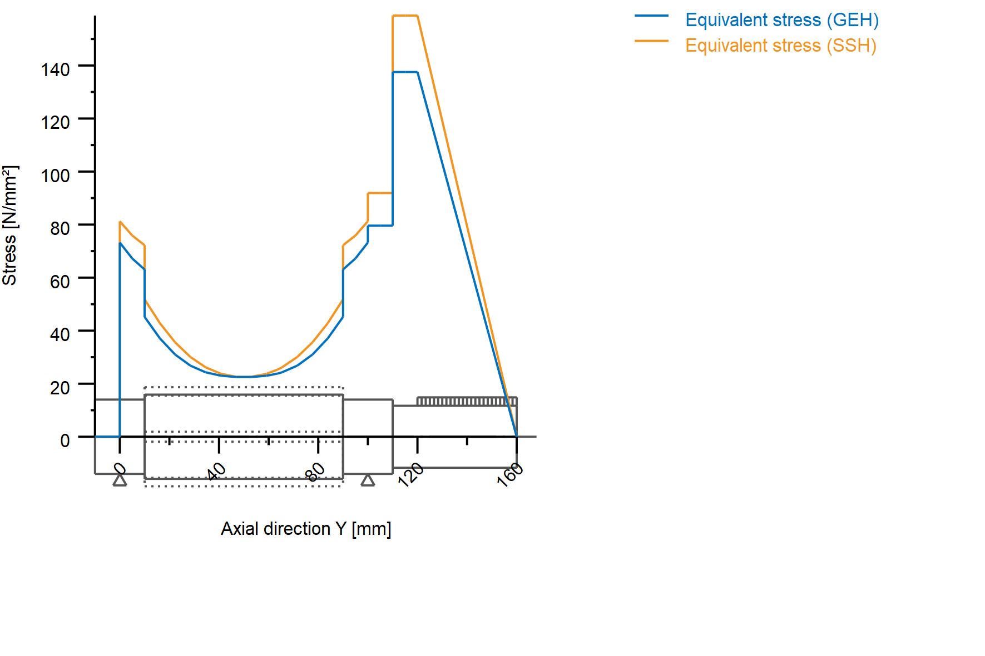
Nominal stresses, without taking into account stress concentrations
GEH(von Mises): sigV = ((sigB+sigZ,D)^2 + 3*(tauT+tauS)^2)^1/2
SSH(Tresca): sigV = ((sigB-sigZ,D)^2 + 4*(tauT+tauS)^2)^1/2

Figure: Equivalent stress

5.2 Bearing

5.3 'Shaft' Bearing 'P4 Support A'
Position (Y-coordinate) [y] 10.00 mm
Bearing reaction force [F_{x}] -2.216 kN
Bearing reaction force [F_{y}] 0.000 kN
Bearing reaction force [F_{z}] -6.084 kN
Bearing reaction force [F_{r}] 6.475 kN
Inclination angle [α_{Fr}] -110.015 °
Bearing reaction moment [M_{x}] -101.105 Nm
Bearing reaction moment [M_{z}] 36.822 Nm
Bearing reaction moment [M_{r}] 107.602 Nm
Inclination angle [α_{Mr}] 159.988 °
Displacement of bearing [u_{x}] 0.000 µm
Displacement of bearing [u_{y}] 0.000 µm
Displacement of bearing [u_{z}] 0.000 µm
Displacement of bearing [u_{r}] 0.000 µm
Misalignment of bearing [r_{x}] 0.000 mrad
Misalignment of bearing [r_{z}] 0.000 mrad
Misalignment of bearing [r_{r}] 0.000 mrad

5.4 'Shaft' Bearing 'P4 Support B'
Position (Y-coordinate) [y] 110.00 mm
Bearing reaction force [F_{x}] -2.216 kN
Bearing reaction force [F_{y}] 0.000 kN
Bearing reaction force [F_{z}] -6.082 kN
Bearing reaction force [F_{r}] 6.474 kN
Inclination angle [α_{Fr}] -110.021 °
Bearing reaction moment [M_{x}] 101.167 Nm
Bearing reaction moment [M_{z}] -36.821 Nm
Bearing reaction moment [M_{r}] 107.659 Nm
Inclination angle [α_{Mr}] -20.000 °
Displacement of bearing [u_{x}] 0.000 µm
Displacement of bearing [u_{y}] -0.000 µm
Displacement of bearing [u_{z}] 0.000 µm
Displacement of bearing [u_{r}] 0.000 µm
Misalignment of bearing [r_{x}] 0.000 mrad
Misalignment of bearing [r_{z}] 0.000 mrad
Misalignment of bearing [r_{r}] 0.000 mrad

End of report (lines: 240)

