Shaft

P4-shaft-static-run

Changed on | 30.10.2026, 21:17:59
Changed by | AAA
Description | P4 candidate - STATIC PREP ONLY - loads/supports must be verified before calculation
 | 2o2dy (5416)
 | KISSsoft Release 2026

Contents

1 Messages
 | Calculation is consistent.
2 Input data

Coordinate system shaft: see picture W-002

2.1 Shafts
2.1.1 Shaft 'Shaft'
Drawing W-007
Initial position (mm) -10.000
Length (mm) 170.000
Speed (1/min) 980.000
Direction of rotation: clockwise

Material, own Input P4 custom DIN743 1000/800/500/400/300
Young's modulus (N/mm²) 206000.000
Poisson's ratio nu 0.300
Density (kg/m³) 7830.000
Coefficient of thermal expansion (10^-6/K) 11.500
Temperature (°C) 20.000
Mass of shaft (kg) 0.982
Note: mass stands for the shaft only without considering the gears
Mass of shaft, including additional masses (kg) 5.218
Mass moment of inertia (kg*mm²) 8077.056
Momentum of mass GD2 (Nm²) 0.317

2.2 Weight force
Position in space (°) [β] 0.000
2.3 Shaft modeling
Gears mounted with stiffness according to ISO
2.4 Shear deformations
Consider deformations due to shearing
Shear correction factor 1.100
2.5 Rolling bearings
Rolling bearing stiffness is calculated from inner bearing geometry
Tolerance field: Mean value
2.6 Housing
Reference temperature (°C) 20.000
2.7 Load applications
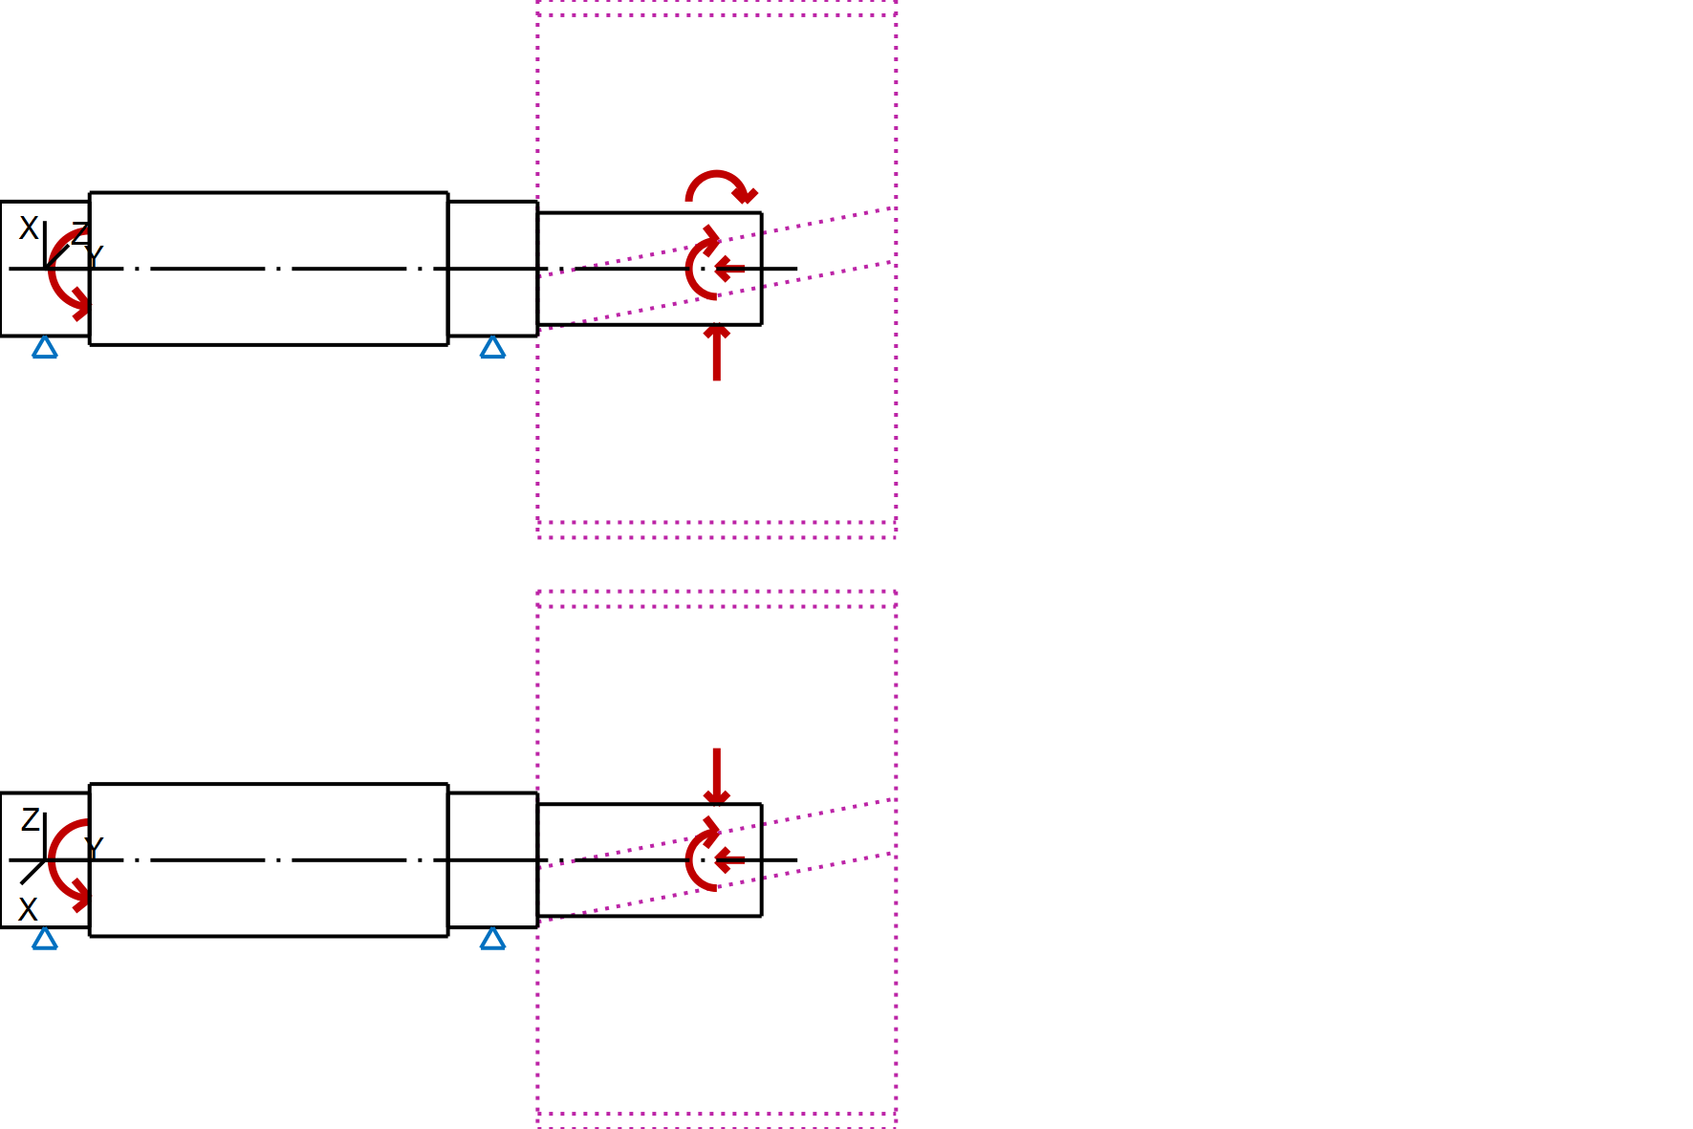
Figure: Load applications

3 Shaft definition (Shaft)
3.1 Outer contour
3.1.1 Cylinder (Cylinder 1), 0.000mm ...20.000mm
Diameter (mm) [d] 30.0000
Length (mm) [l] 20.0000
Surface roughness (µm) [Rz] 4.8000
3.1.2 Cylinder (Cylinder 2), 20.000mm ...100.000mm
Diameter (mm) [d] 34.0000
Length (mm) [l] 80.0000
Surface roughness (µm) [Rz] 16.0000
3.1.3 Cylinder (Cylinder 3), 100.000mm ...120.000mm
Diameter (mm) [d] 30.0000
Length (mm) [l] 20.0000
Surface roughness (µm) [Rz] 4.8000
3.1.4 Cylinder (Cylinder 4), 120.000mm ...170.000mm
Diameter (mm) [d] 25.0000
Length (mm) [l] 50.0000
Surface roughness (µm) [Rz] 4.8000

3.2 Forces
3.2.1 Coupling (Coupling / Motor)

Position on shaft (mm) [y_{local}] 20.0000
Position in global system (mm) [y_{global}] 10.0000
Effective diameter (mm) [d] 0.0000
Radial force factor (-) [K₂] 0.0000
Direction of the radial force (°) [ρ] 0.0000
Axial force factor (-) [K₃] 0.0000
Length of load application (mm) [l] 40.0000
Power (kW) [P] 75.0000 driven (input)
Torque (Nm) [T] 730.8135
Axial force (N) [F_{y}] 0.0000
Radial force X (N) [F_{x}] 0.0000
Radial force Z (N) [F_{z}] 0.0000
Bending moment X (Nm) [M_{x}] 0.0000
Bending moment Z (Nm) [M_{z}] 0.0000
Mass (kg) [M] 0.0000
Mass moment of inertia (kg*m²) [J_{p}] 0.0000e+00
Mass moment of inertia around X-axis (kg*m²) [J_{xx}] 0.0000e+00
Mass moment of inertia around Z-axis (kg*m²) [J_{zz}] 0.0000e+00

3.2.2 Cylindrical gear (Cylindrical gear)

Position on shaft (mm) [y_{local}] 160.0000
Position in global system (mm) [y_{global}] 150.0000
Operating pitch diameter (mm) [d_{w}] 120.0000
Helix angle (°) [β_{w}] 15.0000 Helix left hand
Gear geometry: symmetric
Working pressure angle at normal section (°) [α_{wn}] 20.0000
Position of contact (°) [α_{pos}] 180.0000
Length of load application (mm) [l] 80.0000
Power (kW) [P] 75.0000 driving (output)
Torque (Nm) [T] -730.8135
Axial force (N) [F_{y}] -3263.6815
Radial force X (N) [F_{x}] 4589.6272
Radial force Z (N) [F_{z}] -12180.2252
Bending moment X (Nm) [M_{x}] 0.0000
Bending moment Z (Nm) [M_{z}] 195.8209

3.3 Bearing
3.3.1 P4 Support A (Own input)

Bearing position (mm) [y_{lokal}] 10.000
Bearing position (mm) [y_{global}] 0.000
Degrees of freedom
X: fixed; Y: free; Z: fixed;
Rx: fixed; Ry: fixed; Rz: fixed;
3.3.2 P4 Support B (Own input)

Bearing position (mm) [y_{lokal}] 110.000
Bearing position (mm) [y_{global}] 100.000
Degrees of freedom
X: fixed; Y: free; Z: fixed;
Rx: fixed; Ry: fixed; Rz: fixed;

4 Gears
Gears are considered as mass and as stiffness according to ISO 6336-1 (interference fit).
4.1 Shaft 'Shaft': Cylindrical gear 'Cylindrical gear'
Center point [y] 145.000 mm
Left side of the gear
Position (Y-coordinate) [y] 120.000 mm
Second moment of area [I_{zz}] 1356194.332 mm⁴
Product E·I [E·I_{zz}] 279376.032 Nm²
Right side of the gear
Position (Y-coordinate) [y] 170.000 mm
Second moment of area [I_{zz}] 1356194.332 mm⁴
Product E·I [E·I_{zz}] 279376.032 Nm²
Mass [m] 4.236 kg
Center of mass [y_{S}] 145.000 mm
Polar mass moment of inertia [J_{p}] 7.9550e-03 kg·m²
Mass moment of inertia [J_{xx}] 4.8599e-03 kg·m²
Mass moment of inertia [J_{zz}] 4.8599e-03 kg·m²

5 Results
5.1 Shafts
Maximum deflection (μm) 41.384
Position of the maximum (mm) 160.000
Mass center of gravity (mm) 76.630
Total axial load (N) -3263.682
Torsion of the shaft under torque (°) -0.076
(Difference between left and right shaft end)

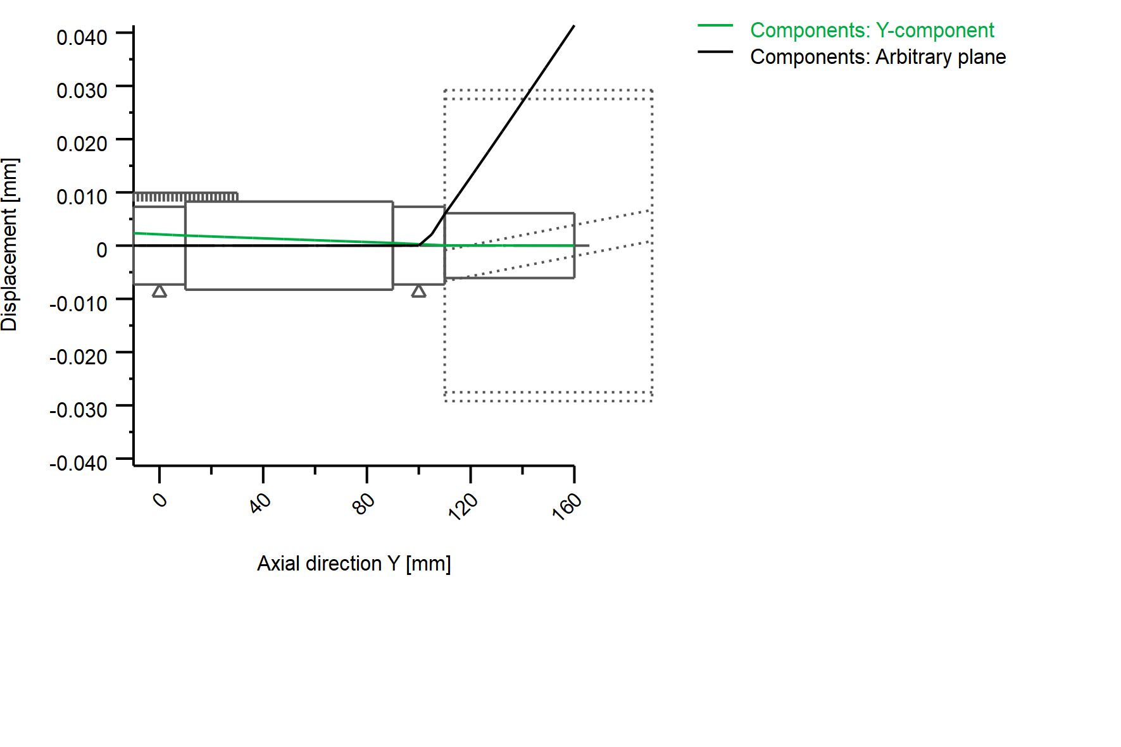
Figure: Deformation (bending etc.) (Arbitrary plane 272.3545 136)

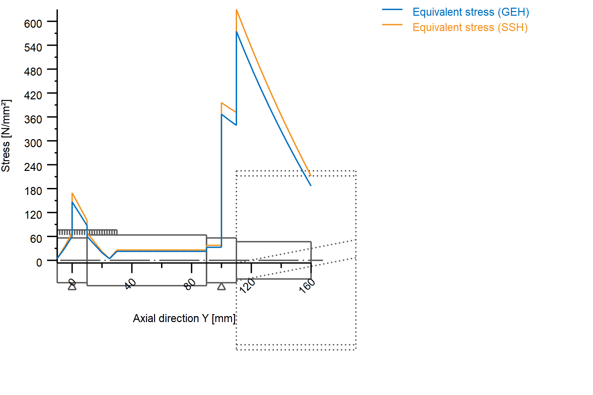
Nominal stresses, without taking into account stress concentrations
GEH(von Mises): sigV = ((sigB+sigZ,D)^2 + 3*(tauT+tauS)^2)^1/2
SSH(Tresca): sigV = ((sigB-sigZ,D)^2 + 4*(tauT+tauS)^2)^1/2

Figure: Equivalent stress

5.2 Bearing

5.3 'Shaft' Bearing 'P4 Support A'
Position (Y-coordinate) [y] 10.00 mm
Bearing reaction force [F_{x}] -0.000 kN
Bearing reaction force [F_{y}] 0.000 kN
Bearing reaction force [F_{z}] 0.004 kN
Bearing reaction force [F_{r}] 0.004 kN
Inclination angle [α_{Fr}] 90.000 °
Bearing reaction moment [M_{x}] 0.050 Nm
Bearing reaction moment [M_{z}] 0.000 Nm
Bearing reaction moment [M_{r}] 0.050 Nm
Inclination angle [α_{Mr}] 0.000 °
Displacement of bearing [u_{x}] 0.000 µm
Displacement of bearing [u_{y}] 2.117 µm
Displacement of bearing [u_{z}] -0.000 µm
Displacement of bearing [u_{r}] 0.000 µm
Misalignment of bearing [r_{x}] 0.000 mrad
Misalignment of bearing [r_{z}] 0.000 mrad
Misalignment of bearing [r_{r}] 0.000 mrad

5.4 'Shaft' Bearing 'P4 Support B'
Position (Y-coordinate) [y] 110.00 mm
Bearing reaction force [F_{x}] -4.590 kN
Bearing reaction force [F_{y}] -0.000 kN
Bearing reaction force [F_{z}] 12.228 kN
Bearing reaction force [F_{r}] 13.061 kN
Inclination angle [α_{Fr}] 110.574 °
Bearing reaction moment [M_{x}] 610.481 Nm
Bearing reaction moment [M_{z}] 33.660 Nm
Bearing reaction moment [M_{r}] 611.408 Nm
Inclination angle [α_{Mr}] 3.156 °
Displacement of bearing [u_{x}] 0.000 µm
Displacement of bearing [u_{y}] 0.272 µm
Displacement of bearing [u_{z}] -0.000 µm
Displacement of bearing [u_{r}] 0.000 µm
Misalignment of bearing [r_{x}] 0.000 mrad
Misalignment of bearing [r_{z}] 0.000 mrad
Misalignment of bearing [r_{r}] 0.000 mrad

End of report (lines: 240)

