1. TI : ETHERNET TUTORIAL

<https://training.ti.com/hercules-how-tutorial-ethernet>

FIGURE – USING HALCOGEN or software

Driver enable - EMAC

PINMUX – MII module

MDIO, MDCLK

1. Iwlp demo

<http://processors.wiki.ti.com/index.php/LAUNCHXL2_570LC43:_lwIP_Demo>

halcogen setup + web led on/off

1. <http://processors.wiki.ti.com/index.php/HALCoGen_Ethernet_Driver_and_lwIP_Integration_Demonstration>

기초 구성 설명

1. 알아야 할 개념 정리

<https://www.youtube.com/watch?v=R_h5rDIvBOE>

VeEX YOUTUBE : Ethernet Networking Fundamentals (1/2 ~ 2/2)

* 1. RJ-45 : connector, UTP(Unshielded Twisted Pairs) : cable,
  2. SFP(Small Form-factor Pluggable) : =AGBIC?but smaller. electrical -> optical

LC Connector : used to connect fiber optics to XFP

tx+ tx- rx+ rx- (~100Mbps)

* 1. OSI Model? (Open System Interconnection)

Designed to connect ANY 2 systems connected on a network can communicate with each other(regardless of s/w used)

Has 7 layers each with headers trailers and interface layer

1. ETHERNET , 기가비트 이더넷제어기 설계와 응용설계

<http://www.idec.or.kr/vod/apply/view/?&page=3&no=115>

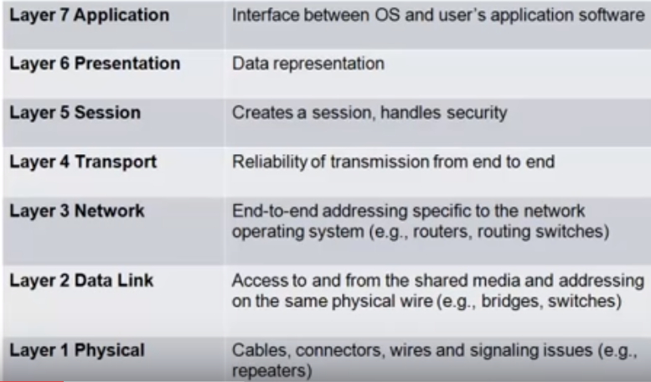

Layer animation explanation : <https://www.youtube.com/watch?v=-6Uoku-M6oY>

Layer 7 : FTP, HTTP, EMAIL 등

Layer 5: communication between applications across a network is controlled

Layer 4: adds reliability

Layer 3: make certain packets sent from one to another device gets there in a reasonable period of time

Layer 1: = PHY physical layer

TCP/IP stack != OSI stack (similar but not identical)

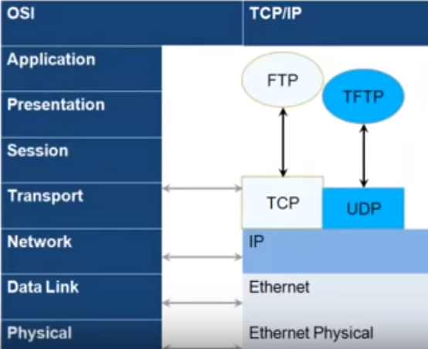

EXAMPLE : SENDING EMAIL

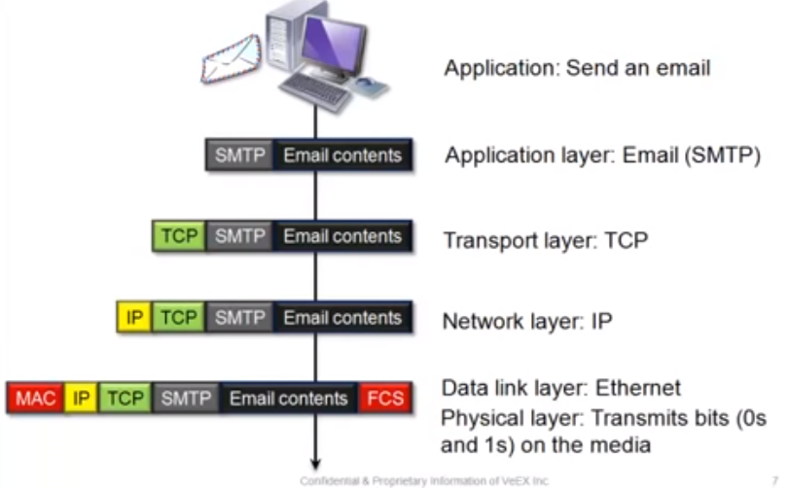

FCS : FRAME CHECK SEQUENCE

SMTP : SIMPLE MAIL TRANSMISSION PROTOCOL

2ndlayer : data link layer :

Ethernet Frame Format determines how the data in layer 1 in are formatted

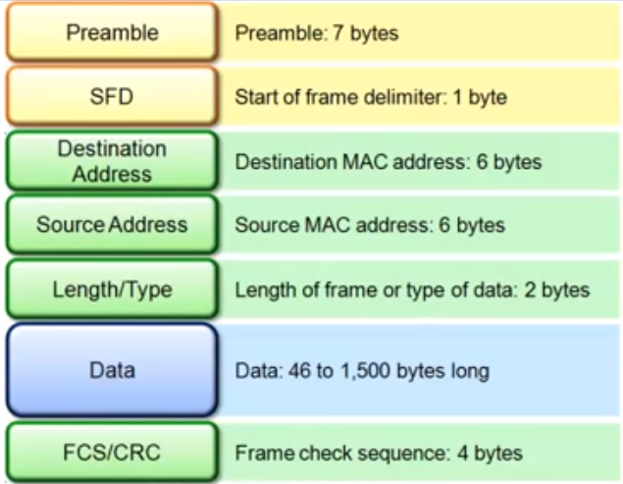

<EFF>

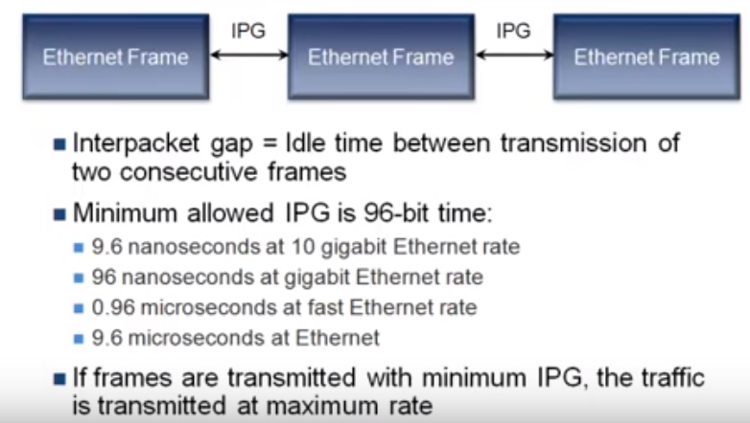

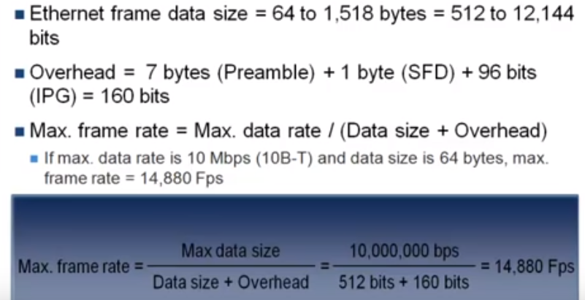

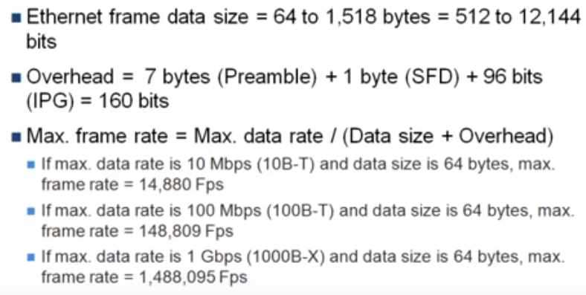

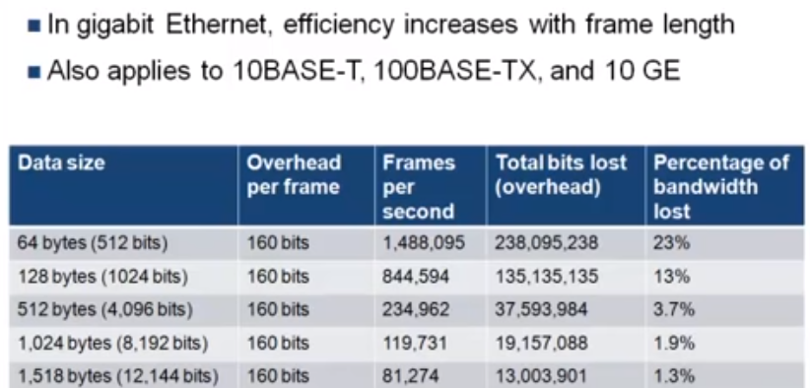

FRAME 사이즈 커질수록IPG 덜들어가니까 전체 Bandwidth 에서 ipg가 차지하는비중이 23%에서 1.3%로 줄어든다.

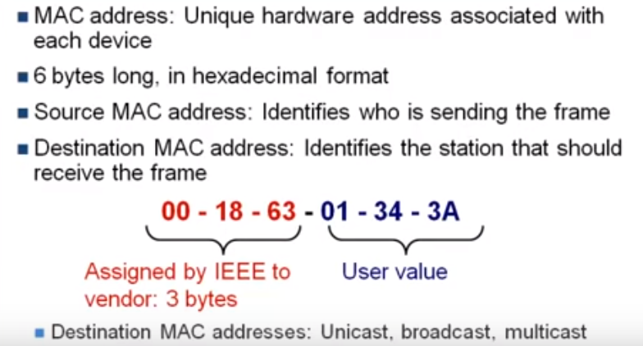

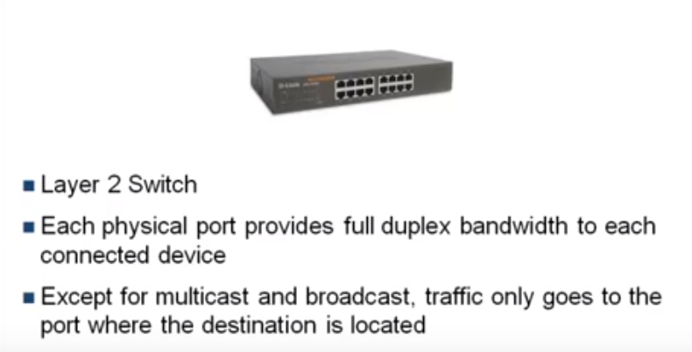

* Layer 3 device : router

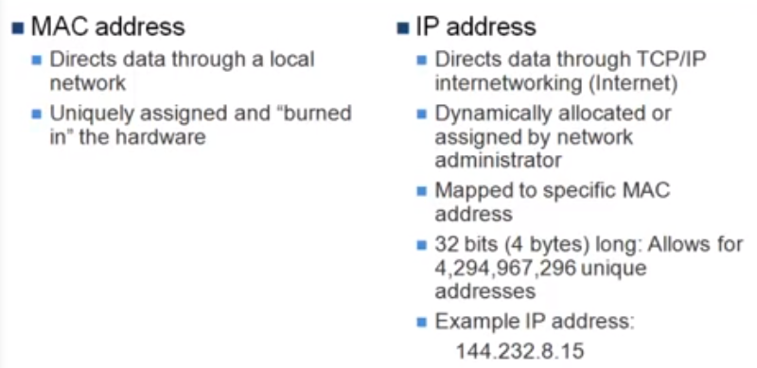

Layer 4 : transport layer (TCP/UDP).

Depends on application use.

Ex) video ~~ : UDP(User Data Protocol) – data loss possible.

FTP(, HTTP : TCP(Transmission Control Protocol)

TCP 3WAY Handshake

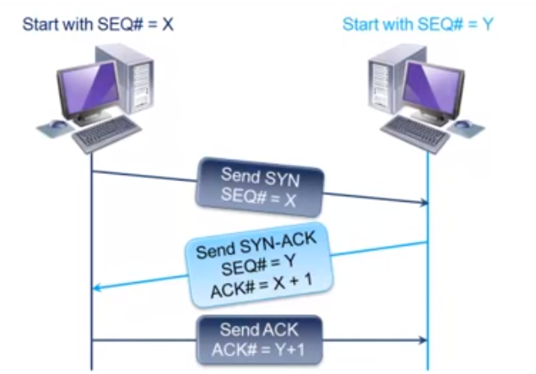

LAYER 7 APPLICATION : HTTP(Hypertext Transfer Protocol) protocol used to transfer thru internet

Runs over TCP connection and uses port80

FTP(File Transfer Protocol)

Uses port20(data),21(ctrl)

SMTP(Simple Mail Transfer Protocol)

Uses port 25

* 1. Transformer
  2. PHY
  3. MAC
  4. TCP/IP Stack
  5. Application (HTTP, FTP, DHCP, SMTP.. )
  6. lwip :light weight implementation of TCP/IP protocol suite for mcu

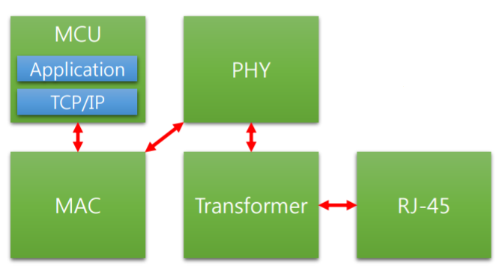

1. Ethernet youtube introduction
   1. Ethernet protocol

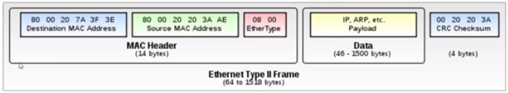

Ethernet Frame Format

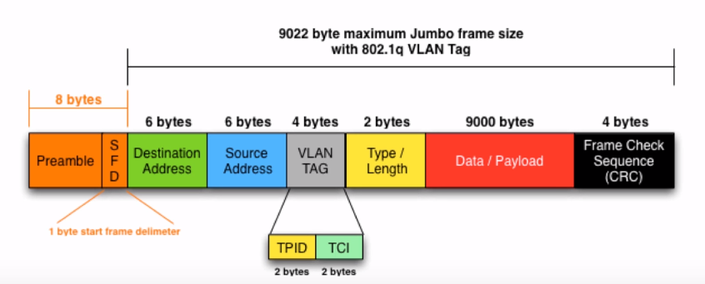

----------------------------------------------------------------------------------------------------------------------------------------

<ti tutorial introduction video>

lwip

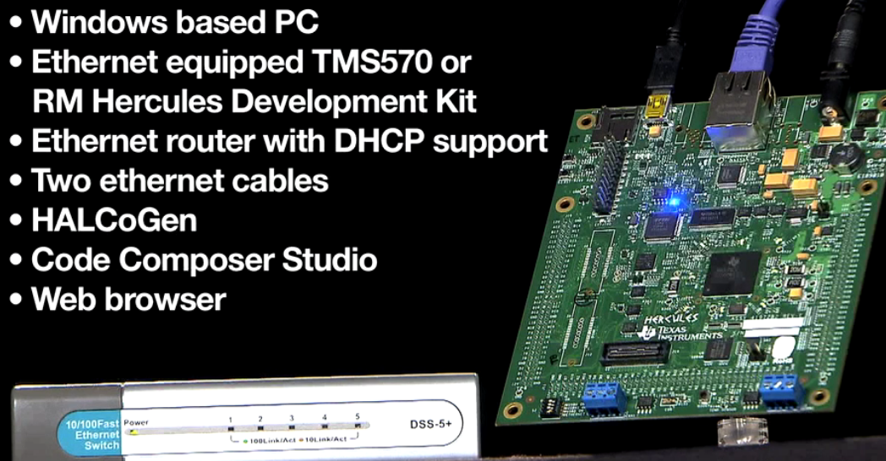

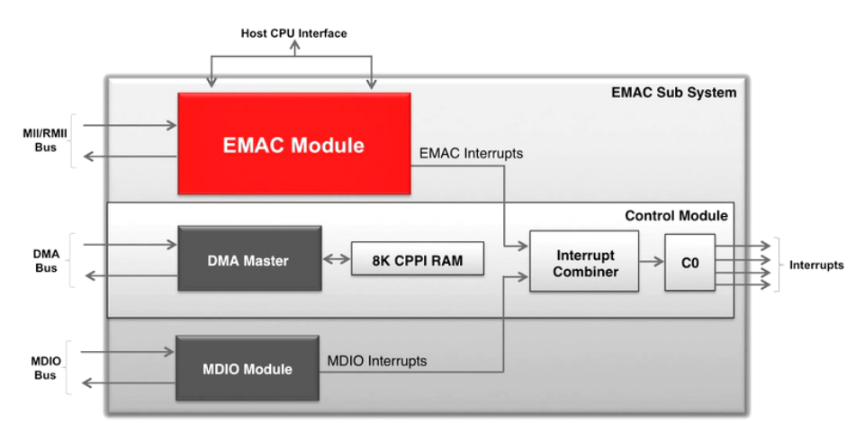

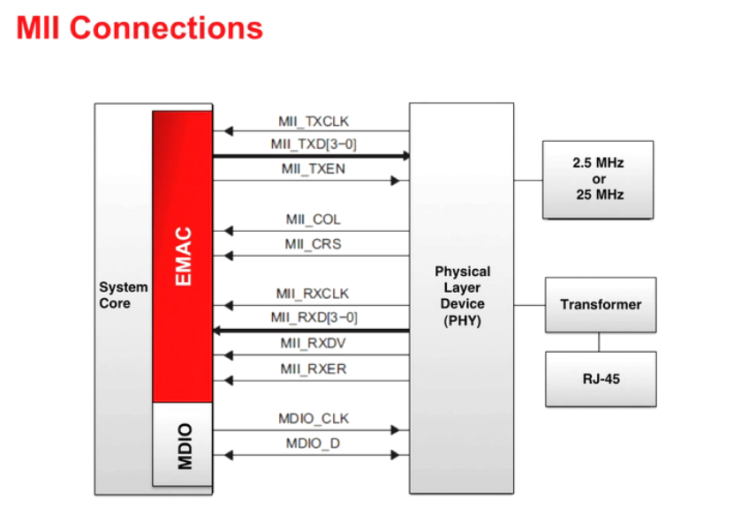

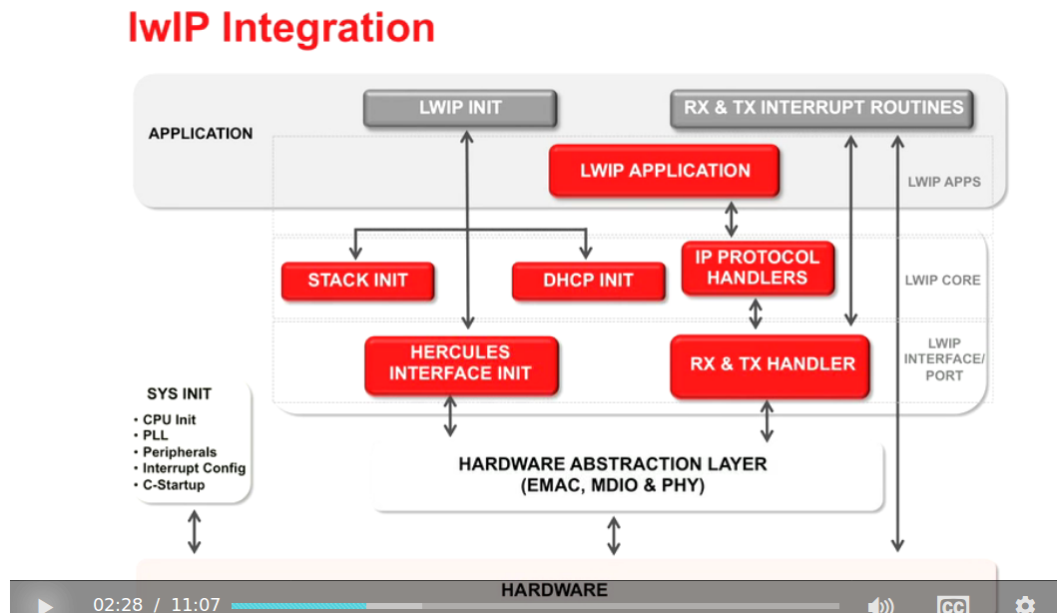

Driver enable - EMAC

Pinmux – MII module box click

scroll down to G3 – MDIO Select. V5 – MD clock select

now F5 to generate

lwIP DEMO 받아 설치 후 CCS에서 IMPORT 후 BUILD 했더니 에러남. Inet.h 못찾겟다고. 그래서 위치 찾아봄.

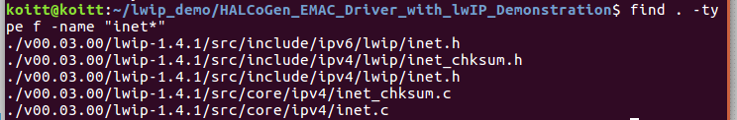

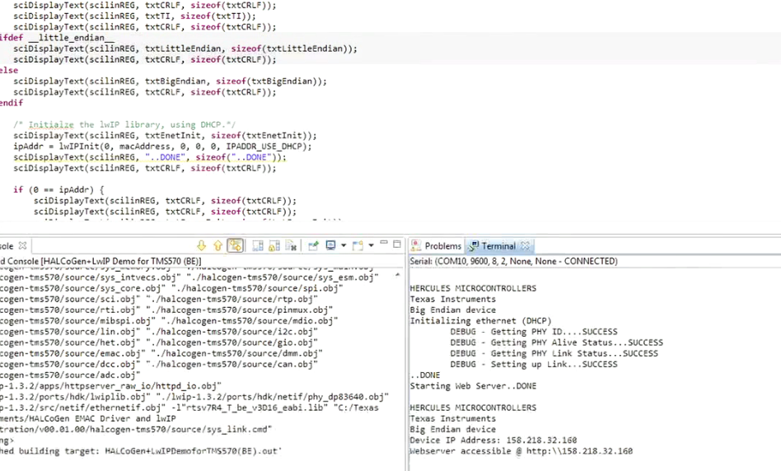

이렇게 떠야하는데

getting PHY ID 에서 안넘어감.