제 목 : arch/x86_64/kernel/head.S 분석
인 원 : 김정수, 이백

* Long Mode 활성화 단계 ( 참조 24593-p.347 )

1. 만약 페이징이 활성화된 보호 모드에서 시작한다면, 페이징을 비활성화, CR0 제어레지스터의 PG ( Paging ) 비트를 0으로 합니다. 이를 위해서, MOV CR0 명령이 가상 주소와 물리 주소가 같은(identity-mapped) 페이지에 있어야 합니다.
- Virtual Address equals Physical Address

2. 아무 순서로나:
- CR4 제어 레지스터의 PAE(Physical-Address Extension) 비트를 1로 설정하여 물리 주소 확장을 활성화시킵니다. 롱 모드에서는 32비트이상의 물리 주소를 사용해야 하기 때문에 PAE를 활성화시켜야 합니다. PAE는 페이징을 활성화하기 전에 반드시 활성화되어 있어야 합니다.

- 4단계 페이지 테이블의 베이스 주소를 CR3에 불러옵니다. (참조 24593-p.132)
- EFER 레지스터의 LME(Long Mode Enable) 비트를 1로 설정합니다.

3. CR0 제어 레지스터의 PG ( Paging ) 비트를 1로 설정합니다.
여기까지 하면, 프로세서가 EFER 레지스터의 LMA(Long Mode Active) 비트를 1로 설정합니다. 페이징을 허용하는 MOV CR0 명령의 다음 명령은 반드시 분기문 이어야 하며, 이 두 명령 모두 identity-mapped 페이지에 있어야 합니다.
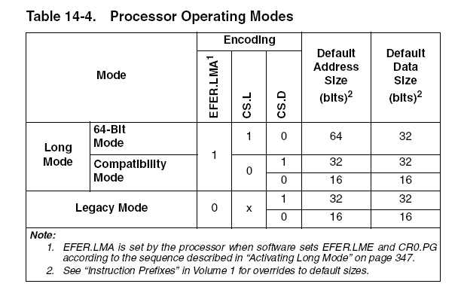

* head.S 하는 일
startup_32:
0. arch/x86_64/boot/compressed/head.S 에서 __PHYSICAL_START로 점프하여 시작하게 되며, 현재 CPU는 페이징이 비활성화 된 32bit protected mode ( CS.D = 1 )로 동작 중입니다.
1. DS를 초기화 합니다.
2. CS.L 비트가 정의된 새로운 GDT를 로드 합니다.
3. Long mode 를 지원하는 CPU 인지 확인합니다.
4. CR4.PAE(Physical Address Extension)를 1로 설정합니다.
5. 4단계 페이지 테이블의 베이스 주소를 CR3에 불러옵니다
6. EFER.LME(Long Mode Enable)를 1로 설정합니다.
7. CR0.PG, CR0.PE를 1로 설정합니다. - PG (Paging), PE ( Protection Enabled )
8. 현재 CPU는 Long Mode 이지만, 32bit Compatibility mode 에 있습니다.
( EFER.LMA = 1, CS.L = 0, CS.D = 1 )
9. startup_64로 점프 합니다. far jump로 CS descriptor를 바꿉니다.
현재는 CS.L=0 인 상태인 CS descriptor에 있습니다.
(EFER.LMA = 1, CS.L = 1, CS.D = 0 )

startup_64:
1. startup_32 에서 혹은 64bit 부트 로더에서 이곳에 올 수 있습니다.
2. CR4.PAE, CR4.PGE를 1로 설정합니다.
– PAE(Physical-Address Extension),
- PGE(Page-Global enable)
=> PGE 의 역할은?
global page 는 task 가 switch 되거나 CR3 가 바뀌어도 TLB 에서 flush 되지 않음
PDE((page-directory entry) 의 G 비트
3. 4단계 페이지 테이블의 베이스 주소를 CR3에 불러옵니다
4. EFER.SCE=1로 설정합니다. – SCE (System Call Extensions)
=> SCE 의 역할은?
- enable SYSCALL, SYSRET
5. cpuid 명령을 사용하여 Execute Disable Bit 가 사용가능 하면,
EFER의 NXE(No-Execute Enable) 를 1로 설정합니다.
=> NXE 의 역할은?
- no-execute page-protection 이 가능하게 됩니다.
페이지 테이블의 NX 비트가 설정되면,
페이지 변환 단계에서 page-fault exeception(#PE) 가 발생됩니다.

6. CR0.PE ( Protection Enabled),
CR0.MP ( Monitor Coprocessor ),
CR0.ET ( Extension Type ), ( Write 못하는데? )
CR0.NE ( Numeric Error ),
CR0.WP ( Write Protect),
CR0.AM ( Alignment Mask ),
CR0.PG ( Paging) 를 1로 설정합니다.

7. RSP 스택포인터를 init_rsp 로 지정합니다.
8. EFLAGS = 0 으로 설정합니다.
9. GDT 를 로드 합니다.
10. dummy PDA 를 설정합니다.
11. es, ss, ds 를 __KERNEL_DS 로 설정합니다.
12. edi 에 real mode structure pointer(0x90000) 를 저장하고,
head64.c 의 x86_64_start_kernel로 점프합니다.

Long Mode Segment Descriptors ( 참조 24593-p.88 )
Code-Segment Descriptors
Base Address 31-24 | G | D | L | A  V  L | Segment  Limit 19-16 | P | D  P  L | 1 | 1 | C | R | A | Base Address 23-16
Base Address 15-0 |  |  |  |  |  | Segment Limit 15-0
Data-Segment Descriptors
Base Address 31-24 | G | D | L | A  V  L | Segment  Limit 19-16 | P | D  P  L | 1 | 0 | E | W | A | Base Address 23-16
Base Address 15-0 |  |  |  |  |  | Segment Limit 15-0

* head.S 의 GDT
/* NULL descriptor */
/* unused */
/* __KERNEL_CS */
0x0 | 1 | 0 | 1 | 0 | 0xF | 1 | 00 | 1 | 1 | 0 | 1 | 0 | 0x0
0x0 |  |  |  |  |  | 0xFFFF
/* __KERNEL_DS */
0x0 | 1 | 1 | 0 | 0 | 0xF | 1 | 00 | 1 | 0 | 0 | 1 | 0 | 0x0
0x0 |  |  |  |  |  | 0xFFFF
/* __USER32_CS */
0x0 | 1 | 1 | 0 | 0 | 0xF | 1 | 11 | 1 | 1 | 0 | 1 | 0 | 0x0
0x0 |  |  |  |  |  | 0xFFFF
/* __USER_DS, __USER32_DS */
0x0 | 1 | 1 | 0 | 0 | 0xF | 1 | 11 | 1 | 0 | 0 | 1 | 0 | 0x0
0x0 |  |  |  |  |  | 0xFFFF
/* __USER_CS */
0x0 | 1 | 0 | 1 | 0 | 0xF | 1 | 11 | 1 | 1 | 0 | 1 | 0 | 0x0
0x0 |  |  |  |  |  | 0xFFFF
/* __KERNEL32_CS */
0x0 | 1 | 1 | 0 | 0 | 0xF | 1 | 00 | 1 | 1 | 0 | 1 | 0 | 0x0
0x0 |  |  |  |  |  | 0xFFFF
/* TSS */
/* LDT */
/* three TLS descriptors */
/* node/CPU stored in limit */
PAGE_SIZE / 8 - GDT_ENTRIES ( 512-16 ) = 496 개

* head.S 의 page table
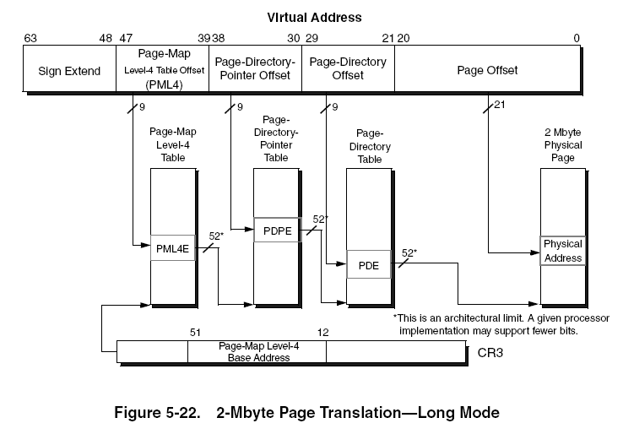
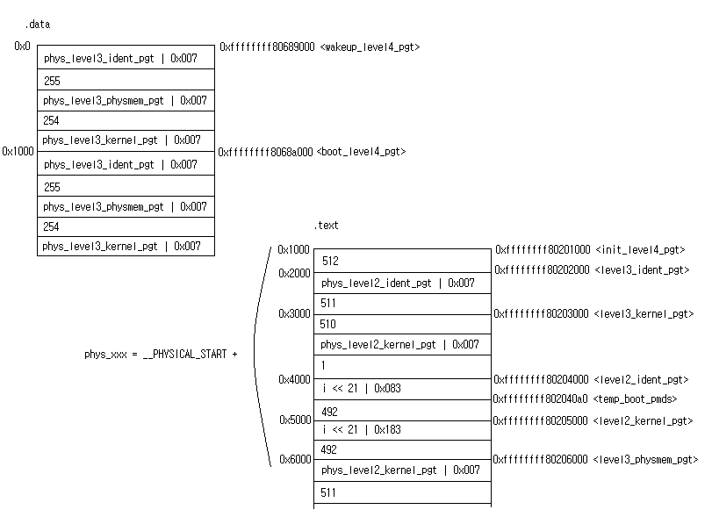

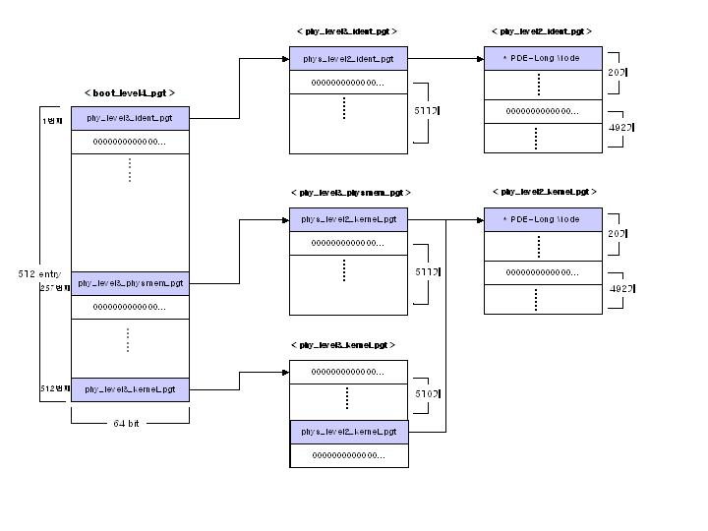
Sign Extend | Page-Map  Level4 Table Offset (PML4) | Page-Directory-  Pointer Offset | Page-Directory  Offset | Page Offset
 | 0 | 0 | 0 ~ 19 | 2M 만큼
 | 256 | 0 | 0 ~ 19 | 2M 만큼
 | 511 | 510 | 0 ~ 19 | 2M 만큼

1. identity page map
0x0000 0000 0000 0000 ~ 0x0000 0000 027f ffff ( 0x2800000 = 40Mbytes)
2 .physical memory page map
0x0000 8000 0000 0000 ~ 0x0000 8000 027f ffff ( 0x2800000 = 40Mbytes)
3 .kernel page map
0x0000 ffff 8000 0000 ~ 0x0000 ffff 827f ffff ( 0x2800000 = 40Mbytes)

Sign Extend 는 언제 사용하는가?

__START_KERNEL_map = 0xffffffff80000000

* 페이지 테이블의 속성
PML4E (page-map level-4 entry)
PDPE (page-directory-pointer entry)
PDE (page-directory entry)
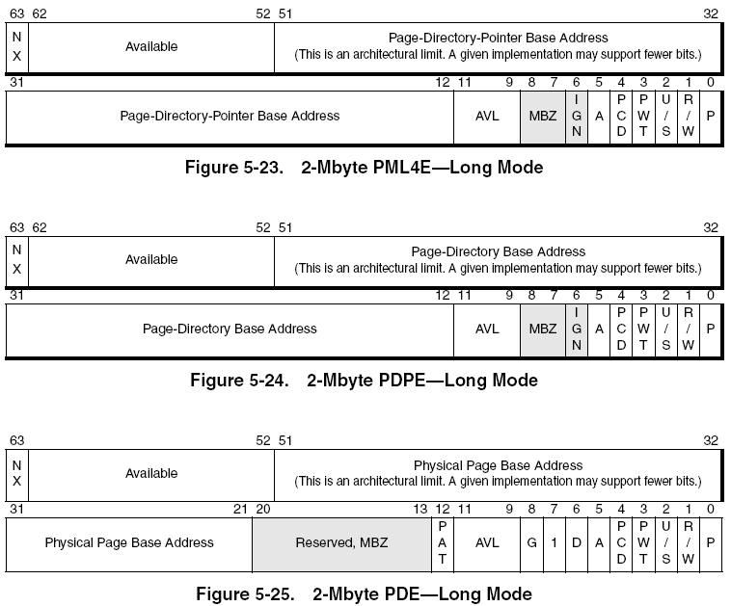
* PML4E와 PDPE 에 0x7 속성을 지정했다.

P : Present , 1 : 물리메모리에 존재
R/W : Read/Write, 1 : Read/Write , 0 : Read Only
U/S : User/Supervisor , 1 : User & Supervisor, 0 : Supervisor

* PDE 에 0x183(110000011b), 0x083 (10000011b)속성을 지정했다.
P , R/W , bit 7(2-Mbyte physical-page translation)
G : Global Page
Physical Page Base Address = 0 ~ 19 지정

Dummy PDA
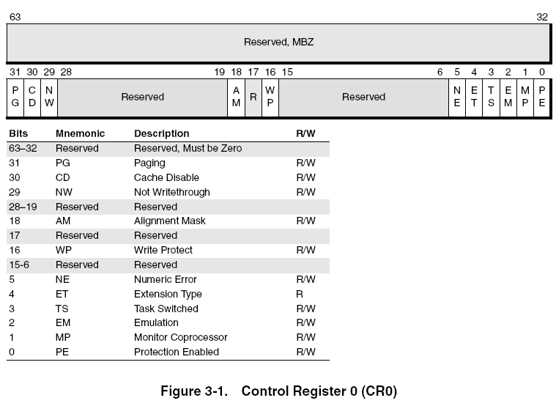
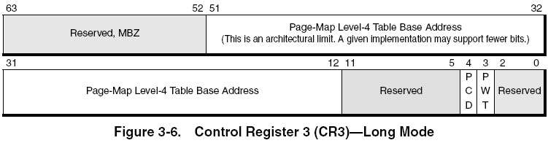
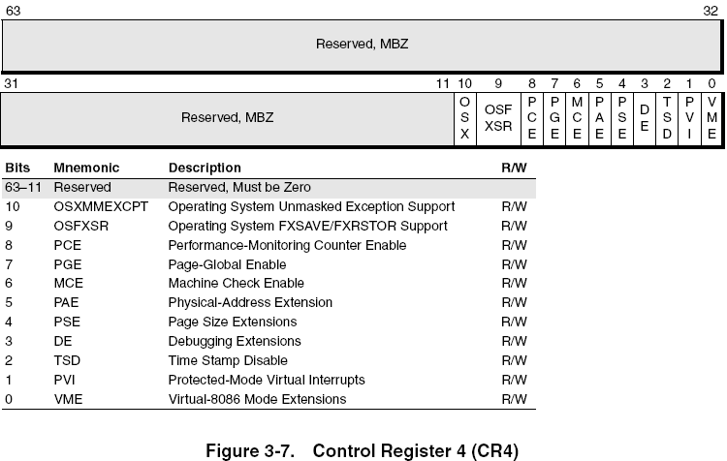
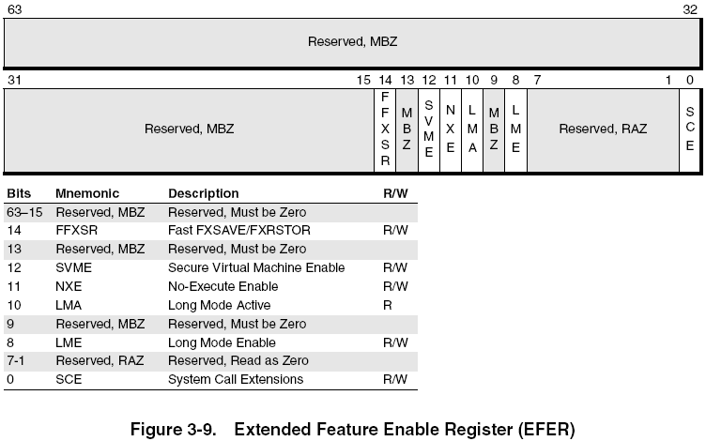
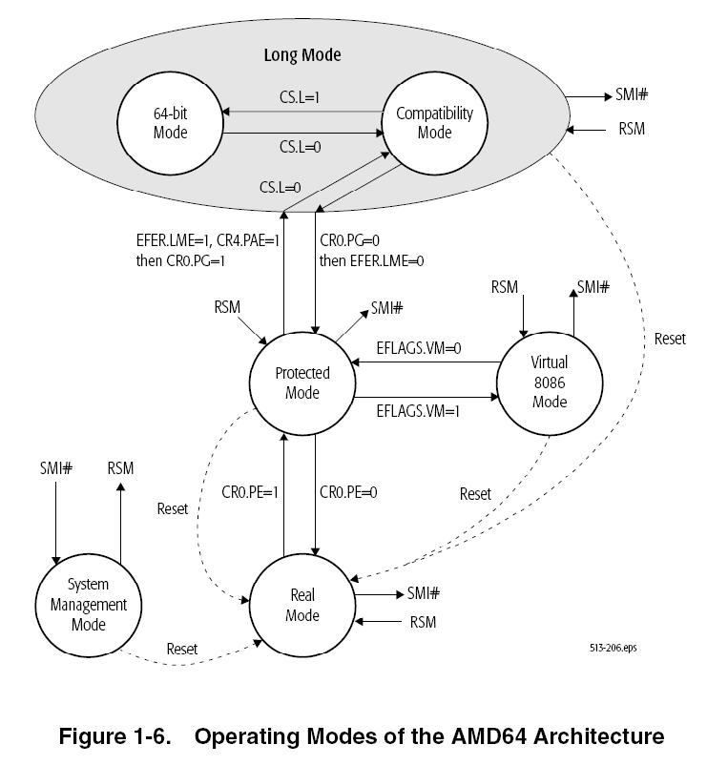
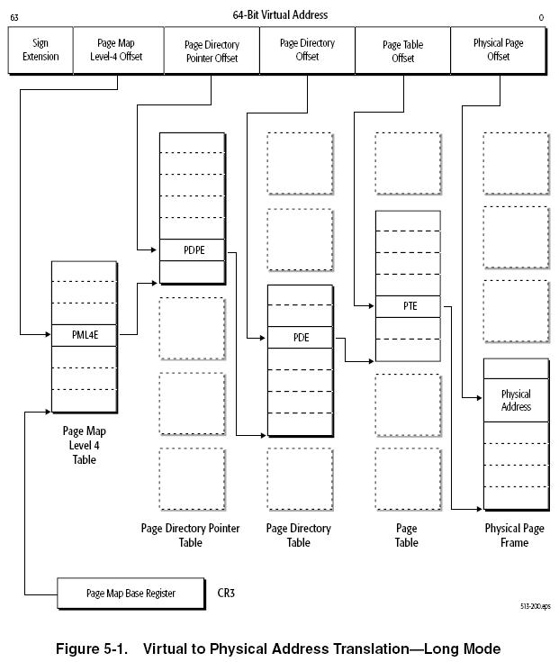
Long-Mode 진입 예제코드
Reference) AMD64 Book2. page 349 14.8절 Long-Mode Initialization Example

mydata segment para
;;;;;;;;;;;;;;;;;;;;;;;;;;;;;;;;;;;;;;;;;;;;;;;;;;;;;;;;;;;;
;
; This generic data-segment holds pseudo-descriptors used
; by the LGDT and LIDT instructions.
;
;;;;;;;;;;;;;;;;;;;;;;;;;;;;;;;;;;;;;;;;;;;;;;;;;;;;;;;;;;;;
;
; Establish a temporary 32-bit GDT and IDT.
;
pGDT32 label fword ; Used by LGDT.
dw gdt32_limit ; GDT limit ...
dd gdt32_base ; and 32-bit GDT base
pIDT32 label fword ; Used by LIDT.
dw idt32_limit ; IDT limit ...
dd idt32_base ; and 32-bit IDT base
;
; Establish a 64-bit GDT and IDT (64-bit linear base-
; address)
;
pGDT64 label tbyte ; Used by LGDT.
dw gdt64_limit ; GDT limit ...
dq gdt64_base ; and 64-bit GDT base
pIDT64 label tbyte ; Used by LIDT.
dw idt64_limit ; IDT limit ...
dq idt64_base ; and 64-bit IDT base
mydata ends ; end of data segment
code16 segment para use16 ; 16-bit code segment
;;;;;;;;;;;;;;;;;;;;;;;;;;;;;;;;;;;;;;;;;;;;;;;;;;;;;;;;;;;;;
; 16-bit code, real mode
;
;;;;;;;;;;;;;;;;;;;;;;;;;;;;;;;;;;;;;;;;;;;;;;;;;;;;;;;;;;;;
;
; Initialize DS to point to the data segment containing
; pGDT32 and PIDT32. Set up a real-mode stack pointer, SS:SP,
; in case of interrupts and exceptions.
;
cli
mov ax, seg mydata
mov ds, ax
mov ax, seg mystack
mov ss, ax
mov sp, esp0
;
; Use CPUID to determine if the processor supports long mode. ;
mov eax, 80000000h ; Extended-function 8000000h.
cpuid ; Is largest extended function
cmp eax, 80000000h ; any function > 80000000h?
jbe no_long_mode ; If not, no long mode.
mov eax, 80000001h ; Extended-function 8000001h.
cpuid ; Now EDX = extended-features flags.
bt edx, 29 ; Test if long mode is supported.
jnc no_long_mode ; Exit if not supported.
;
; Load the 32-bit GDT before entering protected mode.
; This GDT must contain, at a minimum, the following
; descriptors:
; 1) a CPL=0 16-bit code descriptor for this code segment.
; 2) a CPL=0 32/64-bit code descriptor for the 64-bit code.
; 3) a CPL=0 read/write data segment, usable as a stack
; (referenced by SS).
;
; Load the 32-bit IDT, in case any interrupts or exceptions
; occur after entering protected mode, but before enabling
; long mode).
;
; Initialize the GDTR and IDTR to point to the temporary
; 32-bit GDT and IDT, respectively.
;
lgdt ds:[pGDT32]
lidt ds:[pIDT32]
;
; Enable protected mode (CR0.PE=1).
;
mov eax, 000000011h
mov cr0, eax
;
; Execute a far jump to turn protected mode on.
; code16_sel must point to the previously-established 16-bit
; code descriptor located in the GDT (for the code currently
; being executed).
;
db 0eah ;Far jump...
dw offset now_in_prot ;to offset...
dw code16_sel ;in current code segment.
;;;;;;;;;;;;;;;;;;;;;;;;;;;;;;;;;;;;;;;;;;;;;;;;;;;;;;;;;;;;;
; At this point we are in 16-bit protected mode, but long
; mode is still disabled.
;
;;;;;;;;;;;;;;;;;;;;;;;;;;;;;;;;;;;;;;;;;;;;;;;;;;;;;;;;;;;;
now_in_prot:
;
; Set up the protected-mode stack pointer, SS:ESP.
; Stack_sel must point to the previously-established stack
; descriptor (read/write data segment), located in the GDT.
; Skip setting DS/ES/FS/GS, because we are jumping right to
; 64-bit code.
;
mov ax, stack_sel
mov ss, ax
mov esp, esp0
;
; Enable the 64-bit page-translation-table entries by
; setting CR4.PAE=1 (this is _required_ before activating
; long mode). Paging is not enabled until after long mode
; is enabled.
;
mov eax, cr4
bts eax, 5
mov cr4, eax
;
; Create the long-mode page tables, and initialize the
; 64-bit CR3 (page-table base address) to point to the base
; of the PML4 page table. The PML4 page table must be located
; below 4 Gbytes because only 32 bits of CR3 are loaded when
; the processor is not in 64-bit mode.
;
mov eax, pml4_base ; Pointer to PML4 table (<4GB).
mov cr3, eax ; Initialize CR3 with PML4 base.
;
; Enable long mode (set EFER.LME=1).
;
mov ecx, 0c0000080h ; EFER MSR number.
rdmsr ; Read EFER.
bts eax, 8 ; Set LME=1.
wrmsr ; Write EFER.
;
; Enable paging to activate long mode (set CR0.PG=1)
;
mov eax, cr0 ; Read CR0.
bts eax, 31 ; Set PE=1.
mov cr0, eax ; Write CR0.
;
; At this point, we are in 16-bit compatibility mode
; ( LMA=1, CS.L=0, CS.D=0 ).
; Now, jump to the 64-bit code segment. The offset must be
; equal to the linear address of the 64-bit entry point,
; because 64-bit code is in an unsegmented address space.
; The selector points to the 32/64-bit code selector in the
; current GDT.
;
db 066h
db 0eah
dd start64_linear
dw code64_sel
code16ends ; End of the 16-bit code segment
;;;;;;;;;;;;;;;;;;;;;;;;;;;;;;;;;;;;;;;;;;;;;;;;;;;;;;;;;;;;;
;;
;;; Start of 64-bit code
;;
;
;;;;;;;;;;;;;;;;;;;;;;;;;;;;;;;;;;;;;;;;;;;;;;;;;;;;;;;;;;;;
code64 para use64
start64: ; At this point, we're using 64-bit code
;
; Point the 64-bit RSP register to the stack’s _linear_
; address. There is no need to set SS here, because the SS
; register is not used in 64-bit mode.
;
mov rsp, stack0_linear
;
; This LGDT is only needed if the long-mode GDT is to be
; located at a linear address above 4 Gbytes. If the long
; mode GDT is located at a 32-bit linear address, putting
; 64-bit descriptors in the GDT pointed to by [pGDT32] is
; just fine. pGDT64_linear is the _linear_ address of the
; 10-byte GDT pseudo-descriptor.
;
; The new GDT should have a valid CPL0 64-bit code segment
; descriptor at the entry-point corresponding to the current
; CS selector. Alternatively, a far transfer to a valid CPL0
; 64-bit code segment descriptor in the new GDT must be done
; before enabling interrupts.
;
lgdt [pGDT64_linear]
;
; Load the 64-bit IDT. This is _required_, because the 64-bit
; IDT uses 64-bit interrupt descriptors, while the 32-bit
; IDT used 32-bit interrupt descriptors. pIDT64_linear is
; the _linear_ address of the 10-byte IDT pseudo-descriptor.
;
lidt [pIDT64_linear]
;
; Set the current TSS. tss_sel should point to a 64-bit TSS
; descriptor in the current GDT. The TSS is used for
; inner-level stack pointers and the IO bit-map.
;
mov ax, tss_sel
ltr ax
;
; Set the current LDT. ldt_sel should point to a 64-bit LDT
; descriptor in the current GDT.
;
mov ax, ldt_sel
lldt ax
;
; Using fs: and gs: prefixes on memory accesses still uses
; the 32-bit fs.base and gs.base. Reload these 2 registers
; before using the fs: and gs: prefixes. FS and GS can be
; loaded from the GDT using a normal “mov fs,foo” type
; instructions, which loads a 32-bit base into FS or GS.
; Alternatively, use WRMSR to assign 64-bit base values to
; MSR_FS_base or MSR_GS_base.
;
mov ecx, MSR_FS_base
mov eax, FsbaseLow
mov edx, FsbaseHi
wrmsr
;
; Reload CR3 if long-mode page tables are to be located above
; 4 Gbytes. Because the original CR3 load was done in 32-bit
; legacy mode, it could only load 32 bits into CR3. Thus, the
; current page tables are located in the lower 4 Gbytes of
; physical memory. This MOV to CR3 is only needed if the
; actual long-mode page tables should be located at a linear
; address above 4 Gbytes.
;
mov rax, final_pml4_base ; Point to PML4
mov cr3, rax ; Load 64-bit CR3
;
; Enable interrupts.
;
sti ; Enabled INTR
<insert 64-bit code here>

