Table of Contents

Landing Zone 5

Use Glue Studio to ingest data from an S3 bucket 5

customer_landing_to_trusted.py 5

Visual ETL 6

accelerometer_landing_to_trusted.py 7

Visual ETL 8

step_trainer_trusted.py 9

Visual ETL 10

Manually create a Glue Table using Glue Console from JSON data 12

customer_landing.sql 12

accelerometer_landing.sql 13

step_trainer_landing.sql 14

Use Athena to query the Landing Zone. 14

Count of customer_landing 15

Count of accelerometer_landing 15

Count of step_trainer_landing 16

Trusted Zone 16

Configure Glue Studio to dynamically update a Glue Table schema from JSON data 16

query Trusted 16

Customer Trusted 17

Count of customer_trusted 18

Accelerometer Trusted 19

Count of accelerometer_trusted 20

Count of step_trainer_trusted 21

Curated Zone 22

Write a Glue Job to join trusted data 22

customer_trusted_to_curated.py 22

Visual ETL 24

Customer Trusted To Curated 24

Write a Glue Job to create curated data 25

step_trainer_trusted.py 25

Visual ETL 27

Step Trainer Trusted 27

Use Athena to query Curated Glue Tables 28

Count of customer_curated 28

Machine Learning Curated – Visual ETL 29

Count of machine_learning_curated 29

machine_learning_curated.py 30

1. Introduction 32

2. Code Walkthrough 32

2.1 Imports and Setup 32

2.2 Job Initialization 32

2.3 Data Quality Rules 33

2.4 Load Customer Landing Data 33

2.5 Privacy Filter 33

2.6 Data Quality Evaluation 34

2.7 Write Customer Trusted Data 34

2.8 Job Commit 34

AWS Glue ETL Job – Accelerometer Trusted Zone 35

accelerometer_landing_to_trusted.py 35

1. Introduction 35

2. Code Walkthrough 35

2.1 Imports and Setup 35

2.2 Spark SQL Helper Function 35

2.3 Job Initialization 36

2.4 Data Quality Rules 36

2.5 Load Source Data 36

2.6 Join Accelerometer with Customer 37

2.7 SQL Transformation 37

2.8 Data Quality Evaluation 37

2.9 Write Accelerometer Trusted Data 38

2.10 Job Commit 38

4. Key Takeaways 38

AWS Glue ETL Job – Step Trainer Trusted Zone 39

1. Introduction 39

2. Code Walkthrough 39

2.1 Imports and Setup 39

2.2 Spark SQL Helper 39

2.3 Job Initialization 40

2.4 Data Quality Rules 40

2.5 Load Source Data 40

2.6 SQL Transformation 41

2.7 Data Quality Check 41

2.8 Write Final Data to S3 41

2.9 Commit Job 42

4. Key Takeaways 42

AWS Glue ETL Job – Customers Curated Zone 43

1. Introduction 43

2. Code Walkthrough 43

2.1 Imports and Setup 43

2.2 Spark SQL Helper 43

2.3 Job Initialization 43

2.4 Data Quality Rules 44

2.5 Load Source Data 44

2.6 Join 45

2.7 SQL Transformation 45

2.8 Data Quality Check 45

2.9 Write Final Data to S3 46

4. Key Takeaways 46

Machine Learning Curated Glue Job Documentation 47

1. Purpose 47

2. Code Walkthrough 47

1. Import Required Libraries 47

2. Initialize Job 47

3. Define Data Quality Rules 47

4. Load Source Datasets (Trusted Zone) 48

5. Rename Customer Keys Before Join 48

6. Join Step Trainer with Accelerometer 48

7. Join with Customer Data 49

8. Evaluate Data Quality 49

9. Write Curated Dataset to S3 + Catalog 49

10. Commit Job 50

3. Key Takeaways 50

# Landing Zone

## Use Glue Studio to ingest data from an S3 bucket

### Submission Requirements

**customer_landing_to_trusted.py**, **accelerometer_landing_to_trusted.py**, and **step_trainer_trusted.py** Glue jobs have a node that connects to S3 bucket for customer, accelerometer, and step trainer landing zones.

### customer_landing_to_trusted.py

import sys

from awsglue.transforms import *

from awsglue.utils import getResolvedOptions

from pyspark.context import SparkContext

from awsglue.context import GlueContext

from awsglue.job import Job

from awsgluedq.transforms import EvaluateDataQuality

import re

args = getResolvedOptions(sys.argv, ['JOB_NAME'])

sc = SparkContext()

glueContext = GlueContext(sc)

spark = glueContext.spark_session

job = Job(glueContext)

job.init(args['JOB_NAME'], args)

# Default ruleset used by all target nodes with data quality enabled

DEFAULT_DATA_QUALITY_RULESET = """

Rules = [

ColumnCount > 0

]

"""

# Script generated for node Amazon S3

AmazonS3_node1757133904216 = glueContext.create_dynamic_frame.from_options(format_options={"multiLine": "false"}, connection_type="s3", format="json", connection_options={"paths": ["s3://stedi-lake-house-qk/customer/landing/"], "recurse": True}, transformation_ctx="AmazonS3_node1757133904216")

# Script generated for node Privacy Filter

PrivacyFilter_node1757133969699 = Filter.apply(frame=AmazonS3_node1757133904216, f=lambda row: (not(row["shareWithResearchAsOfDate"] == 0)), transformation_ctx="PrivacyFilter_node1757133969699")

# Script generated for node Customer Trusted

EvaluateDataQuality().process_rows(frame=PrivacyFilter_node1757133969699, ruleset=DEFAULT_DATA_QUALITY_RULESET, publishing_options={"dataQualityEvaluationContext": "EvaluateDataQuality_node1757128621835", "enableDataQualityResultsPublishing": True}, additional_options={"dataQualityResultsPublishing.strategy": "BEST_EFFORT", "observations.scope": "ALL"})

CustomerTrusted_node1757134020703 = glueContext.write_dynamic_frame.from_options(frame=PrivacyFilter_node1757133969699, connection_type="s3", format="json", connection_options={"path": "s3://stedi-lake-house-qk/customer/trusted/", "partitionKeys": []}, transformation_ctx="CustomerTrusted_node1757134020703")

job.commit()

### Visual ETL

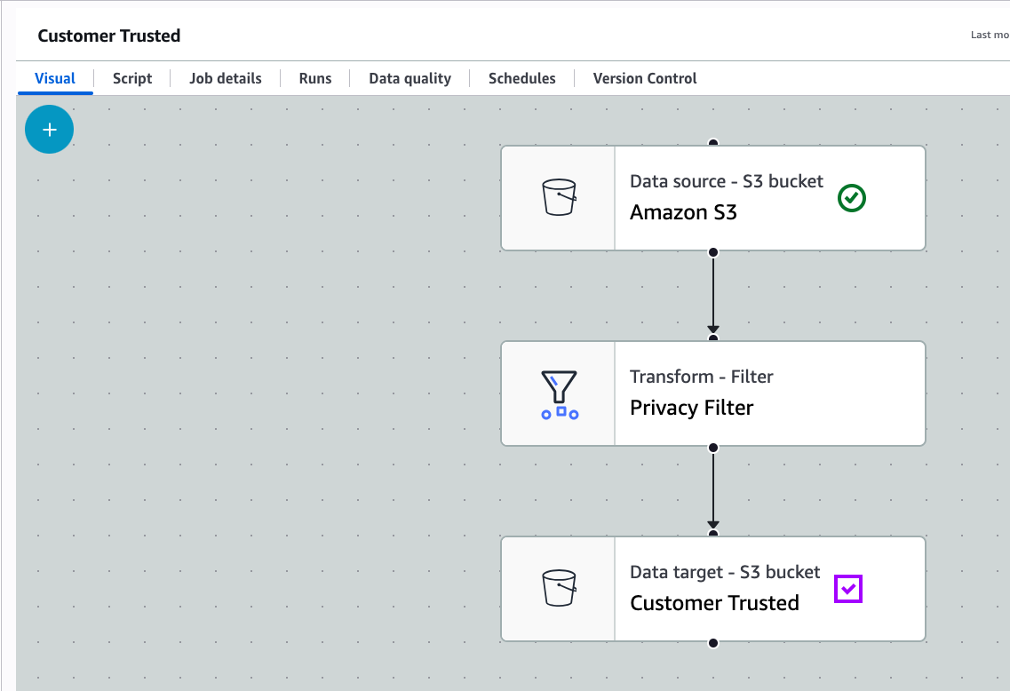

### accelerometer_landing_to_trusted.py

import sys

from awsglue.transforms import *

from awsglue.utils import getResolvedOptions

from pyspark.context import SparkContext

from awsglue.context import GlueContext

from awsglue.job import Job

from awsgluedq.transforms import EvaluateDataQuality

from awsglue import DynamicFrame

def sparkSqlQuery(glueContext, query, mapping, transformation_ctx) -> DynamicFrame:

for alias, frame in mapping.items():

frame.toDF().createOrReplaceTempView(alias)

result = spark.sql(query)

return DynamicFrame.fromDF(result, glueContext, transformation_ctx)

args = getResolvedOptions(sys.argv, ['JOB_NAME'])

sc = SparkContext()

glueContext = GlueContext(sc)

spark = glueContext.spark_session

job = Job(glueContext)

job.init(args['JOB_NAME'], args)

# Default ruleset used by all target nodes with data quality enabled

DEFAULT_DATA_QUALITY_RULESET = """

Rules = [

ColumnCount > 0

]

"""

# Script generated for node Amazon S3

AmazonS3_node1757128664531 = glueContext.create_dynamic_frame.from_catalog(database="stedi", table_name="accelorometer_landing", transformation_ctx="AmazonS3_node1757128664531")

# Script generated for node Amazon S3

AmazonS3_node1757128643733 = glueContext.create_dynamic_frame.from_options(format_options={"multiLine": "false"}, connection_type="s3", format="json", connection_options={"paths": ["s3://stedi-lake-house-qk/customer/trusted/"], "recurse": True}, transformation_ctx="AmazonS3_node1757128643733")

# Script generated for node Customer Privacy Filter

CustomerPrivacyFilter_node1757128680082 = Join.apply(frame1=AmazonS3_node1757128664531, frame2=AmazonS3_node1757128643733, keys1=["user"], keys2=["email"], transformation_ctx="CustomerPrivacyFilter_node1757128680082")

# Script generated for node SQL Query

SqlQuery914 = '''

select user, x, y, z, timestamp from myDataSource

'''

SQLQuery_node1757135173003 = sparkSqlQuery(glueContext, query = SqlQuery914, mapping = {"myDataSource":CustomerPrivacyFilter_node1757128680082}, transformation_ctx = "SQLQuery_node1757135173003")

# Script generated for node Accelerometer Trusted

EvaluateDataQuality().process_rows(frame=SQLQuery_node1757135173003, ruleset=DEFAULT_DATA_QUALITY_RULESET, publishing_options={"dataQualityEvaluationContext": "EvaluateDataQuality_node1757128621835", "enableDataQualityResultsPublishing": True}, additional_options={"dataQualityResultsPublishing.strategy": "BEST_EFFORT", "observations.scope": "ALL"})

AccelerometerTrusted_node1757128772635 = glueContext.write_dynamic_frame.from_options(frame=SQLQuery_node1757135173003, connection_type="s3", format="json", connection_options={"path": "s3://stedi-lake-house-qk/accelerometer/trusted/", "partitionKeys": []}, transformation_ctx="AccelerometerTrusted_node1757128772635")

job.commit()

### Visual ETL

### step_trainer_trusted.py

import sys

from awsglue.transforms import *

from awsglue.utils import getResolvedOptions

from pyspark.context import SparkContext

from awsglue.context import GlueContext

from awsglue.job import Job

from awsgluedq.transforms import EvaluateDataQuality

from awsglue import DynamicFrame

def sparkSqlQuery(glueContext, query, mapping, transformation_ctx) -> DynamicFrame:

for alias, frame in mapping.items():

frame.toDF().createOrReplaceTempView(alias)

result = spark.sql(query)

return DynamicFrame.fromDF(result, glueContext, transformation_ctx)

args = getResolvedOptions(sys.argv, ['JOB_NAME'])

sc = SparkContext()

glueContext = GlueContext(sc)

spark = glueContext.spark_session

job = Job(glueContext)

job.init(args['JOB_NAME'], args)

# Default ruleset used by all target nodes with data quality enabled

DEFAULT_DATA_QUALITY_RULESET = """

Rules = [

ColumnCount > 0

]

"""

# Script generated for node AWS Glue Data Catalog

AWSGlueDataCatalog_node1757143330187 = glueContext.create_dynamic_frame.from_catalog(database="stedi", table_name="customer_curated", transformation_ctx="AWSGlueDataCatalog_node1757143330187")

# Script generated for node Step Trainer Landing

StepTrainerLanding_node1757143347320 = glueContext.create_dynamic_frame.from_options(format_options={"multiLine": "false"}, connection_type="s3", format="json", connection_options={"paths": ["s3://stedi-lake-house-qk/step_trainer/landing/"], "recurse": True}, transformation_ctx="StepTrainerLanding_node1757143347320")

# Script generated for node SQL Query

SqlQuery919 = '''

SELECT st.serialnumber,

sensorreadingtime,

FIRST_VALUE(distancefromobject)

OVER (PARTITION BY st.serialnumber, st.sensorreadingtime ORDER BY st.sensorreadingtime) AS distancefromobject

FROM stedi.step_trainer_landing st

JOIN customer_curated c

ON c.serialnumber = st.serialnumber;

'''

SQLQuery_node1757143772990 = sparkSqlQuery(glueContext, query = SqlQuery919, mapping = {"customer_curated":AWSGlueDataCatalog_node1757143330187, "step_trainer_landing":StepTrainerLanding_node1757143347320}, transformation_ctx = "SQLQuery_node1757143772990")

# Script generated for node Amazon S3

EvaluateDataQuality().process_rows(frame=SQLQuery_node1757143772990, ruleset=DEFAULT_DATA_QUALITY_RULESET, publishing_options={"dataQualityEvaluationContext": "EvaluateDataQuality_node1757139860297", "enableDataQualityResultsPublishing": True}, additional_options={"dataQualityResultsPublishing.strategy": "BEST_EFFORT", "observations.scope": "ALL"})

AmazonS3_node1757143463027 = glueContext.getSink(path="s3://stedi-lake-house-qk/step_trainer/final_output/", connection_type="s3", updateBehavior="UPDATE_IN_DATABASE", partitionKeys=[], enableUpdateCatalog=True, transformation_ctx="AmazonS3_node1757143463027")

AmazonS3_node1757143463027.setCatalogInfo(catalogDatabase="stedi",catalogTableName="step_trainer_trusted")

AmazonS3_node1757143463027.setFormat("json")

AmazonS3_node1757143463027.writeFrame(SQLQuery_node1757143772990)

job.commit()

### Visual ETL

## Manually create a Glue Table using Glue Console from JSON data

SQL DDL scripts **customer_landing.sql**, **accelerometer_landing.sql**, and **step_trainer_landing.sql** include all of the JSON fields in the data input files and are appropriately typed (not everything is a string).

### customer_landing.sql

CREATE EXTERNAL TABLE `customer_landing`(

`customername` string COMMENT 'from deserializer',

`email` string COMMENT 'from deserializer',

`phone` string COMMENT 'from deserializer',

`birthday` string COMMENT 'from deserializer',

`serialnumber` string COMMENT 'from deserializer',

`registrationdate` bigint COMMENT 'from deserializer',

`lastupdatedate` bigint COMMENT 'from deserializer',

`sharewithresearchasofdate` bigint COMMENT 'from deserializer',

`sharewithpublicasofdate` bigint COMMENT 'from deserializer',

`sharewithfriendsasofdate` bigint COMMENT 'from deserializer')

ROW FORMAT SERDE

'org.openx.data.jsonserde.JsonSerDe'

STORED AS INPUTFORMAT

'org.apache.hadoop.mapred.TextInputFormat'

OUTPUTFORMAT

'org.apache.hadoop.hive.ql.io.HiveIgnoreKeyTextOutputFormat'

LOCATION

's3://stedi-lake-house-qk/customer/landing/'

TBLPROPERTIES (

'classification'='json')

### accelerometer_landing.sql

CREATE EXTERNAL TABLE `accelorometer_landing`(

`user` string COMMENT 'from deserializer',

`timestamp` bigint COMMENT 'from deserializer',

`x` float COMMENT 'from deserializer',

`y` float COMMENT 'from deserializer',

`z` float COMMENT 'from deserializer')

ROW FORMAT SERDE

'org.openx.data.jsonserde.JsonSerDe'

WITH SERDEPROPERTIES (

'case.insensitive'='TRUE',

'dots.in.keys'='FALSE',

'ignore.malformed.json'='FALSE',

'mapping'='TRUE')

STORED AS INPUTFORMAT

'org.apache.hadoop.mapred.TextInputFormat'

OUTPUTFORMAT

'org.apache.hadoop.hive.ql.io.HiveIgnoreKeyTextOutputFormat'

LOCATION

's3://stedi-lake-house-qk/accelerometer/landing'

TBLPROPERTIES (

'classification'='json',

'transient_lastDdlTime'='1757062449')

### step_trainer_landing.sql

CREATE EXTERNAL TABLE `step_trainer_landing`(

`sensorreadingtime` bigint COMMENT 'from deserializer',

`serialnumber` string COMMENT 'from deserializer',

`distancefromobject` int COMMENT 'from deserializer')

ROW FORMAT SERDE

'org.openx.data.jsonserde.JsonSerDe'

WITH SERDEPROPERTIES (

'case.insensitive'='TRUE',

'dots.in.keys'='FALSE',

'ignore.malformed.json'='FALSE',

'mapping'='TRUE')

STORED AS INPUTFORMAT

'org.apache.hadoop.mapred.TextInputFormat'

OUTPUTFORMAT

'org.apache.hadoop.hive.ql.io.HiveIgnoreKeyTextOutputFormat'

LOCATION

's3://stedi-lake-house-qk/step_trainer/landing'

TBLPROPERTIES (

'classification'='json',

'transient_lastDdlTime'='1757132555')

## Use Athena to query the Landing Zone.

Include screenshots showing various queries run on Athena, along with their results:

* Count of customer_landing: 956 rows
* The customer_landing data contains multiple rows with a blank shareWithResearchAsOfDate.
* Count of accelerometer_landing: 81273 rows
* Count of step_trainer_landing: 28680 rows

### Count of customer_landing

### Count of accelerometer_landing

### Count of step_trainer_landing

# Trusted Zone

## Configure Glue Studio to dynamically update a Glue Table schema from JSON data

Glue Job Python code shows that the option to dynamically infer and update schema is enabled.

To do this, set the *Create a table in the Data Catalog and, on subsequent runs, update the schema and add new partitions* option to True.

## query Trusted

Include screenshots showing various queries run on Athena, along with their results:

* Count of customer_trusted: 482 rows
  + The resulting customer_trusted data has no rows where shareWithResearchAsOfDate is blank.
* Count of accelerometer_trusted: 40981 rows
* Count of step_trainer_trusted: 14460 rows

However, **if you are following the stand-out suggestions**, your row counts should be as follows:

* Count of customer_trusted: 482 rows
* The resulting customer_trusted data has no rows where shareWithResearchAsOfDate is blank.
* Count of accelerometer_trusted: 32025 rows
* Count of step_trainer_trusted: 14460 rows

### Customer Trusted

Sanitize the Customer data from the Website (Landing Zone) and only store the Customer Records who agreed to share their data for research purposes (Trusted Zone) - creating a Glue Table called **customer_trusted**.

### Count of customer_trusted

### Accelerometer Trusted

### Count of accelerometer_trusted

### Count of step_trainer_trusted

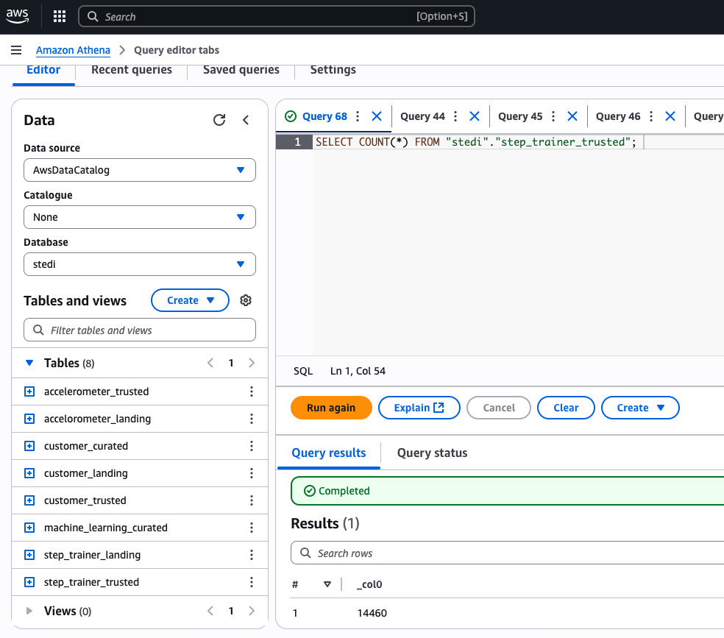

# Curated Zone

## Write a Glue Job to join trusted data

**customer_trusted_to_curated.py** has a node that inner joins the customer_trusted data with the accelerometer_trusted data by emails. The produced table should have only columns from the customer table.

Sanitize the Customer data (Trusted Zone) and create a Glue Table (Curated Zone) that only includes customers who have accelerometer data *and* have agreed to share their data for research called **customers_curated**.

### customer_trusted_to_curated.py

import sys

from awsglue.transforms import *

from awsglue.utils import getResolvedOptions

from pyspark.context import SparkContext

from awsglue.context import GlueContext

from awsglue.job import Job

from awsgluedq.transforms import EvaluateDataQuality

from awsglue import DynamicFrame

def sparkSqlQuery(glueContext, query, mapping, transformation_ctx) -> DynamicFrame:

for alias, frame in mapping.items():

frame.toDF().createOrReplaceTempView(alias)

result = spark.sql(query)

return DynamicFrame.fromDF(result, glueContext, transformation_ctx)

args = getResolvedOptions(sys.argv, ['JOB_NAME'])

sc = SparkContext()

glueContext = GlueContext(sc)

spark = glueContext.spark_session

job = Job(glueContext)

job.init(args['JOB_NAME'], args)

# Default ruleset used by all target nodes with data quality enabled

DEFAULT_DATA_QUALITY_RULESET = """

Rules = [

ColumnCount > 0

]

"""

# Script generated for node Accelerometer Landing

AccelerometerLanding_node1757139949188 = glueContext.create_dynamic_frame.from_options(format_options={"multiLine": "false"}, connection_type="s3", format="json", connection_options={"paths": ["s3://stedi-lake-house-qk/accelerometer/landing/"], "recurse": True}, transformation_ctx="AccelerometerLanding_node1757139949188")

# Script generated for node Customer Trusted

CustomerTrusted_node1757139909252 = glueContext.create_dynamic_frame.from_options(format_options={"multiLine": "false"}, connection_type="s3", format="json", connection_options={"paths": ["s3://stedi-lake-house-qk/customer/trusted/"], "recurse": True}, transformation_ctx="CustomerTrusted_node1757139909252")

# Script generated for node Join

Join_node1757139980937 = Join.apply(frame1=AccelerometerLanding_node1757139949188, frame2=CustomerTrusted_node1757139909252, keys1=["user"], keys2=["email"], transformation_ctx="Join_node1757139980937")

# Script generated for node SQL Query

SqlQuery923 = '''

select distinct customerName, email, phone, birthday, serialNumber,

registrationDate, lastUpdateDate, shareWithResearchAsOfDate,

shareWithPublicAsOfDate, shareWithFriendsAsOfDate from myDataSource

'''

SQLQuery_node1757140002420 = sparkSqlQuery(glueContext, query = SqlQuery923, mapping = {"myDataSource":Join_node1757139980937}, transformation_ctx = "SQLQuery_node1757140002420")

# Script generated for node Customers Curated

EvaluateDataQuality().process_rows(frame=SQLQuery_node1757140002420, ruleset=DEFAULT_DATA_QUALITY_RULESET, publishing_options={"dataQualityEvaluationContext": "EvaluateDataQuality_node1757139860297", "enableDataQualityResultsPublishing": True}, additional_options={"dataQualityResultsPublishing.strategy": "BEST_EFFORT", "observations.scope": "ALL"})

CustomersCurated_node1757140019180 = glueContext.write_dynamic_frame.from_options(frame=SQLQuery_node1757140002420, connection_type="s3", format="json", connection_options={"path": "s3://stedi-lake-house-qk/customer/curated/", "partitionKeys": []}, transformation_ctx="CustomersCurated_node1757140019180")

job.commit()

### Visual ETL

### Customer Trusted To Curated

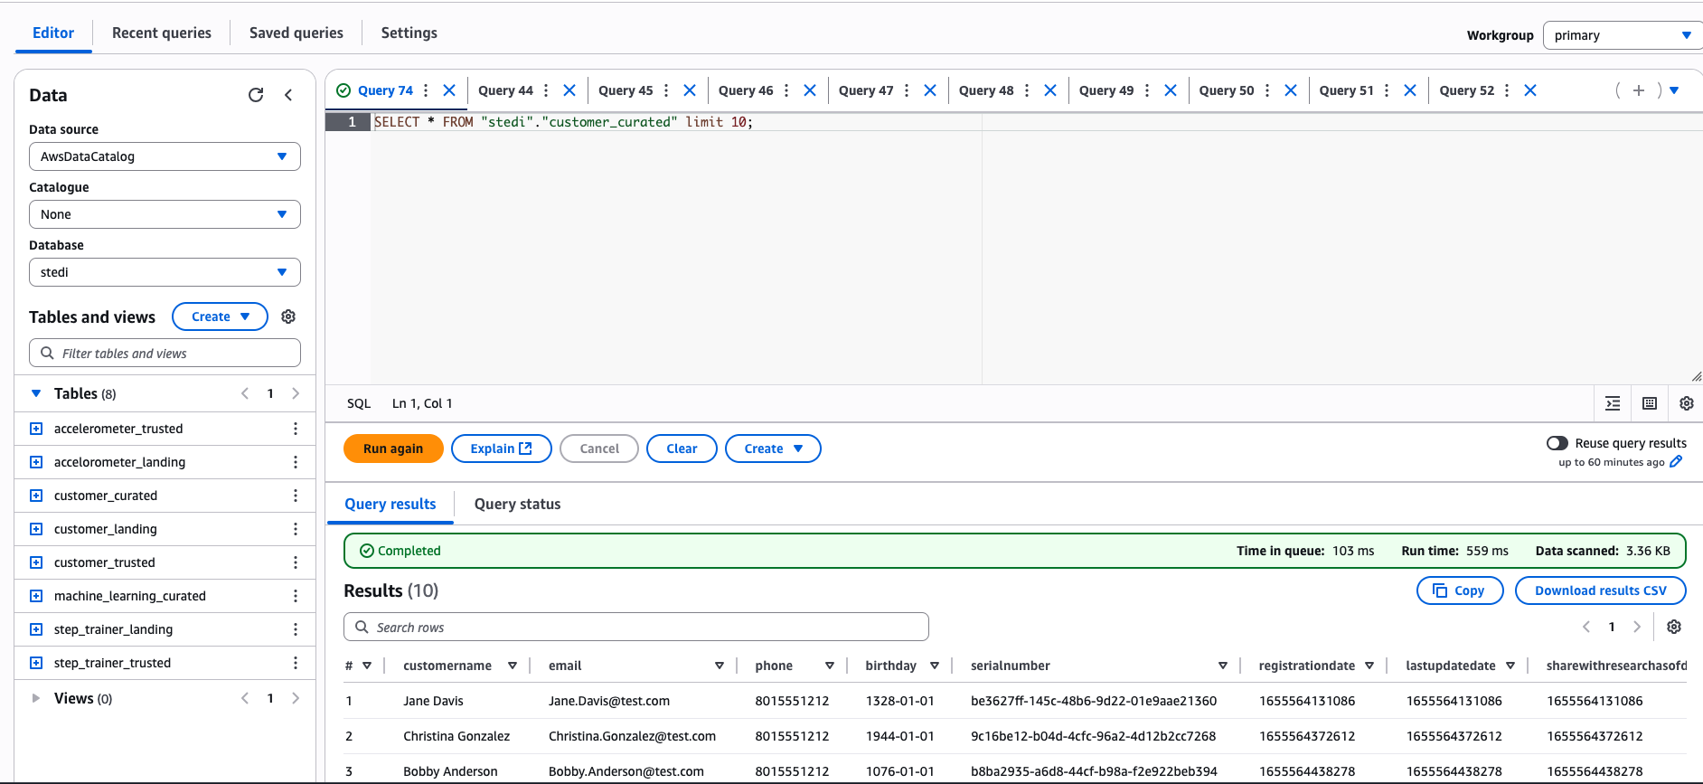

## Write a Glue Job to create curated data

**step_trainer_trusted.py** has a node that inner joins the step_trainer_landing data with the customer_curated data by serial numbers

**machine_learning_curated.py** has a node that inner joins the step_trainer_trusted data with the accelerometer_trusted data by sensor reading time and timestamps

Hints:

* **Data Source - S3 bucket** node sometimes extracted incomplete data. Use the **Data Source - Data Catalog** node when that's the case.
* Use the Data Preview feature with at least 500 rows to ensure the number of customer-curated rows is correct. Click "Start data preview session", then click the gear next to the "Filter" text box to update the number of rows
* As before, the **Transform - SQL Query** node often gives more consistent outputs than any other node type. Tip - replace the JOIN node with it.
* The step_trainer_trusted may take about 8 minutes to run.

### step_trainer_trusted.py

import sys

from awsglue.transforms import *

from awsglue.utils import getResolvedOptions

from pyspark.context import SparkContext

from awsglue.context import GlueContext

from awsglue.job import Job

from awsgluedq.transforms import EvaluateDataQuality

from awsglue import DynamicFrame

def sparkSqlQuery(glueContext, query, mapping, transformation_ctx) -> DynamicFrame:

for alias, frame in mapping.items():

frame.toDF().createOrReplaceTempView(alias)

result = spark.sql(query)

return DynamicFrame.fromDF(result, glueContext, transformation_ctx)

args = getResolvedOptions(sys.argv, ['JOB_NAME'])

sc = SparkContext()

glueContext = GlueContext(sc)

spark = glueContext.spark_session

job = Job(glueContext)

job.init(args['JOB_NAME'], args)

# Default ruleset used by all target nodes with data quality enabled

DEFAULT_DATA_QUALITY_RULESET = """

Rules = [

ColumnCount > 0

]

"""

# Script generated for node AWS Glue Data Catalog

AWSGlueDataCatalog_node1757143330187 = glueContext.create_dynamic_frame.from_catalog(database="stedi", table_name="customer_curated", transformation_ctx="AWSGlueDataCatalog_node1757143330187")

# Script generated for node Step Trainer Landing

StepTrainerLanding_node1757143347320 = glueContext.create_dynamic_frame.from_options(format_options={"multiLine": "false"}, connection_type="s3", format="json", connection_options={"paths": ["s3://stedi-lake-house-qk/step_trainer/landing/"], "recurse": True}, transformation_ctx="StepTrainerLanding_node1757143347320")

# Script generated for node SQL Query

SqlQuery919 = '''

SELECT st.serialnumber,

sensorreadingtime,

FIRST_VALUE(distancefromobject)

OVER (PARTITION BY st.serialnumber, st.sensorreadingtime ORDER BY st.sensorreadingtime) AS distancefromobject

FROM stedi.step_trainer_landing st

JOIN customer_curated c

ON c.serialnumber = st.serialnumber;

'''

SQLQuery_node1757143772990 = sparkSqlQuery(glueContext, query = SqlQuery919, mapping = {"customer_curated":AWSGlueDataCatalog_node1757143330187, "step_trainer_landing":StepTrainerLanding_node1757143347320}, transformation_ctx = "SQLQuery_node1757143772990")

# Script generated for node Amazon S3

EvaluateDataQuality().process_rows(frame=SQLQuery_node1757143772990, ruleset=DEFAULT_DATA_QUALITY_RULESET, publishing_options={"dataQualityEvaluationContext": "EvaluateDataQuality_node1757139860297", "enableDataQualityResultsPublishing": True}, additional_options={"dataQualityResultsPublishing.strategy": "BEST_EFFORT", "observations.scope": "ALL"})

AmazonS3_node1757143463027 = glueContext.getSink(path="s3://stedi-lake-house-qk/step_trainer/final_output/", connection_type="s3", updateBehavior="UPDATE_IN_DATABASE", partitionKeys=[], enableUpdateCatalog=True, transformation_ctx="AmazonS3_node1757143463027")

AmazonS3_node1757143463027.setCatalogInfo(catalogDatabase="stedi",catalogTableName="step_trainer_trusted")

AmazonS3_node1757143463027.setFormat("json")

AmazonS3_node1757143463027.writeFrame(SQLQuery_node1757143772990)

job.commit()

### Visual ETL

### Step Trainer Trusted

## Use Athena to query Curated Glue Tables

Include screenshots showing various queries run on Athena, along with their results:

* Count of customer_curated: 482 rows
* Count of machine_learning_curated: 43681 rows

However, **if you are following the stand-out suggestions**, your row counts should be as follows:

* Count of customer_curated: 464 rows
* Count of machine_learning_curated: 34437 rows

Hint: If you get unexpected results, consider using the **Transform - SQL Query** node rather than Glue-provided nodes.

### Count of customer_curated

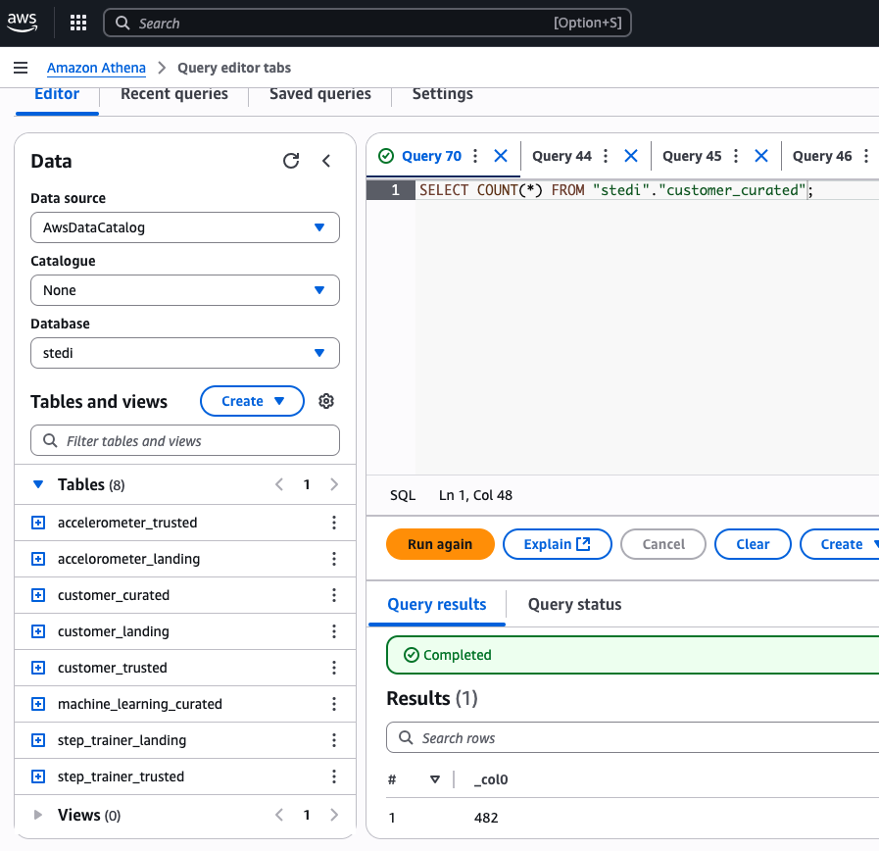

### Machine Learning Curated – Visual ETL

### Count of machine_learning_curated

### machine_learning_curated.py

import sys

from awsglue.transforms import *

from awsglue.utils import getResolvedOptions

from pyspark.context import SparkContext

from awsglue.context import GlueContext

from awsglue.job import Job

from awsgluedq.transforms import EvaluateDataQuality

args = getResolvedOptions(sys.argv, ['JOB_NAME'])

sc = SparkContext()

glueContext = GlueContext(sc)

spark = glueContext.spark_session

job = Job(glueContext)

job.init(args['JOB_NAME'], args)

# Default ruleset used by all target nodes with data quality enabled

DEFAULT_DATA_QUALITY_RULESET = """

Rules = [

ColumnCount > 0

]

"""

# Script generated for node Customer Trusted

CustomerTrusted_node1757155489473 = glueContext.create_dynamic_frame.from_catalog(database="stedi", table_name="customer_trusted", transformation_ctx="CustomerTrusted_node1757155489473")

# Script generated for node Step Trainer Trusted

StepTrainerTrusted_node1757155397491 = glueContext.create_dynamic_frame.from_catalog(database="stedi", table_name="step_trainer_trusted", transformation_ctx="StepTrainerTrusted_node1757155397491")

# Script generated for node Accelerometer Trusted

AccelerometerTrusted_node1757155386493 = glueContext.create_dynamic_frame.from_catalog(database="stedi", table_name="accelerometer_trusted", transformation_ctx="AccelerometerTrusted_node1757155386493")

# Script generated for node Renamed keys for Join

RenamedkeysforJoin_node1757155584336 = ApplyMapping.apply(frame=CustomerTrusted_node1757155489473, mappings=[("serialnumber", "string", "right_serialnumber", "string"), ("sharewithpublicasofdate", "long", "right_sharewithpublicasofdate", "long"), ("birthday", "string", "right_birthday", "string"), ("registrationdate", "long", "right_registrationdate", "long"), ("sharewithresearchasofdate", "long", "right_sharewithresearchasofdate", "long"), ("customername", "string", "right_customername", "string"), ("sharewithfriendsasofdate", "long", "right_sharewithfriendsasofdate", "long"), ("email", "string", "right_email", "string"), ("lastupdatedate", "long", "right_lastupdatedate", "long"), ("phone", "string", "right_phone", "string")], transformation_ctx="RenamedkeysforJoin_node1757155584336")

# Script generated for node Step Trainer Join Accelerometer

StepTrainerJoinAccelerometer_node1757155423358 = Join.apply(frame1=StepTrainerTrusted_node1757155397491, frame2=AccelerometerTrusted_node1757155386493, keys1=["sensorreadingtime"], keys2=["timestamp"], transformation_ctx="StepTrainerJoinAccelerometer_node1757155423358")

# Script generated for node Step Trainer Accelerometer JOIN Customer

StepTrainerAccelerometerJOINCustomer_node1757155472373 = Join.apply(frame1=StepTrainerJoinAccelerometer_node1757155423358, frame2=RenamedkeysforJoin_node1757155584336, keys1=["serialnumber"], keys2=["right_serialnumber"], transformation_ctx="StepTrainerAccelerometerJOINCustomer_node1757155472373")

# Script generated for node Machine Learning Curated.

EvaluateDataQuality().process_rows(frame=StepTrainerAccelerometerJOINCustomer_node1757155472373, ruleset=DEFAULT_DATA_QUALITY_RULESET, publishing_options={"dataQualityEvaluationContext": "EvaluateDataQuality_node1757152980933", "enableDataQualityResultsPublishing": True}, additional_options={"dataQualityResultsPublishing.strategy": "BEST_EFFORT", "observations.scope": "ALL"})

MachineLearningCurated_node1757155615028 = glueContext.getSink(path="s3://stedi-lake-house-qk/machine_learning/", connection_type="s3", updateBehavior="UPDATE_IN_DATABASE", partitionKeys=[], enableUpdateCatalog=True, transformation_ctx="MachineLearningCurated_node1757155615028")

MachineLearningCurated_node1757155615028.setCatalogInfo(catalogDatabase="stedi",catalogTableName="machine_learning_curated")

MachineLearningCurated_node1757155615028.setFormat("json")

MachineLearningCurated_node1757155615028.writeFrame(StepTrainerAccelerometerJOINCustomer_node1757155472373)

job.commit()

AWS Glue ETL Job – Customer Trusted Zone

## 1. Introduction

This document explains the AWS Glue ETL job that processes **Customer Landing data** and produces a **Customer Trusted dataset**.

The purpose of this job is to:

* Load raw customer records from the **Landing Zone** in Amazon S3.
* Apply a **privacy filter** so that only customers who agreed to share their data are included.
* Validate the filtered dataset with **data quality rules**.
* Write the cleaned and trusted data to the **Trusted Zone** in Amazon S3.

This ensures that downstream analytics and machine learning processes only use customer data that meets privacy and quality requirements.

## 2. Code Walkthrough

### 2.1 Imports and Setup

import sys

from awsglue.transforms import *

from awsglue.utils import getResolvedOptions

from pyspark.context import SparkContext

from awsglue.context import GlueContext

from awsglue.job import Job

from awsgluedq.transforms import EvaluateDataQuality

import re

* **AWS Glue Libraries**: Provide transformations, job management, and data quality evaluation.
* **SparkContext & GlueContext**: Initialize Spark and Glue for distributed data processing.
* **Job**: Allows Glue to track and manage the ETL job lifecycle.
* **EvaluateDataQuality**: Enables applying rules to validate data consistency.
* **re**: Python regular expression library (not used in this script but imported by default).

### 2.2 Job Initialization

args = getResolvedOptions(sys.argv, ['JOB_NAME'])

sc = SparkContext()

glueContext = GlueContext(sc)

spark = glueContext.spark_session

job = Job(glueContext)

job.init(args['JOB_NAME'], args)

* Reads job arguments (JOB_NAME) at runtime.
* Creates a **Spark session** (spark) and a **Glue session** (glueContext).
* Initializes the Glue job so AWS can monitor execution and log progress.

### 2.3 Data Quality Rules

DEFAULT_DATA_QUALITY_RULESET = """

Rules = [

ColumnCount > 0

]

"""

* Defines the **ruleset** for evaluating data quality.
* Current rule: Dataset must have at least one column (ColumnCount > 0).
* This is a minimal check. Stronger rules could include:
  + RowCount > 0 (dataset not empty).
  + IsComplete "customerName" (important columns must not be null).
  + IsUnique "email" (no duplicate customers).

### 2.4 Load Customer Landing Data

AmazonS3_node1757133904216 = glueContext.create_dynamic_frame.from_options(

format_options={"multiLine": "false"},

connection_type="s3",

format="json",

connection_options={"paths": ["s3://stedi-lake-house-qk/customer/landing/"], "recurse": True},

transformation_ctx="AmazonS3_node1757133904216"

)

* Reads raw **customer landing data** from S3 (/customer/landing/).
* Data format = JSON.
* recurse=True → includes all nested folders under /landing/.
* Creates a **DynamicFrame**, a Glue data structure optimized for semi-structured data.

### 2.5 Privacy Filter

PrivacyFilter_node1757133969699 = Filter.apply(

frame=AmazonS3_node1757133904216,

f=lambda row: (not(row["shareWithResearchAsOfDate"] == 0)),

transformation_ctx="PrivacyFilter_node1757133969699"

)

* Applies a filter transformation on customer data.
* Keeps only rows where the field **shareWithResearchAsOfDate is not 0**.
* This ensures only customers who **agreed to share their data** are moved to the trusted zone.

### 2.6 Data Quality Evaluation

EvaluateDataQuality().process_rows(

frame=PrivacyFilter_node1757133969699,

ruleset=DEFAULT_DATA_QUALITY_RULESET,

publishing_options={"dataQualityEvaluationContext": "EvaluateDataQuality_node1757128621835", "enableDataQualityResultsPublishing": True},

additional_options={"dataQualityResultsPublishing.strategy": "BEST_EFFORT", "observations.scope": "ALL"}

)

* Runs the **data quality rules** on the filtered dataset.
* Publishes results to AWS Glue Data Quality metrics.
* BEST_EFFORT → logs issues but does not stop the pipeline.

### 2.7 Write Customer Trusted Data

CustomerTrusted_node1757134020703 = glueContext.write_dynamic_frame.from_options(

frame=PrivacyFilter_node1757133969699,

connection_type="s3",

format="json",

connection_options={"path": "s3://stedi-lake-house-qk/customer/trusted/", "partitionKeys": []},

transformation_ctx="CustomerTrusted_node1757134020703"

)

* Writes the curated data into **S3 → /customer/trusted/**.
* Format = JSON.
* No partitioning (partitionKeys=[]).
* The **Customer Trusted Zone** is now available for downstream analytics and ML jobs.

### 2.8 Job Commit

job.commit()

* Marks the job as complete.
* Ensures Glue updates logs, job bookmarks, and metrics.

**4. Key Takeaways**

* This ETL job ensures that **customer privacy preferences** are respected.
* Data is checked for **basic quality** before landing in the trusted zone.
* Trusted data is written back to S3 for secure use in **analytics and machine learning workflows**.
* The pipeline is modular and can be extended with additional quality checks and partitioning strategies.

# AWS Glue ETL Job – Accelerometer Trusted Zone

### accelerometer_landing_to_trusted.py

## 1. Introduction

This document explains the AWS Glue ETL job that processes **accelerometer landing data** and creates a **trusted accelerometer dataset**.

The main goal is to:

* Load accelerometer landing data and customer trusted data.
* Join the datasets to ensure only accelerometer readings from customers who agreed to share are included.
* Use Spark SQL to select relevant fields.
* Apply data quality validation.
* Write the curated accelerometer data into the **Trusted Zone** in Amazon S3.

## 2. Code Walkthrough

### 2.1 Imports and Setup

import sys

from awsglue.transforms import *

from awsglue.utils import getResolvedOptions

from pyspark.context import SparkContext

from awsglue.context import GlueContext

from awsglue.job import Job

from awsgluedq.transforms import EvaluateDataQuality

from awsglue import DynamicFrame

* **AWS Glue Libraries**: Provide transformations, data quality checks, and job utilities.
* **SparkContext / GlueContext**: Start the Spark processing engine and Glue wrapper.
* **Job**: Tracks ETL job execution lifecycle.
* **DynamicFrame**: Glue’s data abstraction for handling semi-structured data.

### 2.2 Spark SQL Helper Function

def sparkSqlQuery(glueContext, query, mapping, transformation_ctx) -> DynamicFrame:

for alias, frame in mapping.items():

frame.toDF().createOrReplaceTempView(alias)

result = spark.sql(query)

return DynamicFrame.fromDF(result, glueContext, transformation_ctx)

* Registers DynamicFrames as temporary Spark SQL views.
* Runs SQL queries against them.
* Converts the result back into a Glue DynamicFrame.

This allows you to run SQL like:

select user, x, y, z, timestamp from myDataSource

### 2.3 Job Initialization

args = getResolvedOptions(sys.argv, ['JOB_NAME'])

sc = SparkContext()

glueContext = GlueContext(sc)

spark = glueContext.spark_session

job = Job(glueContext)

job.init(args['JOB_NAME'], args)

* Retrieves JOB_NAME at runtime.
* Initializes Spark and Glue contexts.
* Prepares the Glue job for execution.

### 2.4 Data Quality Rules

DEFAULT_DATA_QUALITY_RULESET = """

Rules = [

ColumnCount > 0

]

"""

* Ensures that the dataset contains at least one column.
* This is a minimal check. Additional rules could be added (e.g., RowCount > 0, IsComplete "timestamp").

### 2.5 Load Source Data

AmazonS3_node1757128664531 = glueContext.create_dynamic_frame.from_catalog(

database="stedi",

table_name="accelorometer_landing",

transformation_ctx="AmazonS3_node1757128664531"

)

* Reads **Accelerometer Landing** data from the AWS Glue Catalog.

AmazonS3_node1757128643733 = glueContext.create_dynamic_frame.from_options(

format_options={"multiLine": "false"},

connection_type="s3",

format="json",

connection_options={"paths": ["s3://stedi-lake-house-qk/customer/trusted/"], "recurse": True},

transformation_ctx="AmazonS3_node1757128643733"

)

* Reads **Customer Trusted** data directly from S3 in JSON format.
* Includes all subfolders under /customer/trusted/.

### 2.6 Join Accelerometer with Customer

CustomerPrivacyFilter_node1757128680082 = Join.apply(

frame1=AmazonS3_node1757128664531,

frame2=AmazonS3_node1757128643733,

keys1=["user"],

keys2=["email"],

transformation_ctx="CustomerPrivacyFilter_node1757128680082"

)

* Joins accelerometer records with customer trusted data.
* Ensures only records from **customers who agreed to share** are kept.
* Uses user from accelerometer and email from customer trusted as join keys.

### 2.7 SQL Transformation

SqlQuery914 = '''

select user, x, y, z, timestamp from myDataSource

'''

SQLQuery_node1757135173003 = sparkSqlQuery(

glueContext,

query=SqlQuery914,

mapping={"myDataSource":CustomerPrivacyFilter_node1757128680082},

transformation_ctx="SQLQuery_node1757135173003"

)

* Runs SQL on the joined dataset.
* Selects only relevant fields: user, x, y, z, and timestamp.
* Drops all other unnecessary attributes.

### 2.8 Data Quality Evaluation

EvaluateDataQuality().process_rows(

frame=SQLQuery_node1757135173003,

ruleset=DEFAULT_DATA_QUALITY_RULESET,

publishing_options={"dataQualityEvaluationContext": "EvaluateDataQuality_node1757128621835", "enableDataQualityResultsPublishing": True},

additional_options={"dataQualityResultsPublishing.strategy": "BEST_EFFORT", "observations.scope": "ALL"}

)

* Applies data quality validation to the curated dataset.
* Publishes results to Glue metrics.
* Does not block data writing (logs only).

### 2.9 Write Accelerometer Trusted Data

AccelerometerTrusted_node1757128772635 = glueContext.write_dynamic_frame.from_options(

frame=SQLQuery_node1757135173003,

connection_type="s3",

format="json",

connection_options={"path": "s3://stedi-lake-house-qk/accelerometer/trusted/", "partitionKeys": []},

transformation_ctx="AccelerometerTrusted_node1757128772635"

)

* Writes the filtered and curated accelerometer dataset to:  
  s3://stedi-lake-house-qk/accelerometer/trusted/
* Format = JSON.
* No partitioning applied.

### 2.10 Job Commit

job.commit()

* Finalizes the Glue job.
* Ensures metadata, logs, and metrics are stored.

### 4. Key Takeaways

* Ensures accelerometer data is only included if linked to **trusted customers**.
* Filters and reduces data to the necessary columns.
* Validates data with **basic quality rules**.
* Writes results into the **Accelerometer Trusted Zone** in S3.
* Provides a foundation for analytics and machine learning pipelines.

# AWS Glue ETL Job – Step Trainer Trusted Zone

## 1. Introduction

This ETL job processes **Step Trainer landing data** and enriches it with **customer curated data**.

The objectives are to:

* Load Step Trainer landing data from Amazon S3.
* Join it with curated customer data from the Glue Catalog.
* Select relevant fields including **distance from object** readings.
* Apply data quality checks.
* Write curated results into the **Trusted Zone** in Amazon S3 and update the Glue Catalog.

## 2. Code Walkthrough

### 2.1 Imports and Setup

import sys

from awsglue.transforms import *

from awsglue.utils import getResolvedOptions

from pyspark.context import SparkContext

from awsglue.context import GlueContext

from awsglue.job import Job

from awsgluedq.transforms import EvaluateDataQuality

from awsglue import DynamicFrame

* **Glue Libraries**: Support ETL transformations, utilities, and data quality.
* **SparkContext & GlueContext**: Provide distributed data processing.
* **Job**: Handles job lifecycle.
* **DynamicFrame**: AWS Glue abstraction for schema-flexible datasets.

### 2.2 Spark SQL Helper

def sparkSqlQuery(glueContext, query, mapping, transformation_ctx) -> DynamicFrame:

for alias, frame in mapping.items():

frame.toDF().createOrReplaceTempView(alias)

result = spark.sql(query)

return DynamicFrame.fromDF(result, glueContext, transformation_ctx)

* Registers Glue DynamicFrames as SQL tables.
* Executes SQL queries on them.
* Converts SQL results back to DynamicFrame for downstream processing.

### 2.3 Job Initialization

args = getResolvedOptions(sys.argv, ['JOB_NAME'])

sc = SparkContext()

glueContext = GlueContext(sc)

spark = glueContext.spark_session

job = Job(glueContext)

job.init(args['JOB_NAME'], args)

* Retrieves JOB_NAME parameter.
* Creates Spark and Glue contexts.
* Starts the Glue job lifecycle.

### 2.4 Data Quality Rules

DEFAULT_DATA_QUALITY_RULESET = """

Rules = [

ColumnCount > 0

]

"""

* Ensures datasets contain columns.
* Prevents empty or invalid schema propagation.

### 2.5 Load Source Data

AWSGlueDataCatalog_node1757143330187 = glueContext.create_dynamic_frame.from_catalog(

database="stedi",

table_name="customer_curated",

transformation_ctx="AWSGlueDataCatalog_node1757143330187"

)

* Loads **Customer Curated** table from the Glue Data Catalog.

StepTrainerLanding_node1757143347320 = glueContext.create_dynamic_frame.from_options(

format_options={"multiLine": "false"},

connection_type="s3",

format="json",

connection_options={"paths": ["s3://stedi-lake-house-qk/step_trainer/landing/"], "recurse": True},

transformation_ctx="StepTrainerLanding_node1757143347320"

)

* Reads **Step Trainer Landing** data directly from Amazon S3 (JSON format).

### 2.6 SQL Transformation

SqlQuery919 = '''

SELECT st.serialnumber,

sensorreadingtime,

FIRST_VALUE(distancefromobject)

OVER (PARTITION BY st.serialnumber, st.sensorreadingtime ORDER BY st.sensorreadingtime) AS distancefromobject

FROM stedi.step_trainer_landing st

JOIN customer_curated c

ON c.serialnumber = st.serialnumber;

'''

* Joins Step Trainer landing data with customer curated data.
* Filters out records for customers who did not consent.
* Selects:
  + serialnumber
  + sensorreadingtime
  + distancefromobject (first value per serial number & timestamp).

### 2.7 Data Quality Check

EvaluateDataQuality().process_rows(

frame=SQLQuery_node1757143772990,

ruleset=DEFAULT_DATA_QUALITY_RULESET,

publishing_options={"dataQualityEvaluationContext": "EvaluateDataQuality_node1757139860297", "enableDataQualityResultsPublishing": True},

additional_options={"dataQualityResultsPublishing.strategy": "BEST_EFFORT", "observations.scope": "ALL"}

)

* Runs data quality checks on curated output.
* Publishes metrics (non-blocking).

### 2.8 Write Final Data to S3

AmazonS3_node1757143463027 = glueContext.getSink(

path="s3://stedi-lake-house-qk/step_trainer/final_output/",

connection_type="s3",

updateBehavior="UPDATE_IN_DATABASE",

partitionKeys=[],

enableUpdateCatalog=True,

transformation_ctx="AmazonS3_node1757143463027"

)

AmazonS3_node1757143463027.setCatalogInfo(

catalogDatabase="stedi",

catalogTableName="step_trainer_trusted"

)

AmazonS3_node1757143463027.setFormat("json")

AmazonS3_node1757143463027.writeFrame(SQLQuery_node1757143772990)

* Writes curated Step Trainer data to:  
  s3://stedi-lake-house-qk/step_trainer/final_output/
* Format = JSON.
* Updates AWS Glue Data Catalog with table **step_trainer_trusted**.

### 2.9 Commit Job

job.commit()

* Finalizes job execution and closes resources.

### 4. Key Takeaways

* Integrates Step Trainer landing data with customer curated data.
* Ensures only trusted customer data is included.
* Applies SQL transformations with **window functions** for distancefromobject.
* Performs basic data quality validation.
* Publishes trusted dataset to S3 **and registers it in the Glue Catalog**.

# AWS Glue ETL Job – Customers Curated Zone

## 1. Introduction

This AWS Glue ETL job creates the **Customers Curated dataset**.

The purpose of the job is to:

* Load **Accelerometer Landing** data from Amazon S3.
* Load **Customer Trusted** data from Amazon S3.
* Join both datasets on customer identity.
* Extract distinct customer records (removing duplicates).
* Apply data quality checks.
* Write the curated dataset into Amazon S3 in the **Customer Curated Zone**.

## 2. Code Walkthrough

### 2.1 Imports and Setup

import sys

from awsglue.transforms import *

from awsglue.utils import getResolvedOptions

from pyspark.context import SparkContext

from awsglue.context import GlueContext

from awsglue.job import Job

from awsgluedq.transforms import EvaluateDataQuality

from awsglue import DynamicFrame

* Glue and Spark libraries are imported.
* Provide functions for ETL operations, Spark execution, and data quality validation.

### 2.2 Spark SQL Helper

def sparkSqlQuery(glueContext, query, mapping, transformation_ctx) -> DynamicFrame:

for alias, frame in mapping.items():

frame.toDF().createOrReplaceTempView(alias)

result = spark.sql(query)

return DynamicFrame.fromDF(result, glueContext, transformation_ctx)

* Registers Glue DynamicFrames as temporary SQL tables.
* Executes SQL queries.
* Converts SQL result back to a DynamicFrame.

### 2.3 Job Initialization

args = getResolvedOptions(sys.argv, ['JOB_NAME'])

sc = SparkContext()

glueContext = GlueContext(sc)

spark = glueContext.spark_session

job = Job(glueContext)

job.init(args['JOB_NAME'], args)

* Retrieves JOB_NAME.
* Creates Spark and Glue contexts.
* Initializes the Glue job lifecycle.

### 2.4 Data Quality Rules

DEFAULT_DATA_QUALITY_RULESET = """

Rules = [

ColumnCount > 0

]

"""

* Ensures that the output has valid columns.
* Prevents schema errors in downstream datasets.

### 2.5 Load Source Data

AccelerometerLanding_node1757139949188 = glueContext.create_dynamic_frame.from_options(

format_options={"multiLine": "false"},

connection_type="s3",

format="json",

connection_options={"paths": ["s3://stedi-lake-house-qk/accelerometer/landing/"], "recurse": True},

transformation_ctx="AccelerometerLanding_node1757139949188"

)

* Loads **Accelerometer Landing** data from S3 (JSON format).

CustomerTrusted_node1757139909252 = glueContext.create_dynamic_frame.from_options(

format_options={"multiLine": "false"},

connection_type="s3",

format="json",

connection_options={"paths": ["s3://stedi-lake-house-qk/customer/trusted/"], "recurse": True},

transformation_ctx="CustomerTrusted_node1757139909252"

)

* Loads **Customer Trusted** data from S3 (JSON format).

### 2.6 Join

Join_node1757139980937 = Join.apply(

frame1=AccelerometerLanding_node1757139949188,

frame2=CustomerTrusted_node1757139909252,

keys1=["user"],

keys2=["email"],

transformation_ctx="Join_node1757139980937"

)

* Joins Accelerometer Landing with Customer Trusted.
* Join condition:
  + Accelerometer’s user field
  + Customer’s email field

This ensures accelerometer readings are matched only with customers who have given consent.

### 2.7 SQL Transformation

SqlQuery923 = '''

select distinct customerName, email, phone, birthday, serialNumber,

registrationDate, lastUpdateDate, shareWithResearchAsOfDate,

shareWithPublicAsOfDate, shareWithFriendsAsOfDate from myDataSource

'''

* Removes duplicates using distinct.
* Selects curated customer fields:
  + **Identity fields**: customerName, email, phone, birthday
  + **Device field**: serialNumber
  + **Timestamps**: registrationDate, lastUpdateDate
  + **Privacy fields**: shareWithResearchAsOfDate, shareWithPublicAsOfDate, shareWithFriendsAsOfDate

### 2.8 Data Quality Check

EvaluateDataQuality().process_rows(

frame=SQLQuery_node1757140002420,

ruleset=DEFAULT_DATA_QUALITY_RULESET,

publishing_options={"dataQualityEvaluationContext": "EvaluateDataQuality_node1757139860297", "enableDataQualityResultsPublishing": True},

additional_options={"dataQualityResultsPublishing.strategy": "BEST_EFFORT", "observations.scope": "ALL"}

)

* Validates schema integrity.
* Publishes results but does not block job execution.

### 2.9 Write Final Data to S3

CustomersCurated_node1757140019180 = glueContext.write_dynamic_frame.from_options(

frame=SQLQuery_node1757140002420,

connection_type="s3",

format="json",

connection_options={"path": "s3://stedi-lake-house-qk/customer/curated/", "partitionKeys": []},

transformation_ctx="CustomersCurated_node1757140019180"

)

* Writes curated customer data to:  
  s3://stedi-lake-house-qk/customer/curated/
* Format = JSON.
* This becomes the **Customer Curated Zone** dataset.

### 4. Key Takeaways

* Combines **Accelerometer Landing** with **Customer Trusted** datasets.
* Produces a **de-duplicated, curated list of customers** with device and privacy metadata.
* Ensures schema quality before publishing.
* Creates the **Customer Curated Zone** in Amazon S3.

# Machine Learning Curated Glue Job Documentation

## 1. Purpose

This AWS Glue job creates the **machine_learning_curated** dataset by integrating three trusted datasets:

* **Customer Trusted**
* **Step Trainer Trusted**
* **Accelerometer Trusted**

The result is a curated dataset suitable for **machine learning models**, such as predicting customer balance and stability.

## 2. Code Walkthrough

### 1. Import Required Libraries

import sys

from awsglue.transforms import *

from awsglue.utils import getResolvedOptions

from pyspark.context import SparkContext

from awsglue.context import GlueContext

from awsglue.job import Job

from awsgluedq.transforms import EvaluateDataQuality

* Imports Glue libraries, Spark, and Data Quality modules.

### 2. Initialize Job

args = getResolvedOptions(sys.argv, ['JOB_NAME'])

sc = SparkContext()

glueContext = GlueContext(sc)

spark = glueContext.spark_session

job = Job(glueContext)

job.init(args['JOB_NAME'], args)

* Retrieves the job name passed at runtime.
* Creates Spark and Glue contexts.
* Initializes the Glue job.

### 3. Define Data Quality Rules

DEFAULT_DATA_QUALITY_RULESET = """

Rules = [

ColumnCount > 0

]

"""

* Ensures that the dataset contains at least one valid column.
* Provides basic schema validation.

### 4. Load Source Datasets (Trusted Zone)

CustomerTrusted_node = glueContext.create_dynamic_frame.from_catalog(

database="stedi", table_name="customer_trusted"

)

StepTrainerTrusted_node = glueContext.create_dynamic_frame.from_catalog(

database="stedi", table_name="step_trainer_trusted"

)

AccelerometerTrusted_node = glueContext.create_dynamic_frame.from_catalog(

database="stedi", table_name="accelerometer_trusted"

)

* Loads three **trusted datasets** from the Glue Data Catalog.
* These datasets have already passed privacy and quality checks in earlier jobs.

### 5. Rename Customer Keys Before Join

RenamedkeysforJoin_node = ApplyMapping.apply(

frame=CustomerTrusted_node,

mappings=[

("serialnumber", "string", "right_serialnumber", "string"),

("sharewithpublicasofdate", "long", "right_sharewithpublicasofdate", "long"),

("birthday", "string", "right_birthday", "string"),

("registrationdate", "long", "right_registrationdate", "long"),

("sharewithresearchasofdate", "long", "right_sharewithresearchasofdate", "long"),

("customername", "string", "right_customername", "string"),

("sharewithfriendsasofdate", "long", "right_sharewithfriendsasofdate", "long"),

("email", "string", "right_email", "string"),

("lastupdatedate", "long", "right_lastupdatedate", "long"),

("phone", "string", "right_phone", "string")

]

)

* Renames columns in **Customer Trusted** by prefixing them with right_.
* Prevents column name conflicts during join operations.

### 6. Join Step Trainer with Accelerometer

StepTrainerJoinAccelerometer_node = Join.apply(

frame1=StepTrainerTrusted_node,

frame2=AccelerometerTrusted_node,

keys1=["sensorreadingtime"],

keys2=["timestamp"]

)

* Joins **Step Trainer Trusted** with **Accelerometer Trusted**.
* Matches records where sensorreadingtime = timestamp.
* Produces integrated sensor readings.

### 7. Join with Customer Data

StepTrainerAccelerometerJOINCustomer_node = Join.apply(

frame1=StepTrainerJoinAccelerometer_node,

frame2=RenamedkeysforJoin_node,

keys1=["serialnumber"],

keys2=["right_serialnumber"]

)

* Joins the combined **Step Trainer + Accelerometer** dataset with **Customer Trusted**.
* Matches on serialnumber.
* Adds customer profile information to the sensor data.

### 8. Evaluate Data Quality

EvaluateDataQuality().process_rows(

frame=StepTrainerAccelerometerJOINCustomer_node,

ruleset=DEFAULT_DATA_QUALITY_RULESET,

publishing_options={

"dataQualityEvaluationContext": "EvaluateDataQuality_node",

"enableDataQualityResultsPublishing": True

},

additional_options={

"dataQualityResultsPublishing.strategy": "BEST_EFFORT",

"observations.scope": "ALL"

}

)

* Runs data quality validation to ensure schema completeness.
* Publishes results to the Glue Data Quality service.

### 9. Write Curated Dataset to S3 + Catalog

MachineLearningCurated_node = glueContext.getSink(

path="s3://stedi-lake-house-qk/machine_learning/",

connection_type="s3",

updateBehavior="UPDATE_IN_DATABASE",

partitionKeys=[],

enableUpdateCatalog=True

)

MachineLearningCurated_node.setCatalogInfo(

catalogDatabase="stedi",

catalogTableName="machine_learning_curated"

)

MachineLearningCurated_node.setFormat("json")

MachineLearningCurated_node.writeFrame(StepTrainerAccelerometerJOINCustomer_node)

* Writes the final curated dataset to **S3**.
* Registers it in the **Glue Data Catalog** as machine_learning_curated.
* Stored in **JSON format**.

### 10. Commit Job

job.commit()

* Finalizes the Glue job and releases resources.

## 3. Key Takeaways

* Integrates **sensor data (step trainer + accelerometer)** with **customer profiles**.
* Resolves **column conflicts** by renaming customer attributes before joins.
* Performs **data quality validation** to ensure the curated dataset is reliable.
* Outputs a **machine learning–ready dataset** for downstream AI/ML pipelines.
* Saves to **S3** and registers in the **Glue Data Catalog** for discoverability.